Technical and Financial Proposal – About Us Page Design & Development for Trash King™
Development-Only Scope | Shopify or Instant.so | Production-Ready, Responsive Page

Prepared by: Riseup Labs
Date: 05 Jan, 2026

1. Introduction
This proposal outlines the technical approach and financial estimate to implement a premium, story-driven About Us page for Trash King™. The page will be developed from scratch and deployed in a production-ready state on either Shopify (Online Store 2.0 compatible) or Instant.so, using the client-provided copy, brand story, and visual direction.

2. Project Understanding
Trash King™ is a premium, design-led home brand modernizing the trash category with a minimal, confident, and warm brand tone.
Objective: Turn the finalized narrative and visual direction into a high-quality, high-performance About Us page that feels category-leading and consistent with the existing site.

Key Inputs Provided by Client
- Finalized brand story and page copy (no content creation required).
- Visual direction and existing product imagery (additional imagery may be supplied/generated by client).
- Existing Shopify store: https://www.trashkingstore.com/.

Primary Outcomes
- Fully responsive layout for desktop and mobile with strong mobile-first optimizations.
- Mapped visuals to each narrative section to create a cohesive, premium visual flow.
- Light, subtle animations/transitions that feel intentional and do not distract from the story.
- Production deployment on Shopify or Instant.so, including QA and launch support.

3. Scope of Work (Development Only)
Design discovery, branding, and copywriting are out of scope. Development covers implementation of the page experience based on the finalized story and direction.

3.1 Page Build (Shopify or Instant.so)
- Create the About Us page as a production-ready page using Shopify (Online Store 2.0) or Instant.so page builder.
- Implement full page layout for desktop and mobile (responsive grid, typography scale, spacing system).
- Build modular, editable sections so the client can maintain the page in the future (where applicable).

3.2 Narrative-to-Visual Mapping
- Define and implement section-level visual placements (image/video/illustration placeholders or provided assets).
- Ensure visual rhythm (hero → story beats → proof points → closing CTA) aligns with the brand's 'quietly confident' tone.
- Optimize images for performance (modern formats, responsive sizes, lazy loading where appropriate).

3.3 Motion & Micro-interactions (Subtle)
- Add light transitions (fade/slide/parallax-lite) and hover states for premium feel.
- Respect accessibility preferences (reduced-motion support) and performance constraints.
- Avoid heavy animations or gimmicky effects.

3.4 Cross-device Quality & Compatibility
- Mobile optimization (touch targets, readable line lengths, stable layout, fast first paint).
- Cross-browser testing (latest Chrome, Safari, Firefox, Edge) and common mobile devices.
- SEO basics for the page: semantic structure, headings, alt text, metadata alignment.

3.5 Deployment & Handover
- Deploy to production environment (Shopify theme or Instant.so publishing).
- Provide handover notes for future edits (section list, where to update assets/copy).
- Post-launch warranty support period (bug fixes) as defined in Financial Proposal.

4. Proposed Technical Approach
We will implement the About Us page using a componentized, section-based approach so the narrative can be maintained and iterated without code changes (where possible). For Shopify, we recommend aligning with Online Store 2.0 conventions using JSON templates and reusable sections/blocks.

4.1 Build Option A – Shopify (Online Store 2.0)
- Create a dedicated page template (JSON template) and attach it to the About Us page.
- Implement custom theme sections for each narrative block (Hero, Origin, Product System, Values, Proof, Closing).
- Keep configuration in the Theme Editor: headings, body text blocks, images, spacing presets, and toggles for animation.

4.2 Build Option B – Instant.so (No-code Shopify Builder)
- Build the About Us page using Instant's visual editor, aligning with the existing store theme styles.
- Use reusable blocks/sections where available for maintainability.
- Validate that resulting HTML/CSS is performant and consistent with brand typography and spacing.

4.3 Performance, Accessibility, and Quality Guardrails
- Performance: prioritize optimized media, minimal third-party scripts, and safe animation techniques.
- Accessibility: semantic headings, contrast-safe text, keyboard navigability, and reduced-motion support.
- Quality: staging review, QA checklist, and production smoke test.

5. Recommended Technical Stack
Area | Proposed Stack / Tools
Platform | Shopify Online Store 2.0 or Instant.so page builder
Theme/Templating | Liquid, JSON templates, Sections/Blocks (Shopify 2.0)
Styling | Theme CSS (BEM/utility hybrid), responsive grid, modern CSS (clamp(), container queries where safe)
Motion | CSS transitions/animations; minimal JS only when required
Media Optimization | Responsive images (srcset), WebP/AVIF where supported, lazy loading
QA | BrowserStack (or equivalent), Lighthouse checks, manual device testing
Version Control | Git (if theme code changes)
Deployment | Shopify theme publish workflow; Instant.so publish workflow

6. System Architecture Overview
The About Us page will be implemented as a set of modular sections integrated into the existing Shopify storefront. No new backend services are required. All content and assets will be managed within Shopify/Instant and delivered via Shopify's CDN.

Figure 1: High-Level Page Architecture

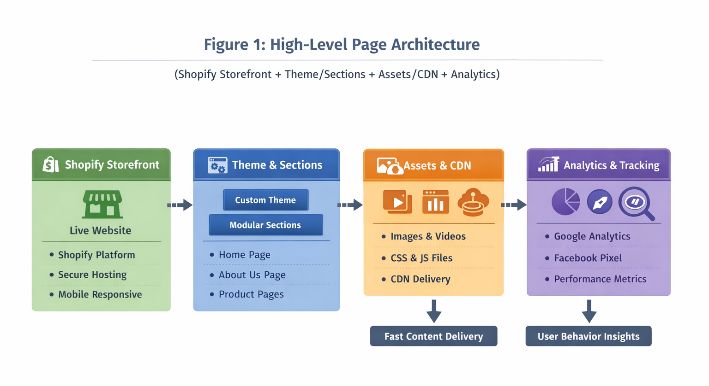Figure 2: About Us Page Section Map

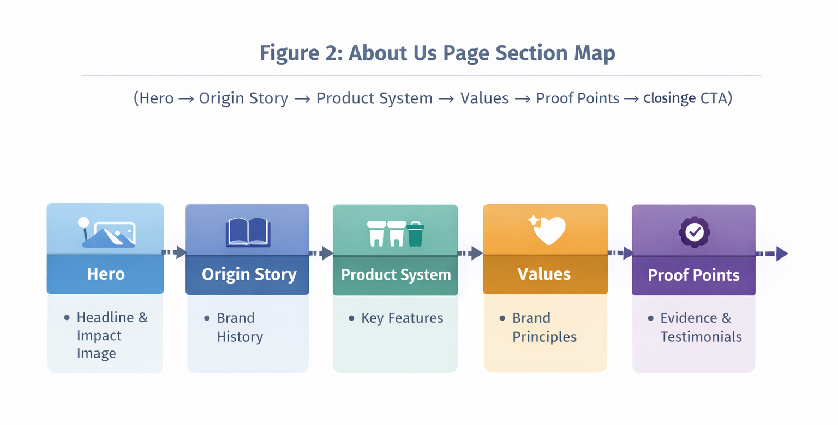

Figure 3: Deployment & QA Workflow

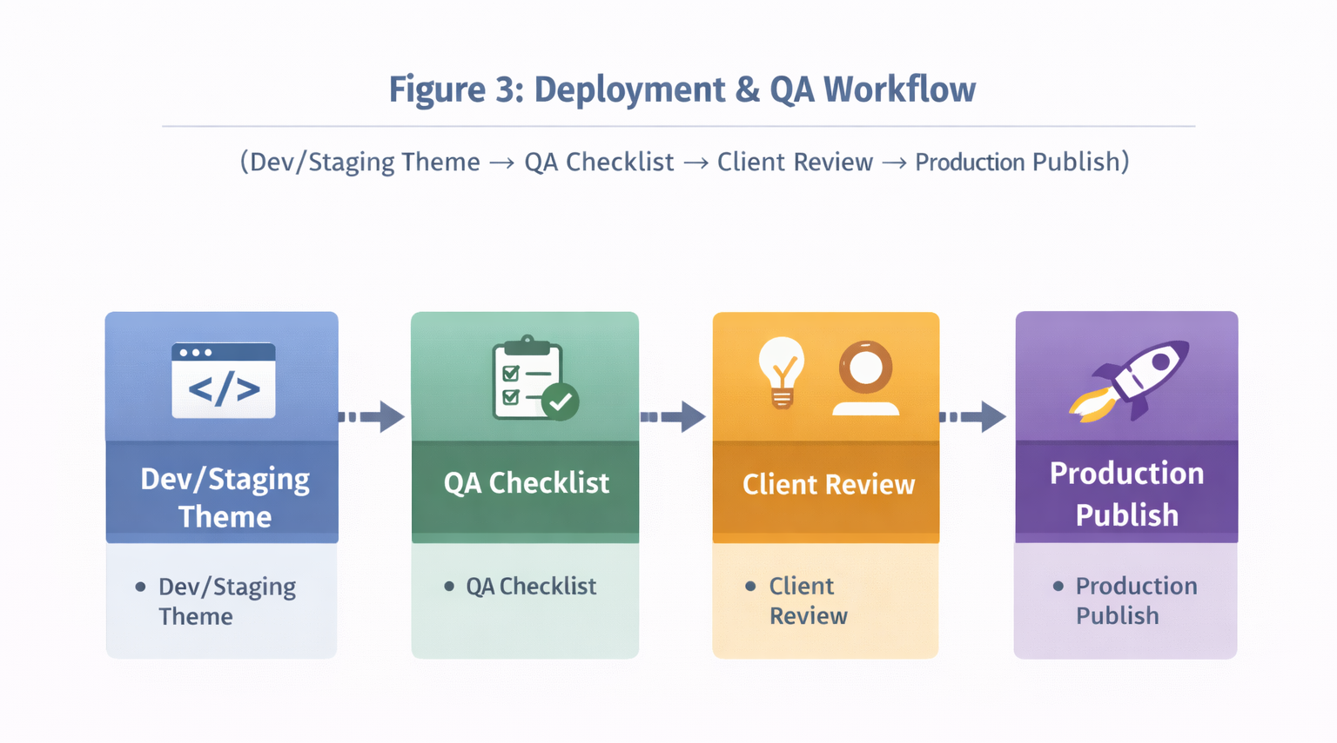7. Security, Privacy, and Compliance Considerations
The scope is a public-facing content page. Security and privacy considerations focus on safe theme changes and avoiding risky scripts.
- No storage of sensitive user data is introduced by this page.
- Avoid adding unnecessary third-party scripts; any analytics integrations will follow existing store setup.
- Shopify platform-level HTTPS and CDN delivery remain unchanged.

8. Development Methodology
We will follow a lightweight Agile delivery approach (short iterations) without phase-wise scope segmentation, as requested.
- Kickoff and requirements confirmation (story, assets, target theme/platform choice).
- Build iteration(s) with internal QA and client review checkpoints.
- Final QA, deployment, and handover.

9. Deliverables
- Live About Us page on Shopify or Instant.so, fully responsive and production ready.
- Reusable sections/blocks (where applicable) enabling future edits via Theme Editor/Instant.
- Performance-optimized media setup and basic SEO structure.
- Handover documentation (what was built, where to edit, and recommended operating guidelines).
- 3 months of complimentary support after delivery (minor bug fixes, basic monitoring guidance, and performance-related frontend issues).
Complimentary Support (3 Months)
- Bug fixing for minor UI issues and crashes reproducible in supported environments.
- Basic performance tuning and UI responsiveness improvements.
- Assistance interpreting frontend logs and issues (requires Client to provide access to crash/analytics tools).

10. Assumptions & Out of Scope

Assumptions
- Client provides final approved copy and brand story, plus visual assets or directions before build begins.
- Existing Shopify theme is Online Store 2.0 compatible (or client agrees to enable a compatible theme workflow).
- Any paid apps/licenses (e.g., Instant.so subscription) are provided by the client if required.

Out of Scope
- Branding, UI/UX, copywriting, and net-new visual identity creation.
- Complex custom backend development or new integrations.
- Store-wide redesign outside the About Us page.
- Major theme migration or re-platforming.

11. Estimated Timeline
The total development timeline depends on feedback turnaround and asset readiness. A typical delivery window is 2 weeks after getting the approved design.

Financial Proposal
Below is an itemized estimate for development-only delivery. Final cost will be confirmed after kickoff once the target platform (Shopify vs Instant.so) and theme constraints are validated.
Scope Focus | Weeks | Estimated Cost (USD)
Story-driven About Us page Development | 2 | $2,000

Payment Terms
- 30% advance payment to initiate development.
- 70% upon final delivery and production publish.
- Any additional requests outside scope will be estimated and approved before implementation.

Remarks
- This estimate excludes any third-party app subscription fees (e.g., Instant.so paid plans) which will be borne by the client if required.
- One round of consolidated feedback is included; excessive iterative rounds may require change requests.
- Complementary support: 3-month post-launch bug-fix window.

Related Project References
- Shanti Jewels eCommerce Website – https://shaantijewels.com/
- HitSqwad – https://hitsqwad.com/
- Arc iGaming – https://arcigaming.com/
- Spark Infrastructure Ltd – https://silbd.net/
- Sisimpur– https://riseuplabs.com/sisimpur/

Conclusion
The About Us Page Design & Development for Trash King™ will be delivered as a fully production-ready, high-performance web page built from scratch on Shopify or Instant.so, aligned precisely with the client’s finalized brand story, copy, and visual direction. The proposed development approach ensures a responsive, mobile-optimized layout with subtle animations and seamless transitions that enhance storytelling without compromising performance or usability. By combining clean code practices, scalable architecture, and deployment-ready configuration, the solution will strengthen Trash King™’s brand credibility, clearly communicate its narrative, and support future growth within the selected platform ecosystem.

