Technical & Financial Proposal
WeFi – Web and Mobile App Development Phase 1.5 (Enhancement & Extension)
Prepared by: Riseup Labs
Date: February 3, 2026

1. Introduction
This document provides a technical and financial proposal for implementing WeFi Phase 1.5 by extending and enhancing the client’s existing web and mobile applications (Android and iOS). UI/UX design work is out of scope; development will follow existing UI patterns and workflows.
Phase 1.5 focuses on delivering a simplified but operational version of the Super Admin Control Panel, Schools (Tuition) module, and Procurement/Hospital module, with an emphasis on manual verification and minimal external integrations in order to accelerate time-to-value.

1.1 Key Constraints & Principles
- The project is NOT developed from scratch; it is an enhancement/extension of existing applications.
- UI/UX design and visual redesign are out of scope; development will follow existing design system/components.
- Phase 1.5 intentionally avoids deep third-party or enterprise system integrations (e.g., LMS/ERP) and supports manual verification flows where needed.
- Mobile and web deliverables will be produced with Flutter.
- Scope will be delivered across three (3) milestones with milestone-wise acceptance and payment.
- This proposal is prepared for an approximately 35–40 pages in UI as scope. If the final UI design exceeds this limit, budget and estimation will be revisited.

2. Project Scope Overview

2.1 In Scope (Development Only)
Implementation and integration (development-side) for the following Phase 1.5 functional areas:
- Super Admin Control Panel (Global Dashboard, Approval Queue workflow, RBAC user management, entity management).
- Schools Module (School onboarding portal, roster upload, school dashboard hierarchy, parent matching flow, payment schedule setup).
- Procurement & Hospital Module (Buyer onboarding, credit limit assignment, invoice/insurance upload, entity dashboard).
- Backend/API extensions required to support the above flows, including data model adjustments, approval actions, KPI aggregation, audit logs, and tenant isolation.
- Quality assurance, security hardening (role-based access, audit logs), staging and production release support (as per client release process).

2.2 Out of Scope
- UI/UX redesign, branding changes, new visual explorations, and Figma design work.
- Deep integration with external/enterprise systems (e.g., school LMS/ERP, dynamic due amount fetching, external payment disbursement automation).
- Automated bank disbursement or payment gateway settlement; Phase 1.5 uses manual payout confirmation by admins.
- UAE Pass or other external identity integrations if not already available in the current system (Phase 1.5 may use manual/limited verification).
- New major modules outside Schools and Procurement/Hospital financing.
- Long-term operations or managed services beyond the one (1) month complimentary support described later.

2.3 Current System Context (To Be Validated in Discovery)
The client currently operates existing web and mobile applications. Before implementation, we will perform a lightweight technical discovery to confirm current codebase structure, environments, API readiness, data model constraints, and release practices. Phase 1.5 will then extend the system following the existing architecture patterns to reduce regression risk.

3. Proposed Approach & Methodology
We will follow an Agile, milestone-based delivery approach. Each milestone is delivered through short iterations consisting of requirement validation, technical design, implementation, integration, QA, and a milestone demo/handover. This approach supports early validation and reduces delivery risk.

3.1 Delivery Methodology (Milestone + Iteration)
- Milestone Kickoff: confirm scope boundaries, acceptance criteria, dependencies, and environments.
- Iteration Planning: convert milestone scope into user stories with clear Definition of Done (DoD).
- Implementation: develop features following existing patterns; introduce minimal changes required to support Phase 1.5 flows.
- Integration: connect UI to APIs, implement validations, error handling, and state management.
- Quality Assurance: feature testing + targeted regression testing on intersecting existing flows.
- Demo & Acceptance: milestone demo, handover package, and sign-off.

3.2 Engineering Principles
- Build on existing codebase and conventions to minimize regression risk.
- Use a unified workflow for approvals and manual payout confirmation.
- Ensure tenant isolation across entities (e.g., School A never accesses School B data).
- Implement audit logging for sensitive admin actions (approve/decline/return-for-info).
- Design for extension: Phase 1.5 should be future-compatible with later deep integrations (ERP/LMS) without rework where possible.

4. Development Milestones (3 Milestones)
The scope is divided into three milestones to enable incremental validation and reduce delivery risk. Timelines are suggested estimates and may be adjusted based on discovery outcomes, API readiness, and stakeholder feedback cycles.

Milestone 1 – Super Admin Control Panel Foundation + Core Platform Enhancements

4.1 Objectives
Deliver a functional Super Admin Control Panel foundation to monitor operations, manage approvals, enforce RBAC, and support manual payout confirmation. This milestone establishes core data and workflow capabilities used by Schools and Procurement modules.

4.2 In-Scope Features
- Global Dashboard with KPI widgets (e.g., Total Active Loans, Total Schools Onboarded, Pending Approvals, Projected Payouts).
- Operational health metrics definition (e.g., failed logins, failed OCR scans if applicable).
- Unified Approval Queue: single table aggregating requests across modules with actions (Approve, Decline with reason, Return for info).
- Manual Payout Toggle: admin marks requests as ‘Paid’ after bank transfer (no auto-disbursement).
- User Management with RBAC roles (Super Admin, Ops Manager, Viewer).
- Entity Management: admin can manually create School/Buyer profiles (bypass frontend onboarding as needed).
- Audit Logging for admin actions (timestamp, admin ID, IP where available).
- Tenant isolation rules and access enforcement baseline.

4.3 Deliverables
- Updated web admin application for Control Panel modules.
- Backend/API endpoints required for dashboard KPIs and approval actions (or extensions to existing APIs).
- Database changes (as needed) to support unified entities, loans, and audit logs.
- Milestone demo build + handover notes and API mapping.
- QA test cases and test report (feature + targeted regression).

4.4 Suggested Timeline
- Duration: 1 week

4.5 Human Resources & Responsibilities (Short)
- PM/BA: backlog, acceptance criteria, stakeholder sync, dependency tracking
- Solution Architect/Tech Lead: technical design, code review, integration planning
- Frontend Developer: web application implementation, state management, API integration
- Flutter Developer(s): mobile app implementation, state management, API integration
- Backend Developer: API and data model extensions, security rules
- QA Engineer: test planning, functional testing, regression verification
- DevOps (part-time): staging deployment support, environment configuration

4.6 Acceptance Criteria (High-Level)
- Admin can log in with assigned role and sees only permitted modules/actions.
- Approval queue supports Approve/Decline/Return-for-info with correct status changes and audit logs.
- Manual payout status can be applied and is reflected in request/loan lifecycle.
- Dashboard KPIs load reliably and match backend aggregated counts within agreed tolerance.

Milestone 2 – Schools (Tuition) Module Enablement (Onboarding + Matchmaking + Scheduling)

4.7 Objectives
Enable schools to onboard, upload rosters, and manage tuition financing requests. Enable parents to be matched to student records and select a repayment schedule. Phase 1.5 uses simplified verification and manual document upload where dynamic school data integration is unavailable.

4.8 In-Scope Features
- School onboarding portal with required fields (e.g., CR number, Tax ID, Corporate IBAN) and verification document uploads.
- Roster upload (CSV/Excel) with defined template (Student ID, Name, Grade, Annual Fee, Parent Emirates ID).
- School dashboard view hierarchy (School → Grade → Class → Student Status: Paid/Pending).
- Parent experience (Matchmaker): login → enter Emirates ID (or existing verification ID) → query roster matches.
- Conflict resolver workflow: if child appears in multiple active rosters, parent selects correct school and system flags other record inactive.
- Payment setup: parent selects plan (e.g., 3 terms or monthly) and system generates repayment schedule.
- Loan disbursement rule for tuition: payout from WeFi to the school; parent repays WeFi per schedule (captured in loan object).
- Manual document upload flow for loan amount verification when required (Phase 1.5 constraint).

4.9 Deliverables
- Mobile app updates (Flutter Android/iOS) for parent flows impacted by tuition module.
- School web portal pages for onboarding and roster upload/dashboards.
- Backend/API endpoints for onboarding, roster ingestion, matchmaker query, schedule generation, and status tracking.
- Data validation rules for roster import and conflict resolution.
- QA test cases and test report for onboarding + matchmaking + schedule flows.

4.10 Suggested Timeline
- Duration: 1 week

4.11 Human Resources & Responsibilities (Short)
- PM/BA: story refinement, school data template finalization, coordination
- Tech Lead: architecture alignment, integration review, data/privacy validation
- Frontend Developer(s): web flows, state management, API integration
- Flutter Developer(s): mobile flows, state management, API integration
- Backend Developer(s): roster parsing service, matchmaker API, schedule generation logic
- QA Engineer: test execution, import edge cases, device matrix testing
- DevOps (part-time): staging rollout, logging/monitoring configuration

4.12 Acceptance Criteria (High-Level)
- School can onboard and upload roster; system validates and stores roster data successfully.
- Parent can find matched student(s) and proceed without accessing other tenants’ data.
- Conflict case is handled with explicit parent selection and proper record status updates.
- Repayment schedule is generated consistently and stored under the loan object; key statuses display correctly.

Milestone 3 – Procurement & Hospital Module + Stabilization + Release Readiness

4.13 Objectives
Enable verified business entities (buyers/hospitals) to onboard, receive a credit limit, upload invoices/insurance documents, and track utilization and repayments. Complete end-to-end stabilization across all Phase 1.5 modules, finalize regression, and prepare production release.

4.14 In-Scope Features
- Entity (Buyer/Hospital) onboarding: verification documents (trade license, audits), profile management.
- Optional credit limit assignment by Admin (e.g., AED-based limits).
- Invoice/insurance upload: vendor name, invoice amount, due date, PDF upload.
- Validation rules: invoice amount must be within available credit limit.
- Entity dashboard: utilization, upcoming repayments, and vendor concentration metrics.
- Release readiness: build generation, deployment runbook, and handover workshop.

4.15 Deliverables
- Web portal updates for procurement/hospital module.
- Mobile app updates user flows for Hospital and Hotel as business, surfaced on mobile
- Backend/API endpoints for entity onboarding, invoice uploads, credit utilization, dashboard insights, and repayments tracking.
- Production release candidate build and handover pack (release notes, configuration checklist).

4.16 Suggested Timeline
- Duration: 1 week

4.17 Human Resources & Responsibilities (Short)
- PM/BA: acceptance sign-off, release coordination, stakeholder training plan
- Tech Lead: cross-module stabilization, security review, performance review
- Frontend Developer(s): web enhancements and stabilization fixes
- Flutter Developer(s): mobile enhancements and stabilization fixes
- Backend Developer(s): invoice workflows, dashboards, validations, audit/logging
- QA Engineer: full regression, release verification, defect triage
- DevOps: production deployment support, monitoring/alerts setup

4.18 Acceptance Criteria (High-Level)
- Entity onboarding and invoice upload flows work end-to-end with credit limit validations.
- Dashboards show correct utilization/repayments data based on stored transactions and schedules.
- All milestones pass agreed regression checklist; critical defects resolved.
- Release candidate is produced with deployment notes and handover completed.

5. Proposed Technical Stack
The project will utilize Flutter as the primary development technology for both mobile and web delivery where applicable.
Layer | Proposed / Existing Choice (To be validated)
Mobile Apps | Flutter (Android & iOS)
Web Admin/Portals | Vue.Js, React.Js
State Management | BLoC / Provider / Riverpod (align to existing app standard)
API Layer | REST APIs (existing + extensions)
Database | PostgreSQL / MySQL (align to existing)
File Storage | Object storage for documents (e.g., S3-compatible / existing storage)
Auth & RBAC | Existing auth + role-based access control
Observability | Centralized logging + audit log store; Crash reporting for mobile if enabled

6. Deliverables
- Milestone-wise working increments of WeFi Phase 1.5 for web and mobile applications.
- Source code updates (as per repository access and branching strategy agreed with the client).
- API specifications / mapping (endpoints, request/response schemas, error codes) for the delivered features.
- Database migration scripts and release notes (where applicable).
- Test cases, test reports, and defect logs for each milestone.
- Deployment and configuration checklist (staging and production).
- Handover workshop and knowledge transfer session(s).

7. Technical Diagrams (Placeholders)
Insert the following diagrams in the indicated placeholders. Titles and descriptions are included to ensure proposal completeness.

Diagram 1: High-Level Solution Architecture
(Frontend Apps → Backend APIs → Database/Storage → Admin Console, with RBAC and Audit Logging).

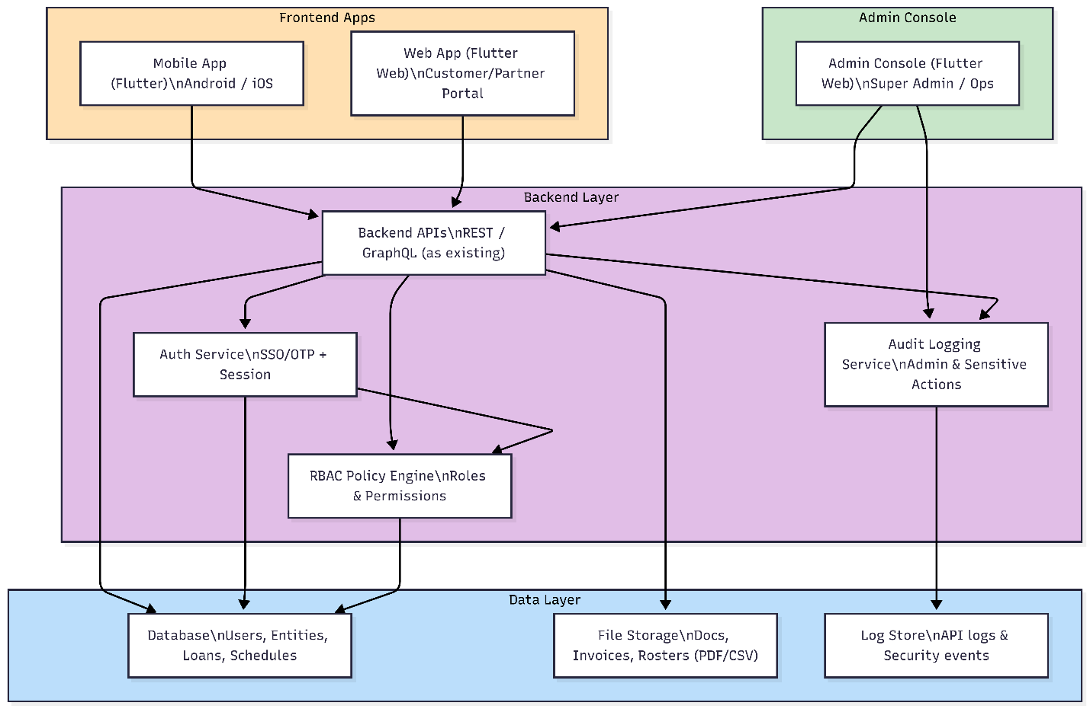Diagram 2: Approval Queue & Manual Payout Workflow
Request Submitted → Pending Review → Approve/Decline/Return → Awaiting Payout → Admin Confirms Paid → Active/Paid.

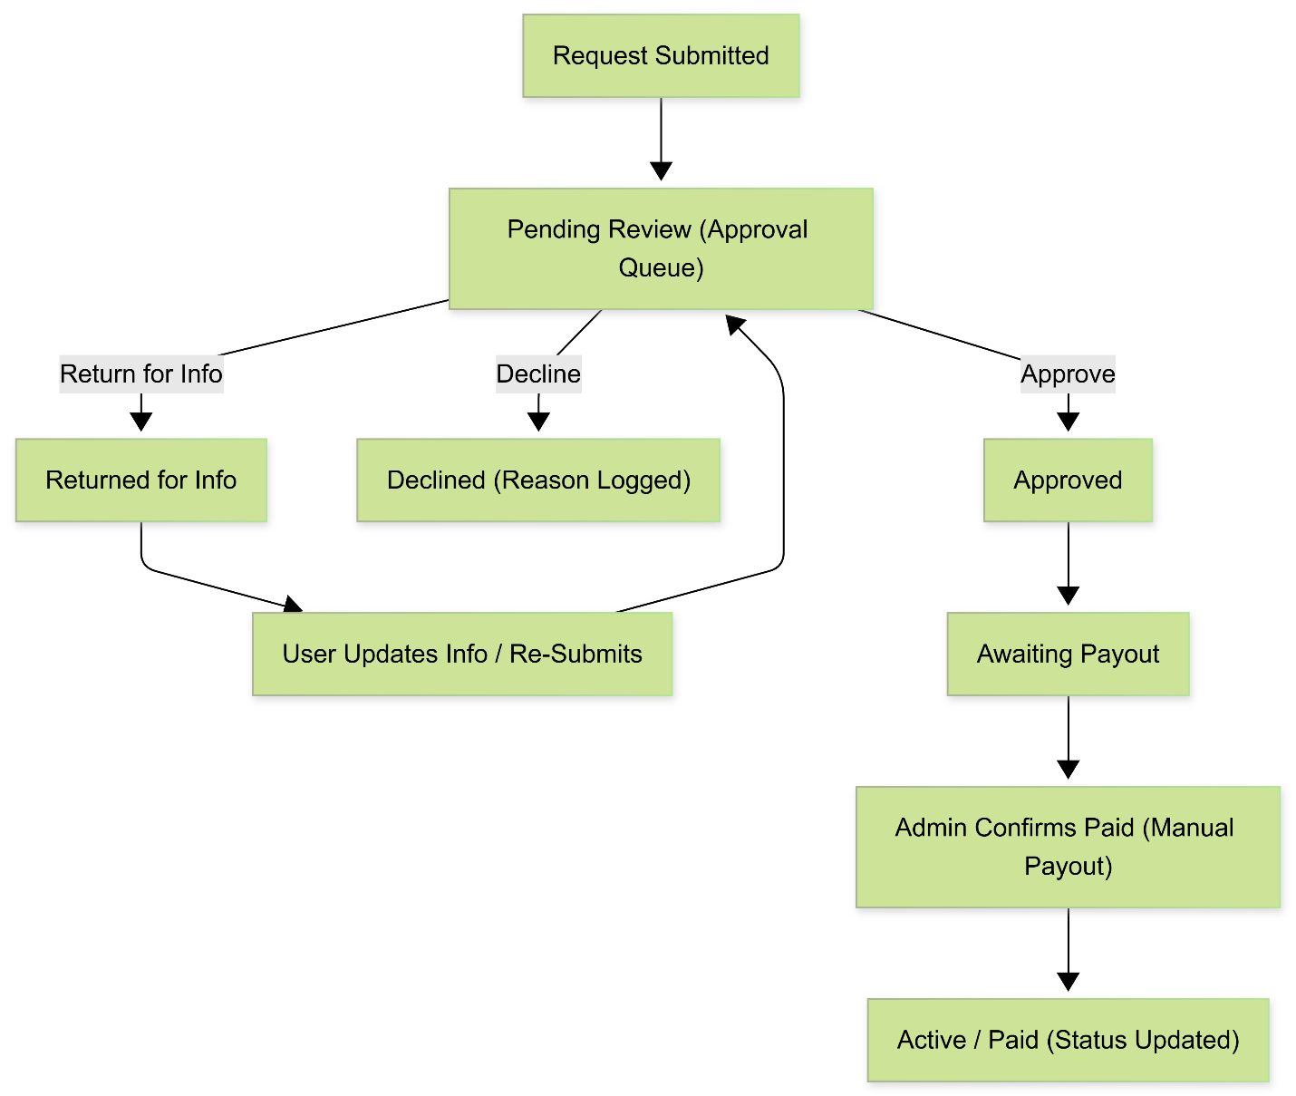Diagram 3: Unified Data Model Overview (ERD – High Level)
(School/Buyer/Hospital), Loans, Repayment Schedule, Students, Roster Imports, Admin Actions/Audit Logs.
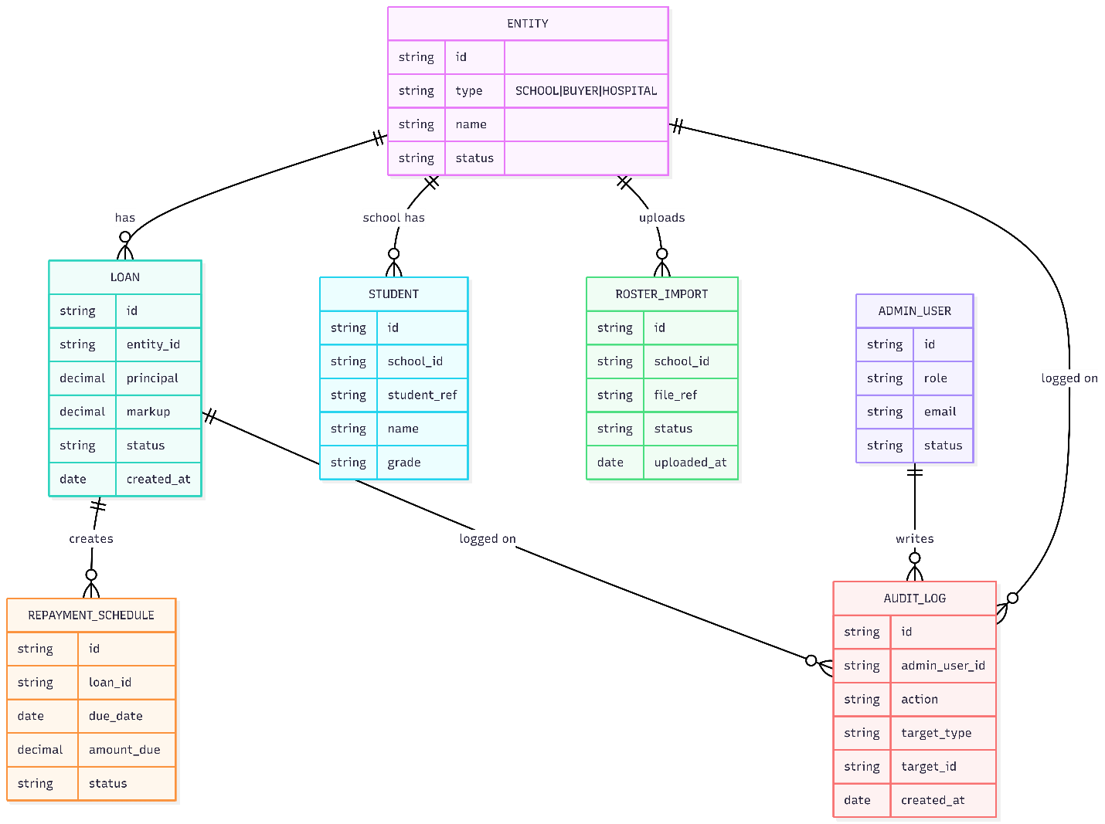

8. Quality Assurance & Testing Approach
Quality assurance will be performed per milestone and includes functional testing, integration testing against staging APIs, and targeted regression testing for intersecting existing flows.

8.1 Testing Types
- Functional testing for new and modified features
- API integration testing (happy paths + negative paths)
- Role-based access testing (RBAC) for admin actions
- Data validation and import testing (CSV/Excel roster ingestion)
- Security checks for tenant isolation and access boundaries
- Regression testing on impacted existing flows
- Release verification testing for milestone builds

8.2 Device & Platform Coverage (Mobile)
- Android: major OS versions and screen sizes agreed with client; minimum coverage to be confirmed in discovery.
- iOS: latest major versions supported by client; TestFlight build validation where applicable.

9. Deployment, Release & Handover
We will support staging and production releases according to the client’s release governance and access model. Each milestone will deliver a testable build and a handover package; the final milestone will deliver a production-ready release candidate.

9.1 Environments
- Development: internal engineering environment
- Staging: client-provided environment for validation
- Production: client-controlled production deployment

9.2 Handover Package
- Release notes and impacted modules list
- API mapping list and configuration keys
- Database migration notes (if applicable)
- Test report and known limitations (if any)
- Operational notes for admin workflows (approval, payout confirmation, audit logs)

10. Complimentary Support (1 Month)
After completion of Milestone 3 and final handover, we will provide one (1) month of complimentary support focused on the delivered Phase 1.5 scope.

10.1 Included
- Bug fixes for issues introduced by the Phase 1.5 changes (reproducible on supported environments).
- Minor adjustments within existing UI patterns (e.g., spacing/alignment, minor copy changes).
- Stabilization support for edge cases discovered in production within scope.
- Support in interpreting logs/crash reports if access is provided.

10.2 Excluded
- New features, new modules, or scope expansion beyond Phase 1.5.
- Changes required due to major backend/API contract changes not initiated by this scope.
- Fixing historical/pre-existing issues not caused by Phase 1.5 changes.
- Ongoing managed services beyond the 1-month complimentary support window.

11. Financial Proposal
All costs are estimated in USD and cover development and QA effort for Phase 1.5 enhancement. Third-party licensing/usage costs (if any) are excluded and will be handled by the client. Final cost confirmation will be performed after short discovery against the existing codebase and environments.

11.1 Milestone-wise Costing (Template)
Milestone | Scope of Work | Suggested Timeline | Estimated Cost (USD)
Milestone 1 | Super Admin Control Panel Foundation + Core Platform Enhancements | 1 week
Milestone 2 | Schools Module Enablement (Onboarding + Roster + Matchmaker + Schedules) | 1 week
Milestone 3 | Procurement & Hospital Module + Stabilization + Release Readiness | 1 week

11.2 Payment Terms
Payment will be collected milestone-by-milestone:
- 30% advance payment at the start of each milestone (upon milestone kickoff).
- 70% payment upon completion, delivery, and handover of that milestone.
- Next milestone will start after the previous milestone payment is cleared.

11.3 Assumptions & Remarks
- Client will provide access to existing repositories, environments, and required credentials/configuration.
- Required APIs will be available in staging with documentation or sample payloads; gaps may affect timelines.
- Any scope beyond the three milestones will be treated as a change request and estimated separately.
- If the final proposal document exceeds 35–40 pages due to expanded scope or additional required sections, the budget will be increased, or a revised estimation will be prepared.

12. Acceptance & Sign-off
Each milestone is considered accepted when the delivered build meets the agreed acceptance criteria, passes the milestone test checklist, and the client provides written sign-off (email or acceptance record).
This proposal is intended for functional assessment and milestone-based estimation purposes. Final timelines and costs will be reconfirmed after discovery.

