Technical Proposal
Briddhi Mobile Investment Platform
Android and iOS Mobile Application Development

1. Executive Summary
This technical proposal presents a focused plan to develop, test, and deploy the Briddhi mobile application for Android and iOS from scratch. The proposed solution is scoped as a mobile-first Mutual Fund investment platform, aligned with the BRD and revised according to the client clarification answers. The client answers are treated as the final source of truth wherever they modify or override the BRD.
The proposal intentionally avoids additional features beyond the confirmed requirement. Gold and Real Estate will remain visible only as “Coming Soon” options without backend or operational setup in this phase. Manual back-office verification will be supported through data capture, document upload/download, and integration with the existing Briddhi webapp/admin environment rather than building a separate full admin panel or external verification integrations in this scope.
- Mobile app development from scratch using a single codebase for Android and iOS.
- MVP scope limited to Mutual Fund discovery, onboarding, profile completion, buy request, sell request, portfolio, transaction, and account service flows.
- Existing Briddhi webapp/admin/back-office process to remain the source for fund data, NAV updates, manual verification, and operational processing.
- No payment gateway implementation in this phase, as clarified by the client answers.
- Security-first implementation for customer data, document storage, authentication, and API access.

2. Scope Basis and Source of Truth

Area | BRD Position | Client Clarification | Proposal Treatment
MVP investment scope | BRD mentions Mutual Fund as active, with Gold and Real Estate as categories. | Client confirmed MVP is strictly Mutual Fund only; Gold and Real Estate remain Coming Soon only. | Keep Mutual Fund only; show Gold and Real Estate as inactive UI placeholders without backend setup.
eKYC and verification | BRD describes eKYC, NID scan, BO, bank, and nominee verification flows. | Client clarified everything is 100% manual and no external APIs are expected for BO, bank, nominee, or verification. | Implement data capture, file upload, status display, and handoff to back-office/manual verification. Do not include live NID/BO/bank verification API scope.
Fund and NAV data | BRD refers to backend/API data sync and real-time updates. | Client clarified fund master data, NAV, price, and portfolio updates will come through the existing webapp/admin panel. | Build mobile API/pipeline to consume or synchronize approved data from the existing webapp/admin source.
Payment gateway | BRD includes SSLCommerz payment gateway flow. | Client clarified “No payment gateway” and instructed to follow the existing webapp user flow. | Remove SSLCommerz/payment gateway from this proposal. Buy flow will create/track investment requests based on the agreed webapp process.
Sell operations | BRD includes sell request, Surrender Form, TRF, DP40 download/upload. | Client clarified sell operations are processed manually through back-office/admin. | Mobile app will allow sell request submission, form download, DP40 upload, and status visibility; processing remains manual/back-office.
Portfolio refresh | BRD mentions near-real-time/real-time updates. | Client clarified portfolios update when NAV is changed in the admin panel. | Portfolio values will refresh based on admin NAV updates and mobile API synchronization, not direct market feeds.
Guest mode | BRD allows users to explore without login. | Client clarified guests can browse funds and performance but cannot buy. | Allow guest browsing until Buy/Invest action; login/profile completion required before buy request.
Tax certificate | BRD includes tax certificate request and possible manual approval. | Client answers indicate manual/back-office pattern for operational workflows. | Include tax certificate request/download flow with manual processing dependency; no tax authority API scope in this phase unless later confirmed.

3. Understanding of the Requirement
Briddhi requires a secure and user-friendly mobile application that enables retail users to discover Mutual Funds, understand fund performance, complete profile and compliance information, submit buy/sell requests, monitor portfolios, and manage account-related services. The mobile application will be newly developed for Android and iOS, while the existing webapp/admin/back-office environment will remain the operational source for data and manual review.
- Target users: retail investors who need a simple mobile journey for Mutual Fund exploration and investment request submission.
- Primary platform: native-quality mobile experience for Android and iOS using one maintainable codebase.
- Core data dependency: existing Briddhi webapp/admin panel for fund data, NAV updates, forms, transaction records, and manual operational processing.
- Primary compliance pattern: collect verified user details and supporting documents in the app; review/approval handled manually by Briddhi/back-office or partners.
- Out-of-scope in this phase: Gold investment backend, Real Estate investment backend, direct external verification APIs, payment gateway, and a new full admin panel.

4. Proposed Technical Approach

4.1 Mobile-First Modular Architecture
The application will be built as a modular mobile platform so that each major user journey can be developed, tested, and released in controlled increments. Modules will include authentication, guest browsing, onboarding/profile completion, Mutual Fund discovery, buy request, sell request, portfolio, transaction history, account service, notifications, and settings.

4.2 Existing Admin/Webapp Integration Approach
Instead of building a new full admin panel, the proposed solution will integrate with the existing Briddhi webapp/admin environment or a controlled middleware/API layer. This will keep the project cost controlled and align with the client clarification that fund data, NAV, manual verification, sell processing, and operational status updates are handled through the existing back-office setup.

4.3 Manual Verification Support
The mobile app will collect required information and documents, show profile completion status, and present the status returned from the back-office process. Since the client clarified that verification is manual, the proposal excludes live NID, BO, bank, nominee, and tax-authority API validations unless later added through a separate scope.

4.4 Security and Data Protection Approach
The platform will treat customer data, NID-related information, bank/BO details, nominee information, uploaded forms, and transaction records as sensitive data. The implementation will apply secure API authentication, encrypted communication, encrypted storage for sensitive documents, role-based back-office access dependency, session timeout, input validation, audit logging for critical actions, and secure file handling.

5. Proposed Feature List
The following feature list is intentionally limited to the confirmed requirement and client clarification. It excludes any enhancement not required for the current mobile MVP.
Module | Included Features
Launch and Guest Entry | Splash screen, promotional banner slider, Login/Register CTA, Experience Briddhi guest entry, smooth Android/iOS transitions.
Authentication and Account Access | Email/phone login, password field with visibility toggle, remember ID, password recovery with OTP, registration with OTP, social login/signup where technically feasible, biometric login toggle for supported devices.
Guest Mutual Fund Browsing | Guest users can open the Invest section, browse Mutual Funds, search/filter/compare, and view fund details/performance. Login and required profile completion are enforced before buying.
Profile Completion and Manual Verification Data Capture | eKYC/NID information capture, profile information, BO account details with statement upload, bank account details with cheque leaf upload, nominee details with NID document upload, completion status blocks, and manual verification status support.
Home/Dashboard | Mutual Fund-focused investment overview, total investment/current value/gain-loss, portfolio chart, My Portfolio card, Popular Fund slider, investment goal progress, and profile setup popup. Gold/Real Estate can appear only as inactive Coming Soon indicators where required.
Invest Page | Mutual Fund CTA active; Gold and Real Estate CTAs inactive with Coming Soon popup only.
Mutual Fund Listing | Category tabs, search by fund name, risk profile filter, fund cards with NAV/type/risk/performance sparkline, empty states, and comparison mode.
Fund Comparison | Select two or more funds, compare NAV performance graph, display fund summary, risk level, NAV, historical return values, and fund manager information based on available admin data.
Mutual Fund Detail | Fund overview, NAV, buy price, sell price, average ACR, last updated date, time-range performance chart, performance history, top shareholding, dividend history, fund description, and fixed Buy button.
Buy Mutual Fund Request | Eligibility check, investment amount, unit price, calculated units, dividend option, nominee allocation, investment goal selection, buy summary, and submission/status flow based on the existing webapp process. Payment gateway is excluded.
Sell Fund Request | Sell page, active holding list, search/filter, sell details, validation against available units/value, sell summary, pending sell requests, Surrender Form/TRF download, DP40 upload, status update display, and empty states.
Portfolio Details | Mutual Fund portfolio overview, category distribution chart, performance line chart, category tabs, collapsible fund records, units, NAV, cost, market value, dividend, realized/unrealized gain, HPR, and annualized return based on available data.
Profile and Account Service | Profile photo/name, logout, profile details, change password, biometric toggle, nominee, BO account, bank account, transaction history, tax certificate request/download, investment goal setup, language switch, privacy policy, terms, contact us, about us, and OTP-protected delete account.
Transaction History and Documents | Buy/Sell/Dividend transaction list, filter by platform/year/type, form/payment/acknowledgement slip downloads where available, and separate download/upload actions where forms must be filled and re-uploaded.
Notifications | In-app and push notification support for relevant system updates such as verification status, transaction status, document availability, and general announcements, subject to admin/webapp data availability.

5.1 Explicitly Excluded / Deferred from This Proposal
- Gold investment backend, Real Estate investment backend, pricing engines, and operational setup.
- Payment gateway integration, including SSLCommerz, card, mobile banking, or internet banking processing.
- Live external APIs for NID/eKYC, BO account verification, bank verification, nominee verification, tax authority validation, or direct AMC integrations.
- A new full admin panel, unless separately requested. The existing webapp/admin/back-office setup will be used as the operational source.
- Automated investment allotment or settlement logic beyond the current Briddhi/webapp/manual operational process.
- Advanced AI, robo-advisory, trading recommendations, or additional investment products not stated in the confirmed scope.

6. Proposed Technical Diagrams
Figure 1: High-Level Mobile Solution Architecture

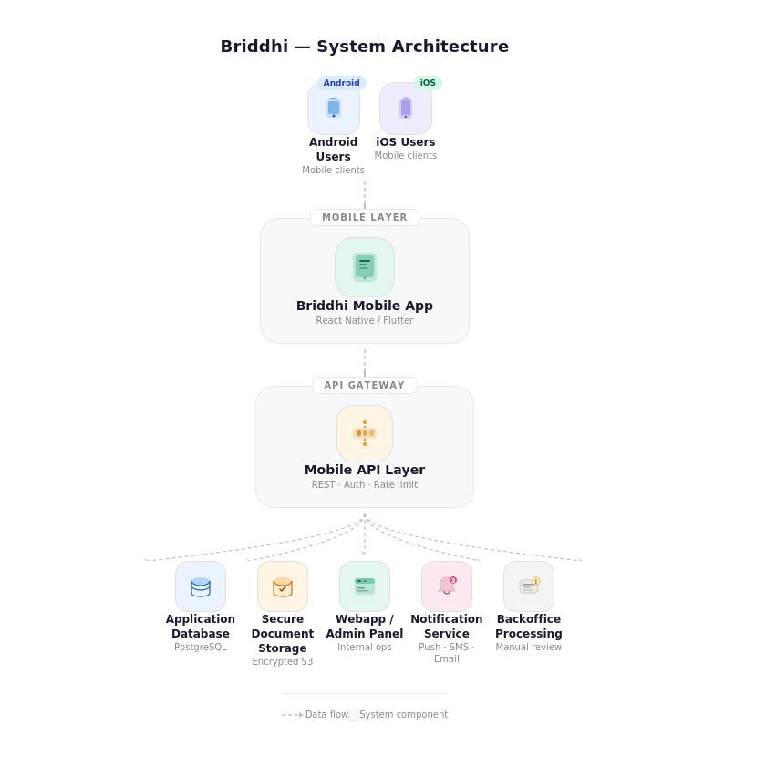

Figure 2: Scope-Adjusted Buy Mutual Fund Flow

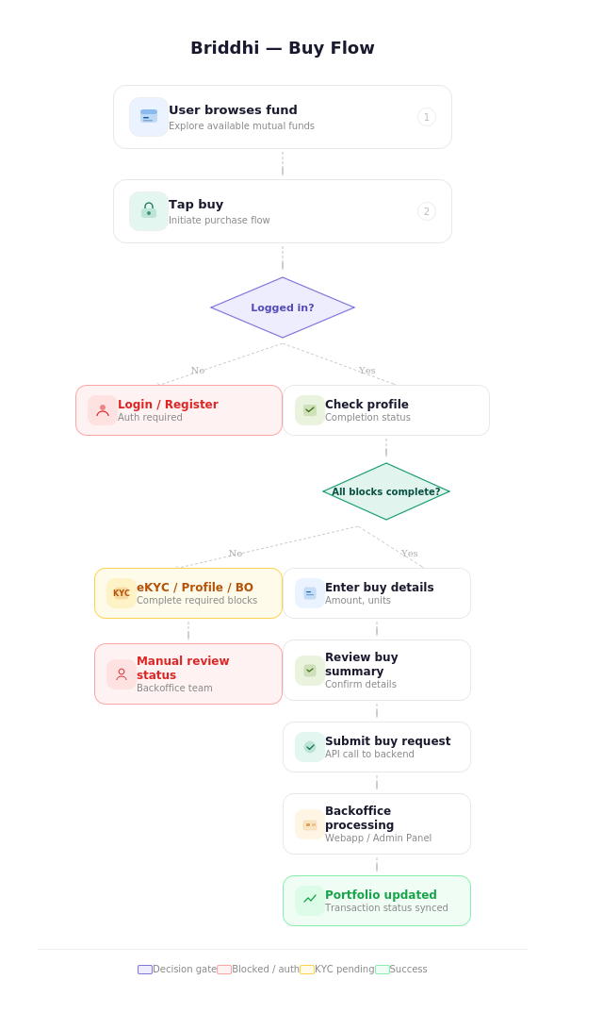

Figure 3: Manual Verification and Data Update Flow

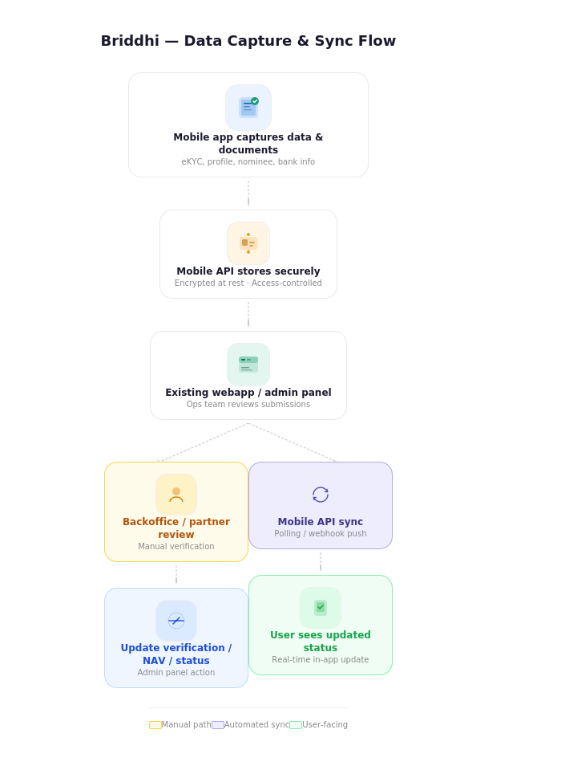

7. Development Methodology
An Agile delivery methodology is recommended, with fixed scope control and milestone-based review. Since the mobile app is being developed from scratch but depends on the existing Briddhi webapp/admin process, early technical discovery and API alignment are important before full-scale development.
Phase | Description
Phase 1: Discovery and Final Scope Alignment | Review BRD and client answers, confirm current webapp/admin flow, identify available data/API/database options, finalize scope exclusions, and prepare final SRS/backlog.
Phase 2: Sprint-Based Development | Develop mobile modules in controlled sprints: authentication, guest browsing, onboarding/profile, fund listing/details, buy/sell, portfolio, profile/account service, documents, and notifications.
Phase 3: Integration and System Testing | Integrate with webapp/admin/pipeline, verify manual status flows, conduct functional testing, API testing, mobile device testing, security testing, and QA support.
Phase 4: Deployment and Handover | Prepare Android/iOS release builds, deployment checklist, configuration documentation, handover guide, and post-deployment support plan.

8. Project Deliverables
Deliverable Group | Deliverables
Requirement and Planning | Final SRS/backlog, confirmed scope matrix, API dependency list, user journey confirmation, and acceptance criteria.
Mobile Application | Android and iOS mobile application developed from scratch using a single codebase.
Backend/API Layer | Mobile API services, authentication/session management, data synchronization services, document upload/download handling, notification hooks, and integration layer with existing webapp/admin where available.
Database and Storage | Application database schema, secure document storage configuration, transaction/profile record backup, and data retention setup as agreed.
Integrations | Integration/pipeline with existing Briddhi webapp/admin panel for fund data, NAV updates, transaction/status visibility, and operational document flows.
Testing and QA | Test plan, test cases, bug reports, regression results, QA support, device/browser matrix for mobile validation, and security testing checklist.
Deployment | Android build, iOS build, environment configuration, app store deployment support, release notes, and rollback checklist.
Documentation and Handover | Technical documentation, API documentation, deployment guide, admin/back-office coordination guide, and source code handover.

9. Proposed Technical Stack
The stack below is selected for a cost-controlled, maintainable Android and iOS app with strong security and scalable API/data handling. Final stack should be aligned after reviewing the current Briddhi webapp/admin technology and hosting environment.
Layer | Recommended Technology | Purpose / Reason
Mobile App | Flutter | Single codebase for Android and iOS, native-like UI performance, faster delivery, easier maintenance.
State Management | Riverpod or Bloc | Structured state handling for authentication, portfolio, fund data, forms, and async API states.
Backend/API Layer | Laravel REST API or Node.js REST API | Secure mobile API, integration layer, business rules, document handling, and synchronization with existing webapp/admin. Final selection should consider the existing Briddhi webapp stack.
Database | PostgreSQL or MySQL | Reliable relational storage for users, profile data, transaction records, requests, and app-side metadata.
Cache/Queue | Redis + queue worker | Background synchronization, notification triggers, document processing jobs, and better response time.
Document Storage | AWS S3 / S3-compatible object storage / secured cloud storage | Encrypted storage for NID, BO, bank, nominee, tax, forms, slips, and DP40 files.
Authentication | JWT/OAuth2-style token flow with secure refresh handling | Secure session management for mobile users and API access.
OTP/SMS/Email | Configurable SMS and email provider | Registration, password recovery, delete account, and critical verification actions. Provider to be finalized by client.
Push Notification | Firebase Cloud Messaging | Cross-platform push notification delivery for Android and iOS.
Analytics/Monitoring | Firebase Analytics/Crashlytics or equivalent | Crash reports, app health monitoring, and controlled event tracking.
Security | TLS, encryption at rest, secure file scanning/checking, rate limiting, audit logs | Protect sensitive financial and identity-related data.
CI/CD | GitHub Actions/GitLab CI + app signing pipeline | Controlled builds, automated testing, release management, and deployment traceability.
Hosting | AWS/Azure/GCP or approved client infrastructure | Scalable API hosting, storage, backups, logging, and environment separation.

10. Testing and Quality Assurance
Testing will focus on functional accuracy, security, cross-device consistency, document handling, and reliable synchronization with the existing webapp/admin process. Special attention will be given to customer data protection and transaction/status integrity.
QA Area | Activities
Requirement Validation | Map every implemented feature against the final scope matrix and remove items overridden by client answers.
Functional Testing | Validate login, registration, OTP, guest browsing, profile completion, fund listing, comparison, detail view, buy request, sell request, portfolio, transaction, documents, and profile services.
Integration Testing | Validate data sync with existing webapp/admin, NAV update reflection, transaction/status updates, document availability, and back-office status changes.
Manual Verification Flow Testing | Check pending/completed/rejected states for eKYC, BO, bank, nominee, tax certificate, buy, and sell requests as supported by the existing process.
Security Testing | Test authentication, session expiry, API authorization, file access control, encryption, input validation, rate limiting, and sensitive data handling.
Mobile Device Testing | Test on representative Android and iOS devices, screen sizes, OS versions, network conditions, and orientation/responsiveness scenarios.
Performance Testing | Check app load time, fund list scrolling, chart rendering, search/filter response, document upload/download reliability, and API response times.
Regression Testing | Run regression suite before each release candidate to ensure new changes do not break existing approved flows.



11. Key Non-Functional Requirements
- Security: customer identity, financial, nominee, and document data must be encrypted in transit and protected at rest.
- Privacy: sensitive records should be accessed only through authorized flows and should not be exposed through local device caching.
- Performance: common screens such as fund list, fund detail, portfolio, and dashboard should load smoothly under normal network conditions.
- Reliability: document uploads should support retry/resume behavior where feasible, with clear user feedback on failure.
- Maintainability: app modules and API services should be separated to support future product categories without changing the existing screen foundation.
- Usability: forms should include inline validation, clear empty states, error states, and user-friendly confirmation messages.
- Compatibility: Android and iOS user experience should remain consistent while following platform-specific permission and biometric requirements.
- Auditability: critical actions such as login, profile updates, document uploads, buy request, sell request, tax certificate request, and delete account should be traceable in system logs.

12. Implementation Timeline
Total proposed timeline: 1 month

13. Assumptions, Dependencies, and Client Inputs Required

13.1 Assumptions
- The current phase is limited to Mutual Fund only; Gold and Real Estate are not active products in this scope.
- The mobile application will be developed from scratch, but operational processing will use the existing Briddhi webapp/admin/back-office environment.
- No payment gateway will be implemented in this phase.
- Verification and approval workflows are manual and will be handled by Briddhi back-office or partners.
- Fund/NAV/portfolio values are dependent on the existing admin/webapp data update process.
- Any new third-party integration not confirmed in the client answers will require separate scope confirmation.

13.2 Client Inputs Required
- Access to current Briddhi webapp/admin environment, including demo credentials, videos, and available API or database documentation.
- Confirmed buy flow from the existing webapp, especially because payment gateway is excluded.
- Final list of Mutual Fund data fields, NAV update schedule, performance history format, dividend data, holdings data, and fund manager data.
- Document templates/forms for Surrender Form, TRF, DP40, tax certificate request, acknowledgement slips, and any other downloadable files.
- OTP/SMS/email provider details, notification content rules, and support contact information.
- Hosting preference, security policy, data retention policy, backup policy, and app store publishing account access.

