Technical Proposal – DARAJA+AI Weather Alert Voice System and Web Platform

1. Project Overview
DARAJA+AI is an AI-powered early warning dissemination platform designed to transform technical weather forecasts into easy-to-understand voice messages in local languages and dialects. The system processes meteorological reports and automatically generates localized voice alerts that can be distributed via radio, messaging platforms, mobile networks, and a web platform. The objective is to ensure vulnerable communities receive timely and understandable warnings related to extreme weather events.

2. Proposed Technical Approach
The proposed solution will implement an automated AI pipeline capable of ingesting meteorological reports, summarizing them into simplified language, converting them into localized speech, and distributing them through multiple channels, while also supporting web-based operational access.
Core processing pipeline:
1. Weather Report Ingestion – Daily and weekly PDF reports are collected from the meteorological authority.
2. AI Text Processing – An LLM processes the report and produces simplified warning summaries.
3. Localization Engine – Messages are adapted to local dialects and geographic contexts.
4. Text‑to‑Speech Generation – Voice messages are generated using a trained dialect‑specific TTS model.
5. Distribution Layer – Messages are delivered through radio, WhatsApp, IVR, social platforms, and the web platform.
6. Monitoring & Feedback – System performance and dissemination metrics are tracked.

3. Development Methodology
The project will follow an Agile iterative development approach with rapid prototyping and incremental improvements. The first operational version will focus on Sudanese Arabic, followed by additional dialects in later iterations.
Implementation Milestones:
- Project Initiation & Requirements Definition
- Audio Data Handover & Readiness Assessment
- LLM Summarizer (orchestration)
- Linguistic & Localization Design
- Data Preparation & Preprocessing
- TTS Base Model Development
- Model Tuning & Quality Evaluation
- System Integration & Deployment Setup
- User Acceptance Testing
- Production Go-Live
- Monitoring, Feedback & Ongoing Support

4. Proposed Technical Stack
- Backend / Web API: Python (FastAPI)
- AI Processing: OpenAI / LLM models or open‑source LLMs
- Speech Synthesis: Coqui TTS / Custom trained TTS models
- Speech Dataset Processing: PyTorch, HuggingFace
- Database: PostgreSQL
- File Storage: AWS S3 / Object Storage
- Message Distribution: WhatsApp API, Twilio, Radio export pipeline
- Infrastructure: Docker, Kubernetes, AWS or equivalent cloud

5. System Architecture
Figure 1: High‑Level System Architecture
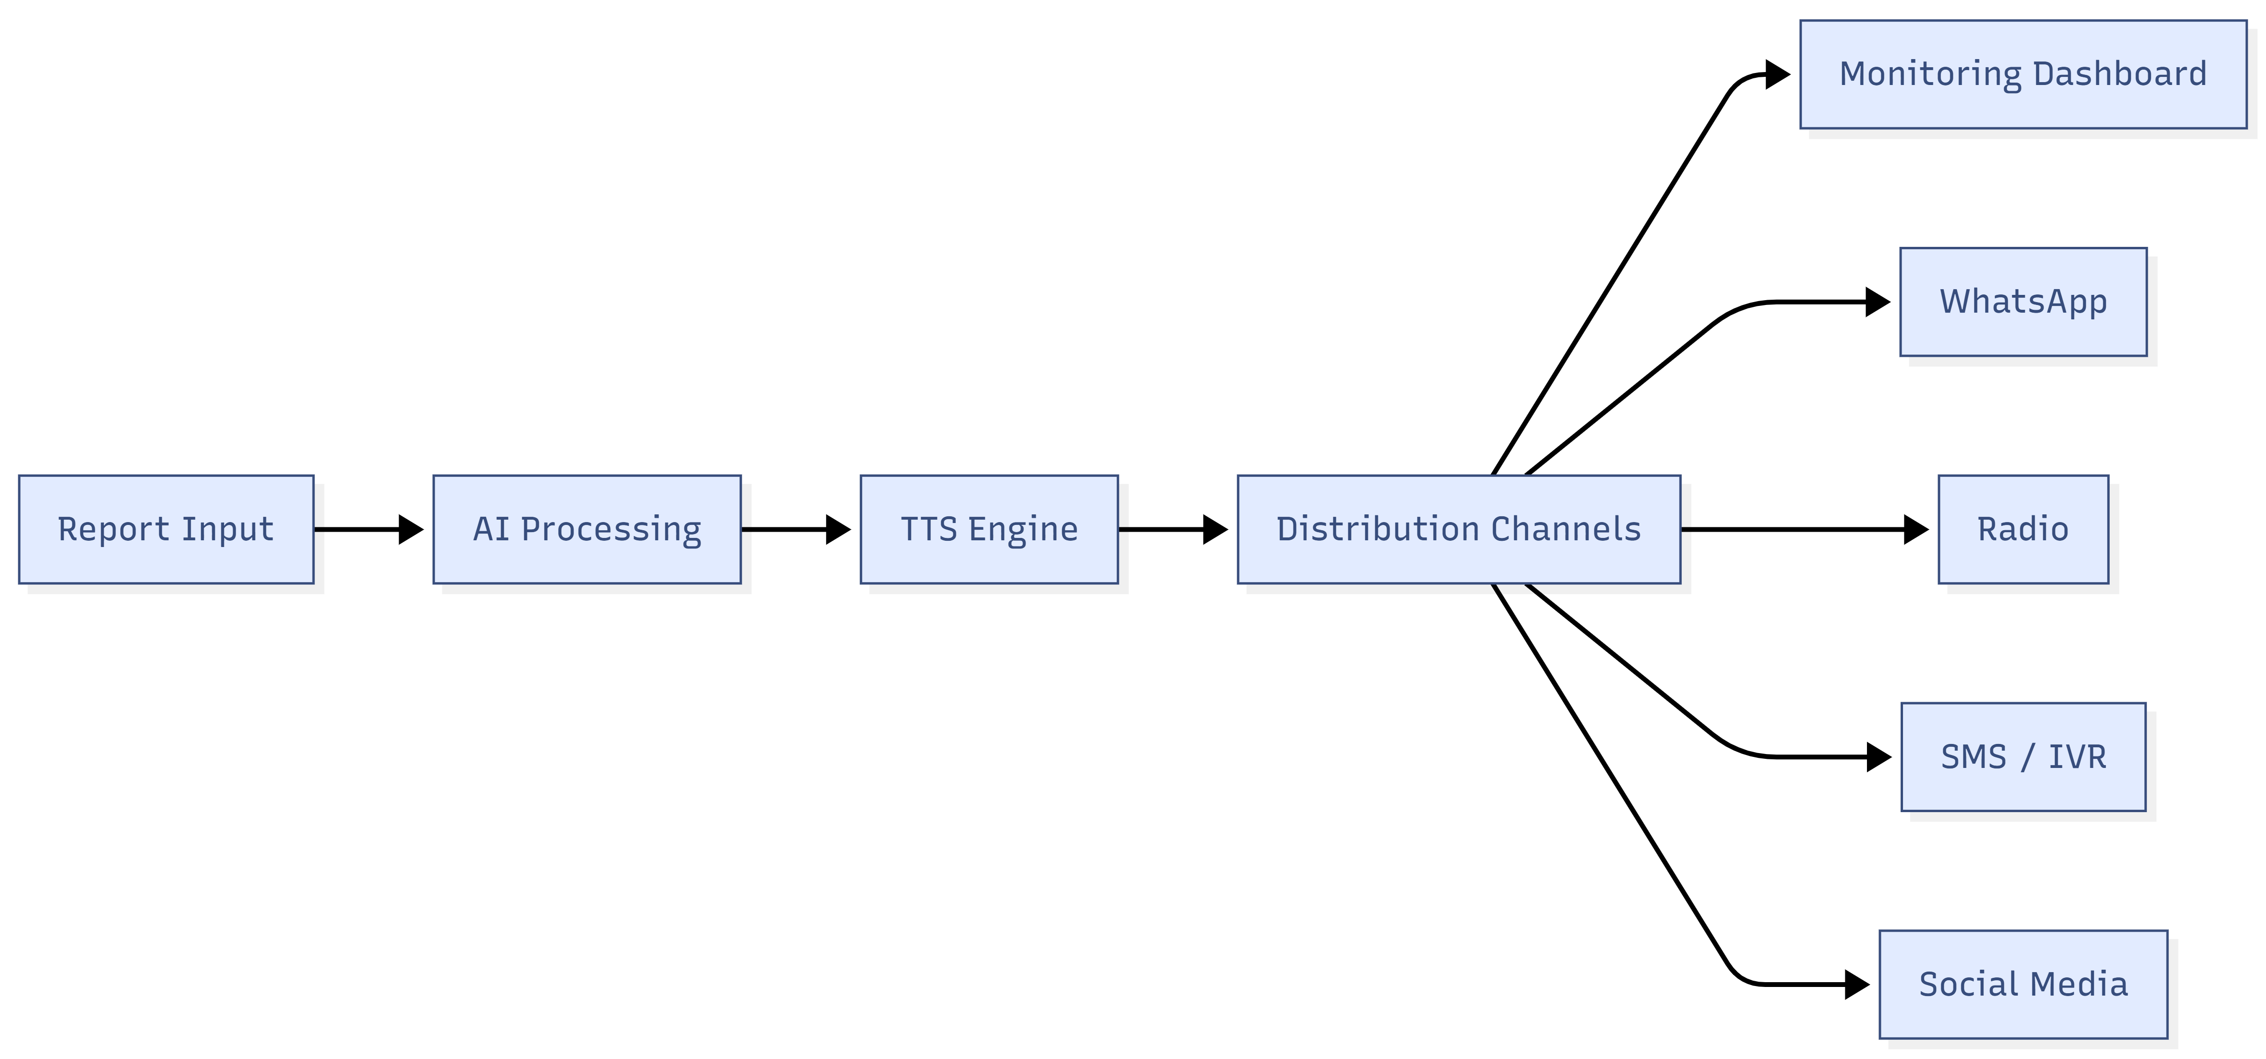

6. AI Processing Pipeline
Figure 2: Weather Forecast AI Processing Pipeline
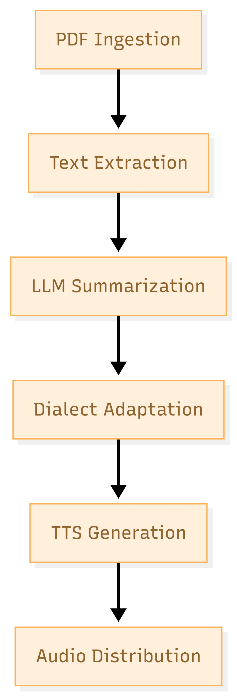

7. Voice Model Training Workflow
Figure 3: Dialect TTS Training Pipeline

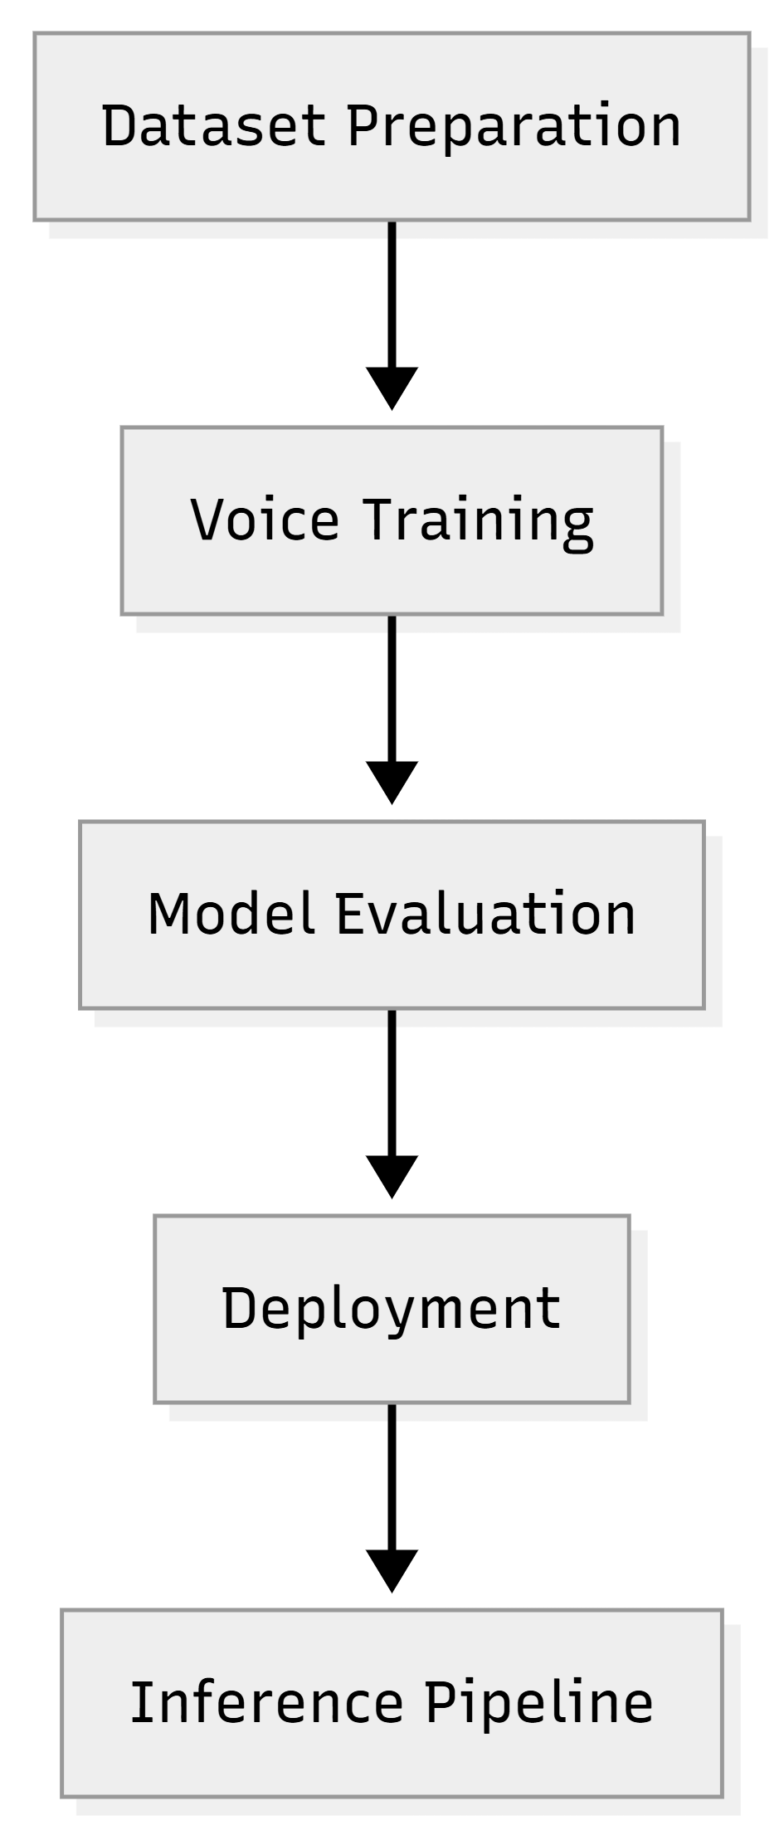

8. Deliverables
- AI weather alert processing system
- Dialect‑specific voice synthesis models
- Automated PDF weather report ingestion pipeline
- Voice alert generation and distribution platform
- System deployment and operational documentation
- Admin monitoring dashboard and web platform

9. Testing and Quality Assurance
A comprehensive QA strategy will be implemented to ensure system reliability, accuracy, and performance.
Testing layers include:
QA Testing – Validation of AI processing modules
Integration Testing – Verification of data pipeline integration
Model Evaluation – Speech clarity and dialect accuracy tests
Load Testing – Alert generation performance under high volumes
Field Testing – Testing dissemination through communication channels


10. Deployment and Operations
The system will be deployed in a scalable cloud environment with containerized services, enabling easy scaling during extreme weather events. Monitoring tools will ensure reliability and uptime of the warning system, with secure browser-based access for administrators and operational teams.

