Technical Proposal - DARAJA+AI Weather Alert Voice System and Web Platform

1. Project Overview
DARAJA+AI is an AI-powered early warning dissemination platform designed to transform technical weather forecasts into easy-to-understand voice messages in local languages and dialects. The system processes meteorological reports and automatically generates localized voice alerts for operational use through the web platform. The objective is to ensure vulnerable communities receive timely and understandable warnings related to extreme weather events.
The three pilot languages are explicitly defined as Arabic - Sudanese, Nubian (Dungolawi), and Tigrai/Tigrinya (Sudan side). The client and their translation firm are working on all three languages simultaneously for the pilot phase.
The voice model scope is intentionally limited to a use-case-specific weather bulletin TTS model. The dataset will be sourced exclusively from historical SMA weather bulletins and will focus on climate and weather terminology only. It is not intended to operate as a full-language or general-purpose TTS model.

2. Proposed Technical Approach
The proposed solution will implement an automated AI pipeline capable of ingesting meteorological reports, summarizing them into simplified language, converting them into localized speech while also supporting web-based operational access.
Core processing pipeline:
1. Weather Report Ingestion - Daily and weekly PDF reports are collected from the meteorological authority.
2. AI Text Processing - An LLM processes the report and produces simplified warning summaries.
3. Localization Engine - Messages are adapted to local dialects and geographic contexts.
4. Text-to-Speech Generation - Voice messages are generated using a trained dialect-specific TTS model.
Scoped TTS approach:
- The system will be trained to accurately reproduce historical SMA bulletin phrases in the correct dialect and pronunciation style.
- Audio recordings will be limited and are expected to remain well under 50 hours in total.
- For Sudanese Arabic, two native speakers are recording. For Nubian (Dungolawi) and Tigrai/Tigrinya (Sudan side), approximately one speaker each is expected.
- The model output will be optimized for recurring weather and climate bulletin phrases, rather than broad open-ended speech generation.
- The architecture will remain expandable so that broader vocabulary, additional speakers, and improved coverage can be added in future phases.

3. Development Methodology
The project will follow an Agile iterative development approach with rapid prototyping and incremental improvements. The first operational version will focus on the three pilot languages: Arabic - Sudanese, Nubian (Dungolawi), and Tigrai/Tigrinya (Sudan side), with all three being prepared simultaneously with the client and their translation firm.

Implementation Milestones:
- Project Initiation & Requirements Definition
- Audio Data Handover & Readiness Assessment
- LLM Summarizer (orchestration)
- Linguistic & Localization Design
- Data Preparation & Preprocessing
- TTS Base Model Development
- Model Tuning & Quality Evaluation
- System Integration & Deployment Setup
- User Acceptance Testing
- Production Go-Live
- Monitoring, Feedback & Ongoing Support

4. Proposed Technical Stack
- Backend / Web API: Python (FastAPI)
- AI Processing: OpenAI / LLM models or open-source LLMs
- Speech Synthesis: Coqui TTS / Custom trained TTS models
- Speech Dataset Processing: PyTorch, HuggingFace
- Database: PostgreSQL
- File Storage: AWS S3 / Object Storage
- Infrastructure: Docker, Kubernetes, AWS or equivalent cloud
- Future Integration Readiness: Modular API layer and connector-ready architecture to support future ClimaWeb integration, without changing the current implementation scope.

5. System Architecture
The system architecture will be modular and extensible, separating weather report ingestion, AI text processing, localization, scoped TTS generation, storage, and web platform access into independent components. This approach allows each component to be improved or replaced without affecting the full system.
ClimaWeb integration does not change the current scope. However, the system will be designed with a future integration layer so that ClimaWeb or similar external climate information platforms can be connected later through API-based workflows when required.

Figure 1: Modular High-Level System Architecture
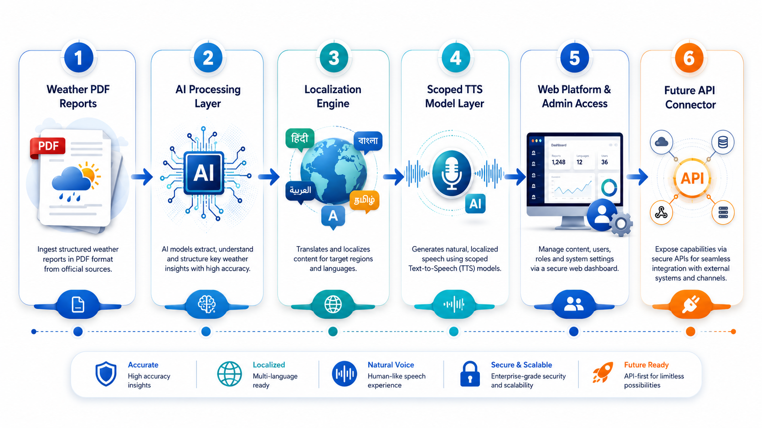
Future API Connector is a readiness layer only and does not expand the current scope.

Component | Purpose / Scope Boundary
Weather PDF Reports | Daily and weekly meteorological reports used as input.
AI Processing Layer | Extracts and summarizes weather information into simplified warning messages.
Localization Engine | Adapts wording into Arabic - Sudanese, Nubian (Dungolawi), and Tigrai/Tigrinya (Sudan side).
Scoped TTS Model Layer | Generates voice using limited weather-bulletin vocabulary trained from historical SMA bulletin data.
Web Platform & Admin Access | Supports browser-based operational access, review, and management.
Future API Connector | Designed for future ClimaWeb or external platform integration without changing current scope.

6. AI Processing Pipeline
The AI processing pipeline will focus on converting technical weather reports into simplified, localized bulletin scripts suitable for controlled TTS generation. The pipeline will use historical SMA bulletin structure as the vocabulary and phrase reference, ensuring the generated content remains aligned with the approved weather-alert use case.

Figure 2: Weather Forecast AI Processing Pipeline
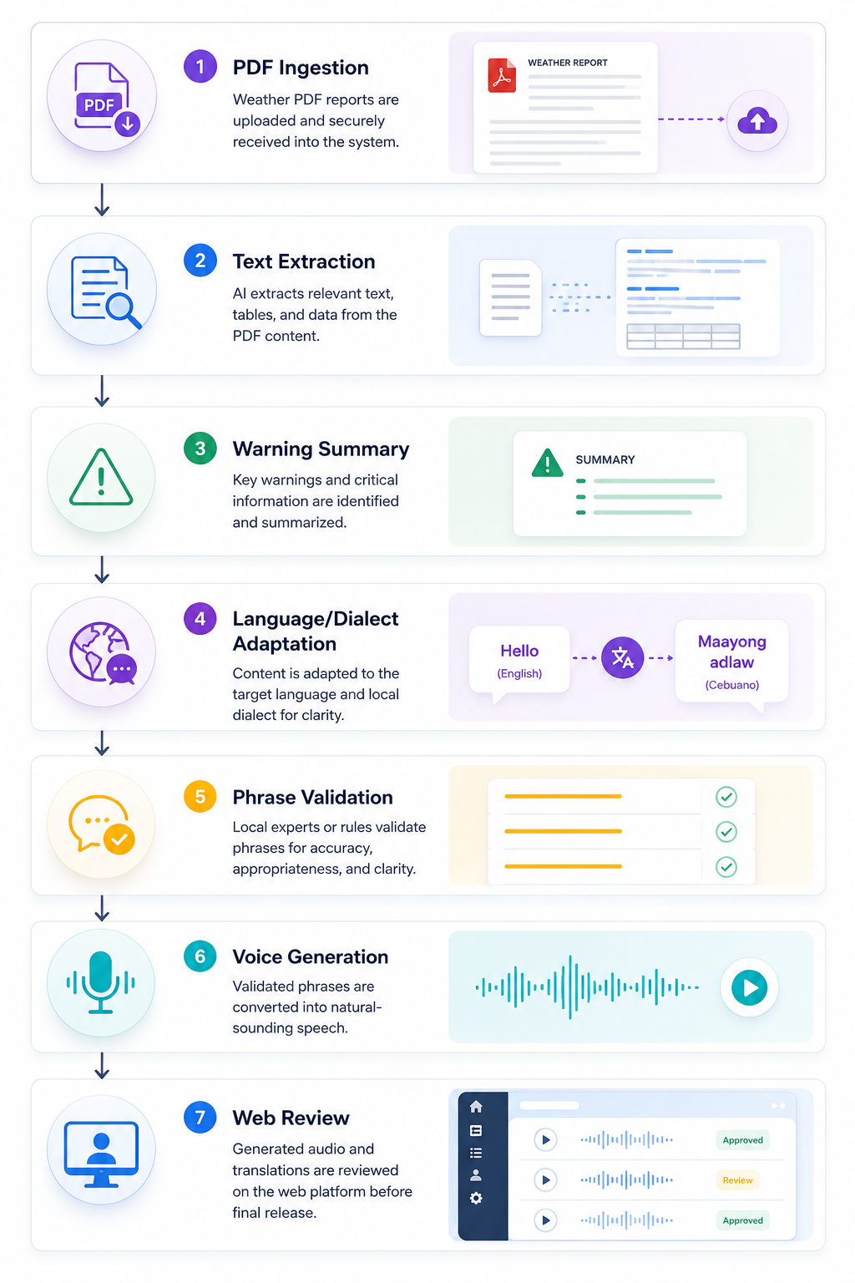
The pipeline is limited to climate and weather bulletin terminology from historical SMA weather bulletins.

7. Voice Model Training Workflow
Audio recordings will be prepared from selected historical SMA weather bulletin phrases and aligned with transcripts for each pilot language. The objective is to reproduce bulletin phrases clearly and accurately in the relevant dialect, not to create a general-purpose TTS model.
The platform/web app will be designed so that the custom-trained TTS voice model can be integrated as a plug-and-play component. Please note, the TTS model training workflow, model builder, training pipeline, training tools, and related preparation processes are not part of the customer-facing deliverable and will not be provided, supplied, transferred, or made available to the customer through the app or otherwise. The voice model training workflow will be undertaken as part of the vendor’s internal development procedure for creating the TTS. This workflow will be based on a controlled and limited dataset as provided by the client. The app deliverable is limited to using the prepared custom TTS model for bulletin generation/playback.

Figure 3: Scoped Dialect TTS Training Pipeline
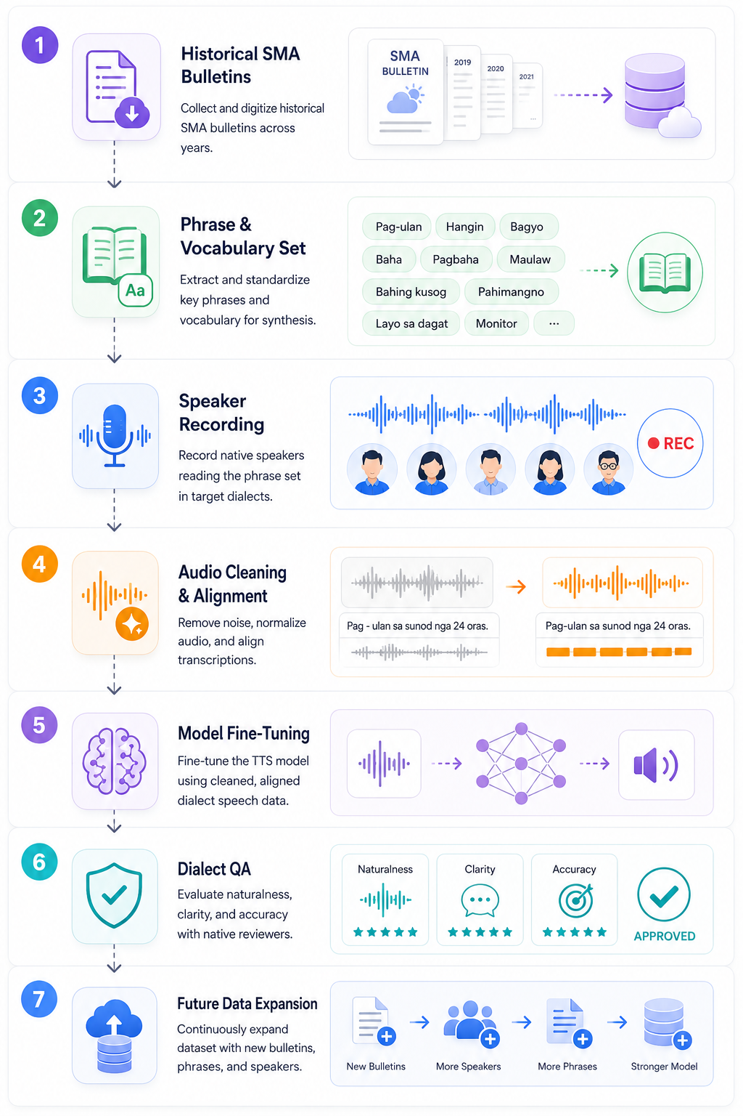
The model can be expanded later as more recordings, speakers, and vocabulary become available.

8. Deliverables
- AI weather alert processing system
- Dialect-specific voice synthesis models for Arabic - Sudanese, Nubian (Dungolawi), and Tigrai/Tigrinya (Sudan side)
- PDF weather report ingestion pipeline
- Voice alert generation and web platform
- System deployment and operational documentation
- Admin monitoring dashboard and web platform
- Modular architecture documentation

9. Testing and Quality Assurance
A comprehensive QA strategy will be implemented to ensure system reliability, accuracy, and performance.
Testing layers include:
QA Testing - Validation of AI processing modules
Integration Testing - Verification of data pipeline integration
Load Testing - Alert generation performance under high volumes

10. Deployment and Operations
The system will be deployed with containerized services, enabling easy scaling during extreme weather events. Deployment would be infra-agnostic for convenient switching between cloud and on-premise deployment. As such, if initial preference is Cloud, then it will use self-managed services so that it can be later deployed to on-premise infra when needed. Monitoring tools will ensure reliability and uptime of the warning system, with secure browser-based access for administrators and operational teams.
The deployment architecture will keep AI processing, TTS generation, storage, and web access modular. This will support future scaling, additional language data, and straightforward integration with ClimaWeb or similar platforms if requested in a later phase.

