Technical Proposal
EUAS RFQ 3.4 - Phase A
Deterministic System Implementation
WordPress + WooCommerce Architecture
Prepared by: Riseup Labs
Prepared for: EUAS
Date: April 2026

Contents
1. Executive Summary 3
1.1 Proposal Objectives 3
2. Understanding of Phase A Requirements 3
2.1 Core Architecture Interpretation 3
2.2 Deterministic Principles 3
3. Proposed Technical Approach 4
3.1 Architecture Principles 4
3.2 Proposed Layered Solution Architecture 4
Figure 1: High-Level Layered Architecture 4
3.3 ACF Canonical Data Layer 5
3.4 Duck Console - Governed Operator System 5
3.5 PZ / DIS Deterministic Logic Engine 5
3.6 PZ Linkage Reference Layer 5
3.7 Intelligent Cart - WooCommerce Enforcement Layer 5
3.8 FOH System - T1 to T7 Elementor Templates 6
3.9 CSV Import and Operational Export 6
3.10 Product Publication Workflow 7
Figure 2: Product Publication and Cart Enforcement Flow 7
3.11 Signal System and Audit Traceability 8
Figure 3: Signal Logging and Audit Flow 8
4. Proposed Technical Stack 9
5. Development Methodology 9
5.1 Methodology Stages 9
5.2 Governance and Change Control 9
6. Deliverables 10
7. Testing and Quality Assurance 10
7.1 QA Strategy 10
7.2 Deterministic Acceptance Criteria 11
8. Implementation Timeline 11
8.1 Phase-Level Review Gates 11
9. Assumptions, Dependencies, and Exclusions 11
9.1 Assumptions and Dependencies 11
9.2 Proposed out of scope 11
10. Risk Management 12

1. Executive Summary
This technical proposal presents a controlled Phase A implementation approach for the EUAS deterministic system using WordPress, WooCommerce, ACF, Elementor, and purpose-built custom plugin modules. The proposed solution follows a strict schema-first and rule-governed architecture where ACF acts as the canonical data layer, Duck Console acts as the governed operator interface, DIS/PZ acts as the deterministic logic engine, WooCommerce acts as the downstream enforcement layer, and Elementor-based FOH templates render approved data without introducing frontend logic.

1.1 Proposal Objectives
- Implement a deterministic WordPress/WooCommerce system aligned with EUAS RFQ 3.4 Phase A.
- Establish ACF as the canonical schema-driven data layer and Duck Console as the controlled operator interface.
- Implement DIS/PZ rule execution with predefined outcomes only: Allow, Modify, Block, or Warning with predefined substitution.
- Ensure WooCommerce cart and checkout enforcement follows DIS/PZ decisions only, without independent business logic.
- Deliver FOH templates T1-T7 through Elementor with ACF-driven rendering and no hidden frontend logic.
- Provide traceable Signal logging for audit and future PULSE extension readiness without behavioral inference.

2. Understanding of Phase A Requirements
EUAS Phase A requires a deterministic enterprise system within a WordPress/WooCommerce architecture. The system must be predictable, auditable, schema-controlled, and free from AI, machine learning, heuristic matching, recursion, dynamic rule generation, or hidden frontend logic.

2.1 Core Architecture Interpretation
Layer | Phase A Interpretation | Implementation Treatment
Layer 1 - ACF Canonical Data Layer | Single source of truth using strict schema-based data and controlled vocabulary. | ACF field groups, structured field validation, controlled values, and schema-aligned storage. No business logic in ACF.
Layer 2 - Duck Console | Governed WordPress Admin entry system for operators. | Custom admin plugin module with structured data entry, schema validation, reference linkage maintenance, CSV import, and controlled CSV export.
Layer 3 - PZ/DIS | Deterministic logic engine with up to 30 Problem Zones. | Predefined rule catalog and rule execution functions. Outputs only Allow, Modify, Block, or Warning with predefined substitution.
Layer 4 - Intelligent Cart | WooCommerce enforcement layer. | Cart/checkout validation and modification based only on DIS/PZ decisions. No independent WooCommerce logic.
Layer 5 - FOH System | Elementor-based frontend templates T1-T7. | Dynamic ACF-driven rendering only. No logic inside frontend templates.
Signal System | Event-driven audit logging. | Logs user actions, cart events, and PZ triggers for traceability without inference or analytics.

2.2 Deterministic Principles
- All decisions must be generated from predefined rules only.
- ACF stores structured data but does not execute logic.
- Duck Console governs data entry and reference maintenance but does not act as a decision engine.
- PZ Linkage associates euas_pz_tags, euas_trigger_profile, and euas_resolution_profile, but all logic execution remains in DIS.
- WooCommerce enforces DIS/PZ outcomes and does not calculate independent compatibility logic.
- FOH templates display data and predefined outcomes only.
- Signal logging records deterministic events and does not perform behavioral inference.

3. Proposed Technical Approach
The proposed technical approach uses a schema-first and plugin-based architecture. Each layer has a defined responsibility, and business logic is isolated inside the DIS/PZ engine to preserve determinism and auditability. Theme templates, ACF field definitions, and WooCommerce hooks will not contain independent decision logic.

3.1 Architecture Principles
- Separation of concerns: data, operator interface, rule logic, cart enforcement, frontend rendering, and audit logging are kept separate.
- Schema-first implementation: ACF schema and controlled vocabulary are finalized before rule execution and publishing workflows are completed.
- Plugin-based logic: custom functionality is implemented through purpose-built plugin modules, not theme-level logic.
- Deterministic rule execution: the DIS/PZ engine uses predefined rules and predefined outputs only.
- Traceability: each relevant user action, cart event, and PZ trigger is captured through the Signal system.
- Cost-controlled scope: only Phase A capabilities clarified by the client are included.

3.2 Proposed Layered Solution Architecture
The system will be structured around six controlled layers: operator entry, canonical data, deterministic logic, WooCommerce enforcement, FOH rendering, and Signal logging.

Figure 1: High-Level Layered Architecture
This diagram shows the separation between Duck Console, ACF, DIS/PZ, WooCommerce, FOH templates, and Signal logging.
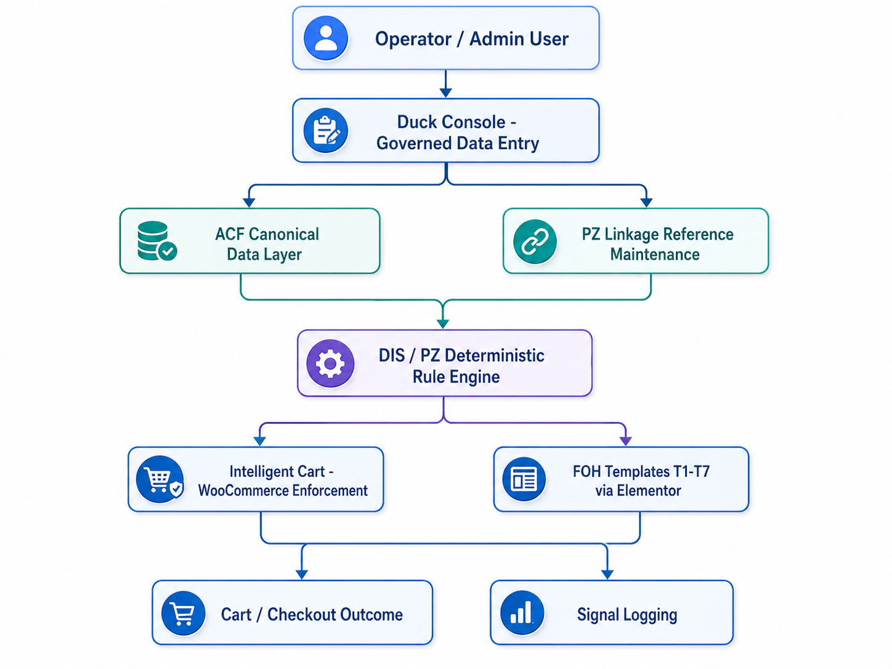

3.3 ACF Canonical Data Layer
ACF will act as the canonical data layer for Phase A. Field groups, field types, controlled vocabularies, validation constraints, required fields, and material/product relationships will be configured based on the structured schema. ACF will store approved data and metadata but will not execute business rules or compatibility decisions.
- Define schema-aligned field groups for materials, product mappings, OTM-related fields, validation attributes, and required reference data.
- Enforce controlled vocabulary and required field constraints at the data-entry layer.
- Use ACF as the single source of truth for FOH rendering and downstream WooCommerce data dependency.
- Prevent logic from being embedded in ACF field definitions or frontend templates.

3.4 Duck Console - Governed Operator System
Duck Console will be implemented as a custom WordPress Admin plugin module. It will provide a structured operator interface for maintaining Phase A data according to the RFQ and supporting materials. It is not treated as a greenfield UI project, and no additional UI design exploration is proposed.
- Structured data entry screens based on the agreed RFQ structure and ACF schema.
- Materials L1/L2 data completion based on schema requirements rather than mockup-only fields.
- PZ Linkage maintenance for euas_pz_tags, euas_trigger_profile, and euas_resolution_profile references.
- CSV import mapped directly to the ACF schema.
- Data Tools section for limited, operator-only CSV exports.
- Role and capability-based access for operator functions.

3.5 PZ / DIS Deterministic Logic Engine
The DIS/PZ layer will be implemented as the only rule execution layer. It will support up to 30 Problem Zones and will execute only predefined logic rules. The engine will not support recursion, chaining, AI behavior, heuristics, or dynamic rule generation.
Rule Output | Meaning | Expected System Action
Allow | The combination or action is permitted. | WooCommerce/cart flow continues without modification.
Modify | The action is permitted with a predefined modification. | Intelligent Cart applies the predefined adjustment.
Block | The action is not permitted. | Cart/checkout action is blocked with controlled message.
Warning + Predefined Substitution | The user/operator is warned and a defined substitution is offered. | System displays the approved warning and substitution option.

3.6 PZ Linkage Reference Layer
The PZ Linkage screen will not execute logic. It will only maintain reference associations required by DIS. Operator interaction will be limited to assigning and maintaining the linkages between euas_pz_tags, euas_trigger_profile, and euas_resolution_profile.

3.7 Intelligent Cart - WooCommerce Enforcement Layer
WooCommerce will function as the downstream execution and enforcement layer. Cart and checkout behavior will be governed by DIS/PZ outputs only. The Intelligent Cart will not introduce independent compatibility logic.
- Validate cart conditions by requesting or reading DIS/PZ decisions.
- Apply deterministic cart modifications only when DIS/PZ returns Modify.
- Block transactions when DIS/PZ returns Block.
- Show controlled warning and substitution messages when predefined by the rule system.
- Log cart-level events and PZ triggers through the Signal system.

3.8 FOH System - T1 to T7 Elementor Templates
The front-of-house layer will be implemented using Elementor templates connected to ACF data. FOH templates will be responsible for presentation and dynamic data rendering only. They will not contain independent rule logic or hidden decision behavior.
Template | Purpose | Implementation Notes
T1 Landing | Entry/landing interface. | ACF-driven content blocks and structured template sections.
T2 Category | Category-level display. | Category data and related products rendered dynamically.
T3 Product | Product detail interface. | Product and material attributes rendered from ACF/WooCommerce data.
T4 PZ Output Interface | Displays deterministic rule outcome. | Shows approved output and messaging from DIS/PZ.
T5 Cart | Cart interface. | Displays cart state and enforcement result.
T6 Checkout | Checkout interface. | Final enforcement before order placement.
T7 Account | Customer account area. | Displays account/order-related content without independent rule logic.

3.9 CSV Import and Operational Export
Phase A will include CSV import and limited operational CSV export only. Both are designed for controlled internal use and must align directly with the ACF schema.
Capability | Included in Phase A | Boundary
CSV Import | Yes - primary bulk upload method. | Direct schema mapping only. No automated transformation or inference.
Operational CSV Export | Yes - for scoped datasets such as SKU mappings, validation queues, and material registry entries. | Manual, read-only, operator-only export under Duck Console Data Tools.
UI / Development Export | No. | Figma export/capture elements are internal development artifacts only.
Analytics Export | No. | No analytics, reporting dashboard, or transformation engine in Phase A.

3.10 Product Publication Workflow
Duck Console will remain the primary system of record. WooCommerce product publication will depend on completed Duck Console data, SKU mapping, material definitions, and validation status. Products should not be published downstream until required Duck Console data is complete.

Figure 2: Product Publication and Cart Enforcement Flow
This diagram shows the controlled publication sequence and how cart enforcement depends on DIS/PZ outcomes.
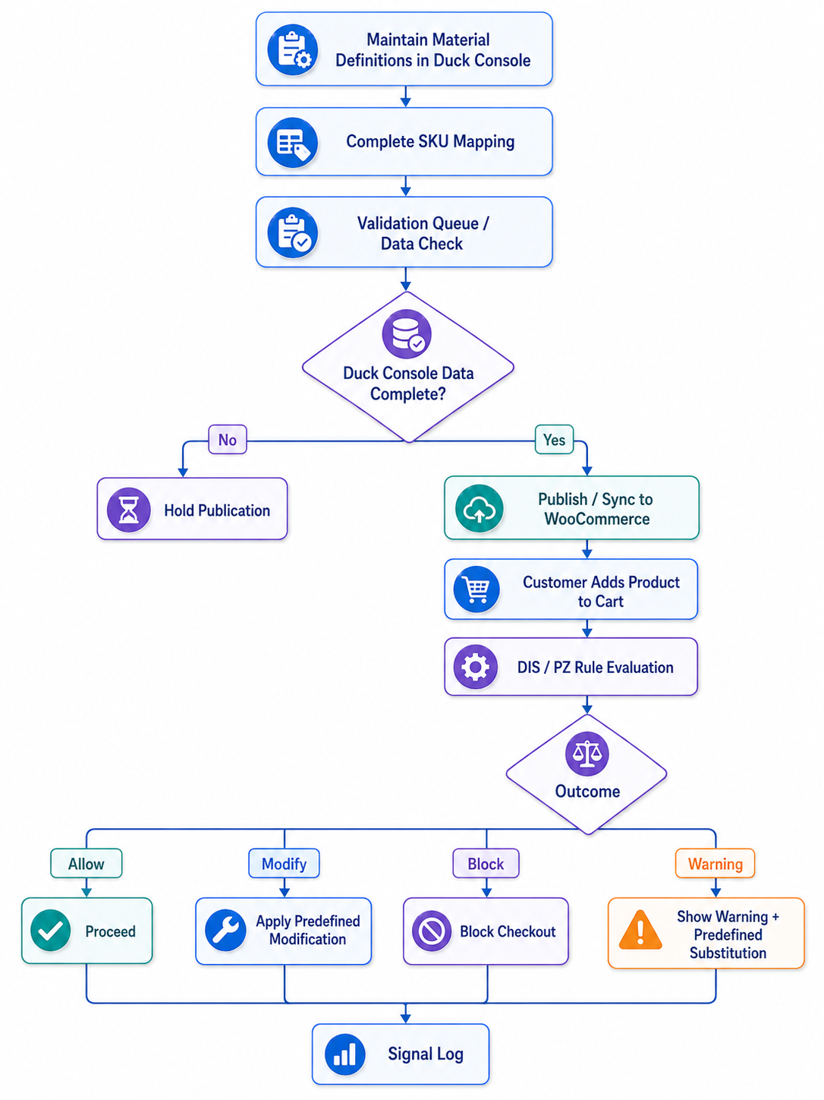

3.11 Signal System and Audit Traceability
The Signal system will capture event-level records for auditability and future PULSE extension readiness. It will record user actions, cart events, and PZ triggers. The Signal system will not infer behavior, generate analytics, or modify decisions.

Figure 3: Signal Logging and Audit Flow
This diagram shows the event sources that feed the Signal log while keeping inference and analytics out of Phase A.
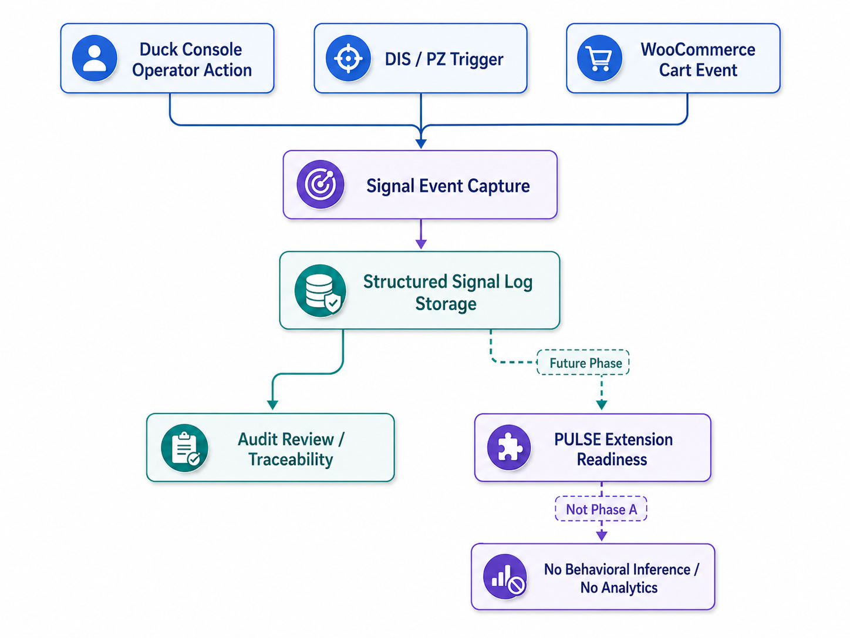

4. Proposed Technical Stack
The following stack is proposed to meet the deterministic Phase A requirements while staying within a WordPress/WooCommerce implementation model. Exact plugin versions and server versions should be finalized during environment readiness review.
Layer / Component | Proposed Technology | Purpose / Notes
CMS Platform | WordPress 6.x | Core CMS and admin platform for Duck Console implementation.
Commerce Layer | WooCommerce | Product, cart, checkout, and order workflow enforcement layer.
Canonical Data Layer | Advanced Custom Fields (ACF / ACF Pro as required) | Structured schema, field groups, controlled data, and dynamic field storage.
Frontend Rendering | Elementor / Elementor Pro | FOH template rendering for T1-T7 using dynamic data.
Custom Plugin Modules | PHP custom plugins | Duck Console, DIS/PZ engine, Intelligent Cart integration, Signal logger, Data Tools.
Database | MySQL or MariaDB | WordPress/WooCommerce data, ACF fields, rule references, and Signal logs.
Backend Language | PHP 8.2+ preferred | Server-side plugin logic and WordPress/WooCommerce extension development.
Frontend Assets | HTML, CSS, JavaScript, WordPress asset enqueueing | Admin interface enhancements and controlled frontend interaction where required.
Build and Version Control | Git, Composer, npm build tooling where needed | Code management, dependency control, and deployable plugin packaging.
Security Controls | WordPress nonces, capability checks, validation, sanitization, escaping, SSL, WAF/CDN if available | Secure admin actions, import/export, frontend output, and checkout operations.
Hosting Environment | Managed WordPress hosting, VPS, or cloud hosting based on client preference | Staging and production environment with backup and deployment readiness.
QA Tools | Browser testing, test case management, log review, WP debug/staging tools | Functional, integration, regression, and security verification.

5. Development Methodology
The project will follow a phase-gated iterative delivery methodology. Each monthly phase will include planning, implementation, internal review, QA, and client validation against the agreed scope. The methodology is designed to keep Phase A deterministic, auditable, and cost-controlled.

5.1 Methodology Stages
Stage | Activity | Output
1. Requirement Confirmation | Review Phase A scope, clarification notes, schema references, field groupings, and rule assumptions. | Confirmed scope baseline and implementation backlog.
2. Architecture and Schema Finalization | Finalize ACF schema, controlled vocabulary, plugin structure, and rule data model. | Approved technical design and schema baseline.
3. Iterative Build | Implement Duck Console, ACF schema, DIS/PZ engine, WooCommerce enforcement, FOH templates, and Signal logging in controlled iterations. | Working modules available in staging.
4. QA and Traceability Review | Validate deterministic behavior, schema compliance, import/export, cart enforcement, and frontend rendering. | Test results, issue logs, and QA sign-off.
5. Deployment and Handover | Deploy production-ready version, provide admin orientation, and hand over technical documentation. | Production deployment and handover package.

5.2 Governance and Change Control
- The clarification document will be used as the final Phase A boundary during development.
- Any new feature request outside Phase A will be logged as a future-phase item and will not be added silently to the implementation scope.
- Rule additions or changes must be documented in the rule catalog before implementation.
- Schema changes after implementation starts will be assessed for impact on import, publication workflow, FOH rendering, and tests.

6. Deliverables
The following deliverables are proposed for Phase A. The deliverables are intentionally limited to the clarified Phase A scope.
Category | Deliverable | Description
Architecture | Final Technical Architecture | Layered architecture covering ACF, Duck Console, DIS/PZ, WooCommerce enforcement, FOH templates, and Signal logging.
Data Layer | ACF Canonical Schema | Configured field groups, controlled vocabulary, required fields, and schema validation rules.
Admin System | Duck Console | WordPress Admin plugin module for governed operator data entry and validation.
Reference Maintenance | PZ Linkage Screen | Operator screen for maintaining euas_pz_tags, euas_trigger_profile, and euas_resolution_profile associations.
Materials Management | Materials L1/L2 Data Screens | Schema-complete materials interface aligned with the ACF model.
Data Tools | CSV Import and Limited CSV Export | Schema-aligned CSV import and controlled operator-only export for scoped datasets.
Rule Engine | DIS/PZ Deterministic Engine | Rule execution layer supporting predefined outputs and up to 30 Problem Zones.
Commerce Enforcement | Intelligent Cart Integration | WooCommerce cart and checkout enforcement based on DIS/PZ decisions only.
Frontend | FOH Templates T1-T7 | Elementor-based ACF-driven templates for landing, category, product, PZ output, cart, checkout, and account pages.
Audit | Signal Logging System | Event logging for operator actions, cart events, and PZ triggers.
QA | Testing Artifacts | Test cases, traceability checklist, issue log, and QA summary.
Deployment | Production Deployment Package | Deployable plugins/configuration, staging-to-production deployment, and technical handover notes.
Documentation | Admin and Technical Handover Guide | Operational guidance for Duck Console usage, CSV handling, rule references, and publication workflow.

7. Testing and Quality Assurance
Testing will focus on deterministic correctness, schema compliance, rule traceability, WooCommerce enforcement, and safe WordPress implementation. QA will confirm that no AI, heuristic, hidden frontend logic, dynamic rule generation, or unapproved Phase A behavior has been introduced.

7.1 QA Strategy
Test Area | What Will Be Tested | Expected Result
Requirement Traceability | Each Phase A requirement and clarification item mapped to implementation and test cases. | All included items are traceable; excluded items are documented.
ACF Schema Validation | Required fields, controlled vocabulary, field constraints, and data completeness. | Invalid or incomplete data is prevented or flagged at source.
Duck Console Functional Testing | Data entry, Materials screens, PZ Linkage maintenance, validation, operator access, and Data Tools. | Operators can complete required workflows without accessing out-of-scope features.
CSV Import Testing | Valid CSV, missing required fields, invalid vocabulary, duplicate/mismatched SKU references. | Only schema-aligned valid data is accepted; errors are clearly reported.
CSV Export Testing | Scoped exports for SKU mappings, validation queues, and material registry entries. | Manual, read-only exports generate expected CSV data without transformation.
DIS/PZ Rule Testing | Allow, Modify, Block, Warning + predefined substitution outcomes across defined Problem Zones. | Same input always produces the same predefined output.
WooCommerce Enforcement Testing | Cart validation, modification, blocking, checkout behavior, and controlled messages. | WooCommerce enforces DIS/PZ decisions only.
FOH Template Testing | T1-T7 dynamic rendering, responsive behavior, and no hidden frontend logic. | Templates display approved data and outcomes correctly across devices.
Signal Logging Testing | Operator actions, cart events, PZ triggers, timestamps, and log storage. | Events are logged for audit without inference or analytics.
Security Testing | Capability checks, nonce validation, input sanitization, output escaping, upload restrictions, and admin access controls. | Admin and frontend actions follow secure WordPress practices.
Regression Testing | Previously passed workflows after fixes or schema/rule changes. | No new defects introduced during later iterations.

7.2 Deterministic Acceptance Criteria
- ACF remains the canonical data source and contains no decision logic.
- Duck Console prevents invalid or incomplete required data entry based on schema rules.
- PZ Linkage does not execute logic and only maintains reference associations.
- DIS/PZ outputs are limited to Allow, Modify, Block, or Warning with predefined substitution.
- WooCommerce does not apply independent compatibility logic.
- FOH templates render ACF and system outcome data only.
- CSV import/export is schema-aligned, controlled, and limited to clarified Phase A use cases.
- Product publication is held until Duck Console data completion requirements are satisfied.
- OTM uses one primary optical mode per product in Phase A.
- Signal logging records audit events without behavioral inference.

8. Implementation Timeline
The implementation timeline follows the three-month phased delivery model provided in the Phase A Technical Proposal. The timeline is subject to timely availability of finalized schema, controlled vocabulary, sample CSV data, plugin licenses, and environment access.
Phase | Timeline | Objectives | Key Deliverables
Phase 1 - Foundation Layer | Month 1 | Finalize architecture, implement ACF schema, set up Duck Console base, and create core plugin framework. | Canonical ACF data model, basic Duck Console, plugin architecture skeleton, schema validation baseline.
Phase 2 - Logic and Enforcement Layer | Month 2 | Implement DIS/PZ rule engine, up to 30 Problem Zones, WooCommerce cart enforcement, and Signal system. | Functional rule engine, cart enforcement, PZ Linkage reference maintenance, Signal storage, import/export base.
Phase 3 - Frontend, Integration, and Deployment | Month 3 | Implement FOH templates T1-T7, complete ACF-to-UI binding, run integration testing, and deploy production-ready system. | Operational Phase A system, end-to-end deterministic workflow, QA sign-off package, production deployment, handover documentation.

8.1 Phase-Level Review Gates
- Month 1 gate: schema and Duck Console foundation approved for logic integration.
- Month 2 gate: DIS/PZ outcomes and WooCommerce enforcement validated in staging.
- Month 3 gate: FOH templates, publication workflow, Signal logging, and end-to-end testing completed for production deployment.

9. Assumptions, Dependencies, and Exclusions

9.1 Assumptions and Dependencies
- Client will provide or confirm the final ACF schema, field groupings, controlled vocabulary, and rule references before development lock-in.
- Client will provide sample CSV files or confirm the expected CSV column structure for import testing.
- Client will provide plugin licenses where required, including ACF Pro and Elementor Pro if paid functionality is needed.
- Client will provide hosting, staging, production, WordPress Admin, database, and server access as required.
- Existing RFQ 3.4 and supporting materials will remain the primary structural source for Duck Console implementation.
- WooCommerce will operate as a downstream layer and not as the primary data governance system.

9.2 Proposed out of scope
- Greenfield UI design, additional UI exploration, or redesign beyond RFQ-defined Duck Console structure.
- AI, machine learning, heuristic matching, probabilistic logic, recursion, chaining, or dynamic rule generation.
- Logic execution inside ACF, PZ Linkage screen, Elementor templates, or independent WooCommerce layer.
- Automated CSV transformation, inference, or dynamic mapping.
- Runtime UI/development export features shown only as Figma or internal development artifacts.
- Analytics dashboards, reporting engines, behavioral inference, or PULSE implementation.
- Multiple optical mode handling, conflict resolution, comparative logic, or probabilistic OTM matching.
- Product publication without completed Duck Console data, material definitions, SKU mappings, and validation.

10. Risk Management
Risk | Potential Impact | Mitigation
Incomplete schema or field definitions | Delays in ACF setup, CSV mapping, validation, and FOH rendering. | Conduct schema confirmation before build lock-in and maintain a change log for schema updates.
Ambiguous rule definitions | Inconsistent DIS/PZ behavior or repeated clarification cycles. | Prepare a rule catalog and obtain confirmation for rule inputs, outputs, and substitution messages.
Plugin or hosting compatibility issues | Deployment delay or unexpected technical constraints. | Use staging environment, confirm plugin versions, review server compatibility, and maintain rollback plan.
CSV data quality issues | Failed imports or incorrect downstream data. | Validate sample files early, define required columns, and provide import error feedback.
Scope expansion during development | Cost/timeline pressure and deterministic model risk. | Use clarification document as baseline and move non-Phase A requests to future backlog.

