TECHNICAL PROPOSAL
Trade Customer Mobile Ordering App and Web Admin Portal
Native Android and iOS Mobile Architecture with Future AR / 3D Readiness

Prepared for Eldergrove Interiors Supply Limited
Prepared By: Riseup Labs


Table of Contents
1. Executive Summary 3
2. Project Understanding 3
3. Proposed Phase 1 Scope 3
3.1 Core Scope Included 3
3.2 Items Kept for Future Phase 4
4. Proposed Technical Approach 4
4.1 Mobile Development Approach 4
4.2 Future-Ready AR and 3D Rationale 4
5. Recommended High-Level Architecture 5
6. Proposed Technical Stack 6
6.1 Recommended Stack 6
6.2 Future AR and 3D Readiness Table 7
6.3 Alternative Technology Options 7
7. Core Mobile Application Workflows 8
8. Web Admin Portal Scope 8
9. Inventory and Pricing Integration Approach 10
10. Security and Access Control 11
11. Development Methodology 11
12. Key Deliverables 11
13. Testing and Quality Assurance 12
14. Proposed Implementation Timeline 12
15. Assumptions and Dependencies 13
16. Key Risks and Mitigation 13
17. Future Phase Considerations 13
18. Conclusion 14

1. Executive Summary
Eldergrove Interiors Supply Limited requires a mobile ordering application for trade customers and a web-based admin portal to digitize its current manual sales, quotation, ordering and product catalogue process. The proposed platform will provide secure self-service access for trade customers, support internal sales activity, and help operations manage products, users, orders, notifications and basic reporting from a centralized admin portal.
The recommended approach is to build the solution from scratch using an API-first, scalable architecture. The mobile application will be developed as separate native Android and native iOS applications instead of using a cross-platform framework. This decision makes the platform future-ready for advanced AR furniture visualization and 3D product interaction, while Phase 1 remains focused on the confirmed core commerce, catalogue, quote, order, account and admin workflows.
Advanced AR furniture visualization, 3D asset preparation, offline mode, barcode scanning, recommendation engine and in-app messaging are recommended for a later phase unless separately approved as additional scope. However, the current native mobile architecture will reduce future redevelopment risk when AR and 3D features are introduced.

2. Project Understanding
The current website presents Eldergrove as a trade-focused interiors supplier with furniture, carpet, lighting, custom order, consultation and delivery-related services. The required mobile app will extend this business into a modern trade self-service platform while keeping the product and ordering experience aligned with the brand.
- Primary users: trade customers such as retailers, designers and developers.
- Secondary users: internal sales and operations team members.
- Business objective: reduce phone, email and brochure-style manual dependency by enabling mobile-first catalogue browsing, quoting and order submission.
- Operational objective: keep product, stock, pricing and order data controlled through admin tools and inventory/account system integration.
- Technical objective: build a scalable native mobile foundation that supports current ordering workflows and future AR/3D product visualization.
- Delivery objective: achieve a practical implementation timeline by prioritizing the core platform while keeping advanced AR/3D as a planned future expansion.

3. Proposed Phase 1 Scope

3.1 Core Scope Included
- Secure trade account login with admin approval workflow and role-based access.
- Native Android application developed using Kotlin and native Android SDK.
- Native iOS application developed using Swift / SwiftUI and native iOS SDK.
- Mobile product catalogue with category browsing, filters, search, product images, spec sheets and related products.
- Quote builder with automatic trade/volume pricing rules and PDF quote generation.
- Order submission workflow based on approved trade account and stock availability.
- Real-time or near-real-time stock visibility depending on available integration support.
- Order history, reorder option and order status tracking.
- Favourites, wishlist and push notifications for key updates.
- Company account dashboard with multi-user access under one trade company account.
- Sales team mobile role for assisted quote/order support and customer account lookup.
- Web admin portal for products, users, approvals, quotes/orders, notifications, reporting and sync monitoring.
- Future-ready product and media structure so selected products can later be mapped with 3D assets and AR metadata.

3.2 Items Kept for Future Phase
- Advanced AR furniture visualization and real-world 3D product placement.
- 3D model creation, optimization, conversion and QA for selected product lines.
- Barcode or QR scanner.
- Offline browsing and offline draft quotes.
- Personalised recommendations engine.
- In-app messaging with sales team.
- Advanced internal analytics dashboard beyond basic admin reporting.
- Online payment gateway, because it is not part of the confirmed core scope.

4. Proposed Technical Approach
The solution will be built from scratch using a clean, modular architecture rather than extending the current brochure website. The system will include two native mobile applications, one web admin portal, a centralized backend API layer and a flexible integration layer for inventory, pricing and order status sync.
- Develop separate native mobile applications for Android and iOS to support performance, device-level access and future AR readiness.
- Develop the admin portal as a responsive web application for operations, sales managers and platform administrators.
- Implement an API-first backend so Android, iOS, admin portal and future modules can use the same business logic.
- Create a clear integration layer for product, stock, pricing and order status sync with the client inventory/account system.
- Use structured data validation and sync logs to prevent incorrect stock, pricing or product information from reaching customers.
- Keep Phase 1 focused on core catalogue, quote, order, account, admin and notification workflows while preparing the mobile foundation for future AR/3D.

4.1 Mobile Development Approach
The mobile application will not be developed using Flutter or another single-codebase framework. Instead, Android and iOS will be developed separately using native technologies. This approach is recommended because the client has a clear future requirement for advanced AR furniture visualization and 3D product interaction.
Native development allows better control over camera access, motion sensors, platform-specific rendering, app performance and device compatibility. Even if AR is introduced after Phase 1, choosing native development now helps reduce future redevelopment risk and avoids rebuilding the mobile app foundation later.

4.2 Future-Ready AR and 3D Rationale
Table 1: Why Native Mobile is Recommended Now
Reason | Explanation
Future ARKit and ARCore readiness | Native iOS and Android apps can directly use Apple ARKit and Google ARCore capabilities when AR is introduced.
Better device-level control | Advanced AR requires camera, motion sensor, gyroscope, depth and rendering optimization that native apps handle more reliably.
Reduced future redevelopment | The client can add AR/3D later without replacing the core mobile architecture.
Higher AR performance potential | Native apps are better suited for real-time rendering, surface detection and heavier 3D scenes.
Platform-specific user experience | iOS and Android can each follow their own best practices for gestures, camera permissions, AR controls and performance tuning.
Long-term scalability | The app can start with catalogue and ordering, then expand into AR-supported product visualization product-by-product.

5. Recommended High-Level Architecture
The proposed architecture separates the Android app, iOS app, admin portal, backend services, data layer and inventory/account system integration. This improves maintainability, scalability and future expansion.
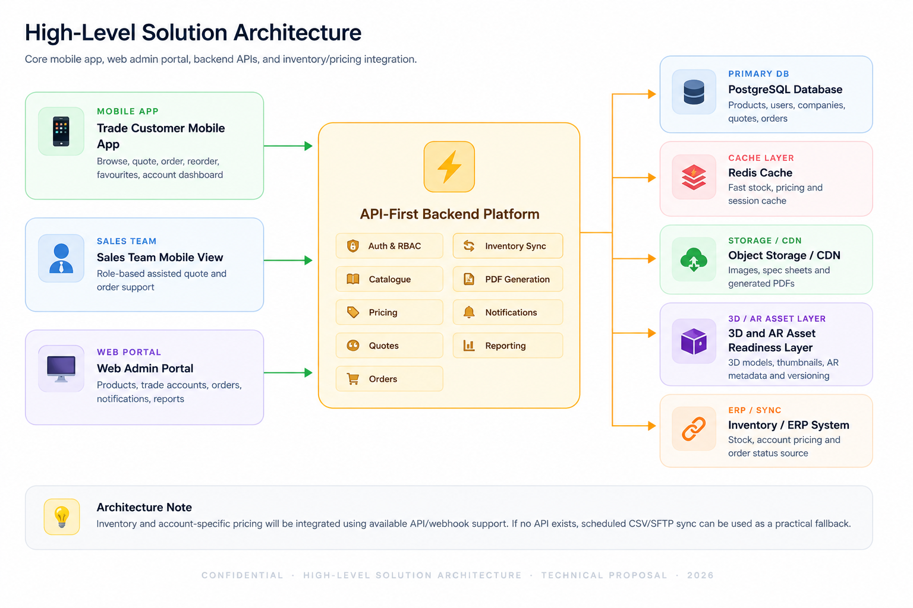
Figure 1: High-Level Solution Architecture
Component | Purpose
Native Android Application | Trade customer and sales team experience on Android with catalogue, quote, order, account, favourites and notifications. Built with Kotlin and native Android SDK.
Native iOS Application | Trade customer and sales team experience on iPhone/iPad with catalogue, quote, order, account, favourites and notifications. Built with Swift / SwiftUI.
Web Admin Portal | Operations interface for products, trade accounts, user approvals, orders, notifications and reports.
Backend API Layer | Central business logic for authentication, pricing, quotes, orders, inventory sync, PDFs and reporting.
Database and Storage | Structured data in PostgreSQL, cache in Redis, product images/spec sheets/PDFs in object storage.
3D and AR Asset Readiness Layer | Future-ready storage and product mapping structure for 3D models, thumbnails, AR metadata and versioning when AR is introduced.
Integration Layer | Connects with inventory/account system through API, webhook, scheduled polling or file-based sync fallback.

6. Proposed Technical Stack

6.1 Recommended Stack
Layer | Recommended Technology | Reason
Android App | Kotlin with native Android SDK | Provides strong Android performance, native device access and future ARCore readiness.
iOS App | Swift / SwiftUI with native iOS SDK | Provides strong iOS performance, native camera/sensor access and future ARKit/RealityKit readiness.
Future AR / 3D Capability | ARCore for Android, ARKit / RealityKit for iOS | Supports advanced future AR furniture placement, 3D interaction, surface detection and real-world visualization.
Admin Portal | Next.js / React with TypeScript | Modern responsive web admin, fast development, reusable UI components and good developer ecosystem.
Backend API | NestJS with Node.js and TypeScript | Structured, modular, scalable API framework suitable for RBAC, integrations, queues and future API expansion.
Database | PostgreSQL | Reliable relational database for users, companies, products, pricing, quotes and orders.
Cache / Queue | Redis + background workers | Improves catalogue/stock response speed and handles sync, PDF generation and notification jobs.
Search | PostgreSQL full-text search for Phase 1 | Keeps Phase 1 lean. Dedicated search such as Meilisearch/OpenSearch can be added if catalogue size requires it.
File and 3D Asset Storage | AWS S3-compatible object storage + CDN | Stores product images, spec sheets, quote PDFs and future 3D model files with fast delivery.
Notifications | Firebase Cloud Messaging + APNs | Push notification delivery to Android and iOS devices.
DevOps | Docker, GitHub Actions, cloud deployment | Repeatable builds, CI/CD, staging environment and production deployment.
Monitoring | Sentry + cloud logs | Error tracking, API logs and basic operational visibility.

6.2 Future AR and 3D Readiness Table
The following table should be included to clearly explain to the client why native Android and native iOS are recommended from the beginning, even though the advanced AR module is planned as a future phase.
Future AR Capability | Why Native Helps
Furniture placement in real space | Native ARKit and ARCore provide stronger access to room tracking, camera frames and surface detection.
Product scaling and rotation | Native rendering gives smoother control over 3D model movement, gestures and interaction.
Floor and wall detection | Native AR frameworks can use supported device sensors and camera data more accurately.
Lighting estimation | Helps future 3D furniture assets look more natural in the user environment.
High-performance 3D model rendering | Native apps are more suitable for heavier AR scenes and device-level performance optimization.
Future AR catalogue expansion | Products can gradually support 3D/AR without rebuilding the mobile app foundation.
3D asset versioning and delivery | Native apps can load optimized model formats and use platform-specific rendering pipelines.
Device compatibility control | Native apps can detect unsupported devices and provide fallback experiences more effectively.

6.3 Alternative Technology Options
Option | Assessment | Recommendation
Flutter / React Native cross-platform app | Suitable for a catalogue and ordering app when advanced AR is not a priority. Future advanced AR would likely require native modules and additional complexity. | Not recommended for this project because advanced AR/3D is a clear future requirement.
Native Android and Native iOS | Best long-term fit for device-level control, performance, camera/sensor access and future ARKit/ARCore integration. | Recommended approach.
Unity-based AR module | Can be considered later if the future AR experience becomes highly 3D-heavy or game-like. It can be integrated with native apps if required. | Keep as a future AR implementation option, not as the core Phase 1 mobile stack.

7. Core Mobile Application Workflows
The mobile apps will be designed around the key trade buying process: log in, browse the catalogue, build a quote, generate a PDF, submit an order, and track progress. The same business workflow will be available on both Android and iOS, while each application will use its own native UI and device-level implementation.
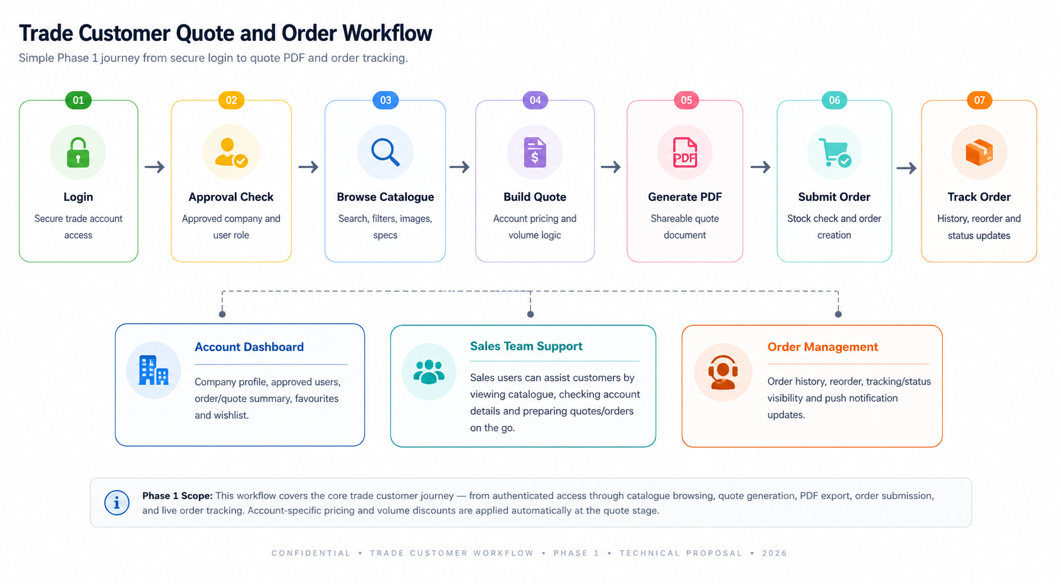
Figure 2: Trade Customer Quote and Order Workflow
Workflow Area | Description
Account Access | Secure login, company account association, admin approval, role-based access for trade customer, company admin, sales user and platform admin.
Catalogue Browsing | Categories, filters, search, high-resolution images, product details, spec sheets and related products.
Quote Builder | Add items, apply trade pricing, apply volume rules, calculate totals and generate quote PDF.
Order Submission | Convert quote to order, validate stock, submit order and show confirmation.
Order Management | Order history, reorder, tracking/status visibility and push notification updates.
Account Dashboard | Company profile, approved users, order/quote summary, favourites and wishlist.
Sales Team Support | Sales users can assist customers by viewing catalogue, checking account details and preparing quotes/orders on the go.

8. Web Admin Portal Scope
The admin portal will be a focused operational tool. It should not become a full ERP system in Phase 1. Its purpose is to manage the mobile platform, trade users, catalogue content and order-related workflows.
Admin Module | Core Capability
Dashboard | Basic summary of trade accounts, quotes, orders, stock sync status and recent activity.
User and Company Management | Approve trade accounts, manage company users, assign roles and deactivate access.
Product Catalogue Management | Create/edit products, categories, images, spec sheets, related products and visibility status.
Pricing Rules | Configure trade pricing tiers and volume pricing rules based on confirmed client logic.
Quote and Order Management | View submitted quotes/orders, update order status and support re-order workflows.
Inventory Sync Monitoring | View last sync time, sync errors, stock mismatch logs and retry status.
Notifications | Send push notifications for order updates, product updates or important account messages.
Reporting | Basic reports for orders, quotes, active customers, popular products and catalogue engagement.
Future AR Asset Management Readiness | Optional future capability to map products with 3D models, AR thumbnails, supported devices, model versions and approval status.

9. Inventory and Pricing Integration Approach
The integration approach will depend on the client’s existing inventory/account system. The platform will be designed with a flexible connector layer so integration can be done through API, webhook, scheduled polling or controlled file import.
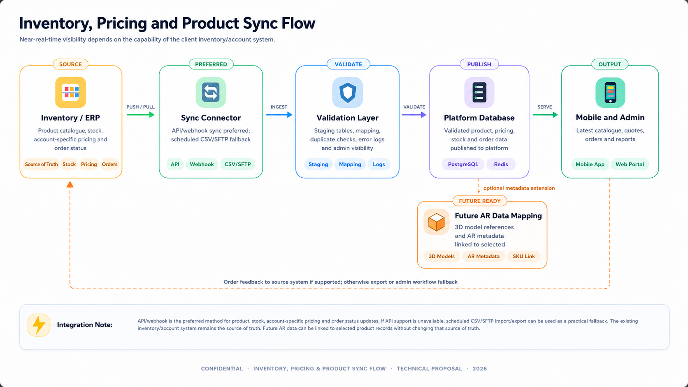
Figure 3: Inventory, Pricing and Product Sync Flow
Area | Approach
Preferred Method | API/webhook-based sync for product, stock, account-specific pricing and order status updates.
Fallback Method | Scheduled CSV/SFTP import/export if the existing system does not provide an API.
Sync Frequency | Near-real-time where supported. Scheduled sync intervals can be configured if real-time support is not available.
Data Validation | Use staging tables, data mapping, duplicate checks, error logs and admin visibility before data is published.
Source of Truth | The existing inventory/account system should remain the source of truth for stock and account pricing.
Order Feedback | Submitted orders can be pushed back to the source system if supported, otherwise exported or handled through admin workflow.
Future AR Data Mapping | Selected product records can later include 3D model references and AR metadata without changing the inventory source of truth.

10. Security and Access Control
- Role-based access control for trade customers, company admins, sales users, operations users and platform admins.
- Trade account approval workflow before customers can access account pricing and order functions.
- Secure authentication using token-based sessions, password policy and optional multi-factor authentication for admin users.
- TLS/HTTPS for all traffic and secure storage of sensitive credentials.
- Audit logs for admin actions such as user approval, product changes, pricing changes and order status updates.
- Input validation, rate limiting, API permission checks and secure file upload handling.
- Environment separation for development, staging and production.
- Future AR/3D asset upload should include file validation, size limits, version control and approved format checks before publishing.

11. Development Methodology
The project will follow an Agile delivery model with short iterations and continuous QA. This allows the team to validate core workflows early and reduce rework before final release. Android, iOS, backend and admin development will run in parallel with shared API contracts and sprint checkpoints.
Step | Description
Discovery and Confirmation | Confirm final user roles, business rules, catalogue data structure, pricing rules, order workflow, integration options and future AR readiness expectations.
UX/UI Design | Design clean Android, iOS and admin screens aligned with the Eldergrove brand and trade customer use cases.
Architecture and Sprint Planning | Prepare backlog, API structure, database model, integration plan and native mobile release milestones.
Iterative Development | Develop backend, Android app, iOS app and admin portal in parallel with regular internal QA cycles.
Integration and Hardening | Connect inventory/pricing/order sync, complete regression testing, security checks and deployment preparation.
Release and Handover | Deploy production environment, prepare Android and iOS app store builds, deliver documentation and source code handover.

12. Key Deliverables
- Finalized requirement understanding and feature backlog for Phase 1.
- Solution architecture, database design and API specification.
- Android and iOS mobile UI/UX design and clickable prototype.
- Native Android application build using Kotlin.
- Native iOS application build using Swift / SwiftUI.
- Responsive web-based admin portal.
- Backend API platform with authentication, RBAC, catalogue, pricing, quote, order and notification modules.
- Inventory/pricing/order integration connector based on available client system support.
- Future-ready data structure for optional 3D model mapping and AR metadata.
- PDF quote generation templates.
- QA plan, test cases, defect logs and test summary report.
- Deployment setup for staging and production environments.
- App store submission-ready builds and deployment support.
- Admin guide, technical handover document and source code repository handover.

13. Testing and Quality Assurance
QA will focus on product quality, platform stability, data accuracy, security and release readiness. Since the mobile apps will be developed natively, mobile QA will cover both Android and iOS separately.
- Functional testing for login, approval workflow, catalogue, filters, search, quote, PDF generation, order submission, reorder and order tracking.
- Native Android compatibility testing on selected Android devices and OS versions.
- Native iOS compatibility testing on selected iPhone/iPad devices and iOS versions.
- Admin portal testing for product management, user approvals, roles, notifications, orders and reports.
- API testing for authentication, role permissions, catalogue, pricing, quote, order and inventory endpoints.
- Integration testing for inventory, stock visibility, account-specific pricing, sync logs and order status updates.
- Data validation testing for product images, spec sheets, stock quantity, pricing tiers and volume pricing rules.
- Security testing covering access control, input validation, file upload handling, token/session handling and common API risks.
- Performance testing for catalogue listing, product search, image loading, quote calculation and high-traffic API endpoints.
- Regression testing after each major feature completion and before release.
- Push notification testing for order updates and admin-triggered notices.
- Build verification for staging and production release candidates.
- Future AR readiness validation for product data fields and asset storage structure, without testing live AR features in Phase 1 unless separately included.

14. Proposed Implementation Timeline
The proposed implementation timeline is estimated at approximately 14 to 20 weeks, depending on final scope confirmation, integration readiness, product catalogue data quality, and app store preparation. Android and iOS development should run in parallel to keep the timeline controlled.
Phase | Estimated Duration | Major Activities
Phase 1: Discovery and Planning | 1 to 2 weeks | Confirm user roles, workflows, pricing rules, inventory integration method, data structure and native mobile approach.
Phase 2: UX/UI and Architecture | 2 to 3 weeks | Prepare Android/iOS app designs, admin screens, API contracts, database model and integration plan.
Phase 3: Core Development | 6 to 8 weeks | Develop backend APIs, Android app, iOS app, admin portal, catalogue, quote, order and account workflows.
Phase 4: Integration and Feature Completion | 3 to 4 weeks | Complete inventory/pricing/order sync, PDF generation, notifications, reporting and platform hardening.
Phase 5: QA, Deployment and Handover | 2 to 3 weeks | Complete regression testing, security checks, production deployment, app store build preparation and documentation handover.

15. Assumptions and Dependencies
- Client will provide access to product catalogue data, product images, spec sheets and category information in a structured format.
- Client will confirm account-specific pricing rules, volume pricing rules and order workflow logic before development starts.
- Client will provide technical details of the current inventory/account system, including API documentation if available.
- If no real-time API is available, near-real-time sync will use scheduled import/export or another agreed connector method.
- Client will provide Apple Developer and Google Play Console access for store release preparation.
- Native Android and iOS development is selected to make the platform future-ready for advanced AR/3D, but the AR feature itself is not included in Phase 1 unless separately approved.
- Future AR/3D will require client-approved 3D product assets, supported device list, user experience scope and additional QA coverage.
- Online payment, live AR visualization, offline mode and messaging are not included in Phase 1 unless separately approved as additional scope.
- The existing public website will remain separate unless the client requests website changes as a separate task.

16. Key Risks and Mitigation
Risk | Impact | Mitigation
Inventory system has no API | Real-time stock and pricing may not be possible in Phase 1. | Use scheduled CSV/SFTP sync or middleware connector with clear sync intervals and logs.
Product data is incomplete or inconsistent | Catalogue quality and search/filter accuracy may be affected. | Provide a data template, run data cleanup, and validate required fields before import.
Complex account-specific pricing rules | Quote totals may become difficult to verify without sample scenarios. | Document pricing rules early and test against approved pricing examples.
High-resolution images slow mobile experience | Catalogue browsing may feel heavy on mobile networks. | Use image compression, CDN delivery, lazy loading and cached thumbnails.
Separate native apps increase coordination effort | Android and iOS feature consistency may be harder to maintain than a single codebase. | Use shared API contracts, common design system, aligned sprint planning and parallel QA checklists.
Future AR scope expands significantly | Timeline and cost may increase when AR is added later. | Keep AR/3D as a separately estimated phase with a clear 3D asset pipeline and device compatibility plan.
3D assets are not production-ready | Future AR experience may be delayed or visually inconsistent. | Define accepted model formats, polygon limits, file sizes, texture rules and asset approval workflow before AR development.
Scope expansion during development | Timeline and cost may increase. | Keep Phase 1 limited to confirmed core scope and move optional items to Phase 2 backlog.

17. Future Phase Considerations
The following items are valuable but should be treated as a separate phase after the core platform is stable and in use. The native Android and iOS approach in Phase 1 is selected so these future capabilities can be added with less architectural rework.
- Advanced AR furniture visualization using ARCore for Android and ARKit / RealityKit for iOS.
- 3D asset preparation for selected product lines, including model creation, optimization, texture setup and device performance testing.
- View in Room / View in AR experience from eligible product detail pages.
- Barcode/QR scanner for sales team or warehouse-assisted workflows.
- Offline mode for draft quotes and catalogue browsing during poor connectivity.
- Basic personalised recommendations based on customer type, browsing behaviour and order history.
- In-app messaging or support thread with assigned sales representatives.
- Advanced analytics dashboard for product demand, customer behaviour and sales performance.

18. Conclusion
The proposed solution provides Eldergrove Interiors Supply Limited with a focused, scalable and brand-aligned digital platform for trade customer self-service, mobile quoting, order submission, sales support and admin control. By keeping Phase 1 limited to core mobile, admin, backend and integration requirements, the project can be delivered in a controlled manner while leaving advanced features such as AR, offline mode and recommendations for a future phase.
The key update in this proposal is the selection of separate native Android and native iOS development. This is a future-ready decision because the client has a clear requirement for advanced AR furniture visualization and 3D product interaction. Native mobile development will allow the platform to use device-level AR capabilities more effectively when that future phase begins, while still delivering the current trade ordering experience in Phase 1.

