Technical Proposal
HIS Online School Website Migration, Conversion Website Build and WordPress Growth Foundation
Prepared for HIS Online School | July 2026

Prepared by Riseup Labs


Table of Contents
1. Executive Summary 4
2. Project Background and Objective 4
Key Project Objectives 4
3. Proposed Scope and Feature List 4
3.1 WordPress Foundation and CMS Setup 4
3.2 Homepage Rebuild 5
3.3 Admissions Journey Page 5
3.4 Trial Class Landing Page 5
3.5 Gated Prospectus and Lead Capture 5
3.6 Communication and Inquiry Channels 5
3.7 Leadership, Curriculum and Credibility Pages 5
3.8 Learning Experience and Media Section 5
3.9 Transparency and Supporting Resource Pages 6
3.10 Search and AI Visibility Foundation 6
3.11 Analytics and Conversion Tracking 6
3.12 Arlo Training Management Integration 6
4. Proposed Technical Approach 6
4.1 Approach Summary 6
4.2 Migration Strategy 7
5. High-Level Technical Architecture 8
6. Arlo Integration Technical Note 8
6.1 Can Arlo be integrated with WordPress? 8
6.2 Key Benefits of Using Arlo 8
6.3 Recommendation: Arlo vs. Building from Scratch in WordPress 9
7. Proposed Technical Stack 9
CMS and Backend 9
Frontend 9
Hosting and Infrastructure 10
Forms and Lead Capture 10
Analytics and Marketing Tracking 10
Search and AI Visibility 10
Communication Tools 10
Arlo Integration 10
Security and Governance 10
8. Development Methodology 11
9. Deliverables 11
10. Testing and Quality Assurance 12
12. Assumptions and Dependencies 12
13. Out of Scope 12
15. Financial Proposal for Maintenance 13
16. WordPress Monthly Maintenance & Support SOP 13
WordPress Monthly Maintenance & Support 13
Scope of Services 14
1. Website Health Monitoring 14
2. WordPress Core Updates 14
3. Plugin Management 14
4. Theme Maintenance 14
5. Website Security 14
6. Backup Management 14
7. Database Maintenance 15
8. Technical Support 15
11. Monthly Maintenance Report 15
Service Exclusions 15
Support Priority 16
Maintenance Schedule 16
Service Renewal 16
Optional Add-on Services 16
Deliverables 17
16. Acceptance Criteria and Handover 18
16.1 Acceptance Criteria 18
16.2 Handover Items 18
17. Conclusion 18

1. Executive Summary
HIS Online School is planning to improve its website foundation so that it can better support admissions growth, paid campaign conversion, organic search visibility, AI search readiness and ongoing content publishing. Based on the platform comparison and the client’s operational requirements, WordPress is recommended as the new long-term website platform, while the current Wix site remains live during development.
The proposed solution focuses on building a conversion-ready WordPress website with clear inquiry paths, admissions-focused landing pages, lead capture, campaign tracking, structured content publishing and migration safeguards. The proposal also includes a technical note on integrating Arlo if HIS requires a course or training management solution.

2. Project Background and Objective
The existing HIS website is currently hosted on Wix and functions as the live public-facing website. The planned website roadmap requires a stronger foundation for admissions conversion and ongoing digital growth. The current platform comparison identifies a need for stronger clarity, better calls-to-action, structured lead capture, search-ready content infrastructure and campaign landing pages before paid Google Ads and Meta Ads traffic scales.
The objective of the proposed implementation is to build the new growth-focused website directly on WordPress, avoid duplicate rework, preserve the existing domain and maintain marketing continuity while the new site is developed in a staging environment.

Key Project Objectives
- Build the new WordPress website in a secure staging environment before launch.
- Improve homepage clarity, admissions messaging and visitor conversion paths.
- Add structured lead capture journeys such as trial class booking, prospectus download and inquiry routing.
- Prepare reusable page templates for future campaign landing pages and content publishing.
- Set up search visibility, schema, analytics and conversion tracking for ongoing optimization.
- Provide an Arlo integration recommendation for course/training management requirements.
- Launch the WordPress site with redirect mapping, tracking verification and post-launch monitoring.

3. Proposed Scope and Feature List
The following feature list is intentionally structured module by module using bullet points only. The scope is limited to the website roadmap, and Arlo integration note requested by the client.

3.1 WordPress Foundation and CMS Setup
- Set up WordPress on a staging environment before any production launch activity.
- Configure a responsive theme structure aligned with the HIS brand direction.
- Create reusable page sections and content blocks for core pages and campaign landing pages.
- Configure role-based CMS access for content editors and administrators at a basic website-management level.
- Set up essential plugins for forms, SEO metadata, performance, security and backups.
- Disable public indexing on staging until the site is approved for launch.

3.2 Homepage Rebuild
- Create a clearer hero section explaining what HIS Online School offers and who it serves.
- Add prominent admissions-focused calls-to-action such as inquiry, WhatsApp, prospectus and trial class.
- Organize value propositions, curriculum highlights, credibility information and student/parent decision points.
- Ensure the homepage is responsive across desktop, tablet and mobile devices.
- Prepare homepage content structure for future content updates through WordPress CMS.

3.3 Admissions Journey Page
- Create a dedicated admissions journey page explaining the inquiry-to-enrollment process.
- Add simple sections for eligibility, next steps, required information and admissions support.
- Add inquiry CTA placement across the page to reduce visitor drop-off.
- Connect the page to lead capture forms and communication channels where applicable.
- Prepare the page for call-centre/FAQ alignment so admissions staff can follow consistent messaging.

3.4 Trial Class Landing Page
- Create a campaign-ready landing page for free trial class registration or inquiry.
- Add a focused form with fields required for admissions follow-up only.
- Add tracking events for landing page views, CTA clicks and form submissions.
- Optimize the page for mobile visitors coming from Google Ads or Meta Ads.
- Keep the page structure reusable for future campaign variations.

3.5 Gated Prospectus and Lead Capture
- Add a prospectus download or gated resource journey as part of the lead generation flow.
- Capture visitor information before delivering the downloadable resource.
- Route form submissions to the agreed email, CRM or call-centre process.
- Store form submission data in WordPress or the selected form tool for admin review.
- Add thank-you confirmation messaging after submission.

3.6 Communication and Inquiry Channels
- Add WhatsApp entry points on key pages for quick admissions inquiries.
- Add live chat or chat widget integration if the selected tool is confirmed by HIS.
- Add click-to-call and contact options where appropriate for mobile visitors.
- Ensure inquiry CTAs are consistent across homepage, admissions page and landing pages.
- Track key CTA clicks through the analytics and marketing tracking setup.

3.7 Leadership, Curriculum and Credibility Pages
- Create a leadership page to support institutional credibility.
- Create curriculum pages by level based on the approved content structure.
- Add content sections that clearly explain learning pathways and school positioning.
- Apply on-page SEO metadata and internal linking to core informational pages.
- Keep content editable by authorized WordPress admins.

3.8 Learning Experience and Media Section
- Add a learning-experience section to present the student experience clearly.
- Support approved image or video embeds provided by HIS.
- Optimize media placement for performance and mobile readability.
- Use this section to support trust-building for parents and prospective students.
- Ensure media content can be updated through the CMS without developer dependency where practical.

3.9 Transparency and Supporting Resource Pages
- Create a transparency/development page or equivalent supporting page as defined in the roadmap.
- Add additional gated resources only where they support the approved admissions and marketing journey.
- Align FAQs and page copy with admissions/call-centre messaging.
- Apply structured headings and metadata for search visibility.
- Keep the scope focused on content and conversion readiness rather than custom portal development.

3.10 Search and AI Visibility Foundation
- Set up SEO-friendly URL structure, page titles, meta descriptions and heading hierarchy.
- Configure schema markup for relevant pages where appropriate.
- Prepare categories/tags or content structure for ongoing article publishing.
- Set up Google Search Console verification and sitemap submission support.
- Implement redirect planning for existing Wix URLs that move or change during migration.
- Prepare an initial content calendar structure for search and AI visibility articles.

3.11 Analytics and Conversion Tracking
- Configure Google Tag Manager or approved tracking method.
- Configure GA4 page view and conversion events.
- Configure Google Ads and Meta Pixel tracking events if tracking IDs are provided.
- Track key actions such as form submission, WhatsApp click, call click, prospectus download and trial class inquiry.
- Verify tracking after staging QA and again immediately after launch.

3.12 Arlo Training Management Integration
- Assess the required training/course management workflow with HIS before implementation.
- Integrate Arlo with WordPress using the official Arlo WordPress plugin if HIS adopts Arlo.
- Display Arlo-powered course or training pages using plugin templates, shortcodes or approved layout options.
- Synchronize course/event information from Arlo into WordPress pages based on the plugin behavior.
- Avoid building custom course catalog, event scheduling, trainer management and registration workflows from scratch if Arlo meets the requirement.
- Use Arlo API or JavaScript controls only if the standard WordPress plugin approach cannot satisfy the approved design or data requirements.

4. Proposed Technical Approach
The implementation will follow a low-disruption migration approach. The current Wix website will continue serving visitors while the new WordPress website is designed, developed and tested separately. This approach protects admissions and marketing activities during the build period and allows HIS to launch only after QA and approval are complete.

4.1 Approach Summary
- Discovery and access confirmation: Confirm existing Wix content, domain access, tracking requirements, CRM/call-centre routing and Arlo requirements if applicable.
- WordPress foundation setup: Provision managed WordPress hosting and staging, configure CMS, theme foundation, essential plugins and admin access.
- Design and page build: Build the homepage, admissions journey, landing pages, content pages and reusable content sections.
- Lead capture setup: Configure forms, WhatsApp/live chat entry points, gated prospectus and agreed inquiry routing.
- Search and tracking setup: Configure metadata, schema where applicable, analytics, conversion events, Search Console and sitemap readiness.
- Arlo integration if approved: Use the official Arlo WordPress plugin first; consider API/custom integration only if standard integration cannot meet approved needs.
- QA and launch: Complete functional, responsive, browser, tracking, SEO and migration testing before switching the domain to WordPress.
- Post-launch monitoring: Monitor redirects, forms, tracking, performance and inquiry paths after go-live.

4.2 Migration Strategy
- Use staging-first development so the new site can be reviewed without interrupting the live Wix website.
- Apply no-index controls on staging to prevent unfinished pages from appearing in search results.
- Prepare a page inventory and URL mapping list from Wix before launch.
- Launch the WordPress website only after design, content, forms, tracking and redirects are approved.
- Point the existing domain to the WordPress hosting environment at launch.
- Verify Search Console, sitemap, analytics events and paid-media conversion tracking immediately after launch.

5. High-Level Technical Architecture
The proposed architecture separates the live website, staging development, conversion tools, analytics, integrations and hosting governance. This supports a safe migration while giving HIS a scalable website foundation after launch.
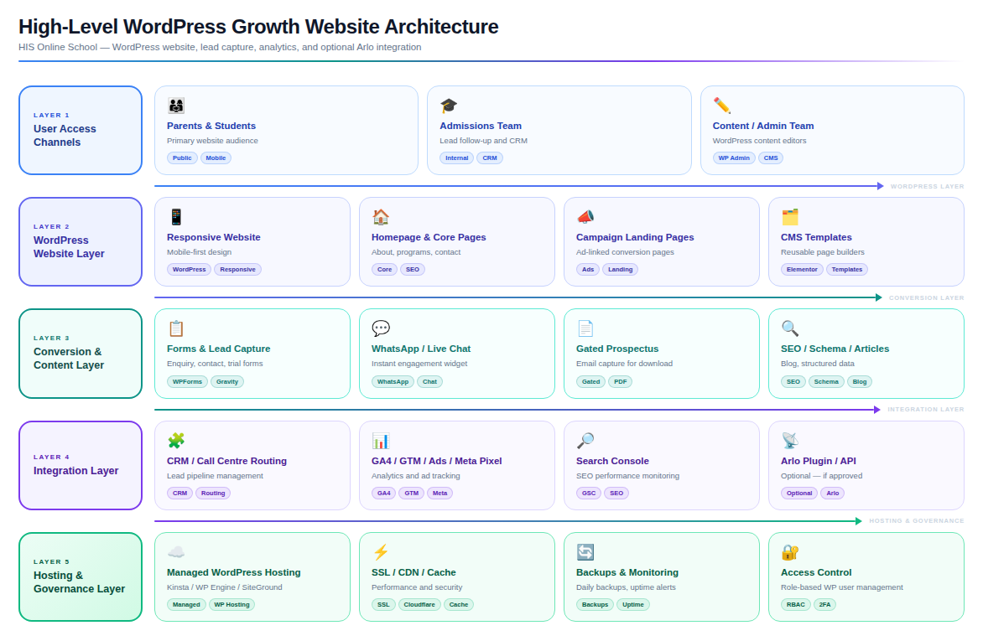
Figure 1: High-Level WordPress Growth Website Architecture

6. Arlo Integration Technical Note

6.1 Can Arlo be integrated with WordPress?
Yes. Arlo provides a WordPress integration approach through its official WordPress plugin. The plugin supports pre-built page templates, shortcodes and theme options, allowing Arlo course and event information to be displayed inside WordPress pages without building a full custom training management system inside WordPress.

6.2 Key Benefits of Using Arlo
- Course and training catalog management from a purpose-built training management platform.
- Event and class scheduling for face-to-face, live online or blended training delivery.
- Online registrations and registration management.
- Trainer/presenter, venue and event information management.
- Automated communications related to registration and course administration.
- Payment and finance workflow support where configured in Arlo.
- CRM, reporting and operational visibility for training-related activity.
- Reduced custom development effort compared with building a course management engine from scratch inside WordPress.

6.3 Recommendation: Arlo vs. Building from Scratch in WordPress
If HIS requires a real course/training management solution with schedules, registrations, trainers, communication automation and operational reporting, Arlo is recommended over building these capabilities from scratch in WordPress. WordPress should act as the public website and content layer, while Arlo should manage the specialized training operations. This reduces custom development complexity, lowers operational risk and keeps the WordPress website focused on admissions, marketing and content growth.
A custom WordPress-only build should be considered only if HIS needs simple static course information pages without scheduling, trainer management, automated communications, registration workflows or payment processing.
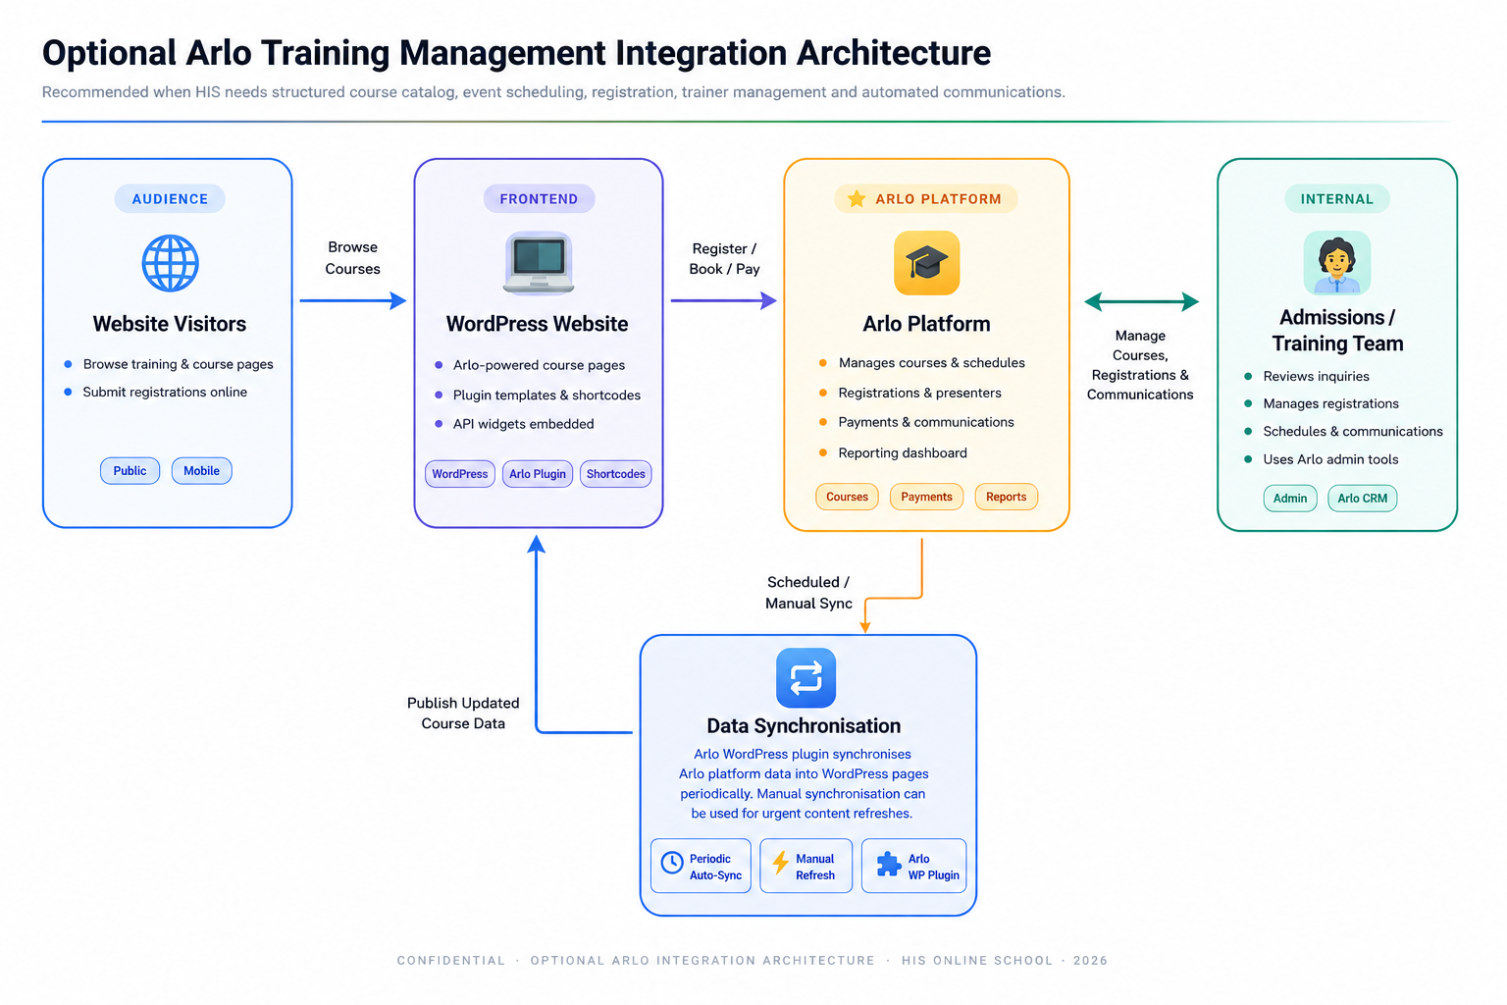
Figure 2: Optional Arlo Training Management Integration Architecture

7. Proposed Technical Stack
The proposed stack is selected to support a content-rich, conversion-ready WordPress website while keeping the implementation practical and aligned with the confirmed requirements.

CMS and Backend
- WordPress CMS
- PHP 8.x
- MySQL or MariaDB database
- Custom post types or structured content where needed

Frontend
- Responsive WordPress theme or child theme
- HTML5, CSS3, JavaScript
- Gutenberg/block-based reusable sections
- Mobile-first layout implementation

Hosting and Infrastructure
- Managed WordPress hosting
- Staging and production environments
- SSL certificate
- CDN/cache layer where supported by hosting
- Automated backup configuration

Forms and Lead Capture
- Vetted WordPress form plugin selected after CRM/routing confirmation
- Email notification, webhook or CRM routing as applicable
- Gated download form workflow
- Spam protection where required

Analytics and Marketing Tracking
- Google Tag Manager
- Google Analytics 4
- Google Ads conversion tracking
- Meta Pixel
- Google Search Console

Search and AI Visibility
- SEO metadata plugin such as Yoast, Rank Math or SEOPress
- XML sitemap
- Schema markup configuration where relevant
- Redirect management plugin or hosting-level redirect rules

Communication Tools
- WhatsApp click-to-chat link or widget
- Live chat tool selected by HIS if required
- Click-to-call and contact CTA tracking

Arlo Integration
- Arlo WordPress plugin as the preferred integration method
- Arlo JavaScript controls or Pub REST API only if the standard plugin cannot meet approved requirements

Security and Governance
- User access control
- Plugin update governance
- Regular backups
- Basic hardening
- Monitoring/log review supported by hosting or selected tools

8. Development Methodology
The delivery approach will follow a lean Agile methodology with milestone-based reviews. This allows the team to prioritize the conversion-critical assets first while progressively completing the remaining roadmap items.
- Discovery and Planning
- Confirm scope, content availability, access requirements, domain/DNS ownership, tracking requirements and Arlo decision points.
- Prepare page inventory, sitemap and implementation backlog.
- Design and Content Structure
- Prepare homepage, admissions, landing page and content page structures.
- Review content hierarchy for clarity, conversion and search readiness.
- Development on Staging
- Build WordPress pages, templates, forms, tracking and integrations in staging.
- Incremental Review and Refinement
- Review completed pages and modules in batches.
- QA, Migration and Launch
- Complete functional, responsive, tracking, SEO and migration testing.
- Switch the domain only after approval and launch readiness checks.
- Post-Launch Stabilization
- Monitor forms, redirects, tracking, performance and inquiry paths after launch.
- Provide handover documentation and CMS guidance.

9. Deliverables
- Discovery notes and finalized implementation scope.
- WordPress staging environment setup.
- Responsive WordPress theme/page templates aligned with HIS brand direction.
- Homepage rebuild with clear admissions messaging and CTAs.
- Admissions journey page.
- Trial class landing page.
- Gated prospectus/resource download journey.
- Lead capture forms and inquiry routing configuration.
- WhatsApp/live chat entry points based on approved communication tools.
- Leadership, curriculum, learning experience and transparency/supporting pages as defined in the roadmap.
- Search and AI visibility foundation including metadata, sitemap, schema where relevant and content structure.
- Analytics and conversion tracking configuration.
- Optional Arlo WordPress integration setup if approved by HIS.
- URL mapping and redirect plan for migration.
- QA test report and launch checklist.
- Production launch support and post-launch verification.
- CMS handover notes and basic admin guidance.

10. Testing and Quality Assurance
Testing and QA will focus on ensuring the WordPress website is stable, responsive, searchable, trackable and ready to support admissions activity before the domain is switched from Wix.
- Requirement coverage review against the approved scope and roadmap.
- Functional testing for all pages, menus, CTAs, forms, gated resource flow, WhatsApp links, chat links and contact points.
- Responsive testing across desktop, tablet and mobile screen sizes.
- Cross-browser testing on current versions of Chrome, Edge, Firefox and Safari where practical.
- Form submission testing including admin notifications, routing, confirmation messages and spam checks.
- Analytics and conversion tracking testing for page views, CTA clicks, form submissions and key campaign events.
- SEO testing for page titles, meta descriptions, heading hierarchy, sitemap, robots controls and schema where applicable.
- Migration testing for URL mapping, 301 redirects, broken links and domain readiness.
- Performance checks for page loading, image optimization, caching and mobile usability.
- Security checks for admin access, SSL, plugin status, backups and basic hardening.
- Content QA for spelling, page consistency, link accuracy and admissions message alignment.
- Arlo integration testing if implemented, including course page display, synchronization behavior and registration path validation.
- Post-launch smoke testing after DNS switch to verify live forms, redirects, tracking and key user journeys.
11. Proposed Timeline
Proposed estimated timeline: 1.5 month

12. Assumptions and Dependencies
- HIS will provide access to Wix, domain/DNS management, hosting decisions and relevant third-party accounts.
- HIS will provide or approve website content, images, brand assets, curriculum details, leadership information and admissions copy.
- The existing domain will remain active on Wix until the WordPress site is approved for launch.
- WordPress staging will remain non-public until final launch readiness.
- CRM, call-centre or email routing requirements will be confirmed before final form configuration.
- Any paid tools, subscriptions, plugin licenses, hosting accounts, Arlo accounts or third-party service accounts will be confirmed by HIS outside this technical proposal.
- Arlo integration depends on HIS selecting Arlo and providing access to the Arlo platform and required configuration details.
- Major Wix redesign work is not planned during the WordPress development period to avoid duplicated effort.
- Final launch timing depends on content approval, QA completion and DNS/domain readiness.

13. Out of Scope
- Financial estimation, commercial pricing or subscription cost comparison.
- Full custom learning management system or training management system development from scratch.
- Custom student, parent or teacher portal development unless separately approved.
- Mobile app development.
- Large-scale CRM product development or call-centre platform development.
- Paid media campaign management beyond website tracking and landing-page readiness.
- Major Wix redesign or full Wix rebuild during the WordPress development period.
- Large-scale video production, photography or brand redesign.
- Advanced multilingual content setup unless content and scope are separately confirmed.
- Custom payment gateway development outside the selected platform/tool capability.
- Ongoing content production beyond the agreed roadmap and publishing cadence.

14. Financial Proposal for Development
Scope of Work | Timeline | Estimated Cost (USD)
Development | 5 weeks | $4000
Total | 5 weeks | $4000
Note: The financial breakdown only consists of the development costs, It doesn’t include any third party costs (Api’s, Servers, Plugins etc.)

Payment terms:
- 30% Advance upon Contract Sign
- 40% Upon publishing the site in staging server after development
- 30% After handover of the whole site

15. Financial Proposal for Maintenance
Scope of Work | Timeline | Estimated Cost (USD)
Monthly Site Maintenance | Billed Monthly | $250 (Per month)
Total |  | $4000
Note: The billing cycle will be Quarterly for Maintenance

16. WordPress Monthly Maintenance & Support SOP

WordPress Monthly Maintenance & Support
To ensure the website remains secure, stable, optimized, and fully functional after deployment, we provide an ongoing Monthly Maintenance & Support service.

Scope of Services

1. Website Health Monitoring
- Weekly website health checks
- Website uptime monitoring
- Broken link monitoring
- Error log review
- Basic functionality verification

2. WordPress Core Updates
- Safe update of WordPress Core
- Compatibility verification before deployment
- Post-update functionality testing
- Rollback support if an update causes issues

3. Plugin Management
- Plugin updates
- Compatibility testing
- Removal of deprecated or vulnerable plugins
- License verification (client-provided premium plugins)

4. Theme Maintenance
- Theme updates
- Child theme compatibility checks
- Layout verification after updates
- Bug fixes related to theme updates

5. Website Security
- Malware scanning
- Security vulnerability monitoring
- Firewall rule verification (if applicable)
- Login security review
- Removal of suspicious files (if detected)
- Security plugin monitoring

6. Backup Management
- Scheduled full website backup
- Database backup
- Backup verification
- Secure backup retention according to the selected maintenance plan
- Website restoration support from available backups

7. Database Maintenance
- Database cleanup
- Spam comment removal
- Post revision cleanup
- Optimization of database tables

8. Technical Support
Support for:
- Website issues
- Contact form issues
- Email configuration issues
- SSL-related issues
- Basic troubleshooting
Support Hours:
- Business Days (Monday–Friday)
- Response Time: Within 1 Business Day

11. Monthly Maintenance Report
A monthly report will include:
- Completed updates
- Backup status
- Security scan results
- Performance summary
- Website uptime
- Issues resolved

Service Exclusions
The Monthly Maintenance Plan does not include:
- New page design
- New feature development
- UI/UX redesign
- Plugin customization
- Theme customization
- Custom coding requests
- Third-party API integrations
- WooCommerce feature enhancements
- SEO campaigns
- Digital marketing
- Content writing
- Graphic design
- Server migration
- Hosting management (unless included separately)
- Recovery from hacking caused by credential leakage or third-party negligence
- Premium plugin/theme license fees
Any work outside the maintenance scope will be quoted separately upon client approval.

Support Priority
Priority | Description | Initial Response
Critical | Website completely inaccessible or major functionality failure | Within 4 Business Hours
High | Major feature malfunction affecting business operations | Within 1 Business Day
Medium | Minor functionality issues | Within 2 Business Days
Low | Content updates or general inquiries | Within 3 Business Days

Maintenance Schedule
Routine maintenance activities are typically performed during non-peak business hours to minimize service disruption.
Emergency maintenance may be performed immediately when necessary to address security or availability issues.

Service Renewal
The Monthly Maintenance Service is provided on a recurring monthly basis and may be renewed according to the agreed maintenance contract.
Failure to renew the maintenance service may result in delayed security updates, reduced technical support availability, and increased security risks.

Optional Add-on Services
The following services may be purchased separately:
- New feature development
- Landing page creation
- WooCommerce enhancements
- SEO optimization
- Website speed optimization (advanced)
- Server administration
- Cloud infrastructure management
- Monthly analytics reporting
- Content management services
- UI/UX improvements
- API integration
- Website migration
- Disaster recovery planning
- Security hardening
- Accessibility compliance improvements

Deliverables
The Monthly Maintenance Plan ensures that the website remains:
- Secure
- Stable
- Updated
- Optimized
- Backed up
- Monitored
- Supported
while minimizing downtime and maintaining an optimal user experience.

16. Acceptance Criteria and Handover

16.1 Acceptance Criteria
- The WordPress website is available on staging for review before launch.
- Approved pages and scoped features are built and responsive.
- Forms, WhatsApp/live chat CTAs, gated prospectus and trial-class inquiry paths are tested.
- Analytics and conversion tracking events are configured and verified.
- SEO metadata, sitemap, schema where applicable and redirect mapping are prepared.
- Domain switch and launch checks are completed without disrupting admissions activity.
- Post-launch smoke testing confirms forms, redirects, page access and tracking on the live website.

16.2 Handover Items
- WordPress admin access handover.
- CMS content update guidance.
- Plugin and theme overview.
- Form and inquiry routing overview.
- Tracking and analytics configuration notes.
- Redirect and migration checklist.
- Backup and maintenance recommendations.
- Arlo integration notes if Arlo is implemented.

17. Conclusion
The recommended approach is to proceed with WordPress as the long-term website foundation for HIS Online School. This provides a safer migration path, protects admissions and marketing continuity, and creates a more scalable base for campaign conversion, content publishing, search visibility and future integrations.
If HIS requires structured course or training management, Arlo should be integrated with WordPress rather than rebuilding the same capabilities from scratch. This allows WordPress to remain the website and content layer while Arlo manages specialized training operations such as course catalog, scheduling, registration and communications.

