Technical Proposal
Marijuana Anonymous Mobile App

1. Executive Summary
Marijuana Anonymous World Services is seeking a development partner to enhance the existing MA Mobile App and support a separate ANLP WooCommerce store integration. This proposal is covering both requested bid areas while keeping them clearly separated for approval, prioritization and implementation planning.
The recommended approach is to continue with the existing React Native and Expo-based mobile application, complete the requested enhancement tickets for Bid Request #1, and implement Bid Request #2 as a focused mobile store integration that uses the existing WooCommerce store instead of building a new e-commerce backend.
The proposal avoids unnecessary feature expansion and does not include financial pricing. Implementation can be approved as a full program, as separate bids, or as selected phases depending on MAWS priorities and governance decisions.

2. Understanding of the Requirement
Area | Client Requirement | Proposal Response
Bid Request #1 | Enhance existing MA mobile app for Version 2.0.3 / 3.0. | Included as primary app enhancement scope.
Bid Request #2 | Integrate ANLP WooCommerce store into the mobile app. | Included as a separate secondary technical scope.
Current Environment | React Native app, iOS and Android deployment, MAWS-owned GitHub, TSML integration. | Reuse current architecture and avoid redevelopment.
Ownership | MAWS must retain source code, documentation, APIs, configs and app store access. | All deliverables remain in MAWS-owned repository and documentation platform.
Delivery Model | Phased implementation based on priorities, funding and approval. | Separate workstreams with clear QA and release gates.
Financial Scope | Client requested financial part to be skipped in this proposal. | No pricing is included; effort and timeline are non-financial planning estimates only.

3. Current Technical Environment
The current technical environment indicates that the app is already built in React Native with Expo, uses file-based routing, local storage, modular services and app store distribution. The proposed work will build on the current foundation to reduce risk and cost.
Existing Item | Observed / Expected Context
Mobile Framework | React Native with Expo SDK 53 baseline from the GitHub Read-Me.
Navigation | Expo Router / file-based screen structure.
Platforms | iOS and Android for the RFP release; web support exists in the Read-Me but is not treated as primary scope.
Repository | MAWS-owned GitHub repository.
Meeting Finder | Current TSML Meeting Finder integration, presently using WebView behavior.
Content and Storage | Local-first app data, document handling, literature access and environment-based API configuration.
Distribution | Apple App Store and Google Play Store.
Store Environment for Bid #2 | Existing WooCommerce-powered ANLP online store with approximately nine products.

4. Proposed Scope of Work
The proposed scope is limited to the RFP items only. Bid Request #1 and Bid Request #2 are presented separately to maintain clear approval, timeline and effort tracking.

4.1 Bid Request #1: MA Mobile App Enhancement Scope
RFP Item | Proposed Implementation | Notes
Literature Display Issue | Fix Books section content cut-off on affected devices, including the reported iPhone 12 / iOS issue. | Priority ticket.
Meeting Finder Improvements | Integrate JSON-based TSML Meeting Finder feed through a secure modular service layer and reduce WebView dependency where feasible. | Includes validation, loading states and scalable structure.
Calendar Button | Remove duplicate Google Calendar button and retain native device calendar functionality only. | Small UX cleanup.
Step 10 Inventory Tool | Build an in-app multi-field fillable inventory form with user-generated entries and native sharing. | Privacy-first implementation.
Sobriety Date Display | Show actual sobriety date wherever sobriety duration is currently displayed. | Example format: October 14, 2025.
Sobriety Counter Bug Fix | Fix reset behavior so the date defaults to current month/year or never defaults to a future date. | Bug fix and regression test.
PDF Sharing | Enable sharing for Meeting Readings and Pamphlets through SMS, Email, WhatsApp and native share options. | Uses native sharing flow.
Audio Literature | Integrate Life with Hope audio playback with play, pause and resume support. | Reusable structure for future audio literature.
Dark Mode | Add user-selectable app-wide dark mode. | Theme-level implementation.
Bottom Navigation Styling | Replace bottom white bar with green gradient design aligned with MA branding. | Visual update.
Push Notifications | Add opt-in notifications for fellowship announcements and app updates with user preferences. | Consent-based notification flow.
Gratitude List | Allow members to maintain entries and optionally share with sponsor, friend or accountability partner. | Local-first data model.
Meeting Counter | Allow members to track meeting attendance with weekly/monthly tracking and milestone-ready structure. | Keep simple for initial release.
Sobriety Counter Widget | Add home screen widget that syncs with app sobriety information. | Platform capability validation required.

4.2 Bid Request #2: WooCommerce / ANLP Store Integration Scope
Bid Request #2 is included as a separate secondary project. The purpose is to improve member access to ANLP literature and store products from inside the MA Mobile App while using the existing WooCommerce store infrastructure.
RFP Item | Proposed Implementation | Notes
Store Access from App | Add a Store entry point within the existing app navigation. | Final placement to be confirmed with MAWS.
Browse Products | Display ANLP store products, including books, pamphlets and recovery resources. | Uses existing product data.
Product Details | Show product title, description, image, price and availability based on store data. | No new product management system.
Search and Filter | Provide simple search and filter options for store products. | Keep lightweight due to small catalog size.
Cart Flow | Allow users to add items to cart and review selected items before checkout. | Implementation may use WooCommerce API or controlled checkout flow.
Secure Checkout | Complete purchases through secure WooCommerce checkout rather than storing payment data inside the app. | Reduces payment and PCI handling risk.
Order Confirmation | Show confirmation or redirect back to the app after successful checkout where technically supported. | Depends on existing store checkout behavior.
Maintenance Structure | Use reusable service layer and documented configuration for future store expansion. | Avoid vendor lock-in.

5. Proposed Technical Approach

5.1 Shared Approach for Both Bids
- Start with repository access, environment setup and technical discovery using the MAWS-owned GitHub repository.
- Confirm the current Expo SDK, dependencies, app store configurations and existing build pipeline before development.
- Convert RFP scope into a prioritized backlog with separate approval checkpoints for Bid #1 and Bid #2.
- Maintain modular service layers for TSML, app content, WooCommerce and native device features.
- Avoid unnecessary backend redevelopment unless required by the approved API integration approach.
- Commit updated source code and documentation to MAWS-approved repositories throughout the project lifecycle.

5.2 Bid #1 Technical Approach
- Resolve priority bugs and UI issues first, including literature cut-off, sobriety date reset, calendar duplication and bottom navigation styling.
- Replace or reduce Meeting Finder WebView dependency with JSON API integration where API access and data structure are available.
- Implement recovery tools using local-first data handling so sensitive personal entries stay on the device unless intentionally shared by the user.
- Use native device sharing capabilities for SMS/Text, Email, WhatsApp and platform-supported share options.
- Implement audio playback and push notifications using the existing Expo/React Native-friendly architecture.
- Validate widget feasibility early because iOS and Android widget behavior differs by platform.

5.3 Bid #2 Technical Approach
- Use a hybrid store integration approach: app-native product discovery with secure checkout handled by the existing WooCommerce store.
- Fetch product and category data from WooCommerce-approved API endpoints or a controlled middleware layer if MAWS prefers not to expose direct store API credentials in the app.
- Keep payment, tax, shipping and order processing within the existing WooCommerce checkout process to minimize compliance and maintenance risk.
- Add a simple cart and checkout handoff flow rather than rebuilding the full WooCommerce backend inside the app.
- Document all store configuration, API access, environment variables, checkout URLs and deployment steps for future maintainability.

6. Technical Diagrams
The following diagrams provide a simple technical view of the proposed implementation. These can be replaced with branded diagrams during final design formatting if required.
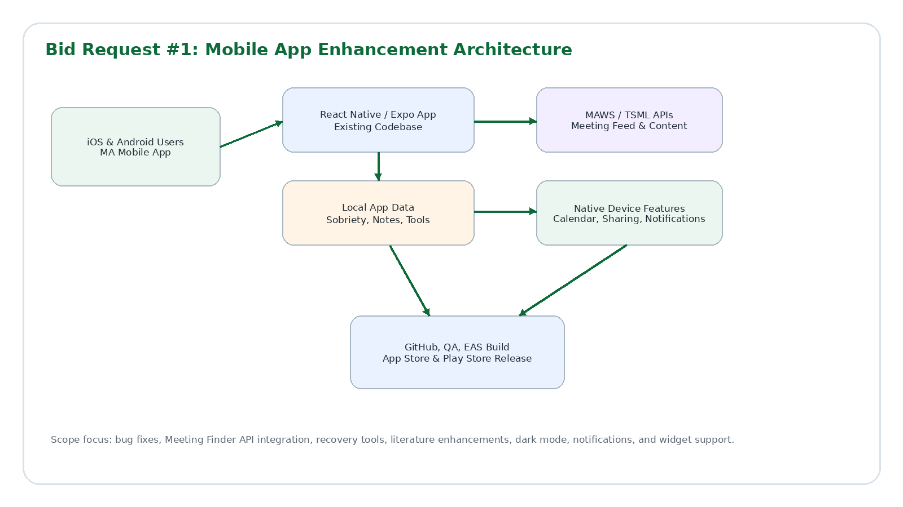
Figure 1: Bid Request #1 Mobile App Enhancement Architecture
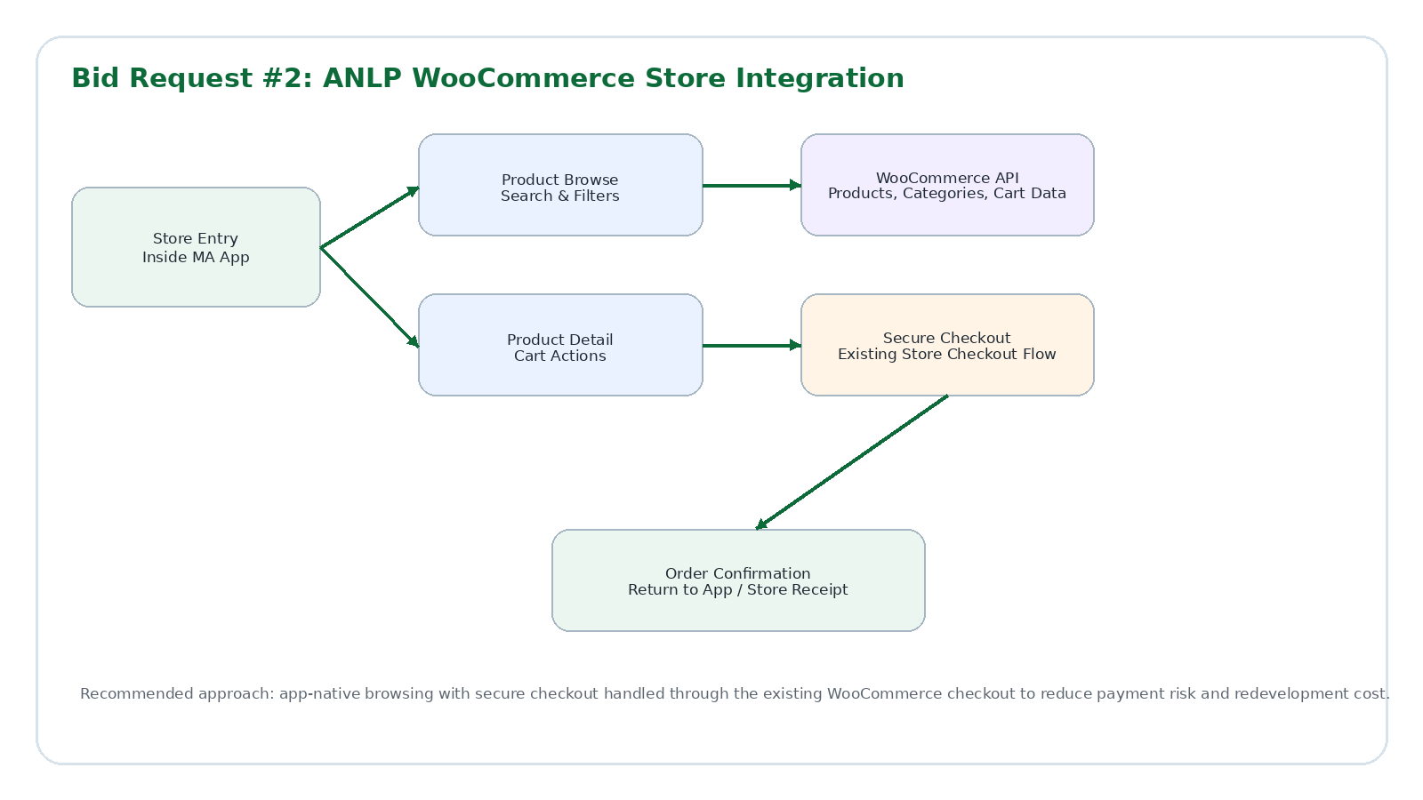
Figure 2: Bid Request #2 ANLP WooCommerce Store Integration Architecture
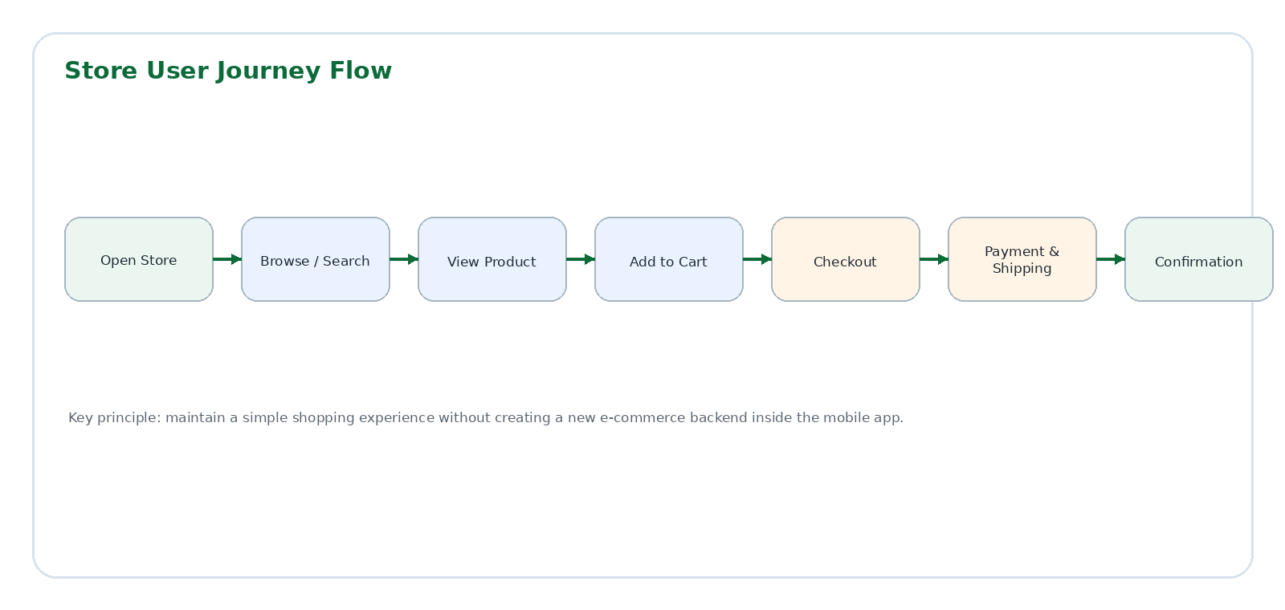
Figure 3: Store User Journey Flow

7. Proposed Technical Stack
The proposed stack keeps the existing app technology as the foundation. Any new tool or package should be added only when necessary for the approved scope.
Layer | Recommended Stack
Mobile Framework | React Native with existing Expo SDK 53 baseline.
Navigation | Expo Router / file-based routing.
Language | TypeScript.
State Management | React Hooks and Context API where already used.
Local Storage | AsyncStorage for non-sensitive local data; secure storage where sensitive data is required.
API Layer | Fetch API with modular services for TSML Meeting Finder, MAWS endpoints and WooCommerce integration.
UI Components | React Native Paper, React Native SVG and existing theme system.
File Handling | Expo File System and native sharing capabilities for literature and PDFs.
Notifications | Expo Notifications or current notification setup aligned with the existing app build.
Audio Playback | Expo/React Native-compatible audio playback package selected after repository review.
Store Integration | WooCommerce REST API or approved store API/middleware with secure WooCommerce checkout handoff.
Build and Release | EAS Build or current approved mobile build pipeline for iOS and Android.
Version Control | MAWS-owned GitHub repository.
Quality Tools | ESLint, TypeScript checks, manual QA, regression testing and app store release validation.

8. Development Methodology
A lightweight Agile methodology is recommended because the work contains multiple enhancement tickets, bug fixes and integrations that need review checkpoints. Each workstream should move through discovery, backlog confirmation, development, QA and release preparation.
- Kickoff and technical discovery
- Backlog confirmation for Bid #1 and Bid #2
- Sprint planning and implementation
- Internal QA and regression testing
- MAWS review and user acceptance testing
- Production build preparation and app store submission support
- Documentation, repository update and handover

9. Deliverables
Deliverable | Description
Technical Audit Summary | Findings from existing code, dependencies, app structure, store integration points and release configuration.
Updated Mobile App Source Code | All approved Bid #1 and Bid #2 implementation committed to MAWS-owned GitHub.
Bid #1 Priority Bug Fixes | Literature display issue, sobriety reset bug, calendar duplication and bottom navigation issue.
Bid #1 Mobile Enhancements | Meeting Finder API integration, Step 10 tool, sobriety date display, gratitude list, meeting counter, PDF sharing, audio playback, push notifications, dark mode and widget support.
Bid #2 Store Integration | ANLP store access, product browsing, product details, search/filter, cart flow, secure checkout handoff and confirmation behavior.
Testing and QA Report | Functional, regression, device, API, security, store checkout and release readiness test results.
Deployment Support | Staging builds, QA builds, release builds and app store submission support.
Documentation | Setup guide, environment configuration, API notes, store integration notes, release process and maintenance guide.
Handover Session | Knowledge transfer for MAWS or future development partners.
Maintenance Recommendation | Post-launch monitoring, bug fixing and future enhancement support options.

10. Testing and Quality Assurance
Testing will be performed throughout implementation and before each release. The QA scope will include the following checkpoints:
- Functional testing for every approved feature and bug fix.
- Regression testing for existing sobriety counter, literature, navigation, search, meeting resources and app settings flows.
- Device testing on selected iOS and Android devices, including the known affected device profile if available.
- UI testing for dark mode, bottom navigation gradient, typography and safe area behavior.
- API testing for TSML Meeting Finder feed, WooCommerce product data, loading states, error handling and fallback behavior.
- Sharing tests for SMS/Text, Email, WhatsApp and native device share options where supported.
- Audio playback testing for play, pause, resume and basic interruption handling.
- Notification permission, opt-in, preference and delivery testing.
- Widget testing for sync behavior and platform-specific limitations.
- Store flow testing for browsing, product details, search, cart, checkout handoff and confirmation behavior.
- Security review for environment configuration, local data handling, API access and checkout flow.
- Build verification for staging and production-ready iOS and Android builds.
- QA support and defect triage before production release.

11. Implementation Timeline
Proposed Timeline: 1 month

12. Ownership, Repository and Handover
- MAWS will retain ownership of all source code, documentation, APIs, integrations, designs, technical specifications and build configurations created under this engagement.
- All custom development will be committed to the MAWS-owned GitHub repository or another MAWS-approved source control environment.
- Source code updates will be committed at milestone completions and approved deliverable points.
- Documentation will include implementation, configuration, deployment, store integration and maintenance notes.
- MAWS will retain access to credentials, licenses, configuration details and deployment information required to operate and maintain the app.
- The approach will avoid vendor lock-in and support future maintenance by MAWS or a future development partner.

13. Assumptions and Dependencies
Area | Assumption / Dependency
Repository | MAWS will provide GitHub access, branch guidelines and current build instructions.
API Access | TSML Meeting Finder API feed and WooCommerce API or approved store integration access will be provided by MAWS or responsible partners.
App Store Access | MAWS will provide required Apple and Google Play access or support release through existing account owners.
Design Assets | Existing brand colors, icons, screenshots and app design references will be provided where needed.
Content | MAWS will provide approved literature, PDF, audio and store content. The vendor will not create new recovery content.
Checkout | Existing WooCommerce checkout, payment, tax, shipping and order processing rules will remain managed by the current store infrastructure.
Approvals | Final implementation priority may depend on Board, Conference or MAWS internal approval.

14. Out of Scope
- Financial proposal, fixed-price pricing and commercial terms.
- New website development, website redesign or full website CMS rebuild.
- Major backend rebuild unless required and separately approved for API integration.
- New payment gateway setup, tax configuration, shipping rule configuration or accounting setup for the WooCommerce store.
- Full WooCommerce store redesign outside the mobile integration flow.
- New product content writing, product photography or creation of new ANLP store items.
- New community, chat, forum or social network features not listed in the RFP.
- Content writing, legal review, translation or creation of new recovery literature.
- Unrequested features that may increase cost or expand beyond the RFP.

15. Conclusion
This proposal covers both MAWS bid requests while keeping them clearly separated for approval and implementation. Bid Request #1 focuses on the required mobile app enhancements, bug fixes, recovery tools, literature improvements, notifications and widget support. Bid Request #2 focuses on integrating the ANLP WooCommerce store into the existing MA Mobile App through a simple, secure and maintainable mobile store experience.
The proposed approach reuses the existing React Native and Expo app foundation, avoids unnecessary redevelopment, protects MAWS ownership of source code and documentation, and provides a practical roadmap for development, QA, release and long-term maintainability.

