Technical Proposal
Micro-Drama OTT Streaming Platform
Clean rebuild from scratch based on the CMS Technical Blueprint and Current Replit Platform Overview
Prepared By: Riseup Labs


Table of Contents
1. Executive Summary 3
2. Understanding of the Current Platform and Client Direction 3
2.1 Current Platform Understanding 3
2.2 Our Accepted Approach to the Client 3
3. Proposed Technical Approach 4
3.1 Rebuild from Scratch with Functional Reference 4
3.2 Modular Monolith First, Service-Ready Architecture 4
3.3 API-First Development 4
3.4 Cloud-Native Deployment on GCP 4
3.5 Secure Video Delivery through Cloudflare Stream 4
3.6 White-Label and Dedicated Instance Readiness 4
4. Proposed Scope of Work 4
4.1 CMS / Admin and Partner Portal 4
4.2 Consumer Web Application 5
4.3 Mobile Application for iOS and Android 5
4.4 Backend API and Data Services 5
4.5 Infrastructure and DevOps 5
5. Proposed Technology Stack 5
6. Proposed Technical Architecture 6
7. Development Methodology 8
8. Deliverables 8
9. Testing and Quality Assurance 8
10. Implementation Timeline 9
11. Deployment, Handover and Client Prerequisites 9
11.1 Deployment Approach 9
11.2 Client Prerequisites 9
11.3 Handover Items 9
12. Scope Control and Future Enhancements 10
12.1 Out of Scope for This Proposal 10
13. Conclusion 10

1. Executive Summary
This proposal presents a clean, production-ready rebuild approach for a micro-drama OTT streaming platform consisting of a CMS/Admin and Partner Portal, consumer web application, iOS/Android mobile application and backend API services. The proposal is based on the provided CMS Technical Blueprint and the Current Replit Platform Overview.
The current Replit implementation is valuable as a working prototype because it demonstrates the main product workflows, including content management, video playback, coin-based monetization, subscriptions, partner submissions, ad campaigns, in-app popups, dynamic theming and reporting. However, for production use, the solution should be rebuilt from scratch to improve long-term maintainability, scalability, security and deployment reliability.
The recommended direction is to use Google Cloud Platform as the primary infrastructure, Cloudflare Stream for scalable video delivery, a structured backend architecture, a modern web CMS and a Flutter-based mobile application. This approach is aligned with the client’s acceptance of a clean rebuild, GCP infrastructure and Cloudflare Stream for video streaming.

2. Understanding of the Current Platform and Client Direction

2.1 Current Platform Understanding
Product Area | Current Prototype / Requirement Reference | Proposed Direction
CMS / Admin Portal | React + Vite based admin and partner portal with dashboard, content management, QA queue, ads, users, coins, white-label settings and popups. | Rebuild as a structured Vue.js CMS with role-based access, cleaner workflows and production-ready API integration.
Consumer Web App | React + Vite consumer application with home feed, search, series details, video player, coin store, subscriptions, rewards and library. | Rebuild as a responsive Vue/Nuxt web application connected to the same backend APIs and theming configuration.
Mobile App | Expo React Native application for iOS and Android with consumer features, device identity and screen capture protection. | Rebuild in Flutter for better cross-platform consistency, maintainability and production mobile performance.
Backend / API | Node.js + Express + Drizzle ORM + PostgreSQL with coin economy, unlocks, Cloudflare signed URLs, stream cap and ad serving. | Rebuild as modular NestJS APIs with PostgreSQL, queue/background jobs, audit logs, role permissions and secure service boundaries.
Video Delivery | Cloudflare Stream is already used for video delivery and signed playback URLs. | Continue with Cloudflare Stream for video hosting, playback and secure access control.
Cloud Direction | Client accepted GCP as the primary infrastructure provider. | Deploy production services on GCP with environment separation, monitoring, backup and CI/CD.

2.2 Our Accepted Approach to the Client
- Replit Codebase Review: The existing Admin/CMS and Web Frontend are built with React, and the mobile app is developed in React Native. The current solution works as a prototype but has limitations around architecture consistency, maintainability, scalability and security best practices.
- Clean Rebuild Recommendation: The existing application should be used as a functional reference, while the production solution should be developed from scratch on a clean and scalable architecture.
- Cloud Infrastructure: GCP will be used as the primary infrastructure provider because the planned services are aligned with the Google ecosystem.
- Video Streaming: Cloudflare Stream will be used for scalable global video delivery and high-concurrency streaming workloads.
- Project Management Tool: Any client-side project management platform integration or deployment will be treated as a separate engagement if required.

3. Proposed Technical Approach

3.1 Rebuild from Scratch with Functional Reference
The production platform will be developed from scratch, while the Replit platform will be used to understand validated user journeys, business rules, content workflows and existing operational logic. This avoids carrying prototype-level technical debt into the production release.

3.2 Modular Monolith First, Service-Ready Architecture
To keep development practical and cost-conscious, the recommended first release should follow a modular monolith backend architecture. Each domain module will be clearly separated inside the backend codebase, while deployment remains simple. This allows the platform to scale later into dedicated services only when actual usage requires it.
- Content and catalogue module for series, episodes, subtitles, genres, cast and assets.
- User and access module for authentication, roles, admin permissions and partner access.
- Monetization module for coins, unlocks, passes, subscription status and payment records.
- Streaming module for Cloudflare Stream integration, signed playback URLs and active stream sessions.
- Campaign module for ads, in-app popups, rewards and basic engagement tracking.
- Reporting module for admin analytics, partner analytics and CSV exports.

3.3 API-First Development
All user-facing applications will consume the same secure backend APIs. This ensures consistent business logic across the CMS, web app and mobile apps, and reduces duplicated logic in frontend code.

3.4 Cloud-Native Deployment on GCP
The platform will be deployed on GCP with separate environments for development, staging and production. The proposed approach supports automated deployment, database backup, structured monitoring, log review and scalable application hosting.

3.5 Secure Video Delivery through Cloudflare Stream
Video assets will be managed through Cloudflare Stream. For paid or restricted content, the backend will validate user entitlement before generating secure playback access. This keeps video delivery scalable while keeping access control inside the platform business rules.

3.6 White-Label and Dedicated Instance Readiness
The platform will be designed to support white-label configuration through CMS-managed branding, themes, platform name, logos and splash screen assets. Where required, the deployment model can support dedicated client instances or strong tenant isolation for user data, reporting and content rights management.

4. Proposed Scope of Work
The proposed scope focuses only on the requirements reflected in the provided documents and the accepted client direction. Items that may increase development cost are kept outside the first release unless approved separately.

4.1 CMS / Admin and Partner Portal
- Admin dashboard with key metrics such as views, revenue indicators, top series and platform activity.
- Series and episode management with metadata, genres, cast/crew, subtitles, aspect ratio, thumbnails, banners and publish/unpublish status.
- Content QA queue for partner submissions with approve, reject and feedback workflow.
- Ad campaign management for banner and pre-roll campaigns with schedule, target URL, impression and click tracking.
- User management with profile, coin balance, subscription status and watch history visibility.
- Coin and subscription admin override for operational adjustments with reason and audit log.
- White-label settings for platform name, brand color, logo and splash screen assets.
- In-app popup management with schedule, CTA, image and audience targeting.
- Partner portal for submission wizard, submission status and scoped analytics.

4.2 Consumer Web Application
- Home feed with trending, new releases and recommended rows based on available business rules.
- Browse and search by genre and series title.
- Series detail page with cover art, synopsis, cast, episodes, free/locked indicators and pricing.
- Video player with play/pause, seek, speed control, subtitle toggle and next episode behavior.
- Coin store and subscription flow integration based on approved payment provider and app store rules.
- Daily rewards and basic engagement mechanics as configured from the backend.
- Library and watch history to resume previously watched episodes.
- Dynamic theming based on CMS brand configuration.
- In-app popup display based on CMS campaign rules.

4.3 Mobile Application for iOS and Android
- Flutter-based iOS and Android applications with Home, Search, Library and Account navigation.
- All core consumer web features implemented natively for mobile experience.
- Device identity support for concurrent stream cap enforcement.
- Native routing for popup CTA actions and external browser handling where required.
- Screen capture protection for video screens where supported by iOS and Android platform capabilities.
- App switcher privacy overlay for sensitive viewing screens where supported.

4.4 Backend API and Data Services
- Authentication integration, role-based access control and permission handling.
- Content catalogue APIs for series, episodes, genres, credits, subtitles and assets.
- Coin wallet, transaction ledger, episode unlocks, batch unlocks and full-series unlock support.
- Subscription/pass status management and entitlement checking.
- Cloudflare Stream integration for video upload/reference, playback token generation and secure playback.
- Concurrent stream session management with heartbeat logic and configurable stream limits.
- Ad serving, popup serving, impression tracking and click tracking APIs.
- Reporting APIs for admin analytics, partner analytics and content provider CSV export.
- Audit logs for sensitive admin actions such as coin grants, subscription adjustment and content publishing.

4.5 Infrastructure and DevOps
- GCP environment setup for development, staging and production.
- Cloud SQL PostgreSQL database setup with backup and environment separation.
- Cloud Storage setup for images, documents and non-video assets.
- Cloudflare Stream configuration and integration with backend services.
- CI/CD pipeline for backend, CMS/web and mobile builds where applicable.
- Logging, monitoring and deployment verification checklist.

5. Proposed Technology Stack
The stack below is selected to support production stability, maintainability and long-term scalability. The primary recommendation uses NestJS and Node.js for the backend because it provides a structured TypeScript architecture and aligns well with API-first product development. Laravel with Vue.js remains a viable alternative if the client prefers the PHP ecosystem.
Layer | Primary Recommendation | Purpose / Reason
CMS / Admin Portal | Vue.js 3 + TypeScript + Vite | Clean admin UI, fast development, maintainable component structure and role-based workflows.
Consumer Web App | Vue.js / Nuxt.js + TypeScript | Responsive consumer experience with routing, SEO-friendly pages if required and shared design system.
Mobile App | Flutter + Dart | Single codebase for iOS and Android with strong UI consistency and long-term maintainability.
Backend API | NestJS + Node.js + TypeScript | Structured modular backend, scalable API development, strong typing and maintainable service boundaries.
Alternative Backend Option | Laravel + Vue.js | Suitable if the client prefers PHP-based backend delivery and Laravel ecosystem support.
Database | PostgreSQL on Google Cloud SQL | Reliable relational data store for users, content, unlocks, coins, subscriptions, sessions and reporting.
Cache / Queue | Redis / GCP Memorystore, Cloud Tasks or Pub/Sub | Supports session heartbeat, queue jobs, async notifications and background processing.
Object Storage | Google Cloud Storage | Stores images, banners, popup assets, documents and non-video media files.
Video Streaming | Cloudflare Stream | Video hosting, playback, scalable delivery and signed access for restricted content.
Authentication | Google Identity Platform / Firebase Auth or Clerk | Final provider to be confirmed. GCP-native identity is preferred; Clerk can be retained if client wants continuity.
Payments / IAP | Apple IAP, Google Play Billing, Stripe or regional gateway | Supports coins, passes and subscriptions depending on approved monetization channels.
Analytics | Custom Reporting + GA4/Firebase Analytics | Product reporting, provider reporting and event tracking for key user journeys.
DevOps | Docker, GitHub Actions / Cloud Build, Cloud Run, Cloud Monitoring | Repeatable deployment, environment control, monitoring and production operations.

6. Proposed Technical Architecture
The following diagrams summarize the proposed architecture and core operational flows. These diagrams can be redesigned by the UI/graphics team later while keeping the same technical meaning.

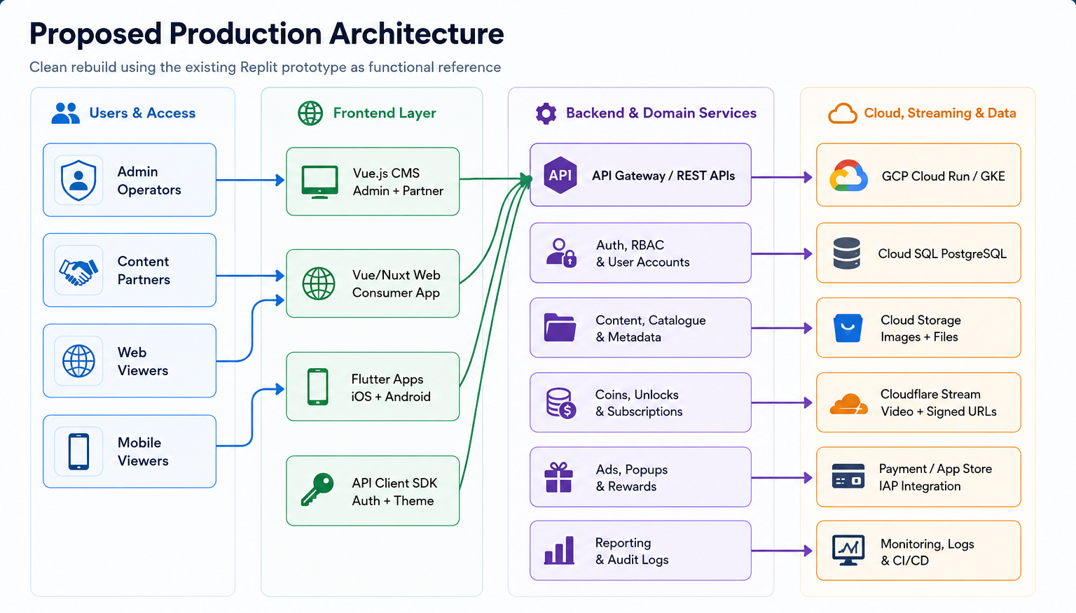
Diagram 1: Proposed production architecture for CMS, web, mobile, backend, GCP and Cloudflare Stream
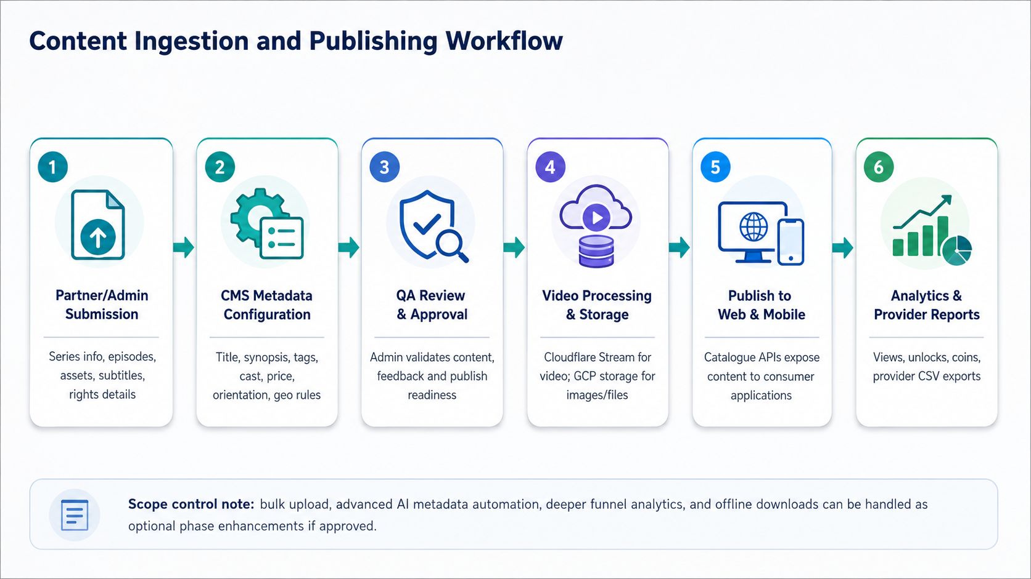
Diagram 2: Content ingestion, review, publishing and reporting workflow
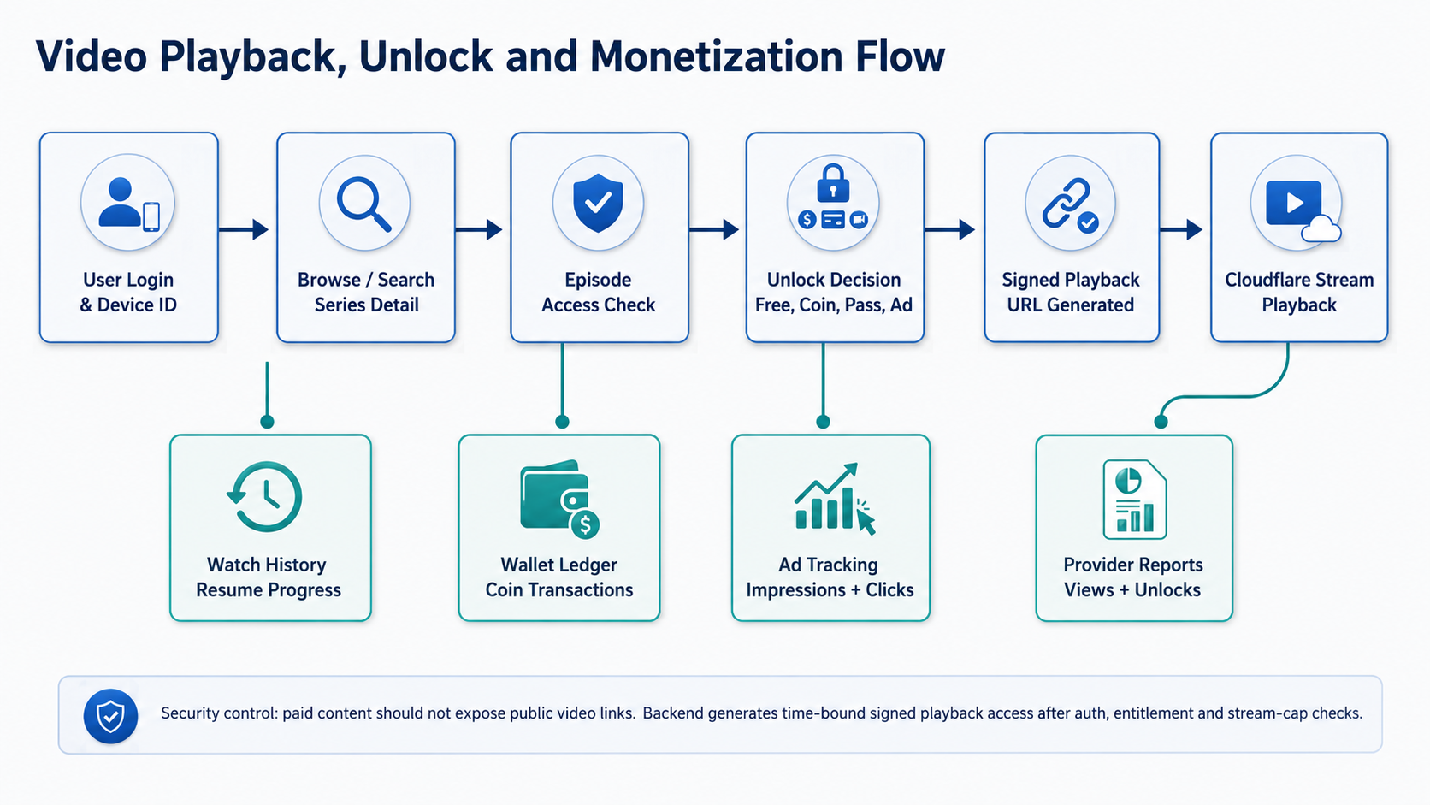
Diagram 3: Video playback, unlock, signed access and monetization flow

7. Development Methodology
The project will follow an Agile, milestone-based development methodology. The goal is to reduce risk through early architecture validation, iterative feature delivery, regular client review and structured quality assurance.
Stage | Activities | Outputs
Discovery and Scope Freeze | Review prototype, confirm feature scope, define assumptions, confirm third-party accounts and finalize acceptance criteria. | Approved scope, user journeys, release plan and technical architecture.
UX/UI and System Design | Prepare core wireframes, design system, CMS workflows, mobile screens and data model. | UI/UX assets, architecture diagrams, database model and API plan.
Sprint Development | Develop backend modules, CMS, web app and Flutter app in parallel sprint cycles. | Working increments, sprint demos and reviewed backlog.
Integration and Hardening | Integrate video streaming, payments/IAP, campaign logic, reporting and security controls. | Integrated staging release and readiness checklist.
QA | Functional, API, mobile, browser, security, regression and QA support. | Bug reports, QA sign-off and  feedback closure.
Deployment and Handover | Production deployment, app store support, documentation and training. | Production release, handover documents and support transition.

8. Deliverables
Deliverable Group | Deliverables
Project and Analysis | Finalized scope document, user journey notes, architecture plan, delivery plan and sprint backlog.
UI/UX Design | CMS/admin screens, partner portal screens, consumer web screens, mobile app screens and reusable design components.
Backend/API | NestJS API source code, database schema, API documentation, authentication/RBAC, content, monetization, streaming and reporting APIs.
CMS/Admin Portal | Admin dashboard, content management, QA queue, ads/popups, user management, white-label settings and partner management workflows.
Consumer Web App | Responsive web frontend with home, browse/search, series detail, player, coins/subscriptions, rewards, library and profile flows.
Mobile Apps | Flutter iOS and Android applications with core consumer features, secure video player behavior and release-ready builds.
Streaming and Media | Cloudflare Stream integration, signed playback URL flow, video metadata linkage and asset storage configuration.
Monetization and Reporting | Coin wallet, unlocks, passes/subscription handling, ad tracking, admin analytics, partner analytics and CSV reports.
DevOps and Deployment | GCP setup, CI/CD configuration, staging deployment, production deployment checklist and monitoring setup.
QA and Handover | Test cases, QA reports, bug summary, QA support, deployment guide, admin user guide and technical handover notes.

9. Testing and Quality Assurance
Quality assurance will be performed throughout the project, not only at the end. The QA process will focus on correctness, security, usability and release readiness across CMS, web, mobile and backend services.
- Requirement-based test case preparation for all approved modules and workflows.
- Unit testing for critical backend services such as entitlement checks, wallet transactions, unlock logic and stream session control.
- API testing for authentication, role permissions, content APIs, payment callbacks, reporting APIs and Cloudflare integration endpoints.
- Functional testing for CMS workflows, partner submissions, content publishing, web playback and mobile user journeys.
- Cross-browser and responsive testing for the consumer web app and CMS screens.
- Mobile device testing on representative Android and iOS devices or simulators, including player behavior and app navigation.
- Streaming workflow testing for free, locked, paid, subscription and ad-unlocked content scenarios.
- Payment/IAP sandbox testing for coin top-up, subscription purchase, entitlement update and failure cases.
- Security testing for RBAC, session handling, signed URL access, API authorization, input validation and sensitive admin actions.
- Performance and load testing for high-traffic API endpoints, authentication flow, content browsing and reporting endpoints.
- Regression testing after major fixes and before QA.
- QA support with issue tracking, fix verification and final acceptance checklist.
- Deployment smoke testing after staging and production releases.

10. Implementation Timeline
Proposed timeline: 2.5 months

11. Deployment, Handover and Client Prerequisites

11.1 Deployment Approach
- Development, staging and production environments will be separated.
- Backend and web services will be deployed through automated CI/CD pipelines.
- Database migration scripts will be version-controlled.
- Cloudflare Stream and GCP service credentials will be managed through environment variables or secret management.
- Production deployment will follow a release checklist with rollback planning.
- Monitoring and logs will be configured for production issue diagnosis.

11.2 Client Prerequisites
Prerequisite | Required From Client
GCP Access | GCP billing/project access or approval to create a project under client ownership.
Cloudflare Stream | Cloudflare account access and Stream plan confirmation.
Developer Accounts | Apple Developer and Google Play Developer accounts owned by the client.
Payment / IAP Credentials | Apple/Google in-app purchase setup and web payment provider credentials, if web payments are required.
Brand Assets | Logo, splash screen, color scheme, watermark, app name and visual guidelines.
Content Samples | Initial series/episode samples, thumbnails, subtitles, legal ratings and geo restriction rules.
Legal and Compliance Rules | Content rights, regional availability, age rating rules, privacy policy and terms of service.

11.3 Handover Items
- Admin/CMS user guide and operational workflow notes.
- Technical handover document covering repositories, environment variables, deployment steps and key services.
- API documentation and database overview.
- QA summary report and known limitation list, if any.
- Training session for admin/content operations team.
- Post-deployment support transition plan, if applicable.

12. Scope Control and Future Enhancements
To keep the first release practical and cost-controlled, the following items should be treated as optional future enhancements unless the client explicitly confirms them as part of the first release.
Item | Recommendation
Offline Download | Keep for Phase 2 because it requires device storage control, expiry logic and stronger content protection.
Advanced Analytics | Start with operational reports and provider CSV exports. Add retention curves, funnel analytics and campaign attribution later.
Web DRM | Keep as optional enhancement depending on licensing requirements and Cloudflare DRM plan availability.
Social Features | Ratings, reviews and share previews can be added later after core streaming and monetization are stable.
Expanded Localization | Start with approved languages from current content requirements. Add additional UI/content languages in later phases.
AI Metadata Automation | Can be retained as a controlled enhancement if confirmed, but should not block the core content publishing workflow.
Project Management Tool | Client project management platform deployment/integration will be handled as a separate engagement, as already communicated.

12.1 Out of Scope for This Proposal
- Direct migration of prototype code into production codebase.
- Third-party platform fees, cloud usage fees, app store fees and payment gateway charges.
- Content creation, video production, subtitles creation and legal rights clearance.
- Full custom recommendation engine beyond basic curated/recommended content rules unless approved.
- Separate project management platform deployment or integration.

13. Conclusion
The proposed approach provides a clear path to convert the validated Replit prototype into a secure, scalable and maintainable production-grade micro-drama OTT platform. By rebuilding from scratch, the platform can avoid prototype-level constraints while preserving the business workflows already validated through the existing application.
Using GCP for cloud infrastructure, Cloudflare Stream for video delivery, NestJS or Laravel for backend development, Vue.js for CMS/web interfaces and Flutter for mobile apps will provide a strong foundation for the platform’s first production release and future scaling needs.

