MOON STORES
Technical Proposal
Presentation Generation System & AI-Assisted Visual Automation
Prepared by: Riseup Labs


Table of Contents
1. Executive Summary 3
2. Understanding of Moon Stores and Project Requirements 3
2.1 Design Requirements Interpreted from the Brief 3
3. Project Objectives 4
4. Scope of Work 4
4.1 Stage 1 - Presentation Template Design and Automated Generation 4
4.2 Stage 2 - AI Automation for Visual Content Preparation 4
4.3 Proposed 10-Slide Template Structure 5
5. Proposed Technical Approach 6
5.1 Template-First Design Approach 6
5.2 Data-Driven Presentation Generation 6
5.3 AI-Assisted, Human-Reviewed Visual Automation 6
5.4 Minimal, Practical Feature Set 6
6. Proposed System Workflow and Technical Diagrams 7
6.1 Proposed System Architecture 7
6.2 Presentation Preparation Workflow 8
6.3 AI Image Processing Pipeline 9
6.4 Proposed Template Structure 10
9. Proposed Technical Stack 11
10. Development Methodology 11
11. Testing and Quality Assurance 12
12. Deliverables 12
13. Assumptions and Client Inputs Required 13
14. Out of Scope Items 13
15. Acceptance Criteria 14
16. Handover and Support 14
17. Conclusion 14

1. Executive Summary
Moon Stores requires a premium presentation template and a practical automation system that helps decorators prepare client presentations faster while keeping the output elegant, minimal, photography-led and aligned with the brand's upscale positioning.
The proposed solution follows the client-provided decorator workflow end to end: Client Brief, Materials Analysis, Space Zoning, AI Zone Processing, Item Selection and Composition Building, AI Item Processing, Item Placement, Final Image Enhancement, Composition Review, More Zones decision, Create New Zone loop and Generate Final Presentation. Stage 1 establishes the premium template and presentation-generation logic; Stage 2 adds AI-assisted visual preparation within the same workflow.
The solution is template-first, zone-based and review-driven. Automation will prepare draft visuals and presentation files for each zone, while decorators retain final creative approval before the final client presentation is generated.

2. Understanding of Moon Stores and Project Requirements
Moon Stores is an interior design and space styling company with more than 10 years of experience. The brand works with interior designers, architectural firms, developers and private clients, and its positioning requires a premium, modern and detail-oriented presentation style.
The client brief identifies two major project stages:
- Stage 1 - Presentation Template Design: Develop a universal presentation template, or a shared design system with two project variants, and enable automatic presentation generation based on selected products and project data.
- Stage 2 - AI Automation: Automate visual preparation tasks such as image enhancement, background removal, interior cleanup, decor removal, item preparation, item placement and final presentation-ready image generation.

2.1 Design Requirements Interpreted from the Brief
- Presentation must look modern, elegant, professional and premium.
- Layout style should avoid marketplace or e-commerce catalog appearance.
- Slides should not be overloaded with text; focus should remain on interiors, items and photography.
- Template should support approximately 10 slides from cover page to contact information.
- Template must support flexible image formats and aspect ratios.
- Product specifications should be generated automatically on a separate slide where possible.
- Standard projects should be quick to prepare and easy for clients to understand.
- Premium projects should allow more detailed individual item presentation while keeping the same brand style.

3. Project Objectives
Objective | Business Value | Controlled Scope
Create a premium template system | Improves client-facing consistency and brand perception | Approx. 10-slide PPTX template with defined slide variants
Automate presentation generation | Reduces repetitive manual preparation by decorators | Generate PPTX/PDF from project data, selected products and approved images
Prepare for AI-assisted visuals | Improves speed of image cleanup and item preparation | AI workflows limited to image enhancement, cleanup, background removal and visualization support
Maintain quality control | Protects brand quality and avoids incorrect AI outputs | Human review before final export

4. Scope of Work

4.1 Stage 1 - Presentation Template Design and Automated Generation
Stage 1 will establish the premium presentation foundation and automate the generation of client-ready presentations from structured project data. The proposed implementation will follow the decorator flow from Client Brief, Materials Analysis and Space Zoning through Item Selection, Composition Review, More Zones decision and Final Presentation generation. A shared master template with two controlled variants, Standard Project and Premium Project, will support the client's requirement while avoiding unnecessary duplication.
- Visual concept and design direction aligned with Moon Stores' premium interior design positioning.
- Universal 10-slide PowerPoint template covering cover, company overview, project concept, area view, item selection, item details, clients, specifications, additional services and contact information.
- Two usage variants within the same design system: Standard Project and Premium Project.
- Flexible image layout system for portrait, landscape, square and mixed-ratio photography.
- Structured slide placeholders for project title, client/project name, room/area, item category, item image, product details and notes.
- Automated product specification slide generation based on selected items and approved product data.
- PPTX output generation and optional PDF export for client sharing.
- Template usage guide for decorators to ensure consistent presentation preparation.

4.2 Stage 2 - AI Automation for Visual Content Preparation
Stage 2 will introduce AI-assisted image processing at the exact workflow points defined in the client flow: AI Zone Processing after Space Zoning, AI Item Processing after Item Selection, Item Placement, Final Image Enhancement and Composition Review before final export. AI outputs will be treated as draft assets until reviewed by the decorator.
- Interior photo improvement, including quality enhancement, color correction and lighting correction.
- Removal of temporary, technical and extraneous objects from interior photos.
- Removal of existing decor from a room to prepare a clean visualization base.
- Background removal from product/item images.
- Image preparation of selected items for use in presentations.
- Automated placement of selected items within the interior with attention to scale, perspective and lighting.
- Final image generation for use in presentation slides.
- Visual review workflow before final presentation export.

4.3 Proposed 10-Slide Template Structure
Slide | Slide Purpose | Primary Content | Automation Support
1. Cover | Introduce project | Project name, hero interior/product image, date | Auto-filled project metadata
2. About the Company | Introduce Moon Stores | Short brand profile and positioning | Locked reusable brand content
3. Project Concept | Premium project context | Concept narrative, mood direction, optional image | Optional for premium projects
4. Area/Premises View | Show space context | Client/site photo and zone label | Image placement and caption
5. Item Selection | Present grouped decor options | Selected items and composition notes | Auto-populated selected products
6. Individual Item Details | Highlight high-value items | Item photo, material, dimensions, unique notes | Product data merge
7. Our Clients | Build trust | Selected brand/client references | Reusable locked content
8. Item Specifications | Summarize selected items | SKU/name, quantity, size, material, finish | Auto-generated table
9. Additional Services | Show capabilities | Interior styling, sourcing, visualization support | Reusable content block
10. Contact | Close presentation | Contact details, website/social links | Locked content with editable fields

5. Proposed Technical Approach

5.1 Template-First Design Approach
The system will be designed around a high-quality PowerPoint master template rather than a generic slide builder. This keeps the output close to the premium design direction required by Moon Stores and avoids a catalog-style or marketplace-style interface.
- Create a controlled visual system: typography, spacing, color palette, image treatment and slide hierarchy.
- Define reusable layout rules for different image ratios and content volumes.
- Lock core brand elements while keeping project-specific content editable.
- Design for minimal text, strong photography and clean negative space.

5.2 Data-Driven Presentation Generation
Project, material, zone and product data will be captured in structured fields and mapped to PPTX placeholders. This allows decorators to move from Client Brief and Materials Analysis to Space Zoning, item selection and automated presentation generation without manually copying the same information into every slide.
- Project record: client/project name, area/room, brief, status and version.
- Product/item record: name, category, material, dimensions, finish, image and notes.
- Slide mapping rules: selected products determine item selection, individual item detail and specifications slides.
- Output control: generation of editable PPTX with optional PDF export.

5.3 AI-Assisted, Human-Reviewed Visual Automation
AI will support the specific automation points shown in the client workflow: photo cleanup and existing decor removal under AI Zone Processing, background removal and image enhancement under AI Item Processing, followed by item placement and final image enhancement. Final approval will remain with the decorator because interior visualization quality depends on composition accuracy, product scale, perspective and lighting consistency.
- Use AI for image cleanup, enhancement, background removal and object preparation.
- Use automated visualization only as a draft generation step.
- Provide before/after preview and retry options for unacceptable output.
- Ensure final images are selected by the project team before presentation export.

5.4 Minimal, Practical Feature Set
The proposed solution avoids broad product-management, e-commerce, marketplace or CRM functionality. The focus is strictly on presentation template design, presentation generation and visual content preparation, as required in the client brief.

6. Proposed System Workflow and Technical Diagrams
The following diagrams define the proposed system structure and the exact decorator workflow from the client brief. The presentation workflow has been updated to mirror the provided flow, including AI processing points, zone repetition and final presentation generation. Additional branded screenshots or final UI mockups can be placed in these sections after the design phase.

6.1 Proposed System Architecture
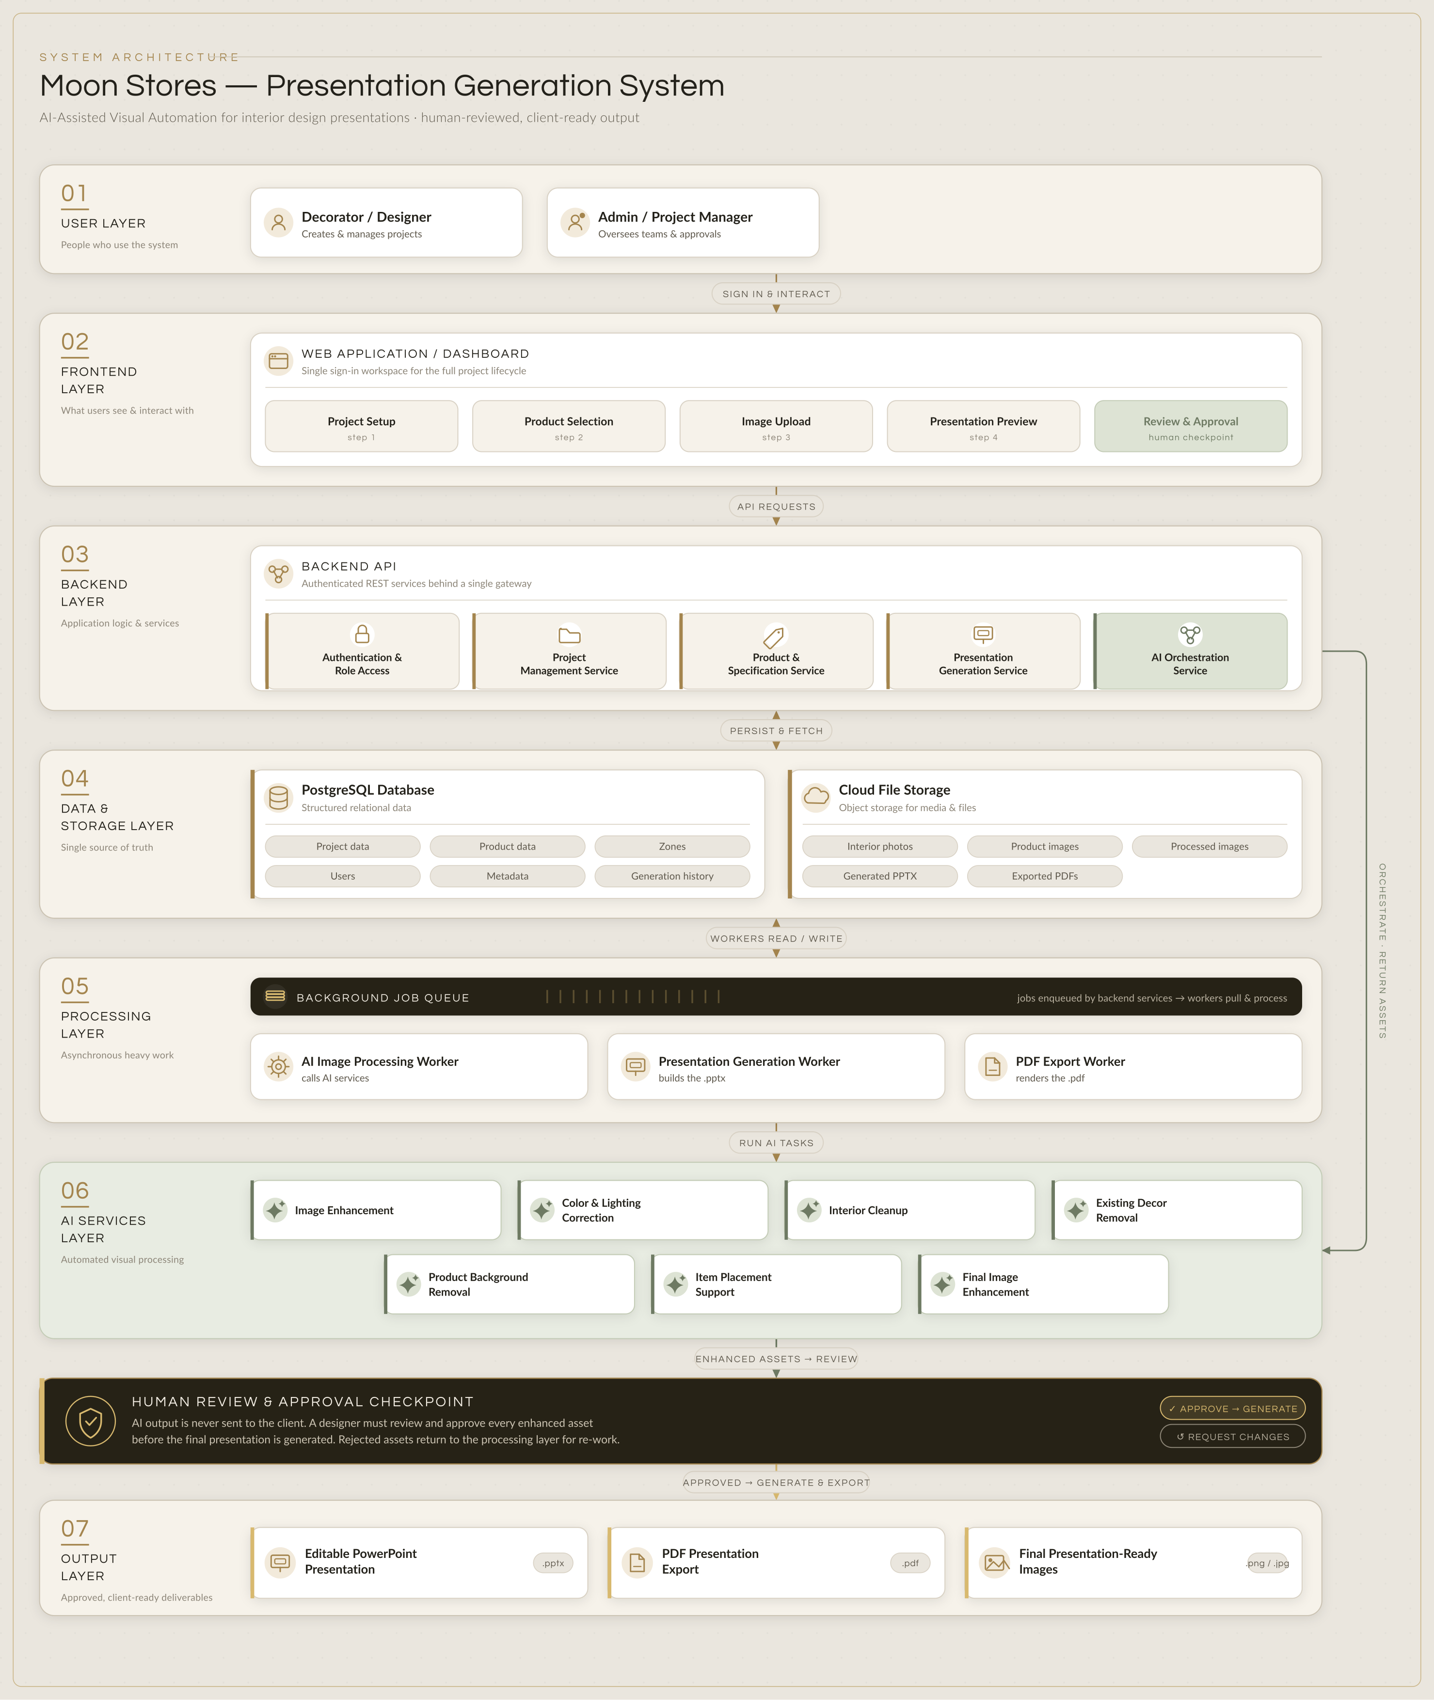
Figure 1: Proposed architecture showing the relationship between user interface, backend API, data store, file storage, presentation engine and AI image services.

6.2 Presentation Preparation Workflow
This workflow is aligned with the client-provided flowchart. Each zone follows the same cycle from brief and materials analysis through AI-assisted processing, item placement, review and final generation. When more zones are required, the system creates a new zone and loops back to Space Zoning before generating the final presentation.
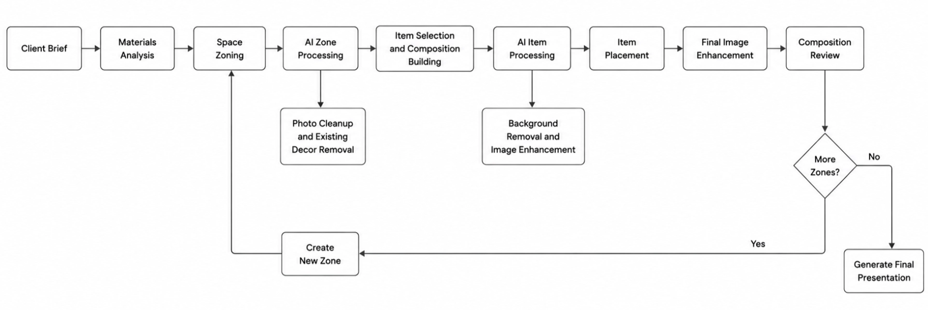
Figure 2: Workflow-aligned presentation preparation flow matching the client-provided sequence, including AI processing points, the More Zones decision, Create New Zone loop and final presentation generation.
Client Workflow Alignment Mapping
Client Flow Step | Proposal/System Alignment | Stage
Client Brief | Project record captures client/project details, area objective, notes and presentation purpose. | Stage 1
Materials Analysis | Decorator uploads/reference materials, room photos and product inputs for presentation preparation. | Stage 1
Space Zoning | System creates one or more zones/areas so each space can have its own visuals and slide series. | Stage 1
AI Zone Processing | Interior photo cleanup, color/lighting correction and existing decor removal are applied to the selected zone. | Stage 2
Item Selection and Composition Building | Decorator selects items and defines composition logic for the zone presentation. | Stage 1
AI Item Processing | Product background removal, image enhancement and item preparation are performed before placement. | Stage 2
Item Placement | Selected items are positioned into the prepared interior image with scale, perspective and lighting review. | Stage 2
Final Image Enhancement | Final visual is refined for presentation use after item placement. | Stage 2
Composition Review | Decorator reviews the generated composition before presentation export. | Stage 1
More Zones? / Create New Zone | If additional areas are needed, a new zone is created and the flow repeats from Space Zoning. | Stage 1
Generate Final Presentation | Approved zones, images, product selections and specifications are merged into the final PPTX/PDF. | Stage 1

6.3 AI Image Processing Pipeline
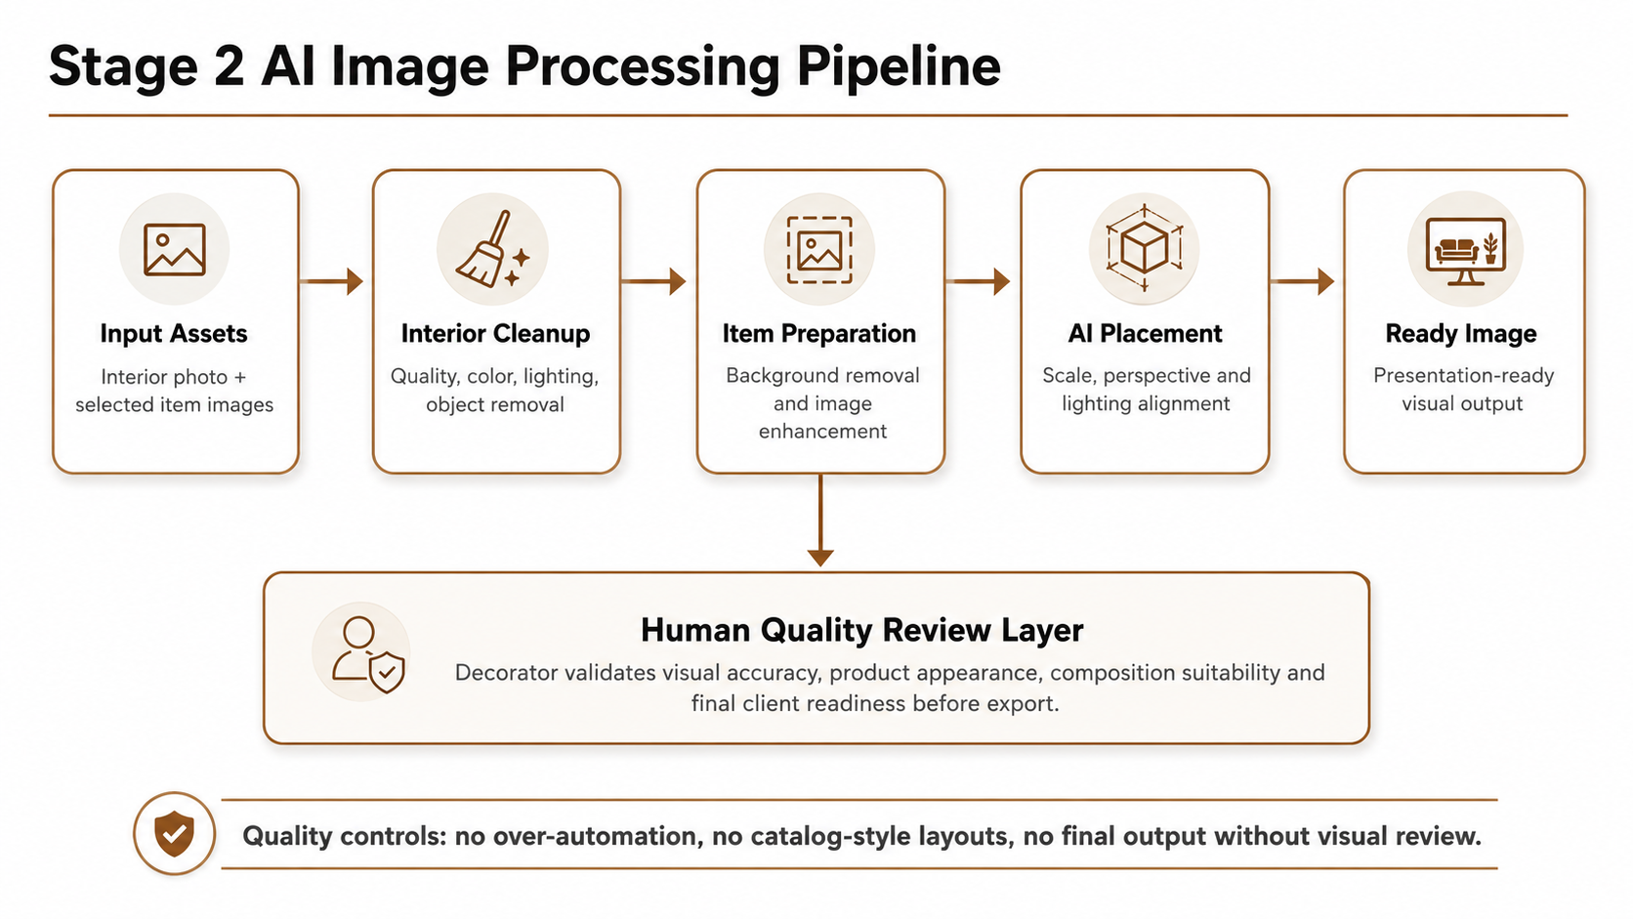
Figure 3: AI image processing pipeline for Stage 2. Human review remains a required quality checkpoint before presentation use.

6.4 Proposed Template Structure
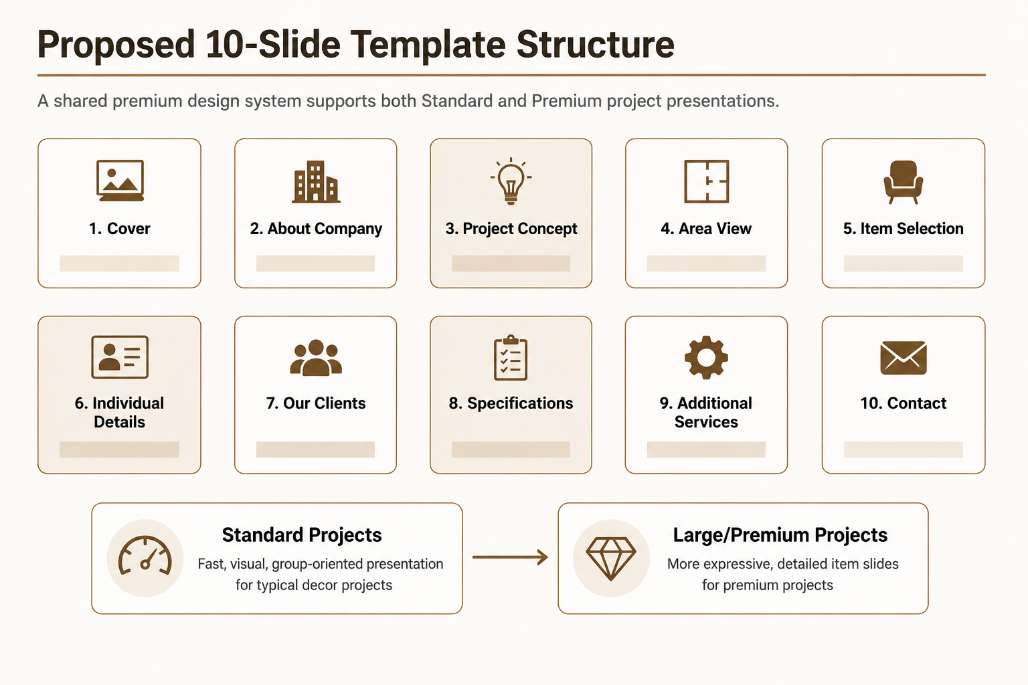
Figure 4: Proposed 10-slide template structure and two project variants supported by one premium design system.

9. Proposed Technical Stack
The stack is selected to support presentation automation, image-heavy workflows and AI processing while keeping the solution modular and scalable for the two-stage roadmap.
Layer | Recommended Technology | Purpose | Reason for Selection
Frontend | React.js / Next.js | Project setup, product selection, image upload, generation preview | Modern UI, strong component structure and good support for image-heavy workflows
Backend API | Python FastAPI | Business logic, template generation API, AI orchestration | Fast development, strong ecosystem for AI/image processing and presentation automation
Presentation Engine | python-pptx / Open XML based PPTX processing | Generate editable PowerPoint decks from templates and structured data | Direct PPTX generation and template-driven slide assembly
AI Image Processing | OpenAI Image API and/or Cloudinary AI transformations | Image enhancement, editing, background removal and generative visual assistance | Established API-based capabilities for generation, edits, background removal and transformations
Image Processing Utilities | Pillow / OpenCV | Resizing, cropping, aspect ratio handling, quality checks | Reliable server-side image preparation before insertion into slides
Database | PostgreSQL | Projects, items, zones, users, job history and metadata | Reliable relational data model and scalable for structured product/project records
File Storage | AWS S3 / Azure Blob / Cloudinary Media Library | Store source images, processed images, PPTX and PDF outputs | Secure object storage suitable for visual assets
Background Jobs | Celery + Redis or managed queue | Run image processing and generation tasks asynchronously | Prevents long-running AI tasks from blocking the user interface
Authentication | JWT-based authentication / Auth0 / Keycloak | Secure decorator/admin access | Role-based access and secure token-based sessions
Deployment | Docker + cloud VM/container hosting | Deploy API, frontend and workers | Portable deployment and easier environment management
CI/CD | GitHub Actions / GitLab CI | Automated builds, tests and deployment pipeline | Improves release consistency and traceability

10. Development Methodology and Implementation Timeline
The project will follow a phased Agile delivery approach with short review cycles. This is suitable because visual quality and template usability require client feedback, while the automation components require technical iteration and testing.
Phase | Activities | Review Output | Approval Point
Discovery | Confirm exact decorator workflow, client brief inputs, materials analysis, zone logic, sample assets and slide structure | Requirements baseline | Client confirms template direction
Design Sprint | Prepare visual concept, master slide style and sample layouts | Template design preview | Client confirms visual direction
Template Build | Build PowerPoint master template and slide variants | Editable PPTX template | Client approves slide system
Automation Build | Develop project data entry, space zoning, product selection, More Zones loop and PPTX/PDF generation | Stage 1 working prototype | Client validates generated presentation
AI Build | Implement image processing and AI visual automation workflow | Stage 2 AI processing prototype | Client validates image quality
QA & Handover | Test, refine, document and hand over | Final system and documentation | Final acceptance

11. Testing and Quality Assurance

Testing will focus on workflow alignment, presentation quality, PPTX generation accuracy, image processing reliability, zone-loop handling and secure handling of project assets.
QA Area | Testing Activities | Acceptance Focus
Workflow Alignment QA | Test Client Brief, Materials Analysis, Space Zoning, AI processing, item placement, review, More Zones loop and final generation sequence | System follows the client-provided flow without missing steps
Zone Loop QA | Test single-zone and multi-zone projects, including Create New Zone and return to Space Zoning | Additional zones are handled before final presentation generation
Template QA | Check typography, spacing, alignment, color use, image placement and consistency across slide variants | Premium, minimal and non-catalog visual quality
PPTX Generation QA | Test generated decks using multiple project sizes and product selections | Correct slide order, data mapping and editable output
Image Ratio QA | Test portrait, landscape, square and mixed-ratio images | No stretching, cropping errors or broken layouts
Specification Slide QA | Validate selected product data against generated specification tables | Accurate product details and no missing fields
AI Image QA | Review background removal, enhancement, object removal, item placement and lighting consistency | Image suitable for presentation after human review
Performance QA | Check upload, preview, generation and export speed for sample projects | Usable decorator workflow without long blocking steps
Security QA | Check authentication, permissions, private file access and environment secrets | Project assets visible only to authorized users
Compatibility QA | Open generated PPTX in Microsoft PowerPoint and export PDF | Slides remain consistent and editable
Regression QA | Retest core flows after changes | No breakage in previously approved functions

12. Deliverables
Deliverable | Description | Stage
Visual Direction & Design System | Premium design concept, typography, colors, layout principles and image handling rules | Stage 1
Editable PowerPoint Template | Universal 10-slide PPTX template with Standard and Premium usage variants | Stage 1
Template Usage Guide | Simple guide for decorators to prepare and review presentations consistently | Stage 1
Presentation Generation Module | Web-based flow to create project records, select products and generate PPTX/PDF output | Stage 1
Product Specification Generator | Automated specification slide/table based on selected item data | Stage 1
AI Image Processing Module | Image enhancement, background removal and image preparation workflow | Stage 2
AI Interior Editing Workflow | Interior cleanup and decor removal workflow with review process | Stage 2
AI Visualization Workflow | Assisted item placement and final image generation for presentation use | Stage 2
Testing Report | Summary of template, automation, image, compatibility and security testing | Both
Deployment Package & Documentation | Source code, deployment notes, environment setup and handover documentation | Both
Workflow-Aligned Automation Flow | System logic reflecting Client Brief, Materials Analysis, Space Zoning, AI processing, Item Placement, Composition Review, More Zones loop and Final Presentation generation | Both

13. Assumptions and Client Inputs Required
- Moon Stores will provide logo, brand references, preferred typography/colors if available, and sample presentation references.
- Moon Stores will provide sample project photos, product/item images and product specification data for initial testing.
- The initial template scope is approximately 10 slides, with repeatable slide series for area views, item selection and individual item details.
- Product specifications will exclude financial pricing unless explicitly requested later.
- AI-generated visual outputs will require human review due to possible variance in scale, perspective, lighting and composition.
- The final hosting environment, AI vendor account and cloud storage account will be confirmed before deployment.
- Client feedback cycles will be provided within agreed review windows to maintain the timeline.

14. Out of Scope Items
The following items are excluded to keep the proposal aligned with the provided requirement and to avoid unnecessary development scope:
- Financial proposal, pricing calculation and commercial quotation generation.
- Marketplace, e-commerce catalog, shopping cart, online payment or order management features.
- Full CRM, ERP, inventory management or supplier management system.
- 3D modeling, AR/VR visualization or CAD/BIM integration.
- Full digital asset management platform beyond project and generated presentation files.
- Real-time multi-user editing of presentations.
- Mobile application development.
- Unlimited AI image revisions without quality review and usage control.
- Content writing services are beyond required slide structure and reusable brand content placeholders.

15. Acceptance Criteria
Area | Acceptance Criteria | Evidence
Template | Template reflects premium Moon Stores style and supports required slide types | Approved PPTX template
Automation | Selected project and product data generate an editable presentation deck | Generated PPTX sample
Specifications | Selected products appear accurately in the specification slide | Data validation checklist
Images | Images appear without distortion and support multiple aspect ratios | Visual QA result
AI Processing | AI output can enhance/remove/prepare images and is suitable after human review | Before/after sample review
Export | Final presentation can be downloaded as PPTX and optionally PDF | Exported files
Documentation | Decorator and technical teams receive usage and handover notes | Documentation package
Workflow Alignment | The system follows the client-provided decorator workflow, including More Zones loop before final generation | Workflow test report

16. Handover and Support
At completion, the project team will hand over the approved template, system access, source code, deployment documentation and operating instructions. A short knowledge-transfer session should be conducted with the Moon Stores team to explain the generation workflow, template usage rules and AI review process.
- Template usage walkthrough for decorators.
- Admin/project creation and product selection workflow demonstration.
- AI image processing review guidelines.
- Deployment and environment documentation for the technical team.
- Known limitations and recommended operational controls for AI usage.

17. Conclusion
The proposed solution gives Moon Stores a practical and premium workflow for preparing interior design presentations. The proposal is now fully aligned with the client-provided decorator flow from Client Brief to Materials Analysis, Space Zoning, AI processing, Item Placement, Final Image Enhancement, Composition Review, zone repetition and final presentation generation. Stage 1 establishes the controlled template and presentation-generation system, while Stage 2 adds AI-assisted visual preparation with decorator review for quality control.

