Technical Proposal
Arabic SaaS CRM Platform for Nonprofit Organizations
Prepared By: Riseup Labs

Table of Contents
1. Executive Summary 3
2. Understanding of the Requirement 3
2.1 Key Business Needs 3
2.2 Research and Compliance Alignment 3
3. Proposed Solution Scope 4
3.1 Phase-Wise Scope 4
3.2 Functional Scope Summary 4
4. Proposed Technical Approach 5
4.1 Build from Scratch 5
4.2 Modular SaaS Architecture 5
4.3 Arabic-First User Experience 5
4.4 API-First Backend 5
4.5 Workflow and Approval Layer 5
4.6 Stripe-Based SaaS Billing 5
4.7 Integration Layer 5
4.8 Security and Audit by Design 5
4.9 Reporting and Compliance Readiness 5
5. Proposed Technical Stack 6
5.1 Why This Stack Fits the Requirement 6
6. Technical Diagrams 7
6.1 High-Level SaaS Architecture 7
6.2 SaaS Subscription and Tenant Activation Flow 8
6.3 Beneficiary Service Delivery Workflow 9
7. Development Methodology 10
8. Deliverables 10
9. Testing and Quality Assurance 10
10. Implementation Timeline 11
11. Assumptions and Dependencies 11
12. Out of Scope 11
13. Conclusion 11

1. Executive Summary
This proposal presents a simple and practical technical approach for developing an Arabic SaaS CRM platform for nonprofit and charity organizations. The platform will be developed from scratch as a secure, web-based, multi-tenant system that supports organization onboarding, beneficiary management, programs and service delivery, fundraising and donations, finance, reporting, volunteer management, governance bodies, committees, and integrations with relevant ecosystem services.
The solution will follow the client-provided phased scope. Phase 1 will focus on the core operational CRM, SaaS administration, fundraising, and integration foundation. Phase 2 will extend the platform with finance, audit, reporting, security, and assets. Phase 3 will add volunteer management and governance body/committee management. The technical foundation will be API-first so that a future mobile application can be introduced without rebuilding the backend.
Stripe will be used for SaaS subscription billing, including monthly and yearly subscription plans, plan-level module access, user limits, billing status, and automated subscription lifecycle events through webhooks.

2. Understanding of the Requirement
The client requires a nonprofit CRM platform for charity organizations operating in the Saudi landscape. The platform must manage interaction between regulatory authorities, donors, volunteers, beneficiaries, and nonprofit organization users. The platform must also cover core charity operations such as programs, service delivery, donations, finance, Zakat, reporting, investment, volunteer operations, governance, committees, and external ecosystem integrations.

2.1 Key Business Needs
- Arabic-first web CRM with right-to-left interface support.
- SaaS model with multi-tenant organization onboarding and tenant-specific configuration.
- Subscription plans based on organization size, number of users, and activated modules.
- Beneficiary registry, eligibility rules, assistance tracking, and service history.
- Program catalog, annual planning, service request workflow, outcome tracking, and impact reporting.
- Fundraising campaigns, donor records, receipt management, donation channel controls, closure reports, and suspicious donation alerts.
- Finance, Zakat ledger, accounting export/integration, audit, assets, banking, investment tracking, dashboards, and compliance reporting.
- Volunteer registry, opportunities, attendance, hours, certificates, safety records, and complaint handling.
- Governance bodies, board/trustee structures, committees, controlled documents, meetings, delegations, and voting methods.
- Secure APIs for payments, documents, reports, notifications, national identity/legal entity verification, donation channels, bank statements, and volunteer systems where commercial/API access is available.

2.2 Research and Compliance Alignment
Research Area | Technical Implication
Saudi nonprofit context | Align the platform with nonprofit sector governance, licensing, financial monitoring, and operational supervision needs.
Personal data protection | Design data collection, consent, retention, access, export, deletion, and privacy controls for sensitive beneficiary, donor, and volunteer data.
Cybersecurity controls | Apply secure architecture, access control, logging, encryption, vulnerability management, backup, disaster recovery, and monitoring practices.
Cloud and tenant isolation | Apply tenant-level isolation across application, database, storage, logs, reports, and administration layers.
Stripe subscriptions | Use Stripe Billing/Checkout and webhooks for subscription plan lifecycle, renewal, failed payment handling, and billing status sync.

3. Proposed Solution Scope
The proposed platform will include only the modules and capabilities requested in the scope overview. The implementation will be structured into three development phases to control delivery risk and avoid unnecessary development cost.

3.1 Phase-Wise Scope
Phase | Focus | Included Modules
Phase 1 | Core SaaS and operational CRM foundation | Platform Admin and SaaS, Organization and Registry Lifecycle, Beneficiary Management, Programs and Service Delivery, Fundraising and Donations, Integrations and API Gateway
Phase 2 | Finance, compliance, reporting, and control layer | Finance, Accounting and Audit, Security, Audit and Access Control, Reporting, Dashboards and BI, Assets, Banking and Investments
Phase 3 | Volunteer and governance expansion | Volunteer Management, Governance Bodies, Committees, Meetings, Delegations, Controlled Documents, and Voting Support

3.2 Functional Scope Summary
Module | Scope Summary
Platform Admin and SaaS | Tenant onboarding, branding, domains, language settings, rule packs, subscriptions, enabled modules, usage limits, renewal dates, tenant billing status, feature flags, templates, notifications, and support tools.
Registry and Entity Lifecycle | Legal entity type selection, rule pack application, formation request submission, founder/identity/registration data, attachments, license tracking, renewal status, and legal personality activation.
Beneficiary Management | Beneficiary profiles, eligibility attributes, consent, documents, program relationship, service history, configurable eligibility rules, approval authority, assistance records, funding source, and duplicate benefit restriction.
Programs and Service Delivery | Program catalog, annual planning, service request intake, eligibility verification, approval, delivery, closure, feedback, outcomes, KPIs, service quality, and impact indicators.
Fundraising and Donations | Campaign requests, permitted purpose, campaign period, collection channel, bank account, donor records, receipts, donation restrictions, campaign closure reporting, and AML/suspicious donation flags.
Finance, Accounting and Audit | Budget preparation, review, approval, versioning, final accounts, financial statements, external auditor records, corrective actions, Zakat ledger, and chart-of-accounts mapping/export.
Assets, Banking and Investments | Bank accounts, signatories, joint signature rules, statements, movable assets, properties, endowments, valuation, disposal approvals, surplus investment rules, returns, and risks.
Reporting, Dashboards and BI | Compliance health dashboard, overdue tasks, upcoming deadlines, missing evidence, pending approvals, risk indicators, regulatory reports, and approved transparency publishing.
Integrations and API Gateway | Secure APIs for entity data, submissions, reports, payments, documents, status updates, identity/legal entity verification, payment gateway, bank statement integrations, email, SMS, and WhatsApp notifications.
Security, Audit and Access Control | RBAC by role, entity, module, authority, sensitivity, and task ownership, full activity logging, retention policy, archival, legal hold, tenant isolation, encryption, MFA, SSO readiness, backup, DR, monitoring, and NCA-aligned controls.
Volunteer Management | Volunteer profiles, identity, skills, interests, availability, agreements, opportunities, attendance, hours, tasks, supervisor validation, certificates, appreciation, rights acknowledgement, incidents, and complaints.
Governance and Committees | Members, fees, voting rights, licenses, bylaws, minutes, decisions, boards, trustees, committees, delegations, meetings, agendas, attachments, invitation deadlines, and applicable voting methods.

4. Proposed Technical Approach

4.1 Build from Scratch
The solution will be developed from scratch using a clean, modular architecture. The existing scope will be used as the functional baseline, and no legacy codebase dependency is assumed.

4.2 Modular SaaS Architecture
The platform will be designed as a multi-tenant SaaS system where core modules can be enabled or disabled based on subscription plans. Tenant settings, branding, workflows, lookup values, notifications, and rule packs will be configuration-driven to reduce future code changes.

4.3 Arabic-First User Experience
The web interface will be designed for Arabic usage with right-to-left layout support, clear navigation, role-based dashboards, form validation, and responsive behavior for desktop, tablet, and mobile browser access.

4.4 API-First Backend
The backend will expose secure REST APIs for web frontend communication and future mobile app support. API documentation will be maintained using OpenAPI/Swagger for easier integration and maintenance.

4.5 Workflow and Approval Layer
The platform will include configurable workflows for service delivery, eligibility verification, donation campaign approvals, finance approvals, auditor observations, committee decisions, and governance-related actions.

4.6 Stripe-Based SaaS Billing
Stripe Billing will handle subscription plans, monthly/yearly billing, customer records, invoices, plan renewals, failed payment notifications, and webhook-based status updates. Tenant access will be linked to active subscription status and enabled modules.

4.7 Integration Layer
A dedicated integration layer will manage external payment channels, bank statement reconciliation, identity/legal entity verification, volunteer platform integration, email, SMS, WhatsApp, and other approved ecosystem services. Each integration will depend on API availability, access approval, and documentation from the relevant provider.

4.8 Security and Audit by Design
Security will be built into the platform from the beginning using tenant isolation, RBAC, MFA readiness, encrypted storage, audit trails, secure APIs, rate limiting, backup, disaster recovery, vulnerability management, and monitoring.

4.9 Reporting and Compliance Readiness
Reporting will be structured around compliance health, operational performance, beneficiary outcomes, campaign closure, financial reporting, activity reports, and approved public transparency publishing.

5. Proposed Technical Stack
Layer | Recommended Technology / Approach
Frontend Web Application | React.js with TypeScript, RTL layout support, Tailwind CSS or equivalent UI framework
Backend Application | Laravel 11 with PHP 8.3, modular service architecture, REST APIs, queue workers, scheduler, policies, and service layer
Database | PostgreSQL with tenant-aware data model, indexing, backups, and reporting-optimized views
Caching and Queue | Redis for caching, background jobs, notification queues, and scheduled processing
File and Document Storage | S3-compatible encrypted object storage for attachments, licenses, bylaws, financial reports, evidence files, and controlled documents
Authentication and Access | JWT/session-based authentication, role-based access control, MFA readiness, SSO/OIDC readiness, secure password policy
Payment Gateway | Stripe Billing, Stripe Checkout, Stripe Customer Portal, Stripe Webhooks, invoice and subscription lifecycle synchronization
Donation and Bank Integrations | Provider-specific APIs for approved donation channels and bank statements, implemented through configurable integration adapters
Notification Services | Email SMTP/SES-compatible service, SMS provider, WhatsApp Business API or approved equivalent
API Documentation | OpenAPI/Swagger documentation for platform APIs and external integration contracts
Reporting and Dashboards | Custom dashboards with exportable reports, plus optional integration with open-source BI tooling if required during detailed design
Infrastructure and Deployment | Linux server environment, Docker, Nginx, CI/CD pipeline, secure environment variables, automated backup, monitoring, and log management
Security Tools | Static code analysis, dependency scanning, API security testing, vulnerability scanning, audit logs, and secure configuration checks

5.1 Why This Stack Fits the Requirement
- Laravel provides a stable backend foundation for complex workflows, role-based permissions, queues, scheduled tasks, and Stripe integration support.
- React with TypeScript supports modern, responsive, component-based web UI development and can handle Arabic RTL interfaces effectively.
- PostgreSQL is suitable for structured nonprofit, finance, audit, beneficiary, reporting, and multi-tenant transactional data.
- Redis improves performance for dashboards, queues, notifications, and scheduled background processing.
- Stripe Billing directly supports the required monthly and yearly SaaS subscription model.
- API-first design supports future mobile app access without changing the core backend architecture.

6. Technical Diagrams
The following diagrams are included to explain the proposed technical structure.

6.1 High-Level SaaS Architecture
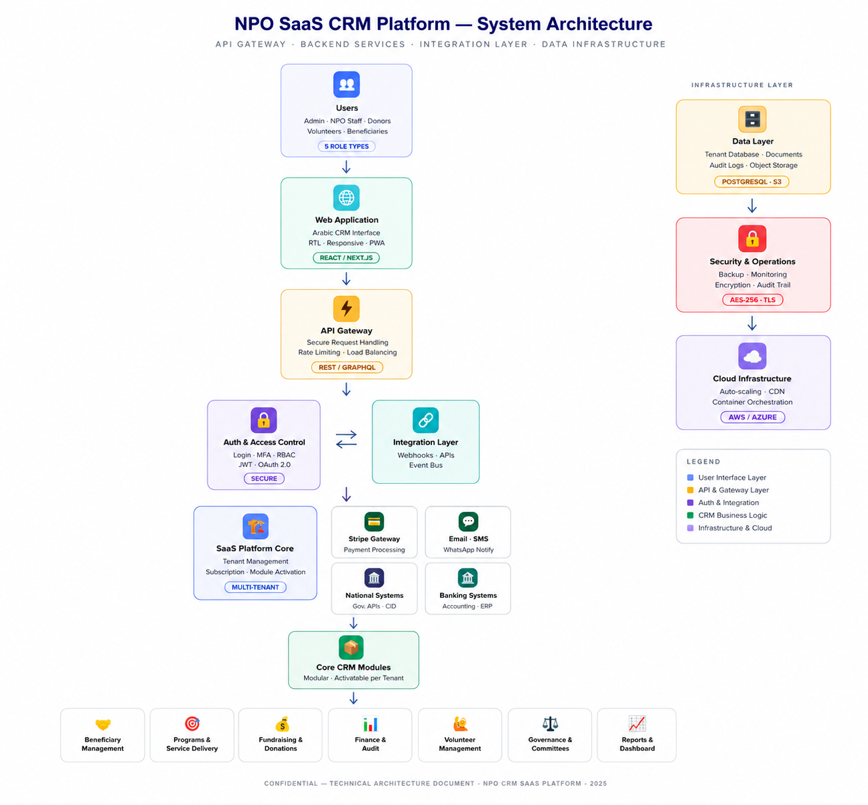
Figure 1: High-level SaaS architecture for the nonprofit CRM platform

6.2 SaaS Subscription and Tenant Activation Flow
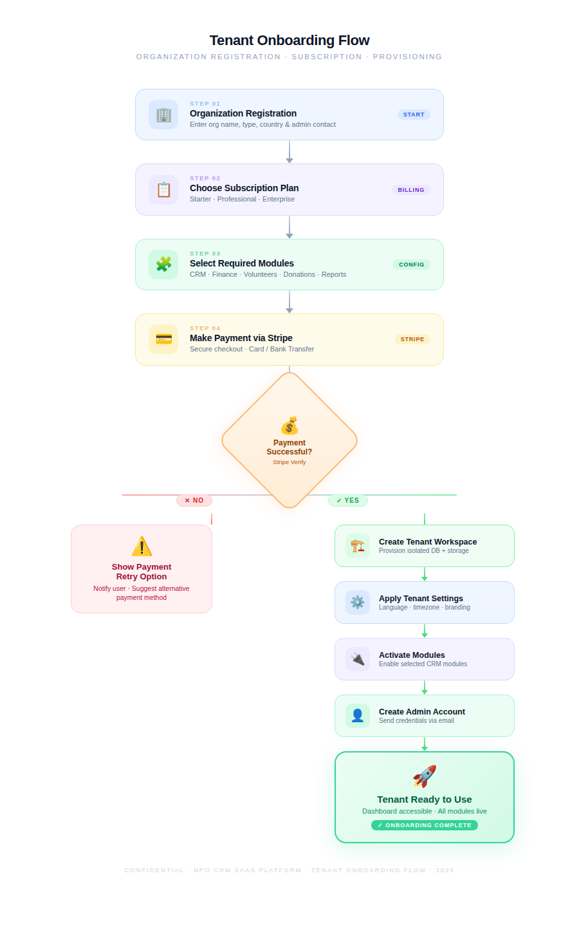
Figure 2: Subscription, billing, and tenant activation flow using Stripe

6.3 Beneficiary Service Delivery Workflow
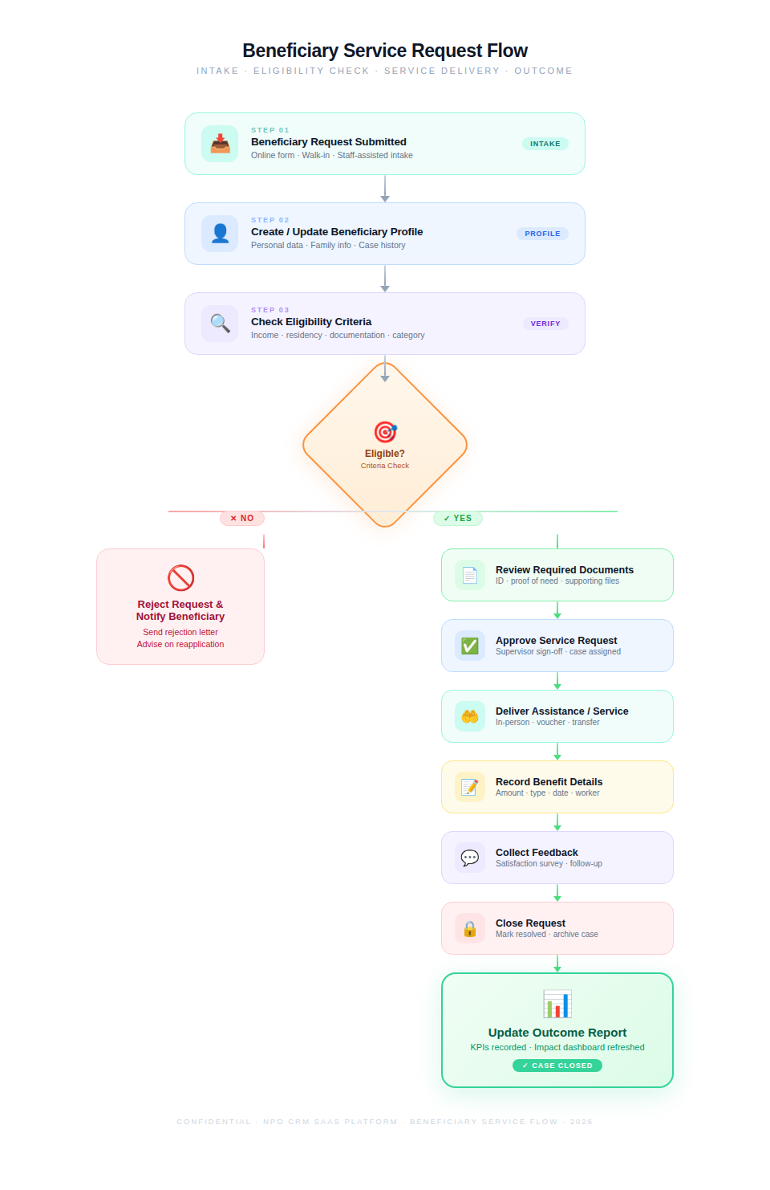
Figure 3: Service request lifecycle from intake to outcome recording

7. Development Methodology
The project will follow an Agile, phased development methodology with short iterations, continuous QA, and controlled scope management. The goal is to deliver a stable Phase 1 foundation first, then extend the platform through Phase 2 and Phase 3 without reworking the core architecture.
Step | Activity | Description
Step 1 | Requirement Finalization | Review the provided scope, finalize process details, define role matrix, confirm integrations, and approve phase-wise backlog.
Step 2 | Solution Architecture | Finalize SaaS architecture, tenant isolation model, database design, integration approach, security model, and deployment plan.
Step 3 | UI/UX Design | Prepare Arabic-first web screens, responsive layouts, dashboards, forms, workflows, and admin configuration screens.
Step 4 | Sprint-Based Development | Develop modules phase by phase using 2-week sprints with backend, frontend, API, database, and integration tasks.
Step 5 | Continuous QA | Run functional, API, integration, regression, security, performance, and compatibility testing throughout implementation.
Step 6 | Deployment and Handover | Deploy the production-ready web application, provide source code, technical documentation, setup guide, and handover materials.

8. Deliverables
- Requirement validation note and finalized phase-wise backlog.
- Solution architecture document and database design document.
- Arabic-first UI/UX screens and clickable prototype for major workflows.
- Developed web-based SaaS CRM application.
- Platform admin panel for tenant, plan, module, configuration, and support operations.
- Tenant-side nonprofit organization portal with role-based modules.
- Stripe subscription billing integration with webhooks and billing status synchronization.
- Integration layer and API documentation for approved external systems.
- Role-based access control, audit log, tenant isolation, backup, and monitoring configuration.
- Reporting dashboards and standard exportable reports as per phase scope.
- QA test plan, test cases, bug reports, regression results, API test results, and security test summary.
- Deployment package, environment configuration guide, source code repository, and release notes.
- Technical handover document and admin/user operation guide.

9. Testing and Quality Assurance
Testing will focus on product quality, system stability, security, performance, and data accuracy. Functional testing for each module, workflow, form, approval process, dashboard, and report.
- API testing for authentication, tenant access, module APIs, payment webhooks, integrations, and reporting endpoints.
- Integration testing for Stripe billing, donation/payment channels, bank statement import, notification services, and national/volunteer system APIs where access is available.
- Role and permission testing for platform admin, tenant admin, finance users, program users, support users, committee users, volunteers, and related roles defined during design.
- Tenant isolation testing to verify that users, documents, audit logs, reports, and records cannot cross tenant boundaries.
- Security testing covering authentication, password policy, MFA readiness, session handling, access control, input validation, API authorization, rate limiting, and common OWASP web risks.
- Database testing for data integrity, required fields, duplicate benefit restrictions, financial records, audit logs, reporting calculations, and retention rules.
- Regression testing after each sprint and before each phase release to ensure new modules do not break existing workflows.
- Performance testing for core dashboards, searches, reports, API responses, file uploads, and high-volume tenant data scenarios.
- Compatibility testing for major browsers, responsive screen sizes, Arabic RTL layout, forms, tables, and printable/exportable reports.
- Backup and recovery verification for database backup, document storage backup, and restoration process checks.
- Release verification for deployment configuration, environment variables, scheduled jobs, queue workers, webhooks, SSL, logging, and monitoring readiness.

10. Implementation Timeline
Proposed timeline: 4 months

11. Assumptions and Dependencies
- The platform will be developed from scratch as a web-based SaaS system.
- Arabic will be the primary interface language with right-to-left layout support.
- Stripe will be used for SaaS subscription billing. Donation channel integrations may depend on the payment providers used by each nonprofit organization.
- External integrations with national identity/legal entity verification, volunteer systems, bank statements, donation channels, SMS, and WhatsApp will depend on API availability, commercial access, approval, and provider documentation.
- The future mobile app is not included in this proposal, but the backend will be API-first to support it later.
- Final workflow rules, role matrix, report formats, and rule packs will be finalized during the discovery and design stage.
- Production hosting location and cloud provider will be finalized based on client compliance, data residency, security, and budget decisions.
- Any regulator-specific submission format or API integration will require official documentation from the relevant authority.

12. Out of Scope
- Licensing cost, hosting cost, third-party API cost, and payment gateway transaction fees.
- Mobile application development in the initial implementation.
- Any AI-based feature, chatbot, predictive analytics, or advanced automation not mentioned in the requirement.
- Custom public website development beyond required public transparency publishing pages.
- Integration with a third-party or national system where API access or approval is not available.
- Advanced accounting product replacement beyond the requested finance records, Zakat ledger, and accounting export/integration mapping.
- Features outside the provided scope overview that may increase development cost.

13. Conclusion
The proposed solution provides a practical, phased, and secure approach for developing the Nonprofit CRM Platform from scratch. It keeps the scope aligned with the provided requirements while establishing a scalable SaaS foundation for organization onboarding, subscription billing, beneficiary services, program delivery, donations, finance, reporting, volunteer management, and governance operations. The recommended architecture, technology stack, QA process, and implementation timeline are designed to support a reliable web-based Arabic CRM platform with future mobile readiness.

