Technical Proposal
Website Redesign and Upgrade for Partners in Health and Development (PHD)
Prepared for: Partners in Health and Development (PHD)
Prepared by: Riseup Labs


1. Executive Summary
Partners in Health and Development (PHD) requires the redesign and upgrade of its existing website into a modern, secure, accessible, bilingual, responsive, and easy-to-manage digital platform. The proposed solution focuses on a CMS-based institutional website that will strengthen PHD's communication, advocacy, transparency, knowledge management, and stakeholder engagement objectives while staying within the minimum feature scope defined in the ToR.
The proposed approach recommends WordPress as the primary CMS due to its mature content management capability, multilingual support, strong publishing workflow, availability of secure managed hosting options, and suitability for a 4-week implementation timeline. The technical architecture will be kept lightweight and scalable so that future modules, such as donation systems, project dashboards, e-learning resources, complaint and feedback systems, and interactive data visualization, can be integrated later without increasing the initial development scope.

2. Understanding of the Assignment
PHD is a national non-profit development organization in Bangladesh with long-standing work across public health, humanitarian response, climate resilience, gender equality, research, capacity development, and partnership management. The upgraded website must therefore present institutional credibility, program visibility, publications, partnerships, emergency response updates, and stakeholder information in a professional and accessible manner.
The ToR indicates that the website should function as an information-sharing platform as well as a strategic communication, advocacy, transparency, knowledge management, and stakeholder engagement tool. The solution must be responsive, secure, accessible, bilingual, SEO-friendly, and manageable by PHD staff through role-based CMS access.

2.1 Assignment Objectives
- Redesign and upgrade the existing website into a modern institutional platform aligned with NGO/INGO communication standards.
- Communicate PHD's mission, vision, programs, achievements, partnerships, publications, and humanitarian response activities.
- Improve user experience for diverse audiences, including mobile and low-bandwidth users.
- Support English and Bangla content management with a clear navigation structure.
- Improve website security, privacy, accessibility, SEO, analytics, and long-term maintainability.
- Prepare the platform for future scalability without implementing unnecessary custom modules in the initial scope.

3. Proposed Scope of Work
The proposed scope is mapped directly to the ToR and organized into practical implementation components. The website will include only the required institutional features and technical capabilities needed for the 4-week assignment.

3.1 Assessment and Planning
- Review the existing PHD website and identify content, UX, navigation, SEO, performance, accessibility, and security gaps.
- Conduct consultation sessions with PHD management and relevant departments to confirm information architecture, priority pages, content ownership, and approval workflow.
- Prepare the proposed sitemap, design concept, development plan, content migration plan, and implementation timeline.

3.2 Website Redesign and Development
Feature Area | Proposed Implementation
Homepage | Modern dynamic homepage with banner/slider, key programs, news, publications, partner highlights, and emergency response links.
About PHD | Mission, vision, values, organizational profile, leadership/governance information, and institutional credibility content.
Programs and Projects | Portfolio-style pages to present PHD programs, project summaries, thematic areas, locations, partners, and key achievements.
News, Events, and Blog | CMS-managed news, events, blog/updates, and announcement publishing with categories and archive pages.
Publications and Download Center | Downloadable reports, policies, publications, forms, and knowledge materials with basic categorization and search support.
Photo and Video Gallery | Interactive gallery for images and embedded videos with optimized media loading.
Donor and Partner Showcase | Dedicated section to present donors, partners, collaborations, and stakeholder credibility.
Career and Vacancy Section | CMS-managed vacancy listing and career information section.
Emergency / Humanitarian Response Updates | Dedicated update section for emergency or humanitarian response activities.
Contact and Inquiry | Contact forms, inquiry routing, office/contact information, map embed if required, and spam protection.
Search and Navigation | User-friendly menu structure, site search, footer navigation, and quick access to priority content.
Staff Email / Contact Integration | Basic staff email/contact integration if required and approved by PHD.

3.3 Technical Features
Technical Requirement | Implementation Approach
CMS-Based Platform | WordPress or equivalent secure CMS with role-based admin access and easy content update capability.
Bilingual Support | English and Bangla content structure using a multilingual CMS workflow.
Responsive Design | Desktop, tablet, and mobile responsive layouts with optimized navigation and readable content hierarchy.
SEO Setup | SEO-friendly URL structure, metadata setup, XML sitemap, robots configuration, image alt text guidance, and Search Console readiness.
Performance Optimization | Caching, image optimization, lazy loading, minimized assets, and hosting-level performance configuration.
Security Integration | SSL/TLS, firewall/WAF configuration, spam protection, hardened admin access, safe plugin policy, and scheduled updates.
Analytics Integration | Google Analytics 4 setup and key website event tracking where feasible within scope.
Backup and Recovery | Automated scheduled backups, restore validation, and basic recovery documentation.
Cross-Browser Compatibility | Testing across common browsers and responsive breakpoints.
Privacy and Compliance | Privacy policy page, cookie notice if applicable, and data privacy best-practice alignment.

3.4 Accessibility and Compliance
- Follow accessibility-friendly design principles aligned with WCAG 2.2 AA where practical for the agreed website scope.
- Ensure clear headings, readable typography, sufficient color contrast, keyboard-friendly navigation, descriptive links, and meaningful image alt text guidance.
- Design mobile-friendly and low-bandwidth-friendly pages using optimized images, lightweight layouts, and content prioritization.
- Use privacy, cookie, and data handling notices where applicable based on the final website functionality.

3.5 Future Scalability Readiness
The ToR mentions possible future modules such as donations, project dashboards, e-learning resources, complaint and feedback systems, and interactive data visualization. These are treated as future-readiness considerations only. The initial solution will keep the CMS structure, hosting environment, plugin selection, and database approach scalable so that such modules can be added later through separate scope confirmation.

3.6 Out of Scope for Initial 4-Week Assignment
- Online donation/payment gateway implementation.
- Custom project dashboard with live data visualization.
- E-learning/LMS module development.
- Complaint and feedback case management workflow.
- Custom mobile application development.
- Complex API integrations with third-party enterprise systems unless separately approved.
- Large-scale content rewriting, translation, or content creation beyond agreed migration and formatting support.

4. Proposed Technical Approach
The proposed technical approach uses a CMS-first, security-conscious, accessibility-friendly, and phased delivery model. The goal is to deliver a professional website quickly while ensuring content governance, long-term maintainability, and post-launch sustainability.
Approach Step | Description
Step 1: Discovery and Audit | Review current website, identify gaps, confirm target audiences, finalize sitemap, content structure, and delivery plan.
Step 2: UX/UI Design | Create wireframes and visual mockups for key templates: homepage, program page, publication listing, news/event page, gallery, career, emergency update, and contact page.
Step 3: CMS Setup and Development | Configure WordPress CMS, theme framework, multilingual structure, user roles, content types, forms, gallery, downloads, and core templates.
Step 4: Content Migration | Migrate agreed existing content/data, format content, optimize images/documents, apply metadata, and validate page accuracy with PHD.
Step 5: Security, SEO, Performance, and Analytics | Configure SSL, WAF/firewall, spam protection, backups, caching, SEO metadata, sitemap, analytics, and privacy pages.
Step 6: QA, Deployment, and Handover | Conduct testing, fix issues, complete QA, deploy to production, provide admin manual, train staff, and transfer credentials/source ownership.

5. Proposed Solution Architecture
The architecture is designed to support a professional public-facing institutional website and a secure CMS backend. It keeps the first release simple, but supports future expansion through scalable hosting, structured content types, role-based CMS access, and secure integration readiness.
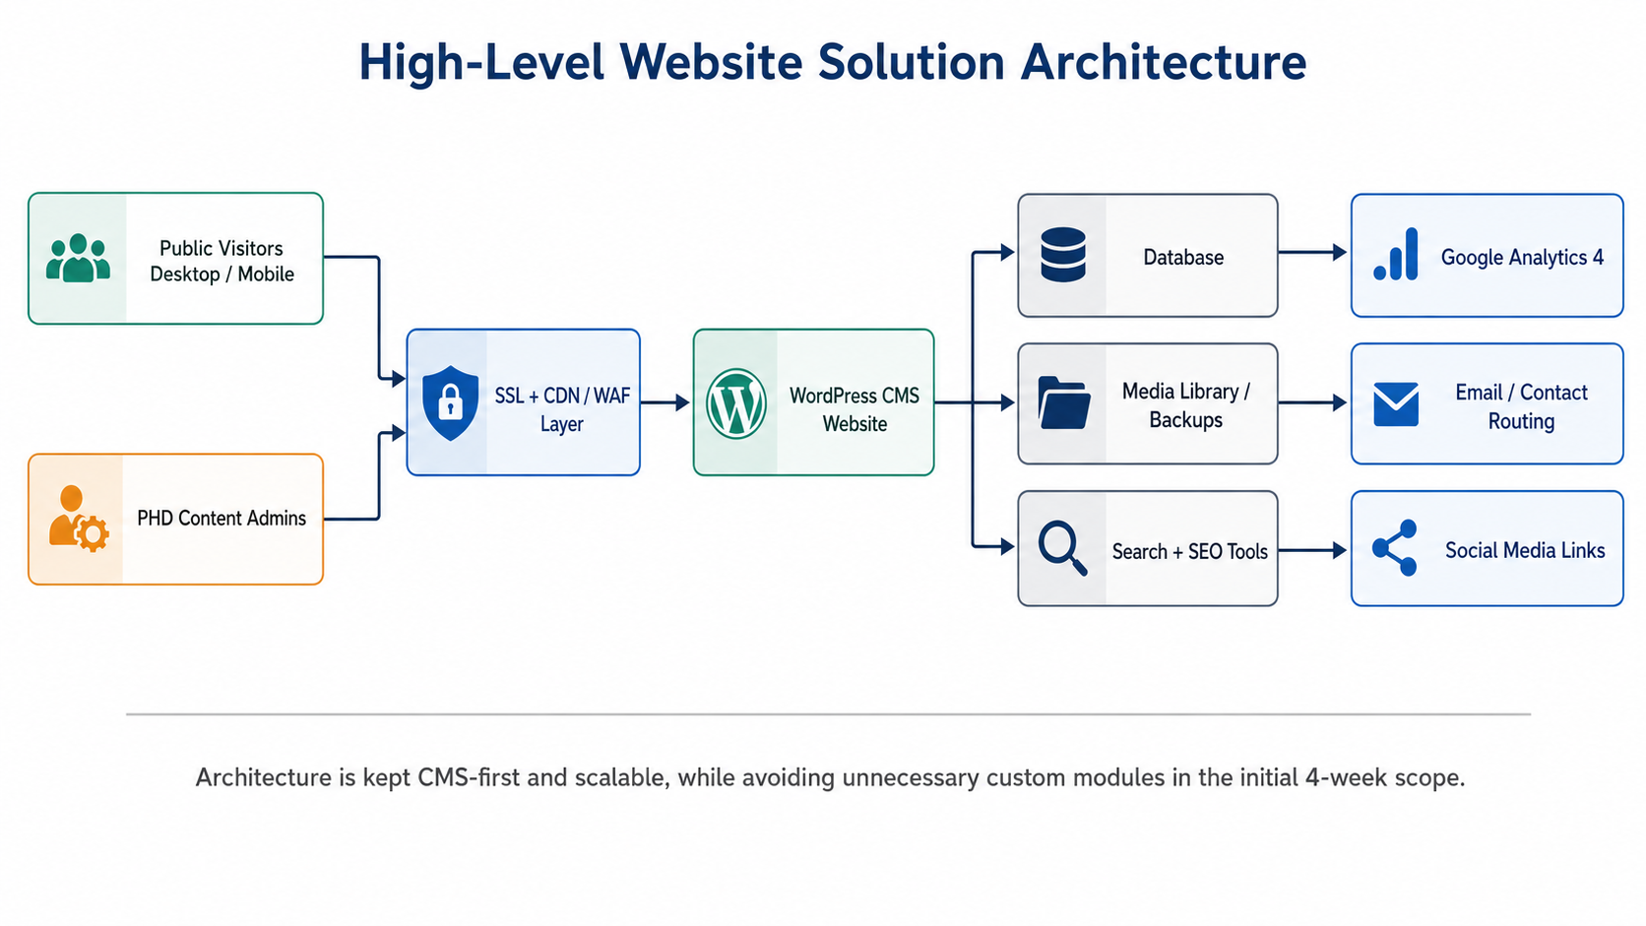
Diagram 1: High-Level Website Solution Architecture

6. CMS Content Management and Governance
PHD staff should be able to update the website without depending on developers for routine content changes. The CMS workflow will therefore support controlled publishing, role separation, and content organization across institutional sections.
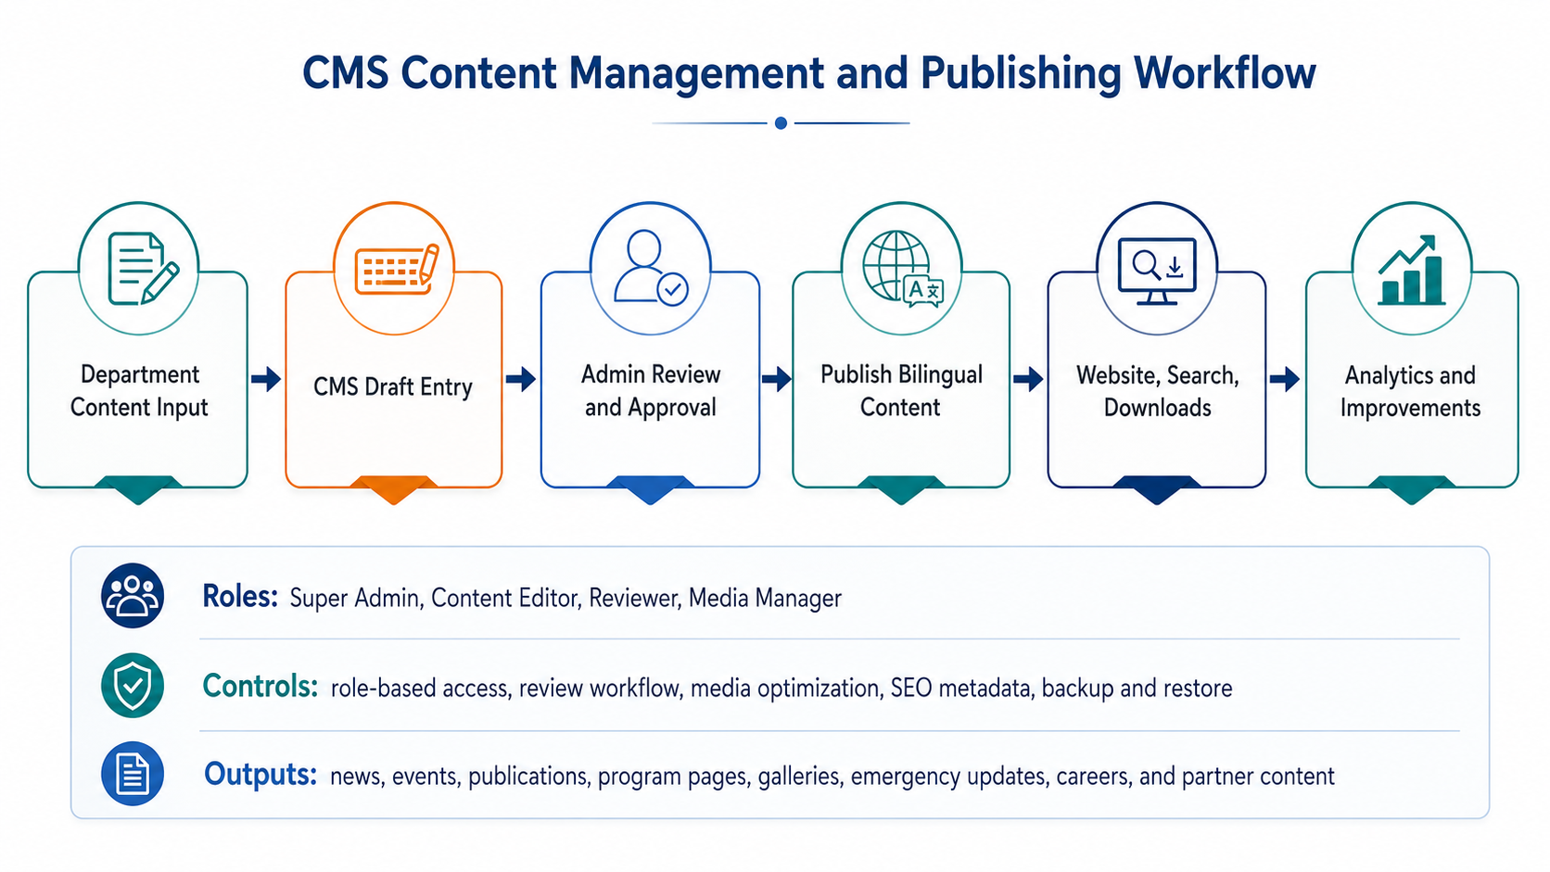
Diagram 2: CMS Content Management and Publishing Workflow

7. Proposed Technical Stack
The proposed technical stack is selected to meet the ToR requirements within the 4-week delivery window while supporting security, scalability, maintainability, and ease of content management.
Layer | Recommended Technology
CMS / Backend | WordPress latest stable version or equivalent secure CMS
Server Language | PHP 8.3+ recommended
Database | MariaDB 10.6+ or MySQL 8.0+
Frontend | Custom WordPress theme or lightweight theme framework using HTML5, CSS3, JavaScript
Hosting Environment | Managed cloud/VPS hosting with Linux, Nginx or Apache, SSL, backup, and staging support
CDN/WAF | Cloudflare or hosting-provider equivalent
Multilingual | WPML, Polylang, or equivalent multilingual setup
Forms and Spam Protection | Secure contact form plugin with reCAPTCHA/hCaptcha and anti-spam rules
SEO | Rank Math, Yoast SEO, or equivalent
Analytics | Google Analytics 4 and Google Search Console
Security | SSL/TLS, WAF, Wordfence/Solid Security or equivalent, 2FA where approved
Backup | UpdraftPlus, hosting backup, or equivalent scheduled backup solution

8. Design and User Experience Strategy
The design strategy will prioritize credibility, clarity, accessibility, and low-friction navigation. The website will use a professional visual system suitable for NGO/INGO audiences, development partners, government stakeholders, communities, researchers, media, and job applicants.
- Clean institutional homepage with clear hierarchy for programs, publications, news, emergency updates, partners, and calls to action.
- Mobile-first layouts for users browsing from smartphones and low-bandwidth environments.
- Consistent page templates for programs/projects, news/events/blogs, publications, gallery, career, and contact pages.
- Accessible typography, color contrast, heading hierarchy, and navigation patterns.
- Optimized media usage to balance visual storytelling with performance.

9. SEO, Analytics, and Content Visibility
The website will be prepared for search engine visibility and ongoing communication measurement. SEO setup will focus on technical readiness and content governance rather than aggressive marketing features.
- SEO-friendly permalink structure and clean page hierarchy.
- Metadata setup for key pages, publications, news/events, and program pages.
- XML sitemap and robots.txt configuration.
- Google Search Console readiness for indexing monitoring.
- Google Analytics 4 setup for traffic and content performance tracking.
- Image alt text and title guidance to support accessibility and SEO.
- Redirect planning for important old website URLs where content is migrated.

10. Security, Privacy, and Backup Approach
Security will be handled through a layered approach covering hosting, CMS configuration, user roles, plugin governance, forms, backups, and operational handover.
Security Area | Proposed Control
SSL/TLS | Configure HTTPS across the website and admin area.
Admin Protection | Use strong passwords, limited admin users, optional 2FA, login attempt control, and role-based access.
Firewall and Spam Protection | Configure WAF/firewall and form spam protection to reduce common attacks and automated submissions.
Plugin and Theme Governance | Use trusted plugins only, remove unused plugins/themes, and document update procedures.
Backup and Recovery | Schedule backups, store copies safely, and validate restoration readiness.
Privacy Readiness | Prepare privacy policy/cookie notice pages if applicable based on final data collection functionality.
Security Testing | Run basic vulnerability, permission, form, and configuration checks before launch.

11. Development Methodology
A lightweight Agile delivery model is recommended because the assignment has a short 4-week timeline and requires close coordination with PHD for sitemap, design, content, feedback, testing, and approval.
Methodology Stage | Activities
Initiation | Confirm scope, timeline, communication channel, responsibilities, and content/data access.
Sprint 1: Planning and Design | Website audit, sitemap, wireframes, design concept, and approval.
Sprint 2: Core Development | CMS setup, theme/templates, multilingual structure, content modules, forms, search, gallery, and downloads.
Sprint 3: Integration and Migration | Content migration, SEO setup, analytics, backup, security, and performance optimization.
Sprint 4: QA, Deployment | Cross-browser testing, responsive testing, bug fixes, production deployment, training, and handover.
Post-Launch Support | Technical support, minor bug fixing, monitoring, and guidance during the agreed support window.

12. Implementation Timeline
The ToR states an approximate 4-week duration.

13. Deliverables
The following deliverables are aligned with the ToR and will be provided upon completion of the relevant project stage.
ID | Deliverable
D1 | Inception report with work plan and timeline
D2 | Proposed sitemap, design concept, wireframes/mockups
D3 | Fully developed and tested CMS-based website
D4 | Migration of agreed existing content/data
D5 | SEO setup, sitemap, metadata structure, and analytics integration
D6 | Website security configuration and backup/recovery setup
D7 | User manual/admin guideline
D8 | Training session for designated PHD staff
D9 | Final source code, CMS access, hosting/domain coordination details, and ownership transfer
D10 | Post-launch technical support and maintenance for minimum 3 months, extendable up to 6 months as agreed

14. Testing and Quality Assurance Plan
Testing and QA will be conducted before production deployment to ensure the website is functional, responsive, secure, accessible, SEO-ready, and stable for handover.
Testing Area | Validation Focus
Functional Testing | Validate menus, pages, forms, search, downloads, gallery, news/events/blog, careers, emergency updates, partner section, and CMS publishing flow.
Responsive Testing | Test key pages on desktop, tablet, and mobile breakpoints to ensure usability and layout consistency.
Cross-Browser Testing | Validate pages on current versions of Chrome, Edge, Firefox, and Safari where feasible.
Accessibility Testing | Review keyboard navigation, headings, labels, alt text, contrast, link clarity, form labels, and screen-reader-friendly structure where practical.
SEO Testing | Check metadata, indexability, URLs, sitemap, robots configuration, page titles, alt text, and Google Search Console readiness.
Performance Testing | Check image optimization, caching, page weight, lazy loading, and PageSpeed/Lighthouse improvement areas.
Security Testing | Verify SSL, firewall, admin access policy, plugin hygiene, spam protection, permissions, and backup/restore readiness.
Content Migration Testing | Validate migrated page content, download files, images, links, media embeds, and bilingual page mapping.

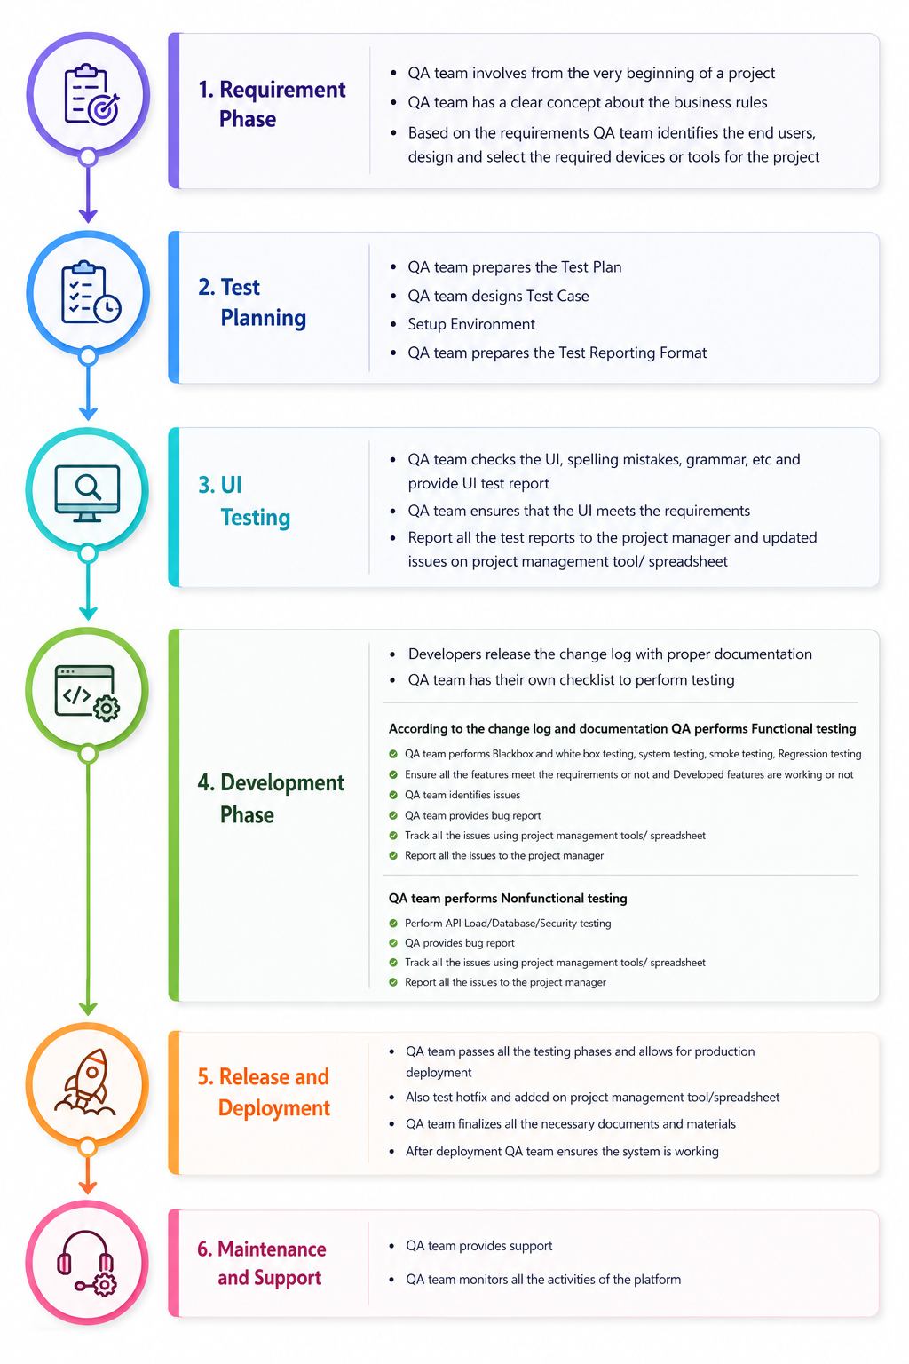

15. Deployment and Handover Plan
- Prepare a staging environment for development and review where hosting access allows.
- Complete final QA issue resolution before production launch.
- Deploy the website to the production domain with SSL enabled.
- Configure redirects for selected old URLs where migrated content requires continuity.
- Transfer CMS credentials, source code/theme files, plugin list, hosting/domain coordination notes, and backup process documentation.
- Conduct training for designated staff on content updates, media uploads, news/events, publications, emergency updates, form review, SEO fields, and basic admin operations.

16. Assumptions and Client Responsibilities
- PHD will provide timely access to existing website content, domain, hosting, CMS credentials, media files, and required organizational documents.
- PHD will nominate focal persons for content review, design approval, and final launch approval.
- Final Bangla and English content will be provided or approved by PHD. Translation or large-scale copywriting is not assumed within the core development scope.
- Third-party plugin licenses, premium theme licenses, hosting charges, CDN charges, and paid services will be handled as per final commercial agreement.
- Any future modules beyond the current ToR scope will be estimated separately after requirement confirmation.

17. Conclusion
The proposed solution provides PHD with a modern, secure, accessible, bilingual, responsive, and maintainable institutional website that is aligned with the ToR and suitable for a 4-week delivery period. The approach focuses on practical CMS-based implementation, strong UX, structured content management, SEO readiness, analytics, security configuration, content migration, staff training, and post-launch support. The solution also maintains future scalability without adding unnecessary custom modules to the initial scope.

