Technical Proposal
RC Topia - Remote-Control RC Vehicles Web Platform
Proof of Concept (POC) to MVP Delivery Plan
Low-Latency WebRTC Streaming + Remote Control + Telemetry

Prepared by: Riseup Labs
Date: 24 February 2026

1. Executive Summary
RC Topia is a browser-based platform that lets users remotely control real RC vehicles inside a physical warehouse in Houston, Texas. The platform must provide low-latency live video/audio streaming, real-time vehicle control, telemetry display, and session management with user and admin dashboards. The client wants to begin with a Proof of Concept (POC) using one vehicle and a simple UI focused on crawling, validating feasibility and end-to-end experience before expanding to racing and broader features.
This proposal presents a phased plan (POC -> MVP -> Expansion-ready architecture), a recommended technical stack centered on WebRTC, and a comprehensive testing and quality assurance approach aimed at achieving target latency and operational safety.

2. Understanding of Scope and Requirements

2.1 Product Goals (MVP)
- Remote control of RC vehicles via a web interface
- Low-latency live video and audio streaming (WebRTC preferred)
- Real-time telemetry display (speed, battery, session time)
- User, session, and vehicle management
- Stability, safety, and scalability

2.2 User Roles

End Users
- Account registration and login
- Book a session or join a queue
- Control the vehicle during an active session (keyboard/gamepad)
- View live video streams and telemetry
- Automatic session time enforcement

Administrator
- Manage users and vehicles (enable/disable)
- Emergency stop / kill switch
- Monitor logs and system health

2.3 Real-Time Requirements and Constraints
- Latency targets from the provided scope:
- Racing: less than 120 ms end-to-end video latency (target)
- Crawling: less than 200 ms end-to-end video latency (target)
- Safety requirements:
- Throttle smoothing and configurable speed limits
- Automatic stop on disconnect or session end
- Manual override and fail-safe controls (kill switch)

2.4 POC Emphasis (Client Request)
The client wants to start with a POC using one vehicle and a simple UI, focusing on low-latency crawling. The POC must validate end-to-end feasibility including WebRTC streaming, real-time control, and basic telemetry, with hardware integration on the vehicle side via Raspberry Pi.

3. Proposed Delivery Strategy (POC -> MVP)

3.1 POC (One Vehicle, Crawling Focus)
- Simple web UI: connect, select vehicle, start session, view video, basic controls (keyboard + optional gamepad).
- WebRTC low-latency video stream from on-vehicle camera (and optional single fixed camera).
- Control channel (WebRTC data channel or secure WebSocket) with throttle smoothing and speed cap.
- Telemetry v1: speed (estimated or sensor-based), battery %, session countdown.
- Admin essentials: vehicle enable/disable, emergency stop, basic logs.
- Deployment in a staging environment with monitoring for latency, packet loss, and errors.

3.2 MVP (Multi-Camera + Booking/Queue + Dashboards)
- Session booking or queue system with fixed session duration (e.g., 20 minutes) and automatic enforcement.
- Multi-camera switching during session (vehicle camera + fixed track cameras).
- Vehicle reset workflow between sessions.
- Usage tracking and basic analytics (sessions completed, minutes driven, popular time slots).
- Hardened admin portal: users, vehicles, session monitoring, system health dashboard.

4. Proposed Solution Architecture

4.1 High-Level Architecture Overview
The solution is composed of four primary layers: (1) Web Client, (2) Application and Signaling Services, (3) Real-Time Media and Control Plane, and (4) Edge Vehicle Gateway (Raspberry Pi) connected to the RC vehicle hardware.

Figure 1: High-Level Solution Architecture

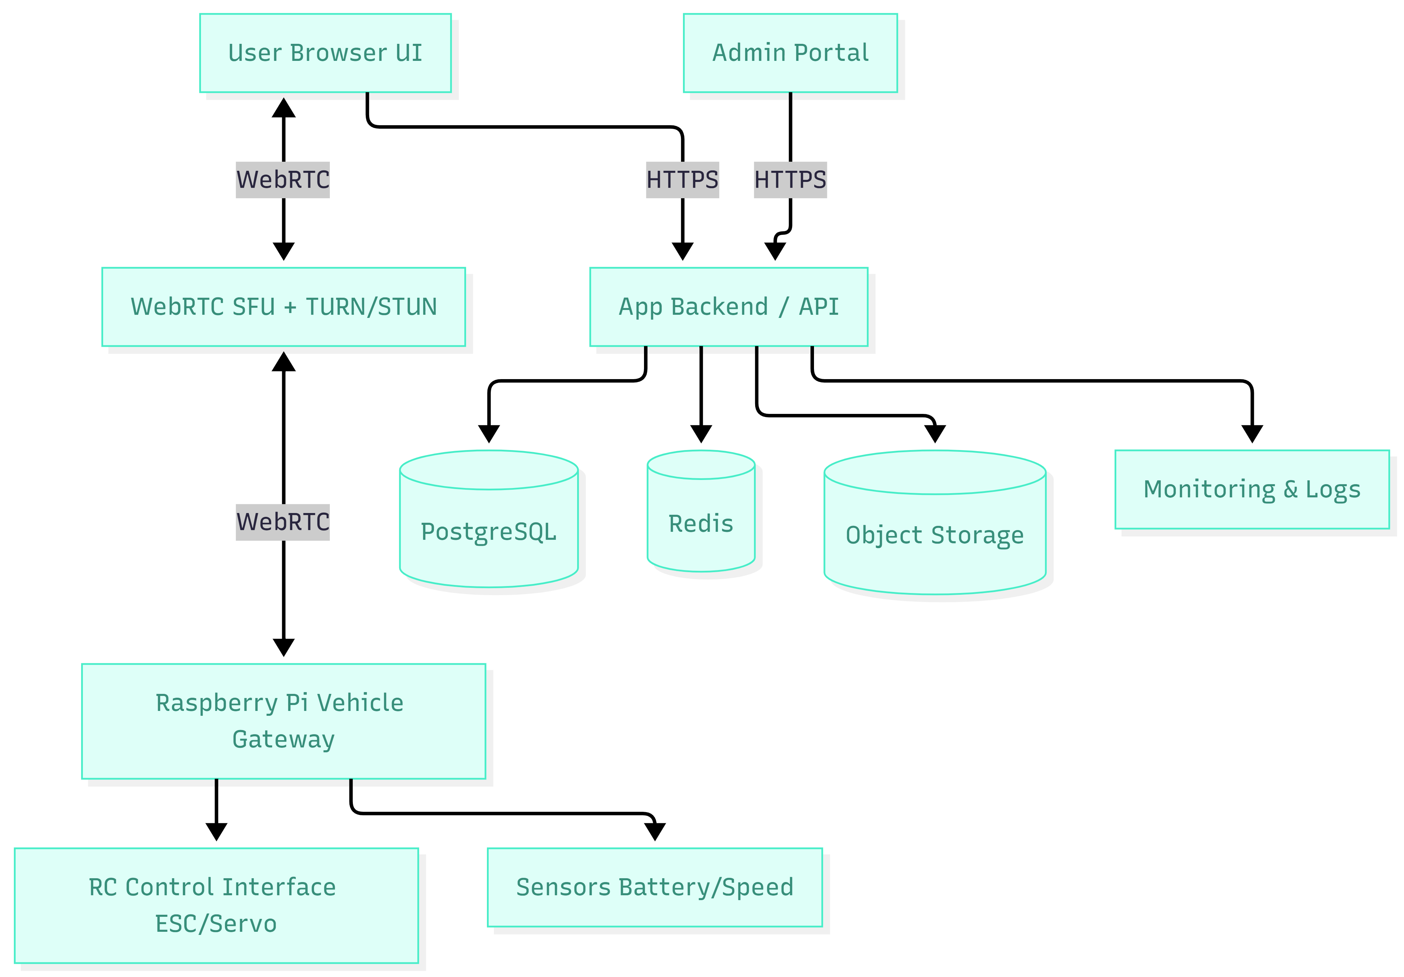

4.2 POC Edge Setup (Vehicle Side)
For the POC, the Raspberry Pi acts as the vehicle gateway. It captures video/audio, publishes telemetry, and receives remote control commands that are translated to RC control signals. The gateway must support fail-safe behavior (stop on disconnect, emergency stop, speed limits).

Figure 2: POC Hardware and Edge Gateway Architecture

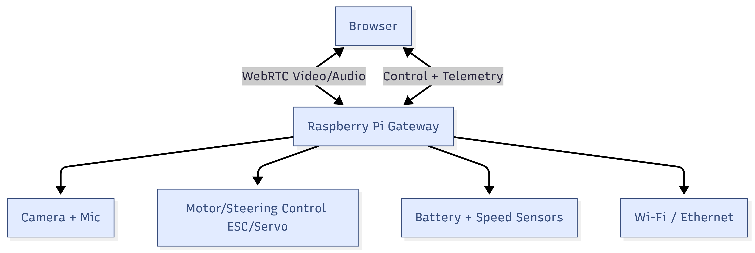

4.3 Real-Time Streaming Topology
WebRTC peer-to-peer is suitable for early feasibility testing. For the MVP, an SFU (Selective Forwarding Unit) is recommended to support multi-camera switching, better network resiliency, and future scaling (spectators, multiple users/vehicles).

Figure 3: WebRTC Topology - P2P vs SFU
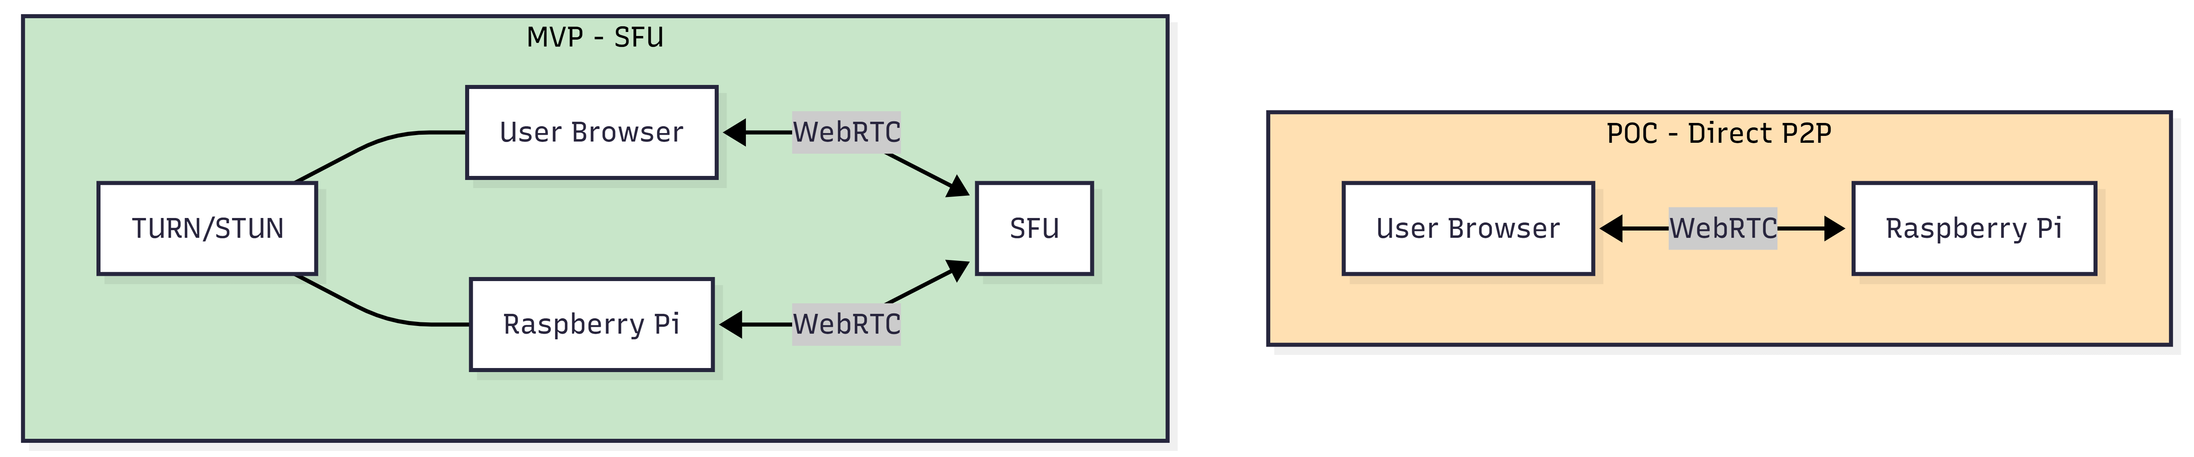

4.4 Data and Session Architecture
The application backend manages authentication, authorization, bookings/queue, active session lifecycle, vehicle status, and audit logs. Telemetry can be transported via WebRTC data channel for low latency during an active session, and also stored asynchronously in the database for analytics.

Figure 4: Session Lifecycle and Data Flow

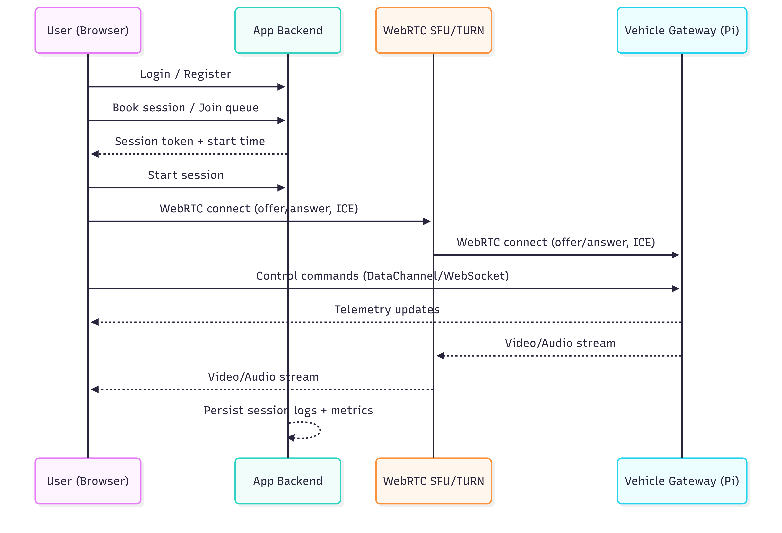

5. Technical Approach

5.1 Low-Latency Control Design
Remote control must feel responsive and safe. The control subsystem will include: input normalization (keyboard/gamepad), throttle smoothing, client-side rate limiting, server-side authorization for active sessions, and edge-side safety enforcement.
- Control messages are compact (e.g., steering angle, throttle value, timestamp, sequence id).
- Edge gateway validates messages and applies speed limits and acceleration constraints.
- Automatic stop on session end, user disconnect, or stale command timeout.
- Emergency stop available to admins and local operators.

5.2 Telemetry Strategy
Telemetry will start minimal in the POC and be extended in the MVP. Core telemetry includes speed, battery %, and session time remaining. The system will also track network metrics (RTT, packet loss, jitter) to diagnose performance.
- POC: real-time telemetry overlay and session timer.
- MVP: telemetry history for sessions, alerts for low battery and degraded network.
- Future: richer sensors (IMU, temperature), track beacons, and lap timing.

5.3 Safety, Security, and Abuse Prevention
- Role-based access control (End User vs Admin).
- Session tokenization: only the active driver can send control commands.
- Encrypted transport: HTTPS for APIs and DTLS-SRTP for WebRTC media.
- WAF/rate limiting for public endpoints and bot protection for auth and booking.

6. Development Methodology

6.1 Approach
An iterative Agile approach will be used, with short sprints and frequent demos. Each phase produces a usable increment, validated in the warehouse environment.

6.2 Key Activities per Sprint
- Sprint planning and backlog grooming (feature and technical tasks).
- Implementation with code review and CI checks.
- Test execution (automated + manual) and defect triage.
- Performance validation (latency, stability, fail-safe behaviors).
- Sprint review demo and retrospective.

7. Deliverables

7.1 POC Deliverables
- POC web UI for crawling control (connect, start session, view video, drive, view telemetry).
- WebRTC streaming pipeline for on-vehicle camera (and optional single fixed camera).
- Control channel with throttle smoothing, speed cap, and disconnect fail-safe.
- Admin essentials: vehicle enable/disable, emergency stop, basic logs.
- Deployment package and setup guide for POC environment (including Raspberry Pi setup).
- Feasibility report with measured latency, network observations, and improvement recommendations.

7.2 MVP Deliverables
- User authentication, profile, and session booking/queue system.
- Multi-camera streaming with in-session camera switching.
- Session time enforcement and vehicle reset workflow.
- Telemetry dashboard (real-time + basic history) and usage analytics.
- Admin portal: manage users/vehicles, monitor live sessions, system dashboard.
- Source code repository with documentation and deployment instructions.

8. Proposed Technical Stack
The stack is selected to support low-latency real-time media, predictable deployment, and rapid iteration. Alternatives are noted where appropriate.
Layer | Recommended | Notes / Alternatives
Web Client (User UI) | Next.js (React) + TypeScript | Responsive UI, gamepad support, WebRTC integration; Vue is also feasible.
Admin Portal | Next.js (React) + RBAC | Can be the same codebase with admin routes.
Backend/API | Node.js (NestJS) + TypeScript
Real-time Signaling | WebRTC (or LiveKit signaling) | Required for WebSocket session setup and presence.
Streaming / SFU | LiveKit (self-hosted or cloud) or mediasoup/ Third Party | SFU recommended for multi-camera and scaling; POC may use direct P2P.
Vehicle Gateway (Edge) | Raspberry Pi + WebRTC stack (GStreamer/Pion/etc.) | Integrates camera/audio, telemetry, and RC controls; safety logic at edge.
Database | PostgreSQL | Alternative: MS SQL; relational model for users/sessions/vehicles/logs.
Cache / Queue | Redis | Session coordination, rate limiting, optional job queue.
Object Storage | S3-compatible (AWS S3) | Logs, media snapshots, exports.
Hosting | AWS (ECS/Fargate) or Kubernetes | Alternative: Azure/GCP; depends on scaling and ops preference.
Observability | Prometheus/Grafana + Loki, or Datadog | Metrics, logs, tracing; includes WebRTC stats and edge heartbeat.
CI/CD | GitHub Actions | Build, test, deploy to staging and production.

9. Testing and Quality Assurance

9.1 Test Strategy
Testing focuses on correctness, performance, safety, and user experience. Because real-time systems depend on network conditions, we will combine automated tests with on-site performance validation.
- Tests: backend services, control smoothing logic, telemetry parsing.
- Integration tests: API + DB, session lifecycle, auth/RBAC.
- End-to-end tests: user login, booking, session start, driving workflow, admin kill switch.
- WebRTC tests: connection establishment, ICE fallback, TURN relay scenarios, camera switching.
- Performance tests: measure latency, RTT, jitter, packet loss impact; validate crawling latency target.
- Soak tests: long-duration session runs to detect memory leaks and stability issues.
- Security tests: OWASP checks for auth/booking APIs, rate limiting, token misuse.

Fig: QA Test Process

9.3 Test Environments
- Local simulation environment (mock vehicle gateway) for early development.
- Staging environment connected to warehouse network for performance validation.
- Production environment with hardened security, monitoring, and operational runbooks.

10. Key Risks and Mitigation
Risk | Mitigation
Latency and network variability | Perform early network assessment; use SFU + TURN; tune bitrate/resolution; prioritize crawling first.
Wi-Fi coverage and interference in warehouse | Site survey; dedicated APs; consider wired backhaul for cameras; VLAN separation.
Hardware instability (power, overheating, camera issues) | Thermal testing; stable power; watchdog and auto-restart services on Pi.
Safety incidents due to uncontrolled vehicle | Edge fail-safe logic; kill switch; speed caps; geofencing if needed; physical barriers.
Scalability to multiple vehicles and spectators | Adopt SFU architecture; stateless backend; horizontal scaling; load tests.

11. Assumptions and Dependencies
- Warehouse has stable uplink bandwidth and low jitter suitable for WebRTC streaming.
- Client provides or approves required hardware components (RC vehicle, cameras, Raspberry Pi, sensors, mounts).
- A local safety operator is available during early testing to intervene if needed.
- Any required third-party services (e.g., email provider, SMS) are approved during MVP planning.
- Legal and safety compliance constraints for remote operation in the warehouse are managed by the client.

