Technical Proposal
SPARK Immersive Training System
AR On-the-Job Guidance (Mobile)

AR Support Scope (Post-Training & Certification)
Android + iOS | Unity

Prepared by: Rise Up Labs
Date: 13 February 2026

1. Executive Summary
This proposal outlines the development of an AR On-the-Job Guidance solution to extend the SPARK training lifecycle after learners complete VR training and receive certificates. The AR solution will provide instant, in-the-moment performance support through marker-based scanning and step-by-step micro-guides. The AR content library will be derived from the 15 VR scenarios currently three certification modules (ServSafe Food Handler, OSHA 10 - General Industry, and NSC Forklift Operator). The mobile AR application will be developed from scratch in Unity and delivered for both Android and iOS.

2. Project Objectives
- Provide instant “show me again” support on demand to reduce memory gaps after certification and during real work.
- Deliver marker-based access to safety guidance, checklists, and SOP references mapped to the 15 existing VR scenarios.
- Enable consistent, standardized on-the-job guidance across facility zones and shifts with minimal disruption to operations.
- Capture lightweight usage and completion records (guides viewed, checklist completion) to support continuous improvement.
- Ensure the AR experience is usable, safe, and reliable on mainstream mobile devices in real workplace conditions.

3. Scope of Work

3.1 In Scope
- Mobile AR application (Android and iOS) developed from scratch in Unity.
- AR On-the-Job Guidance content mapped to 15 VR scenarios across 3 VR modules (5 scenarios per module).
- Marker-based feature: scanning a physical marker displays the relevant safety guidance and micro-guide.
- Content types: step-by-step micro-guides, safety and housekeeping checklists, module refreshers, SOP/system info references.
- Local data storage for offline viewing and logging; optional export/sync for supervisor review (future-ready).
- Marker-to-content mapping approach (marker ↔ scenario ↔ guidance package) with versioning.
- Testing and QA across device matrix, AR tracking robustness, usability, and performance.

4. Assumptions and Dependencies
- Client will confirm target workplace zones and marker placement points (stations, doors, boards, equipment areas).
- Client will provide or validate AR-ready guidance content per scenario (SOP steps, safety notes, any required language).
- Markers will be printed and placed by the client according to provided design and mounting guidelines.
- AR scope reuses the scenario taxonomy and key steps from the existing VR modules; new scenarios follow change control.
- Representative Android and iOS devices will be available for field validation.

5. Proposed Technical Approach

5.1 Experience Model - AR On-the-Job Guidance
The AR experience is designed as fast, task-oriented performance support. Users scan a marker at a workstation or zone and immediately receive the correct guidance package. Guidance is optimized for short sessions (30 seconds to 3 minutes) and can be repeated anytime.
- Scan Marker: identify workstation/zone and load the mapped guidance package.
- Micro-Guide: step-by-step procedure with simple visuals and short text; optional audio prompts (configurable).
- Safety Checklist: quick confirmations (pre-shift checks, housekeeping, PPE, hazard checks).
- Refresher Cards: key concepts from the relevant VR scenario (common mistakes and “critical do-not” items).
- SOP/Reference: equipment specifications, SOP excerpts, and emergency contacts (as provided by client).

5.2 Marker-Based Guidance Mapping
Each physical marker acts as a reliable entry point to the correct guidance for a specific zone, equipment type, or workflow step. Markers are mapped to a guidance package derived from one of the 15 VR scenarios and versioned over time.
- Marker ID → Scenario ID (from VR library) → Guidance Package (micro-guide + checklist + references).
- Support multiple markers per scenario (different stations referencing the same procedure with contextual notes).
- Content versioning to allow updates without breaking existing marker placements.
- Offline-first caching of guidance packages with background updates when connectivity is available.

5.3 Content Reuse Strategy from VR Scenarios (15 Scenarios)
AR guidance will be structured as micro-learning units derived from the same procedural steps and safety events already defined in VR. This ensures consistency between training (VR) and real work (AR), and reduces content re-authoring effort.
- Extract critical steps and critical safety events from each VR scenario to build the AR micro-guide.
- Convert VR assessment rubrics into quick AR checklists (confirmations and reminders).
- Include expected error patterns as “watch-outs” and recovery reminders.
- Maintain a single scenario taxonomy across VR and AR for reporting and future expansion.

5.4 Data Capture and Feedback Loop
- Log scan events, guides viewed, checklist completion, and optional user feedback (e.g., helpful/not helpful).
- Support optional export (CSV/JSON) for supervisors/safety leads to review adoption and identify guidance gaps.
- Future-ready hooks for centralized reporting if a backend dashboard is requested later.

6. Development Methodology
Delivery will follow an iterative, milestone-based approach with agile sprints inside each milestone. Each milestone includes discovery, prototyping, content integration, internal QA, client review and acceptance.

6.1 Agile Delivery Within Milestones
- Sprint planning and backlog refinement aligned to marker flows and scenario mapping priorities.
- Mobile builds shared at an agreed cadence for early validation (tracking, UI readability, field usability).
- Definition of Done: feature completion, QA pass, device matrix checks, and updated documentation.

7. Proposed Technical Stack (Unity - Mobile AR)
- Engine: Unity (LTS).
- AR Framework: Unity AR Foundation (cross-platform), with ARCore (Android) and ARKit (iOS) runtimes.
- Marker Tracking: AR Foundation 2D image tracking (marker-based) with per-marker metadata mapping.
- Content Delivery: Unity Addressables for modular guidance packages and caching.
- Data Layer: Local persistent storage (SQLite or JSON) for offline logs and cached content.
- Optional Services (future-ready): secure API for centralized reporting and content updates.
- Repo: Git-Repo

8. High-Level Solution Architecture
Diagram 1: High-Level AR Solution Architecture

8.1 Core Application Components
- App Shell: onboarding, role selection (learner/supervisor), settings, offline status.
- Scanner & Tracking Module: camera permissions, marker detection, stability checks, reacquisition flow.
- Guidance Player: step-by-step UI, media overlays, checklist interactions, safety callouts.
- Content Mapper: marker ↔ scenario ↔ guidance package resolution and versioning rules.
- Data & Logging: local logs, cached content, export package generator.
- Admin/Config Layer: marker registry import, content package updates, release notes.

9. AR Functional Scope (Mapped to 15 VR Scenarios)

9.1 Common AR Features Across All Modules
- Marker scan to open the correct guidance package for the station/zone.
- Step-by-step micro-guide with clear sequence, visuals, and critical safety reminders.
- Safety and housekeeping checklist with timestamps and completion status.
- Quick refresher cards (key concepts, do-not-do warnings, PPE reminders).
- SOP/system info reference (client-approved content).
- Help and escalation: emergency contacts and reporting guidance (configurable).

9.2 Module Mapping Strategy (ServSafe, OSHA 10, Forklift)
AR guidance will be organized using the same module and scenario structure as VR. Each of the 15 VR scenarios will produce at least one corresponding AR guidance package. Packages can be split further if multiple markers are required per facility zone.
VR Module | AR Guidance Coverage | Example Marker Locations
ServSafe Food Handler (5 scenarios) | Food safety micro-guides and checklists (hygiene, storage temperatures, cross-contamination, allergens, receiving/inspection). | Prep stations, cold rooms, storage shelves, receiving dock.
OSHA 10 - General Industry (5 scenarios) | Hazard recognition reminders, PPE checks, reporting guidance, electrical safety checks, emergency response cards. | Entry points, signage boards, equipment zones, safety stations, evacuation maps.
NSC Forklift Operator (5 scenarios) | Pre-op inspection checklist, safe driving micro-guides, pedestrian awareness, racking/stacking tips, end-of-shift procedures. | Forklift bay, charging/refuel area, racking aisles, loading dock.

9.3 Marker-Based AR Feature Details
- Marker types: high-contrast 2D image markers optimized for fast detection.
- Marker registry: unique ID, location label, mapped scenario, guidance version.
- Scan flow: detect marker → confirm match → load cached content (or download if available) → show guidance.
- Security: no sensitive data is encoded in the marker unless explicitly required; mapping is handled in-app.

10. Milestone-Based Delivery Plan (3 Milestones)
The AR scope will start after the VR training and certification rollout. This plan assumes the AR content library is derived from the already-defined 15 VR scenarios.
Milestone | Scope | Key Activities | Deliverables
M1 - AR Platform Foundation + Pilot Content | Core AR app, marker scanning, guidance player, local cache/logging; pilot guidance packages for one module mapped to its 5 scenarios. | Architecture setup; AR tracking prototype; UI patterns; content packaging; internal QA; | Android + iOS pilot build; marker registry v1; 5 guidance packages; test report; marker placement guide.
M2 - Full Content Expansion (All 15 Scenarios) | Add guidance packages for remaining 10 scenarios; refine UX and offline behavior. | Scenario-to-guide conversion; media integration; checklist logic; device matrix testing; | Android + iOS beta build; total 15 guidance packages; updated marker registry; updated documentation and QA artifacts.
M3 - Stabilization, Field Validation, Release Candidate | Hardening for workplace use; performance tuning; export; final regression and handover. | Field trials; tracking robustness tests; bug fixes; release notes; knowledge transfer. | Release candidate build; final test report; handover package; admin/maintenance guide.
Timeline Note: Detailed week-by-week timeline will be finalized in M1 discovery based on facility constraints, device access, and marker placement readiness.

11. Testing and Quality Assurance

11.1 QA Strategy
- Test Planning: scan flow, guidance playback, checklist completion, offline/online behavior, export.
- AR Tracking Robustness: varied lighting, reflective surfaces, distance/angle, partial occlusion, and motion.
- Device Matrix Testing: representative Android (ARCore) and iOS (ARKit) devices and OS versions.
- Usability & Safety Checks: readability, interaction simplicity, minimal distraction, short session design.
- Regression Testing: full suite before each milestone acceptance and release candidate.
- Bug Triage: severity-based prioritization with fix verification on target devices.

11.2 Acceptance Targets (Mobile AR)
- Reliable marker recognition under expected workplace conditions (targets confirmed during M1 field validation).
- Stable guidance playback with minimal UI latency and graceful fallback when tracking is unstable.
- Offline availability for cached guidance packages; no loss of logs and checklist outcomes.
- No critical crashes; consistent behavior across supported devices and OS versions.

11.3 Test Artifacts Delivered
- Test plan and coverage matrix.
- Device matrix and tracking robustness results.
- Bug list with severity, reproduction steps, and resolution status.

Fig: QA test process

12. Deliverables Summary
- Mobile AR application (Android + iOS) for AR On-the-Job Guidance, built in Unity.
- Marker-based scanning feature with marker registry and scenario-to-guidance mapping.
- AR guidance library derived from 15 VR scenarios across ServSafe, OSHA 10, and Forklift modules.
- Micro-guides, safety/housekeeping checklists, refreshers, and SOP references.
- Local caching and offline viewing; usage logs and optional export package (CSV/JSON).
- Deployment package: marker placement guidelines, installation steps, and release notes.
- Technical documentation: architecture, configuration, and admin/maintenance guide.
- QA documentation: test plans, device matrix results, bug reports, and milestone sign-offs.

13. Diagrams
Diagram 2: AR Data Model Overview
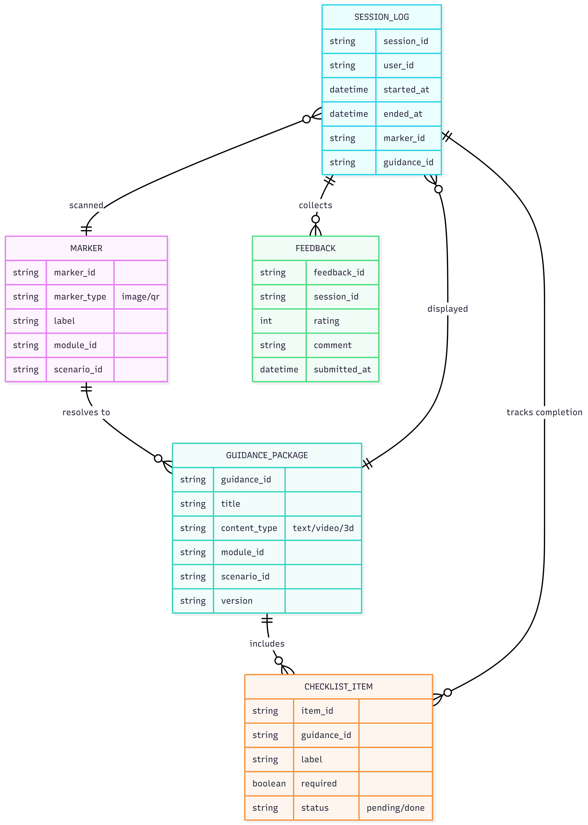

14. Key Risks and Mitigations
Risk | Mitigation
Marker detection instability (lighting, glare, occlusion) | Marker design/placement guidelines; field validation in M1; fallback to non-AR guide mode; tracking parameter tuning.
Content mismatch with real station layout | Alignment workshops; pilot validation; allow multiple markers per scenario with contextual variants.
Device compatibility variability | Define supported device/OS matrix early; test across representative devices; optimize performance and memory.
Operational distraction / unsafe use during tasks | Short, glanceable steps; minimal UI; include safety reminders; supervisor-approved deployment rules.
Scope growth beyond 15 scenarios | Lock scope to 15 VR scenarios for this phase; change control for new scenarios or advanced tracking requests.

15. Handover and Post-Deployment Support
Upon completion, the team will provide a handover package including build artifacts, configuration files, documentation, and knowledge transfer sessions for administrators and trainers. Post-deployment support scope and duration can be agreed separately (financial terms are excluded in this proposal).

