Technical Proposal
SPARK Immersive Training System (VR Only)
Meta Quest 3
Scope: Three VR Certification Modules - ServSafe Food Handler, OSHA 10 (General Industry), NSC Forklift Operator
Delivery Model: Milestone-Based (3 Milestones)
Development: From Scratch in Unity
Prepared by: Rise Up Labs
Date: 13 February 2026

1. Executive Summary
This proposal outlines the development of a VR-only training solution for Meta Quest 3, starting with three certification-aligned modules: ServSafe Food Handler, OSHA 10 (General Industry), and NSC Forklift Operator. Each module will include five immersive training scenarios and will be delivered with measurable learning outcomes, objective scoring, and completion records. The solution will be developed from scratch using Unity and Meta XR tooling, optimized for classroom-based VR stations and repeatable, risk-free practice.

2. Project Objectives
- Provide a safe, repeatable VR training bridge before learners enter live operational environments.
- Deliver certification-aligned training content with a structured learning progression: Observe → Practice → Assess.
- Capture measurable performance data (step completion, safety violations, timing, and outcomes) to validate readiness.
- Support instructor-led classroom delivery with simple session controls and learner progress visibility.
- Enable scalable expansion to additional modules in later phases (out of scope for this proposal).

3. Scope

3.1 In Scope
- VR-only implementation for Meta Quest 3 (standalone headset).
- Three certification modules: ServSafe Food Handler, OSHA 10 (General Industry), NSC Forklift Operator.
- Five scenarios per module (total 15 scenarios), each implemented with Observe, Guided Practice, and Assessment modes.
- Core platform features: onboarding/menu, scenario selection, in-VR guidance, scoring, completion tracking, and certificate-ready completion records.
- Instructor support features: session start/reset, learner profile selection, and basic cohort reporting/export.
- Localization-ready UI (English-first; Spanish-ready structure if content is supplied).
- Testing & QA across functional, usability, and performance dimensions on Meta Quest 3 hardware.

4. Assumptions and Dependencies
- Client will validate certification content alignment and provide any required official training references, pass/fail thresholds, and assessment criteria.
- Client will confirm classroom deployment constraints (number of headsets, available space, supervision model, and learner throughput).
- Five scenarios per module are agreed for the initial release; scenario details will be finalized during discovery of each milestone.
- Hardware target is Meta Quest 3; development and testing will use representative devices and OS versions available during the project.

5. Proposed Technical Approach

5.1 Learning Experience Model
Each scenario follows a consistent three-mode progression to build confidence and competency:
• Observation: immersive demonstration of correct procedures and safety behaviors.
• Guided Practice: step-by-step execution with contextual prompts and corrective feedback.
• Assessment: solo performance with objective scoring, pass/fail thresholds, and repeat attempts.

5.2 Scenario Design Pattern (5 Scenarios per Module)
For planning and estimation, each module will be developed with five scenarios that represent common, high-impact situations. Scenario topics will be confirmed during milestone discovery. Typical scenario coverage includes:
- Scenario A: Standard procedure execution (baseline workflow).
- Scenario B: Variation under constraints (time pressure, limited space, or alternate setup).
- Scenario C: Safety-critical exception handling (hazard recognition, error recovery, or compliance breach).
- Scenario D: Role/environment variation (alternate station layout, equipment type, or shift context).
- Scenario E: End-to-end workflow and combined risks (multiple decision points and safety checks).

5.3 Measurement and Readiness Proof
- Step completion tracking (sequence correctness and required interactions).
- Safety compliance checks (critical errors flagged; unsafe actions blocked or penalized).
- Timing and efficiency metrics (time-to-complete, idle time, retries).
- Outcome scoring (objective rubric per scenario; pass/fail thresholds).
- Completion records for certificate issuance workflow (exportable summary).

6. Development Methodology
An iterative, milestone-based delivery model will be used. Each milestone includes discovery, prototyping, production, internal QA, client review, and acceptance. Feedback is incorporated before progressing to the next milestone to reduce rework and ensure content fidelity.

6.1 Agile Delivery Within Milestones
- Sprint planning and backlog refinement per milestone.
- Playable builds delivered at least bi-weekly (or per agreed cadence) for early validation.
- Definition of Done includes: functional completion, QA pass, performance targets met, and documentation updated.

7. Proposed Technical Stack (Unity + Meta Quest 3)
- Engine: Unity (LTS version aligned with Meta Quest development guidance).
- XR Runtime: OpenXR (Quest compatible).
- Meta SDKs: Meta XR All-in-One SDK; Meta XR Interaction SDK for hands/controllers.
- Interaction Framework: Unity XR Interaction Toolkit (as needed for interaction patterns).
- Rendering: Universal Render Pipeline (URP) with mobile VR performance optimizations.
- Build/CI: Git repository
- Analytics/Reporting: Local persistent storage on device + optional secure export (CSV/JSON) to instructor workstation.
- Optional backend (future-ready): API service for centralized reporting and user management (not required for VR-only pilot).

8. High-Level Solution Architecture
Diagram 1: High-Level VR Solution Architecture
Meta Quest 3 App (Unity) → Local Data Store → Optional Export/Sync

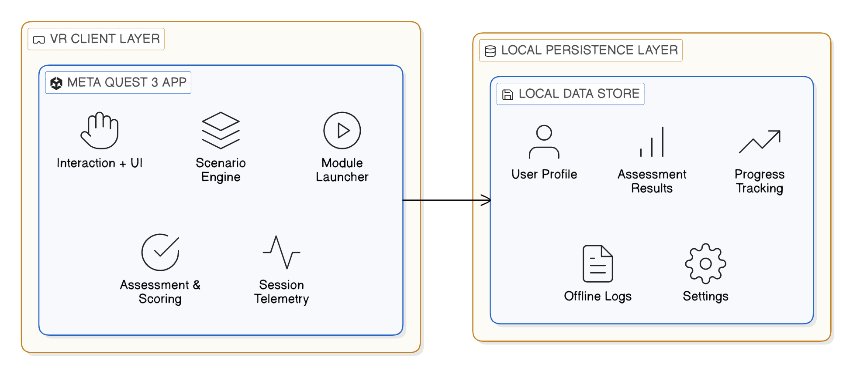

8.1 Core Application Components
- App Shell: language selection, user profile, module/scenario selection, settings.
- Scenario Runtime: state machine for Observe/Practice/Assess; interaction controllers; prompts.
- Scoring Engine: rule-based evaluator for steps, safety events, timing, and outcomes.
- Data Layer: session logs, attempts, results, completion status, export package generator.
- Admin/Instructor Tools: reset session, select learner, view completion summaries, export results.

9. Module Scope Breakdown (VR Only)

9.1 Module 1 - ServSafe Food Handler
Focus: food safety fundamentals, hygiene practices, safe storage/handling behaviors.
Planned Scenarios (5):
- Scenario A: Hygiene and personal protective behaviors in a prep area.
- Scenario B: Food storage and temperature control workflow with correct labeling/rotation.
- Scenario C: Contamination risk identification and corrective actions (cross-contamination, cleaning).
- Scenario D: Allergen awareness and special-order handling with correct prep and labeling.
- Scenario E: Receiving and inspection of deliveries with safe acceptance/rejection and storage actions.

9.2 Module 2 - OSHA 10 (General Industry)
Focus: hazard recognition, prevention measures, and workplace safety protocols.
Planned Scenarios (5):
- Scenario A: Walkthrough hazard identification (PPE, signage, housekeeping).
- Scenario B: Incident-prevention actions (lockout/tagout concepts, safe behavior choices).
- Scenario C: Response to unsafe conditions (reporting/escalation and corrective steps).
- Scenario D: Electrical/energized equipment hazard checks and safe work practices (basic controls and PPE).
- Scenario E: Emergency response drill (e.g., fire/chemical spill) with reporting, evacuation, and corrective steps.

9.3 Module 3 - NSC Forklift Operator
Focus: lift truck operation basics, pedestrian awareness, and safe maneuvering in warehouse settings.
Planned Scenarios (5):
- Scenario A: Pre-operation inspection and basic controls familiarization.
- Scenario B: Load pickup, transport, and placement with safe speed and path rules.
- Scenario C: Hazard scenario (pedestrian crossing, blind corner, unstable load) and safe resolution.
- Scenario D: Stacking/unstacking in racking with load stability and height/clearance rules.
- Scenario E: End-of-shift parking and battery charging/refueling procedure with area safety checks.

10. Milestone-Based Delivery Plan (3 Milestones)
Each milestone results in an accepted, production-ready VR module with five scenarios, including observe/practice/assessment modes and reporting.
Milestone | Scope | Key Activities | Deliverables
M1 | Platform foundation + ServSafe VR module (5 scenarios) | Project setup, core architecture, interaction framework, scoring engine v1, module content build, internal QA, | Quest 3 build; ServSafe module; scoring + completion logs; basic export; technical documentation
M2 | OSHA 10 VR module (5 scenarios) + platform refinements | Scenario discovery, content build, improve UX, expand scoring rules, reporting enhancements, QA | Quest 3 build; OSHA 10 module; updated scoring/rubrics; updated docs/test reports
M3 | NSC Forklift Operator VR module (5 scenarios) + stabilization | Forklift interactions, safety logic, final polish, regression test, release candidate preparation | Final Quest 3 build; Forklift module; consolidated completion records; release notes; handover package
Timeline Note: Detailed week-by-week timeline will be finalized after Milestone 1 discovery and client review of scenario complexity and headset count.

11. Testing and Quality Assurance

11.1 QA Strategy
- Test Planning: test cases derived from scenario steps, safety rules, and pass/fail criteria.
- Functional Testing: interactions, state transitions (observe/practice/assess), scoring, save/export.
- Device Testing: performance and stability validation on Meta Quest 3 (FPS, thermals, memory).
- Usability Testing: comfort checks (motion sickness risk), clarity of instructions, accessibility basics.
- Regression Testing: full suite executed before each milestone acceptance and final release.
- Bug Triage: severity-based prioritization with fix verification in subsequent builds.

11.2 Performance Targets (Quest 3)
Targets will be confirmed during Milestone 1, but typical VR acceptance targets include:
- Maintain stable framerate appropriate for Quest 3 (e.g., 72-90 FPS depending on scene complexity).
- Fast scene loading and minimal frame drops during interactions.
- Comfort-oriented locomotion options (teleport/short-step movement where needed).
- No critical crashes or memory leaks during extended classroom sessions.

11.3 Test Artifacts Delivered
- Test plan and coverage matrix per module.
- Device performance checklist and results.
- Bug list with severity, reproduction steps, and resolution status.

Fig: QA test process

12. Deliverables Summary
- Three VR modules (ServSafe, OSHA 10, Forklift), each with five scenarios and Observe/Practice/Assess modes.
- Scoring and readiness proof engine with configurable rubrics and thresholds.
- Completion records and exportable reports suitable for certificate issuance workflows.
- Installer build packages for Meta Quest 3 + deployment guide.
- Technical documentation: architecture overview, setup/build steps, and admin/instructor guide.
- QA documentation: test plans, reports, and milestone sign-off artifacts.

13. Diagrams
Diagram 2: Module Scenario State Machine (Observe → Practice → Assess).
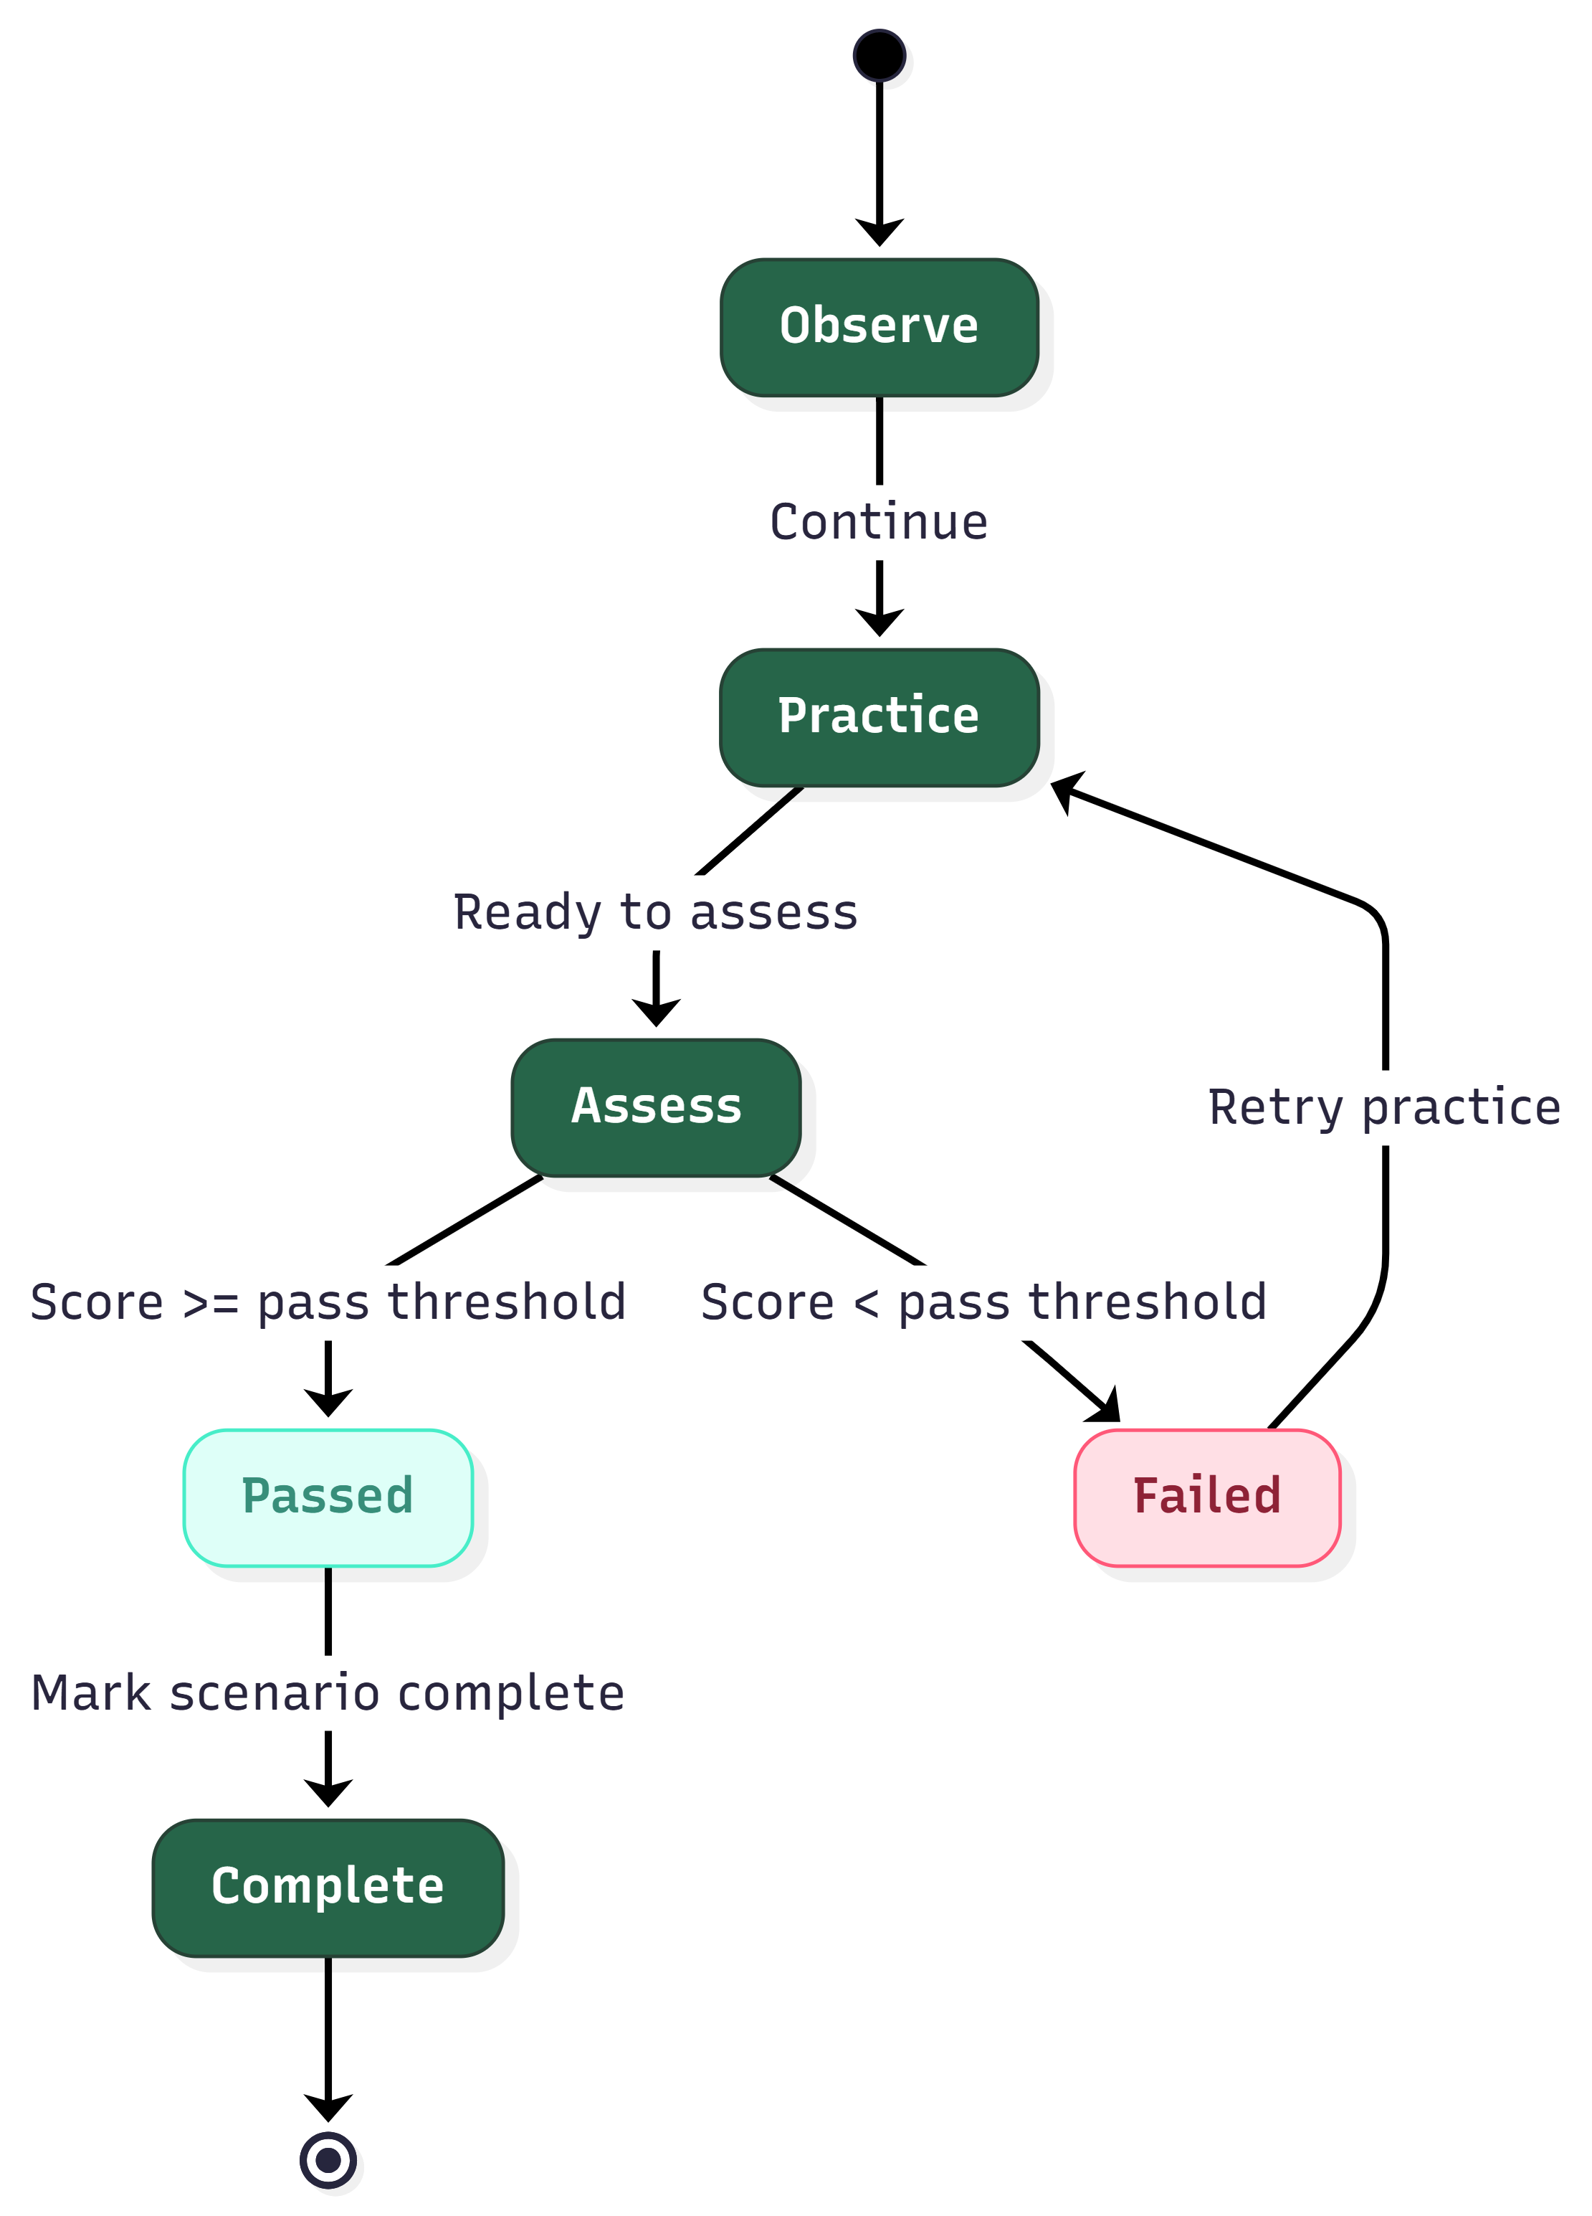

Diagram 3: Data Model Overview (Learner, Session, Attempt, Scenario, Score, SafetyEvent).
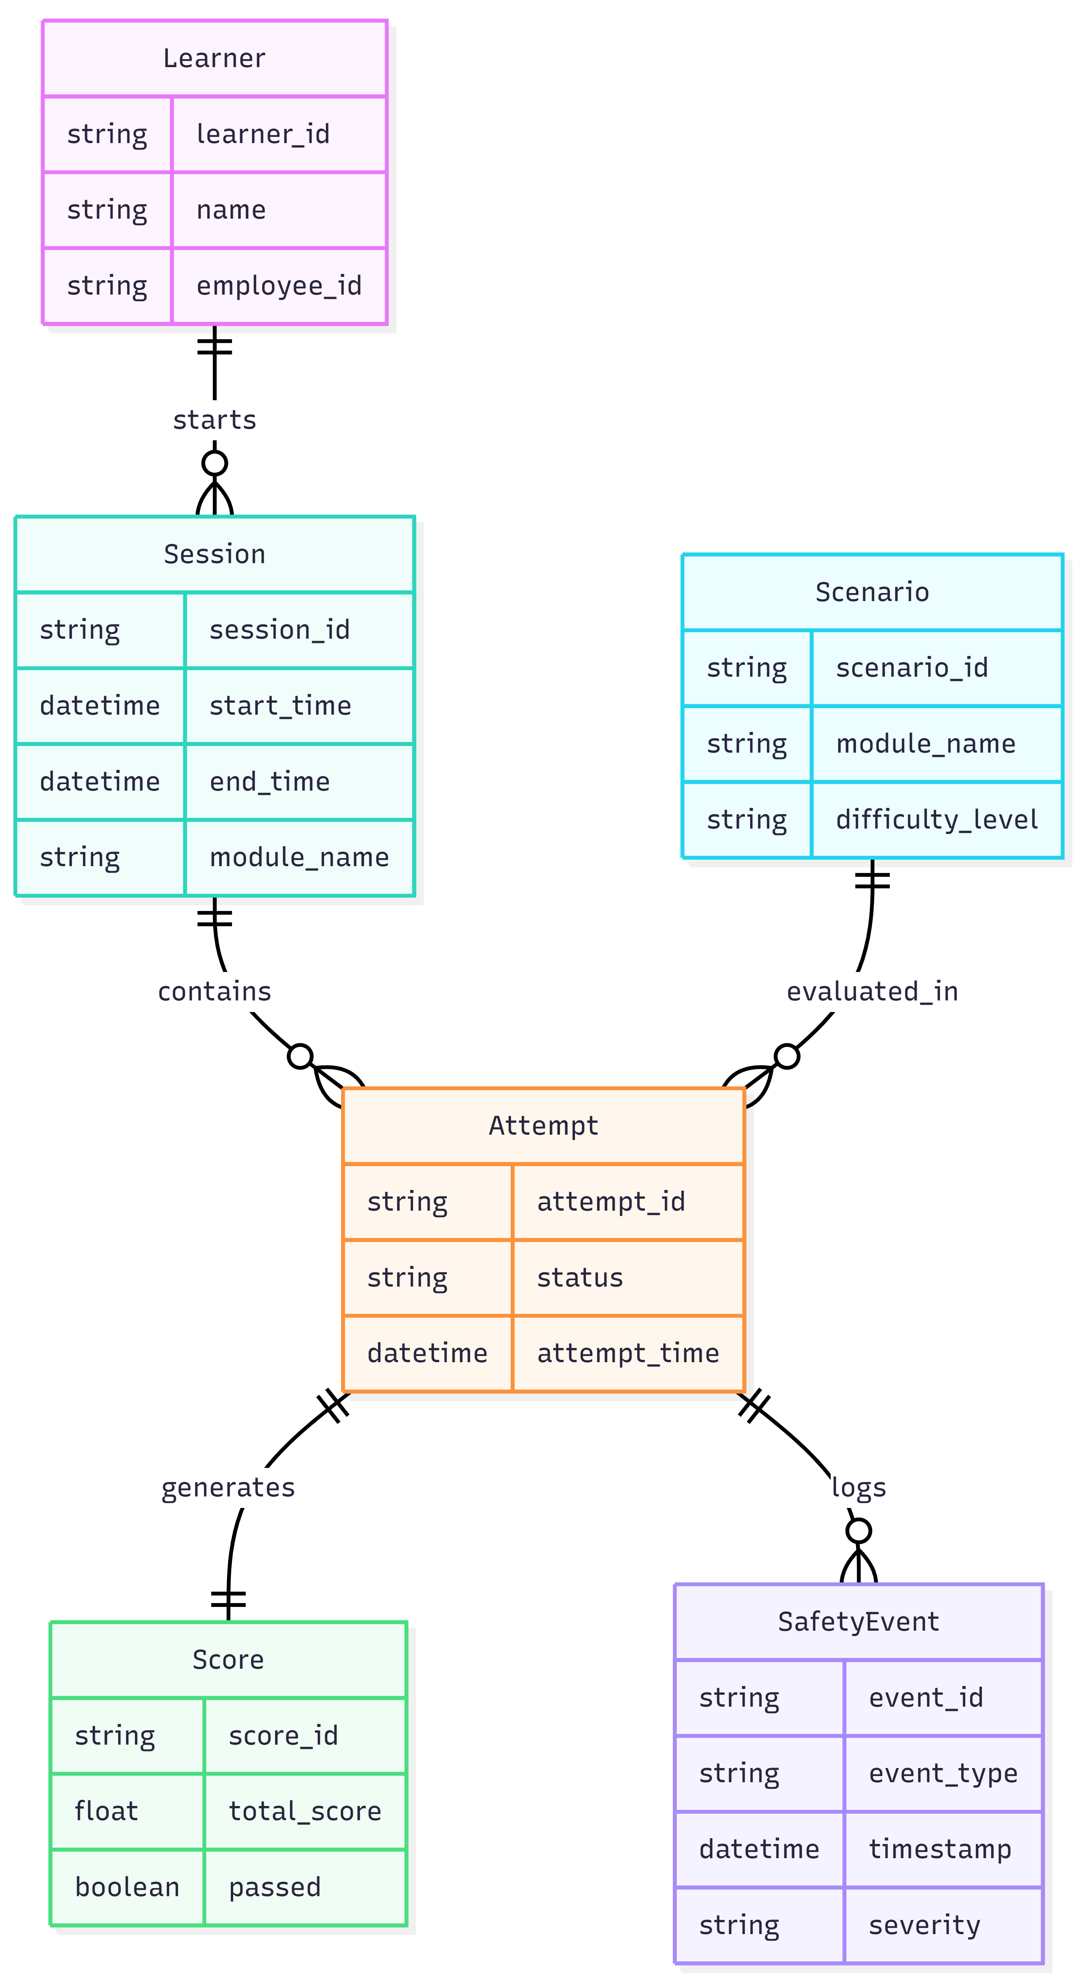

14. Key Risks and Mitigations
Risk | Mitigation
Certification content alignment | Mitigation: early validation workshops per module; rubric sign-off before development.
Scenario complexity growth | Mitigation: lock five scenarios per module for this phase; change control for new scope.
VR comfort and motion sickness | Mitigation: comfort-first design patterns; avoid forced locomotion; user testing.
Quest performance constraints | Mitigation: URP optimization, baked lighting, LODs, profiling from early builds.

16. Handover and Post-Deployment Support
Upon completion, the team will provide a handover package including build artifacts, documentation, and knowledge transfer sessions. Post-deployment support scope and duration can be agreed separately (financial terms are excluded in this proposal).

