Technical Proposal
Corporate Website for Southern Cross Wealth Partners

Prepared By: Riseup Labs


Table of Contents
1. Executive Summary 3
1.1 Project Objectives 3
1.2 Scope Control Statement 3
2. Project Understanding and Research Inputs 3
2.1 Understanding from Client Discussion 3
2.2 Shared Demo Website Review 3
2.3 Compliance and Quality Considerations for Australia 3
3. Project Scope and Deliverables 4
3.1 In-Scope Website Sections 4
3.2 Functional Deliverables 4
3.3 Non-Functional Deliverables 4
3.4 Out of Scope 5
4. Proposed Technical Solution and Approach 5
4.1 Recommended Approach 5
4.2 Technical Stack 5
4.3 Solution Architecture 6
4.4 Lead Capture and Booking Flow 6
5. UI/UX and Development Methodology 7
5.1 UI/UX Methodology 7
5.2 Development Methodology 7
5.3 Content Placement Method 7
6. Testing and Quality Assurance 7
6.1 QA Coverage 7
6.2 QA Deliverables 7
7. Project Timeline and Milestones 8
7.1 Milestone View 8
9. Assumptions, Dependencies, and Risks 8
9.1 Assumptions 8
9.2 Dependencies 8
9.3 Key Risks and Mitigation 9
10. Post-Launch Support and Future Growth 9
10.1 Recommended Future Services 9
11. Conclusion 9

1. Executive Summary
Southern Cross Wealth Partners requires a simple, polished, and conversion-focused corporate website for its new mortgage broking business in Australia. The site will be designed to build credibility, present conventional mortgage and Islamic Finance services clearly, capture inquiries, and allow visitors to book consultations. The shared demo website will be used as a practical design direction, while the final UI will be adjusted to match the client logo, brand identity, and preferred homepage video or animation treatment.
The recommended solution is a lightweight custom website developed from scratch using Laravel and React. Laravel will manage backend routing, inquiry handling, admin/content management, security controls, and deployment structure. React will power the responsive public website experience, reusable UI components, homepage visual treatment, service sections, calculator embed area, and conversion-focused CTAs. This approach gives the client a clean custom website without adding e-commerce, borrower portals, lender integrations, or advanced loan workflows in the first phase.

1.1 Project Objectives
- Create a professional online presence for Southern Cross Wealth Partners.
- Present conventional mortgage broking services and Islamic Finance services as separate pathways.
- Add a visually engaging homepage section using client-approved video, animation, or lightweight motion treatment.
- Capture leads through inquiry forms and consultation booking CTAs.
- Integrate the client-provided Islamic Finance calculator code once supplied.
- Prepare the website for future SEO, digital marketing, lead generation, and maintenance services.

1.2 Scope Control Statement
The initial build will not include e-commerce, customer login, loan application workflow, payment processing, borrower portal, lender integrations, CRM automation, or advanced marketing automation. These can be considered later as separate future enhancements.

2. Project Understanding and Research Inputs

2.1 Understanding from Client Discussion
- The client liked the overall layout and simplicity of the demo website shared by the team.
- The homepage should be more visually engaging, especially through a strong video, animation, or similar visual section.
- Islamic Finance should be treated as a dedicated service area, separate from conventional mortgage services.
- The client will provide all final website content and the final logo.
- The client has industry-approved Islamic Finance calculator code and will share it during the project.
- The website is primarily informational with lead capture and consultation booking options.
- The client is interested in future SEO, digital marketing, lead generation, website maintenance, and content updates.
- The expected timeline is approximately 3 to 4 weeks, with 4 weeks recommended for quality delivery.

2.2 Shared Demo Website Review
Reference demo: mortgagebrokingwebsite.lovable.app
Area | Observed Direction | Proposal Treatment
Structure | Home, Services, Islamic Finance, Calculators, About, FAQs, Contact | Keep a similar simple structure, adjusted to Southern Cross Wealth Partners branding.
Conversion | Prominent consultation and eligibility CTAs | Use clear CTA buttons across home, service, Islamic Finance, calculator, and contact sections.
Service Split | Mortgage and Islamic Finance content are both visible | Present Islamic Finance as a separate primary pathway to avoid mixing it with conventional mortgage services.
Visual Style | Clean corporate design with simple sections | Enhance homepage with video or lightweight animation while keeping performance in mind.
Content | Demo copy is placeholder-style | Replace with client-provided final content and compliance-approved wording.

2.3 Compliance and Quality Considerations for Australia
Consideration | Proposal Relevance
Credit business context | ASIC guidance for mortgage brokers and credit activities should inform the client-provided licence, representative, disclosure, and disclaimer wording where applicable.
Best interests duty | ASIC RG 273 explains best interests obligations for mortgage brokers. Website wording should avoid unsupported claims and use client-approved service descriptions.
Privacy and lead forms | Lead forms collect personal information. The website should include privacy policy links and clear consent language aligned with the Australian Privacy Principles.
Advertising claims | Marketing claims should be accurate, supportable, and reviewed by the client before publishing to reduce misleading or deceptive claim risk.
Accessibility | WCAG 2.2 is used as a practical accessibility reference for headings, labels, contrast, alt text, keyboard navigation, and forms.

Note: This proposal does not provide legal, financial, licensing, or compliance advice. The client should provide or approve all legal, financial, licensing, and compliance wording before launch.

3. Project Scope and Deliverables

3.1 In-Scope Website Sections
Section | Purpose | Key Elements
Homepage | Create first impression and guide visitors to the right service path. | Hero section with video or animation, key value proposition, service overview, Islamic Finance callout, trust section, FAQs preview, CTA.
About | Introduce the company and establish credibility. | Company overview, values, team/profile content if provided, service philosophy, compliance notes if provided.
Conventional Mortgage Services | Present standard mortgage broking service categories. | Home loans, refinancing, investment loans, first home buyer guidance, general service descriptions, inquiry CTA.
Islamic Finance | Present Islamic Finance as a dedicated service area. | Separate page or section, Sharia-compliant positioning based on client content, calculator link, dedicated CTA.
Calculators | Support visitor engagement and service education. | Embed client-provided Islamic Finance calculator code. Other calculators only if provided or approved.
FAQs | Answer common visitor questions and reduce hesitation. | Content managed through lightweight admin if enabled, grouped by general mortgage and Islamic Finance topics if content allows.
Contact and Booking | Capture leads and support consultation scheduling. | Inquiry form, consultation booking link/embed, business contact details, location/service area, privacy consent note.

3.2 Functional Deliverables
- Responsive corporate website compatible with desktop, tablet, and mobile devices.
- Homepage with engaging visual section using client-approved video, animation, or lightweight motion treatment.
- Separate navigation and content pathway for Islamic Finance services.
- Inquiry/contact form with Laravel validation, spam protection, database record, and email notification.
- Consultation booking option using a selected third-party booking tool or embedded booking link.
- Integration area for client-provided Islamic Finance calculator code.
- Lightweight Laravel admin/content management for agreed pages, FAQs, inquiry records, and basic metadata.
- Basic SEO setup including SEO-friendly URLs, titles, meta descriptions, sitemap setup, and analytics-ready structure.
- Security, performance, and backup configuration suitable for a corporate website.
- Deployment to production hosting with SSL configuration support.

3.3 Non-Functional Deliverables
- Mobile-first responsive layout.
- Fast page loading with optimized images and careful handling of video/animation assets.
- Clean content structure for future SEO and marketing campaigns.
- Accessible form labels, readable contrast, keyboard-friendly navigation, and descriptive alt text where images are provided.
- Secure admin access, CSRF protection, input validation, secure environment configuration, and spam protection.
- Easy post-launch maintenance through a limited admin panel and organized codebase.

3.4 Out of Scope
- Online loan application engine or borrower portal.
- Customer login, document upload, lender integration, or workflow automation.
- Payment gateway, e-commerce, subscription, or checkout features.
- CRM implementation or marketing automation beyond basic form notification unless added later.
- Copywriting, financial advice content, legal content, compliance drafting, or translation services.
- Advanced SEO campaign, paid ads, lead generation campaign, or ongoing maintenance package after launch.

4. Proposed Technical Solution and Approach

4.1 Recommended Approach
The website should be delivered as a lightweight custom corporate website using Laravel and React. Laravel is recommended for secure backend logic, routing, form processing, inquiry storage, admin access, and maintainable deployment. React is recommended for a polished frontend experience, reusable UI components, responsive layouts, smooth homepage visual elements, and structured service presentation.
To keep the project budget-conscious, the Laravel admin will remain limited to practical website management needs only. It will not be positioned as a full financial system, borrower portal, CRM, or lending workflow platform. The public website will remain simple, fast, and lead-focused.

4.2 Technical Stack
Layer | Proposed Stack | Reason
Backend | Laravel 11/12, PHP 8.3+, Laravel validation, Laravel Mail, queued email if needed | Secure and maintainable backend for forms, routing, notifications, content blocks, and admin features.
Frontend | React with Vite, responsive component-based UI, HTML5, CSS3/Tailwind or SCSS | Supports polished, reusable, responsive UI and homepage animation without heavy frontend complexity.
Database | MySQL or PostgreSQL | Stores inquiries, page content blocks, FAQs, metadata, admin settings, and calculator embed references.
Admin Panel | Lightweight Laravel admin using Filament or custom admin screens | Keeps content and inquiry management simple without building a costly full CMS.
Forms | Laravel form requests, validation, CSRF protection, reCAPTCHA or Turnstile | Supports secure lead capture, spam prevention, database logging, and email notification.
Booking | Calendly, Google Calendar appointment schedule, Microsoft Bookings, or client-selected booking link/embed | Avoids custom scheduling development and keeps the launch timeline realistic.
Calculator | Client-provided approved calculator code embedded in a React/Laravel page | Reduces risk and avoids rebuilding sensitive finance calculation logic.
SEO Setup | SEO-friendly URLs, page metadata, sitemap, robots.txt, Open Graph metadata | Supports future SEO and marketing without adding a campaign scope.
Analytics | Google Analytics 4 and Google Search Console setup support if access is provided | Allows basic traffic and conversion visibility after launch.
Security | SSL, CSRF, rate limiting, input sanitization, secure admin access, backups, environment protection | Protects admin area and lead forms from basic security and spam risks.
Hosting | Laravel-compatible hosting or VPS with PHP 8.3+, database, SSL, and Node build support | Supports custom Laravel and React deployment with scalable maintenance options.

4.3 Solution Architecture
The following diagram shows the proposed high-level architecture. It is intentionally simple because the website is informational and lead-focused, not transactional.
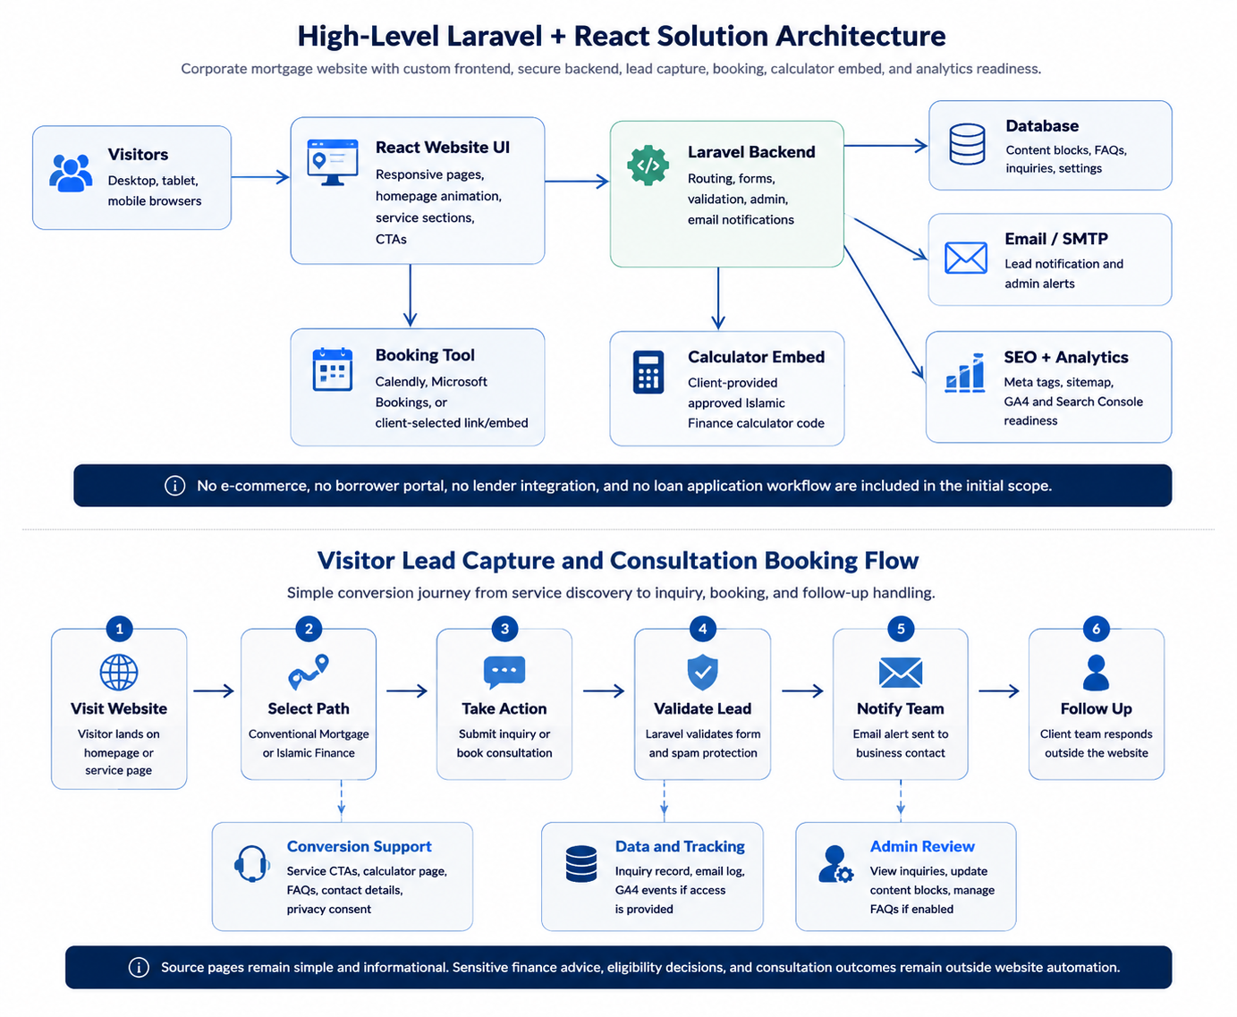

4.4 Lead Capture and Booking Flow
The lead flow focuses on helping visitors move from service discovery to inquiry or consultation booking with minimal friction.

5. UI/UX and Development Methodology

5.1 UI/UX Methodology
Step | Activity | Output
1 | Confirm brand direction using logo, preferred colors, demo reference, and homepage visual expectation. | Brand-aligned mood direction.
2 | Prepare sitemap and homepage structure with separate Islamic Finance pathway. | Approved page structure.
3 | Design homepage and key inner page layouts in Figma. | Responsive UI design screens.
4 | Review visual treatment for video, animation, or hero interaction. | Approved homepage visual approach.
5 | Finalize UI design for React development. | Design handoff with components and layout guidance.

5.2 Development Methodology
- Use an iterative delivery model across 4 weeks with weekly progress review.
- Build the website using approved Figma designs and the agreed Laravel + React stack.
- Create reusable React sections to reduce development time and keep layouts consistent.
- Implement Laravel backend for forms, admin/content management, email notifications, and calculator embed support.
- Place client-provided content into approved page templates.
- Conduct QA throughout development rather than leaving testing only until the end.

5.3 Content Placement Method
- Client provides final text content, logo, service details, compliance statements, calculator code, and any required images or videos.
- Our team formats and places content within the approved website layout.
- If content is delayed, placeholder content may be used for layout progress, but final launch depends on client-approved content.
- Any financial, Islamic Finance, legal, privacy, or licence-related copy must be reviewed and approved by the client before publication.

6. Testing and Quality Assurance
Testing will focus on functional correctness, responsive behavior, security basics, content presentation, and performance readiness.

6.1 QA Coverage
- Responsive testing on desktop, tablet, and mobile screen sizes.
- Cross-browser checks on Chrome, Safari, Edge, and Firefox where practical.
- Navigation, CTA, link, and menu testing across all agreed pages.
- Inquiry form validation, database record creation, email notification, spam protection, and privacy consent check.
- Booking link or embedded booking widget testing.
- Calculator embed loading test using the client-provided approved code.
- Laravel route, error page, admin access, and form security checks.
- Content formatting review for headings, spacing, images, buttons, and CTA consistency.
- Accessibility checks for headings, labels, contrast, alt text, focus states, and keyboard navigation.
- Performance checks for image optimization, video loading behavior, caching, and page speed basics.
- Security checks for SSL, CSRF, secure admin access, input validation, backups, and form spam prevention.
- Basic SEO checks for page titles, meta descriptions, URL structure, sitemap, and index readiness.
- Pre-launch deployment verification after moving the website to production hosting.

6.2 QA Deliverables
- QA checklist covering pages, forms, responsiveness, links, booking, calculator, admin basics, and deployment readiness.
- Issue log with severity and resolution status during the testing phase.
- Final launch readiness confirmation after fixes are completed.

7. Proposed Budget and Timeline

- Development Budget: $2300
- Development timeline: 2 weeks

8. Assumptions, Dependencies, and Risks

8.1 Assumptions
- The website will be built as a corporate informational website with lead capture, not as a custom financial application.
- The client will provide final approved content for all pages before content placement.
- The client will provide the final logo, brand preference, calculator code, and any required video or image assets.
- The consultation booking system will use a third-party tool or booking link selected by the client.
- The website will be developed in English only unless otherwise agreed.
- The first launch will focus on the agreed pages only, with future SEO and marketing handled as separate post-launch services.

8.2 Dependencies
Dependency | Owner | Impact if Delayed
Final logo and brand inputs | Client | Design approval and final UI polish may be delayed.
Final page content | Client | Content placement and launch readiness may be delayed.
Islamic Finance calculator code | Client | Calculator page may be launched with placeholder or held until code is provided.
Compliance, licence, privacy, and disclaimer wording | Client | Website cannot be considered launch-ready without approved legal or compliance text.
Domain, hosting, DNS, email, and SSL access | Client / Technical team | Deployment and production launch may be delayed.
Booking tool account or link | Client | Consultation booking feature cannot be finalized.
Video or animation assets | Client / Design team | Homepage visual section may need a lightweight fallback treatment.

8.3 Key Risks and Mitigation
Risk | Potential Impact | Mitigation
Delayed content from client | Timeline may move beyond 4 weeks. | Start with approved sitemap and placeholders, but finalize launch only after content is received.
Heavy video or animation on homepage | Poor page speed and mobile experience. | Use optimized video, lazy loading, compression, or lightweight animation fallback.
Calculator code compatibility issue | Calculator may not work correctly inside the Laravel/React page. | Review code early, test in staging, and isolate embed if needed.
Compliance wording not approved | Risk of incorrect financial or legal representation. | Client to provide and approve all regulated wording, disclaimers, and licence information.
Too many design revisions | Timeline and cost pressure. | Limit revisions to agreed cycles and confirm design direction in Week 1.
Third-party booking tool limitation | Booking experience may depend on external tool behavior. | Use a reliable booking service and test embed or link behavior before launch.
Post-launch maintenance not planned | Security, framework, and content updates may fall behind. | Recommend separate maintenance agreement after launch.

9. Post-Launch Support and Future Growth
The client has expressed interest in future SEO, digital marketing, lead generation, and maintenance. These services should be treated as optional post-launch phases so the initial website remains simple and budget-conscious.

9.1 Recommended Future Services
- Monthly website maintenance, Laravel security updates, dependency updates, backup monitoring, and security checks.
- Content updates for services, FAQs, team profiles, and compliance pages.
- SEO campaign with keyword research, local SEO, technical SEO, blog strategy, and performance reporting.
- Lead generation campaign support through landing pages, tracking, and paid marketing setup.
- CRM integration when lead volume increases.
- Expanded calculators or interactive tools if the client wants more visitor engagement later.

10. Conclusion
The proposed solution provides Southern Cross Wealth Partners with a professional, startup-friendly, and maintainable corporate website that clearly separates conventional mortgage services and Islamic Finance services. The approach uses Laravel and React to deliver a custom, polished website with secure lead capture, consultation booking, and calculator integration while keeping the first launch focused on the client's confirmed needs. With timely inputs and approvals, the website can be delivered within a 4-week timeline and can later be extended through SEO, lead generation, content updates, and ongoing maintenance services.

