Technical Proposal
Sternotomy VR Surgical Simulation
Desktop VR | Headset + Force-feedback Gloves | Software Development from Scratch
Prepared by: Riseup Labs


1. Executive Summary
This proposal presents a technical plan to develop the Sternotomy VR Surgical Simulation from scratch. The application will be built as a desktop VR training simulation for use with a VR headset and force-feedback gloves. The proposed solution focuses only on the software scope described in the Sternotomy specification and avoids additional modules that would increase cost without being required.
The simulation will reproduce a clinically realistic operating room environment where the surgeon enters their identity, reviews the patient record, enters the operating room, receives the clinical voice brief, requests instruments by voice, performs landmark localization, uses the available marking techniques, performs the documented sternotomy workflow, and completes the step through a clinically natural action trigger. The system will not use points, rewards, game-like prompts, or visible scoring. Instead, the simulation will silently record actions and clinical decision quality for later review or downstream consequences.
The proposed implementation uses a modular VR architecture so that the headset, gloves, voice command engine, clinical state machine, haptic responses, audio, scene assets, and evaluation logs remain separated and maintainable.

2. Understanding of Requirement

2.1 Project Context
- Target environment: desktop VR with headset and force-feedback gloves.
- Agency responsibility: software development only.
- Simulation level: ultra-realistic surgical training with no gaming mechanics.
- Development approach: build from scratch based on the supplied Sternotomy specification.
- Current documented scope: surgeon identity, preoperative patient record, operating room setup,
Step 1 landmark localization and marking,
Step 2 skin incision/dissection/sternotomy workflow, silent evaluation and audio behavior.

2.2 Core Functional Areas
Area | Required Capability | Proposal Interpretation
Session Identity | Player enters name and title. | Build a simple VR entry screen and use name/title in nurse/anesthesiologist interactions.
Patient Record | Summary and full file views, with physical dossier access in room. | Create pre-OR virtual file UI and in-room dossier object with permission-based access behavior.
Operating Room State | Prepared anesthetized patient, monitoring, drapes, equipment and team positions. | Create the initial OR scene and patient state as already prepared; patient preparation is not part of gameplay.
Voice Commands | Instrument requests and selected anesthesiologist commands. | Implement command recognition for the defined nurse and anesthesiologist interactions.
Haptic Interaction | Palpation, instrument grasp, resistance and feedback profiles. | Create glove interaction mappings and a haptic abstraction layer connected to the chosen glove SDK.
Step 1 | Landmarking and five documented marking/localization techniques. | Implement all specified techniques without tutorial guidance or preference.
Step 2 | Incision, dissection, ventilation request, sternotomy and hemostasis. | Implement the specified procedural sequence and conditional events without extra surgical stages.
Silent Assessment | System records technique, deviations, clinical choices and completion triggers. | Build an internal event log and session result model without real-time scoring or alerts.
Audio | OR ambience, monitor sound, surgical equipment sound and short team responses. | Implement spatialized operating room audio and procedural sound variation.

3. Proposed Scope of Work

3.1 Included Scope
- Design and development of the desktop VR application from scratch.
- Intro/session identity screen with name and title entry.
- Preoperative patient record interface with summary and full-view structure.
- Virtual operating room environment including patient state, team positioning, monitoring display, surgical light and accessible dossier object.
- Voice-driven interaction with the scrub nurse for instrument requests and with the anesthesiologist for ventilation-related commands.
- Instrument handoff and grasping interaction using force-feedback gloves.
- Step 1 landmark localization workflow with palpation and all five documented localization/marking techniques.
- Randomized xiphoid-process variation logic as required by the specification.
- Step 2 procedural workflow covering incision, dissection, sternotomy-related interaction, hemostasis and transition to the next step trigger.
- Clinical state machine, conditional events and silent assessment logic based on the supplied specification.
- Operating room audio, monitoring sounds, instrument sounds and concise team voice responses.
- Session logs for internal evaluation, QA and clinical review.
- Windows PCVR build, technical documentation, testing documents and handover package.

3.2 Not Included Unless Separately Agreed
- Hardware procurement, hardware shipping, headset/glove license purchase or physical installation.
- Additional surgical stages beyond the documented Sternotomy Step 1 and Step 2 scope.
- Multiplayer mode, instructor dashboard, LMS integration, cloud analytics or web admin portal.
- Formal medical device certification or regulatory submission.
- Creation of original clinical media/video by the agency unless source material is provided.
- Integration with real hospital systems or real patient data sources.

4. Proposed Technical Approach

4.1 Build-from-Scratch VR Application
The application will be developed as a dedicated PCVR software product rather than a modification of an existing game or simulator. The build will follow the exact Sternotomy training flow, with the clinical procedure implemented through a deterministic state machine, interaction events, instrument states and silent evaluation logs.

4.2 Modular Architecture
The solution will be divided into independent modules so that scene assets, haptics, voice commands, surgical logic and evaluation logs can evolve without breaking the full simulation.
- VR Presentation Layer - operating room scene, patient model, instruments, monitors and visual states.
- Input and Haptic Layer - headset tracking, glove tracking, grasp detection, force feedback and tool interaction mapping.
- Voice Command Layer - command detection, intent routing and nurse/anesthesiologist response triggers.
- Clinical State Machine - Step 1 and Step 2 procedural states, completion triggers and conditional events.
- Instrument Management Layer - instrument availability, handoff logic, grasp state and tool-specific behavior.
- Patient Record Module - summary view, full view and in-room dossier consultation flow.
- Silent Evaluation Logger - timestamps, action quality, technique selection, deviation values and session outputs.
- Audio and Monitoring Layer - spatial operating room ambience, monitor values, ventilation sounds and surgical equipment sounds.

4.3 Haptic and Interaction Strategy
A glove abstraction layer will be implemented between the VR application and the selected force-feedback glove SDK. This avoids hard-coding the simulation to one hardware vendor and allows calibration of grasping, resistance and force-feedback profiles according to the final device selected by the client.

4.4 Clinical Realism Strategy
The simulation will avoid highlighted hints, success pop-ups or gaming-style validation. The user will proceed based on clinical judgment, and the system will internally record choices, timing, trajectories and risk-sensitive events. This matches the stated requirement for ultra-realistic simulation behavior.

4.5 Performance Strategy
The PCVR build will be optimized for a stable headset experience using optimized 3D assets, level-of-detail planning, baked/optimized lighting where appropriate, occlusion culling, texture budget control and profiling on the agreed target hardware. A target of 90 frames per second will be used where supported by the selected headset and PC hardware.

5. Proposed Technical Stack
The proposed stack is practical and limited to the required VR simulation scope. Final confirmation should be made after the client confirms the exact headset and force-feedback glove model.
Layer | Recommended Technology | Purpose | Reason for Selection
VR Engine | Unity 6 LTS / C# | Core desktop VR application development | Strong VR ecosystem, faster iteration and practical hardware SDK integration.
XR Runtime | OpenXR | Headset interface and VR runtime compatibility | Open standard approach to reduce dependency on one headset runtime.
VR Interaction | Unity XR Interaction Toolkit + Unity Input System | Grabbing, hand interaction, UI interaction and input mapping | Component-based interaction system suitable for VR training flows.
Haptic Gloves | Selected glove vendor SDK + custom haptic adapter | Force feedback, grasp detection and tactile response mapping | Keeps the application adaptable to the final glove hardware.
3D Modeling | Blender / Maya, Substance 3D, ZBrush as required | OR, patient, instruments and material creation | Supports realistic assets and PBR material workflow.
Audio | Unity Audio or FMOD | Spatial operating room ambience and procedural sound | Supports layered 3D audio and equipment-specific sound behavior.
Voice Commands | Pluggable speech recognition service or offline / Online command recognizer | Nurse and anesthesiologist commands | Allows privacy and accuracy decision after environment and connectivity confirmation.
Local Data | SQLite / encrypted local JSON configuration | Scenario settings, logs and QA exports | Avoids unnecessary backend cost for the initial standalone VR scope.
Version Control | GitHub or GitLab | Source code and asset version management | Standard development workflow with controlled releases.
Build/QA Tools | Unity Profiler, Frame Debugger, automated build pipeline | Performance profiling and release packaging | Helps maintain VR performance and build stability.
Note: A cloud backend is not proposed for the initial version because the specification focuses on a desktop VR simulation. Centralized dashboards, LMS integration or instructor analytics can be added later as a separate enhancement if required.

6. Technical Diagrams

6.1 High-Level Technical Architecture
The following diagram shows how the VR application will connect device inputs, interaction modules, clinical logic and local evaluation outputs.
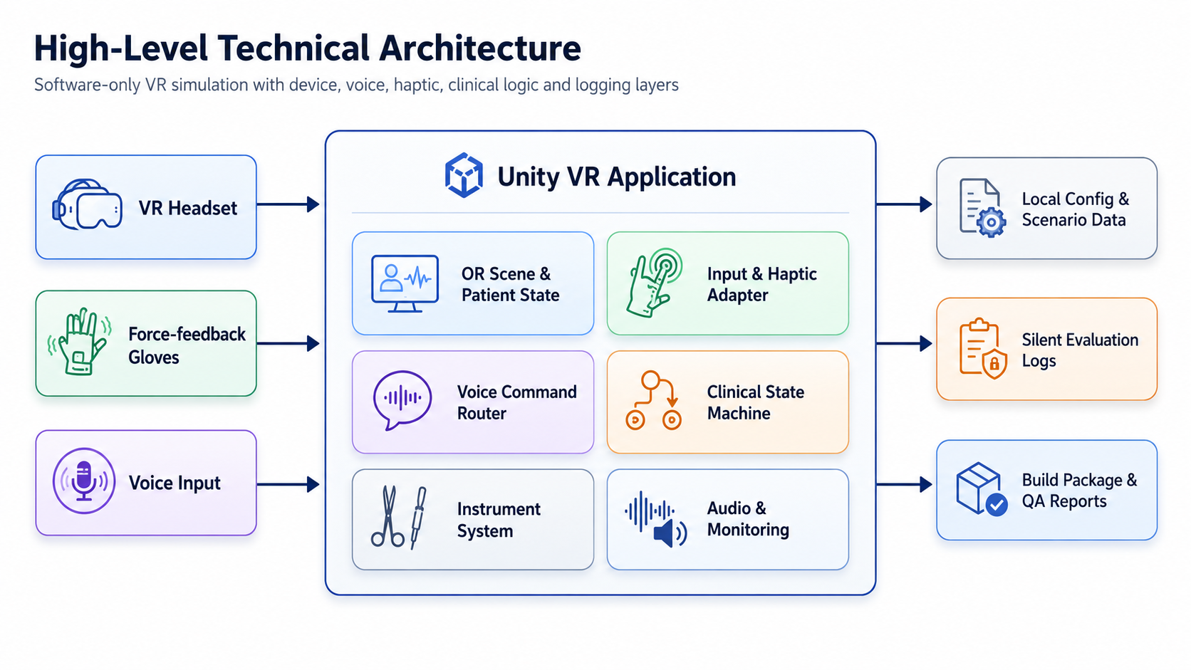
Figure 1: High-Level Technical Architecture

6.2 End-to-End Simulation Workflow
The workflow follows the documented clinical sequence and uses natural actions as progress triggers instead of visible next buttons or scores.
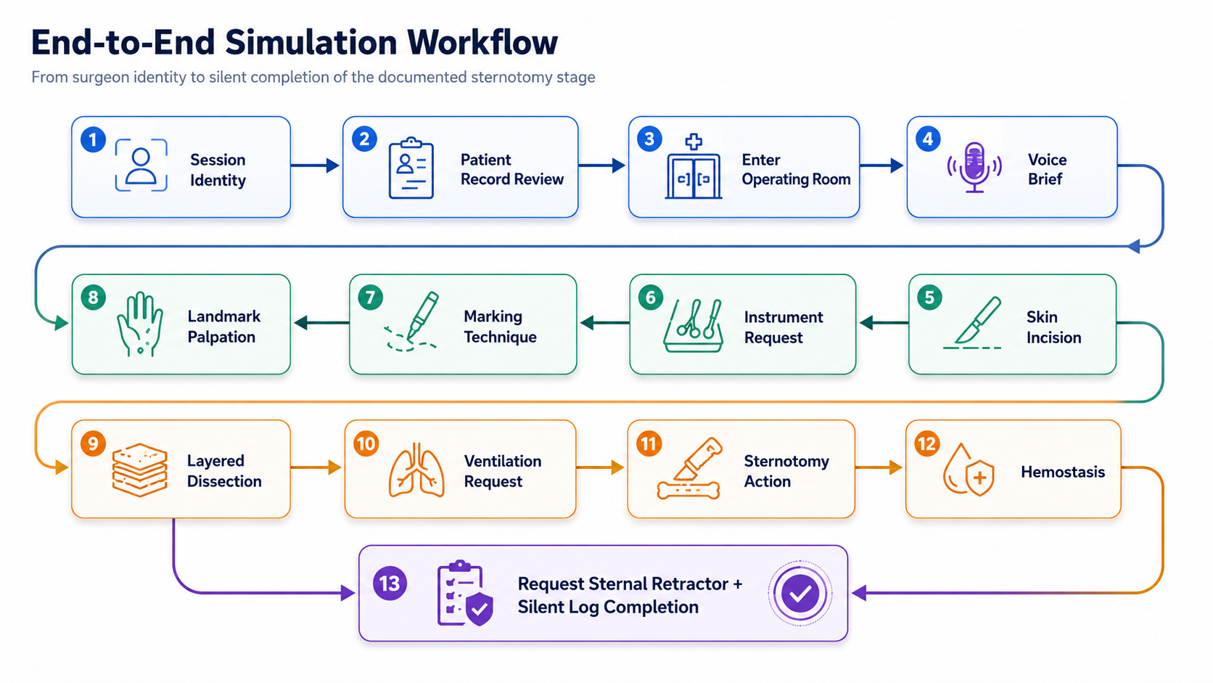
Figure 2: End-to-End Simulation Workflow

6.3 Silent Assessment and State Logic
The logic layer captures user behavior, validates it internally and stores the result without interrupting the clinical flow.
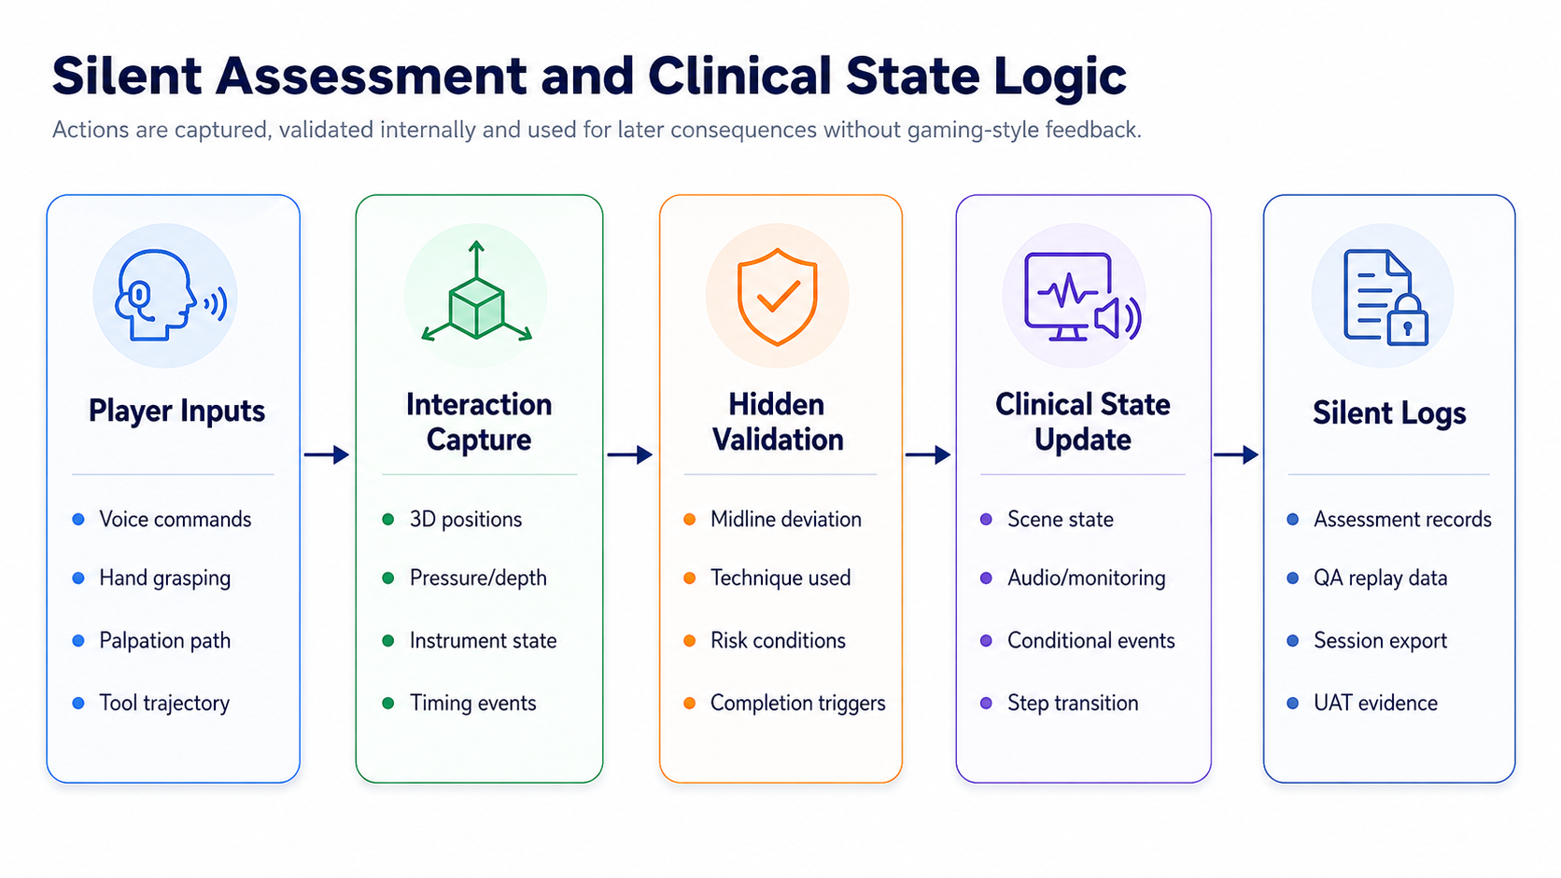
Figure 3: Silent Assessment and Clinical State Logic

7. Development Methodology
The project will follow an Agile delivery approach with short clinical review checkpoints. Because the product is a surgical simulation, clinical validation and iterative review are more important than adding unnecessary features.
Stage | Activities | Output
Discovery and Alignment | Review requirement document, confirm target hardware, confirm final scope boundaries and define acceptance criteria. | Finalized technical scope and sprint plan.
Prototype and Technical Spike | Validate headset setup, glove SDK, grasp detection, voice command feasibility and basic OR interaction. | Approved technical baseline.
Core Scene and Systems Build | Build OR scene, patient state, instruments, patient record, interaction layer and monitoring/audio foundation. | Functional VR environment.
Step 1 Implementation | Implement landmark localization, marking techniques, haptic response and silent evaluation events. | Clinically reviewable Step 1.
Step 2 Implementation | Implement documented incision/dissection/sternotomy sequence, voice interactions, conditional events and assessment logs. | Clinically reviewable Step 2.
QA, Optimization | Run functional, haptic, voice, performance and clinical acceptance testing. | Release candidate and QA sign-off package.
Deployment and Handover | Package Windows PCVR build, setup guide, test report and technical documentation. | Final delivery package.

8. Deliverables
Deliverable | Description | Format
Requirement Validation Note | Confirmed interpretation of the Sternotomy scope, hardware dependencies and acceptance criteria. | DOCX/PDF
Technical Design Document | Architecture, modules, data/state logic, haptic approach and integration details. | DOCX/PDF
VR Application Build | Windows PCVR build of the Sternotomy simulation covering the agreed Step 1 and Step 2 scope. | Executable build package
3D Scene and Asset Package | Operating room, patient state, instruments, monitors and related simulation assets. | Unity project assets
Voice Command Module | Command logic for instrument requests and anesthesiologist interaction. | Integrated module
Haptic Interaction Module | Glove-based grasping, palpation, resistance and instrument interaction mapping. | Integrated module
Silent Assessment Module | Internal event logging and session result model. | Integrated module + sample export
Audio and Monitoring Module | Operating room ambience, monitor values, equipment sounds and concise team responses. | Integrated module
QA Test Report | Functional, device, haptic, voice, performance and QA test summary. | DOCX/PDF
Deployment and Handover Guide | Installation, hardware setup assumptions, build running guide and maintenance notes. | DOCX/PDF

9. Testing and Quality Assurance
Testing will focus on clinical flow correctness, VR usability, hardware integration, haptic response, voice command reliability and performance stability.
Testing Area | What Will Be Tested | Acceptance Focus
Requirement Traceability | Each documented feature mapped to implementation and QA cases. | No required scope item is missed.
Functional Testing | Session identity, patient record, OR entry, instrument handoff, clinical sequence and completion triggers. | Defined flows work consistently.
Haptic Testing | Glove calibration, grasp states, palpation areas, tool resistance and feedback profiles. | Interactions feel stable and repeatable on target hardware.
Voice Command Testing | Instrument requests, inactivity reminders and anesthesiologist commands. | Recognized commands trigger correct responses without unintended actions.
Clinical Scenario Testing | Step 1 techniques, Step 2 sequence, conditional events and silent logging. | Clinical logic matches supplied specification.
Performance Testing | Frame rate, latency, asset performance, load time and device stability. | Smooth PCVR operation on approved hardware.
Audio Testing | Spatial ambience, monitor audio, equipment audio and team responses. | Audio triggers correctly and does not distract from workflow.
Usability and Comfort Testing | VR navigation, posture, reach, readability and interaction comfort. | Comfortable operation for the target training session duration.
Regression Testing | Previously accepted workflows retested after each major build. | New changes do not break approved behavior.

10. Implementation Timeline
Proposed timeline: 4 months

11. Assumptions, Dependencies and Scope Exclusions

11.1 Assumptions
- The client will provide access to the final target headset and force-feedback glove hardware for development and QA.
- The client will provide or approve final clinical reference materials, visual references, voice scripts and any required media assets.
- Clinical validation feedback will be available at planned review checkpoints.
- The simulation will use fictional or provided training data only; no live hospital system integration is required.
- The initial delivery will be a standalone PCVR application unless a centralized reporting system is separately requested.

11.2 Dependencies
- Final headset model, runtime and PC specification.
- Final force-feedback glove model, SDK documentation, license and support access.
- Final voice language/accent requirements for nurse and anesthesiologist interactions.
- Client review turnaround time for clinical accuracy and visual realism.

11.3 Scope Exclusions
The proposal excludes hardware procurement, regulatory certification, additional surgical stages, multiplayer training, LMS integration, cloud dashboards and real hospital data integration unless added through a separate change request.

12. Conclusion
The proposed Sternotomy VR Surgical Simulation will be developed from scratch as a focused, clinically realistic desktop VR training solution. The project will prioritize accurate surgical workflow simulation, voice-based team interaction, instrument handling, haptic feedback, silent performance tracking, and realistic operating room conditions without adding unnecessary gaming mechanics. By following a structured development methodology, validated technical approach, and strong QA process, the solution will support safe, repeatable, and immersive surgical training aligned with the defined scope.

