TECHNICAL PROPOSAL
Sudan-Based Telco Reward Battle Royale Game
Play. Survive. Collect Treasure. Win Rewards.

Prepared By: Riseup Labs


Table of Contents
1. Executive Summary 3
2. Understanding of Requirement 3
2.1 Source Requirement Alignment 3
2.2 Client Constraints Factored In 3
3. Phase 1 Objectives 4
4. Scope of Work and Feature List 4
4.1 Future Phase Items Not Included in Phase 1 5
5. Proposed Technical Approach 5
5.1 Localization Approach 6
5.2 Reward Integrity Approach 6
6. Proposed Technical Stack 6
7. Solution Architecture and Diagrams 7
7.1 High-Level Solution Architecture 7
7.2 Gameplay and Reward Flow 8
7.3 Localized Map Zone Concept 8
8. Development Methodology 9
9. Deliverables 9
10. Testing and Quality Assurance 10
11. Assumptions, Dependencies and Risks 11
11.1 Assumptions 11
11.2 Key Risks and Mitigation 11
12. Acceptance Criteria 11
13. Conclusion 12

1. Executive Summary
The proposed solution is a Sudan-based, mobile-first, real-time multiplayer battle royale prototype designed for telecom-backed customer engagement. The game combines survival gameplay, treasure collection, localized Sudan-inspired environments, and a basic telco reward redemption flow into one lean Phase 1 product.
The Phase 1 objective is to validate the core gameplay loop and telco reward model before investing in larger-scale features such as squads, tournaments, sponsored events, additional maps, or advanced analytics. The solution is therefore scoped around one playable localized map, solo match mode, 20-40 player support, mobile number/OTP login, leaderboard, reward wallet, recharge/data reward flow, and admin control for rewards and campaigns.
The client-specific updates have been factored into the proposal: character designs will be heavily localized for Sudan, the playable map will include Nile bridges, telecom towers, university districts, and shopping markets, and the overall graphics quality will receive a controlled upgrade while still protecting performance on practical mobile devices.

2. Understanding of Requirement
Based on the provided game concept document, the required product is a localized Sudan market multiplayer survival game inspired by the Treasure Wars model. The game should allow players to enter a competitive battlefield, collect gameplay items and treasure, survive a shrinking safe zone, earn points, and redeem eligible rewards through telecom benefits such as recharge or data packs.

2.1 Source Requirement Alignment
Requirement Area | Phase 1 Interpretation | Proposal Response
Game concept | Real-time multiplayer survival and treasure-hunting mobile game for Sudan. | Unity-based mobile prototype with authoritative multiplayer match flow.
Gameplay loop | Login, enter match, collect items/treasure, survive, score, redeem rewards. | Dedicated gameplay and reward flow is included with server-side validation.
Localization | Sudan-inspired map and culturally relevant style. | Localized character art, map props, UI language readiness, and fictionalized Sudan market zones.
Map zones | Nile crossings, urban blocks, markets, local landmarks. | Nile bridges, telecom towers, university districts, and shopping markets are included in the Phase 1 map plan.
Reward operations | Basic telco reward system and admin control. | Reward wallet, redemption tracking, admin campaign/reward configuration, and telco API adapter.
MVP constraint | Self-funded, immediate start, no user benchmark yet. | Lean scope, staged load testing, flexible cloud setup, and no non-required features.

2.2 Client Constraints Factored In
- Budget sensitivity: the first release should avoid over-engineered services and unnecessary game modes.
- Immediate start: discovery, technical setup, and art-direction approval should run in parallel during Week 1.
- Unknown user scale: Phase 1 should support controlled 20-40 player matches and collect operational learnings before scaling infrastructure.
- Localization priority: the game should look clearly Sudan-specific rather than a generic multiplayer game.
- Graphics quality: improve visual quality through stylized art, lighting, UI polish, and optimized assets rather than expensive AAA-style production.

3. Phase 1 Objectives
Objective | Expected Outcome
Validate core gameplay | Players can enter a solo match, move, collect, compete, survive the safe zone, and complete a match result flow.
Validate multiplayer readiness | A controlled real-time match supports 20-40 players, with bot support available if early user density is low.
Validate Sudan localization | One playable map includes the required Sudan-inspired zones and localized character direction.
Validate telco reward flow | Reward wallet and recharge/data pack redemption flow work through a secure backend and telco API adapter.
Validate admin operations | Admin can manage rewards, campaigns, basic player/reward records, and redemption statuses.
Prepare for scale decisions | Prototype generates technical learning on device performance, networking, server capacity, and user engagement potential.

4. Scope of Work and Feature List
The following feature list is intentionally limited to the Phase 1 prototype requirement. Future expansion items are not included in the implementation scope unless separately approved later.
Module | Included Phase 1 Features | Notes / Boundary
Mobile Game App | Android-first mobile game build; mobile number/OTP login; profile entry; lobby; solo match entry; game HUD; match result screen; leaderboard; reward wallet UI. | iOS build can be packaged if required, but Android-first keeps the MVP lean for initial market testing.
Core Gameplay | Solo battle royale mode; 20-40 player match support; basic movement; game item pickup; treasure collection; health/armor; shrinking safe zone; match scoring. | No duo, squad, custom room, tournament, or advanced cosmetics in Phase 1.
Multiplayer | Lobby/matchmaking, match lifecycle, authoritative server validation, session tracking, controlled reconnect handling, optional bot fill. | Focus on stable prototype gameplay rather than large-scale public launch infrastructure.
Localized Characters | Sudan-localized stylized character direction, culturally relevant clothing/color references, controlled character set for Phase 1, animation-ready design preparation. | Characters should be fictional and culturally respectful, not based on real individuals.
Localized Map | One playable map with Nile bridges, telecom towers, university districts, shopping markets, loot/treasure points, safe zone boundaries, and optimized environment props. | Map remains fictionalized and avoids political or conflict references.
Graphics Upgrade | Improved stylized visual quality, optimized shaders, lighting pass, UI polish, mobile-friendly textures, LOD/compression approach. | Upgrade is quality-focused but not a high-cost photorealistic rebuild.
Telco Reward Flow | Reward wallet, reward eligibility rules, redemption request, recharge/data pack reward flow, redemption status, audit trail. | Final issuance depends on telco API/SMS/reward gateway availability.
Admin Panel | Admin login, basic dashboard, reward catalog, campaign setup, redemption review, player/reward records, basic fraud flags. | No full analytics dashboard, CRM, merchant marketplace, or advanced segmentation in Phase 1.
Backend Services | User profile, auth token exchange, match records, leaderboard, reward ledger, campaign/reward APIs, admin APIs, audit logs. | Backend must be server-trusted for rewards and match outcome validation.

4.1 Items Not Included in Phase 1
- Duo/squad modes, custom rooms, tournaments, sponsored events, influencer campaigns, and university tournament management.
- Additional Sudan-inspired maps beyond the single Phase 1 map.
- Advanced cosmetics, branded skin marketplace, partner voucher ecosystem, full analytics dashboard, and advanced reward campaign engine.
- Large-scale production launch infrastructure before the pilot demonstrates user traction.
- Multiplayer server cost.
- SMS cost.
- Reward cost.

5. Proposed Technical Approach
The recommended technical approach is to build a Unity mobile game with an authoritative multiplayer backend and a separate reward/admin backend. This separation keeps gameplay synchronization, reward validation, and admin operations clean, secure, and easier to scale after the prototype stage.
Approach Area | Implementation Direction
Prototype-first game development | Start with a gray-box playable map and core match loop before polishing graphics. This ensures gameplay, networking, and reward logic are validated early.
Server-trusted match and reward model | The client displays gameplay and user actions, but final match results, treasure score, reward eligibility, and redemption approvals are validated server-side.
Lean real-time multiplayer | Use a controlled 20-40 player match target with a single game mode, match lifecycle management, and optional bots to support early-stage testing.
Mobile performance discipline | Use optimized stylized art, texture compression, level-of-detail planning, limited particle effects, and device profiling to protect FPS and memory usage.
API adapter for telco rewards | Build a telco integration adapter so the game backend can work with a mock reward provider during development and switch to real recharge/data APIs during integration.
Scalable but not overbuilt | Start with containerized services on a cost-aware cloud/server setup. Move to orchestration and autoscaling only after user demand is clearer.

5.1 Localization Approach
- Character design will use Sudan-inspired clothing, hairstyles, color palettes, and stylized proportions suitable for a mobile game.
- Map design will use fictionalized versions of Nile bridge areas, telecom tower landmarks, university districts, and shopping markets.
- The environment will avoid sensitive political, military, or conflict-related references and remain entertainment-focused.
- The art pass will reuse suitable existing concept assets where possible, then apply localization, mobile optimization, and visual polish.

5.2 Reward Integrity Approach
- Rewards are generated only after server-side validation of match results and player eligibility.
- Reward wallet transactions are recorded in a backend ledger with status, timestamp, campaign ID, and admin/audit trail.
- Redemption limits and suspicious activity rules will be implemented to reduce basic reward abuse.
- The telco reward adapter will support retry, failure status, and manual admin review for failed redemption attempts.

6. Proposed Technical Stack
Layer | Proposed Stack | Purpose
Game Client | Unity 6, C#, Universal Render Pipeline, Android build target, optional iOS packaging | Mobile gameplay, rendering, UI, animations, local assets, device-level performance.
Real-Time Networking | Unity Netcode for GameObjects with Unity Transport; headless authoritative Unity server | Real-time match synchronization, player state, safe zone, item/treasure events, and match result validation.
Matchmaking / Sessions | Node.js / NestJS service with Redis | Queue management, lobby, match allocation, bot fill rules, temporary session state.
Backend API | Node.js / NestJS REST APIs | Authentication integration, user profiles, leaderboard, match records, reward wallet, redemption workflow, admin APIs.
Database | PostgreSQL | Persistent data for users, rewards, campaigns, wallet transactions, match summaries, admin logs.
Cache / Queue | Redis | Session cache, matchmaking state, lightweight queues, rate limiting.
Admin Panel | React.js, TypeScript, Tailwind CSS | Reward and campaign management, redemption review, player/reward records, and basic operational dashboard.
Authentication | Firebase Phone Auth or telco-approved SMS OTP gateway with backend token exchange | Mobile number verification, OTP sign-in, secure session handling.
Cloud / Deployment | Dockerized services on AWS/GCP/Azure/telco cloud; Linux game server instances | Cost-aware deployment for prototype with a clear path to scale later.
Monitoring / QA | Crashlytics or equivalent, Unity Profiler, API logs, server metrics, load-test tooling | Crash visibility, performance profiling, match stability monitoring, and QA evidence.
Version Control / CI | GitHub/GitLab, GitHub Actions or GitLab CI, Docker registry | Controlled source management, automated builds, release packaging, environment deployment.

7. Solution Architecture and Diagrams
The diagrams below are included to make the proposal implementation-ready.

7.1 High-Level Solution Architecture
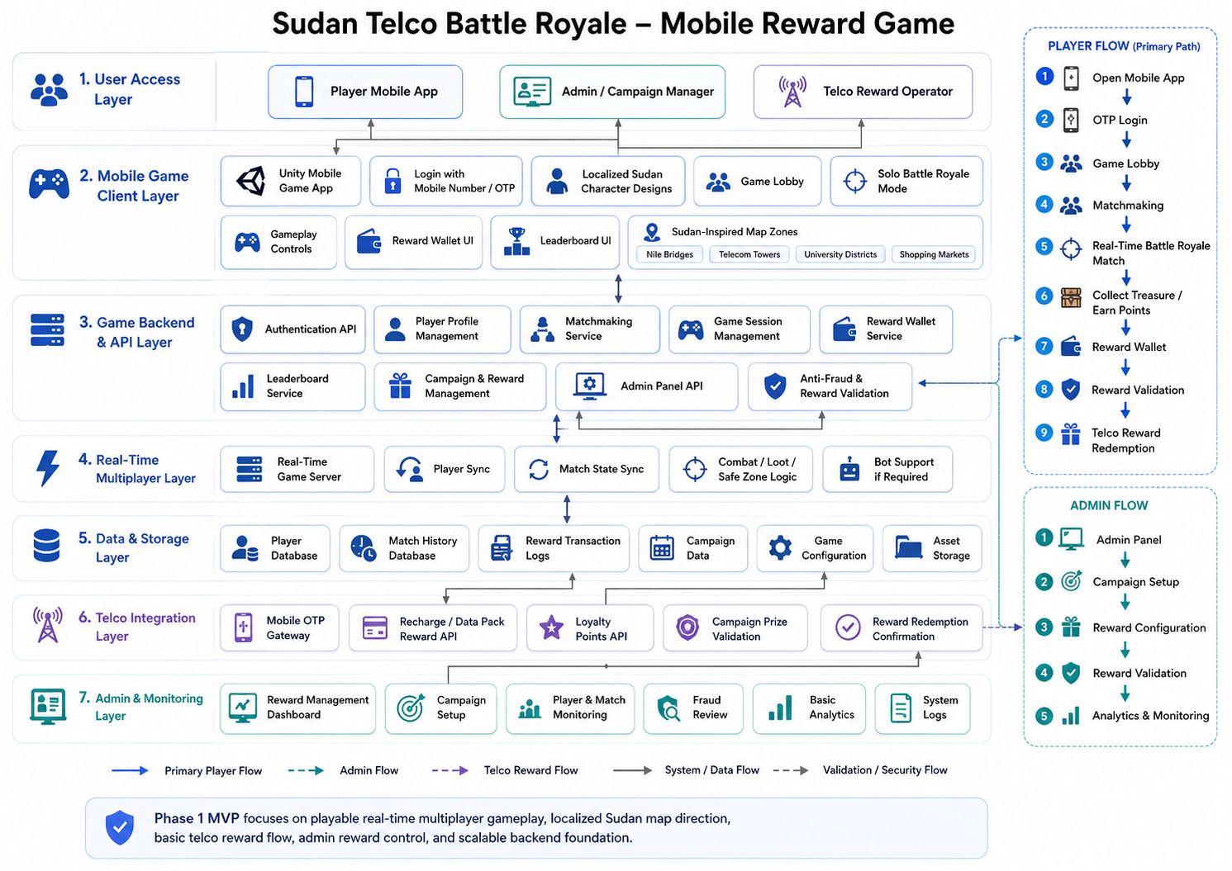
Figure 1: Proposed architecture for a lean Phase 1 multiplayer game with reward validation and telco integration.

7.2 Gameplay and Reward Flow
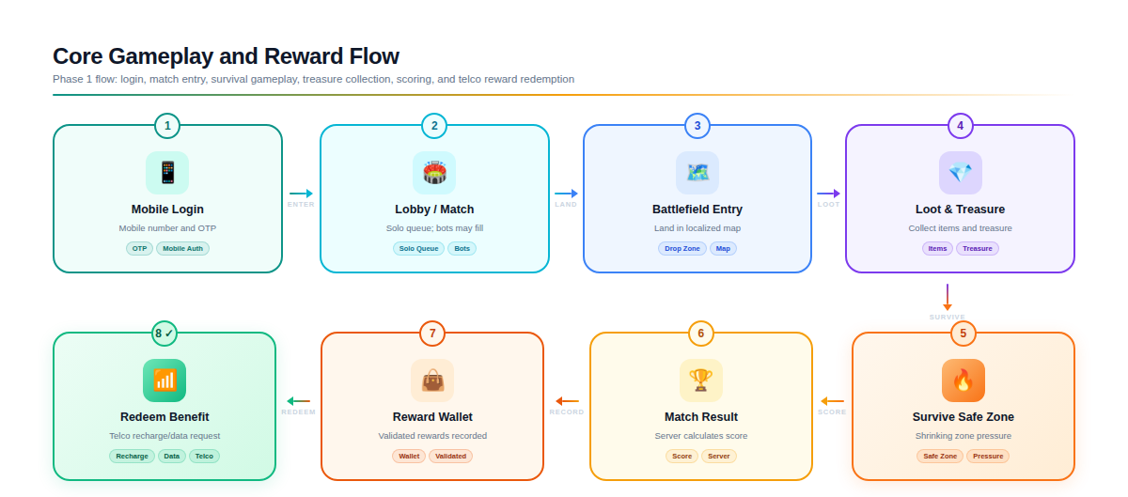
Figure 2: Core gameplay and reward redemption flow for the required Phase 1 scope.

8. Development Methodology
The project will follow an Agile, prototype-first delivery approach with weekly playable builds. The methodology prioritizes early gameplay validation, early network validation, and controlled art localization before final polishing.
Phase | Activities | Output
Discovery and planning | Confirm game scope, technical decisions, target devices, telco API assumptions, art references, and sprint plan. | Approved product/technical backlog and art direction.
Gameplay prototype | Build gray-box map, player controller, match lifecycle, item pickup, treasure flow, safe zone, and scoring. | Playable single-map prototype build.
Multiplayer implementation | Implement matchmaking, server sync, authoritative validation, match start/end, session handling, and bot fill if required. | Real-time multiplayer prototype.
Localization and graphics | Create localized characters, map landmarks, UI polish, lighting, optimized assets, and mobile performance pass. | Localized Sudan-inspired game build.
Reward and admin integration | Develop reward wallet, redemption workflow, admin panel, campaign/reward setup, and telco adapter. | Reward-enabled prototype with admin operations.
QA and stabilization | Run functional, performance, multiplayer, security, reward, and compatibility testing. | Release candidate build and QA report.
Deployment and handover | Prepare staging/production environments, build packaging, source handover, and documentation. | Final Phase 1 prototype package.

9. Deliverables
Deliverable | Description
Project initiation pack | Scope confirmation, backlog, sprint plan, risk register, and communication plan.
Game design and technical design document | Gameplay loop, match rules, reward rules, architecture, API approach, and data model overview.
Playable mobile game build | Android prototype build with login, lobby, solo battle royale match, treasure collection, safe zone, scoring, and reward wallet.
Localized map asset package | One Sudan-inspired playable map with Nile bridges, telecom towers, university districts, shopping markets, and optimized environment props.
Localized character package | Phase 1 localized character designs, selected 3D models/animations, and mobile optimization pass.
Multiplayer game server | Authoritative match server build, session/match lifecycle, match result validation, and basic scaling setup.
Backend API and database | Auth integration, user profile, match records, leaderboard, reward ledger, campaign/reward APIs, and admin APIs.
Admin panel | Reward management, campaign setup, redemption review, player/reward records, and basic operational dashboard.
Telco reward adapter | Integration-ready adapter for recharge/data pack reward flow with mock/sandbox support until live API is available.
QA documentation | Test plan, test cases, compatibility matrix, load test summary, defect log, and release readiness checklist.
Deployment and handover package | Build files, source code repository, deployment guide, environment configuration, API documentation, and admin user guide.

10. Testing and Quality Assurance
Testing will be planned from the first sprint because multiplayer and reward-based systems require early validation. The QA approach will focus on stability, device compatibility, fair reward validation, and practical launch readiness.
QA Area | Testing Coverage | Expected Evidence
Functional QA | Login, lobby, match entry, movement, item pickup, treasure collection, health/armor, safe zone, scoring, leaderboard, reward wallet, admin operations. | Functional test cases and defect log.
Multiplayer QA | 20-40 player room tests, synchronization, latency behavior, match start/end, disconnect/reconnect, server validation, bot fill behavior. | Multiplayer test summary and known limitation log.
Performance QA | FPS, memory, loading time, asset compression, shader performance, UI responsiveness, thermal/device stress checks on target Android devices. | Device performance report and optimization notes.
Compatibility QA | Android OS versions, screen sizes, low/mid-range devices, mobile network conditions, storage and install validation. | Compatibility matrix.
Reward QA | Reward eligibility, wallet ledger, redemption status, failure/retry handling, admin review, telco adapter sandbox testing. | Reward flow test report and sample audit records.
Security and Anti-Fraud QA | OTP abuse controls, API rate limits, server-trusted rewards, token handling, admin permissions, validation bypass checks. | Security checklist and remediation log.
Localization and Visual QA | Character localization, map zone representation, UI text, visual consistency, cultural sensitivity review, graphics quality pass. | Localization review notes and visual QA checklist.
Release QA | Build signing, crash reporting, final regression, deployment configuration, rollback readiness, documentation verification. | Release readiness checklist.

11. Assumptions, Dependencies and Risks

11.1 Assumptions
- The Phase 1 product is a prototype/MVP for market testing, not a full public-scale live operations platform.
- One localized playable map is included in Phase 1.
- The target match size is 20-40 players, with optional bot support if real player density is low during testing.
- Telco reward APIs, SMS OTP gateway, or approved integration details will be provided by the client/telco partner in time for integration.
- The client will provide approval on Sudan localization references, character direction, and map zone references early in the project.
- App store accounts, production SMS credentials, live reward API credentials, and legal/compliance approvals are client-side dependencies.

11.2 Key Risks and Mitigation
Risk | Impact | Mitigation
Telco API delay | Reward flow cannot be fully tested with live recharge/data pack issuance. | Use a mock/sandbox adapter first; keep live adapter isolated for later credential/API activation.
Localization approval delay | Character and map art may need rework. | Approve mood board, character references, and zone sketches in Week 1 before heavy production.
Multiplayer desync or latency | Poor gameplay experience during real-time match testing. | Build multiplayer foundation early, use server authority, run latency tests, and keep Phase 1 match rules simple.
Low/mid-range device performance | Game may lag or overheat on target devices. | Use mobile-first URP settings, optimized assets, texture compression, LODs, limited effects, and device profiling.
Unknown user benchmark | Server sizing may be inaccurate for a public launch. | Start with controlled pilot capacity and use monitoring/load testing before scaling.
Reward abuse | Users may attempt to manipulate rewards or replay results. | Validate results server-side, store reward ledger, apply redemption limits, rate-limit APIs, and log suspicious activity.

12. Acceptance Criteria
- Mobile game build installs successfully on agreed Android test devices and supports OTP login or approved test authentication.
- A player can enter a solo match, collect items/treasure, survive the safe zone, complete a match, and see match results.
- Controlled multiplayer test supports the agreed 20-40 player target with documented performance results.
- One localized map includes Nile bridges, telecom towers, university districts, and shopping markets in a fictionalized Sudan-inspired style.
- Localized character design direction is implemented and approved for Phase 1 quality level.
- Reward wallet records eligible rewards after server validation and supports recharge/data pack redemption through mock, sandbox, or live telco API adapter depending on available credentials.
- Admin panel supports reward/campaign management and redemption review for Phase 1 operations.
- QA report, known issues list, deployment notes, source code, and handover documentation are delivered.

13. Conclusion
This technical proposal presents a clean, lean, and implementation-ready Phase 1 plan for the Sudan-based Telco Reward Battle Royale Game. The proposed approach keeps the scope limited to the required core gameplay, Sudan localization, multiplayer prototype, reward wallet, telco reward flow, and admin control. The architecture is intentionally practical for a self-funded market test while keeping a clear path for scale and future expansion after validation.

