Technical Proposal
AI-Based Invoice Processing Solution
for Bills Payable Automation
Prepared by: Riseup Labs


Table of Contents
1. Executive Summary 3
2. Understanding of Requirements 3
3. Proposed Solution Capabilities 4
4. Proposed Architecture 4
5. Technical Approach 6
5.1 Document Intake 6
5.2 Pre-Processing and Extraction 6
5.3 Supporting Document Retrieval 6
5.4 Validation and Matching 6
5.5 Exception Handling 6
5.6 SAP Posting 6
5.7 Reporting and MIS 6
5.8 Learning and Accuracy Improvement 6
6. SAP Integration Feasibility 7
7. Proposed Technical Stack 9
8. Development Methodology 9
9. Deliverables 10
10. Testing and Quality Assurance 10
11. Infrastructure and Deployment Requirements 11
12. Security, Governance and Compliance 11
13. Assumptions and Dependencies 12
14. Conclusion 12

1. Executive Summary
The proposed solution is an AI-based invoice processing platform for automating and strengthening the Bills Payable function. The platform will capture invoice data from scanned invoices, PDF files and images, validate the extracted information against supporting documents and SAP master/transactional data, highlight exceptions, support controlled review and maintain complete audit records.
The recommended implementation uses React for the user interface and Laravel for the backend API, workflow, validation orchestration, audit logging and integration layer. AI/OCR capabilities will be implemented through a pluggable extraction service so that the client can use an approved OCR/AI engine, SAP Document Information Extraction, or a custom OCR/ML model depending on licensing, accuracy and governance preferences.
The solution is intentionally focused on the requested core capabilities: invoice extraction, document validation, exception detection, SAP integration, audit trail, dashboard reporting, machine-learning-assisted improvement and secure access control.

2. Understanding of Requirements
Requirement Area | Client Need | Proposed Response
Invoice data extraction | Extract data from scanned invoices, PDFs and image files. | OCR + AI extraction pipeline with confidence scoring and review of low-confidence fields.
Supporting document validation | Validate invoice details against PR, PO, CS, GRN, Delivery Challan, Contract and Approval Matrix. | Validation engine retrieves data from SAP/repository and compares invoice header, vendor, amount, quantity, rate and approval details.
Exception detection | Identify mismatches, missing approvals, duplicates, quantity/rate variances and policy non-compliance. | Configurable rule checks with exception queues and audit trail.
SAP integration | Retrieve documents, validate against SAP data and post invoices. | SAP connector using approved OData/API/RFC/BAPI/IDoc channel depending on client SAP landscape.
Audit and governance | Maintain complete audit trail of validation, exception and user actions. | Immutable activity log, role-based access and traceable status history.
Dashboard and MIS | Provide reporting, KPI monitoring and management MIS. | Operational dashboards for volume, exception aging, processing status, validation result and accuracy trend.
Learning over time | Use historical transactions to improve accuracy. | Feedback loop from approved corrections and historical invoice patterns to improve extraction templates/rules.
Security and compliance | Ensure secure access, data security and corporate governance alignment. | RBAC, encryption, secure file storage, API security, access logs and environment segregation.

3. Proposed Solution Capabilities
Invoice Capture and Upload: Upload scanned invoices, PDFs and image files through a secure web portal. Files are stored in an encrypted document repository and assigned tracking IDs.
AI/OCR Extraction: Extract invoice number, vendor, invoice date, amount, tax, currency, PO reference, line items, quantity, rate and totals. Each field will include confidence status for review handling.
Document Matching and Validation: Validate invoice information against PR, PO, CS, GRN, Delivery Challan, contract and approval matrix details available in SAP or approved repositories.
Exception Identification: Identify duplicate invoices, missing approvals, vendor mismatch, quantity/rate variance, amount variance, missing GRN/delivery confirmation and policy non-compliance.
Exception Review Workflow: Route exceptions to the AP team or authorized user group for review, correction, clarification and controlled approval before posting.
SAP Document Retrieval and Invoice Posting: Retrieve required SAP data for validation and post approved invoices to SAP using the agreed integration mechanism.
Dashboard, KPI and MIS Reporting: Track invoice volume, processed invoices, exception rate, pending review, validation success rate, posting status and processing turnaround indicators.
Audit Trail and Governance: Capture each system validation, user action, exception decision and SAP response with date/time, user ID and status history.
Accuracy Improvement: Use historical invoices and approved corrections to improve extraction rules, templates, field mapping and confidence thresholds over time.
Security and Access Control: Provide role-based access, secure authentication, API-level authorization, encrypted file handling and controlled access to reports and actions.

4. Proposed Architecture
The architecture separates the user portal, application API, AI/OCR processing, validation logic, SAP connector, storage, audit and reporting layers. This approach keeps the core application maintainable while allowing the AI extraction component and SAP connectivity method to be adjusted based on the client environment.
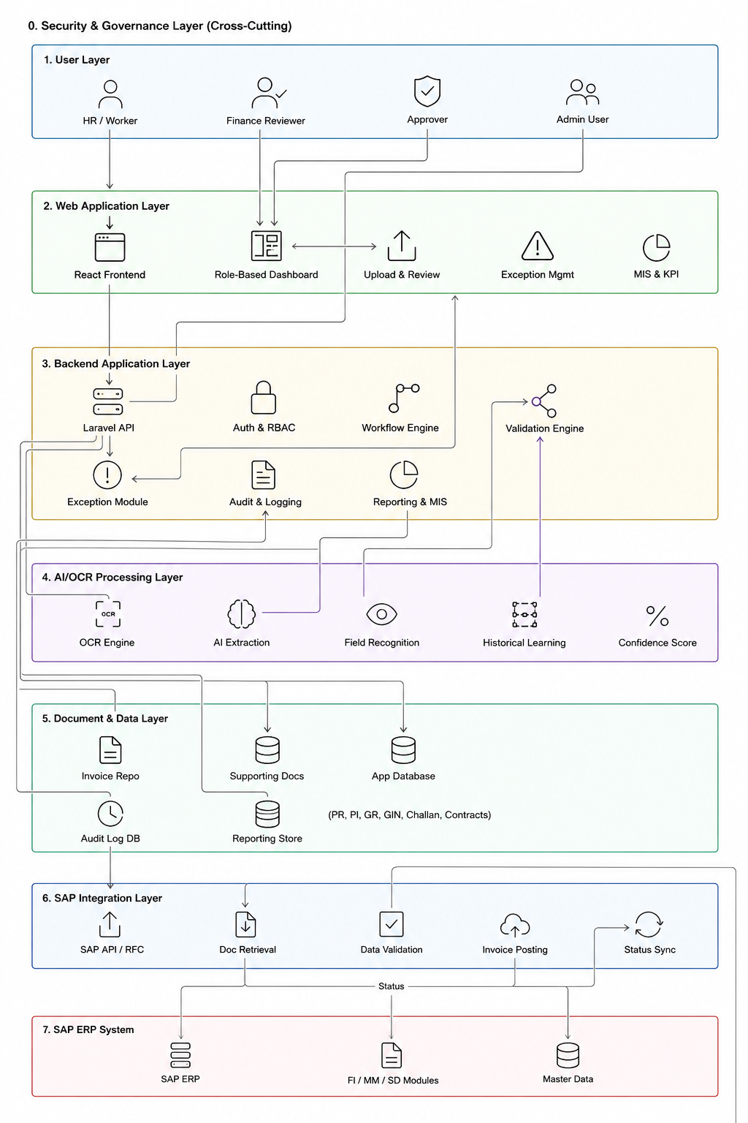
Figure 1: Proposed high-level solution architecture

5. Technical Approach

5.1 Document Intake
The system will allow authorized users to upload invoice documents in PDF, scanned image and common image formats. Each document will be assigned a unique tracking ID and stored in a secure repository. Basic file checks will validate file type, file size and processing status.

5.2 Pre-Processing and Extraction
Invoices will be cleaned and prepared for extraction using image pre-processing where required. OCR and AI extraction will identify invoice header fields and line-item details. Extracted values will be stored with confidence indicators so that only uncertain fields require user review.

5.3 Supporting Document Retrieval
The system will retrieve or receive relevant reference information such as PR, PO, CS, GRN, Delivery Challan, contract and approval matrix data from SAP or approved client repositories. The final retrieval approach will be confirmed during SAP discovery.

5.4 Validation and Matching
The validation engine will compare invoice data with supporting documents and SAP records. Core rules will cover vendor, invoice number, PO reference, amount, tax, quantity, rate, GRN/delivery reference, approval status, duplicate invoice and defined policy/tolerance checks.

5.5 Exception Handling
Records that fail validation or have low confidence will be routed to an exception queue. Authorized users can review the reason, correct extracted values if required, add remarks and move the invoice toward approval or rejection based on the agreed workflow.

5.6 SAP Posting
Invoices that pass validation and approval will be posted to SAP through the agreed integration channel. SAP posting responses, document numbers, error messages and retry statuses will be captured in the platform.

5.7 Reporting and MIS
Dashboards will show invoice processing status, exception categories, aging, validation success rate, posting status and other agreed KPIs. Reports will focus on operational control rather than adding unnecessary analytics features beyond the requested scope.

5.8 Learning and Accuracy Improvement
The system will retain approved corrections and validation outcomes to improve extraction rules, templates and field confidence thresholds over time. Any model training or advanced learning mechanism will be implemented within approved data governance boundaries.
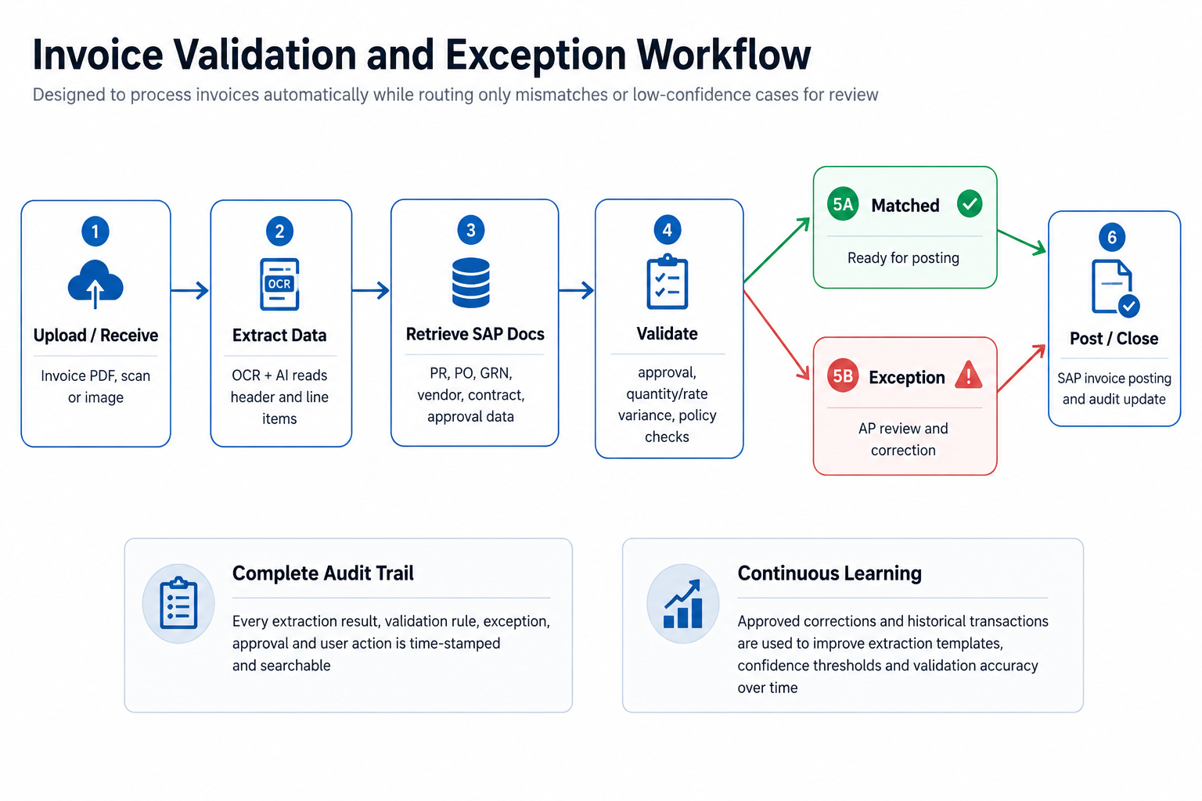
Figure 2: Invoice validation and exception workflow

6. SAP Integration Feasibility
The solution is technically feasible for SAP integration, subject to confirmation of the client SAP version, available APIs, network/security policy, sandbox access and posting approval rules. SAP officially supports enterprise integration through SAP Integration Suite, which connects cloud and on-premise applications and provides prebuilt integration capabilities, API management and connectivity options [R1].
For supplier invoice posting in SAP S/4HANA Cloud, SAP provides supplier invoice APIs including create/read/release/reverse operations through the Supplier Invoice API service [R2]. Where the client uses SAP ECC or a customized landscape, the integration design can use approved RFC/BAPI, IDoc, OData, middleware or file-based interface after SAP technical discovery.
SAP also provides document information extraction and invoice capture capabilities in its invoice management ecosystem, including support for OCR and AI-assisted extraction in relevant SAP products [R3][R4]. This confirms that AI-based extraction and SAP invoice processing are aligned with SAP-supported enterprise patterns; the proposed solution can either integrate with such SAP capabilities or use a custom extraction layer based on client preference.
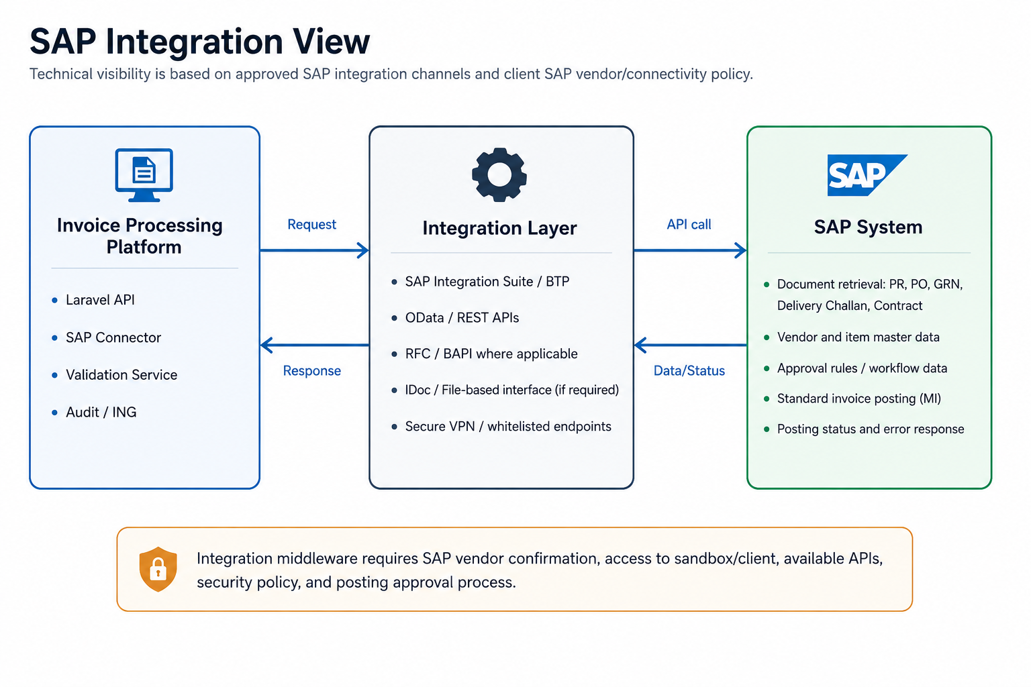
Figure 3: SAP integration view
SAP Touchpoint | Purpose | Preferred Integration Option | Output
Master data | Vendor, tax, currency and company code validation | SAP API/OData/RFC depending on landscape | Validated master data
PR / PO | Match invoice reference, vendor, amount and line items | SAP MM data retrieval API/interface | PO/PR matching result
GRN / Delivery Challan | Validate receipt/delivery confirmation | SAP MM interface or approved repository | Quantity and receipt confirmation
Contract / CS | Validate contract/commercial terms where available | SAP/document repository integration | Rate/term matching result
Approval Matrix | Confirm approval status and authority | SAP workflow/custom table/approved source | Approval validation result
Supplier Invoice Posting | Create approved invoice posting in SAP | SAP Supplier Invoice API/RFC/BAPI/IDoc | SAP document number/status

7. Proposed Technical Stack
Area | Proposed Technology | Purpose
Frontend | React, TypeScript, HTML5, CSS/SCSS | Responsive web portal for upload, review, dashboard and administration screens.
Backend | Laravel, PHP 8.x, REST APIs | Application logic, workflow, validation orchestration, audit logging and integration APIs.
Database | PostgreSQL or MySQL | Transactional data, validation results, configuration, audit records and reporting tables.
Document Storage | Encrypted object storage or secure file server | Invoice and supporting document storage with access control.
AI/OCR Service | Pluggable OCR/AI engine; SAP Document Information Extraction or custom OCR/ML service | Invoice extraction from PDFs/scans/images with confidence score.
Queue & Jobs | Laravel Queues, Redis/Supervisor | Background OCR, validation, SAP sync and retry processing.
SAP Connectivity | SAP Integration Suite/BTP, OData/REST, RFC/BAPI, IDoc as applicable | Retrieve reference data and post approved invoices.
Authentication & Authorization | Laravel Sanctum/Passport or corporate SSO integration | Secure login, API security and role-based access control.
Reporting | React dashboards, Laravel reporting APIs | KPI, MIS and exception monitoring.
Deployment | Dockerized deployment on client-approved cloud/on-premises environment | Repeatable deployment across dev, staging and production.

8. Development Methodology
A phased Agile delivery approach is recommended to keep the implementation controlled, transparent and aligned with the core scope. Each phase will produce reviewable outputs and working increments rather than waiting until the end of development.
Phase 1: Discovery and Solution Design: Confirm invoice formats, SAP landscape, validation rules, approval matrix source, reporting KPIs, user roles and infrastructure policy.
Phase 2: UX and Technical Design: Prepare wireframes, data model, integration design, validation rule matrix, security model and deployment plan.
Phase 3: Core Platform Development: Build React portal, Laravel APIs, document upload, user roles, audit trail, rule configuration and basic dashboards.
Phase 4: AI/OCR and Validation Implementation: Implement invoice extraction, field review, confidence scoring, validation engine and exception workflow.
Phase 5: SAP Integration: Connect with SAP sandbox/client for data retrieval and invoice posting, including error handling and integration audit.
Phase 6: QA, Pilot and Stabilization: Conduct functional, integration, security and performance testing; complete user review and production readiness activities.

9. Deliverables
- Solution requirement confirmation document and validation rule matrix.
- System architecture, data flow and SAP integration design.
- UI/UX wireframes for invoice upload, review, exception handling and dashboards.
- React-based web portal.
- Laravel backend API and workflow services.
- AI/OCR extraction service integration and field mapping configuration.
- Validation engine for supporting document matching and exception detection.
- SAP integration connector for document retrieval and invoice posting.
- Role-based access control, audit trail and activity logs.
- Dashboard, KPI and MIS reporting screens.
- Testing reports, issue log and deployment checklist.
- User guide, admin guide and knowledge transfer session.
- Deployed application in client-approved environment.

10. Testing and Quality Assurance
QA Area | Validation Focus
Functional Testing | Validate upload, extraction, review, exception, approval, dashboard, audit and posting workflows against agreed requirements.
OCR/Extraction Accuracy Testing | Test field-level extraction accuracy using representative invoice samples, including scanned invoices, PDFs and image files.
Validation Rule Testing | Verify duplicate invoice checks, quantity/rate variance, approval matrix, missing GRN/delivery confirmation and policy checks.
SAP Integration Testing | Validate data retrieval, posting, error handling, retry behavior and SAP response logging in sandbox/staging environment.
Role and Permission Testing | Confirm that each role can only access permitted screens, documents, actions and reports.
Security Testing | Check authentication, authorization, file access, API security, logging and sensitive data handling.
Performance Testing | Test processing queue behavior and dashboard response for the agreed invoice volume and concurrency assumptions.
Regression Testing | Verify that changes do not break previously accepted workflows across development iterations.
Data Integrity Testing | Confirm that extracted, corrected, validated and posted values remain consistent across database, audit and SAP response records.
Deployment Testing | Validate environment configuration, backups, migration scripts, scheduled jobs and monitoring readiness.

11. Infrastructure and Deployment Requirements
The final deployment model can be on-premises, private cloud or client-approved cloud environment. The following baseline infrastructure is recommended for initial production planning and can be adjusted after expected invoice volume and SAP connectivity are confirmed.
Component | Minimum Requirement | Notes
Application Server | 2 vCPU, 8 GB RAM, Linux, Docker-capable | Laravel API and React web application hosting.
Worker Server | 2-4 vCPU, 8-16 GB RAM | OCR, validation and SAP sync background jobs. Can be separated for scaling.
Database Server | Managed PostgreSQL/MySQL or 2 vCPU, 8 GB RAM | Transactional records, audit log, reporting data.
Storage | Encrypted object storage or secure file storage | Invoice PDFs/images and supporting documents.
Cache/Queue | Redis | Job queues, retries and background processing.
Network | Secure connectivity to SAP, VPN/whitelisting if required | Required for SAP data retrieval and invoice posting.
Security | TLS certificate, firewall, backup policy and access control | Client security standard to be followed.
Monitoring | Application, job queue and server monitoring | Processing status, failures and system health visibility.

12. Security, Governance and Compliance
- Role-based access control for AP users, reviewers, approvers, administrators, auditors and management viewers.
- Secure authentication through application login or client-approved SSO integration where available.
- Encryption in transit using HTTPS/TLS and encryption at rest for documents and sensitive records based on infrastructure capability.
- Audit trail for document upload, extraction, validation, exception review, approval, posting and user actions.
- Segregated development, staging and production environments.
- Secure API keys/secrets management for SAP and OCR/AI services.
- Backup and retention policy aligned with client finance and governance requirements.
- Controlled access to dashboard and MIS reports based on user role.

13. Assumptions and Dependencies
- Client will provide representative invoice samples covering major vendor formats, scanned documents and PDF invoices.
- Client will confirm supporting document sources, including SAP tables/APIs or document repositories for PR, PO, CS, GRN, Delivery Challan, contract and approval matrix data.
- Client SAP team will provide sandbox access, API/interface details, test credentials and posting rules.
- Final OCR/AI engine will be selected based on client preference, data governance, licensing and expected accuracy.
- Validation tolerance rules, approval matrix logic and exception categories will be confirmed during discovery.
- Production hosting will follow client-approved infrastructure, security and compliance standards.
- Historical transaction data availability will determine the depth of initial learning and accuracy improvement.

14. Conclusion
The proposed AI-based invoice processing solution will automate invoice data extraction, validation, exception detection, SAP integration, audit tracking, and reporting. With a Laravel and React-based architecture, the system will improve processing accuracy, reduce manual effort, strengthen compliance, and support faster decision-making for the Bills Payable function.

