Technical Proposal

CDIP Phonebook Mobile Application (Frontend Development Only)
Prepared by: Riseup Labs
Date: 3 February 2026

1. Introduction
This proposal outlines the technical approach, methodology, deliverables, and recommended technology stack to build the CDIP Phonebook mobile application based on the provided Functional Requirements Document (FRD). The solution will be developed from scratch and will focus exclusively on frontend/mobile app development, including offline-first local storage, SSO-based authentication integration, push notification client integration, multi-language (English/Bengali) UI, and usability features such as search, favorites, QR/vCard sharing, and quick actions.

2. Project Context and Objectives
The CDIP Phonebook application will provide staff directory access organized by Department, Unit/Project, and Staff. It will offer fast search and navigation, quick call/SMS/email actions, group SMS, staff profile details (including QR code and vCard export), offline access with background synchronization, and role-based access controls such as phone number privacy for sensitive groups. The application must support Android (including Android 8 and above) and iOS distribution requirements.

3. Scope of Work

3.1 In Scope (Frontend)
- Cross-platform mobile application development (Android and iOS) from scratch.
- Implementation of all UI screens and frontend logic per FRD modules: organizational hierarchy, staff profile, quick actions, search & navigation, group communication UI, favorites/recent activity, theming, and localization.
- Offline-first local data storage using SQLite and secure client-side background sync mechanisms.
- Integration with client-provided APIs (consumption only): staff directory, org structure, profile assets, sync endpoints, group messaging endpoints (if provided), and notification payload handling.
- SSO integration in the mobile app with the organization’s identity provider (client-provided endpoints/flows).
- Push notification client integration (Android and iOS) as per client’s notification service configuration.
- App store packaging support: iOS build publication support under developer company account; Android source delivery for client Play Store publishing.

3.2 Out of Scope
- Backend API development and hosting (explicitly owned by the client as part of their HRM system).
- Server-side SSO/identity provider configuration and user provisioning.
- Server-side notification engine and admin notification management portal.
- HRM system changes, database design on client servers, or any middleware services.
- UI/UX design services beyond basic implementation refinements for usability and consistency.

3.3 Key Assumptions and Dependencies
- Client will provide documented API specifications (endpoints, payloads, auth method, error codes) and test environments.
- Client will provide SSO method details (e.g., OAuth2/OpenID Connect/SAML via mobile-compatible flow) and required client IDs/secrets.
- Client will provide push notification configuration details (APNs/FCM keys, payload format, topics/segments) and testing access.
- Client will provide staff images via accessible URLs or API endpoints, plus a policy for phone number privacy masking/unmasking.
- Client will provide bilingual content (English and Bengali strings) or approve translations to be used in the app.

4. Functional Coverage Summary (Mapped to FRD)
The following high-level modules will be delivered as per the FRD:
FRD Area | Frontend Delivery Coverage
A. Organizational Structure | Department → Unit/Project → Staff hierarchy, predefined groups, EMT pinned at top, quick access from dashboard, access-aware phone privacy.
B. Staff Profile Module | Profile details, avatar, designation, contact fields, QR code, vCard download/share, long-press copy actions.
C. Quick Actions | Call, SMS, Email actions available across listings and search results.
D. Search & Navigation | Global search with multiple parameters, instant results, swipe gestures, collapsible lists.
E. Group Communication | Group SMS selection UI for departments/groups/staff, confirmation prompts for large sends.
F. Offline Access & Synchronization | Full offline access using SQLite, background sync with last-modified strategy and manual Sync Now.
G. Authentication & Access (SSO) | SSO login, staff mapping, secure sessions, access control for active/disabled staff.
H. Additional Features & Controls | Push notifications, export all contacts as vCard, sharing via WhatsApp/email/QR, favorites, recent activity, dark/light mode, Android 8+ support.

5. Proposed Technical Approach

5.1 Solution Overview
The mobile app will be implemented with an offline-first architecture. On first successful authentication, the app performs an initial secure sync to pull organizational hierarchy, staff profiles, and related metadata into a local SQLite database. After that, users can browse/search and perform quick actions even without connectivity. Background synchronization periodically checks last-modified timestamps and updates local records to minimize data usage. A manual Sync Now option is also provided.

5.2 Integration Approach (Client APIs)
- API Consumption Layer: a dedicated client module to call HRM APIs, handle auth tokens, retries, pagination, and error normalization.
- Sync Strategy: pull-based sync using last-modified timestamps; optional delta endpoints if client provides them.
- Security: all network calls over TLS; no sensitive tokens stored in plain text; secure storage for session tokens.
- Phone Privacy: masking/unmasking rules enforced in UI based on user role or flags from the server response.

5.3 Offline Data Model (Mobile)
A local SQLite schema will store departments, units/projects, staff profiles, group definitions, favorites, and recent activity. Media caching will be applied for profile images to improve performance and reduce bandwidth. A lightweight local change log may be used for user-only data (favorites and recent activity), while authoritative staff records remain server-synced.

5.4 Multi-language and Accessibility
- Internationalization (i18n): English and Bengali strings via standard localization files; runtime language switch (if required) and system-language default.
- Font and rendering: ensure Bengali script support across devices; test on low-end Android devices.
- Accessibility: scalable text, adequate contrast (dark/light), and screen-reader friendly labels on key actions.

5.5 Performance and Scalability Considerations
- Fast search: local search index on key fields (name, designation, dept, phone/email) to deliver instant results even offline.
- Large directory handling: list virtualization and pagination for smooth scrolling; caching for images and frequently accessed groups.
- Background work: controlled sync frequency with backoff and battery-friendly scheduling.

6. Technical Diagrams (Placeholders)
The following diagrams should be included in the final submission. Space is reserved below for inserting images/exports later.
Figure 1: High-Level Solution Architecture (Frontend App + Client-Owned APIs)

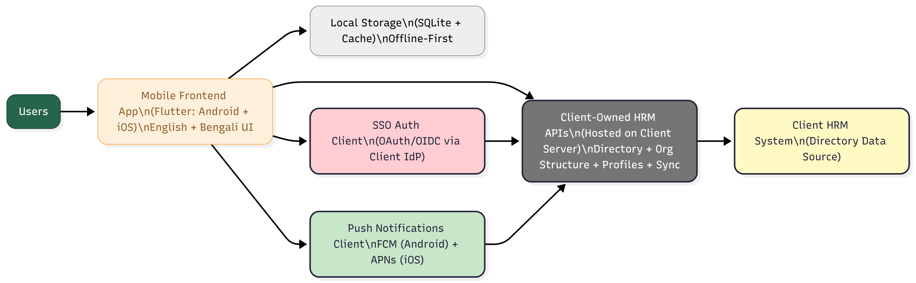

Figure 2: Offline-First Data Sync Workflow (Initial Sync + Delta Sync + Manual Sync)
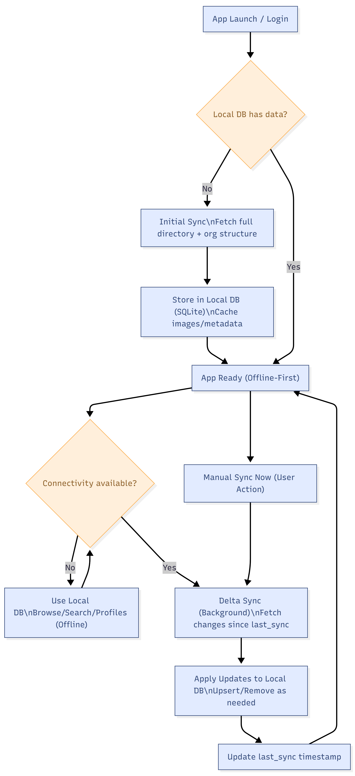

Figure 3: Authentication and Session Flow (SSO Login, Token Handling, Disabled User Enforcement)

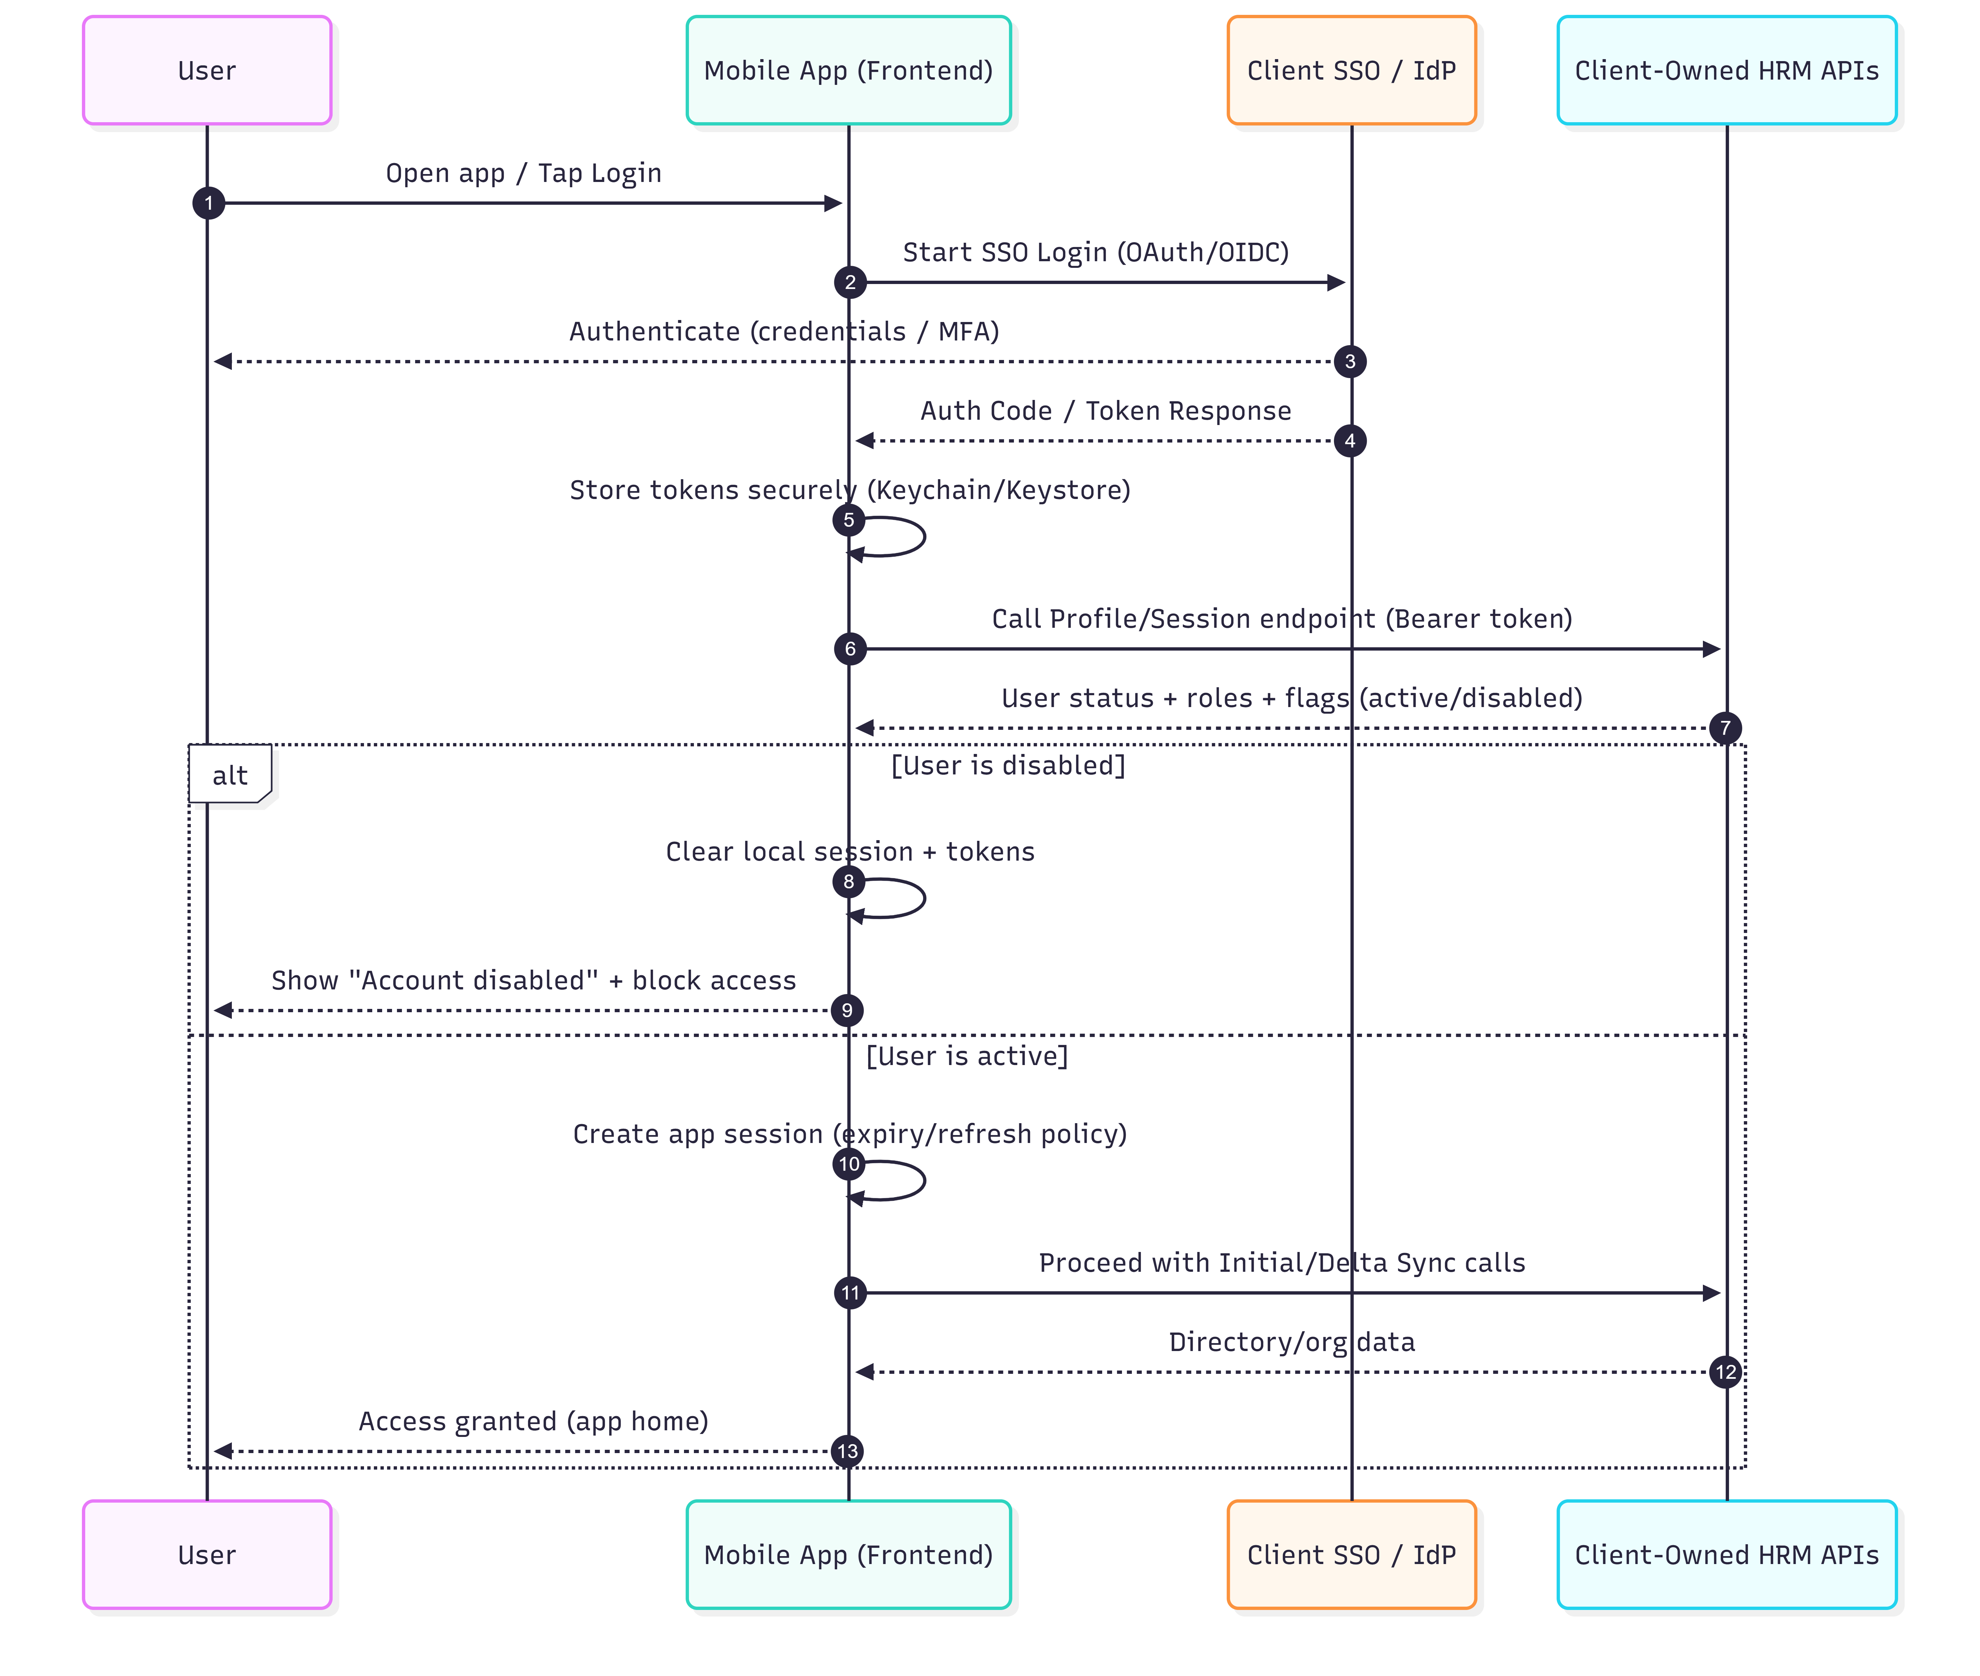

Figure 4: Module Navigation Map (Dashboard, Departments, Search, Profile, Groups, Settings)

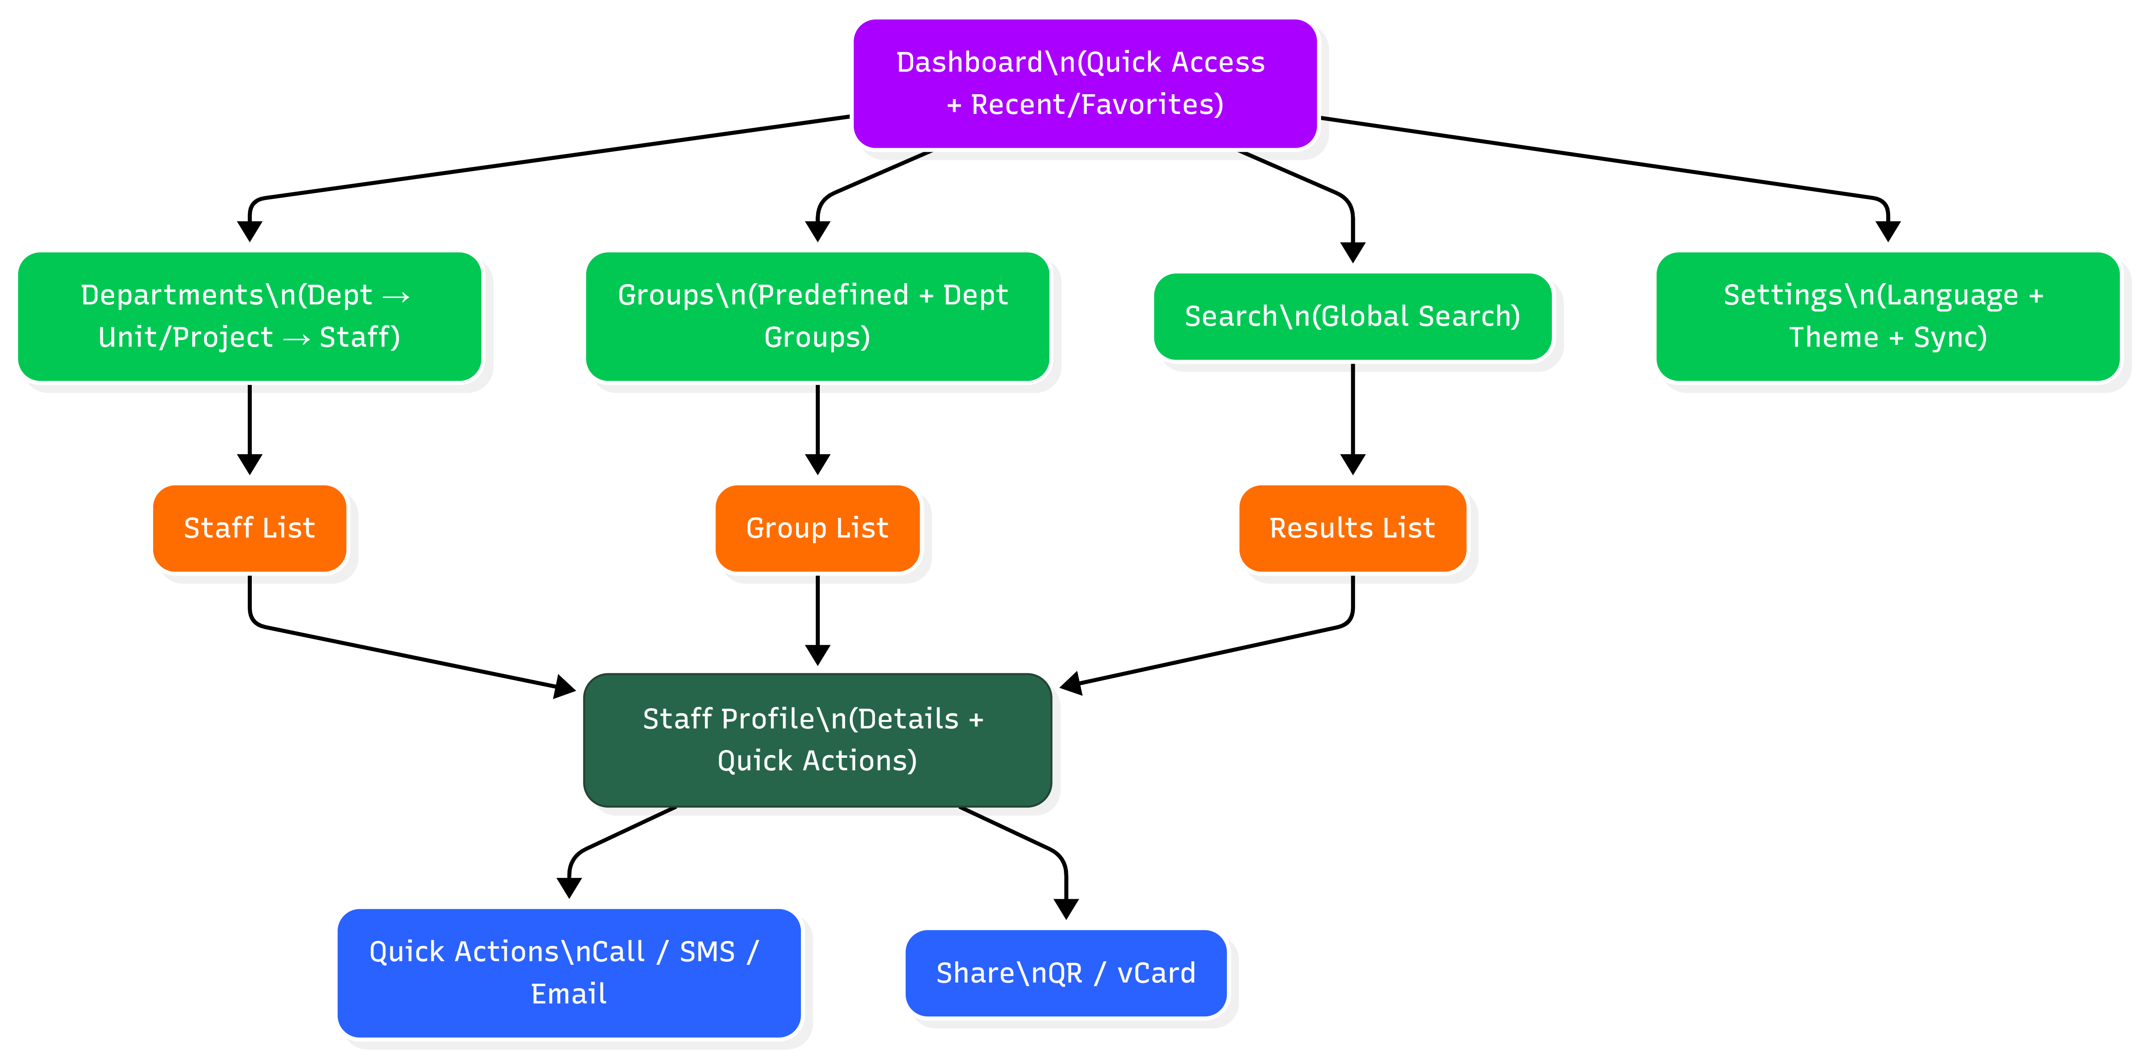

7. Development Methodology

7.1 Delivery Model
An iterative Agile approach will be used, with sprint-based delivery and regular demos to validate functionality against the FRD. Each sprint will include development, unit testing, QA verification, and a demo build. Continuous integration will be used to produce repeatable builds for Android and iOS.

7.2 Typical Sprint Activities
- Sprint planning: confirm scope and acceptance criteria for prioritized modules.
- Implementation: frontend UI, business logic, local storage, API integration (client-provided endpoints).
- Testing: unit tests for core logic, integration tests for API client, and QA test execution.
- Demo and sign-off: sprint review with client stakeholders; backlog refinement for next sprint.

7.3 Quality Assurance and Testing Approach
- Functional testing based on FRD acceptance criteria and edge cases (offline mode, disabled users, privacy rules).
- Device coverage: Android 8+ and representative iOS versions; low-memory device performance checks.
- Security checks: secure storage validation, no sensitive logs, network security (TLS), and session timeout enforcement.
- Release readiness: smoke testing on release builds and store packaging validation.



8. Proposed Technology Stack (Frontend Only)
The following stack is recommended to meet offline-first, cross-platform, and localization requirements:
Layer | Proposed Technology | Rationale
Mobile App | Flutter (Dart) | Single codebase for Android/iOS; strong performance; mature i18n; good offline + UI components.
State Management | Riverpod or Bloc | Predictable state, testability, clean separation of concerns.
Local Database | SQLite (sqflite) + migrations | Meets FRD offline requirement and supports large datasets efficiently.
Secure Storage | flutter_secure_storage | Secure token storage using Keychain/Keystore.
Networking | Dio / HTTP client | Robust interceptors, retries, logging control, and typed API wrappers.
Push Notifications | FCM (Android) + APNs (iOS) via Flutter plugins | Industry-standard delivery; integrates with client’s server-driven notifications.
Analytics/Crash (Optional) | Firebase Crashlytics (optional) | Improves stability monitoring; can be enabled if client permits.
Repository Manage | GitHub / GitLab | Code base is shared with Git Repository.
Note: The backend stack is intentionally excluded because the client will develop and host all required APIs on their own server as part of the HRM system.

9. Deliverables

9.1 Core Deliverables
ID | Deliverable | Contents
D1 | Requirements confirmation workshop notes and API integration checklist | Validated FRD coverage, integration dependencies, test endpoints.
D2 | Mobile app source code repository (Flutter) with documentation | Clean codebase, modular structure, build instructions.
D3 | Android build artifacts and signing support | Release-ready Android App Bundle/APK and guidance for Play Store submission.
D4 | iOS release build and publication support | Release build and support for App Store publication under developer company account.
D5 | Test plan and QA evidence | Test cases, execution summary, and defect log closure evidence.
D6 | User guide (short) and admin/IT handover notes | Installation, login, sync behavior, and support troubleshooting.

10. Acceptance Criteria (High Level)
- All FRD features are implemented in the mobile app and validated through QA testing.
- Offline-first operation works reliably, including search/browse while offline and background sync when connectivity returns.
- SSO login works with client identity provider and session policies (timeout, disabled users) are enforced.
- Multi-language UI supports English and Bengali correctly across core flows.
- Android build runs on Android 8 and above; iOS build meets App Store packaging requirements.
- Source code, build instructions, and handover documentation are delivered and accepted.

11. Risks and Mitigations (Technical)
Risk | Impact | Mitigation
Incomplete/unstable APIs or missing documentation | Delays integration and testing | Early API checklist, mock server stubs, agreed contract tests.
SSO flow not mobile-ready (e.g., missing OIDC/OAuth PKCE) | Login cannot be completed securely | Confirm SSO protocol early; propose PKCE-based OAuth/OIDC mobile flow.
Large staff directory performance on low-end devices | Slow search/list performance | Local indexing, list virtualization, image caching, profiling.
Phone number privacy rules unclear | Potential privacy breach | Role-based flags from API; UI masking defaults; audit with client IT policy.
Push notification delivery dependencies | Notifications unreliable | Validate APNs/FCM configuration early; staged testing with sandbox/prod keys.

12. Reference
Functional Requirements Document (FRD) – CDIP Phonebook, pages 1-4.

