ENTERPRISE AI STRATEGY
& GOVERNANCE CONSULTING
Technical Proposal for BRAC Bank PLC

Prepared for: BRAC Bank PLC
Prepared by: Riseup Labs

Table of Contents
1. Executive Summary 3
Key Proposal Commitments 3
2. Engagement Understanding and Scope 4
2.1 Purpose of the Engagement 4
2.2 In-Scope Consulting Services 4
2.3 Engagement Design Principles 4
3. Proposed Approach and Methodology 5
3.1 Delivery Model 5
Mobilize and Align 5
Assess and Discover 5
Prioritize and Validate 5
Design Governance and Target State 5
Roadmap and Business Case 6
Transfer and Close 6
3.2 Evidence and Research Methodology 6
3.3 Reference Frameworks 6
4. Outcome A — AI Readiness and Prioritized Use-Case Portfolio 7
4.1 Outcome Objective 7
4.2 AI Readiness Assessment Dimensions 7
4.3 Maturity Scoring Method 7
4.4 Use-Case Discovery and Prioritization 8
Prioritization Criteria 8
4.5 Real-World Use-Case Demonstration Approach 9
4.6 Outcome A Deliverables 9
4.7 Measurable Business Value from Outcome A 9
5. Outcome B — Enterprise AI Governance and Control Framework 10
5.1 Outcome Objective 10
5.2 Governance Design Principles 10
5.3 Governance Policy and Standards Design 10
5.4 Control Catalogue and Testing Approach 11
5.5 Outcome B Deliverables 11
5.6 Measurable Business Value from Outcome B 11
6. Outcome C — Enterprise AI Strategy, Architecture, Roadmap and Business Case 12
6.1 Outcome Objective 12
6.2 Enterprise AI Strategy 12
6.3 Target-State Architecture and Reference Technology Stack 12
Business and Experience Layer 13
AI Services Layer 13
Model and MLOps Layer 13
Data and Knowledge Layer 13
Integration Layer 13
Infrastructure Layer 13
Security and Governance Rails 13
6.4 Three-Year Roadmap Method 14
6.5 Enterprise Business Case Method 14
6.6 Outcome C Deliverables 14
6.7 Measurable Business Value from Outcome C 15
7. Deliverable-Wise Work Plan 16
7.1 AI Readiness Diagnostic — Outcome A 16
7.2 Portfolio and Prioritization of Existing Use Cases — Outcome A 16
7.3 Prioritization of External, Proven Use Cases — Outcome A 16
7.4 Use Case Prioritization Template — Outcome A 16
7.5 Readiness Gap Summary — Outcome A 16
7.6 AI Governance Framework — Outcome B 17
7.7 Control Tower Operating Model — Outcome B 17
7.8 Controls Catalogue & Testing Plan — Outcome B 17
7.9 Executive Reporting Pack — Outcome B 17
7.10 AI Strategy Document — Outcome C 17
7.11 Target-State Architecture & Platform Blueprint — Outcome C 18
7.12 3-Year Phased Roadmap — Outcome C 18
7.13 Enterprise Business Case — Outcome C 18
7.14 Final Executive Readout — Outcome C 18
Mandatory Deliverable Coverage Matrix 19
8. Global Banking Benchmark 20
8.1 Benchmarking Method 20
8.2 Benchmark Dimensions to be Applied 20
9. Recommended AI Dashboard and Visual Reporting Framework 21
9.1 Recommended Dashboard Views 21
Executive Portfolio Summary 21
AI Readiness 21
Use-Case Portfolio 21
Governance and Risk 21
Roadmap and Value Realization 22
10. Role-Based Stakeholder Journeys 22
10.1 Executive Sponsor / Steering Committee Journey 22
10.2 Business Unit Sponsor / Use-Case Owner Journey 22
10.3 Risk, Compliance, Legal, Privacy and Internal Audit Journey 22
10.4 Technology, Data, Cybersecurity and Architecture Journey 22
10.5 AI Control Tower / Coordinating Office Journey 22
10.6 Change, Learning and Employee Enablement Journey 23
11. Delivery Plan, Gantt Chart and Milestones 23
11.1 Indicative Consulting Timeline 23
11.2 Key Milestones 23
11.3 Review and Approval Gates 24
12. Team Structure and Engagement Governance 24
12.1 Engagement Governance 24
13. Risk Management 25
13.1 Roadmap Risk Categories 25
14. Knowledge Transfer and Capability Uplift 26
Outcome A Transfer 26
Outcome B Transfer 26
Outcome C Transfer 26
Transfer Formats 26
14.1 Knowledge Transfer Acceptance 26
15. Deliverable Quality Assurance and Acceptance 27
15.1 Acceptance Principles 27
16. Proposed Supporting Deliverables 27
16.1 Stakeholder and Evidence Register 27
16.2 AI Risk Classification and Use-Case Intake Pack 27
16.3 Value Realization Framework and Dashboard Concept 27
16.4 Knowledge Transfer and Handover Pack 27
17.1 Key Assumptions 28
17.2 Information Required from BRAC Bank 28
18. Out of Scope 28
19. Conclusion 28

1. Executive Summary
BRAC Bank is seeking an advisory partner to establish an evidence-based view of its AI readiness, define an enterprise AI governance and control framework, and produce an enterprise AI strategy supported by a target-state architecture, a phased three-year roadmap, and a quantified business case. The engagement is designed to help the Bank coordinate AI adoption as a governed, value-driven enterprise capability rather than a collection of isolated initiatives.

The proposed approach is technology-agnostic but technology-aware. It begins with the Bank’s current technology estate, data platforms, security standards, private-cloud investments, governance bodies and in-flight initiatives. New technology is recommended only where a validated capability gap exists and reuse of existing assets is not sufficient.
Outcome | Primary Question | Proposed Solution | Decision Enabled
A — Readiness & Use Cases | Where does the Bank stand, and which AI opportunities should be prioritized? | Maturity assessment, use-case inventory, external benchmark, scoring and gap analysis. | Evidence-based portfolio and early-value priorities.
B — Governance & Controls | How should AI be governed responsibly without creating parallel structures? | Policy framework, lifecycle controls, operating model, RACI and executive reporting. | Clear accountability, proportionate controls and audit readiness.
C — Strategy, Roadmap & Business Case | What target state should the Bank pursue, in what sequence, and with what value? | AI vision, architecture blueprint, capability plan, 3-year roadmap and quantified business case. | Fundable, sequenced and measurable AI transformation plan.

Key Proposal Commitments
- All fourteen minimum deliverables stated in the ToR are covered and mapped to Outcomes A, B and C.
- An indicative 16-week consulting engagement is proposed, with parallel workstreams and formal validation gates. The final schedule will be confirmed at mobilization.
- A separate three-year implementation roadmap will define short-, mid- and long-term initiatives, dependencies, owners, value milestones and capability requirements.
- Global benchmarking will use publicly available and verifiable sources; no confidential competitor information will be used.
- The recommended AI dashboard is a conceptual executive reporting and visual framework. Functional dashboard development is not included in the current scope.
- All business-value estimates will be based on Bank-validated operational, financial, risk and customer-experience baselines; no unsupported benefit numbers will be introduced.

2. Engagement Understanding and Scope

2.1 Purpose of the Engagement
The purpose is to give BRAC Bank a disciplined enterprise framework for deciding where AI should be used, how it should be controlled, how existing technology and private-cloud investments should be reused, and how initiatives should be sequenced to deliver measurable business value.

2.2 In-Scope Consulting Services
- Current-state AI readiness and maturity assessment across business, strategy, operating model, data, technology, infrastructure, talent, governance, risk, adoption and change.
- Inventory and assessment of existing, planned and potential AI initiatives, including federated activities already underway.
- External, proven financial-services use-case research and applicability assessment for BRAC Bank.
- Use-case scoring, prioritization, intake and portfolio governance framework.
- AI governance framework, policies, standards, responsible-AI principles, model-risk lifecycle, vendor controls, operating model, RACI, controls catalogue and testing approach.
- Enterprise AI vision, strategic ambition, target-state architecture, platform approach, capability-build plan, vendor strategy, training and change approach.
- Three-year phased roadmap with initiative sequencing, dependencies, owners and value-realization milestones.
- Enterprise business case covering future investment, expected value, TCO, ROI profile and benefit realization.
- Executive reporting pack, conceptual dashboard visual, final executive readout and knowledge transfer.

2.3 Engagement Design Principles
- Outcome-led: every activity must support one or more required outcomes and deliverables.
- Evidence-based: findings will be traceable to documents, interviews, workshops, data or architecture evidence.
- Existing-estate first: recommendations will maximize reuse of Bank-approved technology, data and private-cloud investments.
- Integrated governance: AI oversight will connect to existing business, risk, audit, data and technology governance rather than duplicate them.
- Risk-proportionate: controls and assurance intensity will reflect use-case materiality, customer impact and regulatory sensitivity.
- Value-driven: use cases and roadmap initiatives will be linked to measurable value, accountable owners and benefit baselines.
- Practical transfer: templates, playbooks and training will enable Bank teams to continue the process after the engagement.

3. Proposed Approach and Methodology
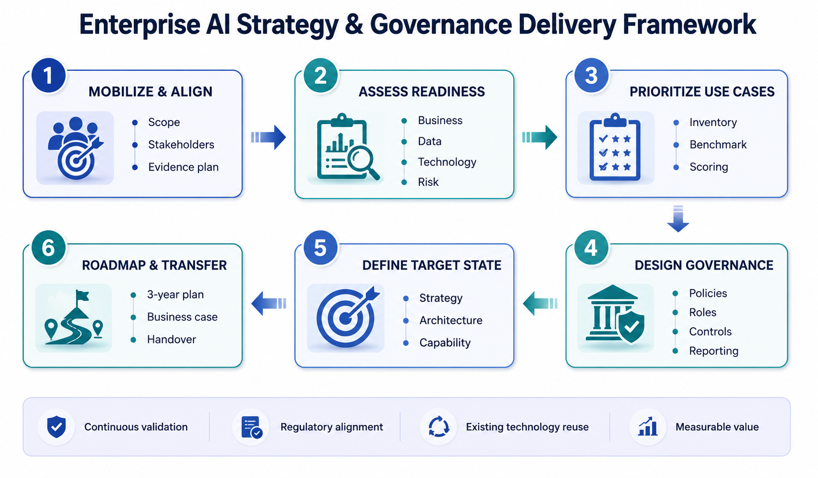
Figure 1. Overall consulting delivery framework.

3.1 Delivery Model
The engagement will be executed through three connected outcome workstreams supported by a common evidence, program management, quality assurance, regulatory research and value-realization layer. Outcome A starts first because its evidence and prioritized use-case portfolio inform the governance, architecture, roadmap and business case produced under Outcomes B and C. Selected activities under Outcomes B and C run in parallel to shorten the engagement while preserving validation dependencies.

Mobilize and Align
- Confirm scope, stakeholders, governance, working methods, deliverable templates and acceptance process.
- Issue a structured evidence request covering strategy, policies, architecture, data, current initiatives, risk, audit and capabilities.
- Agree confidentiality, information handling, interview plan and decision calendar.

Assess and Discover
- Review evidence and conduct executive, business, technology, data, risk and control interviews.
- Run structured readiness assessment and document the current AI initiative inventory.
- Establish peer and global leading-practice benchmark themes.

Prioritize and Validate
- Identify, rationalize and score use cases through agreed value, feasibility, risk and strategic-alignment criteria.
- Identify early-value candidates without committing implementation before evidence and governance review.
- Validate findings and priorities with business owners and executive sponsors.

Design Governance and Target State
- Design policy, standards, model-risk lifecycle, controls, roles, decision rights and reporting.
- Define target architecture principles and technology capability gaps, anchored to current Bank investments.
- Establish talent, vendor, partnership, training and change requirements.

Roadmap and Business Case
- Sequence initiatives across a three-year horizon with dependencies, owners, risks and value milestones.
- Quantify value and TCO using Bank-approved baselines and scenario assumptions.
- Create an executive decision narrative and recommendations.

Transfer and Close
- Deliver role-based training, playbooks, templates and walkthroughs.
- Resolve final comments and provide a structured handover repository.
- Present the final executive readout and next-step decisions.

3.2 Evidence and Research Methodology
Evidence sources: Bank-provided documents, policies, architecture artefacts, inventories, operational metrics, stakeholder interviews, structured workshops, public regulatory guidance and official public disclosures from benchmark institutions.
Evidence traceability: Each material finding will be linked to its evidence source, affected capability, risk implication and roadmap recommendation.
Benchmarking boundary: Only public and attributable sources will be used. External practices will be translated into locally relevant design implications rather than copied without context.
Regulatory interpretation: The consulting team will map relevant regulatory expectations and sound practices; final legal or regulatory interpretation remains with the Bank’s Legal, Compliance and relevant control functions.

3.3 Reference Frameworks
The methodology will be tailored to BRAC Bank and will use the following as reference lenses rather than assuming certification or direct legal applicability:
- Bangladesh Bank Guideline on ICT Security for Banks and Non-Bank Financial Institutions, 2023, including ICT governance, security, project management, lifecycle security and emerging-technology expectations.
- Bangladesh Bank Guidelines on Cloud Computing, March 2023, as listed in the regulator’s guidance repository.
- ISO/IEC 42001:2023 for enterprise AI management-system concepts, policies, objectives, risk and continual improvement.
- NIST AI Risk Management Framework and the Generative AI Profile for governance, mapping, measurement and management of trustworthy-AI risks.
- Monetary Authority of Singapore FEAT principles and AI/model-risk management guidance as financial-sector reference practices.
- BIS and Financial Stability Board publications on AI governance, model risk, data governance, third-party dependencies and financial-stability considerations.
- Federal Reserve revised 2026 model-risk management guidance as an international banking reference for risk-based model governance.

4. Outcome A — AI Readiness and Prioritized Use-Case Portfolio

4.1 Outcome Objective
Provide a clear, evidence-based view of BRAC Bank’s AI readiness and produce a prioritized portfolio of existing, planned, potential and externally proven AI use cases aligned to business strategy, expected value, feasibility and risk.

4.2 AI Readiness Assessment Dimensions
- Strategy and operating model: clarity of ambition, sponsorship, funding, ownership and coordination.
- Business and process readiness: pain points, process maturity, decision points, adoption barriers and outcome ownership.
- Data readiness: availability, quality, lineage, accessibility, privacy, retention and suitability for prioritized use cases.
- Technology and infrastructure: current platforms, integration patterns, compute, storage, private cloud, monitoring and resilience.
- AI/ML engineering and MLOps: development, validation, registry, deployment, monitoring, change and retirement capability.
- Talent and capability: role coverage, skills, sourcing model, training, communities of practice and leadership literacy.
- Governance, risk and controls: policies, model risk, responsible AI, third-party oversight, assurance and incident management.
- Adoption and change: employee readiness, communications, training, process redesign and value ownership.

4.3 Maturity Scoring Method
A five-level maturity scale will be used across agreed assessment dimensions. Detailed descriptors will be customized during mobilization so that scoring reflects the Bank’s context and does not rely on generic assumptions.
- Level 1 — Initial: fragmented, reactive or undocumented.
- Level 2 — Developing: emerging practices with partial ownership or coverage.
- Level 3 — Defined: documented, repeatable and governed practices.
- Level 4 — Managed: measured, integrated and actively controlled practices.
- Level 5 — Optimized: enterprise-wide, continuously improved and value-led practices.

4.4 Use-Case Discovery and Prioritization
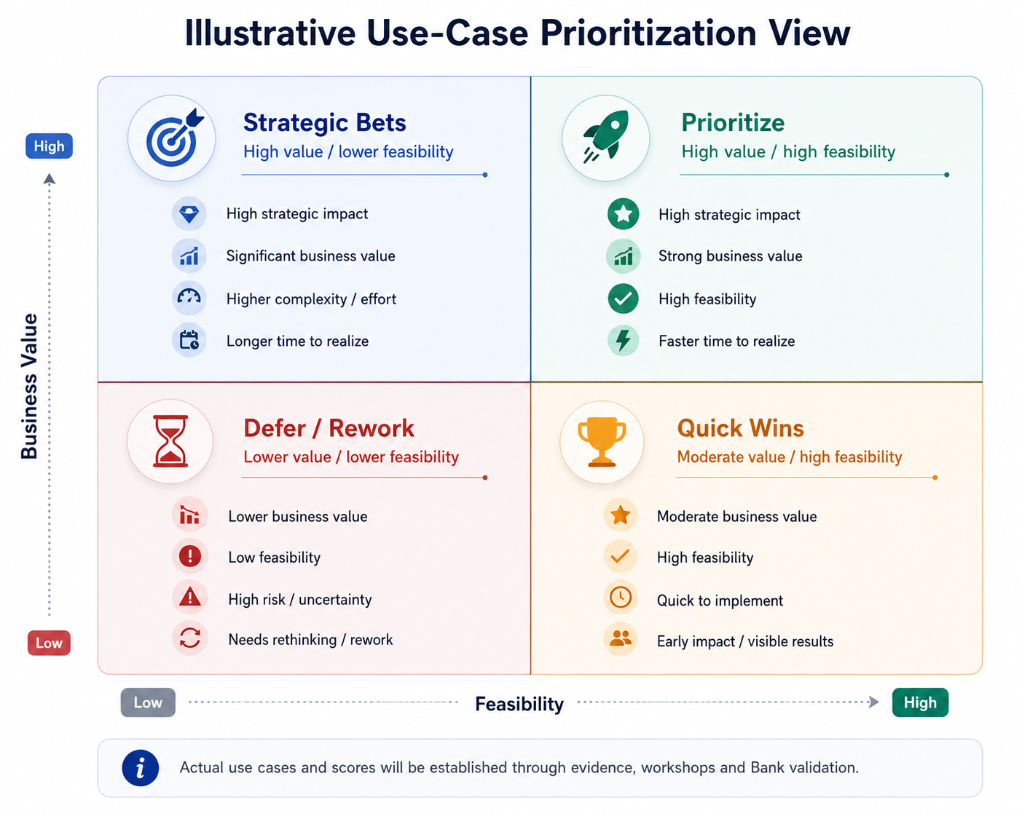
Figure 2. Illustrative use-case prioritization view.
Use cases will be collected from the current initiative inventory, business workshops, technology and data teams, strategic priorities, customer and employee pain points, and public financial-services examples. Each candidate will be rationalized to remove duplication and will have a named business owner, problem statement, target users or process, data dependency, expected outcome and material risks.

Prioritization Criteria
- Business value: revenue, cost, risk, customer experience, employee productivity or strategic value.
- Expected outcomes and KPI measurability.
- Strategic alignment with Bank priorities.
- Data availability and quality.
- Technical feasibility and reuse of current assets.
- Regulatory, ethical, privacy, security and model-risk exposure.
- Implementation effort, dependency and time to value.
- Organizational readiness and accountable business ownership.

4.5 Real-World Use-Case Demonstration Approach
The use-case portfolio will be supported by real-world demonstrations through official case evidence, solution walkthroughs, workflow illustrations, vendor-neutral architecture examples or non-production demonstrations using synthetic/non-sensitive data where approved. The objective is to make business and operating implications tangible without creating a production implementation commitment.
Custom PoC development, production data integration and live deployment are not included unless BRAC Bank separately confirms and contracts such work.

4.6 Outcome A Deliverables
- 1. AI Readiness Diagnostic
- 2. Portfolio and Prioritization of Existing Use Cases
- 3. Prioritization of External, Proven Use Cases
- 4. Use Case Prioritization Template
- 5. Readiness Gap Summary

4.7 Measurable Business Value from Outcome A
- Creates one consolidated view of AI initiatives and reduces the risk of duplicate or conflicting investments.
- Identifies early-value opportunities and separates them from strategic bets requiring capability build.
- Links capability gaps directly to roadmap actions, supporting better investment sequencing.
- Improves decision consistency through a reusable scoring, intake and selection framework.
- Establishes baseline maturity and portfolio metrics that can be remeasured over time.
Example KPIs: Percentage of initiatives inventoried; percentage with business owners and defined KPIs; number of duplicate initiatives rationalized; average time from intake to decision; maturity score change; estimated value of approved portfolio; percentage of priority use cases with sufficient data readiness.

5. Outcome B — Enterprise AI Governance and Control Framework

5.1 Outcome Objective
Establish an enterprise framework for governing AI as a managed capability, integrating policy, model governance, responsible AI and continuous controls with the Bank’s existing risk, audit, business, data and technology governance.
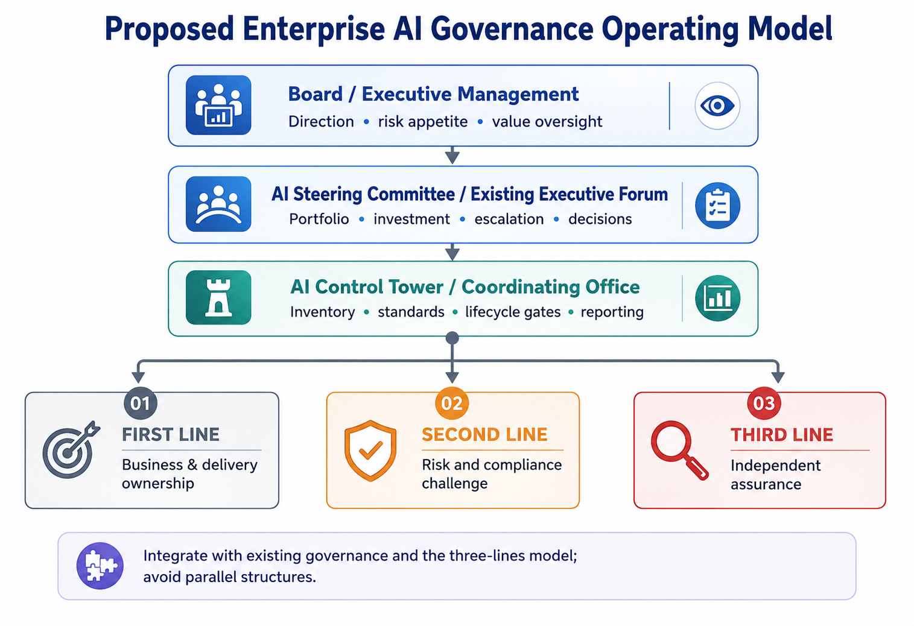
Figure 3. Proposed enterprise AI governance operating model.

5.2 Governance Design Principles
- Integrate with existing committees and three-lines responsibilities; avoid unnecessary parallel structures.
- Assign clear accountability to business owners while preserving independent risk challenge and assurance.
- Apply proportionate governance based on use-case risk, materiality, customer impact and degree of autonomy.
- Cover the full lifecycle from discovery and design through development, deployment, monitoring, change and retirement.
- Include third-party, embedded and employee-used AI, not only internally developed models.
- Maintain human oversight, traceability, transparency, data protection and escalation appropriate to the use case.
- Use measurable control evidence and regular executive reporting.

5.3 Governance Policy and Standards Design
The policy architecture will be designed after assessing existing Bank policies to prevent duplication. Depending on current coverage, the framework may comprise a single enterprise AI policy supported by standards, procedures, templates and playbooks.
- AI acceptable-use and prohibited-use principles.
- Responsible-AI principles and customer/employee impact expectations.
- AI and model risk classification.
- Use-case intake, approval and lifecycle stage gates.
- Data suitability, privacy, security and confidentiality requirements.
- Model development, validation, testing, deployment, monitoring, change and retirement standards.
- Generative AI, prompt, grounding, content and human-review controls.
- Third-party and vendor AI due diligence, contractual control expectations and ongoing oversight.
- Incident management, exception management and escalation.
- Record keeping, evidence retention, executive reporting and audit access.

5.4 Control Catalogue and Testing Approach
Controls will be mapped to the AI lifecycle and assigned to an owner, evidence source, testing method, frequency, escalation threshold and reporting route. The catalogue will distinguish preventive, detective and corrective controls and will allow risk-tiered testing cadence.
- Discovery/intake: ownership, purpose, risk classification, legal basis, value hypothesis and duplication check.
- Design/data: data suitability, privacy, security, bias/fairness, explainability and human oversight design.
- Development/acquisition: approved environment, documentation, vendor due diligence, model evaluation and segregation of duties.
- Validation/approval: independent challenge, performance testing, robustness, adverse scenarios, limitations and residual-risk acceptance.
- Deployment: release approval, access, logging, rollback, integration and business readiness.
- Monitoring: performance, drift, bias, incidents, control exceptions, vendor changes and benefit tracking.
- Change/retirement: revalidation triggers, version control, decommissioning, data retention and communication.

5.5 Outcome B Deliverables
- 6. AI Governance Framework
- 7. Control Tower Operating Model
- 8. Controls Catalogue & Testing Plan
- 9. Executive Reporting Pack

5.6 Measurable Business Value from Outcome B
- Reduces unmanaged AI usage by creating a single intake, inventory and accountability process.
- Improves regulatory and audit readiness through documented lifecycle evidence and control ownership.
- Enables faster, more consistent decisions by defining decision rights and risk-tiered approval paths.
- Reduces vendor and model risk through formal due diligence, validation and monitoring requirements.
- Creates executive visibility of portfolio risk, control exceptions and value realization.
Example KPIs: Percentage of AI initiatives registered; percentage risk-classified; approval turnaround time; percentage with completed validation; overdue control actions; number of material incidents; monitoring coverage; third-party AI review completion; policy-training completion.

6. Outcome C — Enterprise AI Strategy, Architecture, Roadmap and Business Case

6.1 Outcome Objective
Define the Bank’s enterprise AI vision and adoption strategy, recommend a target-state architecture and platform approach anchored to existing investments, and provide a phased three-year roadmap supported by a quantified and fundable business case.

6.2 Enterprise AI Strategy
- AI vision and strategic ambition linked to the Bank’s approved business priorities.
- Guiding principles for value, customer trust, responsible AI, technology reuse, security, human oversight and accountability.
- Enterprise operating model and relationship between central capability and federated business delivery.
- Priority capability domains and portfolio themes derived from Outcome A.
- Build, buy or partner decision principles.
- Talent, sourcing, vendor, partnership, training and change strategy.
- Value-realization model and executive measures of success.

6.3 Target-State Architecture and Reference Technology Stack
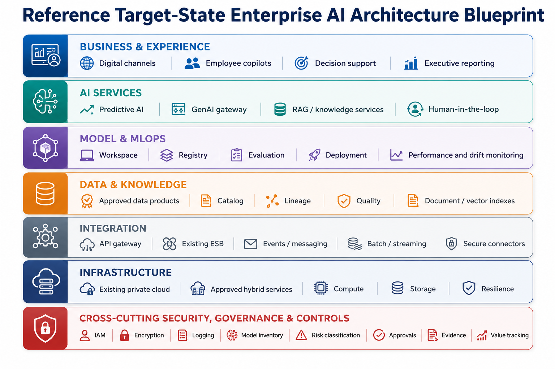
Figure 4. Reference target-state enterprise AI architecture blueprint.
The architecture recommendation will be finalized after discovery. It will not replace Bank platforms without a validated gap and approved business rationale. The reference stack is category-based so the Bank can map existing products and approved vendors to the required capabilities.

Business and Experience Layer
- Digital channels, employee workbenches, analytics, decision support and executive reporting.

AI Services Layer
- Predictive services, language and document services, retrieval-augmented generation, approved foundation-model access and human-in-the-loop workflows.

Model and MLOps Layer
- Development workspace, feature management, model/prompt registry, evaluation, release orchestration, deployment, monitoring, drift and incident integration.

Data and Knowledge Layer
- Approved data products, warehouse/lakehouse, metadata, catalog, lineage, quality, document and vector indexes, retention and access controls.

Integration Layer
- Existing API gateway/ESB, batch and event integration, secure connectors, service authentication and interface monitoring.

Infrastructure Layer
- Existing private cloud, approved hybrid services where permitted, compute, containers, storage, backup, resilience and capacity management.

Security and Governance Rails
- IAM/PAM, encryption, secrets, DLP, SIEM, audit logging, model inventory, risk classification, approvals, evidence and value tracking.
Final product selections will be based on BRAC Bank’s existing platforms, architecture standards, information-security requirements, private-cloud capability, approved vendors, procurement constraints and regulatory interpretation.

6.4 Three-Year Roadmap Method
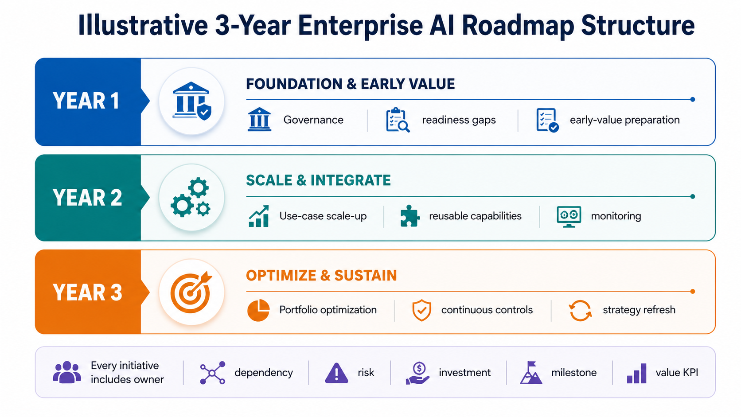
Figure 5. Illustrative three-year enterprise AI roadmap structure.
The final roadmap will be initiative-based rather than a generic list. Each initiative will include an owner, rationale, dependency, prerequisite capability, implementation route, risk classification, investment category, target milestone, value measure and decision gate. Exact use cases will be taken from the validated Outcome A portfolio.

6.5 Enterprise Business Case Method
The business case will quantify future AI investment and value using Bank-approved baselines. It will separate one-time and recurring costs, identify uncertainty, and provide base, downside and upside scenarios where data supports them.
- Revenue value: incremental acquisition, conversion, cross-sell, retention or fee income attributable to the initiative.
- Cost value: reduced processing time, manual effort, rework, servicing cost, technology duplication or control effort.
- Risk value: expected-loss reduction, fraud/financial-crime prevention, error reduction, control strengthening or loss avoidance.
- Customer-experience value: turnaround time, first-contact resolution, digital completion, satisfaction or complaint reduction.
- Employee value: productivity, quality, knowledge access and capacity reallocation.
- TCO: platform, data, integration, model/provider, infrastructure, security, licences, people, training, monitoring, support and change.
- Financial measures: annual benefit, net benefit, ROI, payback period and value-realization milestones.
Value discipline: All assumptions will be documented with source, owner, confidence level and sensitivity. Benefits will not be presented as committed savings unless the Bank validates the baseline and accountable owner.

6.6 Outcome C Deliverables
- 10. AI Strategy Document
- 11. Target-State Architecture & Platform Blueprint
- 12. 3-Year Phased Roadmap
- 13. Enterprise Business Case
- 14. Final Executive Readout

6.7 Measurable Business Value from Outcome C
- Creates a shared enterprise direction and prevents fragmented platform decisions.
- Maximizes reuse of current data, technology and private-cloud assets.
- Provides a sequenced and dependency-aware plan that can be funded and governed.
- Links investment decisions to measurable revenue, cost, risk and customer-experience outcomes.
- Builds executive confidence through scenario-based TCO, ROI and milestone visibility.
Example KPIs: Percentage of roadmap initiatives with approved owners and business cases; existing-asset reuse rate; planned vs realized value; investment variance; time to deploy approved initiatives; model/service reuse; platform availability; benefit realization by value category; ROI and payback by initiative.

7. Deliverable-Wise Work Plan
This section explains how each mandatory deliverable will be produced and what decision or value it enables.

7.1 AI Readiness Diagnostic — Outcome A
Purpose: Establish the current state, maturity scorecard and peer benchmark.
How it will be produced
- Confirm assessment dimensions and evidence criteria.
- Review documents, conduct interviews and score capabilities.
- Validate scores and evidence with accountable Bank stakeholders.
- Produce current-state narrative, heatmap, benchmark and priority observations.
Output package: Current-state report, maturity scorecard, heatmap, evidence register and executive summary.
Business value: Creates a fact base for prioritization and roadmap investment.

7.2 Portfolio and Prioritization of Existing Use Cases — Outcome A
Purpose: Create one consolidated and ranked portfolio of existing, planned and potential use cases.
How it will be produced
- Inventory initiatives across business and technology areas.
- Normalize duplicates and define owner, problem, outcome, data and risk.
- Score and rank candidates with Bank-approved criteria.
- Identify early-value candidates and strategic dependencies.
Output package: Use-case register, scoring results, prioritized portfolio and portfolio visual.
Business value: Improves investment focus and reduces duplication.

7.3 Prioritization of External, Proven Use Cases — Outcome A
Purpose: Bring relevant financial-services practices for consideration by BRAC Bank.
How it will be produced
- Research official and credible public sources.
- Select use cases with proven relevance to banking outcomes.
- Assess local applicability, data needs, regulation, feasibility and value.
- Integrate shortlisted external cases into the portfolio process.
Output package: External use-case catalogue, evidence notes, applicability assessment and recommendation.
Business value: Expands the opportunity set without relying on unverified trends.

7.4 Use Case Prioritization Template — Outcome A
Purpose: Provide a reusable framework for intake, rationalization, scoring and selection.
How it will be produced
- Define mandatory intake fields and ownership.
- Agree weighted criteria, risk gates and decision thresholds.
- Design portfolio decision workflow and training guidance.
- Pilot the template against shortlisted use cases.
Output package: Intake form, scoring model, decision workflow, playbook and training guide.
Business value: Enables repeatable portfolio governance after the engagement.

7.5 Readiness Gap Summary — Outcome A
Purpose: Link capability gaps to target blueprint and roadmap actions.
How it will be produced
- Consolidate gaps from readiness, use-case and architecture assessments.
- Assess impact, urgency and dependency.
- Identify remediation options emphasizing existing-asset reuse.
- Map gaps to roadmap initiatives and owners.
Output package: Gap register, priority heatmap, target capability implications and roadmap linkage.
Business value: Turns assessment findings into actionable capability decisions.

7.6 AI Governance Framework — Outcome B
Purpose: Define policies, standards, lifecycle governance and responsible-AI principles.
How it will be produced
- Assess existing governance and policy coverage.
- Map regulatory and sound-practice expectations.
- Design policy architecture and lifecycle requirements.
- Validate with business, risk, legal, compliance, audit and technology stakeholders.
Output package: Governance framework, policy/standard set, principles and lifecycle model.
Business value: Creates consistent guardrails and clear accountability.

7.7 Control Tower Operating Model — Outcome B
Purpose: Define the coordinating structure, roles, decision rights, charters and RACI.
How it will be produced
- Map existing committees and decision forums.
- Design integrated oversight and escalation routes.
- Define mandate, membership, cadence and information flows.
- Develop RACI and interaction model across the three lines.
Output package: Operating-model document, committee charters, decision matrix and RACI.
Business value: Avoids parallel governance and improves decision speed.

7.8 Controls Catalogue & Testing Plan — Outcome B
Purpose: Map controls across the AI lifecycle with ownership and testing cadence.
How it will be produced
- Identify control objectives by lifecycle stage and risk tier.
- Assign owner, evidence, method, frequency and escalation.
- Define testing and monitoring approach.
- Validate control feasibility with first, second and third lines.
Output package: Controls catalogue, testing plan, evidence guide and exception process.
Business value: Supports continuous control, validation and audit readiness.

7.9 Executive Reporting Pack — Outcome B
Purpose: Provide KPI, risk dashboard and reporting cadence templates.
How it will be produced
- Confirm executive information needs and decision cadence.
- Define portfolio, risk, control, incident and value KPIs.
- Design dashboard views and narrative reporting templates.
- Agree data ownership and reporting frequency.
Output package: Executive pack, KPI dictionary, dashboard concept and reporting calendar.
Business value: Gives management consistent visibility of risk and value.

7.10 AI Strategy Document — Outcome C
Purpose: Define enterprise AI vision, ambition, principles and alignment to Bank priorities.
How it will be produced
- Synthesize readiness, portfolio, benchmark and leadership input.
- Define strategic choices, operating model and capability priorities.
- Establish guiding principles and success measures.
- Validate through executive working sessions.
Output package: Executive strategy document and strategic narrative.
Business value: Creates a common direction for enterprise decision-making.

7.11 Target-State Architecture & Platform Blueprint — Outcome C
Purpose: Recommend the target data, model, MLOps, security and platform approach.
How it will be produced
- Baseline the current architecture and approved standards.
- Map prioritized use-case requirements to capabilities.
- Define target layers, integration, security and governance rails.
- Identify reuse, gaps, transition principles and architecture decisions.
Output package: Architecture blueprint, capability map, principles and transition considerations.
Business value: Guides coherent technology investment while maximizing reuse.

7.12 3-Year Phased Roadmap — Outcome C
Purpose: Sequence initiatives, dependencies, owners and value milestones across three years.
How it will be produced
- Group initiatives into foundation, scale and optimization horizons.
- Identify prerequisites, dependencies and decision gates.
- Assign proposed owners and value milestones.
- Validate feasibility and executive priorities.
Output package: Three-year roadmap, initiative cards, dependency map and milestone plan.
Business value: Creates a practical path from strategy to funded execution.

7.13 Enterprise Business Case — Outcome C
Purpose: Quantify investment, value, TCO, ROI and value-realization milestones.
How it will be produced
- Collect and validate business baselines.
- Estimate costs and value by initiative and scenario.
- Calculate financial metrics and sensitivity.
- Define benefit owners and measurement cadence.
Output package: Business-case model, assumptions register, scenarios and executive summary.
Business value: Supports transparent, fundable investment decisions.

7.14 Final Executive Readout — Outcome C
Purpose: Present one integrated narrative across Outcomes A, B and C.
How it will be produced
- Synthesize findings, decisions, recommendations and unresolved items.
- Show how initiatives produce measurable value and manage risk.
- Present roadmap, business case and next-step decisions.
- Deliver executive session and final revisions.
Output package: Executive presentation, decision summary and next-step recommendations.
Business value: Enables management alignment and formal transition to implementation planning.

Mandatory Deliverable Coverage Matrix
# | Deliverable | Outcome | Primary Proposal Section
1 | AI Readiness Diagnostic | A | 4 and 7
2 | Portfolio and Prioritization of Existing Use Cases | A | 4 and 7
3 | Prioritization of External, Proven Use Cases | A | 4 and 7
4 | Use Case Prioritization Template | A | 4 and 7
5 | Readiness Gap Summary | A | 4 and 7
6 | AI Governance Framework | B | 5 and 7
7 | Control Tower Operating Model | B | 5 and 7
8 | Controls Catalogue & Testing Plan | B | 5 and 7
9 | Executive Reporting Pack | B | 5 and 7
10 | AI Strategy Document | C | 6 and 7
11 | Target-State Architecture & Platform Blueprint | C | 6 and 7
12 | 3-Year Phased Roadmap | C | 6 and 7
13 | Enterprise Business Case | C | 6 and 7
14 | Final Executive Readout | C | 6 and 7

8. Global Banking Benchmark
The benchmark below uses public disclosures from selected large global and regional banks. It is not a ranking of BRAC Bank and does not infer BRAC Bank’s current maturity before assessment. It identifies verifiable practices that can inform the Bank’s strategy, governance, technology and value-realization design.
Institution | Publicly Disclosed Practice | Relevant Benchmark Theme | Implication for BRAC Bank Assessment
JPMorgan Chase | Publicly emphasizes enterprise AI capability and dedicated AI research in finance, including agents, planning, optimization and domain foundation models. | Central research capability connected to business outcomes. | Assess whether research/innovation, engineering and business delivery responsibilities are clearly connected and governed.
Bank of America | Uses AI at scale across client and employee services and publicly states human oversight, transparency and accountability for outcomes. | Reusable platforms, adoption and measurable operational value. | Assess opportunities for reusable enterprise services, employee enablement and outcome measurement with human accountability.
HSBC | Reports scaled GenAI adoption, lifecycle governance, AI review councils and mandatory responsible-AI training. | Governance embedded from experimentation to production. | Design lifecycle gates, federated review structures and role-based training integrated with existing risk frameworks.
DBS | Reports industrialized AI across a large use-case/model portfolio and explicit economic-value tracking. | Platform-process-people industrialization and value realization. | Build portfolio governance, reusable capabilities and a disciplined value-measurement model.
Standard Chartered | Publicly describes strong data foundations, transparent governance, human accountability, an enterprise AI platform and central AI Control Tower. | Central platform with enterprise oversight and human judgment. | Assess the fit of a coordinating Control Tower and shared platform capabilities while retaining business and risk ownership.

8.1 Benchmarking Method
- Select benchmark banks by scale, public evidence, responsible-AI maturity and relevance to financial services.
- Compare strategy, use-case themes, governance, operating model, data/technology platform, talent, partner model and value measurement.
- Distinguish disclosed fact from consultant interpretation.
- Contextualize lessons for Bangladesh, BRAC Bank’s strategy, current estate and regulatory obligations.
- Use the benchmark as a design input, not as a requirement to reproduce another bank’s model.

8.2 Benchmark Dimensions to be Applied
- Enterprise AI ambition and sponsorship.
- Centralized, federated or hybrid operating model.
- Use-case portfolio and reusable enterprise services.
- Data, platform and MLOps industrialization.
- Responsible AI, model-risk and third-party governance.
- Human oversight and customer-impact safeguards.
- Talent, training and adoption.
- Economic-value and benefit-realization measurement.

9. Recommended AI Dashboard and Visual Reporting Framework
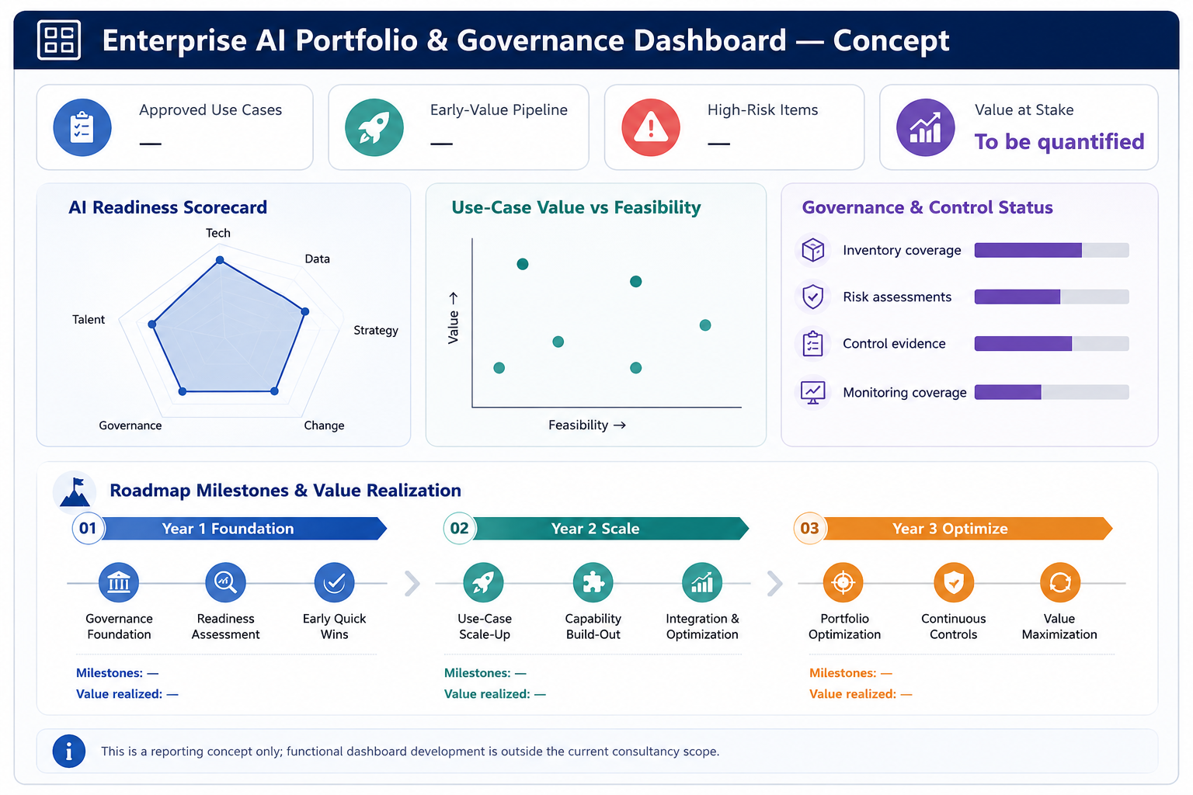
Figure 6. Recommended executive AI dashboard concept.
The dashboard is recommended as part of the Executive Reporting Pack. It will be delivered as a conceptual reporting design, KPI dictionary and static visual template. It is intended to guide future dashboard implementation but is not itself a production application. The reporting pack will specify the owner, source, calculation method, refresh cadence and escalation threshold for each KPI; metrics that cannot be reliably sourced will not be presented as automated or production-ready measures.

9.1 Recommended Dashboard Views

Executive Portfolio Summary
- Total initiatives by stage, business area and risk tier.
- Approved early-value pipeline and strategic bets.
- Top dependencies, decisions and exceptions.

AI Readiness
- Maturity by strategy, data, technology, talent, governance and change.
- Current vs target maturity and priority gaps.

Use-Case Portfolio
- Business value vs feasibility.
- Expected value by revenue, cost, risk and CX.
- Ownership, readiness and delivery stage.

Governance and Risk
- Inventory coverage, risk classifications and approval status.
- Control completion, overdue actions, incidents and third-party exposure.

Roadmap and Value Realization
- Milestone status by year and initiative.
- Planned vs realized value, TCO and ROI.
- Benefits at risk and management actions.

10. Role-Based Stakeholder Journeys
The engagement does not include a user-facing software product; therefore, the relevant journeys are stakeholder participation and decision journeys. The following journeys show how each proposed role group contributes from discovery through handover.

10.1 Executive Sponsor / Steering Committee Journey
1. Align: confirm strategic priorities, risk appetite, success measures and decision calendar.
2. Direct: resolve cross-functional access or scope issues and confirm major assumptions.
3. Prioritize: review maturity findings and approve portfolio principles and early-value shortlist.
4. Govern: approve the governance operating model, key policy choices and escalation routes.
5. Invest: review the target architecture, roadmap, business case and funding implications.
6. Close: approve the final executive narrative, owners and next-step decisions.

10.2 Business Unit Sponsor / Use-Case Owner Journey
1. Discover: describe business pain points, strategic opportunities, current initiatives and target users/processes.
2. Define: establish a clear problem statement, outcome, baseline KPI and accountable owner.
3. Assess: validate data, process, customer and operational feasibility with technical and control teams.
4. Prioritize: participate in scoring, resolve overlaps and accept value assumptions.
5. Plan: own roadmap milestones, dependencies, adoption activities and benefit realization.
6. Operate: use the intake, governance and reporting templates after handover.

10.3 Risk, Compliance, Legal, Privacy and Internal Audit Journey
1. Baseline: provide existing policies, risk frameworks, audit findings and regulatory interpretations.
2. Classify: define risk dimensions, materiality thresholds and mandatory review triggers.
3. Design: co-create policies, control objectives, decision rights and evidence requirements.
4. Challenge: review use-case assumptions, architecture implications and residual risks.
5. Assure: agree testing cadence, independent validation and audit/reporting access.
6. Sustain: receive playbooks and templates for ongoing oversight and assurance.

10.4 Technology, Data, Cybersecurity and Architecture Journey
1. Baseline: document current platforms, private-cloud capability, integration, data, security and operational standards.
2. Assess: identify reusable assets, constraints, capability gaps and technical debt affecting priority use cases.
3. Design: define target capabilities, architecture principles, security controls and transition options.
4. Validate: confirm feasibility, resilience, data availability and operating responsibilities.
5. Roadmap: sequence platform, data and MLOps capabilities against use-case dependencies.
6. Handover: accept architecture artefacts, decision principles and implementation inputs.

10.5 AI Control Tower / Coordinating Office Journey
1. Form: agree mandate, placement, relationship to existing forums and initial membership.
2. Inventory: establish the enterprise AI register and intake process.
3. Orchestrate: coordinate portfolio decisions, lifecycle gates and cross-functional reviews.
4. Report: maintain executive risk, control, value and milestone reporting.
5. Improve: monitor regulatory/technology change and update policies, templates and controls.
6. Transfer: receive operating playbooks, RACI, calendar and reporting pack.

10.6 Change, Learning and Employee Enablement Journey
1. Identify: assess role impacts, skill gaps and priority audiences.
2. Design: create role-based awareness, practitioner and governance training paths.
3. Prepare: align communications, process changes and adoption measures to roadmap initiatives.
4. Enable: deliver train-the-trainer sessions and reusable materials.
5. Measure: track participation, proficiency, adoption and change risks.
6. Sustain: establish ownership for future training updates and community support.

11. Delivery Plan, Gantt Chart and Milestones

11.1 Indicative Consulting Timeline
An indicative 16-week engagement is proposed. The schedule uses parallel workstreams and assumes timely access to documents, stakeholders, architecture information and validation forums. The detailed baseline plan will be confirmed during mobilization.
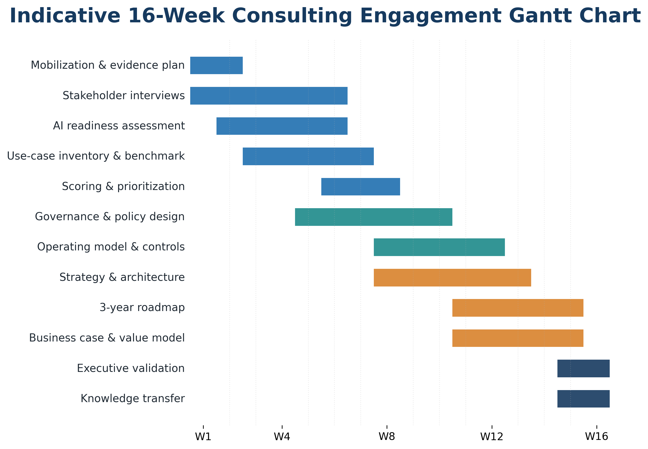
Figure 7. Indicative 16-week consulting engagement Gantt chart.

11.2 Key Milestones
- M1 — Kick-off, engagement governance and evidence request approved.
- M2 — Current-state evidence collection substantially complete.
- M3 — Draft readiness diagnostic and initiative inventory validated.
- M4 — Use-case scoring framework and prioritized portfolio approved for strategy design.
- M5 — Draft governance framework, operating model and control structure reviewed.
- M6 — Draft AI strategy and target-state architecture reviewed.
- M7 — Three-year roadmap and business-case assumptions validated.
- M8 — Final executive readout, knowledge transfer and handover completed.

11.3 Review and Approval Gates
- Working-level validation: evidence accuracy and factual corrections.
- Cross-functional design validation: business, technology, data, risk and control alignment.
- Executive decision gate: strategic choices, prioritization, risk appetite and roadmap direction.
- Final acceptance: agreed deliverable comments resolved and handover completed.

12. Team Structure and Engagement Governance
The final proposal should include named personnel, CVs, relevant banking/AI credentials, senior-management involvement and availability commitments. Placeholders below identify the required capability mix without inventing team-member names.
Role | Primary Responsibility | Outcome Coverage
Engagement Partner / Executive Sponsor | Executive quality, client sponsorship, issue resolution and final recommendations. | A, B, C
Program Director / Project Manager | Integrated plan, governance, milestones, dependencies, risk and delivery control. | A, B, C
AI Strategy Lead | Readiness, use-case portfolio, strategy and roadmap synthesis. | A, C
AI Governance & Responsible AI Lead | Policy, operating model, lifecycle governance, controls and reporting. | B
Enterprise Data / AI Architect | Current-state technology assessment, target architecture and platform blueprint. | A, C
Banking / Financial Services SME | Banking strategy, operating context, external use cases and value interpretation. | A, B, C
Risk & Regulatory SME | Regulatory mapping, model risk, compliance, third-party and control design. | B, C
Business Case & Value Analyst | Benefits, TCO, ROI, scenarios and value-realization framework. | C
Business Analysts / Use-Case Consultants | Interviews, process/use-case analysis, scoring, evidence and documentation. | A
Change & Knowledge Transfer Lead | Capability uplift, training, adoption and handover. | A, B, C

12.1 Engagement Governance
- Executive Steering: periodic decisions on scope, priorities, issues and strategic recommendations.
- Program Management: weekly plan, risk, dependency, action and deliverable control.
- Outcome Workstreams: focused working sessions for A, B and C with cross-workstream traceability.
- Design Authorities / Review Forums: targeted review with architecture, data, security, risk, compliance and audit stakeholders.
- Quality Assurance: partner and specialist peer review before client circulation.

13. Risk Management
Risk management will cover both consulting-delivery risks and risks that affect the future three-year AI roadmap. Risks will be recorded with probability, impact, owner, mitigation, trigger and escalation status.
Risk | Potential Impact | Preventive / Mitigating Action | Owner | Escalation Trigger
Delayed stakeholder or evidence access | Assessment and timeline delay. | Early stakeholder map, evidence tracker, sponsor escalation and parallel research. | Bank PM / Project Manager | Critical evidence or interviews delayed beyond agreed date.
Incomplete inventory of federated AI initiatives | Readiness and portfolio findings may be incomplete. | Multiple discovery channels, attestations and reconciliation with technology/vendor records. | AI Strategy Lead | Material initiative discovered after portfolio validation.
Unvalidated baseline data for business case | Benefits or ROI may lack confidence. | Assumption register, confidence grading, scenarios and owner sign-off. | Value Analyst / Business Owner | No accountable owner or reliable baseline.
Regulatory interpretation uncertainty | Governance or roadmap decisions may be delayed. | Early involvement of Legal/Compliance and explicit decision log. | Risk & Regulatory SME | Conflicting interpretations affect a key recommendation.
Cross-functional disagreement on priorities | Portfolio or roadmap approval delay. | Transparent scoring, facilitated workshops and executive decision gates. | Program Director | Unresolved scoring dispute at decision gate.
Sensitive-data handling constraints | Limits analysis or demonstrations. | Use approved environments, minimum necessary access and synthetic/non-sensitive examples. | Bank Security / Project Manager | Requested evidence cannot be accessed under agreed controls.
Technology recommendation conflicts with current standards | Architecture rework or poor reuse. | Architecture baseline first, current-estate mapping and design-authority validation. | Enterprise Architect | Recommendation requires an unapproved platform or architecture exception.
Scope drift into implementation or custom development | Budget, schedule and accountability ambiguity. | Formal scope boundary and change-control process. | Project Manager | Request requires coding, integration, production data or deployment.
Insufficient knowledge transfer | Bank dependency after engagement. | Role-based sessions, playbooks, train-the-trainer and handover acceptance. | Change Lead | Required Bank owners unavailable for transfer sessions.

13.1 Roadmap Risk Categories
- Data quality, privacy and lineage.
- Model performance, explainability, bias, drift and misuse.
- Cybersecurity, confidentiality and prompt/data leakage.
- Third-party concentration, vendor lock-in and provider change.
- Legacy integration, resilience and operating ownership.
- Regulatory change and cross-border/cloud constraints.
- Skill shortage, change resistance and inadequate human oversight.
- Value under-realization and benefit leakage.

14. Knowledge Transfer and Capability Uplift
Knowledge transfer will run throughout the engagement rather than being limited to final handover. The content will be role-based so executives, business owners, control functions and technical teams receive the level of detail required to operate the frameworks.

Outcome A Transfer
- Readiness assessment toolkit and scoring guide.
- Use-case intake, rationalization and prioritization training.
- Portfolio review and value-hypothesis workshop.

Outcome B Transfer
- Governance-policy walkthrough.
- Control Tower operating playbook and RACI orientation.
- Control catalogue, evidence and testing-plan training.
- Executive reporting pack and KPI ownership.

Outcome C Transfer
- Strategy and target-architecture walkthrough.
- Roadmap ownership and dependency-management workshop.
- Business-case model, assumptions and value-tracking training.
- Build/buy/partner and vendor-evaluation guidance.

Transfer Formats
- Executive briefings.
- Practitioner workshops.
- Train-the-trainer sessions.
- Templates, playbooks and editable working files.
- Recorded sessions where Bank policy permits.
- Structured handover repository and open-item log.

14.1 Knowledge Transfer Acceptance
- Bank owners are identified for each framework, template and roadmap component.
- Required sessions are completed and materials are handed over in editable formats.
- Open questions and implementation decisions are documented.
- Bank participants can explain and apply the use-case intake, governance and value-tracking processes.

15. Deliverable Quality Assurance and Acceptance
Quality assurance applies to consulting outputs, evidence and design consistency; it is not software testing. Each deliverable will pass the following checks before final submission:
- Requirement traceability: all ToR and clarification requirements mapped to deliverables and sections.
- Evidence verification: factual findings supported by Bank evidence or cited public sources.
- Internal peer review: specialist review for AI strategy, governance, architecture, banking risk and business case.
- Cross-deliverable consistency: use cases, gaps, governance, architecture, roadmap and business case use consistent definitions and assumptions.
- Regulatory review: mappings clearly distinguish local requirements, international references and emerging consultation material.
- Client validation: working sessions, comment log, resolution and approval gates.
- Executive usability: concise narrative, visuals, decisions, risks and measurable value are clear to senior management.
- Handover quality: editable files, source register, assumptions, templates and ownership are complete.

15.1 Acceptance Principles
- Acceptance criteria and reviewers will be agreed at mobilization.
- Draft, review and final versions will be controlled through a deliverable register.
- Comments will be logged, assigned and resolved transparently.
- Changes outside the agreed outcomes or scope boundary will follow formal change control.

16. Proposed Supporting Deliverables
The following supporting deliverables are proposed alongside the fourteen mandatory deliverables. They are directly required to strengthen evidence, reporting, transfer and value realization and do not introduce a new implementation scope.

16.1 Stakeholder and Evidence Register
Purpose: Tracks requested evidence, source, owner, status, interview coverage, findings and traceability.
Linked outcomes: Outcomes A, B and C

16.2 AI Risk Classification and Use-Case Intake Pack
Purpose: Combines the reusable intake form, initial risk tiering, mandatory review triggers and decision route.
Linked outcomes: Outcomes A and B

16.3 Value Realization Framework and Dashboard Concept
Purpose: Defines KPI ownership, baseline, calculation, reporting cadence and conceptual executive visuals.
Linked outcomes: Outcomes B and C

16.4 Knowledge Transfer and Handover Pack
Purpose: Consolidates editable templates, playbooks, training materials, ownership and open decisions.
Linked outcomes: Outcomes A, B and C
17. Assumptions, Dependencies and Client Inputs

17.1 Key Assumptions
- The Bank will nominate an executive sponsor, project owner and outcome-level stakeholders.
- Relevant documents, architecture information and current initiative details will be made available within agreed confidentiality and security controls.
- Business, technology, data, risk, compliance, legal, audit and security stakeholders will participate in scheduled interviews and validation sessions.
- Business-case values will use Bank-approved baselines and assumptions; where data is unavailable, ranges and confidence levels will be disclosed.
- The 16-week timeline assumes timely evidence access and review decisions; the baseline will be adjusted at mobilization if constraints are identified.
- Technology recommendations will remain category-based until current platforms, private-cloud capability, approved vendors and standards are validated.
- No production customer data will be removed from Bank-approved environments for this consulting work.

17.2 Information Required from BRAC Bank
- Corporate and digital strategy, business priorities and approved transformation plans.
- Existing AI, ML, analytics, automation and GenAI initiative inventory, including owners and vendors.
- Current enterprise, data, application, integration, security and private-cloud architecture artefacts.
- Data governance, privacy, retention, security, model, risk, audit, vendor and technology policies.
- Existing committee structures, charters, RACI and decision processes.
- High-level process volumes, service levels, cost, revenue, risk and customer-experience baselines required for value modelling.
- Current talent, capability, sourcing, training and vendor information.
- Relevant regulatory interpretations, audit findings and known constraints.

18. Out of Scope
The following are not included in the current Enterprise AI Strategy & Governance Consulting scope unless separately confirmed through a written scope change or subsequent engagement:
- Development, configuration or customization of AI applications, chatbots, copilots, models, dashboards, web/mobile applications or other software.
- Custom functional proof-of-concept development. Case-based demonstrations, workflow visuals and non-production walkthroughs remain included as described in Outcome A.
- Production data engineering, data migration, data cleansing execution or creation of enterprise data platforms.
- API development, core-banking/CRM/channel integration, workflow automation or changes to existing applications.
- Implementation or deployment of MLOps platforms, model registries, monitoring tools, infrastructure, containers, private-cloud services or cybersecurity tooling.
- Execution of the three-year roadmap or implementation of selected AI use cases.
- Procurement, licensing, hardware, cloud consumption, vendor contracting or managed services.
- Production operations, maintenance, monitoring, incident response or post-deployment support.
- Independent audit, regulatory certification, legal opinion or formal approval from Bangladesh Bank or any other regulator.
- Commercial proposal, consulting fees or bidder pricing in this technical document. The future enterprise AI business case remains in scope as a strategic deliverable.

19. Conclusion
The proposed engagement provides BRAC Bank with a complete and connected enterprise AI decision framework: a defensible current-state assessment, a prioritized use-case portfolio, integrated governance and controls, a target-state architecture, a practical three-year roadmap, a quantified business case and the capability to sustain these mechanisms internally. The approach is intentionally anchored to the Bank’s existing technology, private-cloud, risk and governance environment and does not assume software development within the current consultancy scope.

