Technical Proposal
Excelsior Travel Service Website
Prepared based on the provided page-wise feature list and reference website context
Prepared by: Riseup Labs


Table of Contents
1. Executive Summary 3
2. Understanding of Requirements 3
Core Business Objectives 3
Scope Boundary 3
3. Proposed Feature List 3
3.1 Feature Coverage Validation 4
4. Technical Approach 5
4.1 Solution Architecture 5
4.2 Frontend and User Experience Approach 5
4.3 Laravel Admin and Content Management Approach 5
4.4 Inquiry and Booking Interest Flow 6
4.5 Social Media and Facebook Feed Integration 6
4.6 Laravel Admin Content Update Flow 6
5. Proposed Technical Stack 7
6. Development Methodology 8
7. Deliverables 8
8. Testing and Quality Assurance 8
9. Assumptions, Dependencies and Out of Scope 9
9.1 Assumptions and Dependencies 9
9.2 Out of Scope 9
10. Conclusion 9

1. Executive Summary
This technical proposal outlines a focused, cost-conscious website development approach for Excelsior Travel Service. The proposed solution is a responsive, React-based website with a Laravel backend/admin panel that presents the company profile, Hajj and Umrah packages, service call-to-action sections, downloadable brochures, customer inquiry options, and social media updates.
The proposal is structured around the provided page-wise feature list only. The recommended implementation prioritizes clean navigation, easy content updates, clear package presentation, reliable inquiry handling, responsive performance, and controlled operational maintenance.

2. Understanding of Requirements
The website will act as a public-facing travel service platform focused on trust-building, package discovery, service awareness, and inquiry generation. The core pages covered are Home, Hajj, Umrah, About Us and Contact Us. A dedicated social media section will also show recent Facebook updates and connect users to official social channels.

Core Business Objectives
- Present Excelsior Travel Service as a reliable and experienced travel and pilgrimage service provider.
- Showcase Hajj and Umrah packages with clear details, inclusions, amenities, duration options and brochure downloads.
- Guide visitors toward inquiry, phone contact, email communication or package booking interest through clear CTAs.
- Maintain trust elements such as partner logos, testimonials, legacy statements, values, mission, vision and affiliate information.
- Allow authorized staff to update package content, brochures, testimonials and page content through a manageable Laravel-based content management workflow.

Scope Boundary
The proposal focuses on the website features mentioned in the provided requirement document. Advanced travel booking engines, payment processing, flight inventory APIs, hotel reservation APIs and mobile applications are not included in the proposed scope.

3. Proposed Feature List
The following feature list is structured page-by-page to keep the implementation aligned with the requirement and avoid unnecessary cost expansion.
Page / Module | Proposed Features
Home Page | Hero banner with legacy tagline; service showcase for Hajj and Umrah; Hajj Packages CTA; Umrah Packages CTA with schedule and budget filter direction; Visa Services CTA for country-wise visit visa process activities and steps; Air Tickets CTA/short description area; Corporate Packages CTA for booking/logistics-related service promotion; partner logos/trust badges (Nusuk, Visit Saudi, Riyadh Air, Saudi Arabian Airlines and Accor Hotels); 200,000+ hotels widget via Mawasim by AlMosafer; customer testimonials; legacy statement; navigation menu; footer with contact and social links.
Hajj Page | Hajj package listing with pricing, duration and inclusions; all-inclusive package details; premium Mina tent amenities; accommodation tiers including Azizia and proximity-based options; dedicated transport services; pilgrim support guides and group leaders; flexible duration options; SAR pricing transparency and exchange rate note; downloadable PDF brochures; booking/inquiry CTA; ritual education content; legacy and trust copy.
Umrah Page | Curated package listing for different needs, schedules and budgets; standard packages; luxury packages; Ramadan packages; 7-day, 15-day and 21-day duration tiers; 5-star accommodation details including Accor Hotels reference; VIP transport; fast-track immigration support; multilingual guides; complimentary SIM card information; meal options; ziyarat tours; family and elderly support; scholar-led tour information; booking guidance.
About Us Page | Company overview; group structure; operating presence and reach; customer milestone; values including integrity, transparency, trust, competence, leadership and passion; mission and vision; parent company FRG information; infrastructure; industry affiliates; brand portfolio; awards and achievements.
Contact Us Page | Contact form; primary phone number; fax number; email address; department extensions; physical address; social media links; feedback invitation; service directory covering Hajj, Umrah, Corporate Travel, Leisure, Visa and Hotels; downloadable Hajj and Umrah brochures; office hours information.
Social Media Integration | Official website social links and a dedicated Facebook/latest updates section to display recent Facebook posts directly on the website, subject to Facebook page access, embed availability and platform permissions.

3.1 Feature Coverage Validation
The feature list was cross-checked against the provided page-by-page requirement. The following validation table keeps the proposal traceable to the original scope and makes previously summarized items explicit without adding new modules.
Page / Area | Requirement Items Checked | Proposal Coverage
Home Page | Hero banner, service showcase, Hajj CTA, Umrah CTA, Visa Services CTA, Air Tickets CTA, Corporate Packages CTA, partner logos/trust badges, 200,000+ hotels widget via Mawasim by AlMosafer, testimonials, legacy statement, navigation and footer. | Covered through Laravel admin-managed Home Page sections and CTA blocks. Visa and Air Tickets are treated as content/CTA sections, not automated booking engines.
Hajj Page | Package listing, all-inclusive details, Mina amenities, accommodation tiers, transport, pilgrim support, duration, SAR pricing, brochures, booking CTA, ritual education and trust copy. | Covered through structured Hajj package page/content sections with brochure download and inquiry CTA.
Umrah Page | Standard, luxury and Ramadan packages; duration tiers; accommodation; VIP transport; immigration support; guides; SIM; meals; ziyarat; family/elderly support; scholar-led tours and booking guidance. | Covered through structured Umrah package/content sections with tier-based presentation and inquiry CTA.
About Us Page | Company overview, FRG/group structure, presence, milestone, core values, mission, vision, infrastructure, affiliates, brand portfolio and awards. | Covered through Laravel admin-managed About Us sections and trust-building content blocks.
Contact Us Page | Form, phone, fax, email, department extensions, address, social links, feedback notes, service directory, brochures and office hours. | Covered through Contact Us page content, inquiry form, brochure links and verified contact information blocks.
Social Media Integration | Social links and a dedicated section to show latest Facebook posts without leaving the website. | Covered through Facebook embed/plugin or approved API method with fallback link if platform permission is delayed.

4. Technical Approach
The recommended solution is a responsive React-based website supported by a Laravel backend and admin content management panel. This approach is appropriate for the defined scope because it supports clean page publishing, easy package updates, brochure management and low-maintenance content operations without building expensive custom booking or inventory systems.

4.1 Solution Architecture
The solution will be organized into React presentation, Laravel backend/admin, data/media, integration and hosting layers. Website visitors access the public website, while authorized admins manage content through a secure Laravel admin dashboard.
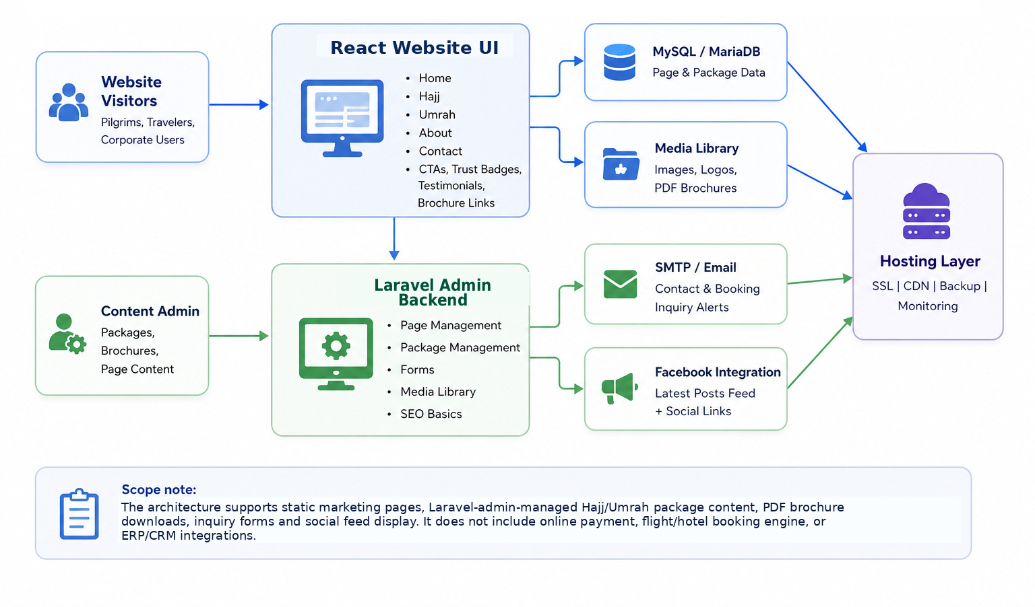
Figure 1: High-Level Solution Architecture

4.2 Frontend and User Experience Approach
- Build a clean, modern and responsive interface for desktop, tablet and mobile users.
- Use clear navigation for Home, Hajj, Umrah, About Us and Contact Us pages.
- Use strong CTAs for viewing packages, downloading brochures and submitting inquiries.
- Keep content blocks structured and readable for religious travel customers, families and corporate users.
- Optimize images, banners, testimonials and partner logo sections for fast loading and professional presentation.

4.3 Laravel Admin and Content Management Approach
- Configure Laravel-admin-managed pages for Home, Hajj, Umrah, About Us and Contact Us.
- Create manageable content sections for Hajj and Umrah package details, package inclusions, durations, pricing labels and brochure downloads.
- Enable admin-level updates for testimonials, partner logos, service CTAs, contact details and downloadable PDFs.
- Maintain simple role-based access so only authorized staff can update website content.
- Use structured content fields where required to reduce formatting errors during future updates.

4.4 Inquiry and Booking Interest Flow
The website will support inquiry generation through package CTAs, contact form, phone, email and social links. Online payment or automated booking confirmation is not included; the business team will continue manual follow-up after receiving inquiries.
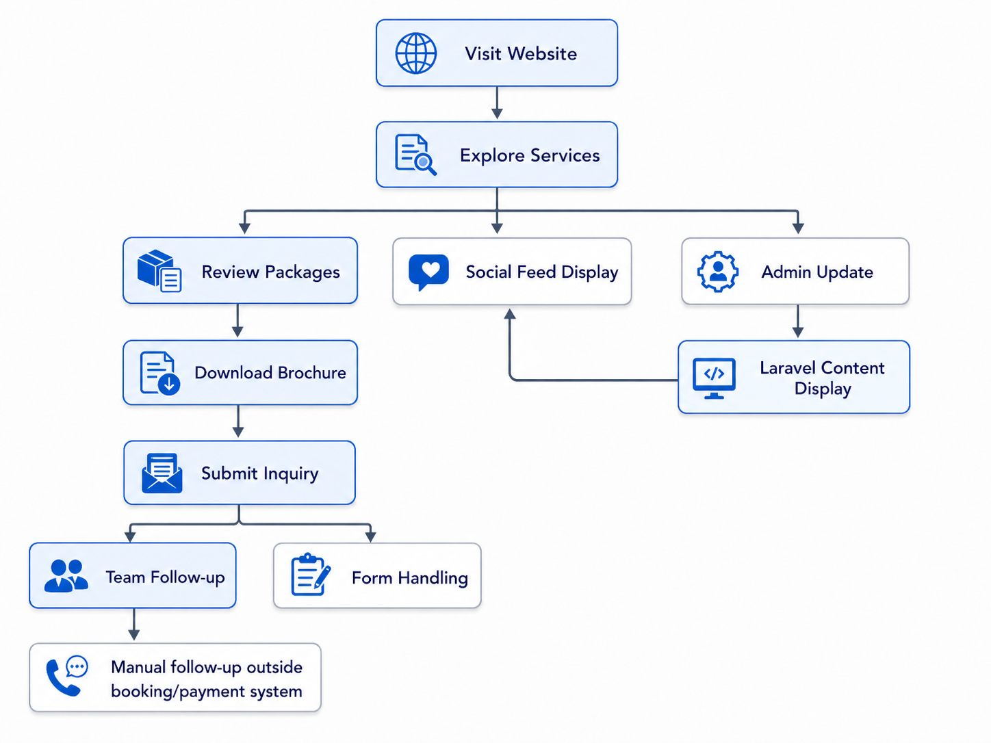
Figure 2: Customer Inquiry and Booking Interest Flow

4.5 Social Media and Facebook Feed Integration
- Add official social media links in the footer and relevant contact sections.
- Create a dedicated section for latest Facebook posts on the website.
- Implement the feed using an approved Facebook embed/plugin or Graph API-based method depending on page access, API approval and hosting compatibility.
- Provide fallback display with a Facebook page link if live feed access is delayed by platform permission or API restrictions.

4.6 Laravel Admin Content Update Flow
The Laravel admin panel will allow authorized staff to update page content, package information and brochures without requiring code changes for regular content updates.
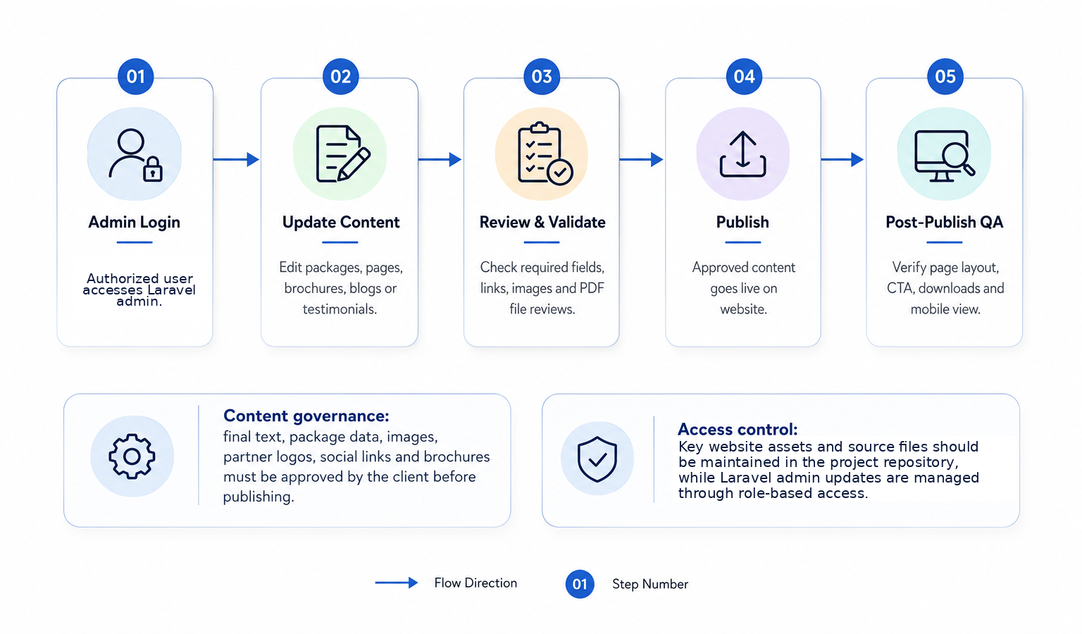
Figure 3: Laravel Admin Content Update Flow

5. Proposed Technical Stack
A React and Laravel-based stack is recommended for this scope because it supports a modern responsive frontend, secure backend/admin content management, package information pages, brochure publishing, contact forms and social feed integration while keeping development and maintenance practical.
Layer | Recommended Technology / Tooling
Frontend | React.js, HTML5, CSS3, JavaScript/TypeScript, Tailwind CSS or Bootstrap as required
Backend / Admin Panel | Laravel with custom admin panel and required content management sections
Backend Framework / Language | Laravel (PHP 8.x)
Database | MySQL or MariaDB
Content Management | Laravel admin-managed pages, reusable content sections, media library and PDF brochure management
Inquiry Handling | Laravel-based secure contact form with validation, spam protection and SMTP/email notification
Social Integration | Facebook page embed/plugin or Meta Graph API-based feed, integrated through the Laravel backend where required, based on page access and approval
Hosting | Linux hosting or cloud VPS with Nginx/Apache, SSL certificate, backup configuration and CDN support
Performance | React asset optimization, image optimization, caching, minified assets and CDN where available
Security | HTTPS, Laravel authentication/role control, CAPTCHA/spam protection, secure admin access and backup policy

6. Development Methodology
The proposed methodology follows a lightweight Agile delivery model with clear milestones, review points and client feedback loops. This keeps the website delivery controlled while allowing the client team to validate page structure, content presentation and inquiry flow before launch.
Stage | Activity
Requirement Confirmation | Review page scope, content structure, branding, assets, social access and brochure files.
Information Architecture | Finalize navigation, page sections, CTA placement and content hierarchy.
UI Design | Prepare clean responsive page layouts for Home, Hajj, Umrah, About Us and Contact Us.
Frontend & Backend Development | Develop React frontend, Laravel backend/admin sections, package listing structure, form handling and brochure download flow.
Content Upload | Upload approved text, images, partner logos, testimonials, package data and PDF brochures.
QA & Launch Readiness | Conduct functional, responsive, content, form, social feed, browser and launch-readiness testing.
Deployment | Deploy to production hosting, configure SSL, backup, admin access and post-launch checks.

7. Deliverables
- Responsive website design and development for Home, Hajj, Umrah, About Us and Contact Us pages.
- Laravel admin panel setup with manageable page content, package sections, testimonials, partner logos/trust badges including Nusuk, Visit Saudi, Riyadh Air, Saudi Arabian Airlines and Accor Hotels and brochure uploads.
- Home page CTA sections for Hajj Packages, Umrah Packages, Visa Services, Air Tickets and Corporate Packages as content-driven links/blocks.
- Hajj and Umrah package listing structures with package detail presentation, duration/pricing labels, brochure downloads and inquiry CTA placement.
- Contact page setup with inquiry form, phone, fax, email, department extensions, physical address, office hours, service directory and brochure links.
- Social media links and Facebook/latest-posts display section, subject to page access and platform permissions.
- Basic performance, security and responsive optimization setup.
- Deployment support, admin handover and short Laravel admin usage guidance.

8. Testing and Quality Assurance
Testing will focus on ensuring the website is stable, readable, responsive and aligned with the approved feature scope.
QA Area | Validation Focus
Functional Testing | Validate navigation, CTAs, package listings, brochure downloads, contact form submission and social links.
Content Testing | Check page copy, package details, contact information, pricing labels, downloadable brochures, images and partner logos.
Responsive Testing | Verify layouts on desktop, laptop, tablet and common mobile screen sizes.
Cross-Browser Testing | Check latest versions of Chrome, Edge, Safari and Firefox where practical.
Form & Email Testing | Validate form fields, error messages, spam control, SMTP delivery and inquiry notification format.
Social Feed Testing | Confirm Facebook feed display, fallback behavior, post rendering and link accuracy.
Performance Testing | Review page speed, optimized images, caching and asset loading.
Security Testing | Check HTTPS, admin access controls, CAPTCHA/spam protection, plugin hygiene and backup readiness.
Launch Support | Validate final corrections and support go-live preparation.

9. Assumptions, Dependencies and Out of Scope

9.1 Assumptions and Dependencies
- Client will provide final approved content, package details, service descriptions, images, partner logos and testimonials.
- Client will provide final Visa Services and Air Tickets short descriptions, including any country-wise visa process content to be published.
- Client will provide all Hajj and Umrah PDF brochures to be uploaded.
- Client will provide official phone, fax, email, department extensions, office hours and service directory content for the Contact Us page.
- Client will provide domain, hosting, DNS and SSL-related access or approve the recommended hosting setup.
- Client will provide official Facebook page access or required credentials/permissions for social feed integration.
- Any third-party platform limitation, approval delay or API permission issue may affect live social feed behavior.

9.2 Out of Scope
- Online payment gateway or payment collection workflow.
- Real-time flight, hotel or transport booking engine/API integration.
- CRM, ERP, accounting or call center system integration.
- Mobile application development.
- Advanced customer portal, user login or account dashboard.
- Automated visa processing engine beyond website CTA/content presentation.
- Online air ticket booking, ticket inventory or airline API integration beyond Air Tickets CTA/content presentation.
- Multilingual website unless separately confirmed.
- Large-scale marketing automation beyond website contact form and social links.

10. Conclusion
The proposed solution provides a clean, focused and maintainable website for Excelsior Travel Service. It supports the required public pages, Hajj and Umrah package presentation, brochure downloads, contact/inquiry generation, trust-building content and social media integration. The approach is intentionally lightweight and Laravel-admin-driven, making it suitable for current business needs while keeping future content updates manageable.

