Technical Proposal
Next-Gen Website Enhancement & Student Mobile App Development
for Focus University Admission Coaching

Prepared for: Focus University Admission Coaching
Prepared by: Riseup Labs
Date: 28 January 2026

1. Project Overview
Focus University Admission Coaching currently operates an online learning platform that includes basic login, a video player, simple MCQ exams, PDF uploads, class schedules, and notifications. The client wants to enhance the existing website (not build from scratch) by adding data-driven marketing features, stronger learning and assessment capabilities, AI-powered student support, and richer dashboards for teachers and parents. In addition, the client requires a new student-facing mobile app (built from scratch) that provides both existing and new features in a modern, high-performance experience.

2. Current Platform Summary
Existing capabilities (as provided by the client):
- Basic authentication (login)
- Video lesson playback (basic)
- MCQ exams (basic)
- PDF/resource uploads
- Class schedules / routine
- Notifications
Enhancement direction (high level):
- Conversion and lead generation improvements (marketing analytics, funnel design, SEO content)
- Advanced exam, ranking and merit features (batch and national context)
- AI-powered Q&A and adaptive learning to improve learning outcomes and reduce teacher workload
- Teacher, parent and admin control features (dashboards, QA loops, operational visibility)
- Upgraded content delivery (YouTube-grade player, categorized resources, smart notes)
- New mobile app to serve students with a cohesive portal experience

3. Objectives and Key Outcomes
The upgraded ecosystem targets three measurable outcomes:
- Higher conversion: capture qualified leads, track marketing ROI, and improve enrollment conversion.
- Optimized learning experience: provide interactive learning, clarity after every exam, and personalized practice.
- Operational excellence: enforce support SLAs, build quality loops, and enable teacher/parent oversight.
Key success indicators (examples):
- Lead conversion rates from “Book a Free Class / Free Trial” flow and attribution by channel.
- Average AI response time (0–2 minutes) and teacher response SLA (within business hours).
- Student performance uplift in weak topics through adaptive remediation sets.
- Reduced support load on teachers for repetitive doubts via AI instant support.
- Engagement metrics: video completion, practice frequency, and retention by cohort.

4. Proposed Solution Overview
The proposal delivers an integrated web + mobile + AI ecosystem through an incremental enhancement strategy:
- Enhance the existing website without breaking current operations (incremental releases).
- Modernize the front-end experience using a Next.js-based web application (as per provided direction) while keeping backend services API-driven.
- Develop a new student mobile app from scratch with the same core portal experience and additional mobile-first features (notifications, QR scan, practice, AI help).
- Introduce AI services for instant Q&A and adaptive learning using a controlled, traceable workflow with human review options.
- Implement data instrumentation (Meta Pixel, GA4, CleverTap, email marketing) for marketing ROI and funnel optimization.
Primary user groups supported:
- Students
- Teachers
- Parents/Guardians
- Admins/Operations

5. Scope of Work (Enhancements + New Mobile App)

5.1 Website Enhancement (Not from scratch)
A. Data-driven conversion and marketing analytics
- Integrate Facebook/Meta Pixel, Google Analytics (GA4), CleverTap, and email marketing tools for full-funnel tracking.
- Implement lead generation gates such as “Book a Free Class / Free Trial” before syllabus/routine downloads.
- Post-preview conversion nudges: show course price and reviews immediately after preview/free trial consumption.
- SEO-driven blog module and lead management: university information blogs, preparation guidelines, discount coupons, and lead tracking.
B. Learning experience enhancements
- YouTube-grade video player: resume playback, playback speed, quality selection, lesson drawer, and improved navigation.
- Categorized resources: PDFs and notes organized per class/lesson; easy download and access.
- Smart class notes aligned to structured note-taking (e.g., Cornell-style sections) with downloadable PDF.
- Lesson transcript and summarization features to support quick review and accessibility.
C. Exams, rankings and merit systems
- Central merit system: combined merit position across all branches, supporting timer and negative marking rules.
- Advanced rankings: batch rank, national rank, subject-wise rank, percentile, and visual analytics.
- Exam improvements: MCQ option randomizer (A-B-C-D), timer-based delivery, answer breakdown (correct/wrong/skip) with explanation per question.
- Written exam support: answer sheet viewer for students and repository of top-scorer sample copies (standard writing references).
- Retake policy flow: missed exam status, retake rules, and messaging that retakes do not impact official ranking.
D. Stakeholder dashboards (Teacher and Parent)
- Teacher dashboard: class management, attendance tracking, student progress visibility, and feedback insights (online and offline).
- Parent dashboard: view attendance, results, class schedule, and relevant student performance indicators.
- Progress tracker: weak/strong areas based on results and practice history.
E. Feedback and operational quality loop
- 360-degree feedback: online resource correction forms (report error on PDFs/videos) and offline class feedback using QR/app prompts.
- Teacher answer quality enforcement: structured answer format requirements (concept used, step-by-step solution, common mistakes, exam tips).
- Rating system on answers and QA restrictions based on low ratings to ensure continuous quality improvement.
- Teacher gamification: badges, XP, weekly leaderboards to reinforce fast, high-quality support.

5.2 Student Mobile App (Developed from scratch)
The mobile app will provide a full student portal experience with mobile-first enhancements:
- Authentication and profile, with role-ready foundation (student, parent as viewer, teacher access if required).
- Course/class access: lesson list, lesson drawer, resources, notes, and schedules.
- Upgraded video player experience aligned with the website (resume, speed, quality, downloads where allowed).
- MCQ and written exam participation with result dashboards and rank insights.
- AI Help: instant Q&A, 24-hour AI support, and adaptive learning recommendations.
- Push notifications via Firebase Cloud Messaging (FCM) and in-app notification center.
- Optional QR scan module for “phygital” bridge use cases (chapter hub, subscription check, parent visibility).

5.3 AI Q&A System (Instant + Teacher SLA)
Core capabilities:
- ‘Ask Instantly’ for quick MCQ/formula/concept doubts with target SLA of 0–2 minutes.
- Teacher SLA tracking for non-instant questions during business hours with visibility of average response times.
- AI answer format includes step-by-step reasoning and reference links (e.g., lesson timestamps or note sections) with a clear “AI-generated; teacher review pending” label where applicable.
- Teacher answer submission UI enforces pedagogical structure and minimum sections before submission.
- Feedback loop: students rate answers; low ratings trigger QA actions and restrict future assignment if needed.
- Gamification: clarity badges, XP, and leaderboards to reinforce responsiveness and quality.

5.4 AI Adaptive Learning (Personalized Recommendations)
- Digital question bank for self-practice by subject and chapter selection.
- Track every attempt: correctness, time taken, retries, and confidence signals.
- Weakness diagnosis: frequent error patterns, weak chapters, and slow-solve areas.
- Personalized remediation: generate targeted practice sets for identified weaknesses.
- Prediction module: cross-reference weak topics with historical patterns to produce ‘high-chance’ predicted questions for upcoming exams.
- Visual trend reports showing improvement over time.

5.5 Interactive Practice and Engagement
- Drag-and-drop practice (e.g., spatial labeling, maps, gap filling).
- Flashcards with click-to-reveal mechanism for active recall.
- Special batch logic: eligibility based on sincerity metrics and average marks threshold.
- Performance alerts and motivational messaging for students falling behind.

5.6 Optional/Backlog Items (Subject to client prioritization)
- Career / ‘Join the Mission’ portal with CV upload and demo video submission for hiring.
- Community/Discord-like structured help/notice/resource channels inside the platform.
- Live class polling integration (e.g., Zoom + Slido) for real-time engagement.

6. Proposed Technical Approach

6.1 Incremental enhancement strategy (Website not from scratch)
To avoid disruption to current users, the enhancement will follow an incremental migration approach. New modules will be introduced behind feature flags, integrated via APIs, and released in controlled iterations. Where a UI modernization is required (e.g., Next.js conversion), pages can be migrated gradually while keeping existing backend services operational.

6.2 API-first modular architecture
- Expose core platform capabilities through versioned REST APIs (auth, content, exams, ranks, dashboards, notifications).
- Use a layered backend structure: Controllers/API Gateway layer, domain services, and data access layer.
- Implement background processing for high-latency tasks (AI generation, video processing, analytics events) using queues/workers.

6.3 AI services with quality control (Human-in-the-loop)
- AI answers on approved class content (notes, transcripts, solutions).
- Maintain traceability: store prompts, sources, and generated outputs with an audit trail and versioning.
- Route complex questions to teachers with SLA tracking; AI handles instant support and drafts for teacher review.
- Implement guardrails: content safety filters, hallucination prevention via citations to internal sources, and confidence thresholds.

6.4 Ranking, merit and analytics computation
- Central merit engine calculates combined ranking across branches with configurable rules (negative marking, timer).
- Percentile and subject-wise breakdown computed from normalized score distributions.
- Visualization layer provides charts and comparisons (accuracy, time vs score, topic weaknesses).

6.5 Video delivery design
- Store videos in object storage and deliver through CDN with adaptive bitrate streaming (HLS/DASH).
- Support resume playback via user progress checkpoints and device sync.
- Player features include speed control, quality selection, lesson drawer, and chapter markers.

6.6 Security and privacy fundamentals
- Secure authentication (JWT/OAuth2), password policies, and optional MFA for admins.
- Role-based access control across student, teacher, parent, and admin functions.
- Data protection: encryption in transit (TLS) and at rest for sensitive fields and files.
- Audit logs for admin changes, answer edits, and result/merit recalculations.

7. Proposed Technology Stack
The final stack can be aligned to the existing system; below is the recommended, scalable stack for the proposed enhancements and mobile app.
Layer | Recommended Technology | Purpose | Notes
Web Frontend | Next.js (React) + TypeScript | Modern UI, SEO, performance | Supports incremental migration and SSR/SSG for marketing pages.
Admin Web | React (or Next.js) + TypeScript | Admin, teacher and parent dashboards | Can be delivered as a separate app or within Next.js routes.
Mobile App | Flutter (Dart) | Single codebase iOS/Android | Native-like performance, strong UI components and offline-ready patterns.
Backend APIs | Laravel (PHP) or Node.js (NestJS) | Core APIs and business logic | Selection to align with current backend; both support clean architecture and queues.
Database | PostgreSQL | Primary relational store | Supports analytics queries and extensions such as pgvector if needed.
Cache/Queue | Redis + Worker framework | Queues, caching, rate limiting | Used for AI jobs, notifications, leaderboards, and performance.
AI Service | Python (FastAPI) | AI Q&A and adaptive learning services | Integrates with LLM provider, vector store, and content ingestion pipelines.
Storage | AWS S3 (or equivalent) | PDFs, images, videos, uploads | Versioning and lifecycle policies recommended.
Video Pipeline | HLS/DASH + Transcoding (FFmpeg/MediaConvert) | Adaptive video streaming | Enables quality selection and stable playback.
Analytics | GA4 + Meta Pixel + CleverTap | Marketing and product analytics | Tag Manager recommended for flexible instrumentation.
Notifications | Firebase Cloud Messaging (FCM) | Push notifications | Works for web + mobile.
CI/CD | GitHub Actions / GitLab CI + Docker | Automated builds and deployments | Supports staging and production pipelines.

8. Development Methodology
We propose an Agile delivery model to support iterative enhancements, frequent stakeholder review, and controlled releases.

8.1 Delivery model
- Sprint-based development (2-week sprints) with prioritized backlog and acceptance criteria.
- Kickoff and discovery sprint to confirm existing system constraints, integrations, and data model.
- Incremental releases with feature flags and staged rollout to production.

8.2 Key ceremonies and governance
- Sprint planning, daily standups, sprint review/demo, and retrospective.
- Weekly stakeholder checkpoint for scope alignment, priority updates, and risk review.
- Definition of Done includes code review, unit tests, QA sign-off, and updated documentation.

8.3 Requirements and acceptance management
- User stories mapped to modules (Student, Teacher, Parent, Admin).
- Acceptance criteria and test scenarios prepared for each story.
- Traceability from requirements to releases (release notes, change log).

9. Deliverables
Primary deliverables for this engagement include:
- Requirements confirmation pack: refined scope, user roles, and prioritized backlog.
- Solution architecture and technical design: API map, data model, and integration plan.
- Enhanced website modules: marketing analytics, lead generation flow, content/resource improvements, exams and rankings, dashboards.
- New student mobile app (iOS and Android): portal features, video, exams, AI help, notifications.
- AI Q&A and adaptive learning services: SLA workflow, admin review controls, analytics.
- QA artifacts: test plan, test cases, bug reports, and test summary reports per release.
- Deployment and handover: environment setup, CI/CD pipeline, monitoring dashboards, admin training guide, and documentation.
Suggested delivery milestones (indicative):
- Milestone 1: Discovery, architecture, instrumentation plan, and core portal enhancements baseline.
- Milestone 2: AI Q&A (instant + teacher SLA), dashboards, and enhanced results/rank analytics.
- Milestone 3: Adaptive learning, interactive practice, and central merit system completion.
- Milestone 4: Mobile apps stabilization, release readiness, and production rollout with monitoring.

10. Testing and Quality Assurance
A dedicated QA process will be applied across web, mobile, and AI features to ensure stability, correctness, and performance.

10.1 Test levels
- Testing for backend services and mobile components.
- API integration testing for auth, exams, ranking engine, dashboards, and analytics events.
- End-to-end (E2E) testing for critical journeys: signup/login, video learning, exam taking, results/rank viewing, AI Q&A, and dashboard workflows.
- Regression testing for every release to protect existing features on the current website.


10.2 Non-functional testing
- Performance testing: video playback load, exam concurrency, ranking computation, and AI response latency.
- Security testing: authentication, authorization (RBAC), file upload validation, and OWASP top risks.
- Reliability testing: queue retries, failure handling, and backup/restore validation.

10.3 Mobile testing matrix
- Device coverage across common Android versions and iOS devices (phone + tablet as applicable).
- Network scenario testing (WiFi, 4G/5G, low bandwidth) with offline/poor connectivity handling where relevant.
- Store readiness checks: crash-free sessions, performance metrics, and permission review.

10.4 AI quality and safety checks
- Grounding validation: ensure AI responses cite internal sources (notes/transcripts) where applicable.
- Hallucination reduction: confidence thresholds and fallback to teacher escalation.
- Audit logging and human review tools for edits and approvals.

11. Deployment, Release and Environments
We recommend a standard multi-environment setup to ensure safe releases:
- Development: daily builds and internal testing.
- Staging: client review environment with production-like data structures (sanitized).
- Production: controlled rollout with monitoring, alerts and rollback plan.
Release management approach:
- CI/CD pipeline for automated build, test and deployment steps.
- Blue/green or rolling deployment strategy for minimal downtime.
- Feature flags for staged enablement of new modules and safe experimentation.

12. Assumptions, Dependencies and Out of Scope

12.1 Assumptions
- Client will provide access to the existing website codebase, hosting details, and current database schema for impact analysis.
- Client will provide or approve third-party analytics accounts (Meta, GA4, CleverTap) and required keys.
- Content (videos, notes, question banks) and policy rules (merit computation, negative marking) will be provided and validated by the client.

12.2 Out of Scope (unless added later)
- Complete redesign activities, UI/UX design, or branding work beyond implementation of provided designs.
- AR/VR features (explicitly excluded in the provided requirements).
- Deep integrations with third-party live class platforms beyond agreed polling or meeting links.
- Creation of new video/animated content; only platform support for content delivery is included.

13. Risks and Mitigation
Risk | Impact | Mitigation
Existing codebase constraints (legacy dependencies) | May slow down new module integration | Discovery sprint, incremental migration, feature flags, prioritize high-impact modules first.
AI accuracy and trust issues | Student dissatisfaction or wrong guidance | human review workflow, logging and continuous tuning.
Ranking/merit rule ambiguity | Incorrect leaderboards or disputes | Formalize rulebook, test with sample datasets, sign-off before launch.
Video delivery performance under load | Playback failures and dropout | CDN-backed streaming, adaptive bitrate, load testing, caching and monitoring.
App store approval delays | Release schedule risk | Early store preparation, compliance checks, staged rollout and beta testing.

14. Diagram Placeholders
The following diagrams should be inserted in the final version to strengthen the proposal and provide visual clarity. Placeholders are included below for easy insertion.

Figure 1: High-Level Solution Architecture
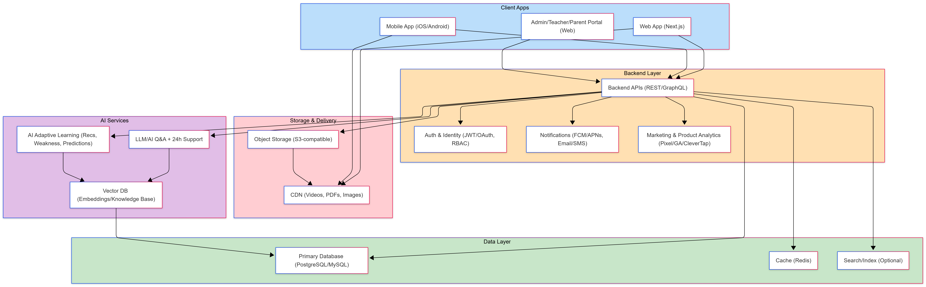
Shows Web (Next.js) and Mobile App communicating with Backend APIs, Databases, Storage/CDN, and AI Services.

Figure 2: AI Q&A Workflow (Instant + Teacher SLA)
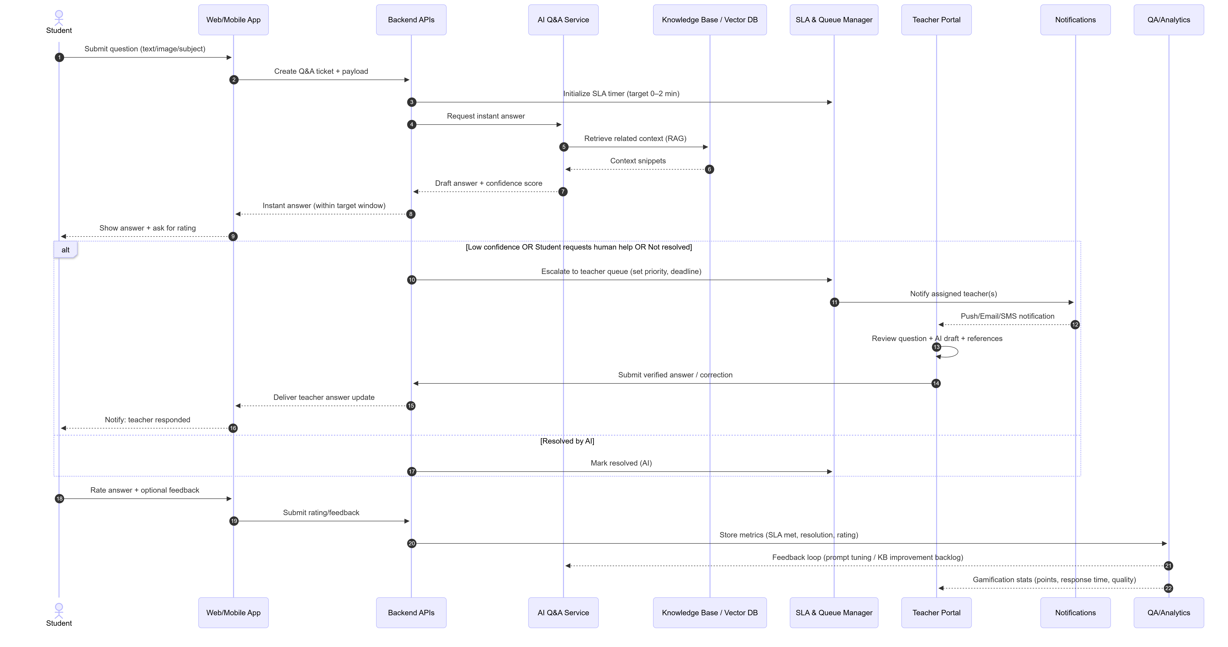
Sequence from student question -> AI instant response -> escalation to teacher with SLA -> rating and QA feedback loop.

Figure 3: Core Data Model Overview (ERD)
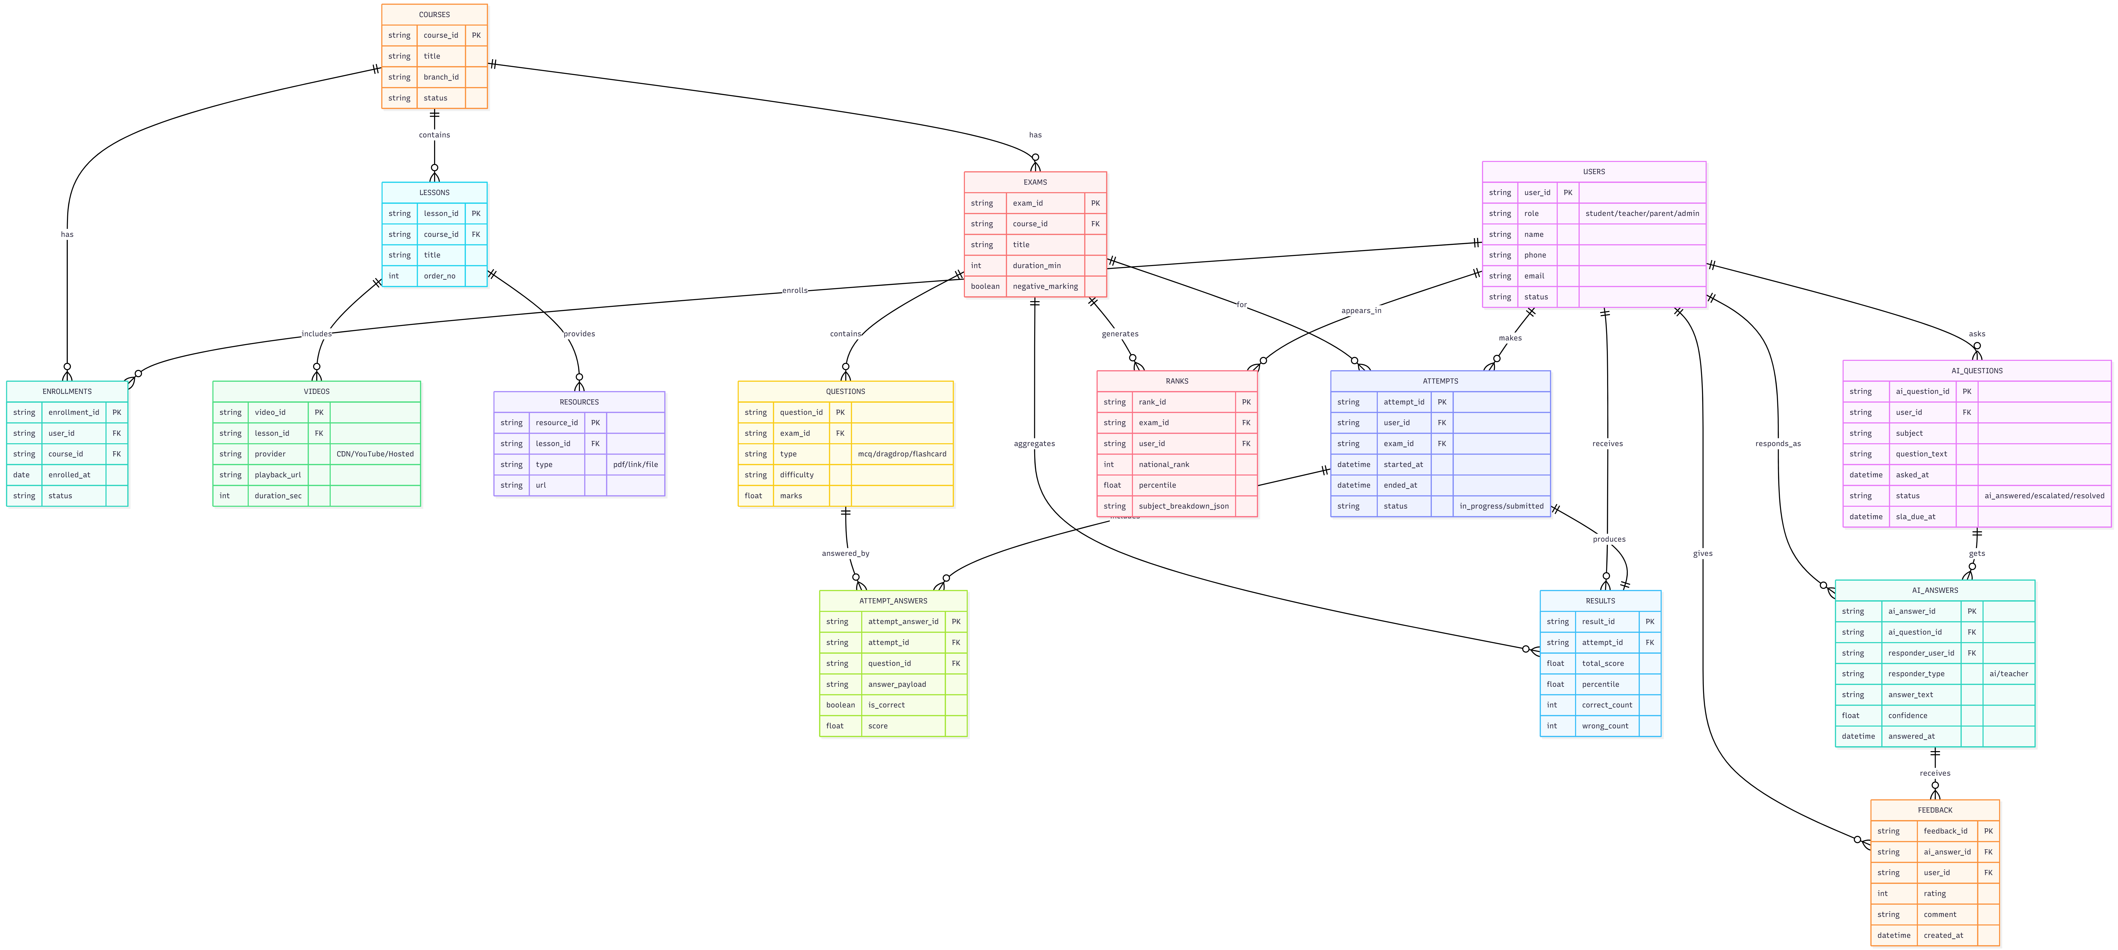
Key entities: Users, Courses, Lessons, Videos, Resources, Exams, Questions, Attempts, Results, Ranks, AI Questions, AI Answers, Feedback.

Figure 4: Mobile App Module Map
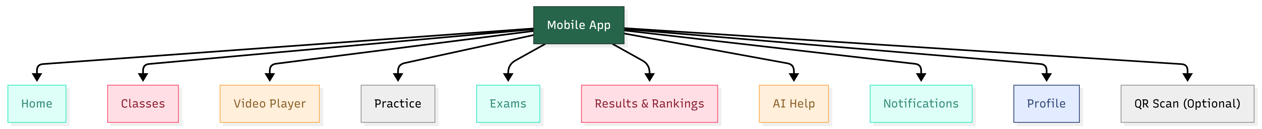
Major app modules: Home, Classes, Video Player, Practice, Exams, Results & Rankings, AI Help, Notifications, Profile, QR Scan (optional).

15. Conclusion
This proposal outlines a practical, incremental approach to upgrade the existing learning website into a measurable conversion engine and high-performance learning ecosystem, while delivering a new mobile app from scratch for students. The proposed architecture and technology stack emphasize scalability, traceability for AI features, and strong quality assurance to ensure stable operations and improved learning outcomes.

