Technical Proposal
Globe Pharma Group Website Rebuild and Hostinger Migration
Prepared By: Riseup Labs


1. Executive Summary
Globe Pharma Group requires a stable, secure and maintainable website environment for its corporate group websites. The current websites are running on an older WordPress and PHP setup with outdated plugins and theme components. The proposed solution is to rebuild the websites from a clean WordPress installation on Hostinger, migrate the existing content and media, upgrade the technology stack and prepare the platform for routine content management by the internal team.
The rebuild will keep the website functionality aligned with the current requirement. The objective is not to introduce a new complex product or e-commerce platform. The focus is on a clean WordPress implementation, child theme architecture, safe plugin usage, performance improvement, cross-browser compatibility, mobile responsiveness, launch support and knowledge transfer.

2. Understanding of Current Requirement
Based on the provided requirement document, the project covers the complete rebuild, migration, upgrade, testing and launch of the Globe Pharma Group website environment.
Requirement Area | Understanding
Current Situation | The current website environment is WordPress-based, hosted on an existing platform and running on an older PHP version with outdated theme and plugin components.
Target Hosting | The websites need to be moved to the new Hostinger hosting environment.
Website Count | The requirement mentions a total of eight company websites/properties to be migrated or rebuilt.
Technology Upgrade | WordPress core, PHP, theme and retained plugins must be upgraded to latest stable and compatible versions.
Theme Architecture | A child theme must be implemented so future updates do not break customizations.
Plugin Management | Retained plugins need to be upgraded, deprecated or vulnerable plugins removed and compatibility issues resolved.
Performance | The websites should load fast on desktop and mobile and avoid major performance warnings from standard tools.
Admin Independence | The internal team should be able to manage pages, products/catalog content, images, homepage banners, news posts, menus and safe plugin updates without developer dependency.
Training and Handover | Administrator access, basic user documentation and knowledge transfer session are required.

3. Proposed Scope of Work
The scope is designed as a fresh WordPress rebuild with controlled migration from the existing websites. Existing content, structure, banners, products/catalog information, news and functional behavior will be retained unless the client approves changes.

3.1 In-Scope Activities
• Audit the existing WordPress websites, plugins, theme customizations, content types and media assets.
• Prepare a fresh WordPress environment on Hostinger with SSL, database and recommended PHP settings.
• Rebuild the websites using a clean theme and child theme architecture.
• Migrate or recreate required pages, product/catalog content, banners, news posts, menus, forms, media and tables/charts as applicable.
• Upgrade WordPress core, theme and retained plugins to latest stable compatible versions.
• Remove or replace deprecated, unsupported or vulnerable plugins only when required for security or compatibility.
• Configure performance improvements including caching, image optimization and basic front-end optimization.
• Apply basic WordPress security hardening, admin role setup and backup readiness.
• Test the websites across required browsers and mobile devices.
• Launch the websites on Hostinger after QA approval.
• Provide administrator access, basic user guide and knowledge transfer session.

3.2 Out-of-Scope Items
• New e-commerce checkout, online payment or order management features unless already part of the existing approved website scope.
• Custom ERP, CRM, inventory, pharmaceutical compliance portal or third-party system integration.
• New mobile application, custom web application or advanced marketing automation.
• Paid plugin/theme license purchase cost, hosting subscription cost or third-party service cost.
• Major branding redesign unless separately approved.

3.3 Proposed Website Management Capability
After handover, Globe Pharma Group administrators will be able to perform routine content activities through the WordPress dashboard.
• Edit website pages and page sections.
• Add or update products/catalog items where such sections exist.
• Upload and manage images and documents.
• Change homepage banners and sliders.
• Publish news and announcements.
• Manage menus and basic navigation.
• Update plugins safely using the documented process.
• Manage routine website content without developer dependency.

4. Technical Approach
The proposed technical approach follows a low-risk rebuild model. Instead of directly patching the old installation, the team will prepare a clean WordPress setup on Hostinger, migrate approved content and then perform compatibility, security and performance checks before launch.

4.1 Discovery and Audit
• Collect access to existing WordPress admin, hosting panel, database, file manager and domain/DNS details.
• Prepare an inventory of pages, products/catalog entries, news posts, banners, forms, menus, plugins, media and custom theme areas.
• Identify outdated plugins, license-dependent plugins and compatibility risks before rebuild.

4.2 Fresh Hostinger Setup
• Create a new WordPress installation on Hostinger under a staging or temporary URL.
• Configure supported PHP version, database, SSL, file permissions and basic hosting settings.
• Create admin, editor and technical access according to approved user roles.

4.3 Theme and Child Theme Implementation
• Set up the approved parent theme or clean base theme.
• Create a child theme for custom styles, templates and functions.
• Move all required customizations into the child theme to reduce future update risk.
• Preserve existing website look and functional behavior unless changes are approved.

4.4 Plugin Upgrade and Compatibility
The retained plugin set will be reviewed and upgraded carefully. Existing plugins mentioned in the requirement include Contact Form 7, Slider Revolution, WPBakery Visual Composer, WP Fastest Cache, Smush, Kadence Security or Really Simple Security, Visualizer Tables & Charts, Mobile Menu and Akismet Anti-Spam.
• Upgrade retained plugins to latest stable compatible versions.
• Remove plugins that are deprecated, vulnerable, duplicated or not required.
• Resolve conflicts between theme, PHP version and plugin versions.
• Avoid unnecessary plugin additions to keep maintenance cost and performance risk low.

4.5 Content Migration and Rebuild
• Migrate or recreate website pages, menus, banners, products/catalog content, forms, news and media.
• Review migrated pages against the existing sites to ensure content consistency.
• Optimize image size where practical without changing approved visual content.
• Prepare repeatable content management patterns for the internal team.

4.6 Security and Performance Configuration
• Enable HTTPS and confirm SSL across all live URLs.
• Configure basic login protection, strong admin access practices and secure user roles.
• Disable unsafe file editing from the dashboard where applicable.
• Configure caching, image optimization and cleanup of unused assets/plugins.
• Prepare backup and restore readiness before final launch.

4.7 Launch and Handover
• Run final pre-launch checklist and QA fixes.
• Switch DNS or Hostinger domain mapping after client approval.
• Verify live website access, forms, responsive views, browser compatibility and admin login.
• Provide basic user guide and knowledge transfer for routine content management.

5. Proposed Technical Stack
The proposed stack is based on a maintainable WordPress architecture. Versions will be finalized during implementation based on Hostinger availability and plugin compatibility testing.
Layer | Proposed Stack | Purpose
Hosting | Hostinger hosting environment | Target hosting platform for the rebuilt websites.
CMS | Latest stable WordPress | Website content management, admin dashboard and publishing workflow.
Server Language | PHP 8.3 or higher, with compatibility testing for PHP 8.4/8.5 where supported | Modern supported PHP runtime aligned with WordPress recommendations and plugin compatibility.
Database | MySQL 8.0+ or MariaDB 10.6+ | WordPress content, settings, users and plugin data storage.
Theme Architecture | Approved parent theme with custom child theme | Future-safe customization layer for styles, templates and functions.
Page/Content Editing | WordPress editor and retained page builder where required | Editable pages, banners, product/catalog content and news posts.
Forms | Contact Form 7 or compatible retained form plugin | Contact and inquiry form handling.
Slider/Banner | Slider Revolution only if required by existing approved design | Homepage banner and slider management.
Performance | Caching, image optimization and lightweight asset cleanup using retained tools such as WP Fastest Cache/Smush where compatible | Faster desktop and mobile loading.
Security | SSL, secure roles, login protection and retained security plugin such as Kadence Security/Really Simple Security | Basic WordPress hardening and admin protection.
Backup | Hostinger backup and manual pre-launch backup package | Rollback readiness during migration and launch.
Compatibility | Chrome, Edge, Firefox, Safari, Android and iPhone | Required browser and mobile coverage.

6. Development Methodology
A phased agile delivery approach will be followed. This allows the team to work in controlled batches, validate each company website and reduce launch risk.
Phase | Activities
Phase 1: Discovery | Access collection, existing site review, plugin audit, content inventory and risk log.
Phase 2: Setup | Hostinger environment, WordPress installation, SSL/PHP/database setup and staging URL.
Phase 3: Rebuild | Child theme setup, page/template rebuild, content and media migration in batches.
Phase 4: Optimization | Plugin upgrade, compatibility fixes, security configuration and performance tuning.
Phase 5: QA | Browser, mobile, admin workflow, forms, content and performance testing.
Phase 6: Launch | DNS/domain cutover, live smoke test, admin access, documentation and training.

6.1 Governance and Communication
• Weekly progress review with completed website list, pending issues and next actions.
• Issue tracking for content gaps, plugin conflicts, browser bugs and launch blockers.
• Client approval before replacing any plugin or changing visible website behavior.
• Change control for any requirement beyond the agreed scope.

7. Technical Diagrams
7.1 High-Level Website Solution Architecture
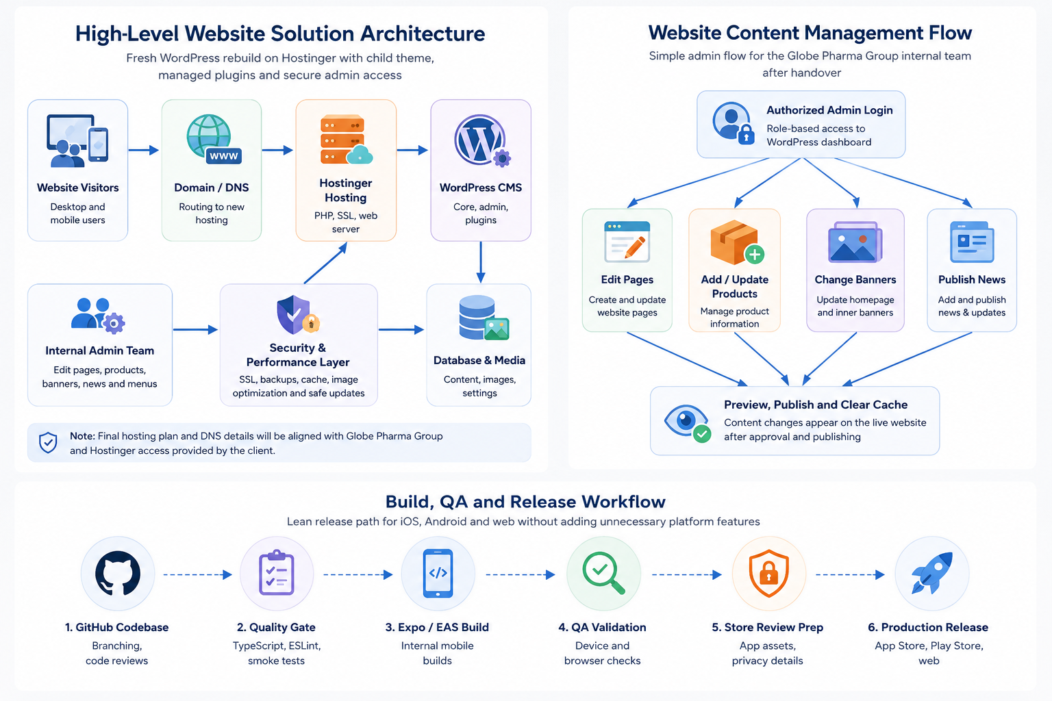
Figure 1: Proposed high-level architecture for the rebuilt WordPress websites on Hostinger.

7.2 Development and Deployment Workflow
Figure 2: Controlled rebuilding and deployment workflow for the eight company websites.

7.3 Website Content Management Flow
Figure 3: Internal admin content management flow after handover

8. Deliverables
Deliverable | Description
Requirement and Site Inventory | List of existing pages, content types, plugins, banners, forms, menus, products/catalog content and identified risks.
Fresh WordPress Setup | Clean WordPress installation on Hostinger with supported PHP, database and SSL configuration.
Child Theme Implementation | Future-safe theme structure with customizations stored in a child theme.
Rebuilt Website Pages | Recreated or migrated pages, banners, media, news, menus and products/catalog content for the required eight company websites/properties.
Plugin Upgrade and Cleanup | Retained plugins upgraded, unnecessary or unsafe plugins removed and compatibility issues resolved.
Security Configuration | Basic WordPress hardening, admin role setup, SSL verification and secure update practice.
Performance Configuration | Caching, image optimization, cleanup and basic performance tuning for desktop and mobile.
QA Report | Summary of browser, mobile, content, admin, form, performance and security test results.
Launch Checklist | Pre-launch and post-launch checklist including backup, DNS/domain verification and live smoke testing.
Administrator Access | Admin access provided to the authorized Globe Pharma Group team.
User Guide and KT Session | Basic documentation and training session for routine content, banner, product/catalog, news, menu and plugin update management.
Backup Package | Pre-launch backup and final website backup/restore readiness handover.

9. Testing and Quality Assurance
Testing will be performed in a practical and focused way to ensure the websites are stable, responsive, secure and ready for routine content management.

9.1 QA Coverage
• Content verification against the existing websites and approved scope.
• Page layout testing for key pages, banners, menus, product/catalog sections and news posts.
• Form submission testing including recipient email verification.
• Plugin compatibility testing after WordPress, PHP, theme and plugin upgrades.
• Responsive testing on desktop, tablet and mobile breakpoints.
• Browser testing on Chrome, Edge, Firefox and Safari.
• Mobile compatibility testing on Android and iPhone views.
• Admin workflow testing for edit pages, upload images, update products/catalog content, change banners, publish news and manage menus.
• Performance testing using standard tools such as Google PageSpeed Insights or GTmetrix.
• Security checks for SSL, login protection, admin roles, plugin status and unsafe file editing settings.
• Backup and restore readiness validation before launch.
• Final live smoke test after DNS/domain cutover.

10. Assumptions, Risks and Mitigation

10.1 Assumptions
• Globe Pharma Group will provide access to the existing WordPress sites, hosting, database, file system, Hostinger account and domain/DNS controls.
• Existing content, media, logos and brand assets will be reused unless new content is provided.
• Required premium plugin licenses, if any, will be provided by Globe Pharma Group.
• No major new feature, payment gateway, e-commerce checkout or custom system integration is included in this proposal.
• The selected Hostinger plan will support the required number of websites, traffic, storage, database needs and PHP version.

10.2 Risks and Mitigation
Risk | Possible Impact | Mitigation
Legacy theme or plugin incompatibility | Layout or functionality may break after upgrades. | Use staging, audit plugins, upgrade gradually and replace only when necessary.
Missing plugin licenses | Some premium plugin updates may not be possible. | Confirm licenses during discovery and keep client approval for alternatives.
Content mismatch across eight websites | Pages or media may be missed during migration. | Use content inventory and batch-based review checklist.
DNS propagation delay | Temporary access inconsistency after launch. | Plan launch window and verify DNS before cutover.
Hosting resource limitation | Performance may be affected if plan capacity is insufficient. | Review Hostinger plan during discovery and recommend adjustment only if required.
Admin update mistakes after handover | Future plugin/theme updates may create issues. | Provide update guide, role setup, backup process and knowledge transfer.

11. Handover and Training Plan
The handover will ensure the Globe Pharma Group internal team can manage routine website operations independently.
• Provide administrator access and user role setup.
• Provide a basic user guide covering page editing, product/catalog update, image upload, banner change, news publishing, menu management and safe plugin update steps.
• Conduct one knowledge transfer session with practical demonstration.
• Share final backup and launch checklist.
• Provide QA summary for client record.

12. Conclusion
The proposed solution provides Globe Pharma Group with a clean, updated and maintainable WordPress website environment on Hostinger. By rebuilding the websites from a fresh installation, implementing child theme architecture, upgrading the WordPress ecosystem and providing training, the project will reduce future maintenance risk and enable the internal team to manage routine content updates with confidence.
The proposal intentionally remains focused on the provided requirement so the development effort stays controlled, practical and cost-conscious.

