Technical Proposal
WordPress CMS Upgrade for the IPCC Website
Upgrade of Existing WordPress Content Management System

Proposal Type | Technical Proposal
Prepared On | 7 April 2026

1. Executive Summary
The IPCC website is a high-traffic public information platform with a large and continuously growing body of scientific and institutional content. Based on the Terms of Reference, the required engagement is an upgrade of the existing WordPress CMS and related server-side dependencies, not a full rebuild. Our approach is therefore centered on assessment, compatibility planning, protected execution in a staging environment, controlled production deployment, and documented handover.
The proposed work will preserve existing content structures, themes, plugins, and business-critical functionality wherever feasible; replace only unsupported components that cannot be maintained securely; and align the platform with current WordPress, PHP, Linux hosting, and operational best practices.

2. Understanding of Requirement
The ToR requires a controlled upgrade of the existing IPCC website to the latest stable WordPress version, with full preservation of content and functionality, better performance and maintainability, improved security posture, minimal disruption, and alignment with the Linux hosting environment managed with UNICC.
• Assessment of the current WordPress core, plugins, themes, PHP version, database version, Linux configuration, and compatibility risks.
• Backup, restorability verification, and rollback planning before any upgrade activity.
• Preparation of a staging environment that mirrors production as closely as possible.
• Upgrade of WordPress core, themes, plugins, and related PHP/server dependencies as required.
• Testing across functionality, browsers, performance, security, links/forms, and data integrity.
• Controlled deployment to production followed by monitoring, documentation, and administrator handover.

3. Proposed Technical Approach

3.1 Discovery and Technical Assessment
Review the current hosting stack, WordPress version, active theme, custom code, installed plugins, PHP compatibility, database configuration, and file structure. The output of this step is a practical upgrade matrix, issue log, and execution plan.

3.2 Backup, Recovery and Rollback Readiness
Coordinate a full backup of application files, database, media, themes, plugins, and any configuration items within project scope. A restoration test will be performed in the staging environment to confirm that rollback is feasible.

3.3 Staging-first Upgrade Execution
All upgrade activities will be performed in staging first. This includes PHP alignment, WordPress core update, plugin and theme upgrades, configuration review, and targeted remediation of deprecated or unsupported components.

3.4 Controlled Production Release
After staged validation and sign-off readiness, the upgrade will be deployed to production during a controlled release window with backup checkpointing, final smoke testing, and post-deployment monitoring.

4. Development Methodology
A concise upgrade methodology is proposed to reduce operational risk while keeping the engagement efficient:
Phase | Focus | Key Activities | Output
Assess | Baseline review | Audit platform, hosting dependencies, risks, and compatibility | Assessment findings and upgrade plan
Prepare | Risk control | Backup, rollback planning, staging setup, restoration check | Safe upgrade environment
Upgrade | Technical execution | Upgrade core, PHP/dependencies if needed, plugins, themes, configs | Upgraded staging build
Validate | Quality assurance | Functional, browser, performance, security, links/forms, DB integrity | Tested release candidate
Deploy | Go-live & handover | Production deployment, smoke checks, monitoring, documentation | Live upgraded site and handover pack

5. Proposed Technical Stack
Because this is an upgrade of an existing platform, the proposal keeps the current CMS and hosting direction intact and introduces only the versions, tools, and controls required for a stable modernization.
Layer | Proposed Stack | Notes
CMS | WordPress latest stable release | Upgrade target aligned with the current officially maintained stable version.
Application Runtime | PHP 8.3 as preferred target; PHP 8.4 subject to full compatibility confirmation | Final version should be confirmed against hosting support and plugin/theme compatibility.
Web Server / OS | Existing Linux hosting environment | Maintain compatibility with the current UNICC-managed infrastructure.
Database | Existing production database engine/version | Retain current DB platform unless version alignment is required for supportability.
Theme Layer | Existing theme / child theme | Preserve front-end behavior; update only for compatibility and security.
Plugin Layer | Existing approved plugins upgraded to latest compatible versions | Unsupported components replaced only where necessary and approved.
Version Control & Release | Controlled change set, release checklist, backup checkpointing | Supports traceability and rollback.
Testing Toolset | Manual QA plus browser, performance, security, and broken-link validation tools | Tool choice can be adapted to the client/hosting environment.

6. Technical Diagram
The following placeholders are included so visual diagrams can be inserted later without changing the document structure.
Figure 1. Existing-to-Target Upgrade Flow
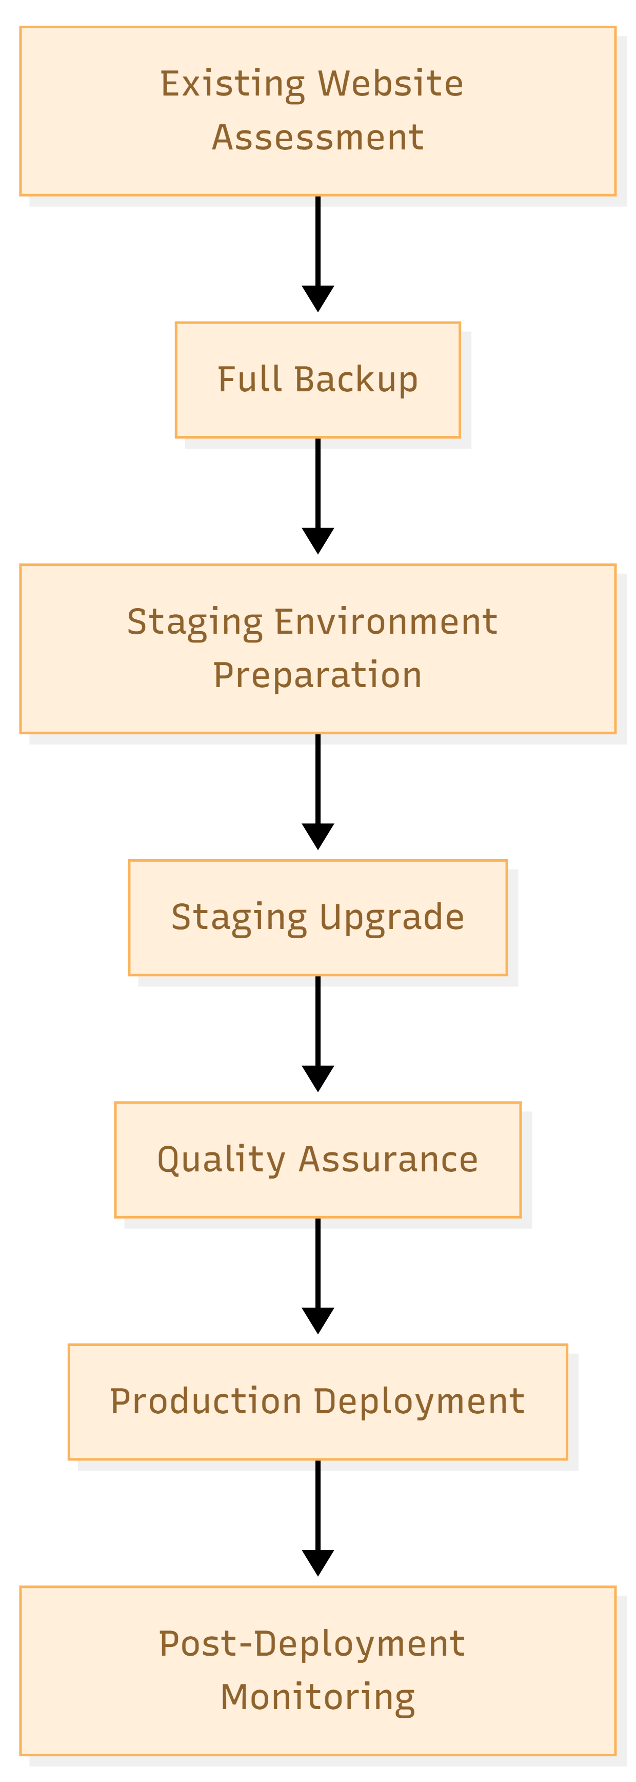

7. Testing and Quality Assurance
Testing will be concise but comprehensive enough to confirm that the upgraded site is stable, secure, and production ready.
Functional Testing: Validate key page templates, content display, navigation, search, forms, admin workflows, and critical user journeys.
Browser Compatibility Testing: Check core behavior across major modern browsers and responsive breakpoints relevant to the existing site.
Performance Verification: Compare selected baseline pages before and after upgrade to identify regressions in load behavior.
Security Verification: Review update completeness, configuration hygiene, access exposure, and common hardening points relevant to WordPress.
Broken Link and Form Testing: Verify that key forms, internal links, attachments, and redirection behaviors are working correctly.
Database Integrity Verification: Confirm that content, metadata, and media relationships remain intact after upgrade.
Post-deployment Smoke Testing: Validate core public and admin functions immediately after production release.


8. Deliverables
Deliverable | Description
Technical assessment and upgrade plan | Current-state findings, compatibility/risk summary, upgrade sequence, and rollback approach.
Verified backup and recovery readiness | Backup coordination and restoration validation in line with project scope.
Upgraded staging environment | Updated WordPress core, compatible plugins/themes, and aligned runtime/dependencies.
Testing outputs | Compatibility, quality, security, and performance verification summary.
Production deployment | Controlled rollout of the upgraded website with minimal disruption.
Technical documentation and handover | Upgrade record, maintenance guidance, and administrator-oriented reference notes.

9. Assumptions and Scope Boundaries
• This engagement covers upgrade and stabilization of the existing IPCC WordPress website, not a redesign or rebuild.
• Content migration is not treated as a separate workstream because existing content is expected to remain in place and be preserved.
• Unsupported plugin replacement is limited to functionally necessary substitution where secure upgrade is not possible.
• Major UX redesign, new feature development, and large-scale content restructuring are outside the intent of this proposal unless separately approved.
• Any hosting-level change outside normal compatibility alignment will be addressed only if required by the upgrade path and approved by stakeholders.

10. Conclusion
The proposed approach is intentionally practical and risk-controlled. It aligns with the ToR by modernizing the existing IPCC WordPress platform, preserving current content and functions, improving security and maintainability, and executing the change through a staging-first release process with documentation and handover.

