TECHNICAL PROPOSAL
IPTEC Corporate Website Redesign & Digital Infrastructure Platform
Prepared for IPTEC Limited

Prepared By: Riseup Labs


Executive Summary
This proposal presents a practical and scalable approach to redesign and redevelop the IPTEC corporate website from scratch as a modern digital platform. The solution is aligned with the RFP objective of creating a strong corporate brand platform, enterprise lead generation channel, customer information hub, and future-ready digital foundation. The recommendation focuses only on the scope requested in the RFP and avoids unnecessary features that would increase delivery cost or complexity.
The proposed website will combine a modern responsive frontend, structured content management capability, SEO-ready page architecture, analytics integration, Zoho One CRM integration, non-voice AI chatbot support in English and Arabic, calendar integration, and hardened cloud deployment. The implementation approach prioritizes fast page load performance, secure administration, easy content maintenance by IPTEC staff, and flexibility for future expansion into customer portals or self-service capabilities.

Understanding of Requirements
- Based on the RFP, the website must serve both branding and business-generation needs. It is not only a presentation site; it must support enterprise prospect engagement, showcase IPTEC services and industry solutions, and create a reliable platform for future digital service expansion.
- Develop the website from scratch with professional information architecture and responsive user experience.
- Implement a CMS so IPTEC staff can manage blog posts, services, news, and other routine content updates internally.
- Include the required core pages, service pages, and industry solution pages with SEO-friendly structure.
- Integrate lead capture forms, WhatsApp contact options, click-to-call actions, and required analytics/marketing tags.
- Connect approved lead capture forms and consultation requests with Zoho One / Zoho CRM so qualified inquiries can be routed and tracked by IPTEC.
- Provide non-voice AI chatbot support in English and Arabic for website visitor assistance, basic service guidance, and inquiry handoff.
- Provide calendar integration so website visitors can request or book consultations through the approved scheduling workflow.
- Meet the RFP expectations for speed, security, mobile usability, and future scalability.

Requirement-to-Solution Mapping
Area | Proposal Response
Corporate Positioning | Use a clean enterprise-grade website structure and messaging-oriented page layouts to present IPTEC as a trusted digital infrastructure provider in South Sudan.
Lead Generation | Deploy inquiry forms, consultation forms, support forms, partnership forms, WhatsApp CTA, click-to-call pathways, calendar booking/request flow, and Zoho One / Zoho CRM lead handoff on key landing pages.
CRM Integration | Integrate website lead capture and inquiry forms with Zoho One / Zoho CRM for structured lead collection, tracking, and follow-up routing.
AI Chatbot | Add a third- party non-voice website chatbot that supports English and Arabic, answers approved service queries, and guides visitors toward inquiry or support flows.
Calendar Integration | Provide third-party calendar integration for consultation booking or request scheduling, subject to IPTEC-approved availability rules and calendar tool selection.
SEO Readiness | Create service- and industry-specific landing pages, SEO-friendly URLs, metadata fields, schema markup, XML sitemap, and structured internal linking.
Performance | Optimize frontend assets, images, caching, CDN usage, and code delivery to target fast page loads and high PageSpeed performance.
Security | Apply SSL, WAF/CDN configuration, restricted admin access, backups, update management, and security hardening for the CMS and hosting environment.
Manageability | Provide a structured CMS backend, reusable page blocks, training, and documentation so IPTEC can manage routine content without developer dependency.
Scalability | Use modular architecture and clean deployment practices so future customer portal or billing/self-service modules can be integrated later.

Proposed Solution Overview
The recommended solution is a custom-developed corporate website built from scratch using a modern frontend layer and an enterprise-configured content management backend. This approach balances marketing performance, editorial manageability, security, and future extensibility without introducing unnecessary enterprise overhead.
- A modern responsive user interface tailored for corporate credibility and telecom/ICT service presentation.
- Dedicated templates for service pages, industry solution pages, blog/news content, support pages, and standard corporate pages.
- A CMS-driven content architecture enabling controlled editing, publishing, SEO field management, and media updates.
- A cloud-hosted deployment architecture with CDN, SSL, caching, backup strategy, and controlled release management.
- Integration support for Zoho One CRM, non-voice English/Arabic AI chatbot, and calendar booking/request workflows as part of the website conversion layer.
- A structured QA and launch process including staging, deployment checklist, and handover.

Figure 1. Proposed High-Level Solution Architecture
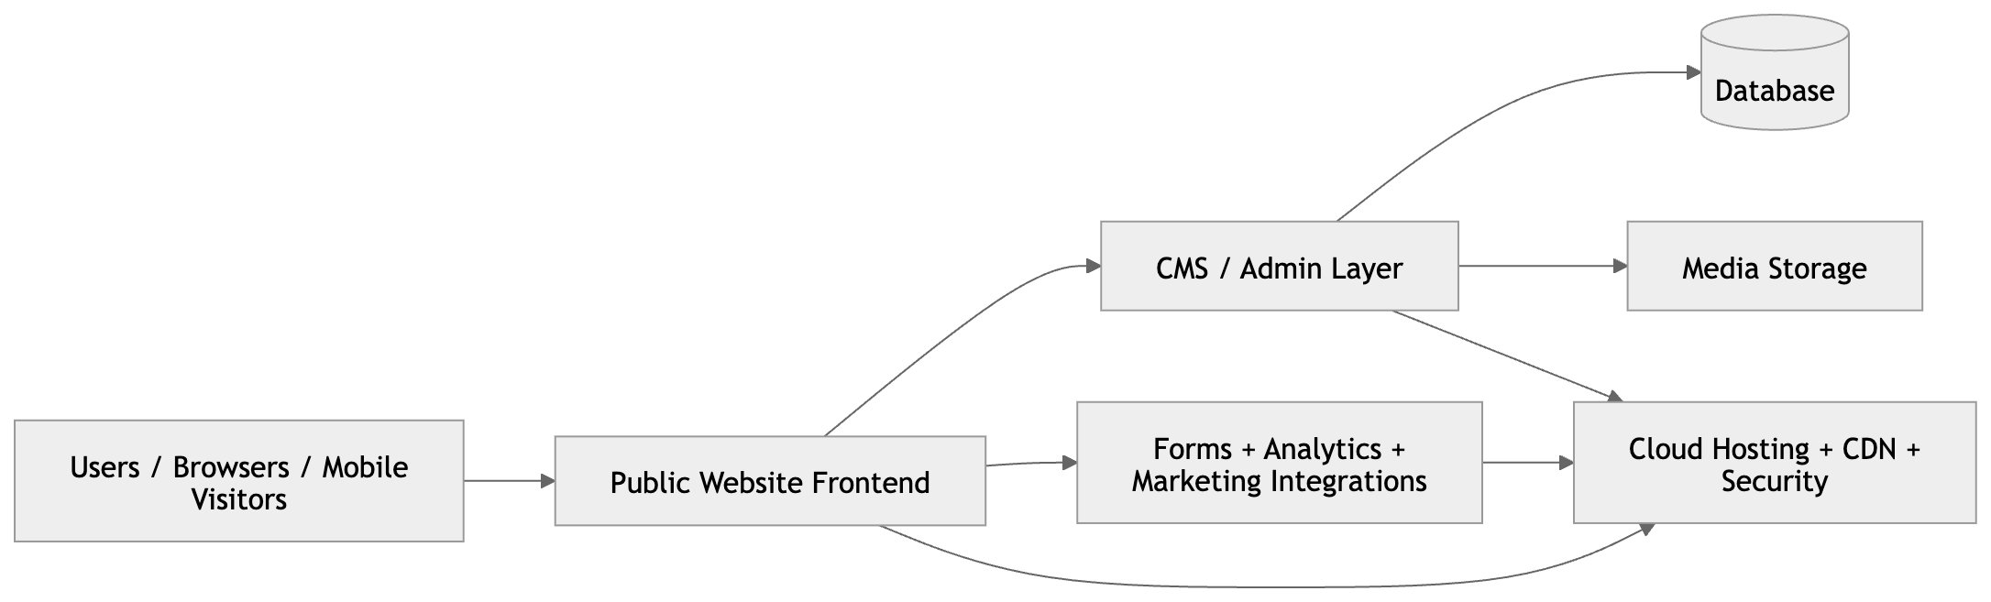

Proposed Technical Approach
The technical approach is divided into six controlled workstreams to ensure the project remains aligned with the approved scope and timeline.

1. Discovery & Planning
Review the RFP in detail, confirm content hierarchy, validate all required pages, define conversion points, confirm technology decisions, and prepare the delivery plan.

2. UX / UI Definition
Prepare wireframes and page layout direction for homepage, service pages, industry pages, blog, support, and contact flows. The design system will emphasize enterprise trust, clear service storytelling, and mobile-first usability.

3. Platform Development
Set up the CMS, configure reusable content models, build the frontend templates, implement navigation, forms, CTA components, analytics tags, SEO controls, Zoho One CRM integration, AI chatbot widget configuration, and calendar integration.

4. Performance & Security Hardening
Configure caching, media optimization, CDN delivery, SSL, admin restrictions, update policies, and defensive hardening before user acceptance testing.

5. Validation & QA
Run structured functional testing, browser/device testing, performance review, integration validation for CRM, chatbot, and calendar flows, and stakeholder QA on a staging environment.

6. Launch & Handover
Deploy the approved release to production, complete final smoke testing, provide documentation, and train IPTEC staff on content administration.

Website Information Architecture
The following information architecture is based directly on the minimum structure defined in the RFP and is intentionally limited to the requested scope.

Page Structure Summary
Area | Proposal Response
Core Pages | Home, About IPTEC, Services, Solutions, Network Infrastructure, Coverage Map, Industries Served, Blog / Insights, Customer Support, Contact Us
Service Landing Pages | Dedicated Fiber Internet, Wireless Broadband, Starlink Internet Solutions, Managed ICT Services, Enterprise Network Solutions
Industry Pages | NGO Connectivity Solutions, Banking & Financial Institutions, Government Connectivity, Oil & Gas Sector, Hospitality Industry, Education Sector
Conversion Pages / Components | Service inquiry, enterprise consultation, partnership request, support request, CTA banners, WhatsApp contact, click-to-call, AI chatbot entry point, calendar booking/request flow
Editorial Areas | Blog / Insights, News updates, careers page, selected service content blocks editable through CMS

Figure 2. Sitemap / Information Architecture Placeholder
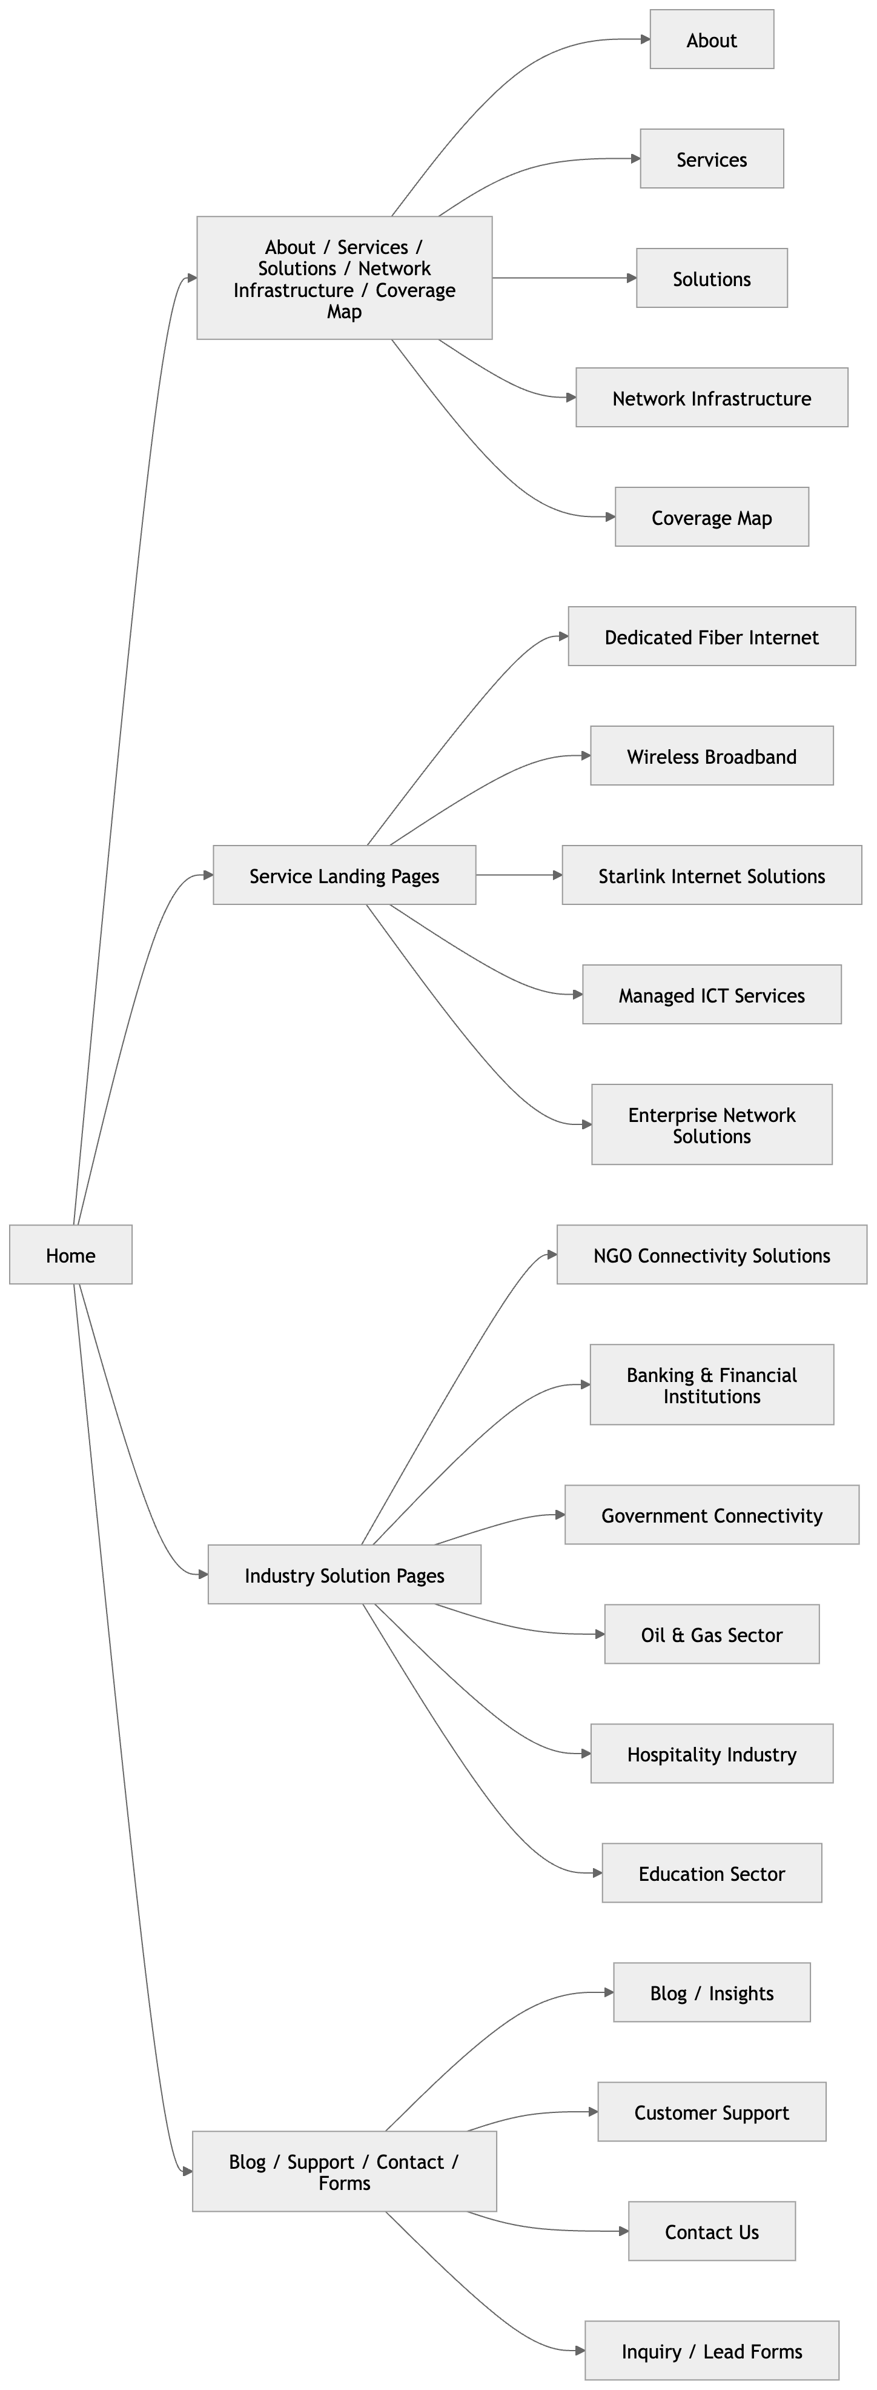

Proposed Technology Stack
The recommended stack stays within the technologies preferred by the RFP and is selected for maintainability, performance, and future growth.

Recommended Stack
Area | Proposal Response
Frontend | Next.js (React-based) for a fast, SEO-friendly, responsive frontend with reusable page components and strong performance optimization options.
CMS | Headless WordPress in enterprise configuration for easy editorial management, custom content types, role-based access, and future extensibility.
Backend / API Layer | WordPress REST API / custom endpoints as needed for forms, content retrieval, and admin-managed content delivery.
Hosting | Cloud hosting on AWS, DigitalOcean, or Google Cloud. Final selection can be aligned to IPTEC operational preference and support arrangement.
CDN & Edge Security | Cloudflare for CDN delivery, SSL, WAF, DNS management, caching support, and DDoS mitigation.
Database | Managed MySQL/MariaDB supporting the CMS.
Media & File Handling | Structured media library within CMS with optimized image handling and compressed modern formats.
Analytics / Marketing | Google Analytics 4, Google Search Console, LinkedIn Insight Tag, Facebook Pixel, and Zoho One / Zoho CRM tracking and form handoff as approved.
CRM Integration | Zoho One / Zoho CRM integration using approved API, embedded forms, or webhook-based handoff for lead capture, consultation requests, and support inquiries.
AI Chatbot | Non-voice website chatbot layer supporting English and Arabic, configured with approved service knowledge, response controls, and inquiry handoff to website forms or CRM.
Calendar Integration | Calendar/scheduling integration through the approved IPTEC tool, such as Zoho Bookings / Zoho Calendar, Google Calendar, or Outlook Calendar, depending on operational preference.
DevOps / Environments | Separate development, staging, and production environments with release controls and rollback-ready deployment practice.

Why this stack is recommended
- Matches the RFP preference for WordPress and/or headless architecture with React / Next.js.
- Provides strong SEO capability through server-side rendering and structured page output.
- Allow non-technical staff to maintain content through a familiar CMS backend.
- Supports modular future integrations without forcing portal functionality into the initial scope.
- Supports the approved Zoho One CRM, chatbot, and calendar integrations while keeping the website architecture modular.
- Enables strong performance and security controls when combined with cloud hosting and Cloudflare.

Development Methodology
A stage-gated agile delivery approach is recommended. This means the project moves through controlled phases with review and approval checkpoints, while development inside each phase is handled iteratively. This approach reduces rework, keeps the scope aligned to the approved RFP, and enables visible progress throughout the 10-week schedule.

Methodology Summary
Area | Proposal Response
Delivery Model | Stage-gated agile delivery
Working Style | Short design and development iterations with weekly progress review
Review Gates | Sitemap approval, wireframe/design approval, staging review, QA sign-off, go-live approval
Project Control | Issue tracking, change control log, prioritized bug fixing, and milestone-based status reporting
Collaboration | Regular feedback cycles with IPTEC stakeholders for timely approvals and content clarification

Testing & Quality Assurance
Testing will be embedded across the project, with a dedicated final QA stage before launch. The QA scope is aligned to the non-functional requirements in the RFP.

QA Coverage
Area | Proposal Response
Functional Testing | Navigation, forms, CTA flows, CMS publishing, redirects, blog templates, contact actions, chatbot entry points, calendar request flow, and administrative functions
Integration Testing | Validate Zoho One / Zoho CRM lead handoff, AI chatbot English and Arabic response flow, inquiry handoff, and calendar booking/request workflow on staging.
Responsive Testing | Desktop, tablet, and smartphone behavior across current major browsers and common screen sizes
Performance Testing | Image compression, asset optimization, lazy loading where suitable, caching checks, and PageSpeed review
SEO Validation | URL structure, metadata, schema, sitemap, robots.txt, alt text, internal linking, crawl-readiness
Security Validation | SSL verification, role-based admin access, plugin/theme hardening, brute-force mitigation, backup validation, WAF configuration review

Quality targets
- Target page load experience aligned to the RFP objective of sub-2-second loading for optimized priority pages under normal conditions.
- Target PageSpeed and mobile performance readiness through code and media optimization.
- Production release only after critical and major defects are resolved or accepted by IPTEC during QA.
- Delivery of a launch checklist and post-launch verification checklist.

Project Timeline
The proposed implementation timeline follows the intent of the RFP while organizing the work into practical delivery stages. It assumes timely review and approval from IPTEC for design, content, and deployment checkpoints.
Week | Phase | Key Activities | Outputs
1 | Discovery & Planning | Kickoff, requirement validation, sitemap confirmation, content inventory, technical planning | Project plan, confirmed sitemap
2–3 | UX / UI Design | Wireframes, homepage and inner page design system, mobile-responsive layouts, review iterations | Approved key page designs
4–7 | Development | CMS setup, frontend implementation, backend configuration, page template development, forms and integrations, Zoho One CRM connection, AI chatbot setup, calendar integration | Working staging website with approved integration flows
8 | Content Population & SEO Setup | Content entry support, metadata, schema, redirects plan, image optimization, analytics tags, CRM field mapping, chatbot knowledge alignment, calendar configuration | Content-ready pre-release build with configured integrations
9 | QA | Functional testing, responsive checks, speed tuning, security hardening, integration testing, bug fixing, user acceptance support | QA-approved release candidate
10 | Launch & Handover | Production deployment, final verification, documentation, staff training, support initiation | Live website and handover pack

Deliverables

Planned Deliverables
Area | Proposal Response
1. Discovery Outputs | Validated sitemap, page inventory, implementation plan, and project schedule
2. Design Outputs | Approved wireframes and high-fidelity UI layouts for key page types
3. Developed Website | Responsive website built from scratch and deployed to staging, then production after approval
4. CMS Configuration | Configured CMS backend with editable sections, content types, roles, and media handling
5. SEO Setup | Metadata structure, schema basics, XML sitemap, robots.txt, redirects planning, internal linking foundation
6. Integration Setup | Analytics and marketing tags as defined in the RFP, approved form routing, Zoho One / Zoho CRM integration, non-voice AI chatbot setup in English and Arabic, and calendar integration
7. Performance & Security Setup | Caching, CDN/WAF setup, SSL, backups, and admin security hardening
8. Documentation | Admin guide, deployment summary, and maintenance guidance
9. Staff Training | Knowledge transfer session for content updates and routine administration
10. Post-Launch Support | Three months of post-launch technical support in line with the RFP expectation

Assumptions, Dependencies & Exclusions
- The proposal excludes financial pricing and commercial terms, as requested.
- Website content, branding assets, logos, service copy, team information, and legal text will be provided or approved by IPTEC during the project.
- Final Zoho One / Zoho CRM fields, calendar availability rules, chatbot knowledge sources, and handoff workflows will be confirmed by IPTEC during discovery.
- Third-party subscription fees, paid plugins, hosting charges, SMS gateway fees, advertising platform costs, Zoho One / CRM licensing, calendar/booking tool fees, and chatbot / AI API usage costs are outside this technical proposal unless later approved.
- Future modules such as customer portal, online billing, service ordering, status dashboard, and support portal are treated as future scalability options only and are not included in the initial build.
- Large-scale copywriting, full multilingual website implementation beyond the English and Arabic non-voice chatbot support, custom CRM development beyond Zoho One integration, and ERP-style business process automation are excluded unless specifically added through change request.
- Any scope expansion after approval of sitemap and design should be handled through formal change control to protect timeline and quality.

Post-Launch Support
Following launch, the project will enter a 1-month support period aligned with the RFP. This period is intended to stabilize the live website and ensure a smooth operational handover.
• Bug fixing for issues within the delivered scope.
• Monitoring and correction of deployment-related defects.
• Support for minor content or configuration adjustments required for stabilization.
• Guidance for IPTEC administrators during the early live operation period.

Closing Statement
This proposal is designed to meet the IPTEC RFP with a practical, cost-aware, and standards-based delivery plan. The recommended approach focuses on building a professional corporate website from scratch that is secure, fast, editable, SEO-ready, and positioned to support IPTEC’s continued digital growth in South Sudan.

