Technical Proposal
Ice Cream Delivery Platform (Dhaka) - Mobile App (Android + iOS) + Admin Dashboard

Prepared By | RiseupLabs
Date | 20 Feb 2026

Introduction
This technical proposal describes the recommended approach to design and develop a zone-based ice cream delivery mobile application for Dhaka City Corporation. The solution targets fast, SLA-driven delivery with an end-to-end operational workflow across customers, dealers, riders, and administrators.

Objectives
- Enable customers to place orders and receive ice cream deliveries via slot-wise scheduling and express delivery options.
- Automate nearest dealer/hub and rider allocation based on distance and time, aligned with configurable SLA rules.
- Provide dealer and rider apps for order acceptance, pickup, navigation, and proof of delivery.
- Provide an admin operations dashboard for live monitoring, configuration, manual override, and basic reporting.
- Deliver Bengali-first UX with English as a secondary option, optimized for low-learning operational usage.

Project Understanding and Scope
Based on the provided feature list, the platform is planned in three incremental phases. Each phase is designed to be independently shippable and to progressively increase operational control, payment enablement, and real-time visibility.

Phased Delivery Roadmap
Phase | Theme | Key Capabilities | Outcome
Phase 1 | Core Ordering MVP | Order placement, dealer and rider allocation, slot and express logic, basic dealer and rider workflows, notifications, basic reporting (no advanced live tracking). | Go-live ready MVP for Dhaka zones.
Phase 2 | Ops Control + Payments + Security | Admin ops dashboard, manual override/reassignment, payment integration baseline (COD and wallet-ready architecture), rider status monitoring, security hardening. | Operational stabilization and monetization readiness.
Phase 3 | Real-Time Tracking + Stock/Hub Logs | Live rider location tracking, ETA, routing, hub/fridge stock logs, collection and handover records. | Scale readiness and higher customer trust.

In-Scope Applications and Roles
- Customer, Dealer and Rider Mobile App (Android and iOS).
- Admin Web Dashboard for operations and configuration.

Key Business Rules (SLA and Zone-Based Delivery)
- Zone-wise delivery rules configured by admin (city-based configuration).
- Slot-wise delivery scheduling and express delivery eligibility (example: 30-minute committed delivery).
- Automatic rejection/hold when SLA cannot be met due to distance, time, or rider availability thresholds.
- Address update handling with automated notifications and re-validation of SLA eligibility.
- Configurable maximum on-road time and maximum distance per zone or delivery type.

Out of Scope (for the initial delivery unless separately agreed)
- Advanced promotions, vouchers, and loyalty programs.
- Full grocery or wholesale ordering flows (scope-ready only).
- Advanced analytics, ML-driven demand forecasting, and route optimization beyond baseline ETA and routing.
- Chat/voice support (scope-ready only).
- Automated rider payouts and complex payroll (only policy flags/exports).

Proposed Technical Solution
The solution is designed as a mobile-first platform with a single backend API, a real-time event channel for tracking and operations, and a web-based admin dashboard. Mobile apps will share a common Flutter codebase (using flavors and role-based modules) to reduce duplication while still shipping separate customer, dealer, and rider apps for clarity and store distribution.

High-Level Architecture

Figure 1: High-Level System Architecture

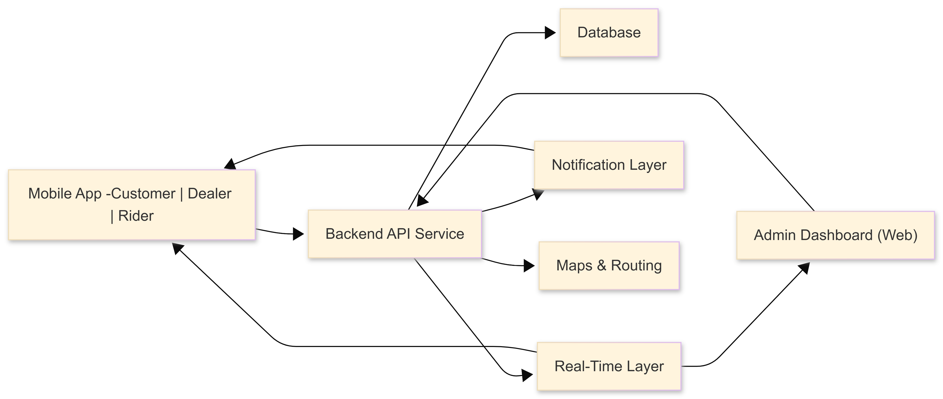

Figure 2: End-to-End Order Lifecycle (Customer to Delivery)

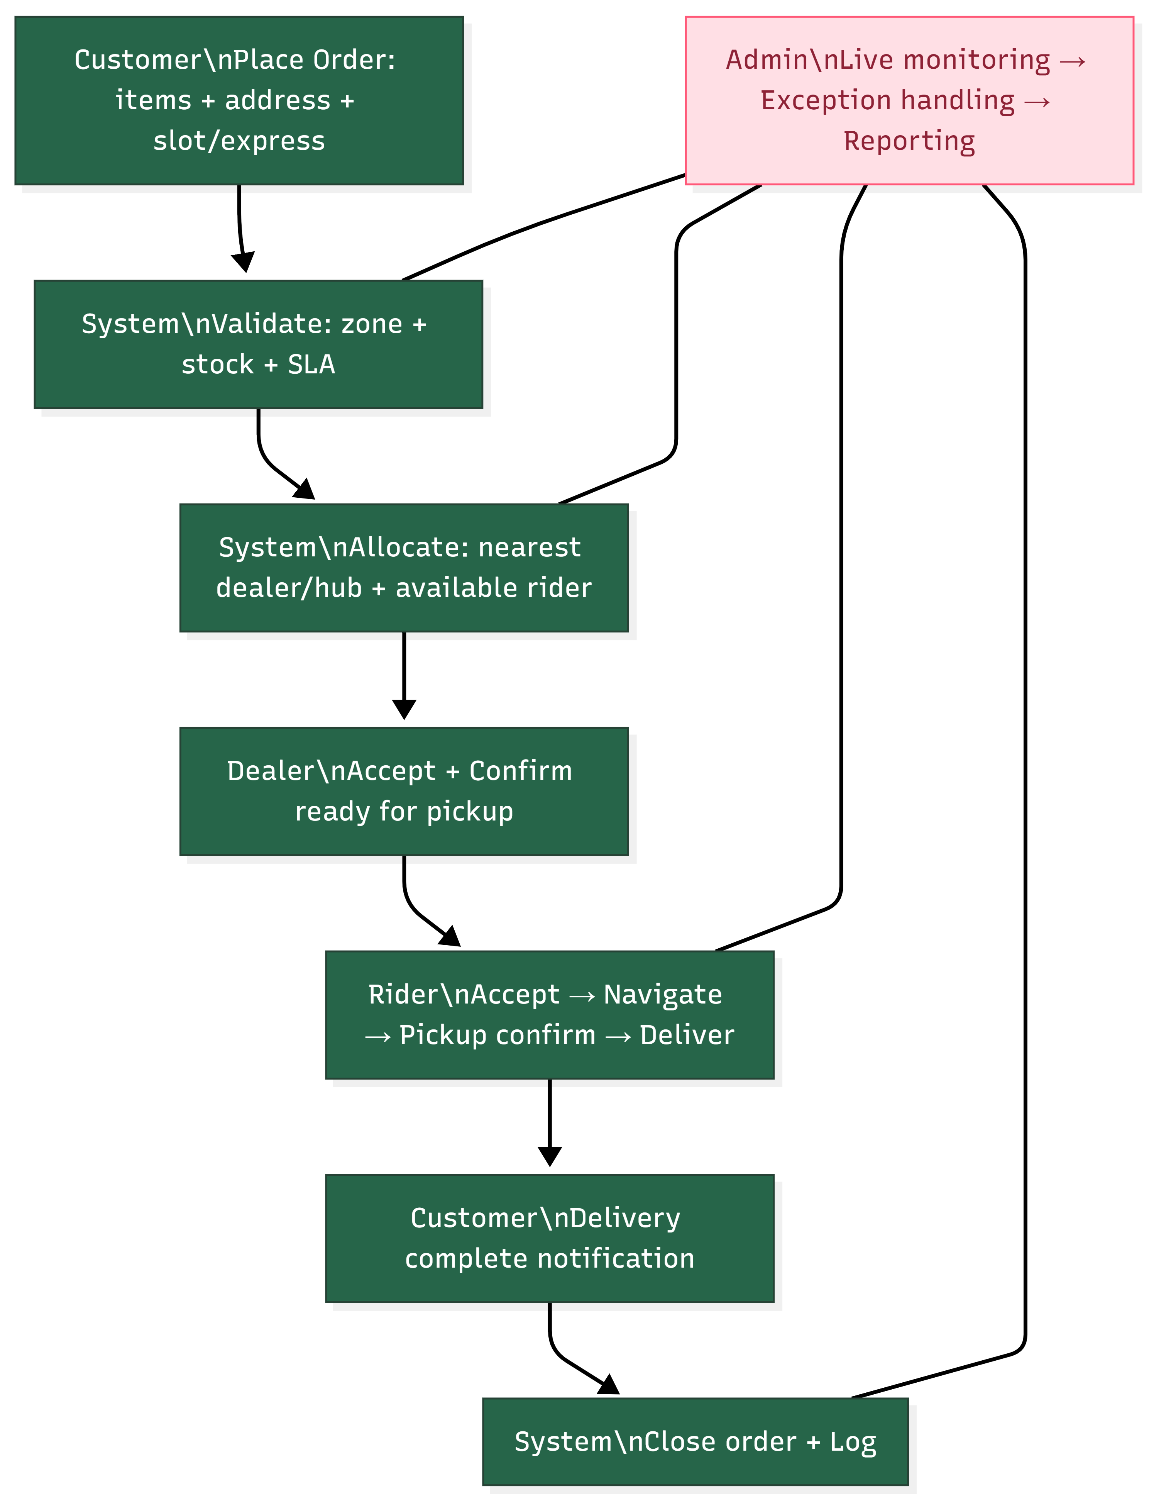

Data Model Overview

Figure 3: Data Model Overview

Figure 4: Real-Time Tracking and ETA Update Flow
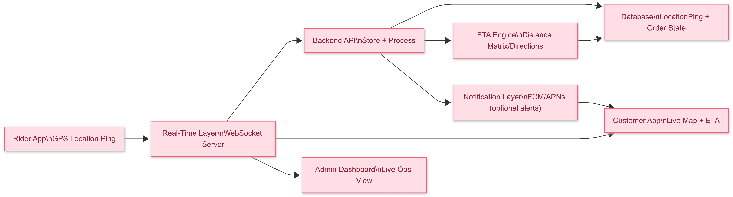

Proposed Technology Stack
The following stack is selected to enable fast delivery, strong maintainability, and reliable real-time capabilities. Where alternatives exist, the selected option is highlighted as the default recommendation.
Layer | Technology | Purpose
Mobile Apps | Flutter | Single codebase for Android and iOS app (Customer/Dealer/Rider).
Admin Dashboard | Laravel | Operations dashboard, configuration, and reporting.
Backend API | Laravel (single backend service, REST API) | Core business services: auth, orders, SLA, allocation, payments, reporting.
Real-Time | Socket.IO or Pusher | Live tracking and live ops updates (Phase 3).
Database | MySQL | Relational storage for orders, users, zones, configs, logs.
Cache/Queue | Redis | Caching, background jobs, rate limiting, event buffering.
Push Notifications | Firebase Cloud Messaging (FCM) + Apple APNs | Order status notifications and operational alerts.
Maps/Routing | Google Maps Platform (Distance Matrix + Directions) | Dealer/rider allocation, ETA calculation, navigation links.
Auth | OTP login + JWT/PAT tokens | Bengali market-friendly login with secure token sessions.
CI/CD | GitHub Actions / GitLab CI | Automated build, test, and deployment pipeline.
Monitoring | Sentry + centralized logs | Crash/error tracking and operational observability.

Development Methodology and Work Plan
The project will follow an Agile delivery approach (Scrum) with short iterations, frequent demos, and a phased rollout aligned to the three delivery phases. Each phase ends with a production-ready release candidate, UAT, and a controlled rollout to selected zones/dealers before broader expansion.

Methodology
- Sprint length: 2 weeks (configurable).
- Artifacts: product backlog, sprint backlog, acceptance criteria, Definition of Done, release notes.
- Ceremonies: sprint planning, daily standup, backlog grooming, sprint review/demo, retrospective.
- Environments: local/dev, staging/UAT, production with separate configuration and secrets.
- Documentation: API specification (OpenAPI), runbooks, admin user guide, and app store deployment checklist.

Proposed Work Breakdown by Phase

Phase 1 - Core Ordering MVP
- Requirements finalization workshops for zones, dealer onboarding, rider policy, and SLA thresholds.
- Flutter apps foundation: authentication, localization (BN/EN), navigation and core UI flows.
- Backend foundation: RBAC, core entities, order status machine, allocation engine baseline.
- Dealer workflows: accept order, mark picked, manual stock flags.
- Rider workflows: availability, accept/reject, navigation links, mark delivered, optional photo proof.
- Notifications: push + in-app events for status changes.
- Admin dashboard baseline: live order list, zone/dealer configurations, basic reports.
- UAT and pilot go-live for selected zones.

Phase 2 - Ops Control, Payments, and Security
- Payment integration: COD flow and digital payment gateway integration (tokenized and gateway-handled).
- Admin enhancements: reassignment flows, operational overrides, audit logs.
- Rider monitoring: status timeline, availability controls, policy flags.
- Security hardening: rate limiting, device binding, sensitive data encryption, logging and alerts.
- Reporting expansion: success vs failure reasons, dealer performance, rider performance snapshots.
- Stabilization release and operational SOP alignment.

Phase 3 - Real-Time Tracking and Stock/Hub Logs
- Real-time tracking: rider location pings, WebSocket publish/subscribe, customer live map view, admin live map view.
- ETA calculations and live updates based on routing APIs.
- Hub/fridge stock logs: inbound/outbound records, handover and collection records.
- Data retention policies for location logs and audit events.
- Performance tuning for tracking throughput and dashboard responsiveness.
- Scale-readiness testing and final release.

DevOps and Deployment Approach
- Containerized services for backend and admin (Docker) to simplify deployment and scaling.
- CI/CD pipeline for build, test, and deploy (GitHub Actions/GitLab CI).
- Separate configuration per environment using environment variables and secret management.
- Monitoring and alerting: application logs, error tracking, uptime monitoring, and database health metrics.
- Backup and recovery plan for database with regular snapshots and tested restore procedures.

Testing and Quality Assurance
Quality assurance will be integrated throughout the delivery lifecycle with automated testing, manual validation, and production-readiness checks for performance, security, and reliability.

Test Strategy
- Test pyramid: unit tests (business rules), integration tests (API + DB), end-to-end tests (critical journeys).
- Shift-left: QA starts from sprint 1; acceptance criteria and test cases created with each user story.
- Device coverage: common Android devices (low-mid range) and iOS versions supported by the target market.
- Release gates: no critical defects; regression suite passed; security and performance checks completed.

Fig- QA Test Process

Deliverables

Phase-wise Deliverables
Phase | Mobile Apps | Backend and Admin | Documentation and QA
Phase 1 | Customer app MVP, Dealer app MVP, Rider app MVP (Flutter, BN/EN). | Backend API v1, Admin dashboard baseline, basic reporting. | Test cases, regression checklist, API spec, deployment guide (staging/prod).
Phase 2 | App updates for payment states and ops controls. | Payment integration, manual override and audit logs, enhanced reports, security hardening. | Security checklist, updated API spec, UAT sign-off pack, release notes.
Phase 3 | Live tracking UI (customer and admin), rider tracking module, hub/stock log UI. | WebSocket tracking service, ETA and routing integration, data retention configuration. | Performance report, tracking load test results, operational runbook updates.

Assumptions, Dependencies, and Exclusions

Assumptions
- Initial rollout will cover Dhaka City Corporation with a zone-based model (example: 13 zones and corresponding dealer points), configurable in admin.
- Client will provide confirmed list of delivery zones, dealer points, service hours, and initial SLA thresholds.
- Client will provide product catalog, pricing rules, and any seasonal availability constraints.
- Client will provide rider onboarding policy (in-house vs third-party) and operational SOP for pickup and handover.
- Payment gateway credentials and merchant onboarding will be supported by the client when Phase 2 starts.
- A map service API key (for distance, routing, geocoding) will be provided for allocation and ETA features.

Dependencies
- Stable internet connectivity for push notifications and (Phase 3) real-time tracking.
- Availability of app store accounts (Google Play Console and Apple Developer Program).
- Timely feedback during sprint reviews and UAT cycles to maintain delivery schedule.
- Access to representative devices for performance and localization testing.

Exclusions
- Operational call center tooling beyond basic communication flows.
- Complex marketplace settlement, automated rider payouts, or advanced accounting modules.
- Integration with external ERP/WMS unless separately scoped.
- Advanced promotional engine and loyalty programs unless separately scoped.

Risks and Mitigation
Risk | Impact | Mitigation
SLA failures due to rider shortage or traffic spikes | Late deliveries, cancellations, customer dissatisfaction | Zone-wise capacity limits, express eligibility checks, proactive notifications, manual reassignment tools, phased rollout by zone.
Inaccurate dealer stock updates (manual in early phases) | Order rejection after confirmation, operational overhead | Simple stock flags in Phase 1, hub/stock logs in Phase 3, optional barcode-based verification in future.
Push notification delivery delays | Customer uncertainty and support load | In-app notification inbox, retry policies, fallback SMS integration as future option.
Location privacy concerns with tracking | Compliance risk and user trust issues | Track only during active delivery, minimize retention, clear consent notices, access controls.
App performance on low-end devices | Poor UX and higher dropout | Performance budgets, profiling, image optimization, caching, staged feature rollout, device testing coverage.

