PHD Website Redesign and Upgrade
______________________________
Prepared by: Riseup Labs


Table of Contents
1. Executive Summary 3
2. Understanding of the Assignment 3
2.1 Assignment Objectives 3
3. Proposed Scope of Work 3
3.1 Assessment and Planning 4
3.2 Website Redesign and Development 4
3.3 Technical Features 4
3.4 Accessibility and Compliance 4
4. Revised Functional Scope Based on Client Requirements 5
5. Proposed Website Structure and Modules 5
6. Updated Technical Architecture and Diagrams 6
6.1 Homepage and Project Interaction Flow 7
6.2 Automated Community Feedback Flow 7
7. Proposed Technical Stack 8
7.1 Rationale for React and Laravel 8
8. Design and User Experience Strategy 8
9. SEO, Analytics, and Content Visibility 9
10. Security, Privacy, and Backup Approach 9
11. Development Methodology 9
12. Implementation Timeline 10
Post-Launch Maintenance Period 10
13. Deliverables 10
14. Testing and Quality Assurance Plan 10
15. Deployment and Handover Plan 11
16. Maintenance and Support Plan 11
Maintenance Scope Boundary 11
17. Assumptions and Client Responsibilities 12
19. Conclusion 12

1. Executive Summary
Partners in Health and Development (PHD) requires a modern, secure, accessible, bilingual, responsive, and easy-to-manage website that can better represent its institutional profile, programmatic activities, publications, updates, and community-facing information. The proposal keeps the original website redesign and upgrade objective while incorporating the client-requested changes around homepage visibility, project interaction, AI-assisted content generation, automated community feedback, and extended maintenance support.
The solution will use React for the frontend and Laravel for the backend. This replaces the earlier CMS-first assumption with a custom, maintainable web application approach where PHD staff can manage content, projects, media, feedback, and AI-assisted drafts through a controlled administrative workflow.
The implementation will remain practical and scope-controlled. The new functionality will be limited to the requested changes and will not introduce unnecessary advanced modules that may increase development cost or complexity beyond the website redesign requirement.

2. Understanding of the Assignment
The assignment focuses on redesigning and upgrading PHD’s existing institutional website into a more usable, credible, and manageable platform for public visitors, development partners, donors, stakeholders, job seekers, media users, and internal website administrators.
The original proposal considered a modern CMS-based website with bilingual support, accessible design, structured content management, SEO readiness, analytics, security controls, content migration, staff training, and post-launch support. This revised version keeps the same intention but updates the implementation model to a React frontend and Laravel backend architecture.

2.1 Assignment Objectives
- Redesign the PHD website with a modern, professional, responsive, and accessible user interface.
- Present PHD’s institutional identity, programs, projects, publications, news, events, careers, gallery, partner information, and contact information in a structured way.
- Add a homepage summary dashboard or summary reflection section to quickly communicate PHD’s key impact areas and current activities.
- Ensure that 2-3 new or updated projects are always visible on the homepage based on admin-managed project updates.
- Introduce AI-assisted content generation to support draft creation for project summaries, news snippets, and short homepage copy, with final approval by PHD staff before publication.
- Provide project hover interaction so visitors can view short project details before opening the full project page.
- Automate the community feedback mechanism and include a dedicated community feedback section on the website.
- Provide 1.5 years of maintenance support after launch.
- Ensure security, accessibility, SEO, analytics, performance, backup, and staff handover readiness.

3. Proposed Scope of Work
The proposed scope of work remains focused on redesigning and developing the PHD website, migrating agreed content, configuring administrative controls, and handing over a maintainable platform to PHD staff. The revised scope incorporates the new client-requested items without adding unrelated features.

3.1 Assessment and Planning
- Review the existing PHD website structure, content types, key pages, media assets, and current content management limitations.
- Confirm final sitemap, navigation model, content hierarchy, language requirements, and priority pages.
- Identify content that requires migration, content cleanup, image optimization, and file organization.
- Define admin roles and content approval responsibilities for projects, news, publications, feedback, and AI-generated draft review.
- Prepare a detailed implementation plan aligned with the 4-week development timeline.

3.2 Website Redesign and Development
- Develop a modern React-based frontend with responsive layouts for desktop, tablet, and mobile users.
- Develop a Laravel backend with secure APIs and an administrative content management panel.
- Create reusable frontend components for homepage sections, project cards, news cards, publications, galleries, feedback items, and common page sections.
- Implement bilingual-ready content structure for English and Bangla content where applicable.
- Create a clean and accessible navigation structure for institutional content, programs/projects, updates, publications, gallery, careers, and contact information.
- Configure CMS/admin workflows for content creation, editing, publishing, and updating.

3.3 Technical Features
- React-based frontend application for reusable, component-driven user interface development.
- Laravel backend application for API management, admin CMS, authentication, role-based access, content management, project management, media management, feedback management, and AI integration.
- Secure database-driven content structure for pages, programs, projects, news/events/blogs, publications, galleries, careers, feedback, and admin users.
- Homepage summary dashboard or summary reflection section for PHD’s key updates, project impact, program highlights, or selected indicators.
- Automatic display logic for 2-3 new or updated projects on the homepage.
- Project card hover interaction to show project details such as title, short description, location/category, status, or latest update summary.
- AI-assisted draft generation for controlled admin use, with human review before publication.
- Automated community feedback submission, storage, admin review, status handling, and selected feedback publishing.
- Search, filtering, and organized content browsing where relevant to the approved sitemap.
- SEO metadata management, analytics integration, performance optimization, SSL readiness, spam protection, backup readiness, and cross-browser compatibility.

3.4 Accessibility and Compliance
- Design and develop the website with accessibility considerations aligned to WCAG 2.2 principles.
- Use readable typography, meaningful headings, sufficient color contrast, accessible navigation, and keyboard-friendly interactions.
- Provide proper alt text support for images and structured page markup for assistive technologies.
- Ensure forms include clear labels, validation messages, error states, and confirmation messages.
- Use responsive and device-friendly layouts to support access from different devices and screen sizes.

4. Revised Functional Scope Based on Client Requirements
The following additions are included in this revised proposal because they were specifically requested by the client.
Client Requested Change | Proposed Implementation | Admin Control | Scope Boundary
Homepage summary dashboard or summary reflection section | A dedicated homepage section will show key institutional reflections, impact highlights, program summaries, or selected indicators in a concise visual format. | Admin can update text, labels, indicators, and highlighted items from backend. | No complex BI system is included; the section is website-content driven.
2-3 new or updated projects always visible on homepage | The homepage will automatically display the latest or admin-marked 2-3 project items based on update date or featured status. | Admin can mark projects as featured or rely on latest update order. | Limited to project highlights; not a separate project management platform.
Auto AI generation functionality | AI-assisted draft generation will support admin users in creating short project summaries, news snippets, homepage reflection copy, or feedback response drafts. | Admin reviews, edits, and approves all AI drafts before publication. | No autonomous publishing; no replacement of official editorial review.
Hover over a project to display details | Project cards will show key details on hover for desktop users and tap/expand behavior for mobile users. | Details come from project fields maintained in admin panel. | Short preview only; full details remain on project detail page.
Automated community feedback and dedicated section | A feedback form, database workflow, moderation panel, notification/status handling, and public feedback listing section will be implemented. | Admin can review, approve, archive, or respond to submissions. | Feedback is moderated before public display.
1.5 years maintenance support | Post-launch maintenance support will be provided for 18 months after website launch. | Support coordination will follow agreed communication and issue reporting process. | Major redesign, new modules, or third-party paid service fees are outside maintenance unless separately agreed.

5. Proposed Website Structure and Modules
The website structure will continue to support the original institutional website redesign scope, with additional homepage, project, AI draft, and community feedback capabilities added as controlled modules.
Module / Page Area | Proposed Scope
Homepage | Hero banner, mission summary, summary dashboard/reflection, 2-3 latest or updated project highlights, news/event highlights, partner/donor highlights, key call-to-actions, and quick links.
About PHD | Organizational profile, vision, mission, values, governance/leadership, history, and institutional background.
Programs and Projects | Program/project listing, project categories, project details, hover preview, project gallery or attachments where applicable, and featured/latest project control.
News, Events, and Blog | News/event updates, announcements, stories, blog-style content, category/tag organization, and SEO metadata support.
Publications and Download Center | Reports, documents, policy papers, research publications, newsletters, and downloadable resources with categorization.
Photo and Video Gallery | Image and video content organization with optimized media presentation.
Donor and Partner Showcase | Partner/donor logo and profile presentation based on approved content.
Community Feedback | Dedicated feedback section, feedback submission form, moderation workflow, approved public feedback display, and admin status management.
Careers and Vacancy | Vacancy listing, job detail pages, application instructions, and archive/expiry control where applicable.
Emergency / Humanitarian Updates | Important notices, emergency updates, and response-related information where applicable.
Contact and Inquiry | Contact details, inquiry form, map/location embed, department/office information, and spam-protected form submission.
Admin CMS / Backend | Secure login, role-based access, content management, project management, publication/media management, feedback management, AI draft generation, SEO fields, and basic reports/logs.

6. Updated Technical Architecture and Diagrams
The architecture is updated from a generic CMS model to a React frontend and Laravel backend model. React will manage the public website user interface, while Laravel will manage APIs, admin CMS, content workflows, authentication, feedback processing, database operations, and AI-assisted generation features.
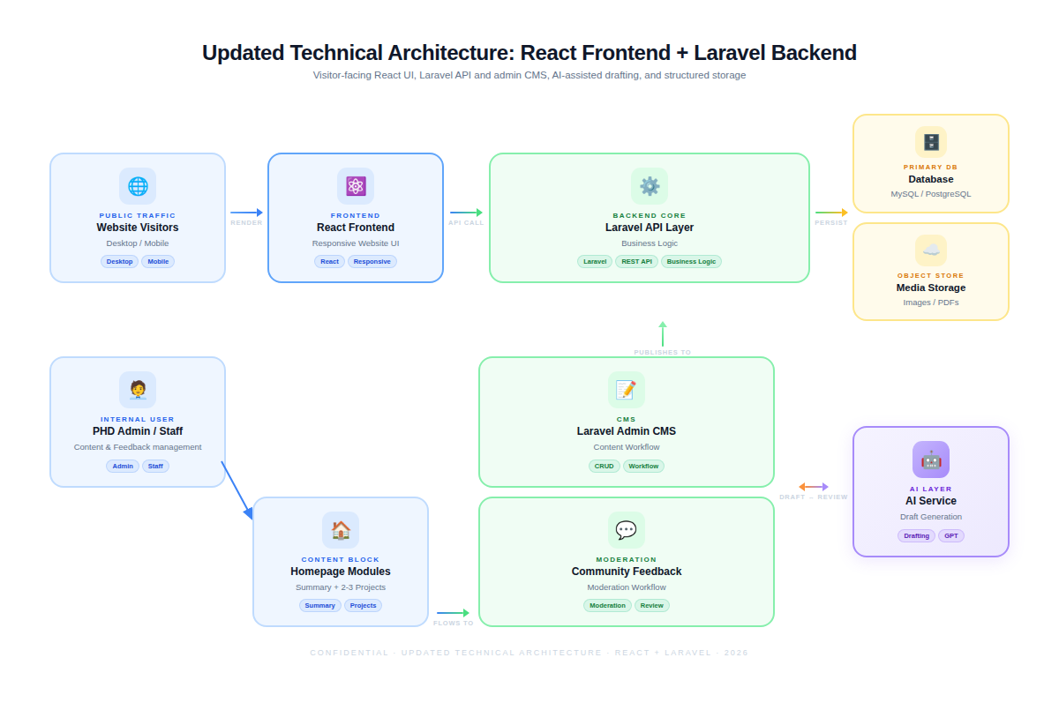
Figure 1: Updated Technical Architecture

6.1 Homepage and Project Interaction Flow
The homepage will include a summary dashboard/reflection section and automatically present 2-3 new or updated project items. Desktop users will see project details on hover, while mobile users will receive a tap/expand-friendly interaction to maintain usability across devices.
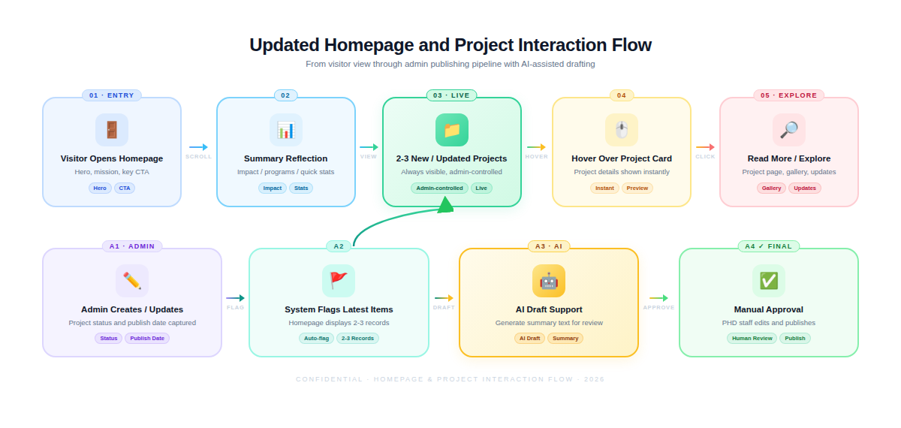
Figure 2: Updated Homepage and Project Interaction Flow

6.2 Automated Community Feedback Flow
Community feedback will move from a manual process to a structured digital workflow. Submissions will be validated, stored, reviewed by authorized admin users, and selectively published if approved.
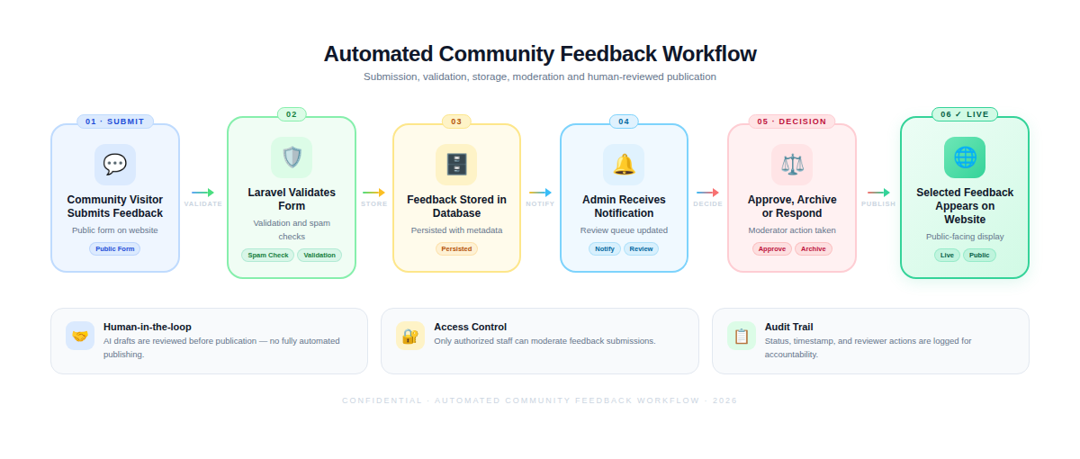
Figure 3: Automated Community Feedback Workflow

7. Proposed Technical Stack
The revised technical stack is aligned with the client-requested frontend and backend technologies while keeping the website maintainable, secure, and scalable for the approved scope.
Layer | Technology | Purpose
Frontend | React | Responsive website UI, reusable components, project hover interactions, homepage summary/reflection section, project cards, feedback section, and public content pages.
Backend | Laravel | API layer, admin CMS, authentication, role-based access, content workflows, project management, feedback management, media management, and AI draft generation integration.
Database | MySQL or PostgreSQL | Structured storage for pages, projects, news/events, publications, media metadata, feedback, users, roles, logs, and settings.
AI Integration | Approved AI API / LLM service integration | Admin-only draft generation for short summaries and content support, with human review and approval before publication.
Media Storage | Server storage or cloud object storage, based on hosting decision | Optimized handling of images, PDF publications, and downloadable resources.
Analytics | Google Analytics 4 and/or Search Console setup | Visitor analytics, traffic monitoring, and search visibility tracking.
Security | SSL, Laravel auth controls, CSRF protection, validation, rate limiting, spam protection, backup, and access control | Secure administration and public form processing.
Deployment | Linux-based hosting, VPS, cloud hosting, or client-approved infrastructure | Production deployment, environment configuration, domain/SSL coordination, and post-launch support readiness.

7.1 Rationale for React and Laravel
- React frontend: React is suitable for a component-driven website interface where homepage sections, project cards, hover previews, feedback blocks, and content layouts can be developed as reusable UI components.
- Laravel backend: Laravel is suitable for a secure web application backend, admin CMS, API development, authentication, validation, CSRF protection, and structured content workflows.
- Separation of concerns: The public website UI and backend content management logic will be separated, making the solution easier to maintain and extend within the approved scope.
- Controlled AI use: AI generation will be implemented as an admin-support feature rather than an uncontrolled public-facing automation feature.

8. Design and User Experience Strategy
The design strategy will focus on institutional credibility, simplicity, accessibility, responsive usability, and clear presentation of PHD’s mission, programs, projects, publications, and community-facing information.
- Use a clean and professional visual style aligned with PHD’s institutional identity and development-sector communication needs.
- Prioritize clear content hierarchy for public visitors, donors, partners, community members, job seekers, and internal users.
- Design a homepage summary dashboard/reflection section that communicates key program or impact information without overwhelming users.
- Use project cards with concise information, hover details, and clear navigation to full project pages.
- Ensure mobile-friendly interaction alternatives for hover-based project details.
- Present community feedback in a trustworthy and moderated way.
- Maintain accessible typography, spacing, buttons, labels, and navigation patterns.

9. SEO, Analytics, and Content Visibility
The website will be developed with SEO and analytics readiness so that PHD’s institutional pages, project pages, publications, and updates can be more discoverable and measurable.
- SEO-friendly URL structure for key pages, programs, projects, news, events, publications, and feedback-related public content where applicable.
- Page-level metadata fields in the admin panel for title, description, keywords/tags, and social sharing content.
- Structured heading hierarchy and semantic markup to support search engine understanding and accessibility.
- Optimized images, compressed media, and performance-focused frontend implementation.
- Google Analytics 4 measurement setup and Search Console readiness, subject to client account access.
- Sitemap and robots.txt configuration for crawlability and indexing control.

10. Security, Privacy, and Backup Approach
Security and privacy will be considered throughout the implementation to protect administrative access, content workflows, form submissions, community feedback, and AI-assisted draft generation features.
- Secure admin authentication and role-based access control for authorized PHD staff.
- Laravel CSRF protection, request validation, secure session configuration, and form spam protection.
- Input validation and output handling for public forms, admin forms, feedback submissions, and AI-generated content.
- Human review of AI-generated drafts before content is published.
- Secure handling of community feedback data with moderation before public display.
- SSL configuration and HTTPS enforcement in production, subject to hosting environment.
- Regular backup configuration for application code, database, and media assets according to hosting capability.
- Basic activity/logging approach for important admin actions such as content publication, feedback moderation, and AI draft generation.

11. Development Methodology
The project will follow a practical, iterative, and milestone-driven development methodology suitable for a 4-week website redesign and upgrade project. The approach will combine requirement confirmation, UI/UX refinement, frontend and backend development, content migration, QA, deployment, and handover.
- Requirement confirmation and sitemap/content alignment.
- UI/UX design refinement and key page layout finalization.
- React frontend development and Laravel backend/admin CMS development.
- Implementation of homepage summary/reflection, latest project display, project hover details, AI draft generation, and automated community feedback workflow.
- Content migration and media optimization based on approved content inventory.
- Testing, QA, bug fixing, and user/admin flow verification.
- Production deployment, training, documentation, and support transition.

12. Implementation Timeline
The core website redesign and development implementation timeline remains 4 weeks. The 1.5 years maintenance support period will begin after final launch and handover.

Post-Launch Maintenance Period
After launch, maintenance support will continue for 1.5 years. This period is separate from the 4-week development timeline and will focus on stability, bug fixing, security updates, minor content-support guidance, monitoring support, and technical assistance within the agreed maintenance scope.

13. Deliverables
- Final sitemap and content structure confirmation.
- UI/UX design direction and responsive key page layouts.
- React-based responsive frontend website.
- Laravel-based backend, API layer, and admin CMS.
- Homepage summary dashboard or summary reflection section.
- Automatic 2-3 new or updated project display on the homepage.
- Project hover/tap detail preview interaction.
- AI-assisted admin draft generation workflow with human approval before publication.
- Automated community feedback submission, review, and selected publishing workflow.
- Core website pages and modules based on the approved sitemap.
- Migrated and organized content based on approved content inventory.
- SEO metadata setup and analytics integration support.
- Security, backup, and deployment configuration support.
- Admin user manual and staff training session.
- Source code, deployment details, and administrative access handover.
- 1.5 years post-launch maintenance support.

14. Testing and Quality Assurance Plan
Testing and QA will be performed across design, functionality, responsiveness, accessibility, content, security, and deployment readiness. The QA approach will focus on practical validation of the approved scope.
QA Area | Validation Focus
Functional Testing | Verify homepage sections, project listing, project detail, project hover/tap preview, AI draft generation workflow, community feedback submission, feedback moderation, publishing workflow, search/navigation, and admin content management.
Responsive Testing | Verify layouts and interactions on common desktop, tablet, and mobile screen sizes.
Cross-Browser Testing | Verify compatibility on modern versions of Chrome, Edge, Firefox, and Safari where feasible.
Accessibility Checks | Verify headings, labels, keyboard navigation, color contrast, image alt text, form messages, and screen-reader-friendly structure.
SEO Checks | Verify metadata fields, URLs, headings, sitemap, robots.txt, and basic crawlability readiness.
Security Checks | Verify authentication, access control, validation, CSRF protection, spam controls, file upload restrictions, secure configuration, and error handling.
AI Workflow Checks | Verify admin-only access, prompt input controls, generated draft review, manual approval, and prevention of direct public publishing without review.
Feedback Workflow Checks | Verify form validation, spam handling, database storage, notification/status flow, moderation, approval, archive, and public display controls.
Performance Checks | Verify image optimization, page loading behavior, frontend bundle optimization, cache readiness, and hosting configuration support.
Content QA | Verify migrated content formatting, links, downloadable files, image placement, and bilingual-ready content areas where applicable.

15. Deployment and Handover Plan
- Prepare production-ready build and deployment package for approved hosting environment.
- Configure environment variables, database, media storage, SSL, and production settings.
- Deploy React frontend and Laravel backend with proper routing and API configuration.
- Coordinate domain/DNS and SSL setup with the client or hosting provider.
- Set up initial admin users and roles for authorized PHD staff.
- Configure analytics measurement and search visibility tools subject to client account access.
- Provide admin training on content management, project updates, homepage project selection, AI draft generation, and community feedback moderation.
- Provide user manual, technical handover notes, source code handover, and deployment documentation.

16. Maintenance and Support Plan
The revised proposal includes 1.5 years of post-launch maintenance support. The maintenance period will begin after production launch and handover acceptance.
Support Area | Scope
Bug Fixing | Fix issues related to delivered functionality within the agreed scope.
Security Updates | Support security-related updates for Laravel packages, frontend dependencies, and production configuration where applicable.
Minor Content Support Guidance | Guide PHD admin users on content update processes and administrative workflows.
Backup and Monitoring Support | Assist with backup verification and basic website availability/performance checks based on hosting capability.
AI and Feedback Workflow Support | Support delivered AI draft generation and community feedback workflows, including minor fixes and configuration support.
Browser/Device Compatibility Support | Address compatibility issues that arise within supported modern browsers and devices.
Technical Assistance | Provide technical support for delivered features, deployment environment coordination, and issue investigation.

Maintenance Scope Boundary
- Maintenance does not include major redesign, new large modules, third-party paid subscription fees, major infrastructure migration, or major changes beyond the delivered scope unless separately agreed.
- AI service usage cost, if applicable, depends on the selected provider/account and is outside the technical proposal unless separately requested.
- Content writing, large-scale new content migration after launch, and continuous editorial operation are not included unless separately agreed.
- Client-provided hosting, domain, SSL, analytics, and third-party service access must remain available for maintenance support.

17. Assumptions and Client Responsibilities
- PHD will provide approved brand assets, logo, color references, fonts if any, images, content, publications, project information, and required media files.
- PHD will confirm the final sitemap, page list, priority content, and language requirements before full development begins.
- PHD will provide access to domain, hosting, server, analytics, email, or third-party services required for implementation and deployment.
- PHD will nominate responsible stakeholders for content approval, design feedback, AI draft review, and community feedback moderation decisions.
- Final public content remains subject to PHD review and approval before publication.
- Any additional modules, integrations, workflows, or content migration beyond the agreed scope will be treated as a change request.

18. Conclusion
This revised technical proposal maintains the original objective of redesigning and upgrading the PHD website into a modern, secure, accessible, bilingual, responsive, and easy-to-manage digital platform. The revision incorporates the client-requested homepage summary/reflection section, automatic display of 2-3 new or updated projects, AI-assisted draft generation, project hover details, automated community feedback, a dedicated feedback section, React frontend, Laravel backend, and 1.5 years maintenance support.
The proposed solution remains practical, scope-aligned, and suitable for the approved website redesign requirement. It gives PHD stronger control over website content, project visibility, community feedback, and future website maintenance while avoiding unnecessary expansion beyond the requested changes.

