TECHNICAL PROPOSAL
Robotic Process Automation (RPA) Software
for Commercial Department Document Automation
Bangladesh Bank Online Export Monitoring System - EXP Issue Automation
Prepared by: Riseup Labs


Table of Contents
1. Executive Summary 3
2. Understanding of Requirement 3
2.1 Source Documents Reviewed for Proposal Preparation 3
2.2 Requirement Summary 3
3. Project Objectives 4
4. Scope of Work 4
5. Proposed Functional Scope 4
5.1 Data Field Mapping Summary 5
6. Proposed Technical Approach 5
6.1 Approved Data Input and Registration 5
6.2 Field Checks and Data Rules 5
6.3 Bangladesh Bank Portal Automation 6
6.4 Dashboard and Reporting 6
7. Proposed Solution Diagrams 7
8. Proposed Technical Stack 7
9. Development Methodology 7
10. Testing and Quality Assurance 8
10.1 Quality Gates 8
11. Project Deliverables 9
12. Assumptions, Dependencies and Controlled Out of Scope 9
12.1 Assumptions and Dependencies 9
12.2 Controlled Out of Scope 9
13. Conclusion 9

1. Executive Summary
The proposed solution is an attended RPA platform for the Commercial Department to reduce manual effort and improve field-level consistency for Bangladesh Bank EXP issue data entry. The system will use approved, pre-prepared data, populate the required fields in the Bangladesh Bank Online Export Monitoring System, and capture the generated Export Number for correct database mapping and reporting.
A human user will complete the portal login, review the prepared information, and initiate the bot. The bot will automate repetitive portal navigation, field population, status tracking, exception handling, and Export Number capture.

2. Understanding of Requirement
The requirement is to build RPA software for Commercial Department portal data entry. The reviewed requirement and sample materials clarify the required EXP fields, reference values, and manual portal steps. The target outcome is consistent preparation of approved data and attended entry into the Bangladesh Bank Online Export Monitoring System.

2.1 Source Documents Reviewed for Proposal Preparation
Source Document | Purpose in Proposed Solution
Commercial Invoice XLSX | Reference for the approved EXP data fields and structured values used for portal entry.
Bangladesh Bank Online Export Monitoring System Instruction Document | Understanding of the manual steps: login, dashboard navigation, transaction menu, and EXP issue sequence.
User Requirement Specification (URS) | Primary requirement source for portal data-entry automation, field mapping, reporting, documentation, and deployment.
Shipping Bill PDF | Reference for customs and export field definitions used during field mapping.
HBL/FCR PDF | Reference for shipment and forwarding field definitions such as number, date, port, destination, package count, and weight.
EXP Form PDF | Reference structure for the target EXP data fields and portal mapping.

2.2 Requirement Summary
- Attended portal automation for Bangladesh Bank EXP issue data entry using approved, pre-prepared information.
- Configured field mapping between the approved input format and the required EXP issue portal fields.
- Required-field and format checks before the bot begins portal entry.
- Portal response capture to store the generated Export Number against the correct process record.
- Basic dashboard and reporting for processing status, exceptions, and submission results.

3. Project Objectives
Objective | Description
Reduce manual data entry | Automate repeated portal navigation and field population for EXP issue activities.
Improve data consistency | Apply required-field and format checks before portal entry.
Improve processing visibility | Provide clear processing status, exception information, and submission results through a basic dashboard.
Enable controlled scaling | Use configurable field mappings and rules so approved field changes can be accommodated without rebuilding the core bot.

4. Scope of Work
Scope Area | Included Work
Requirement Finalization | Process walkthrough, field mapping, PDD/FRS finalization, exception scenarios, and approval points.
Approved Data Input | Structured input format and review screen for pre-prepared EXP issue data.
Data Checks | Mandatory-field checks, format checks, duplicate checks, and exception flagging.
EXP Issue Automation | Attended browser automation to navigate the Bangladesh Bank EXP issue sequence, populate approved fields, and capture the generated Export Number for correct mapping and storage.
Review and Exception Handling | User review screen, exception list, correction handling, and status tracking.
Dashboard and Reports | Basic process dashboard, exception summary, submission status, and operational reports.
Deployment and Handover | Production deployment, user manual, SOP, and admin guidance.

5. Proposed Functional Scope
The functional scope is kept focused on the required Bangladesh Bank portal data-entry process.
Module / Capability | Functional Description
Approved Data Input | Receive pre-prepared EXP issue data through the agreed structured input format or review screen and register each entry request with its processing status.
Field Mapping | Map approved input values to EXP issue fields such as exporter, importer/consignee, commodity, HS code, destination, quantity, value, incoterm, contract/LC reference, FCR/HBL number/date, port, and sector.
Validation Rules | Validate required values and formats before the bot starts portal entry and route missing or invalid values to user review.
EXP Data Review | Provide a review screen so users can confirm or correct the approved data before portal population.
Attended RPA Execution | Automate navigation and field population in the Bangladesh Bank Online Export Monitoring System after the user completes portal login, then capture the generated Export Number and store it against the correct process record.
Exception Management | Show field-level errors, portal timeouts, Export Number capture issues, and submission blockers with a clear status and corrective action note.
Dashboard and Reporting | Show processing status, exception summary, processed entry count, submission status, and captured Export Number.

5.1 Data Field Mapping Summary
Field Group | Approved Input Reference | Entry / Check Rule
Exporter / Consignee / Notify Party | Approved structured input / user-confirmed value | Confirm required party names are present before entry.
Invoice No. and Date | Approved structured input / user-confirmed value | Check invoice number and date format.
EXP No. / Declaration Reference | Approved structured input / user-confirmed value | Capture the Export Number from the portal and map it to the correct process record.
HS Code / Commodity | Approved structured input / user-confirmed value | Check HS code format and commodity value.
Quantity, Units and Packages | Approved structured input / user-confirmed value | Check quantity, package count, and unit of measure.
Value, Currency and Incoterm | Approved structured input / user-confirmed value | Check amount, currency, and incoterm values.
Contract / LC / PO Reference | Approved structured input / user-confirmed value | Check contract, LC, or PO reference format and date.
Shipment and Port Details | Approved structured input / user-confirmed value | Check port, destination, and shipment date values.
Bank / Authorized Dealer / Sector | Approved structured input / user-confirmed value | Apply approved static values where formally confirmed.

6. Proposed Technical Approach

6.1 Approved Data Input and Registration
- The user will provide approved, pre-prepared data through the agreed structured input format or the review screen.
- Each entry request will be registered with a unique reference, shipment reference, processing status, and timestamp before portal population.
- The configured field list will cover the approved EXP issue data required for the portal entry sequence.

6.2 Field Checks and Data Rules
- Mandatory-field checks will confirm that the required EXP issue values are present before automation begins.
- Format and value checks will be applied to fields such as HS code, quantity, invoice value, currency, dates, and reference numbers.
- Controlled rules will be configurable for approved field formats and static values where feasible.
- The bot will pause and show a clear exception when required data is missing or invalid.

6.3 Bangladesh Bank Portal Automation
- The solution will use an attended RPA pattern. The user completes the portal login and initiates the bot for navigation and field population.
- The bot will follow the approved portal steps, populate the EXP issue form, capture the generated Export Number, and store it against the correct process record.
- Portal errors, timeouts, or missing responses will be shown as clear exceptions for user action.
- Portal selectors and field mappings will be verified during development and regression testing.

6.4 Dashboard and Reporting
- A lightweight dashboard will show processing status, completed entries, pending reviews, and exceptions.
- Operational reports will summarize processed entries, exception status, and submission results.
- The dashboard will allow users to review the captured Export Number and the latest processing status.

7. Proposed Solution Diagrams
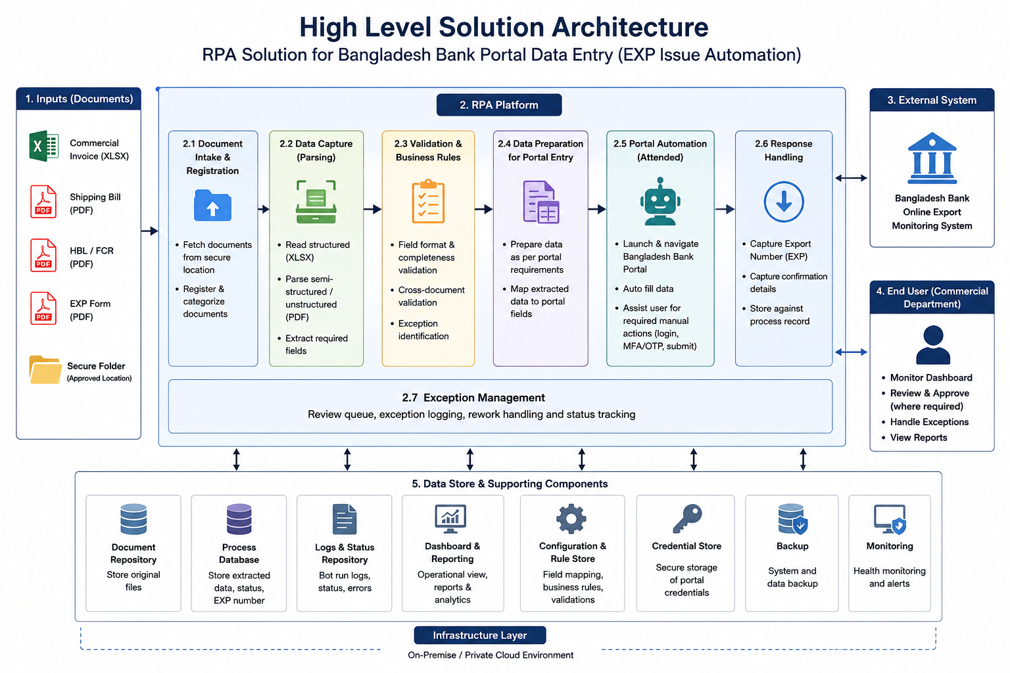
Diagram 1: High Level Solution Architecture

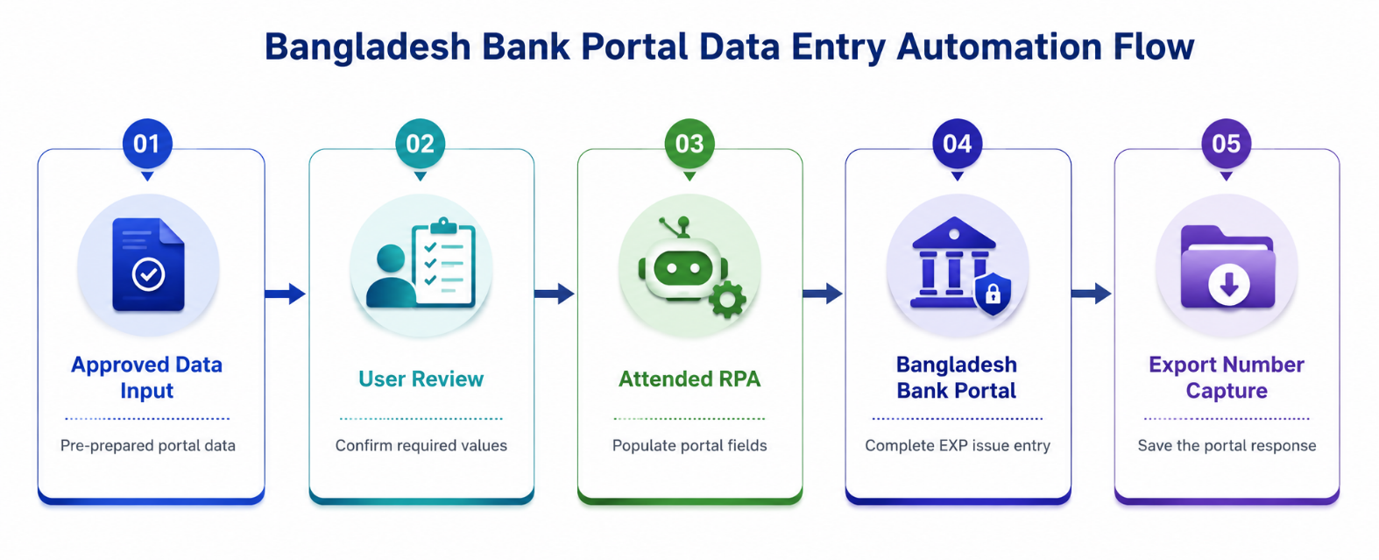
Diagram 2: Bangladesh Bank Portal Data Entry Automation Flow.

8. Proposed Technical Stack
Layer | Recommended Stack | Purpose / Notes
Frontend / Admin Console | React.js with TypeScript | Review screen, dashboard, exception list, configuration, and reports.
Backend API | Python FastAPI | API services, input validation, field mapping, configuration, and portal automation coordination.
RPA Automation | Python Playwright, Selenium | Browser automation for portal navigation, field population, and Export Number response capture within the user session.
Approved Data Input | Python openpyxl / pandas | Read pre-prepared EXP issue data from the agreed structured input format.
Database | PostgreSQL | Process records, approved input values, field mappings, configuration, exceptions, and reports.
File Storage | Client-provided server storage | Storage for approved input files and generated reports where required.
Deployment | Dockerized services on client-provided Linux/Windows VM server | Portable deployment on the client-provided VM server and controlled environment setup.

9. Development Methodology
The project will follow an Agile-incremental delivery model with clear documentation checkpoints. This approach allows early confirmation of portal behavior, field mapping, and business-rule correctness while keeping the scope controlled.
Phase | Activities | Outputs
Phase 1: Discovery & PDD | Process walkthrough, approved field review, field mapping, exception scenarios, and access dependency analysis. | Process Definition Document, field mapping, and high-level automation design.
Phase 2: Solution Design | Architecture, data model, rule design, review screen, dashboard, and portal automation approach. | Solution Design Document / SDS, refined FRS, and test strategy.
Phase 3: Build Iterations | Develop approved data input, field checks, review screen, dashboard, bot automation, and Export Number capture/storage. | Working modules delivered in controlled increments.
Phase 4: Portal Automation Stabilization | Client-provided VM setup, portal selector verification, field mapping checks, and regression preparation. | Pre-production release.
Phase 5: Testing | System testing, functional testing, portal automation testing, regression testing, and issue resolution. | Test reports and defect summary.
Phase 6: Deployment and Handover | Production deployment, user training, SOP handover, and admin guidance. | Live system and handover pack.

10. Testing and Quality Assurance
Testing will cover approved input handling, field checks, portal automation stability, data integrity, reporting, and regression behavior. QA activities will be performed throughout development and finalized before production release.
QA Area | Testing Focus | Expected Evidence
Requirement Traceability | Every requirement mapped to design, development and test cases. | Requirement Traceability Matrix.
Input Data Validation | Required fields, formats, duplicate checks, and field mapping from the approved input. | Validation test report and exception results.
Functional Testing | Approved data input, review screen, correction handling, dashboard, exceptions, and reports. | Functional test report.
RPA Automation Testing | Portal navigation, selector stability, field population, Export Number capture, timeout handling, and retries. | Bot execution test results.
Performance and Reliability Testing | Expected processing volume, retry behavior, application responsiveness, and database performance. | Performance observations and tuning notes.
Regression Testing | Repeat tests after changes to field mappings, rules, or portal selectors. | Regression test report.

10.1 Quality Gates
- No critical or high-severity defects open before go-live.
- Mandatory EXP fields are correctly validated before portal entry begins.
- Portal automation completes agreed test cases under supervised user login, including Export Number capture and database mapping.

11. Project Deliverables
Deliverable | Description
Process Definition Document (PDD) | Detailed current and proposed automation process, exception scenarios, business rules, and process boundaries.
Solution Design Document / SDS | Architecture, components, data flow, deployment model, and portal automation design.
Functional Requirement Specification (FRS) | Final functional scope, field mapping, data checks, review requirements, and portal entry requirements.
Configured RPA Bot | Attended bot for Bangladesh Bank EXP issue navigation, field population, and Export Number capture using the user portal session.
Approved Data Input Module | Structured input handling, configured field mapping, required-field checks, and database storage.
Review Dashboard / Admin Console | Review screen, exception list, dashboard, submission status, reports, and configuration access.
Testing and QA Artifacts | Test cases, test reports, regression results, and defect summary.
User Manual and SOP | Bot operation guide, data review steps, exception handling, and admin guidance.
Deployment and Handover Pack | Deployment instructions, environment configuration, and handover checklist.

12. Assumptions, Dependencies and Controlled Out of Scope

12.1 Assumptions and Dependencies
- Client will provide the approved EXP field list, sample structured input, process walkthroughs, and field-level rules.
- Access to the Bangladesh Bank Online Export Monitoring System will be provided for development, testing, and production use.
- The user will complete the portal login before initiating the attended bot.
- Client IT will provide the VM server, database access, and required network connectivity for deployment.
- Any change in the Bangladesh Bank portal user interface or field names before delivery may require selector updates and regression testing.

12.2 Controlled Out of Scope
- Licensing pricing or commercial costing.
- Modification of the Bangladesh Bank portal or any third-party banking/government system.
- Unattended submission without user review when required data is missing or invalid.
- Additional business modules or analytics beyond the provided requirement unless formally approved as a change request.

13. Conclusion
The proposed RPA solution provides a practical attended automation approach for Commercial Department data entry in the Bangladesh Bank Online Export Monitoring System. It combines approved data input, field mapping, required-field checks, portal field population, Export Number capture, a review dashboard, and operational reporting within a focused implementation scope.

