TECHNICAL PROPOSAL
Robotic Process Automation (RPA) Software
for Commercial Department Document Automation
Bangladesh Bank Online Export Monitoring System - EXP Issue Automation
Prepared by: Riseup Labs


Table of Contents
1. Executive Summary 3
2. Understanding of Requirement 3
2.1 Source Documents Reviewed for Proposal Preparation 3
2.2 Requirement Summary 3
3. Project Objectives 4
4. Scope of Work 4
5. Proposed Functional Scope 4
5.1 Data Field Mapping Summary 5
6. Proposed Technical Approach 5
6.1 Document Intake and Registration 5
6.2 Extraction and OCR Approach 5
6.3 Validation and Business Rules 5
6.4 Bangladesh Bank Portal Automation 6
6.5 Dashboard, Monitoring and Reporting 6
6.6 Security and Compliance-by-Design 6
7. Proposed Solution Diagrams 7
8. Proposed Technical Stack 8
9. Development Methodology 9
10. Testing and Quality Assurance 9
10.1 Quality Gates 9
11. Project Deliverables 10
12. Assumptions, Dependencies and Controlled Out of Scope 10
12.1 Assumptions and Dependencies 10
12.2 Controlled Out of Scope 10
13. Post-Go-Live Support 11
14. Conclusion 11

1. Executive Summary
The proposed solution is an RPA-based document automation platform for the Commercial Department to reduce manual effort, improve field-level consistency, and provide auditable processing for export documentation and EXP issue activities. The system will capture data from commercial invoices, shipping bills, HBL/FCR documents, and other approved export documents, validate the extracted values, and support authorized data entry into the Bangladesh Bank Online Export Monitoring System.
The solution will be implemented as a controlled, attended automation model for sensitive portal operations. A human user will remain responsible for authorized login, MFA/OTP completion, review of extracted information, and final oversight where required. The bot will automate repetitive data capture, field population, evidence capture, status tracking, exception logging, and reporting.

2. Understanding of Requirement
The requirement is to build RPA software for Commercial Department document automation. The reviewed requirement and sample documents indicate that the solution must process both structured documents such as Excel-based commercial invoices and scanned/PDF documents such as Shipping Bill and HBL/FCR. The target output is accurate data preparation and controlled entry for EXP issue processing within the Bangladesh Bank Online Export Monitoring System.

2.1 Source Documents Reviewed for Proposal Preparation
Source Document | Purpose in Proposed Solution
Commercial Invoice XLSX | Structured export invoice data extraction, including invoice details, buyer/consignee information, sales terms, contract/PO references, HS code, quantity, unit price, amount, weights and shipment references.
Bangladesh Bank Online Export Monitoring System Instruction Document | Understanding of manual steps: login, dashboard navigation, transaction menu and EXP issue workflow.
User Requirement Specification (URS) | Primary requirement source for OCR, extraction, ERP/application integration, email monitoring, workflow execution, reports, audit trail, security, documentation, UAT and support.
Shipping Bill PDF | Customs/export document fields and cross-check data source for EXP, HS code, packages, country, bank, quantity and value.
HBL/FCR PDF | Shipment and forwarding information such as FCR/HBL number, vessel, port, destination, package count, weight and issue date.
EXP Form PDF | Reference structure for target EXP data fields and validation mapping.

2.2 Requirement Summary
- Automated extraction from commercial and shipping documents using OCR and structured-data parsing.
- Continuous monitoring of an approved email inbox and/or secure folder for incoming documents.
- Business-rule-driven workflow execution for data extraction, validation, review, exception handling and submission support.
- Integration capability with ERP and other required internal applications where access is approved.
- Dashboard, dynamic reporting, audit trail and activity logs for operational transparency.
- MFA, RBAC, encryption, secure credential management, backup/DR, endpoint security and policy-compliant deployment.
- Required documentation including PDD, SDD/SDS, URS/FRS, SOP/user manual, backup/DR/security documentation, UAT scripts and validation reports.
- Minimum 6 months of post-go-live hypercare support, monitoring, troubleshooting and updates.

3. Project Objectives
Objective | Description
Reduce manual data entry | Automate repeated extraction and entry preparation for EXP issue activities.
Improve data consistency | Apply cross-document validation between invoice, shipping bill, HBL/FCR and EXP fields.
Strengthen compliance evidence | Maintain traceable audit logs, bot run history, exception records, screenshots/evidence and user actions.
Protect sensitive information | Use MFA/RBAC, encryption, vault-based credentials, controlled access and backup/DR controls.
Enable controlled scaling | Use configurable templates and rules so additional approved document layouts can be onboarded without rebuilding the core system.

4. Scope of Work
Scope Area | Included Work
Requirement Finalization | Process walkthrough, field mapping, PDD/FRS finalization, exception scenarios and approval points.
Document Intake | Secure folder/email monitoring for approved document types and file naming conventions.
Data Extraction | Structured Excel extraction and OCR-based PDF extraction for required export fields.
Data Validation | Mandatory-field checks, cross-document consistency checks, duplicate detection and exception flagging.
EXP Issue Automation | Attended browser automation to navigate the Bangladesh Bank EXP issue workflow and populate approved fields.
Review & Exception Handling | User review screen, exception queue, correction workflow and status tracking.
Dashboard & Reports | Basic process dashboard, run history, exception summary, submission status and operational reports.
Security & Access | MFA/RBAC, encrypted storage/transmission, vault-based credential management and audit logs.
Deployment & Handover | Production deployment support, user manual, SOP, admin guidance and post-go-live hypercare.

5. Proposed Functional Scope
The functional scope is kept focused on the required export document automation workflow.
Module / Capability | Functional Description
User & Role Management | Role-based access for Commercial User, Supervisor/Approver, Bot Administrator and Auditor/Read-Only users. MFA will be configured based on client policy.
Document Upload / Intake | Receive or select approved documents from monitored inbox/folder. Register each process instance with document type, shipment reference and processing status.
OCR & Extraction | Extract data from structured Excel invoices and scanned/PDF shipping documents. Maintain template rules and confidence indicators for extracted values.
Field Mapping | Map extracted data to EXP issue fields such as exporter, importer/consignee, commodity, HS code, destination, quantity, value, incoterm, contract/LC reference, FCR/HBL number/date, port and sector.
Validation Rules | Validate required fields, compare invoice amount/quantity with shipping bill and EXP references, detect missing/uncertain OCR values and route exceptions to review.
EXP Data Review | Provide a review screen before the bot populates the portal so authorized users can confirm or correct data.
Attended RPA Execution | Automate navigation and field population in the Bangladesh Bank Online Export Monitoring System after authorized human login and MFA/OTP completion.
Exception Management | Capture field-level errors, OCR uncertainty, portal timeouts and submission blockers with clear status and corrective action notes.
Dashboard & Reporting | Show process status, bot run history, exception summary, processed document count and submission evidence.
Audit Trail | Record user action, bot action, timestamp, source document reference, extracted field changes, screenshots/evidence and status transitions.
Notification & Alerts | Send alerts for processing completion, exceptions, approval pending, bot failures and other critical status events.
Backup & Recovery | Automated backup procedures for database/configuration and secure document repository with restore procedure documentation.

5.1 Data Field Mapping Summary
Field Group | Primary Source | Validation / Cross-Check
Exporter / Consignee / Notify Party | Commercial Invoice, Shipping Bill, HBL/FCR | Compare party names across documents and flag mismatch for review.
Invoice No. and Date | Commercial Invoice | Confirm against Shipping Bill invoice reference where available.
EXP No. / Declaration Reference | Invoice, Shipping Bill, EXP reference | Normalize formatting and validate date/reference consistency.
HS Code / Commodity | Invoice, Shipping Bill, EXP reference | Verify code and commodity description alignment.
Quantity, Units and Packages | Invoice, Packing/Shipping data, Shipping Bill, HBL/FCR | Compare quantity, package count and unit of measure.
Value, Currency and Incoterm | Invoice, Shipping Bill, EXP reference | Validate invoice value, FOB/value fields, currency and incoterm.
Contract / LC / PO Reference | Invoice, HBL/FCR, EXP reference | Check contract/PO reference format and date.
Shipment and Port Details | HBL/FCR, Shipping Bill, EXP reference | Verify port of loading/shipment, destination and shipment date.
Bank / Authorized Dealer / Sector | Shipping Bill, EXP reference, ERP/exporter profile | Apply static profile values only where formally approved.

6. Proposed Technical Approach

6.1 Document Intake and Registration
- A monitored email inbox and/or secure shared folder will be configured for approved export document packages.
- Each package will be registered as a process instance with unique reference, source documents, status and processing timestamp.
- Document-type classification will identify commercial invoice, shipping bill, HBL/FCR, EXP reference and other approved supporting documents.

6.2 Extraction and OCR Approach
- Structured Excel invoices will be processed through direct workbook parsing and template mapping to reduce OCR dependency for known invoice formats.
- PDF/scanned documents will be processed using OCR, image preprocessing, layout recognition and field-specific extraction rules.
- The extraction layer will maintain confidence indicators and route low-confidence or missing values to the review/exception workflow.
- A local OCR-first deployment will be preferred for sensitive document processing. AI-assisted or commercial OCR engines may be added only where formally approved by the client.

6.3 Validation and Business Rules
- Mandatory field checks will ensure that required EXP issue fields are present before automation proceeds.
- Cross-document validations will compare HS code, quantity, invoice value, package count, destination, contract/PO reference and key party names.
- Business rules will be maintained in configurable rule sets so authorized administrators can update controlled values without code changes where feasible.
- The bot will not auto-submit when critical fields are missing, uncertain or mismatched.

6.4 Bangladesh Bank Portal Automation
- The automation will use an attended RPA pattern. The authorized user logs in and completes MFA/OTP; the bot then continues with navigation and field population.
- The bot will follow approved portal steps such as dashboard navigation, transaction selection and EXP issue form entry.
- Screenshots and run logs will be captured at key steps for evidence and troubleshooting.
- Portal UI changes will be handled through selector maintenance and regression testing.

6.5 Dashboard, Monitoring and Reporting
- A lightweight dashboard will show process status, completed runs, pending reviews, exceptions and bot execution history.
- Operational reports will be generated for processed document packages, exception aging, status summary and audit review.
- Alerts will notify the responsible users for process completion, errors, approval needs and portal automation failures.

6.6 Security and Compliance-by-Design
- User authentication will be protected through MFA and granular RBAC aligned with the client security policy.
- Data in transit will use TLS and data at rest will use encryption with secure storage controls.
- Credentials for ERP, email and portal automation will be managed using a vault or approved secure credential store; secrets will not be hardcoded.
- Audit logs will capture user actions, bot actions, document references, field changes, exceptions and timestamps.
- Backup, disaster recovery and business continuity procedures will be documented and validated during implementation.
- Hosting servers/VMs will be maintained with antivirus/EDR, patching and endpoint hardening in coordination with the client IT team.

7. Proposed Solution Diagrams
The following diagrams are included to make the proposal technically clear. They may be replaced with final branded architecture diagrams during the design phase if required.
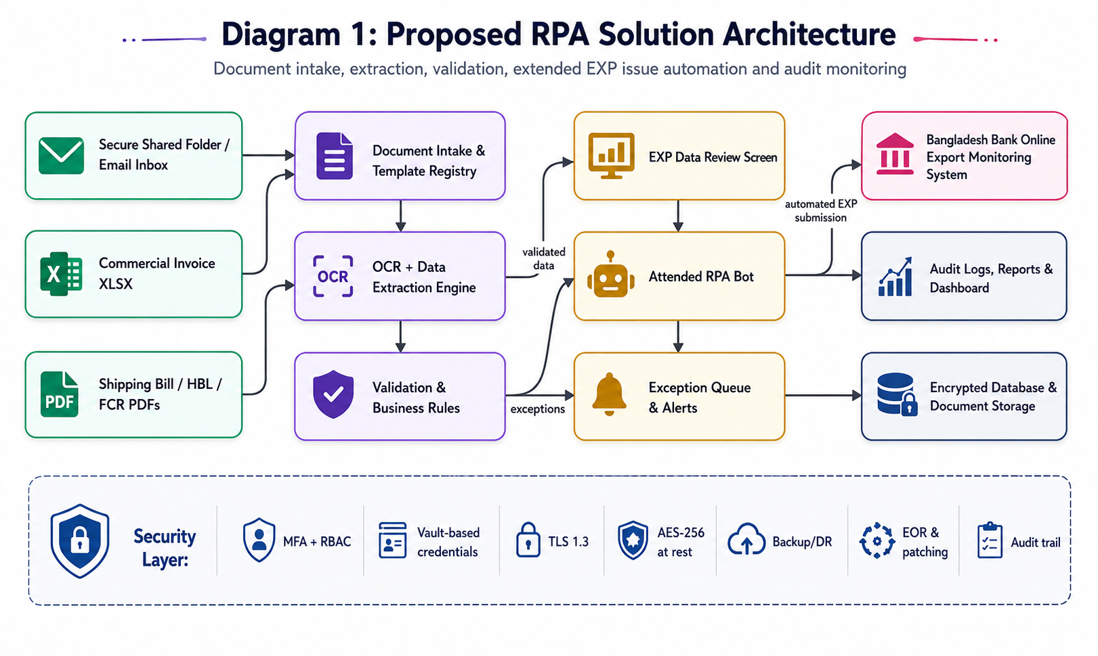
Diagram 1: Proposed RPA solution architecture covering intake, extraction, validation, attended portal automation, storage, audit and security controls.
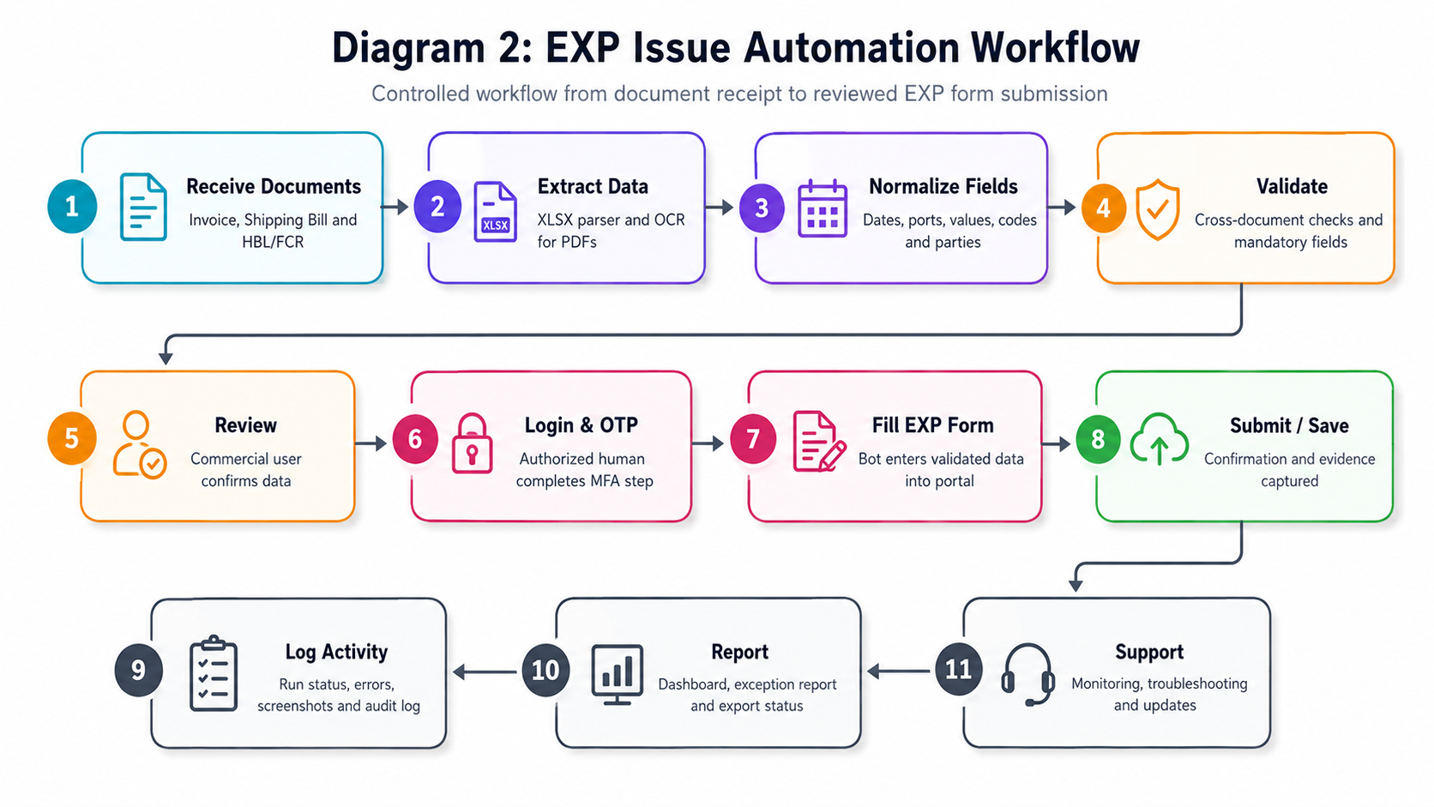
Diagram 2: EXP issue automation workflow showing the controlled handoff from document receipt to bot-assisted portal entry.
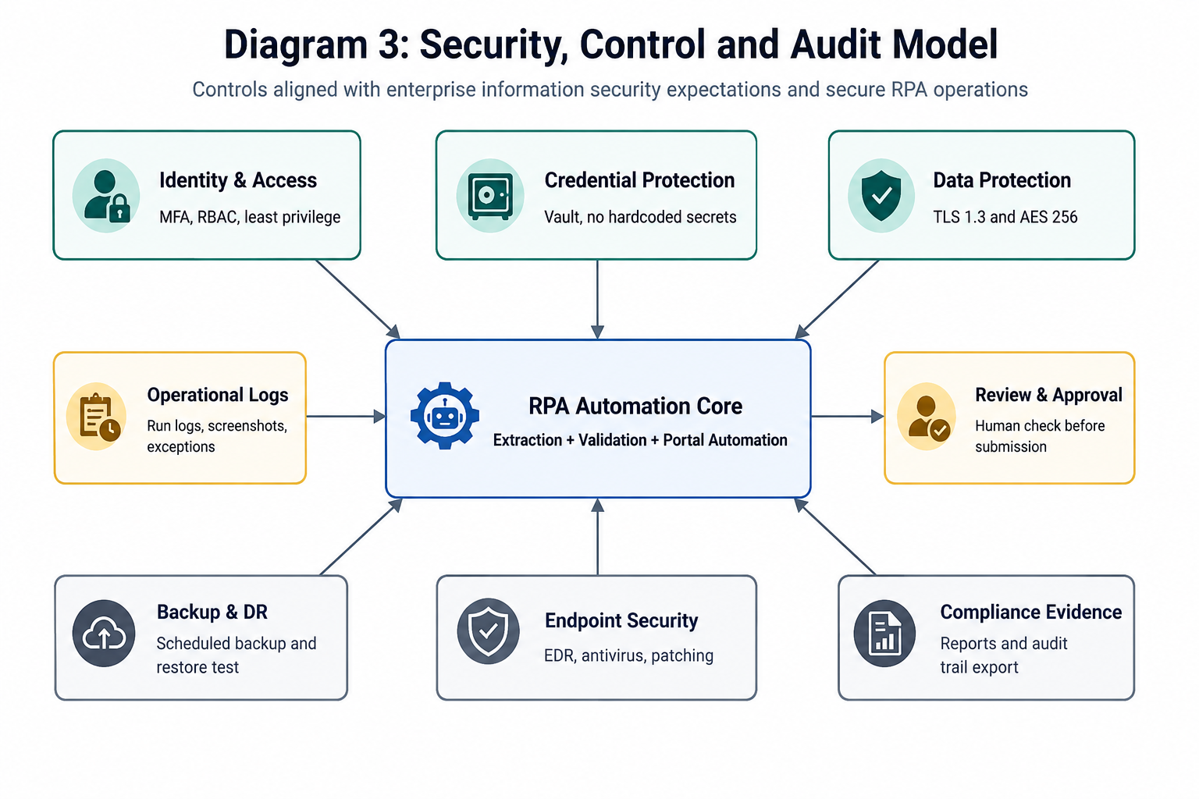
Diagram 3: Security, control and audit model showing the major controls required for secure RPA operation.

8. Proposed Technical Stack
Layer | Recommended Stack | Purpose / Notes
Frontend / Admin Console | React.js with TypeScript | Review screen, dashboard, exception queue, configuration and reports.
Backend API | Python FastAPI | API services, workflow orchestration, validation and integration layer.
RPA Automation | Python Playwright, Selenium | Reliable browser automation for authorized portal navigation and field population.
OCR & Document Processing | Tesseract OCR, OpenCV, PyMuPDF/PDF processing, configurable extraction templates | Local OCR-first approach for scanned PDFs and image preprocessing. AI/commercial OCR can be optional only with client approval.
Structured Excel Processing | Workbook parser and template-based mapping | Direct extraction of known invoice fields without OCR where document structure is stable.
Database | PostgreSQL | Process records, extracted fields, user actions, audit logs, configuration and reports.
Queue / Background Jobs | Celery or RQ with Redis | Document processing jobs, retries, scheduled monitoring and notification tasks.
File Storage | Encrypted server storage or S3-compatible object storage | Secure storage for uploaded documents, extracted text, evidence screenshots and reports.
Authentication & Access | MFA-enabled login, RBAC, optional AD/LDAP integration | Granular permissions and controlled user access.
Credential Management | HashiCorp Vault or approved enterprise secret store | Secure storage of system/service credentials and rotation support.
Notifications | SMTP / corporate email integration | Exception, approval and process status alerts.
Deployment | Dockerized services on client-approved Linux/Windows server or private cloud | Portable deployment, controlled environment setup and easier maintenance.
Monitoring & Logs | Application logs, audit logs, health checks, optional centralized log integration | Operational visibility and troubleshooting.

9. Development Methodology
The project will follow an Agile-incremental delivery model with strong documentation checkpoints. This approach allows early validation of OCR accuracy, portal automation behavior and business-rule correctness while keeping the scope controlled.
Phase | Activities | Outputs
Phase 1: Discovery & PDD | Process walkthrough, sample document analysis, field mapping, exception scenarios, access dependency analysis. | Process Definition Document, field mapping, high-level automation design.
Phase 2: Solution Design | Architecture, security model, template strategy, data model, rule design and portal automation approach. | Solution Design Document / SDS, refined FRS, test strategy.
Phase 3: Build Iterations | Develop intake, extraction, validation, review screen, dashboard, bot automation, notifications and audit logging. | Working modules delivered in controlled increments.
Phase 4: Integration & Hardening | ERP/email integration as approved, security configuration, backup setup, environment hardening and portal regression checks. | Integrated pre-production release.
Phase 5: Testing & UAT | System testing, extraction testing, security testing, regression testing, user validation and issue resolution. | Test reports, UAT scripts, validation reports and sign-off inputs.
Phase 6: Deployment & Handover | Production deployment support, user training, SOP handover, monitoring setup and hypercare start. | Live system, handover pack and support plan.

10. Testing and Quality Assurance
Testing will cover document extraction accuracy, business-rule validation, portal automation stability, security controls, data integrity, reporting and user validation. QA activities will be performed throughout development and finalized before production release.
QA Area | Testing Focus | Expected Evidence
Requirement Traceability | Every requirement mapped to design, development and test cases. | Requirement Traceability Matrix.
Document Extraction Testing | Excel invoice parsing, OCR output, scanned PDF handling, confidence scores and field mapping. | Extraction test report and field-level accuracy observations.
Cross-Document Validation | Quantity, HS code, invoice value, package count, destination, contract/PO and key party matching. | Validation test cases and exception report.
Functional Testing | Document intake, review screen, correction workflow, dashboard, notifications and reports. | Functional test report.
RPA Automation Testing | Portal navigation, selector stability, field population, timeout handling, screenshots and retries. | Bot execution test logs and screenshots.
Security Testing | MFA/RBAC, role permission checks, vault usage, access restrictions and encryption configuration. | Security checklist and access-control validation.
Performance & Reliability Testing | Batch processing behavior, background job retries, system health checks and database performance under expected volume. | Performance observations and tuning notes.
Backup / Restore Testing | Backup schedule, restore procedure and data recovery validation. | Backup/DR validation report.
Regression Testing | Repeat tests after changes to extraction templates, rules or portal selectors. | Regression test report.
UAT | Commercial user validation of end-to-end workflow and generated outputs. | UAT scripts, validation report and sign-off inputs.

10.1 Quality Gates
- No critical or high-severity defects open before go-live.
- Mandatory EXP fields correctly extracted or routed to review when confidence is low.
- Portal automation completes agreed test cases under supervised user login.
- Audit log captures required bot/user actions and status transitions.
- Backup/restore and security access controls are validated before production deployment.
- UAT scripts and validation reports are completed with stakeholder feedback incorporated.

11. Project Deliverables
Deliverable | Description
Process Definition Document (PDD) | Detailed current and proposed automation process, exception scenarios, business rules and process boundaries.
Solution Design Document / SDS | Architecture, components, data flow, deployment model, security controls and integration details.
Functional Requirement Specification (FRS) | Final functional scope, user roles, field mapping, workflows and validation requirements.
Configured RPA Bot | Attended bot for Bangladesh Bank EXP issue navigation and field population using authorized user access.
Document Extraction Engine | Excel and OCR/PDF extraction components with configured templates and field mapping.
Review Dashboard / Admin Console | Review screen, exception queue, dashboard, run history, reports and configuration access based on role.
Audit and Logging Module | Bot run logs, user actions, document status, screenshots/evidence and exception logs.
Notification Setup | Email alerts for completed processing, exceptions, approval pending and bot errors.
Security and Access Management Documentation | RBAC/MFA configuration, encryption approach, credential management and access control notes.
Backup, DR and Business Continuity Procedures | Backup schedule, restore steps, DR assumptions and continuity procedure.
Testing and QA Artifacts | Test cases, test reports, UAT scripts, validation report and defect summary.
User Manual and SOP | Bot operation guide, review workflow, exception handling steps and admin maintenance guide.
Deployment and Handover Pack | Deployment instructions, environment configuration, support model and handover checklist.
Post-Go-Live Support | Minimum 6 months hypercare support, monitoring, troubleshooting and necessary updates.

12. Assumptions, Dependencies and Controlled Out of Scope

12.1 Assumptions and Dependencies
- Client will provide approved sample documents, process walkthroughs and field-level validation rules.
- Authorized access to the Bangladesh Bank Online Export Monitoring System will be provided for testing and production use.
- MFA/OTP will be handled by an authorized user; the proposed solution will not bypass MFA or security controls.
- ERP/email/shared-folder access will be provided through approved service accounts or user accounts according to client policy.
- Client IT will provide or approve hosting environment, database/server access, backup location, EDR/antivirus and required firewall/network configuration.
- Any change in Bangladesh Bank portal UI, field names or access policy may require bot selector updates and regression testing.
- OCR accuracy depends on document quality, scan clarity, stamps, handwriting, resolution and template consistency.
- Final UAT acceptance criteria and accuracy thresholds will be confirmed during the PDD/FRS stage.

12.2 Controlled Out of Scope
- Financial proposal, licensing pricing or commercial costing.
- Modification of Bangladesh Bank portal or any third-party banking/government system.
- Bypassing MFA, OTP, captcha, access restrictions or authorized user controls.
- Unattended submission without user review where sensitive/critical data is missing or uncertain.
- Full ERP implementation or broad enterprise-wide workflow automation beyond the Commercial Department document automation scope.
- Additional document categories, business modules or analytics beyond the provided requirement unless formally approved as a change request.
- External OCR/AI service subscription costs or third-party license costs unless separately approved.

13. Post-Go-Live Support
A minimum 6-month hypercare support period will start after successful deployment and go-live. The support model will focus on stabilization, issue resolution, monitoring and necessary updates.
Support Area | Activities
Monitoring | Bot run monitoring, error review, exception trend tracking and dashboard observation.
Troubleshooting | Issue diagnosis for document extraction, field mapping, portal navigation and user workflow errors.
Template Maintenance | Adjust extraction templates/rules for approved layout variations and portal selector changes.
Security and Patch Coordination | Coordinate with client IT for server patching, EDR/antivirus checks and credential rotation support.
Knowledge Transfer | Operational handover, SOP reinforcement and administrator guidance.
SLA-Based Support | Response and resolution targets to be finalized in the support agreement.

14. Conclusion
The proposed RPA solution provides a secure, auditable and practical automation approach for Commercial Department export document processing and Bangladesh Bank EXP issue support. It combines structured invoice parsing, OCR-based extraction, rule-driven validation, attended portal automation, dashboards, audit logs and security controls required for enterprise adoption.

