TECHNICAL PROPOSAL
Website Maintenance and Technical Support Services
for SAJIDA Foundation USA and SAJIDA Foundation Uganda
Prepared by: Riseup Labs


Table of Contents
1. Executive Summary 3
2. Understanding of the Assignment 3
2.1 Key ToR Requirements Mapped to Proposed Response 3
3. Project Objectives 3
4. Proposed Scope of Services 4
4.1 Codebase Health Check and Bug Fixing 4
4.2 Database Backup and Recovery Readiness 4
4.3 Laravel Version and Dependency Maintenance 4
4.4 Existing Feature Issue Resolution 4
4.5 Content Upload Support 4
4.6 Minimal Feature and Design Changes 4
5. Proposed Technical Approach 4
5.1 Phase-Based Technical Approach 4
5.2 Preventive Maintenance Approach 5
5.3 Corrective Maintenance Approach 5
5.4 Security and Performance Considerations 5
6. Maintenance Methodology and Governance 5
6.1 Monthly Maintenance Cycle 5
6.2 Issue Priority Handling 6
6.3 Communication and Reporting 6
7. Proposed Technical Stack 6
8. Testing and Quality Assurance 6
8.1 Production Release Checklist 7
9. Technical Diagrams 7
9.1 Maintenance Operating Model 7
9.4 Website Maintenance Architecture 8
10. Deliverables 8
11. Assumptions and Dependencies 9
12. Out-of-Scope / Separately Approved Items 9
13. Conclusion 9

1. Executive Summary
SAJIDA Foundation intends to maintain two existing websites: SAJIDA Foundation USA and SAJIDA Foundation Uganda. The assignment requires reliable website maintenance and technical support for a 12-month period from July 2026 to June 2027, with a focus on stable operation, security, performance, timely issue resolution, database backup, Laravel codebase updates, content upload, and minimal feature or design changes.
The proposed approach is designed around controlled maintenance rather than new product development. It combines preventive maintenance, corrective maintenance, safe release practices, backup readiness, QA validation, and monthly reporting to ensure both websites remain stable and maintainable throughout the contract period.
The solution will use a Laravel-aligned maintenance stack, supported PHP runtime, version control, staging-based validation, database backup procedures, dependency review, performance checks, security hygiene, and structured issue tracking. The approach keeps the scope aligned with the ToR and avoids unnecessary feature expansion.

2. Understanding of the Assignment
The ToR requests website maintenance and technical support services for two websites:
- SAJIDA Foundation USA: https://www.sajidausa.org/
- SAJIDA Foundation Uganda: https://sajidauganda.org/
The selected agency will be responsible for maintaining both websites under a single maintenance agreement covering July 2026 to June 2027. The objective is to ensure uninterrupted operation, security, performance optimization, and timely technical support through preventive and corrective maintenance services.

2.1 Key ToR Requirements Mapped to Proposed Response
ToR Requirement | Technical Response
Regular code checkups and bug fixes | Perform periodic code health checks, review logs/errors, identify issues, and fix confirmed bugs through a controlled release process.
Database backup | Set up and monitor scheduled database backup routines, maintain backup logs, and conduct periodic restore-readiness checks.
Update codebase to latest stable Laravel version | Audit current Laravel version, dependencies and hosting compatibility, then apply planned Laravel and package updates through staging before production release.
Resolve issues in existing features | Analyze reported or detected issues, reproduce them, fix within existing scope, validate on staging, and release after QA.
Upload content as required | Upload provided text, images, documents, pages, news, or updates through the existing CMS/admin process or backend access.
Minimal feature and design changes | Support minor layout, style, text, and small functional adjustments that do not require new module development or substantial redesign.

3. Project Objectives
- Maintain uninterrupted availability and operational stability of both websites.
- Keep the Laravel codebase and key dependencies secure, compatible, and maintainable.
- Provide timely preventive and corrective support for bugs and existing feature issues.
- Ensure recurring database backup and basic recovery readiness.
- Support required content uploads and minor design/feature changes within the existing website structure.
- Maintain a clear communication, reporting, QA, and release process throughout the 12-month engagement.

4. Proposed Scope of Services

4.1 Codebase Health Check and Bug Fixing
- Periodic review of Laravel application logs, server errors, broken pages, form issues, routing issues, dependency warnings, and browser-console issues.
- Bug reproduction, root-cause analysis, code correction, staging validation, and release note preparation.
- Minor refactoring only where needed to safely fix bugs or support Laravel version compatibility.

4.2 Database Backup and Recovery Readiness
- Scheduled database backup setup or review based on the existing hosting environment.
- Backup retention review, backup log maintenance, and periodic verification that backup files are generated properly.
- Restore-readiness checks in a safe environment when access and hosting permissions allow.

4.3 Laravel Version and Dependency Maintenance
- Assess current Laravel version, PHP version, Composer packages, frontend build dependencies, server compatibility, and breaking-change risks.
- Prepare an upgrade plan aligned with the latest stable Laravel version that is compatible with the website codebase and hosting stack.
- Apply framework, package, and security updates through a staged process with backup, testing, and rollback readiness.

4.4 Existing Feature Issue Resolution
- Resolve issues in existing pages, content sections, forms, media upload, navigation, admin workflows, and other currently available website functions.
- Verify fixes across affected pages, desktop/mobile views, and supported browsers.
- Document completed fixes in release notes or monthly maintenance reports.

4.5 Content Upload Support
- Upload provided website content, images, documents, pages, news items, and approved updates.
- Check formatting, link behavior, image display, file accessibility, and responsive appearance after upload.
- Coordinate with the SAJIDA content owner for approval when content placement or formatting requires confirmation.

4.6 Minimal Feature and Design Changes
- Minor UI/content layout adjustments within the current theme and website structure.
- Small functional changes that do not require a new module, new business workflow, or major redesign.
- Minor style corrections, spacing adjustments, broken UI fixes, and simple component updates.

5. Proposed Technical Approach
The maintenance approach is based on four operating principles: protect the current live websites, validate changes before release, keep the Laravel ecosystem current, and provide transparent reporting.

5.1 Phase-Based Technical Approach
Approach Phase | Description
Phase 1: Onboarding and Baseline Review | Collect access, review hosting, repository, database, admin panel, Laravel version, backups, and current issue list. Prepare a baseline report.
Phase 2: Stabilization and Maintenance Setup | Set up support workflow, backup routine, staging/release process, code health checklist, and monthly reporting format.
Phase 3: Ongoing Preventive Maintenance | Perform regular code checkups, dependency review, database backup monitoring, security hygiene, performance checks, and content support.
Phase 4: Corrective Maintenance and Releases | Handle reported issues, bug fixes, existing feature issues, minor changes, QA validation, production deployment, and release documentation.
Phase 5: Closure and Handover | Prepare final maintenance summary, open issue list, backup status, update history, and recommended next steps at the end of the 12-month period.

5.2 Preventive Maintenance Approach
- Review Laravel logs, server logs, broken URLs, visible page issues, media paths, and common front-end errors.
- Check Composer dependencies and package health before applying updates.
- Validate scheduled backups and keep a backup-status record.
- Run basic performance checks on important public pages and identify practical optimization opportunities.
- Review access permissions and configuration hygiene to reduce avoidable security risks.

5.3 Corrective Maintenance Approach
- Log and categorize each reported issue or change request.
- Reproduce and analyze the issue before making changes.
- Apply fixes in a development or staging environment where access permits.
- Run QA validation and receive approval for visible changes where needed.
- Deploy to production with backup and rollback readiness.
- Update the issue tracker and monthly maintenance report.

5.4 Security and Performance Considerations
Security and performance activities will remain within the maintenance scope and will focus on practical website hardening and optimization rather than large-scale re-engineering.
- Laravel and Composer package updates after compatibility review.
- Review of exposed environment files, debug mode, file permissions, and sensitive configuration practices.
- SSL/TLS status and browser security warning checks.
- Review of broken links, missing assets, large images, cache behavior, and obvious page-load bottlenecks.
- Use of web application security awareness practices aligned with OWASP Top 10 categories such as broken access control, injection, security misconfiguration, vulnerable/outdated components, and logging/monitoring issues.

6. Maintenance Methodology and Governance
The proposed methodology combines a lightweight agile support cadence with a controlled release process. The goal is to respond quickly to maintenance needs while protecting production stability.

6.1 Monthly Maintenance Cycle
Monthly Cadence | Maintenance Activities
Week 1 | Review open issues, backup status, logs, security/dependency alerts, and planned content updates.
Week 2 | Execute approved bug fixes, content uploads, Laravel/package updates, and minor changes in staging.
Week 3 | Conduct QA, client review for visible changes, deployment readiness, and production release if approved.
Week 4 | Post-release validation, documentation, backup status review, and monthly maintenance report submission.

6.2 Issue Priority Handling
Priority | Typical Scenario
Critical | Website unavailable, severe production error, security concern, or database-related issue affecting public access.
High | Important page, form, content area, or admin function is not working as expected.
Normal | Content upload, minor layout issue, small bug, or existing feature adjustment.
Low | Cosmetic improvement, scheduled change, or non-urgent maintenance task.

6.3 Communication and Reporting
- A single coordination channel will be maintained for issue intake, approval, and update sharing.
- Each completed change will be documented with status, summary, affected website, release date, and QA notes.
- Monthly reports will summarize completed activities, backup status, open issues, risks, recommendations, and next-month priorities.
- Any item that appears to exceed the ToR maintenance scope will be flagged before execution for separate approval.

7. Proposed Technical Stack
The final technical stack will be confirmed after access to the existing codebase, server, and hosting environment. The proposal assumes the websites are Laravel-based as referenced in the ToR requirement to update the codebase in line with the latest stable Laravel version.
Layer | Proposed Stack / Tooling
Application Framework | Laravel latest stable compatible release at the time of upgrade. Current official documentation lists Laravel 13.x, with Laravel 13 requiring PHP 8.3 or above.
Runtime | Supported PHP branch compatible with the selected Laravel version and hosting environment, preferably PHP 8.4/8.5 where feasible after compatibility testing.
Database | MySQL or MariaDB, depending on the existing hosting configuration.
Frontend | Blade templates, HTML5, CSS3, JavaScript, and the existing theme framework/library currently used by the websites.
Package Management | Composer for PHP dependencies; npm or existing frontend package tooling if already present.
Version Control | Git repository with release branches/tags for controlled maintenance changes.
Server/Hosting | Linux-based hosting with Nginx or Apache, SSL/TLS, cron support, file storage, and database access.
QA and Diagnostics | Laravel logs, browser dev tools, Lighthouse/PageSpeed Insights, Composer audit/outdated checks, and functional test checklists.
Backup and Monitoring | Hosting-level backups, database export jobs, secure backup storage, backup logs, uptime/SSL checks, and restore-readiness verification.

8. Testing and Quality Assurance
QA activities will be executed for each fix, update, content upload, and minor change based on the affected website areas. The QA approach is practical and maintenance-focused.
QA Area | Details
Functional QA | Validate affected pages, forms, navigation, admin actions, content blocks, links, and existing features after fixes or updates.
Regression QA | Check that the fix or update does not break related pages, layouts, routes, or content sections.
Responsive QA | Review key pages on desktop, tablet, and mobile screen sizes for layout and content display issues.
Cross-Browser QA | Check latest stable versions of Chrome, Edge, Firefox, and Safari where access/devices allow.
Content QA | Verify spelling, formatting, image placement, downloadable files, links, and content consistency after upload.
Security QA | Check debug mode, sensitive file exposure, access permissions, forms, upload paths, and dependency/security warnings.
Performance QA | Run page-level checks using Lighthouse/PageSpeed Insights and identify practical optimization items within scope.
Backup QA | Confirm database backup generation and perform restore-readiness verification based on access and hosting permissions.
Deployment QA | Validate live site after production deployment through a smoke test and release checklist.

8.1 Production Release Checklist
- Confirm scope and approval for the planned change.
- Take or verify recent code and database backup before production release.
- Apply change in staging/development and validate affected pages or functions.
- Run smoke test on critical public pages and admin actions affected by the change.
- Deploy to production during an agreed maintenance window where needed.
- Verify production pages, forms, content, links, assets, and admin access after release.
- Document release status, issue ID, change summary, QA result, and rollback note.

9. Technical Diagrams
The following diagrams summarize the proposed operating model, request workflow, safe deployment process, and high-level maintenance architecture. These diagrams can be replaced with branded visuals later while keeping the same titles and technical logic.

9.1 Maintenance Operating Model
This diagram shows how baseline audit, preventive checkups, issue triage, staging fixes, QA, production release, validation, and reporting connect into a continuous maintenance cycle.
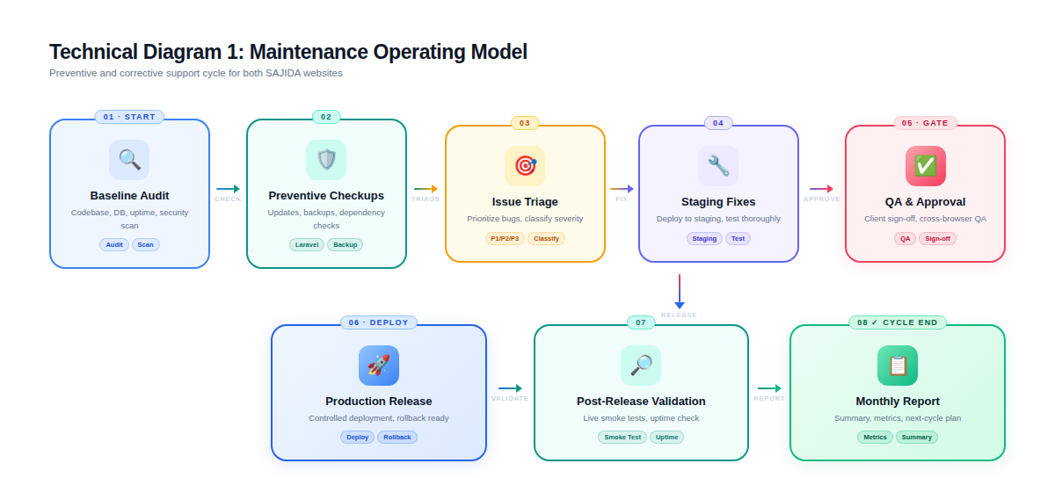

9.2 Website Maintenance Architecture
This diagram shows the high-level components involved in maintaining both Laravel-based websites, including users, server, application, database, file storage, admin/content team, maintenance team, backups, and monitoring.
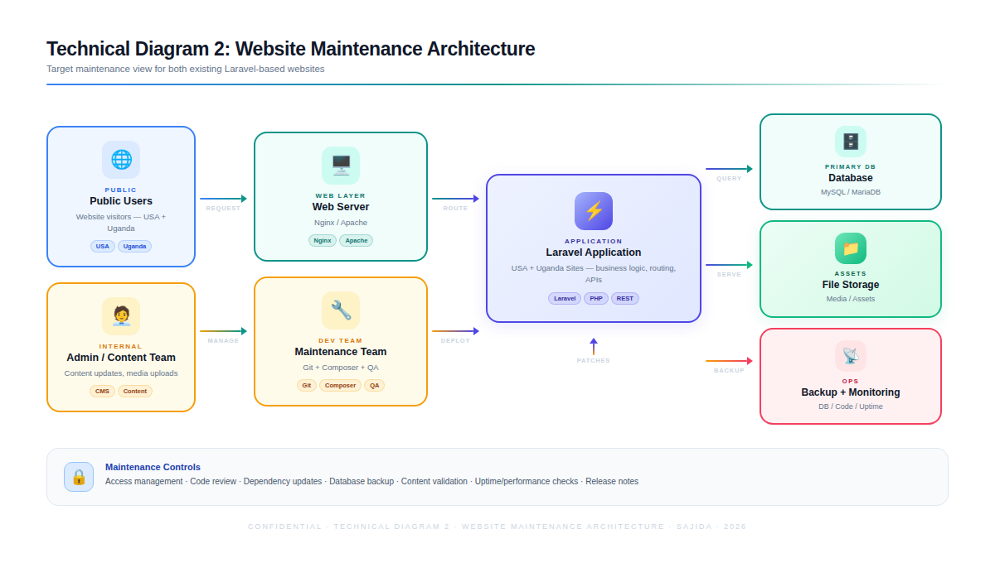

10. Deliverables
Deliverable | Description
Maintenance Baseline Report | Initial review of codebase, hosting, Laravel version, dependencies, backup setup, current risks, and recommended maintenance priorities.
Access and Environment Checklist | Documented list of required access, environment details, and maintenance readiness status.
Backup Setup / Backup Status Log | Backup routine confirmation, backup schedule, retention status, and backup verification notes.
Laravel and Dependency Update Plan | Version assessment, compatibility notes, staging test result, and planned update steps before production deployment.
Bug Fix and Issue Resolution Log | Record of reported issues, root cause, action taken, QA result, release status, and completion date.
Content Upload Log | Record of uploaded content, affected pages, files/images, approval status, and formatting QA notes.
Minor Change Release Notes | Summary of minor feature/design changes completed within the ToR scope.
QA Checklist and Test Evidence | Functional, regression, responsive, security, performance, and deployment validation checklist per release.
Monthly Maintenance Report | Monthly summary of completed tasks, open items, backup status, risks, recommendations, and next-month plan.
Final Maintenance Closure Report | End-of-contract summary covering update history, backup status, completed activities, pending issues, and handover notes.

11. Assumptions and Dependencies
- SAJIDA Foundation will provide required website admin, hosting, server, database, repository, DNS/SSL, and backup-related access as applicable.
- A staging or development environment will be available, or will be configured if allowed by the current hosting setup.
- All content for upload will be provided in final approved format, including text, images, files, links, and placement guidance.
- Laravel upgrade scope will depend on the current codebase version, package compatibility, PHP version, hosting support, and database compatibility.
- Any change that may affect public content, layout, navigation, or key functions will require client review/approval before production deployment.
- Third-party paid tools, premium plugins, hosting upgrades, external integrations, and new licenses will require separate approval if needed.

12. Out-of-Scope / Separately Approved Items
The following items are outside routine website maintenance and should be separately reviewed and approved before execution:
- Major feature development or new module development.
- Substantial website redesign or complete UI/UX redesign.
- Large-scale content writing, translation, or content strategy work.
- Major hosting migration, server re-architecture, or cloud infrastructure redesign.
- New third-party integration, payment integration, CRM integration, or API-based module.
- SEO campaign execution, paid marketing, analytics strategy, or ongoing digital marketing services.
- Security penetration testing or formal vulnerability assessment beyond maintenance-level checks.

Note:
- Uploading content as required
- Minimal features and design changes
These activities are expected to require up to 10 hours per scope per month. Any additional requests beyond these scopes or requiring extra effort will be treated as out-of-scope and billed separately based on the estimated additional hours, which will be communicated and approved in advance.

13. Conclusion
This proposal outlines a practical and structured approach to maintaining and supporting the SAJIDA Foundation USA and SAJIDA Foundation Uganda websites over the 12-month agreement period. The proposed maintenance model focuses on stability, security, regular backups, Laravel codebase updates, issue resolution, content support, and minimal design or feature adjustments as required. Through a preventive and corrective maintenance approach, we will ensure both websites remain reliable, secure, updated, and aligned with SAJIDA Foundation’s operational needs.

