Technical Proposal
AI-Powered Applicant Tracking System (ATS)
with Intelligent CV Screening
Prepared for: Square Toiletries Limited
Prepared by: Riseup Labs


Contents
1. Executive Summary 3
2. Understanding of the Requirement 3
Key Business Objectives 3
Core Requirement Areas 3
3. Proposed Solution Overview 4
Solution Design Principles 4
4. Scope of Work and Feature List 4
1. User Management & Security 4
2. CV Upload & Parsing 4
3. AI Screening & Matching 5
4. Candidate Database & History Tracking 5
5. Export & Reporting 5
6. Integration & Workflow 5
7. AI Governance & Accuracy 5
5. Requirement Alignment Matrix 6
6. Proposed Technical Approach 7
6.1 Modular Architecture 7
6.2 CV Intake and Parsing Approach 7
6.3 AI Screening and Matching Approach 7
6.4 Duplicate Identification Approach 7
6.5 Handling Fake or Manipulated Experience 7
6.6 Performance and Batch Processing Approach 8
7. Technical Architecture 8
8. Data Architecture 10
9. Proposed Technology Stack 11
Cloud or On-Premise Deployment 12
10. Security, Privacy and AI Governance 12
10.1 Application Security 12
10.2 AI Governance 12
10.3 Data Retention 12
10.4 Research-Informed Governance Considerations 12
11. Testing and Quality Assurance 13
AI Accuracy Benchmark Approach 13
12. Development Methodology 14
13. Deliverables 14
14. Assumptions and Dependencies 14
15. Conclusion 15

1. Executive Summary
Square Toiletries Limited requires a comprehensive AI-Powered Applicant Tracking System (ATS) with Intelligent CV Screening capability, not only a standalone CV parser. The proposed solution will help HR teams manage large-volume recruitment, parse diverse CV formats, screen candidates against configurable job-specific criteria, maintain a centralized candidate history, automate selected recruitment workflows, and generate actionable reports.
The system will be designed with a controlled and practical scope based on the provided requirement documents. The proposed platform will include user management, bulk CV intake, CV parsing, AI-based screening, candidate database management, reporting, notification, interview scheduling support, and AI governance mechanisms such as explainable scoring, HR manual override and human review before final rejection.
The proposed architecture separates the ATS web application, backend workflow engine, AI processing service, storage, search and integration layers. This separation will improve scalability, support batch processing of at least 5,000 CVs, and allow either cloud or on-premise deployment depending on the client’s infrastructure preference.

2. Understanding of the Requirement
Based on the provided user specification and summary, the expected product is a unified recruitment system that combines ATS workflow and AI-enabled CV screening. The system should help HR reduce manual screening effort while retaining decision control.

Key Business Objectives
- Reduce manual effort in CV screening and candidate shortlisting.
- Enable structured processing of large CV volumes during recruitment campaigns.
- Improve consistency of screening by using position-wise criteria, templates and weight-based scoring.
- Create a reusable candidate database and talent pool for future hiring needs.
- Provide transparent AI scoring explanations so HR can review and validate AI recommendations.
- Support reporting, export and interview workflow coordination from a centralized system.

Core Requirement Areas
Area | Requirement Understanding
User Management & Security | Admin/user login, password management and role-based access for Admin, HR, Hiring Manager and Viewer roles.
CV Upload & Parsing | Bulk upload, drag-and-drop upload, support for PDF, Word, scanned copies and JPG/PNG CVs, duplicate detection and email/job portal import capability.
AI Screening & Matching | Custom screening criteria, criteria weighting, position-wise templates/prompts, include/exclude keywords, AI matching score, auto shortlisting and red flag indicators.
Candidate Database | Application history, last application date, previous applied positions, previous shortlist status, tagging/bookmarking and talent pool creation.
Export & Reporting | Bulk CV download, customizable Excel export, final candidate summary, screening reports and interview panel summary.
Integration & Workflow | Automated email/SMS notifications and interview scheduling support.
AI Governance & Accuracy | Explainable AI score, HR manual override, validation benchmark, controlled model customization and human review before final rejection.

3. Proposed Solution Overview
The proposed system will be a secure web-based ATS platform supported by an AI processing service. HR users will be able to create job positions, define screening criteria and weights, upload or import CVs, parse candidate information, run screening, review shortlists, generate reports and coordinate interview workflows.

Solution Design Principles
Principle | Application in Proposed Solution
Requirement-first scope | Only requirement-aligned modules are included to keep the implementation practical and controlled.
Human-in-the-loop recruitment | AI will assist with scoring and ranking, but HR review remains mandatory before final rejection or final hiring decision.
Explainable scoring | Each matching score will show the criteria contribution and the extracted CV evidence used in the decision.
Scalable batch processing | CV processing will use asynchronous queues and background workers to support large upload batches.
Flexible screening configuration | HR can define position-wise templates, criteria weights, include/exclude keywords and score thresholds.
Secure candidate data handling | RBAC, audit logs, encryption and retention configuration will be applied to protect candidate information.

4. Scope of Work and Feature List
The following feature list is prepared directly from the provided requirement documents and organized into implementation-friendly modules.

1. User Management & Security
- Admin/user ID and password management.
- Role-based access control for Admin, HR, Hiring Manager and Viewer roles.
- User activation/deactivation and access control per module.
- Basic audit trail for important actions such as upload, scoring, override, export and shortlist changes.

2. CV Upload & Parsing
- Drag-and-drop CV upload from web interface.
- Bulk upload capability for minimum 5,000 CVs per batch through queued background processing.
- Support for readable PDF, Word, scanned CV copies and JPG/PNG images.
- CV file validation and processing status tracking.
- Duplicate CV detection within current upload batch.
- Duplicate candidate identification against previous candidate database.
- Email inbox import and job portal import capability subject to available access/API.

3. AI Screening & Matching
- Position-wise screening templates/prompts.
- Customizable screening criteria: age, gender, education, years of experience, specific position, skills, location, certifications and other agreed structured fields.
- Multiple filtering combinations across structured criteria.
- Criteria weight configuration for different positions.
- Include and exclude keyword filtering.
- AI matching score generation in percentage format.
- Auto shortlisting based on configurable score threshold.
- Auto movement of shortlisted CVs into a separate shortlist folder/list.
- Red flag indicators for career break, frequent job change, missing information, overqualification, underqualification and skill gap analysis.

4. Candidate Database & History Tracking
- Centralized candidate profile creation from parsed CV data.
- Candidate application history tracking.
- Display of last application date, previously applied position and previous shortlist status.
- Candidate tagging and bookmarking.
- Talent pool/database creation for future hiring.

5. Export & Reporting
- Bulk CV download for filtered or shortlisted candidates.
- Customizable Excel export fields including name, contact number, email, home district, education and experience.
- Final candidate summary generation in predefined Excel format.
- Downloadable screening reports.
- Interview panel summary generation.

6. Integration & Workflow
- Automated email notification capability.
- Automated SMS notification capability using an agreed SMS gateway.
- Interview scheduling support for selected candidates.
- Notification and schedule status tracking.

7. AI Governance & Accuracy
- Explainability of AI scoring and decision support.
- Manual override by HR with reason capture.
- Weighted scoring suggestion for CV screening templates.
- Accuracy benchmark/validation report during testing.
- Controlled retraining/customization based on company hiring patterns and validated HR feedback.
- Human review before final rejection.

5. Requirement Alignment Matrix
Requirement | Proposed Response
Admin/User ID & password management | User authentication, password policy and admin-controlled user management will be implemented.
Role-based access control | Role permissions will be configured for Admin, HR, Hiring Manager and Viewer.
Readability of PDF, Word, scanned copy, JPG/PNG CVs | Document ingestion will use OCR and parsing service for supported digital and scanned formats, with accuracy testing by sample CV set.
Bulk upload minimum 5,000 CVs | Asynchronous batch processing queue will process large uploads without blocking the web interface.
Drag-and-drop upload | The React web interface will include drag-and-drop upload and upload progress status.
Duplicate CV detection | Duplicate detection will use file hash, contact details and candidate similarity matching.
Email/job portal integration | Email inbox import and job portal/API import capability will be provided based on credentials and API availability.
Custom screening criteria and weights | Screening templates will allow criteria, filters, weights, thresholds and include/exclude keyword setup.
AI matching score and auto shortlisting | Each candidate will receive a score and can be auto-shortlisted based on position-specific threshold.
Red flag indicators | The AI/rule engine will identify career break, frequent job change, missing information, over/under qualification and skill gap indicators.
Candidate history tracking | Candidate profile will store application history, last application date, previous position and shortlist status.
Talent pool creation | Candidates can be tagged, bookmarked and retained in a searchable talent pool.
Custom Excel export | Users can select export fields and generate Excel files in agreed formats.
Screening and panel reports | Downloadable screening reports and interview panel summaries will be generated.
Email/SMS notification | Notification templates and sending workflow will be integrated with SMTP and SMS gateway.
Interview scheduling | Scheduling support will allow HR to create and communicate interview slots.
Explainable AI and manual override | AI output will show score drivers and HR can override decisions with reason logging.
Model customization/retraining | Validated HR decisions can be used as feedback data for controlled screening model tuning.

6. Proposed Technical Approach

6.1 Modular Architecture
The system will be implemented as modular services: a web frontend, backend ATS API, AI processing service, relational database, object storage, search index, queue workers and external integration adapters. This allows recruitment workflow, document parsing and AI scoring to scale independently.

6.2 CV Intake and Parsing Approach
- Uploaded CVs will first be validated for file type, file size and readability.
- Original CV files will be stored in secure object storage with metadata in the database.
- Digital files will be parsed directly where possible; scanned CVs and images will pass through OCR.
- The parser will extract candidate identity, contact details, education, experience, skills, certifications, location and other agreed fields.
- Extraction confidence and missing field indicators will be stored for HR review.
- Bangla + English mixed CVs will be handled through Unicode text normalization, language-aware OCR and bilingual keyword dictionaries for skills, education and location.

6.3 AI Screening and Matching Approach
- HR will create a job/position and configure screening template criteria with weights and thresholds.
- The scoring engine will combine rule-based filtering, structured field matching, keyword matching and semantic skill matching.
- Criteria-level scores will be aggregated into a final AI matching score in percentage format.
- The result will include explanation: matched criteria, missed criteria, extracted evidence and red flag indicators.
- If screening criteria are changed after upload, the system will re-run scoring using already parsed structured candidate data. Re-upload will not be required unless the original parsing was incomplete or unreadable.
- Auto shortlisting will be based on configured threshold, but HR can review and override any system recommendation.

6.4 Duplicate Identification Approach
- Exact duplicate CV files will be detected using file checksum/hash.
- Candidate duplicates will be detected using normalized email, phone number, name and candidate profile similarity.
- Duplicate candidates from previous database will be flagged for HR review instead of being deleted automatically.

6.5 Handling Fake or Manipulated Experience
The system can provide inconsistency and risk indicators, but it should not be positioned as a definitive fraud verification tool unless integrated with external employment verification sources. Within the current scope, the system will detect possible issues such as overlapping employment dates, unrealistic experience duration, missing employer details, inconsistent job progression and repeated wording patterns. Final verification will remain an HR process.

6.6 Performance and Batch Processing Approach
- A background queue and worker-based architecture will process large CV batches.
- Processing status will be visible to HR as pending, processing, parsed, failed, duplicate, screened or shortlisted.
- Batch processing performance will be benchmarked during QA using representative CV samples.
- System performance for 5,000 CVs will depend on CV length, scan quality, OCR engine, infrastructure and concurrent load.

7. Technical Architecture
The following diagram shows the proposed high-level architecture. It can be implemented in cloud or on-premise environment depending on Square Toiletries Limited's IT preference.
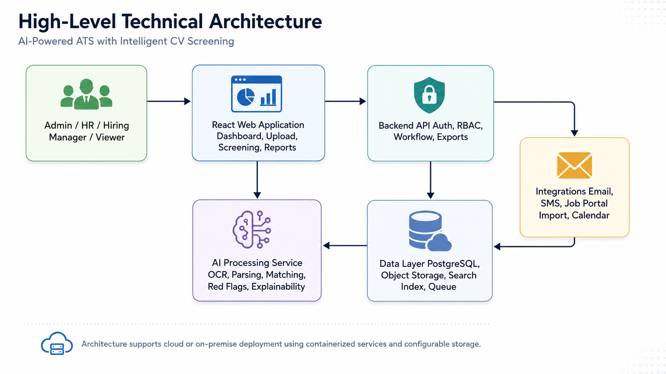
Figure 1: High-Level Technical Architecture
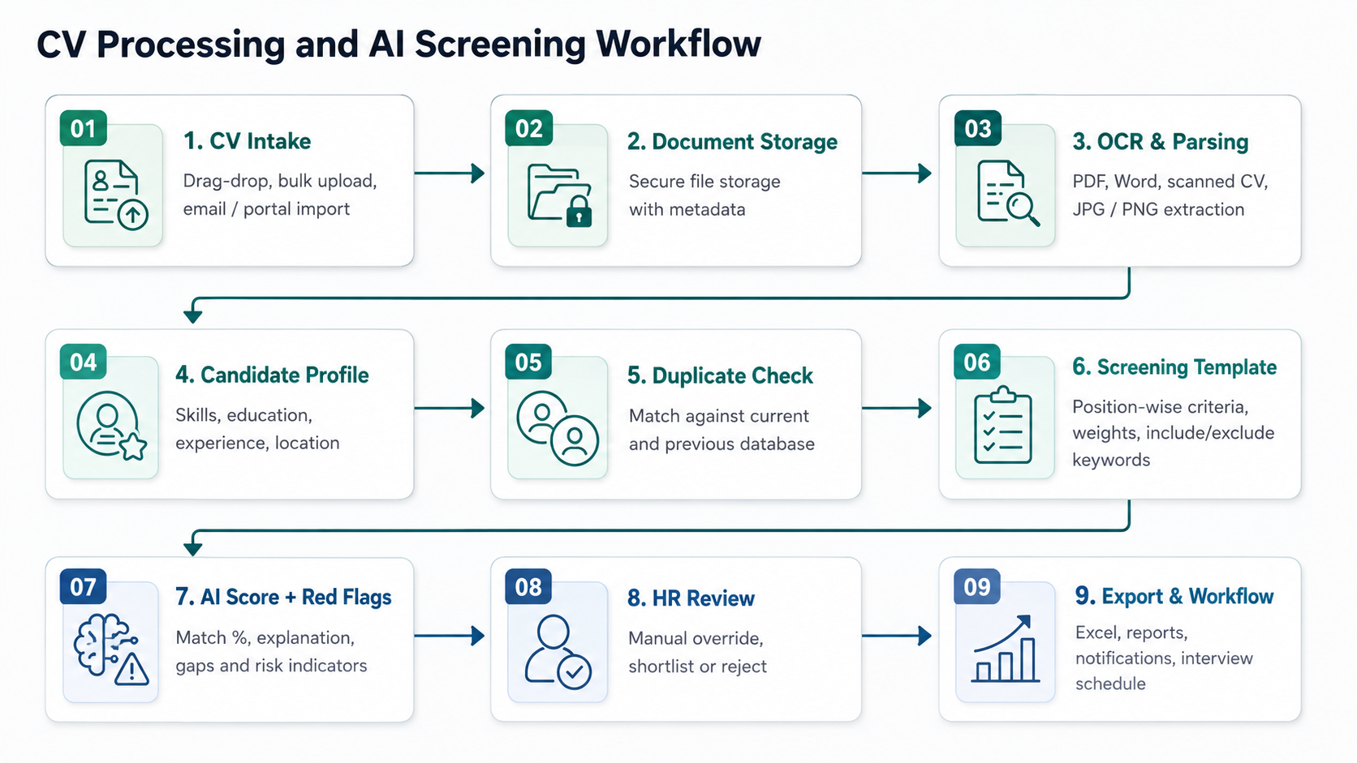
Figure 2: CV Processing and AI Screening Workflow
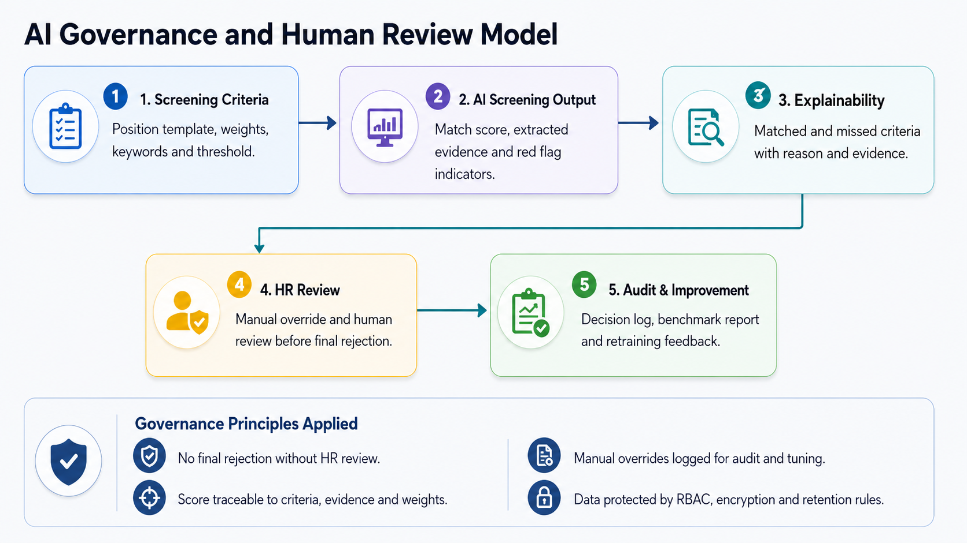
Figure 3: AI Governance and Human Review Model

8. Data Architecture
The solution will maintain structured candidate and recruitment workflow data separately from original CV files. This improves searchability, reporting, duplicate identification and re-screening when criteria change.
Entity | Purpose
User | System users including Admin, HR, Hiring Manager and Viewer.
Role & Permission | Access rules for modules, reports, exports and administrative functions.
Job Position | Recruitment position with department, designation, criteria template and status.
Screening Template | Position-wise screening criteria, weights, thresholds and include/exclude keywords.
Candidate | Candidate master profile with identity, contact details, district, education, skills and work summary.
Application | Candidate application record against a specific job position.
CV Document | Original CV file metadata, storage path, file type, upload source and processing status.
Parsed Profile | Structured data extracted from CV with confidence and missing field indicators.
Screening Run | Screening execution record for a specific job/template/version.
Score Explanation | Criteria-level score, evidence, red flags and AI decision explanation.
Tag/Bookmark | HR-defined labels and bookmarks for talent pool management.
Interview Schedule | Interview date, panel summary, candidate communication and status.
Notification | Email/SMS message record and delivery status.
Report/Export Log | Generated reports and audit trail for downloads.

9. Proposed Technology Stack
The proposed stack uses widely adopted enterprise web technologies with a separate AI processing layer. This keeps ATS business workflow stable while allowing OCR, NLP and AI components to be tuned independently.
Layer | Proposed Technology | Purpose
Frontend | React.js with TypeScript | Responsive web portal for HR, hiring managers and administrators.
UI Component Layer | Ant Design / Material UI | Enterprise dashboards, data tables, forms, upload screens and reports.
Backend API | Laravel REST API | Authentication, RBAC, recruitment workflow, reporting and integration orchestration.
AI Processing Service | Python FastAPI | CV parsing, OCR orchestration, NLP extraction, scoring and explainability.
Database | PostgreSQL | Candidate, application, screening, audit and configuration data.
Search | OpenSearch / Elasticsearch | Fast search across candidate profiles, skills, tags and parsed CV content.
Queue & Background Jobs | Redis Queue / Celery / Laravel Horizon | Bulk CV processing, notification jobs and report generation.
File Storage | S3-compatible storage / Azure Blob / MinIO | Secure storage for original CV files and generated reports.
OCR Layer | Azure Document Intelligence / Google Document AI / On-prem OCR option | OCR for scanned PDFs and image-based CVs; final engine to be selected based on deployment preference and accuracy benchmark.
AI/NLP Layer | Transformers, sentence embeddings, rule engine and controlled LLM prompts where required | Skill matching, experience extraction, red flag detection and explainable scoring.
Notifications | SMTP email service and agreed SMS gateway | Candidate and internal workflow notifications.
Deployment | Docker, Nginx, Linux server | Portable deployment for cloud or on-premise infrastructure.
CI/CD | GitHub Actions / GitLab CI | Automated build, test and deployment pipeline.
Monitoring | Application logs, worker logs, error tracking and audit logs | Operational visibility and issue diagnosis.

Cloud or On-Premise Deployment
Option | Description
Cloud Deployment | Recommended when managed OCR, scalable storage and flexible processing capacity are preferred. Candidate data policies and data residency requirements must be confirmed.
On-Premise Deployment | Recommended when candidate data must remain within the client-controlled infrastructure. On-prem OCR/model options may require stronger server resources and accuracy validation.
Hybrid Option | Application and database may be on-premise while selected OCR/AI APIs are used through secure API calls, subject to client approval.

10. Security, Privacy and AI Governance
Because the platform will handle candidate personal information and AI-assisted decision support, the implementation will apply secure application design, controlled access, auditability and human review.

10.1 Application Security
- Role-based access control for all major modules and data actions.
- Secure password handling and session/token management.
- Input validation, file type validation and malware scanning integration readiness for uploaded CV files.
- Encryption in transit through HTTPS/TLS.
- Encryption at rest for file storage and sensitive data where infrastructure supports it.
- Audit logs for upload, parsing, screening, export, shortlist movement, override and administrative actions.
- Least-privilege access for integrations and background workers.
- Backup and recovery process to be aligned with client infrastructure policy.

10.2 AI Governance
- AI score explainability will show why a candidate received a score and which fields contributed to the score.
- HR manual override will be available for all AI-driven recommendations.
- Human review will be mandatory before final rejection.
- AI screening templates and prompts will be version-controlled to support traceability.
- Benchmark reports will compare parsed fields and screening results against a manually reviewed sample set.
- Model customization will use validated HR feedback and controlled retraining/tuning cycles.
- The system will not use sensitive criteria beyond the client-approved screening setup and applicable policy.

10.3 Data Retention
Candidate data retention will be configurable based on Square Toiletries Limited's HR and compliance policy. The system will support retention configuration, archival or deletion workflows, and audit logs for data lifecycle actions.

10.4 Research-Informed Governance Considerations
- NIST AI Risk Management Framework principles will be considered for trustworthy AI risk management, evaluation and governance.
- ISO/IEC 42001 concepts will inform AI management practices such as transparency, reliability, traceability and continuous improvement.
- OWASP application security and LLM security risks will guide controls around access, injection, prompt safety, sensitive data disclosure and excessive AI autonomy.

11. Testing and Quality Assurance
Testing will be performed across functionality, AI accuracy, performance, security and user acceptance. The goal is to validate both ATS workflow and AI screening reliability before production deployment.
QA Area | Testing Coverage
Functional Testing | Validate login, RBAC, job setup, CV upload, parsing status, candidate profile, screening, shortlisting, tagging, reports and notification workflows.
File Format Testing | Test PDF, Word, scanned PDF, JPG and PNG CV samples with different layouts and quality levels.
Bangla + English Testing | Validate OCR and extraction for mixed-language CVs, Unicode text, Bangla names, locations and mixed skill keywords.
Parsing Accuracy Testing | Compare extracted fields against manually prepared ground truth sample CVs.
AI Screening Validation | Validate score calculation, criteria weight impact, red flags, include/exclude keywords and explainability output.
Regression Testing | Ensure changes to templates, parser or scoring rules do not break previously validated scenarios.
Performance Testing | Benchmark batch processing with large CV sets, including minimum 5,000 CV upload workflow.
Security Testing | Validate authentication, authorization, file upload security, audit logs, export permissions and common web security issues.
Integration Testing | Test email, SMS, interview schedule and agreed job portal/email import integration.
Deployment Testing | Validate staging and production deployment, environment configuration, worker jobs and backup readiness.

AI Accuracy Benchmark Approach
- Prepare a representative test dataset of CVs covering different formats, languages, experience levels and roles.
- Manually annotate key fields such as education, experience, skills, location, contact details and certifications.
- Measure parser extraction accuracy field-wise and document-level.
- Measure screening alignment by comparing AI ranking/shortlisting with HR-reviewed outcomes.
- Document benchmark results, known limitations and improvement recommendations before go-live.

12. Development Methodology
A hybrid Agile delivery approach is proposed. Core scope and architecture will be confirmed upfront, while implementation will proceed through iterative sprints with regular demonstrations and feedback.
Phase | Method
Discovery & Requirement Finalization | Confirm business rules, user roles, report formats, CV samples, screening criteria, integrations and deployment preference.
UX/UI Design | Prepare key screens for dashboard, upload, candidate profile, screening template, shortlist, reporting and administration.
Iterative Development | Develop modules in sprints with weekly/bi-weekly demonstrations.
AI Model/Rule Configuration | Build and tune parsing, scoring and red flag logic using sample CVs and HR feedback.
QA and Validation | Run functional, AI accuracy, performance, security and integration tests.
Deployment and Handover | Deploy to selected environment, provide documentation and conduct training.

13. Deliverables
- Finalized technical requirement/SRS document based on confirmed scope.
- UX/UI design for key screens and workflows.
- System architecture, data architecture and workflow diagrams.
- Frontend web application.
- Backend ATS API and admin modules.
- AI processing service for OCR orchestration, parsing, screening and red flags.
- Candidate database, talent pool and history tracking module.
- Screening template and scoring configuration module.
- Reporting and Excel export module.
- Email/SMS notification and interview scheduling support.
- Role-based access control and audit logging.
- QA test plan, test cases and test execution summary.
- AI accuracy/benchmark validation report.
- Deployment guide and environment configuration document.
- User manual/admin guide.
- Source code repository handover.
- Training session for admin and HR users.

14. Assumptions and Dependencies
- Square Toiletries Limited will provide representative CV samples covering PDF, Word, scanned CV and image formats for parser and AI validation.
- Final screening criteria, weights, report formats and Excel templates will be confirmed during discovery.
- Email, SMS and job portal integration require access credentials, API documentation and approval from the client or relevant third-party provider.
- Cloud or on-premise deployment preference will be finalized before infrastructure setup.
- Bangla + English CV accuracy will be validated against the client-provided sample dataset.
- External verification of fake or manipulated experience is not included unless third-party verification data/API is provided.
- Data retention period and archival/deletion rules will be confirmed by the client’s HR and compliance stakeholders.
- Processing time for 5,000 CVs will be benchmarked during QA because it depends on infrastructure, CV file quality, OCR requirement and number of concurrent workers.

15. Conclusion
The proposed AI-Powered ATS with Intelligent CV Screening will modernize the recruitment process for Square Toiletries Limited by combining large-scale CV intake, intelligent parsing, configurable screening, candidate database management, workflow automation, reporting and explainable AI governance in a single platform.
The solution is designed to improve speed, consistency and visibility in recruitment while keeping HR professionals in control through manual review, override, audit logs and transparent scoring explanations. The modular architecture and proposed technology stack will support scalability, maintainability and future controlled tuning based on validated hiring patterns.

