TECHNICAL PROPOSAL
Development of Smart Agriculture Website & Mobile Application
For Dhrubotara Youth Development Foundation (DYDF)
Krishi Samridhi Project | STP 2025

1. Executive Summary
Dhrubotara Youth Development Foundation (DYDF) requires a bilingual Smart Agriculture digital platform for the Krishi Samridhi Project to support farmers with weather information, government notices, market access, farmer records, voice-based accessibility, and AI-assisted agricultural FAQ support. The proposed solution will be developed from scratch as an integrated public website, admin dashboard, REST API backend, and Android-first mobile application with offline capability for low-connectivity rural environments.
The proposal keeps the scope aligned with the provided Terms of Reference: no payment gateway, no logistics management, no commission mechanism, and no additional high-cost features are introduced. The marketplace will operate as an inquiry and contact facilitation system where farmers can publish crop/product listings and verified buyers can browse, search, inquire, or call.

2. Understanding of the Assignment
Based on the ToR, the platform must support farmers, buyers, and DYDF administrators through a unified digital ecosystem. The solution should provide practical agricultural information and market connectivity while remaining simple enough for low-literacy and low-connectivity users.
Area | Understanding
Primary Users | Farmers, buyers, DYDF administrators, district-level staff, and support/extension stakeholders where applicable.
Primary Channels | Responsive public website, admin dashboard, and Android-first mobile application.
Language Requirement | Full English and Bangla interface with seamless language switching.
Connectivity Requirement | Offline access for core data and automatic synchronization after connection restoration.
Core Data Sources | Weather information, agricultural notices/advisories, farmer profiles, product listings, and FAQ knowledge base.
Accessibility Requirement | Bangla voice typing and Bangla text-to-speech/read-out support for users who have difficulty typing or reading.

3. Proposed Scope of Work
The scope below is intentionally limited to the functional requirements provided in the ToR. Any feature not listed here should be treated as out of scope unless formally approved through change control.

3.1 Platform Components
Component | Scope Description
Public Website | Fast-loading, responsive, bilingual website with SEO-friendly public pages and access to farmer-facing content/features.
Admin Dashboard | Secure dashboard for DYDF staff to manage content, notices, farmer records, marketplace listings, FAQ content, and access roles.
Android Mobile App | Lightweight Android-first app optimized for Android 8.0+ and low-end smartphones, with push notifications and offline mode.
Backend API | Secure RESTful API connecting web, mobile, admin dashboard, database, file storage, and third-party integrations.
Database and Storage | Central database for user/farmer/listing/notice data, plus file storage for listing images and managed content.

3.2 Functional Module Scope
Module | Included Requirement
Weather Alert System | District-level weather data integration using BMD/BAMIS or equivalent approved data source; 7-day forecast; push notifications for extreme weather; offline caching of last received data.
Government Notices & Advisory | Agricultural circulars, subsidy notices, and advisories from DAE/Ministry sources; searchable archive; new-notice notification; admin-managed fallback if official feed/API is not available.
Farmer Database | Secure farmer registration with name, NID/mobile, location, crop type, and land size; CSV bulk import/export; district/upazila filtering; role-based access.
Farmer Marketplace | Farmer crop/product listings with photo, price, quantity, and location; buyer browsing, search, filters; listing dashboard; safe inquiry system; no platform fee.
Calling / Contact Feature | Click-to-call or direct call facilitation between registered farmers and verified buyers/extension officers; optional SMS/WhatsApp integration subject to credentials/API availability.
Voice Input & Read-Out | Bangla voice typing for text fields and Bangla text-to-speech/read-out aligned with Android accessibility services.
AI-Powered FAQ Chatbot | AI assistant using approved FAQ/advisory knowledge base; Bangla and English responses; escalation to human support where the answer is not available or confidence is low.

3.3 Scope Controls
Category | Clarification
Included | Website, admin dashboard, Android app, API backend, database, farmer database, marketplace inquiry, weather/notice integrations, voice input/read-out, AI FAQ, offline caching/sync, deployment, QA, training, and documentation.
Not Included Unless Separately Approved | Payment gateway, escrow, order fulfillment, delivery/logistics, wallet, transaction settlement, IoT device integration, crop disease image detection, advanced BI dashboards, call center operations, and custom LLM model training.
Third-Party Costs | Any paid API usage, cloud hosting, SMS/WhatsApp charges, Play Store fees, AI usage, speech API usage, or premium weather/government data access will require separate client-side provisioning or commercial approval.

4. Proposed Technical Approach

4.1 From-Scratch Development Approach
The solution will be designed and developed from scratch to ensure a clean architecture, optimized performance, bilingual user experience, secure role-based operations, and maintainable codebase. The build will follow modular separation between the public web layer, mobile app, admin dashboard, backend API, database, and external integration services.

4.2 Offline-First Mobile Architecture
The mobile app will use a local database for critical read operations and a background sync queue for updates created during poor connectivity. Core records such as stored farmer data, cached notices, cached weather, and pending marketplace actions will remain available offline. When the device regains connectivity, pending updates will be synchronized with the backend through validation rules and conflict handling.

4.3 Bilingual and Accessibility-First UX
All user-facing interfaces will support English and Bangla. The interface will use simple labels, large readable text, clear icons where needed, low-data media handling, and accessible interaction patterns. Voice typing and read-out will be implemented for farmer-facing input and content consumption to support low-literacy users.

4.4 Integration Approach
Integration Area | Proposed Approach
Weather Data | Connect to Bangladesh Meteorological Department, BAMIS, or equivalent approved data provider. If API access is limited, use approved feed/import/admin update workflow as fallback.
Government Notices | Use official DAE/Ministry feed/API where available. If not available, provide admin-managed notice publishing and searchable archive to maintain platform continuity.
Push Notifications | Use Firebase Cloud Messaging for Android weather alerts, notice alerts, and important admin announcements.
Voice/Speech | Use Android accessibility services and supported speech APIs for Bangla voice input and text-to-speech/read-out.
AI FAQ | Use OpenAI API or equivalent approved LLM API with a predefined FAQ/advisory knowledge base and escalation rule.

4.5 API and Data Governance Approach
A secure REST API layer will centralize business logic, validation, authentication, authorization, logging, and synchronization. Sensitive user and farmer data will be protected through HTTPS, role-based access control, consent-aware data collection, regular backups, and OWASP-aligned security controls.

5. Proposed Technical Architecture and Diagrams
The following diagrams can be used directly in the proposal and can also be replaced later by polished visual graphics if required.
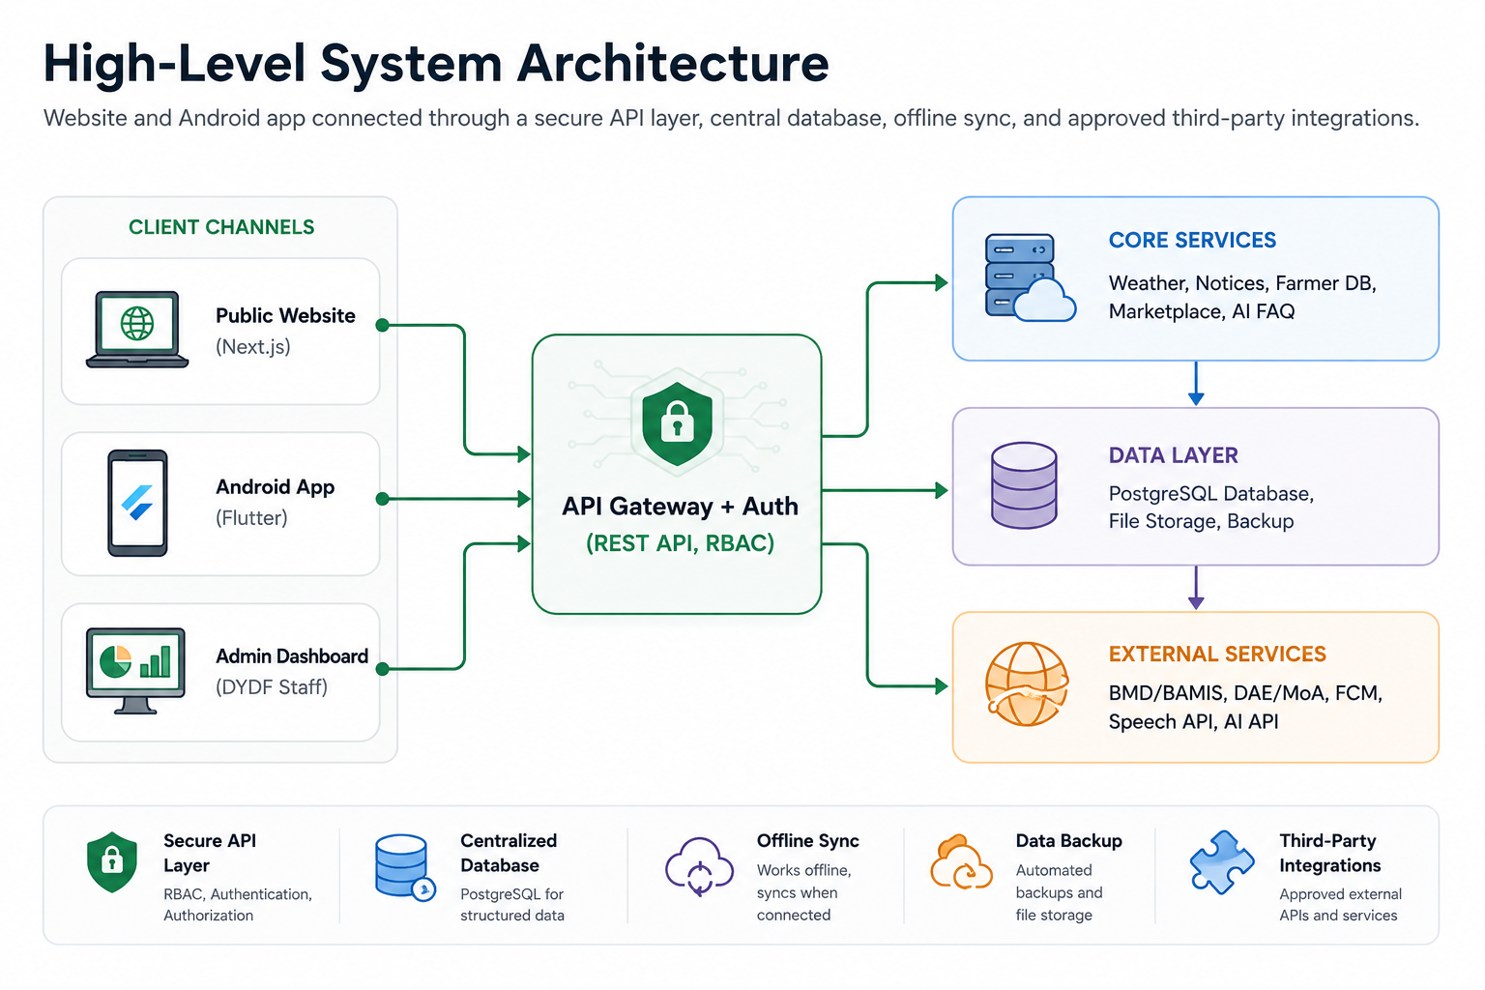
Figure 1: High-Level System Architecture

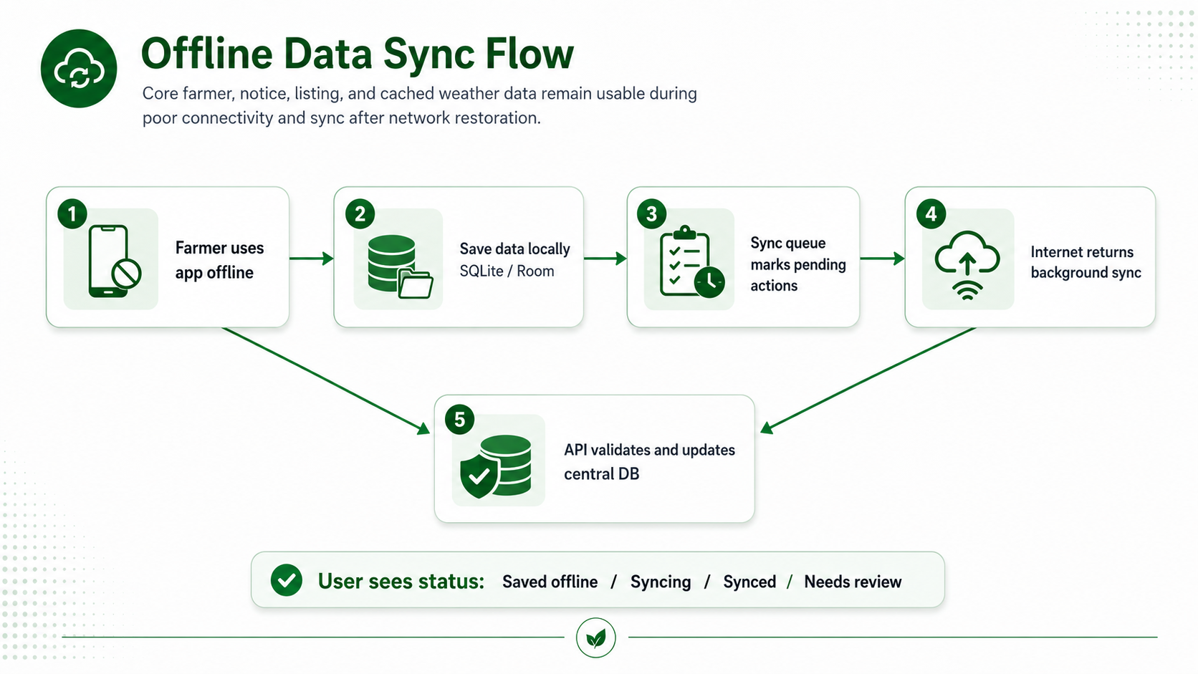
Figure 2: Offline Data Sync Flow
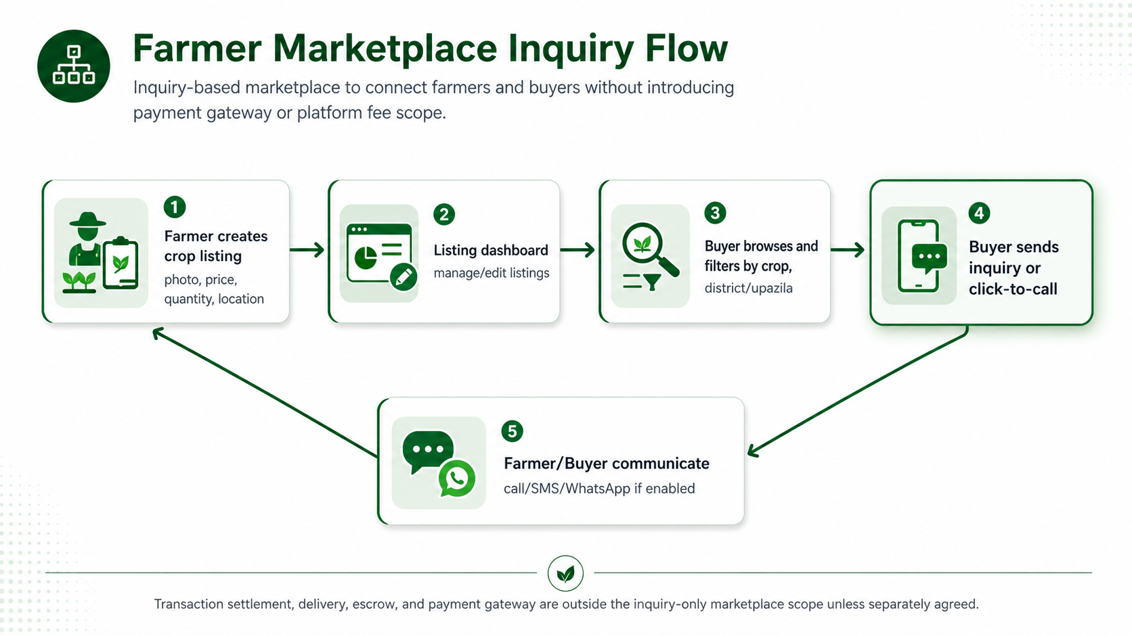
Figure 3: Farmer Marketplace Inquiry Flow

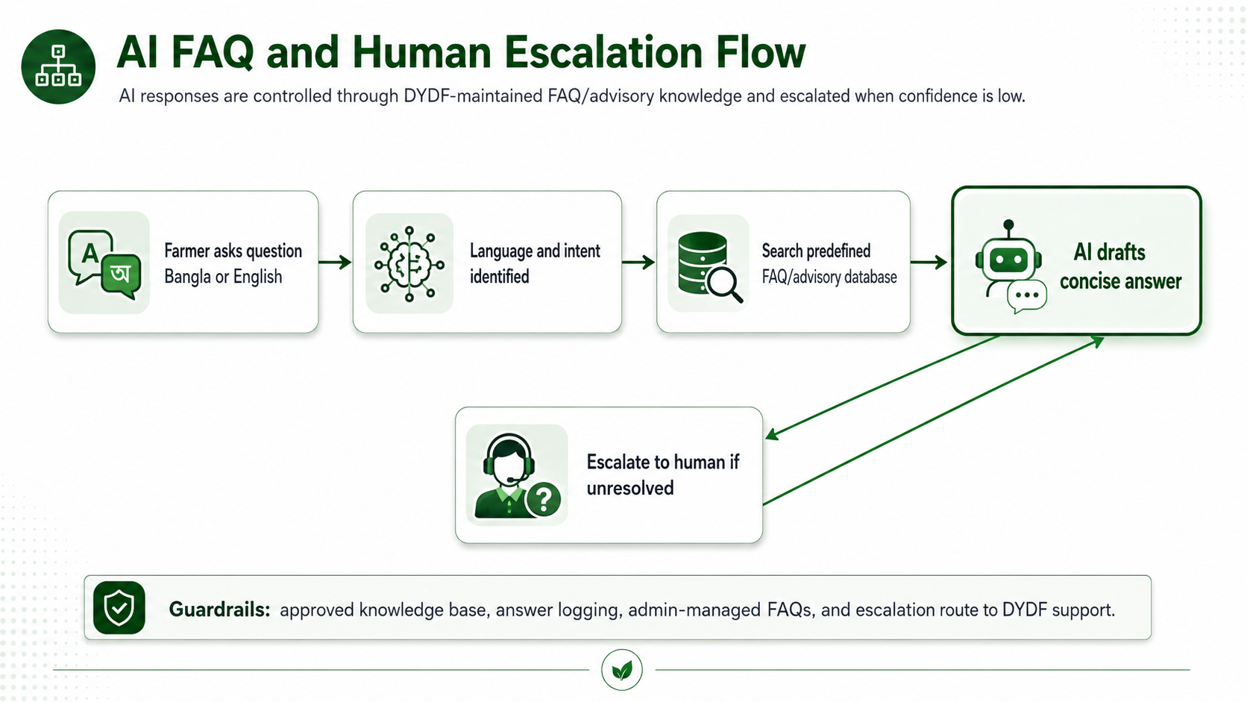
Figure 4: AI FAQ and Human Escalation Flow

6. Proposed Technology Stack
The proposed stack follows the ToR preferences while prioritizing maintainability, low-bandwidth performance, offline mobile capability, security, and future scalability.
Layer | Suggested Technology | Reason / Fit
Public Website | Next.js with React.js | SEO-friendly rendering, responsive UI, fast-loading public pages, bilingual support.
Admin Dashboard | React.js / Next.js Admin UI | Unified admin experience for content, notices, farmer records, listings, FAQ, and role management.
Mobile App | Flutter using Dart, SQLite/Drift or SQLite for local storage | Android-first APK development with offline-first storage, smooth UI performance, reusable codebase, and future flexibility to extend the app to iOS if required.
Optional iOS Path | Flutter using Dart, SQLite/Drift or SQLite for local storage | iOS is preferred in the ToR but should be confirmed as part of final scope and timeline.
Backend | Laravel or Node.js REST API | Secure API, modular services, authentication, role management, integrations, sync endpoints.
Database | PostgreSQL | Reliable relational data model for farmers, listings, notices, users, roles, and audit records.
Mobile Offline Store | SQLite / Room | Local persistence for offline reads and sync queue for pending writes.
File Storage | Cloud Object Storage | Secure storage for listing photos, content assets, and downloadable files.
Push Notifications | Firebase Cloud Messaging | Weather alerts, new notices, and important platform notifications.
Voice Input | Google Speech-to-Text or Android speech services | Bangla voice typing support where technically available.
Text Read-Out | Android Text-to-Speech / accessibility services | Bangla read-out support for farmer-facing content.
AI FAQ | OpenAI API or equivalent approved one LLM API | Controlled FAQ response generation using DYDF-approved knowledge base.
Hosting | AWS, Google Cloud, Azure, or equivalent | Secure SSL hosting, backups, monitoring, and scalable deployment.

7. Development Methodology
A lightweight Agile delivery method is recommended because the project has a short implementation window and requires early validation of bilingual UI, offline mode, integrations, and accessibility features. The methodology will combine sprint-based development with milestone reviews.
Method Step | Activities
1. Inception and Requirement Confirmation | Confirm scope, roles, data fields, API/feed availability, content sources, branding, hosting, and acceptance criteria.
2. UX and Prototype Validation | Prepare bilingual user flows and clickable screens for website, mobile app, and admin dashboard. Validate low-literacy accessibility needs.
3. Modular Development | Develop backend, admin dashboard, website, Android app, offline sync, and integrations in parallel modules.
4. Continuous QA | Run functional, integration, mobile compatibility, offline, performance, security, and bilingual QA throughout the build.
5. UAT Support and Stabilization | Support DYDF review, fix validated issues, optimize performance, and prepare deployment.
6. Deployment and Handover | Deploy website/backend, prepare Android APK/Play Store release, conduct admin training, and submit documentation.

8. Deliverables
Deliverable | Description
Inception Report | Detailed technical plan, confirmed stack, API/integration assumptions, risk/dependency list, and project schedule.
Wireframes / UI Prototype | Bilingual screens and user flows for website, app, and admin dashboard, including accessibility flow demonstration.
Responsive Website | Public-facing bilingual website with relevant content pages and integration points.
Admin Dashboard | DYDF staff dashboard to manage users, farmers, notices, marketplace listings, FAQ content, and basic settings.
Android Mobile App | Android-first mobile application with offline mode, push notifications, voice support, and feature parity with the core platform.
Backend API and Database | REST API, database schema, role-based access, sync endpoints, integrations, and backup configuration.
Core Modules | Weather alert, government notices, farmer database, marketplace, contact/calling, voice input/read-out, and AI FAQ modules.
Testing Artifacts | Test cases, bug log, QA summary, security/performance checklist, and UAT support notes.
Deployment Package | Live website/backend deployment, SSL configuration, Android APK/Play Store submission support, and environment setup notes.
Training and Documentation | Admin/user guide, technical handover document, deployment notes, and 2-day admin training support.

9. Testing and Quality Assurance
The QA plan will focus on validating the functional requirements in the ToR and reducing operational risk before final deployment. The following test categories are recommended.
QA Area | Testing Focus
Requirement Traceability Testing | Validate every functional module against the agreed scope and acceptance criteria.
Functional Testing | Test registration, login, role access, notices, weather, farmer profiles, marketplace listing, inquiry, call/contact, FAQ, and admin workflows.
Bilingual Testing | Verify English and Bangla labels, content rendering, language switching, date/number formatting, and text overflow.
Offline and Sync Testing | Test cached weather/notices, local farmer data, pending marketplace actions, sync restoration, and conflict handling.
Mobile Compatibility Testing | Test Android 8.0+ and selected low-end devices/emulators for app performance and storage footprint.
Voice and Accessibility Testing | Test Bangla voice input, read-out behavior, font size, contrast, touch target usability, and farmer-friendly interaction flows.
Integration Testing | Test weather/notice data source, FCM push notifications, AI FAQ API, speech services, and optional SMS/WhatsApp if enabled.
Security Testing | Check authentication, RBAC, input validation, file upload restrictions, session handling, SQL injection/XSS protection, and HTTPS enforcement.
Performance Testing | Validate page loading targets, API response time, app responsiveness, image optimization, and 3G-like network conditions.
Regression and UAT Support | Fix validated issues from internal QA and DYDF feedback before final deployment.

10. Implementation Timeline
Proposed Implementation timeline:

11. Security, Performance and Accessibility Considerations

11.1 Security Controls
Control | Implementation Direction
HTTPS/SSL | All web, API, and admin endpoints will enforce HTTPS.
Role-Based Access Control | Separate permissions for Super Admin, District Admin, Farmer, Buyer, and verified access groups where applicable.
Data Privacy | Consent-aware data collection and clear handling of farmer profile information.
Input Validation | Server-side validation, file upload restrictions, and protection against common injection and XSS attacks.
Backups | Automated daily backup mechanism and recovery plan.
Audit Trail | Basic logs for critical admin actions such as record changes, notice publishing, and listing management.

11.2 Performance Targets
Target Area | Approach
Web Load Time | Target under 3 seconds on 3G-like connection for optimized public pages, subject to hosting and content weight.
Mobile App Size | Target lightweight Android APK with optimized assets and minimal dependencies.
Concurrent Users | Scalable backend deployment designed to support growth toward 10,000 concurrent users through cloud scaling, caching, and optimized APIs.
Low Data Usage | Image compression, API pagination, cached content, and minimal payload design.
Offline Activation | Automatic offline behavior when connectivity drops, with visible sync status for users.

11.3 Accessibility and Low-Literacy Support
Accessibility Area | Implementation Direction
Simple Navigation | Clear menu labels, limited steps, and farmer-friendly workflows.
Readable Interface | Large text, proper contrast, localized labels, and responsive layouts.
Voice Typing | Bangla speech input for farmer-facing forms where supported by device/API.
Read-Out | Bangla read-out for key content such as notices, advisories, weather, and FAQ responses.
Error Guidance | Plain-language validation messages in both Bangla and English.

12. Assumptions, Dependencies and Scope Controls
Area | Assumption / Dependency
Content and Branding | DYDF will provide approved logo, color preference, content, notices/advisories format, privacy text, and Bangla/English content validation.
API and Data Access | Access to official weather/government notice API/feed/data source will be provided or approved by DYDF. If unavailable, admin-managed content publishing will be used as fallback.
Third-Party Credentials | FCM, speech API, AI API, SMS/WhatsApp, hosting, domain, SSL, and store account credentials will be provided or commercially approved.
Farmer Data | Any existing farmer database for import will be provided in a clean CSV/Excel structure with required consent clearance.
Review Availability | DYDF stakeholders will provide timely feedback during prototype review, beta review, and UAT support.
Device Compatibility | The primary target is Android 8.0+ low-end smartphones. iOS implementation/release will be confirmed separately if required.
Change Control | New features beyond the ToR will require separate review, timeline impact assessment, and approval.

13. Handover and Training
The final handover will ensure that DYDF can operate the platform after deployment. The handover package will include environment details, admin credentials handover process, technical documentation, user guide, and training for key administrative users.
Handover Item | Description
Admin Training | 2-day admin training covering content, notices, farmer records, marketplace listings, FAQ management, and user role handling.
Technical Handover | Source code repository, environment variables guide, deployment steps, backup process, and third-party integration configuration.
Operational Guide | Step-by-step guide for regular admin operations and escalation process for support issues.
Post-Deployment Support Window | Issue monitoring and bug-fix support during the agreed stabilization period, subject to final commercial arrangement.

14. Conclusion
The proposed Smart Agriculture platform will provide DYDF with a practical, bilingual, and farmer-friendly digital solution to support the Krishi Samridhi Project. By combining a responsive website, Android-first mobile app, secure admin dashboard, farmer database, marketplace inquiry system, weather/notice access, voice accessibility, AI FAQ, and offline synchronization, the platform can improve farmers' access to information and market opportunities while remaining aligned with rural connectivity realities.
The proposed scope is intentionally controlled and directly aligned with the ToR to avoid unnecessary development cost. Final technology selection, integration method, and deployment environment should be confirmed during the inception phase before full-scale development begins.

