Technical Proposal
Enhanced AI-Powered Applicant Tracking System (ATS)
with Intelligent CV Screening
Prepared for: Square Toiletries Limited
Prepared by: Riseup Labs


Table of Contents
1. Executive Summary 4
2. Understanding of the Requirement 4
Key Business Objectives 4
Requirement Sources Used 4
3. Enhanced Proposal Positioning 5
Scope Positioning 5
4. Scope of Work and Feature List 6
4.1 User Management & Security 6
4.2. CV Upload & Parsing 6
4.3. AI Screening & Matching 6
4.4. Candidate Database & History Tracking 6
4.5. Export & Reporting 6
4.6. Integration & Workflow 7
4.7. AI Governance & Accuracy 7
5. Proposed Features 8
7. Proposed Technical Approach 9
Approach Principles 9
AI and OCR Processing Approach 10
8. Technical Architecture 11
Architecture Components 12
9. Data and AI Processing Architecture 12
Data Flow 12
AI Governance Data Captured 13
10. Proposed Technology Stack 14
Deployment Options 15
11. Security, Privacy and AI Governance 15
Security Controls 15
Privacy and Candidate Data Controls 15
AI Governance Controls 15
12. Testing and Quality Assurance 16
AI Accuracy Validation Plan 16
13. Development Methodology 17
Methodology Steps 17
14. Deliverables 17
15. Assumptions and Dependencies 18
16. Conclusion 18

1. Executive Summary
Square Toiletries Limited requires a comprehensive AI-Powered Applicant Tracking System (ATS) with intelligent CV screening capability. Based on the provided user specification and summary, the platform must support CV upload and parsing, AI-based candidate matching, candidate database management, recruitment workflow, reporting, communication and explainable human-reviewed hiring decisions.
This updated version of the technical proposal keeps the original ATS/CV screening requirements and updates the enhanced scope based on the attached feature list. The enhanced modules cover job requisition approval, job posting and career page management, recruitment pipeline/Kanban board, hiring manager review, interview scorecards, recruitment analytics, consent and data retention management, notification template management, advanced Boolean search, candidate comparison and duplicate master candidate profile management.
The proposed solution is designed as a secure web-based platform with separate layers for user access, recruitment workflow, AI processing, document parsing, notification services, reporting, audit logging and data storage. HR will remain in control of all final decisions through explainable AI scoring, manual override, review workflow and complete decision history.

2. Understanding of the Requirement
The requirement is not limited to a standalone CV parser. The system is expected to operate as a complete recruitment platform where departments, HR users and hiring managers can work in a single-controlled environment.

Key Business Objectives
- Reduce manual effort in large-volume CV collection, parsing, screening and shortlisting.
- Enable structured recruitment from requisition approval through candidate review, interview evaluation, final selection and talent pool management.
- Improve screening and hiring consistency through structured criteria, interview scorecards and candidate comparison.
- Create a reusable candidate database with search, duplicate detection, tagging and application history.
- Improve collaboration between HR and hiring managers through review portal, comments and scorecards.
- Provide transparent, auditable AI-assisted decisions with human review before rejection or final decision.
- Generate recruitment dashboards, reports and Excel outputs for HR and management decision-making.

Requirement Sources Used
Source Document | Relevant Scope Area | How It Is Reflected in This Proposal
User Specification 16.06.2026 | User management, CV upload, parsing, AI screening, database, reporting, integration, governance and operational questions | Included as the base functional and non-functional scope.
Summary | Positioning of the product as an AI-powered ATS rather than a simple CV parser | Used to shape the overall solution architecture and workflow.
Attached Feature List Image | Proposed ATS lifecycle, collaboration, analytics, consent, search and duplicate management features | Used to update the enhanced proposal scope without adding unrelated features.

3. Enhanced Proposal Positioning
The enhanced version converts the solution from a CV screening-focused platform into a practical recruitment lifecycle platform. The system will still prioritize the critical requirement of processing large batches of CVs and producing AI-assisted screening results, while adding the specific workflow and management features shown in the attached feature list.

Scope Positioning
Layer | Existing Requirement Coverage | Enhanced Feature Coverage
Recruitment Start | Position-wise criteria and templates | Job requisition, approval workflow, job posting and career page links
Application Collection | Bulk CV upload, email/job portal import, duplicate detection | Career page intake, shareable job links and deadline-based applicant collection
Screening | CV parsing, AI score, red flags, skill gap and shortlist threshold | Advanced Boolean search and saved filters to improve talent database reuse
Review & Decision | HR manual override and interview panel summary | Pipeline/Kanban board, hiring manager portal, interview scorecards and comparison view
Data & Reporting | Candidate database, Excel export and reports | Recruitment analytics, advanced Boolean search, master profile merge and data retention controls
Communication | Email/SMS notifications and interview scheduling support | Template management for shortlist, interview, rejection, reminder and status updates

Figure 1: Enhanced ATS module map combining original requirements and proposed extra features.

4. Scope of Work and Feature List
The following scope consolidates the existing requirements and the attached feature list into implementation-friendly modules.

4.1 User Management & Security
- Admin/user ID and password management.
- Role-based access control for Admin, HR, Hiring Manager and Viewer roles.
- User activation/deactivation and access control per module.
- Basic audit trail for important actions such as upload, scoring, override, export and shortlist changes.

4.2. CV Upload & Parsing
- Drag-and-drop CV upload from web interface.
- Bulk upload capability for minimum 5,000 CVs per batch through queued background processing.
- Support for readable PDF, Word, scanned CV copies and JPG/PNG images.
- CV file validation and processing status tracking.
- Duplicate CV detection within current upload batch.
- Duplicate candidate identification against previous candidate database.
- Email inbox import and job portal import capability subject to available access/API.

4.3. AI Screening & Matching
- Position-wise screening templates/prompts.
- Customizable screening criteria: age, gender, education, years of experience, specific position, skills, location, certifications and other agreed structured fields.
- Multiple filtering combinations across structured criteria.
- Criteria weight configuration for different positions.
- Include and exclude keyword filtering.
- AI matching score generation in percentage format.
- Auto shortlisting based on configurable score threshold.
- Auto movement of shortlisted CVs into a separate shortlist folder/list.
- Red flag indicators for career break, frequent job change, missing information, overqualification, underqualification and skill gap analysis.

4.4. Candidate Database & History Tracking
- Centralized candidate profile creation from parsed CV data.
- Candidate application history tracking.
- Display of last application date, previously applied position and previous shortlist status.
- Candidate tagging and bookmarking.
- Talent pool/database creation for future hiring.

4.5. Export & Reporting
- Bulk CV download for filtered or shortlisted candidates.
- Customizable Excel export fields including name, contact number, email, home district, education and experience.
- Final candidate summary generation in predefined Excel format.
- Downloadable screening reports.
- Interview panel summary generation.

4.6. Integration & Workflow
- Automated email notification capability.
- Automated SMS notification capability using an agreed SMS gateway.
- Interview scheduling support for selected candidates.
- Notification and schedule status tracking.

4.7. AI Governance & Accuracy
- Explainability of AI scoring and decision support.
- Manual override by HR with reason capture.
- Weighted scoring suggestion for CV screening templates.
- Accuracy benchmark/validation report during testing.
- Controlled retraining/customization based on company hiring patterns and validated HR feedback.
- Human review before final rejection.

5. Proposed Features
The proposed features from the attached table are organized below based on business value, implementation priority and implementation scope.
Proposed Feature | What It Includes | Business Value | Recommended Priority
Job Requisition & Approval Workflow | Department can request hiring, define vacancy count, hiring reason and approval status before recruitment starts. | Make the ATS useful from the beginning of the hiring process. | High
Job Posting & Career Page Management | Create job circulars, publish on company career page, set deadlines and generate shareable application links. | Reduces manual CV collection and creates a complete applicant intake channel. | High
Recruitment Pipeline / Kanban Board | Visual stages such as Applied, Parsed, AI Screened, Shortlisted, HR Review, Interview Scheduled, Selected, Rejected and Talent Pool. | Improves visibility and faster day-to-day recruitment management. | High
Hiring Manager Review Portal | Hiring managers can view shortlisted candidates, CVs, AI summaries, comments and approve/reject candidates. | Improves HR and department collaboration without giving full admin access. | High
Interview Evaluation Scorecard | Structured interview ratings, comments, recommendations and comparison with AI score. | Keeps interview feedback organized and reduces scattered Excel/email decisions. | High
Recruitment Analytics Dashboard | Total jobs, applicants, shortlisted candidates, interviews, selection ratio, time-to-shortlist, time-to-hire and source performance. | Make recruitment performance measurable for HR and management. | High
Consent & Data Retention Management | Candidate consent, retention period configuration, archive/delete rules and data policy settings. | Improves privacy readiness and database cleanliness. | High
Notification Template Management | Editable email/SMS templates for shortlist, interview invitation, rejection, reminder and status updates. | Reduces repetitive communication and keeps messages consistent. | Medium
Advanced Search & Boolean Search | Search by keyword, skill, education, experience, location, organization, AND/OR/NOT logic and saved filters. | Makes the talent database reusable for future hiring. | High
Candidate Comparison View | Compare 2 to 5 candidates by education, experience, skills, AI score and interview score. | Supports faster decision-making for HR and hiring managers. | Medium
Duplicate Merge & Master Candidate Profile | Merge duplicate records and keep all application history under one master profile. | Prevents duplicate shortlisting and improves candidate history accuracy. | High

7. Proposed Technical Approach
The proposed technical approach is modular, secure and scalable. Recruitment workflow and user-facing features will run through the ATS web application, while heavy CV parsing, OCR, AI analysis and bulk processing will run as asynchronous background services. This prevents large upload batches from slowing down normal HR operations.

Approach Principles
- Modular ATS architecture: separate modules for requisition, jobs, candidates, screening, pipeline, interviews, reporting and administration.
- Asynchronous processing: bulk uploads and AI screening will use queues/workers to handle high-volume CV processing reliably.
- Human-in-the-loop AI: AI recommendations will support HR, not replace HR decision-making.
- Explainability by design: every AI score will show matched criteria, missing data, skill gaps and red flags.
- Governance by default: criteria changes, AI outputs, overrides, candidate movements and final decisions will be logged.
- Flexible deployment: cloud or on-premises deployment can be finalized based on STL infrastructure and security preference.
- Integration-ready design: email, SMS, career page, job portal and internal SSO/API integrations can be connected through configurable integration services.

AI and OCR Processing Approach
- Document ingestion will identify file type, quality, language and duplicate status before processing.
- OCR and document extraction will handle scanned/image-based CVs, while digital PDF/Word CVs will be parsed through text extraction and layout-aware parsing.
- Bangla and English mixed CV handling will be supported through multilingual extraction, normalization and field mapping.
- The matching engine will combine rule-based filters, weighted criteria and AI summarization to generate a consistent screening output.
- AI output will be stored with criteria version, model/prompt version, score explanation and HR review status.
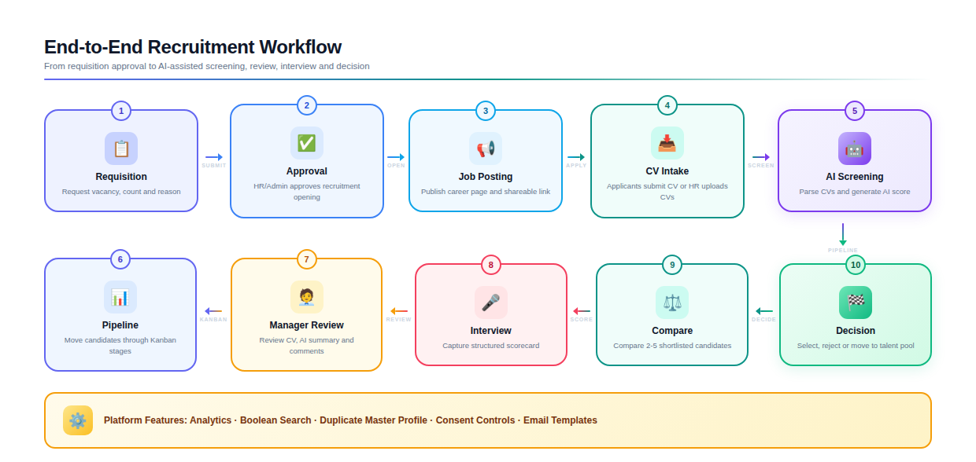
Figure 1: End-to-end recruitment workflow for the enhanced ATS.

8. Technical Architecture
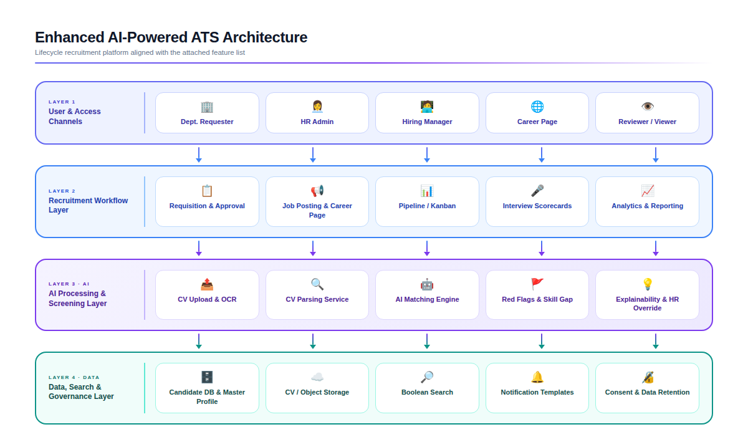
Figure 2: Enhanced AI-powered ATS technical architecture.

Architecture Components
Layer | Main Components | Purpose
Presentation Layer | Admin web portal, HR portal, Hiring Manager portal, Career page | Provides role-specific access to recruitment workflows and applicant intake.
Backend Application Layer | REST/GraphQL API, workflow service, RBAC, requisition/job module, pipeline service, scorecard service | Manages business logic, workflows, permissions and integrations.
AI Processing Layer | OCR, parsing service, scoring engine, red flag detector, skill gap analyzer, explanation service | Extracts CV data and produces structured AI-assisted screening results.
Data Layer | Relational database, object storage, search index/vector index, audit log store | Stores structured data, CV files, searchable candidate profiles and audit history.
Integration Layer | Email, SMS, job portal/career page, SSO/API gateway | Connects external communication and applicant sources.
Governance Layer | Consent records, data retention policy, audit trail, validation reports | Supports privacy readiness, decision traceability and controlled candidate record lifecycle.

9. Data and AI Processing Architecture
The platform will store both structured and unstructured recruitment data. Structured data includes candidate fields, career page application data, consent records, screening criteria, scores, pipeline stages and interview scorecards. Unstructured data includes CV files, parsed text, AI summaries and supporting notes.

Data Flow
1. Candidate applies through the career page/shareable job link, or HR uploads CVs manually or from connected source.
2. System validates file type, size and duplicate indicators.
3. Document is queued for OCR/parsing and uploaded to secure object storage.
4. Parser extracts candidate details, education, experience, skills, certifications, location and other agreed fields.
5. Screening engine applies the active criteria version and generates score, AI summary, red flags and skill gap output.
6. HR reviews AI results, applies manual override if needed and moves candidates through the pipeline.
7. Hiring manager reviews shortlisted candidates and adds decision/comments through restricted portal.
8. Interview scorecards, final decision and candidate status are logged for reporting and future history.
9. Retention rules archive or delete candidate records based on policy and consent status.

AI Governance Data Captured
Data Captured | Reason | Example
Criteria version | Allows traceability when rules change | Position template v1.2, threshold 75%, skill weights
AI score explanation | Helps HR understand why a candidate was ranked | Matched 7/10 skills, 4 years experience, missing certification
Human override note | Ensures final decision accountability | HR moved candidate to shortlist due to relevant FMCG experience
Candidate movement history | Supports audit and collaboration | Applied > AI Screened > HR Review > Interview Scheduled
Retention status | Controls privacy and database cleanliness | Consent captured, retain for 24 months, archive after expiry
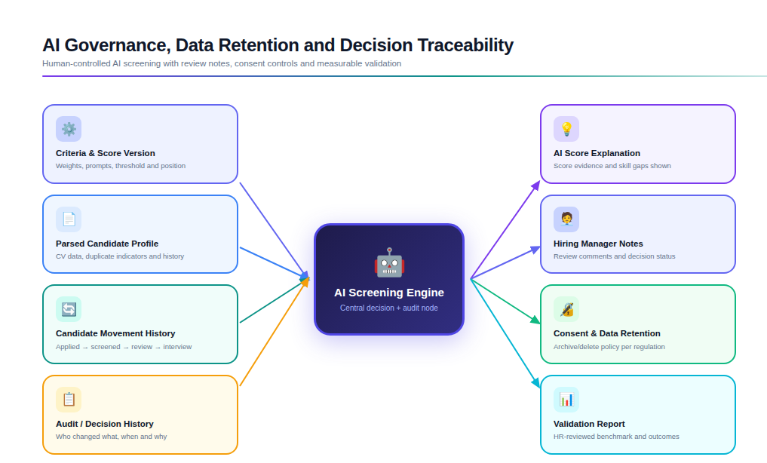
Figure 3: AI governance, version control and auditability model.

10. Proposed Technology Stack
The final stack can be confirmed after infrastructure preference, integration availability and security requirements are finalized. The following stack is recommended for a scalable enterprise ATS with AI screening capability.
Area | Recommended Technology | Purpose / Notes
Frontend | React.js with TypeScript | Responsive admin portal, HR portal, hiring manager portal and career page.
Backend API | Laravel REST API | Workflow logic, RBAC, recruitment modules, integrations and business rules.
AI / ML Service | Python FastAPI, NLP libraries, OCR pipeline, LLM API or private model option | CV parsing, AI matching, scoring explanation, summarization and red flag analysis.
Database | PostgreSQL | Structured recruitment data, users, jobs, candidates, criteria, pipeline and reports.
Search | Elasticsearch/OpenSearch or PostgreSQL full-text search with pgvector option | Advanced search, Boolean search, saved filters and future semantic matching.
File Storage | S3-compatible object storage or on-premises file storage | Secure storage of CVs, generated reports and attachments.
Queue & Workers | Redis/RabbitMQ/Celery/BullMQ | Background processing for 5,000-CV batch uploads, OCR and AI screening.
Notification | SMTP/Email service, SMS gateway integration | Shortlist, interview, rejection, reminder and status update notifications.
Authentication | JWT/OAuth2, optional SSO/SAML/LDAP integration | Secure login, session management and enterprise identity readiness.
Reporting | Backend report engine, Excel export library, dashboard charts | Screening reports, interview summaries, analytics dashboard and export files.
DevOps | Docker, CI/CD pipeline, Nginx, Git-based deployment | Reliable deployment, version control and controlled release process.
Monitoring & Logging | Application logs, error monitoring, audit logs, performance monitoring | Operational visibility, issue tracing and compliance support.

Deployment Options
Option | Suitable When | Key Notes
Cloud Deployment | STL prefers fast provisioning, elasticity and managed services | Can use managed database, object storage, queue and AI services with proper security controls.
On-Premises Deployment | STL requires internal hosting and direct infrastructure control | Requires server sizing, GPU/CPU planning if local AI is needed, backup and operations support.
Hybrid Deployment | STL wants internal ATS data but selected AI/OCR services from cloud | Needs careful data security, network access control and data transfer policy.

11. Security, Privacy and AI Governance
The system will process sensitive candidate data, so security, privacy and AI governance must be treated as core design requirements. The architecture will follow secure application development practices and AI governance references such as NIST AI RMF, ISO/IEC 42001 and OWASP application/LLM security guidance.

Security Controls
- Role-based access control by module, job, candidate record and workflow stage.
- Password policy, secure sessions and optional two-factor authentication/SSO depending on STL preference.
- Encryption in transit using HTTPS/TLS and encryption at rest for sensitive files and database fields where required.
- Secure file upload validation for file type, size, malware scan integration and restricted storage access.
- Audit logging for login, upload, export, scoring, criteria change, override, deletion and candidate status movement.
- Data backup, restore process and environment separation between development, staging and production.
- Security testing aligned with OWASP ASVS/Top 10 practices for access control, injection, misconfiguration, authentication and logging risks.

Privacy and Candidate Data Controls
- Candidate consent capture through the application form or manual upload declaration.
- Configurable candidate data retention period and archive/delete workflow.
- Controlled export permissions to reduce unnecessary data download.
- Data minimization in reports, dashboards and user roles where full CV data is not required.
- Masking or restricted visibility for sensitive fields based on role and policy.
- Clear audit trail for candidate deletion, archive and retention changes.

AI Governance Controls
- AI screening will provide score explanations rather than only a numeric score.
- Screening criteria and weights will be versioned and traceable.
- HR users can override AI recommendations with reason notes.
- AI validation benchmark will be prepared using sample CVs and HR-reviewed expected outcomes.
- Human review will be required before final rejection or final hiring decision.
- Sensitive criteria such as age or gender should be configurable only under approved HR policy and applicable legal review.
- Model/prompt updates and retraining/customization rules will be controlled through admin approval and audit logging.

12. Testing and Quality Assurance
Testing will cover functional correctness, AI output reliability, security, performance, usability and integration readiness. Because the system includes AI-assisted decision-making, QA will include both software testing and validation of AI screening outputs against HR-reviewed sample data.
Testing Area | What Will Be Tested | Expected Outcome
Functional Testing | User roles, requisition workflow, job posting, career page links, upload, parsing, screening, pipeline, scorecards, reports and notifications | All agreed modules work as per approved scope.
CV Parsing QA | PDF, Word, scanned copy, JPG/PNG, Bangla-English mixed CVs and duplicate detection | Parsing fields are extracted with acceptable accuracy and error handling.
AI Screening Validation | Criteria, weights, score threshold, red flags, skill gaps, explanations and re-screening | AI outputs are consistent, explainable and reviewable by HR.
Performance Testing | Bulk upload and processing for 5,000 CVs, queue behavior, dashboard loading and search response | System handles expected volume without blocking normal use.
Security Testing | Authentication, authorization, file upload, injection risks, access control, export permissions and audit logs | Sensitive candidate data is protected and unauthorized access is prevented.
Integration Testing | Email/SMS gateway, career page, mailbox/job portal import and scheduling flow where applicable | External communication and intake flows work reliably.
Usability Testing | HR user flow, hiring manager review portal, pipeline movement, scorecard entry and candidate comparison view | Users can complete common tasks with minimal training.
Regression Testing | Existing features after new feature changes and bug fixes | New releases do not break approved functionality.
Deployment Verification | Production configuration, database migration, backups, environment variables and service health | System is ready for controlled go-live.

AI Accuracy Validation Plan
- Prepare a representative sample set of CVs across different positions, formats and languages.
- Define HR-approved expected extraction fields and screening outcomes for validation.
- Measure extraction accuracy for key fields such as name, contact, education, experience, skills and location.
- Compare AI shortlist recommendations against HR-reviewed benchmark decisions.
- Document mismatch cases and refine prompts, criteria weights, extraction rules or templates before production rollout.
- Provide a validation summary report before go-live.

13. Development Methodology
The project will follow an Agile delivery approach with structured discovery, sprint-based development and iterative review. This approach is suitable because the platform includes multiple workflows, AI validation and user role-specific screens that benefit from early stakeholder feedback.

Methodology Steps
1. Discovery and requirement validation with HR, recruitment stakeholders and IT/security representatives.
2. Workflow mapping, data field finalization, user role definition and criteria template design.
3. UI/UX wireframe preparation for HR portal, hiring manager portal, career page, pipeline, scorecards and dashboards.
4. Architecture setup, database schema design and integration planning.
5. Sprint-based module development with demo at the end of each sprint.
6. AI/OCR pipeline implementation and validation using representative CV samples.
7. System integration, QA, security review and performance testing.
8. Deployment, training, documentation and handover.

14. Deliverables
- Finalized technical specification and implementation backlog.
- UI/UX wireframes and approved screen designs for HR, admin, hiring manager and career page flows.
- ATS web application with user management, roles and permission control.
- Job requisition, approval workflow, job posting and career page management modules.
- Career page management, job circular publishing, shareable application links and applicant intake workflow.
- Bulk CV upload, OCR, parsing, duplicate detection, queue and error handling module.
- AI screening engine with criteria templates, weighted scoring, red flags, skill gap analysis and explanation output.
- Candidate database, master profile, application history, tagging/bookmarking and talent pool.
- Recruitment pipeline/Kanban board and hiring manager review portal.
- Interview evaluation scorecards and candidate comparison view.
- Recruitment analytics dashboard, downloadable reports and customizable Excel exports.
- Notification template management and email/SMS integration where gateway access is available.
- AI audit trail, screening version control, data retention and consent management controls.
- Security controls, audit logs and deployment configuration.
- QA report, AI validation report and performance testing summary.
- Deployment package, user manual, admin guide and training/handover session.

15. Assumptions and Dependencies
- STL will provide final recruitment workflow rules, approval hierarchy and user role definitions.
- STL will provide sample CVs, expected output formats, existing Excel templates and interview panel summary format.
- STL will confirm whether deployment will be cloud, on-premises or hybrid.
- STL will provide email/SMS gateway access and job portal/API/mailbox access where integration is required.
- OCR accuracy depends on scan quality, image resolution, document layout and language mix.
- AI scoring accuracy depends on quality of screening criteria, training/validation samples and HR feedback during validation.
- Use of sensitive screening criteria will require client-side policy approval and legal/compliance review.
- Offer management and assessment/test module are treated as optional advanced modules unless confirmed as part of the final implementation scope.
- Final server/storage sizing will be confirmed after expected CV volume, retention period, concurrent users and deployment model are finalized.

16. Conclusion
The proposed enhanced AI-Powered ATS will help Square Toiletries Limited manage recruitment from requisition to hiring decision through a unified, secure and data-driven platform. By combining existing CV parsing and AI screening requirements with additional workflow, collaboration, audit, analytics and data management features, the system will reduce manual effort and improve recruitment transparency without removing HR control from final decisions.
The enhanced proposal is designed to be practical, scalable and implementation-ready. It allows STL to start with the high-priority recruitment lifecycle features identified in the attached feature list and activate optional advanced modules after final scope confirmation.

