Technical Proposal
Suzuki Bangladesh Website Frontend UI/UX Revamp

1. Executive Summary
Suzuki Bangladesh requires a refreshed and modern website frontend that improves user experience, responsiveness, content discoverability, SEO readiness, and engagement while retaining the existing backend and page-level content structure. The proposed solution is a frontend UI/UX revamp using Next.js and Tailwind CSS, integrated with the existing backend APIs/data sources and developed with a reusable component-based architecture.
The proposal is intentionally scoped to avoid unnecessary cost expansion. It retains existing page components, allows rearrangement or regrouping for better user experience, and introduces only controlled value-added enhancements such as improved bike discovery, clearer service journeys, better CTA visibility, SEO/SMO metadata support, responsive reusable UI components, and improved content hierarchy.

2. Understanding of Current Website and Requirements

2.1 Current Website Review Summary
The current Suzuki Bangladesh website includes core navigation areas such as Bikes, Service, Shop, Dealer Locator, Offers, Life at Suzuki, Contact, and Login.
Key observations from the current website review are:
- The Bikes section includes product listing, filtering/sorting options, bike images, starting prices, color availability, and bike detail entry points.
- The Services section includes service packages, package prices, service checkpoints, book service CTA, dealer locator connection, and quick links to maintenance, warranty, service policy, free/paid service checkpoints, and pre-ride check pages.
- The Dealer Locator allows users to search by current location, division, and optional district, and separates Sales Point and Service Point discovery.
- The Offers area presents bike-specific promotional prices with offer detail entry points.
- The footer contains hotline, social links, sitemap, about, contact, dealer, services, and policy pages, including warranty, privacy, sales/refunds, service, shipping, payment, legal, and terms pages.

2.2 Client Requirement Interpretation
Requirement Area | Proposal Response
Existing website review | Review current frontend structure, navigation, content sections, CTAs, forms, and responsive behavior before revamp.
Modern UI/UX design | Create a refreshed visual interface aligned with Suzuki brand identity, modern web patterns, and motorcycle browsing behavior.
Next.js and Tailwind CSS frontend | Develop a reusable, responsive frontend using Next.js and Tailwind CSS.
Retain existing page components | Keep current components and content intent, but allow rearrangement, grouping, and new sections/pages where it improves user experience.
Value-added enhancements | Add controlled engagement improvements without introducing heavy backend-dependent functionality.
Responsive UI elements | Ensure sliders, cards, images, grids, forms, navigation, comparison blocks, and CTAs work across desktop, tablet, and mobile.
SEO and SMO optimization | Implement metadata, clean URLs, structured headings, Open Graph/Twitter tags, sitemap/robots support, and share previews.
Existing backend retained | Integrate the new frontend with the current backend. Add fields only if needed for SEO, SMO, or improved frontend display.
Current frontend code provided | Review current frontend code during development to understand component logic, data mapping, and integration points.

3. Proposed Scope of Work

3.1 In Scope
- Frontend UI/UX revamp of the Suzuki Bangladesh website based on the provided sitemap and existing website components.
- New responsive frontend implementation using Next.js and Tailwind CSS.
- Component-based frontend development for headers, navigation, hero sliders, bike cards, offer cards, service package cards, forms, content blocks, footers, and reusable sections.
- Integration with the existing backend and existing data model/API where available.
- Addition of limited new backend fields only where required for SEO, SMO, metadata, image alt text, content ordering, or new frontend display needs.
- SEO and SMO optimization at page and component level.
- Responsive testing across desktop, tablet, and mobile breakpoints.
- Frontend quality assurance, cross-browser testing, performance checks, and deployment support.

3.2 Out of Scope
- Complete backend redevelopment or replacement of the existing backend system.
- Major database redesign beyond minor field additions required for frontend/SEO display.
- New ecommerce engine, new payment gateway development, or major shop backend changes unless already supported by the existing backend.
- Mobile application development.
- Large-scale CRM, ERP, loyalty, chatbot, or third-party marketing automation systems.

4. Proposed Technical Approach

4.1 Approach Overview
The solution will follow a frontend modernization approach where the existing backend remains the source of content, product, service, dealer, offer, and policy data. The new frontend will be developed as a modern Next.js application with Tailwind CSS for responsive styling and a reusable design system. The approach will prioritize performance, mobile usability, SEO, SMO, and maintainability.
Step | Approach Area | Description
Step 1 | Discovery and Website Audit | Review current website, frontend code, sitemap, page templates, content hierarchy, responsive issues, and backend integration points.
Step 2 | UX Restructuring and UI Design | Prepare refreshed layouts while retaining existing page components and content. Improve navigation, CTAs, hierarchy, and mobile journeys.
Step 3 | Component System Development | Develop reusable components for listing cards, hero sliders, forms, filters, comparison blocks, service packages, content blocks, and footer sections.
Step 4 | Frontend Integration | Connect the new frontend with existing backend APIs/data endpoints and add limited fields only if required.
Step 5 | SEO/SMO and Performance Optimization | Configure metadata, social preview, sitemap/robots, image optimization, and performance improvements.
Step 6 | Testing and Deployment Support | Perform QA, browser/device testing, responsive checks, bug fixing, user acceptance support, and deployment assistance.

4.2 Frontend Architecture Principles
- Component-first design to keep pages consistent and easy to maintain.
- Mobile-first responsive layouts for all pages, cards, sliders, images, tables, and forms.
- Data-driven page rendering so the existing backend can continue to manage content and product information.
- Reusable SEO/SMO metadata pattern for static pages, dynamic bike details, offers, and news details.
- Accessible UI patterns such as readable typography, clear contrast, keyboard-friendly controls, descriptive alt text, and properly labeled forms.
- Performance-aware asset handling through optimized images, lazy loading where suitable, and clean frontend bundle structure.

5. Feature List

5.1 Home
Existing/Required Components: Hero banner/slider, featured bikes, brand shop highlights, offers/deals, services CTA, test ride CTA, dealer locator CTA, top news, footer.
Proposed Enhancement: Refreshed responsive hero, improved CTA hierarchy, better card spacing, mobile-first sections, SEO-friendly homepage structure, and improved content grouping.

5.2 Bikes

All Bikes
Existing/Required Components: Bike listing, price, colors, image, filter, sort, and explore bike CTA.
Proposed Enhancement: Improved listing grid, mobile filter drawer, clearer price/color display, optimized product cards, and better category navigation.

Sports
Existing/Required Components: Category-specific bike listing.
Proposed Enhancement: Retain category structure with improved category landing layout and card design.

Commuter
Existing/Required Components: Category-specific bike listing.
Proposed Enhancement: Improved user journey for practical bike discovery with key specs preview if available from the backend.

Scooter
Existing/Required Components: Category-specific bike listing.
Proposed Enhancement: Clear scooter listing layout and category filters based on available backend data.

Bike Detail
Existing/Required Components: Bike image/gallery, price, colors, specifications, features, and related CTAs.
Proposed Enhancement: Modern detail page with image gallery, key specs section, color selector display, compare/test ride/dealer CTAs, SEO metadata, and social sharing readiness.

5.3 Compare Bikes
Existing/Required Components: Bike comparison journey.
Proposed Enhancement: Responsive comparison layout, selected bike cards, specification comparison table, and mobile-friendly stacked comparison view.

5.4 Offers

Offers Listing
Existing/Required Components: Offer slider/listing, bike offer cards, special price, MRP, color availability, and detail CTA.
Proposed Enhancement: Improved offer cards, stronger CTA, responsive layout, and offer validity/terms field if already supported or approved as a minor backend field.

Offer Detail
Existing/Required Components: Offer-specific bike/price details.
Proposed Enhancement: Clear offer detail page with CTA to bike detail, dealer locator, or test ride.

5.5 Services

Service Overview
Existing/Required Components: Service introduction, package CTA, dealer locator CTA, and quick links.
Proposed Enhancement: Modern service landing page with service value proposition and quick access cards.

Service Packages
Existing/Required Components: Executive, Premium, Signature packages and checkpoints.
Proposed Enhancement: Responsive pricing/package cards and comparison-style checkpoint display.

Book a Service
Existing/Required Components: Service booking CTA/form based on existing backend.
Proposed Enhancement: Improved form layout, validation states, clear confirmation flow, and mobile-friendly input design.

Maintenance Schedule
Existing/Required Components: Maintenance schedule content.
Proposed Enhancement: Responsive table/content blocks with clear headings and print-friendly structure if existing content supports it.

Warranty Policy
Existing/Required Components: Warranty information.
Proposed Enhancement: Readable policy layout, anchor navigation for long content, and SEO metadata.

Service Policy
Existing/Required Components: Service policy content.
Proposed Enhancement: Clean policy template, better spacing, and mobile readability.

Free/Paid Service Checkpoints
Existing/Required Components: Checkpoint list/content.
Proposed Enhancement: Structured checkpoint cards/table with mobile-friendly formatting.

Pre-Ride Check
Existing/Required Components: Pre-ride guidance content.
Proposed Enhancement: Step-based checklist layout and user-friendly presentation.

5.6 Dealer Locator
Existing/Required Components: Current location search, division/district search, sales/service point filtering, and dealer result display.
Proposed Enhancement: Improved locator interface, responsive filters, result cards, and map/list display based on existing backend capability.

5.7 Bike Financing
Existing/Required Components: Financing information and CTA.
Proposed Enhancement: Clear financing landing content, eligibility/CTA section, and dealer/contact pathway.

5.8 Book Test Ride
Existing/Required Components: Test ride request form/CTA.
Proposed Enhancement: Improved form UX, bike/dealer selection fields if supported, responsive validation, and confirmation state.

5.9 Shop
Existing/Required Components: Accessories, engine oil, genuine parts, and shop listing/entry points.
Proposed Enhancement: Improved shop category cards and product/category landing presentation without adding a new ecommerce engine.

5.10 Life at Suzuki

News / Events
Existing/Required Components: News/event listing and top news carousel.
Proposed Enhancement: Modern news listing, category/date display, responsive article cards, and SEO-friendly listing.

News Detail
Existing/Required Components: News article content.
Proposed Enhancement: Readable article template with metadata, share image, related news, and social preview tags.

5.11 About
Existing/Required Components: Company profile, history, head office, manufacturing unit, year founded, company type, size, and specialties.
Proposed Enhancement: Modern about page layout with company milestones/fact cards and improved readability.

5.12 Contact
Existing/Required Components: Contact information and inquiry pathway.
Proposed Enhancement: Clear contact sections, hotline visibility, and responsive form if existing backend supports it.

5.13 Login
Existing/Required Components: Existing login access.
Proposed Enhancement: Retain login flow with refreshed frontend styling only. No authentication system rebuild.

5.14 Policy Pages
Existing/Required Components: Warranty, privacy, sales/refunds, service, shipping, payment, legal, and terms pages.
Proposed Enhancement: Reusable policy template, anchor navigation, metadata, and improved mobile readability.

6. Proposed Technical Stack
Layer/Area | Proposed Stack | Purpose
Frontend Framework | Next.js | Modern React-based frontend, routing, page rendering, metadata handling, and performance-ready implementation.
Styling | Tailwind CSS | Utility-first responsive styling, reusable design tokens, and faster UI development.
Language | TypeScript | Type-safe frontend development, improved maintainability, and fewer runtime errors.
UI Components | Custom component library using Tailwind CSS | Reusable headers, footers, cards, forms, buttons, modals, sliders, and content sections.
Animation/Interaction | Lightweight CSS/Tailwind transitions; optional Framer Motion for selected sections | Controlled micro-interactions without heavy performance impact.
API Integration | Existing backend APIs/data endpoints | Retain current backend as content and data source.
Image Handling | Next.js Image component / optimized responsive images | Performance-focused display for bike images, banners, and content media.
SEO/SMO | Next.js Metadata API, dynamic metadata, OG/Twitter tags, sitemap and robots setup | Search and social sharing optimization for pages and dynamic content.
Forms | Existing backend-supported form endpoints with frontend validation | Book service, test ride, contact, or dealer-related forms based on current backend capability.
Version Control | Git | Branch-based development and controlled code review.
Hosting/Deployment | Client-approved existing hosting or compatible Node.js/Next.js hosting environment | Final hosting approach depends on current infrastructure and backend deployment model.
Analytics/Tracking | Existing analytics or Google Analytics/Tag Manager if approved | Basic page engagement and conversion tracking, subject to client approval.

7. Development Methodology
The project will follow an iterative Agile delivery model with structured discovery, design approval, frontend development, integration, QA support. This ensures that the client can review major page templates early while the development team continues controlled implementation across the sitemap.
Phase | Name | Key Activities
Phase 1 | Discovery and Audit | Website review, frontend code review, backend/API understanding, sitemap confirmation, and UI/UX improvement mapping.
Phase 2 | UX/UI Design and Prototype | Wireframe/layout planning, visual direction, component library planning, and responsive design approval.
Phase 3 | Frontend Development | Next.js setup, Tailwind configuration, component development, page implementation, and responsive behavior.
Phase 4 | Backend Integration | Connect frontend with existing backend and add limited fields only where required.
Phase 5 | SEO/SMO and Optimization | Metadata, social preview, sitemap/robots, image optimization, and performance refinement.
Phase 6 | QA and Deployment Support | Testing, bug fixing, QA support, deployment coordination, and handover.

8. Testing and Quality Assurance
Testing Area | Coverage
Functional Testing | Validate all pages, links, CTAs, filters, forms, listings, detail pages, comparison, and navigation flows.
Responsive Testing | Test desktop, laptop, tablet, and mobile breakpoints for sliders, cards, images, menus, forms, and tables.
Cross-Browser Testing | Validate Chrome, Firefox, Edge, and Safari-compatible behavior.
Integration Testing | Verify frontend data binding with existing backend APIs/endpoints and form submissions.
SEO Testing | Check titles, meta descriptions, canonical tags, OG tags, heading hierarchy, sitemap, and robots setup.
SMO Testing | Validate social preview tags and shared image readiness for key pages.
Performance Testing | Run Lighthouse/PageSpeed-oriented checks and optimize major frontend issues.
Accessibility Review | Check color contrast, keyboard navigation, alt text readiness, form labels, and readable typography.
Regression Testing | Confirm existing components and journeys remain available after frontend revamp.
QA Support | Support client review, feedback tracking, issue resolution, and approval closure.

9. Deliverables
ID | Deliverable | Description
D1 | Current Website Review Summary | Findings from the current website review, component inventory, and improvement direction.
D2 | UI/UX Design Direction | Approved refreshed design layouts for major page templates and responsive states.
D3 | Frontend Component Library | Reusable Next.js/Tailwind components for key UI elements and page sections.
D4 | Revamped Frontend Pages | Implemented frontend pages aligned with the sitemap and existing backend content.
D5 | Backend Integration Support | Frontend integration with existing backend APIs/data and limited field additions if required.
D6 | SEO/SMO Implementation | Metadata, OG/Twitter tags, structured headings, image alt support, sitemap/robots setup.
D7 | QA Test Report | Functional, responsive, browser, integration, SEO, SMO, and performance test summary.
D8 | Deployment Support | Deployment coordination and environment handover support.
D9 | Handover Documents | Frontend setup guide, environment configuration notes, and component/page maintenance guidance.

12. Implementation Timeline
Total proposed timeline- 1 month

13. Technical Diagram

Figure 1: Proposed High-Level Frontend Architecture

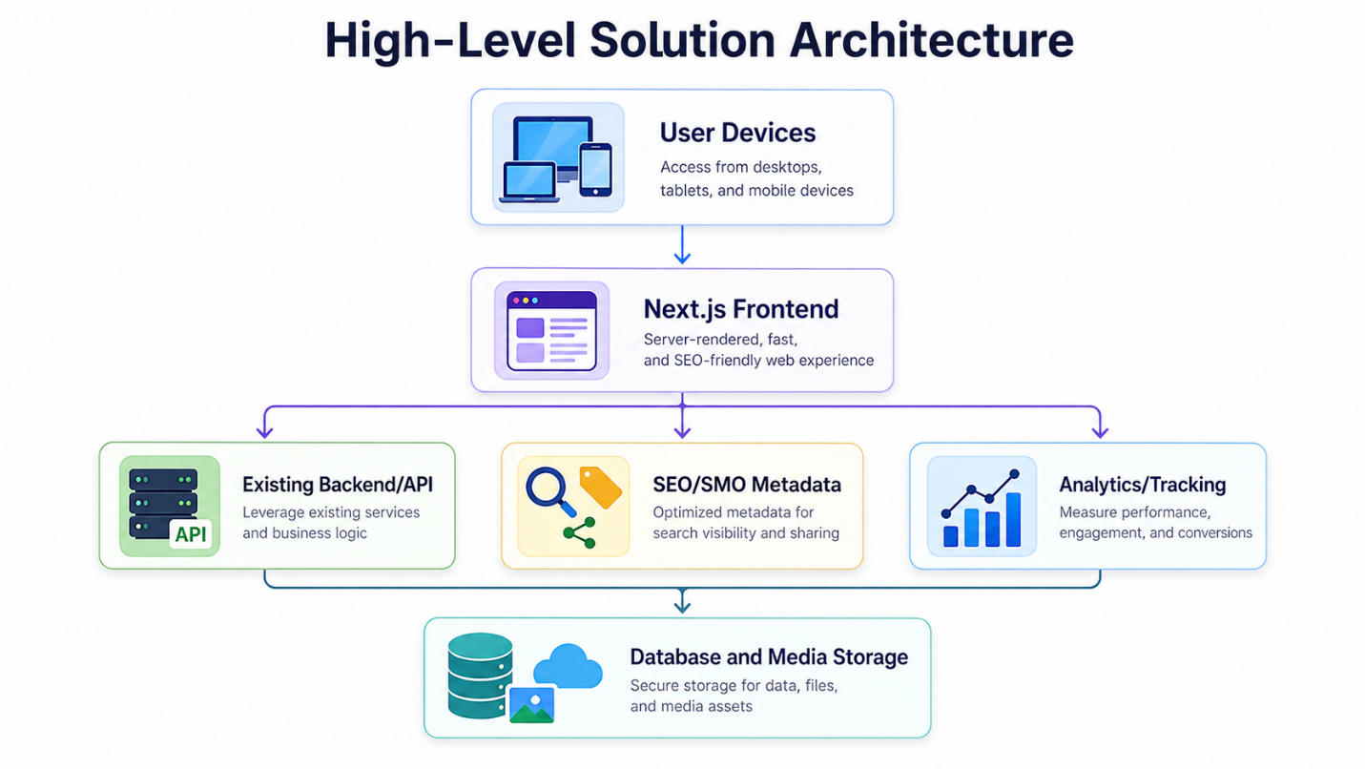

Figure 2: Frontend and Existing Backend Integration Flow

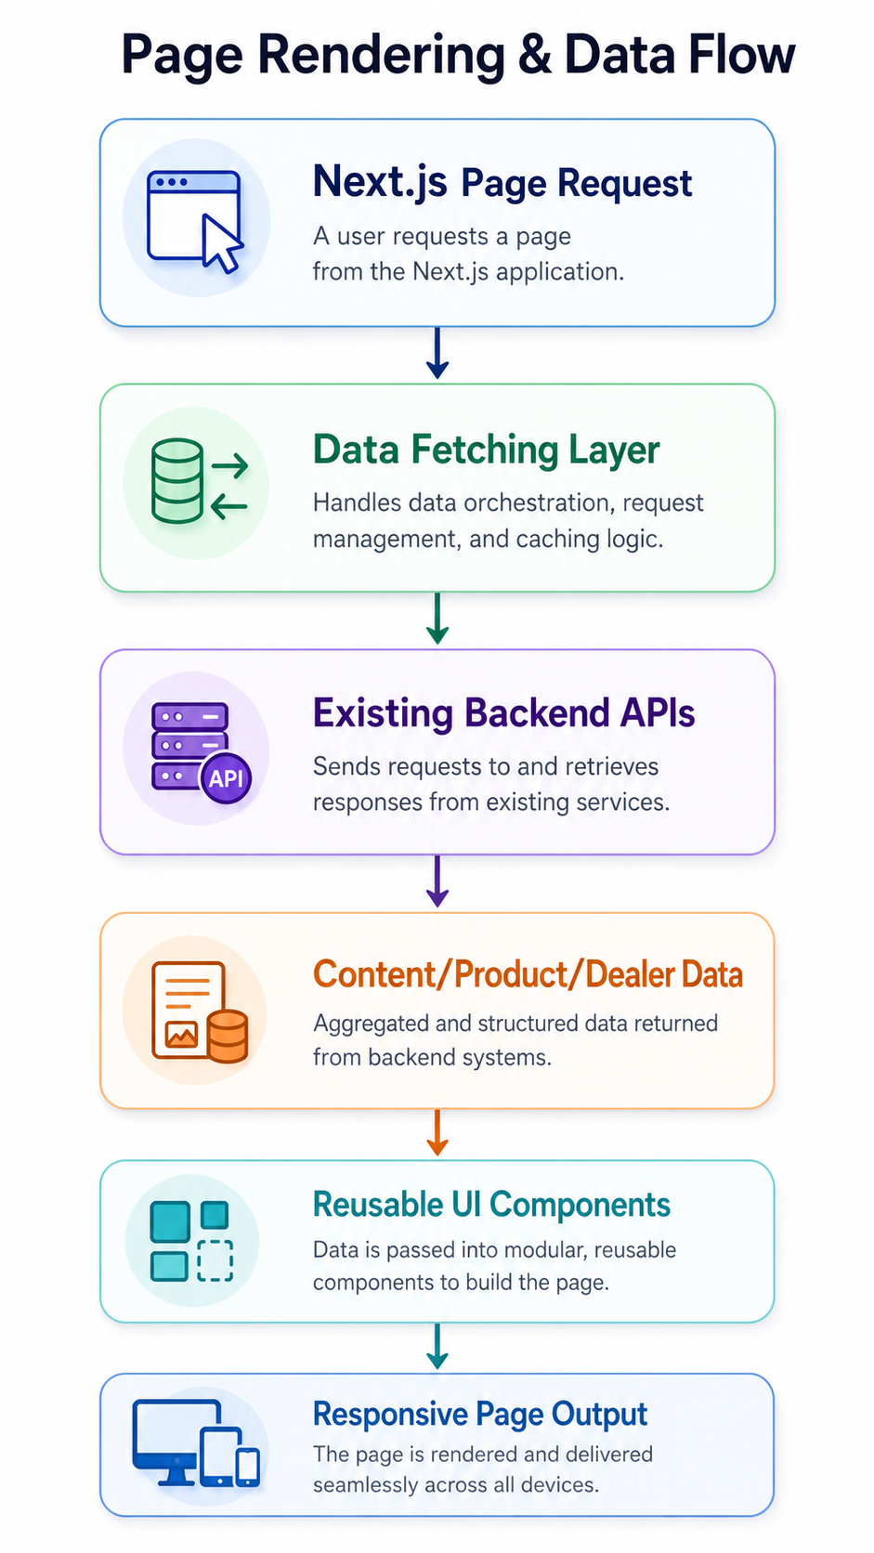

13. Assumptions, Dependencies and Exclusions
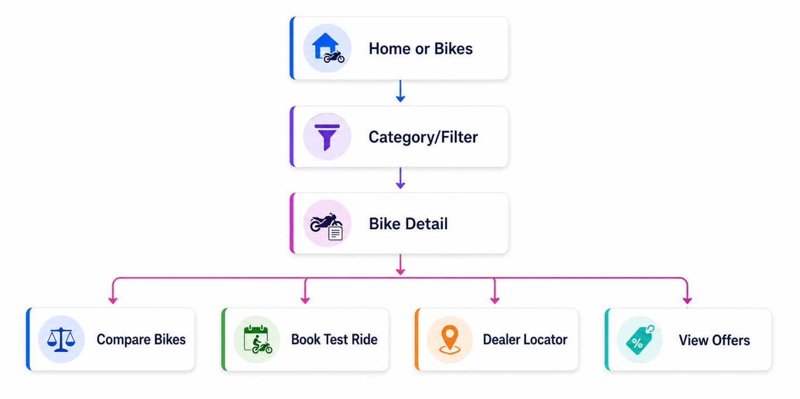

13. Assumptions, Dependencies and Exclusions

13.1 Assumptions
- The existing backend will remain operational and accessible during development.
- Required backend APIs, credentials, current frontend source code, and asset files will be provided by the client.
- Current content, product information, dealer data, service information, offers, and policies will be reused unless the client provides updated content.
- Any new backend fields will be limited to display, SEO, SMO, or content ordering needs only.
- Final hosting/deployment approach will depend on the current infrastructure and backend environment.

13.2 Dependencies
- Timely access to current frontend code and backend/API documentation.
- Client approval of UI/UX design direction and page templates.
- Availability of updated images, banners, bike assets, and brand guidelines if any.
- Access to staging/production deployment environment when required.
- Timely QA feedback from client stakeholders.

13.3 Exclusions
- Backend redevelopment, major database restructuring, or replacement of current admin/backend system.
- New payment gateway, new ecommerce engine, or large shop platform rebuild.
- Mobile app, loyalty program, CRM, marketing automation, or chatbot development.
- Content writing, product photography, and video production unless separately agreed.

