Technical Proposal
Development and Implementation of a Digital ESG Platform
for
Bangladesh Knitwear Manufacturers and Exporters Association (BKMEA)
Under the Pathway to Prosperity (P2P) Project
Prepared for:
Solidaridad Network Asia (SNA) and BKMEA
Prepared by:
Riseup Labs
Date: 25 February 2026

1. Executive Summary
This proposal presents a complete, from-scratch approach to design, develop, deploy, and handover a secure web-based Environmental, Social, and Governance (ESG) data platform for BKMEA, with initial onboarding of up to 100 member factories. The platform will centralize fragmented ESG and compliance information, standardize data capture through dynamic questionnaires mapped to recognized schemes, automate key calculations (including carbon and water footprints), and provide dashboards, benchmarking, GIS visualization, and exportable reports to support monitoring and buyer/regulatory readiness.
The solution will be delivered in phased milestones aligned with the assignment duration (20 March 2026 to 31 December 2026), including inception, solution design, iterative development, pilot onboarding, quality assurance (including security testing), training, and full handover of source code and documentation to BKMEA for long-term institutional ownership.

Key Outcomes
- Centralized ESG data platform managed by BKMEA with RBAC and approval-driven onboarding.
- Configurable ESG questionnaires aligned with ESRS/CSRD topics and relevant certification schemes as defined by BKMEA.
- Automated calculations and dashboards for energy, water, emissions (Scope 1, 2 and selected Scope 3), and readiness indicators.
- Document repository with versioning, audit trails, and expiry alerts for key licenses and approvals.
- GIS factory mapping integrated with Mapped in Bangladesh (MiB) for location-based visualization and analysis.
- Interoperability via API-based integrations (where available) and secure manual imports/exports.
- Capacity building for BKMEA administrators and factory users, supported by manuals and runbooks.

2. Understanding of the Assignment
BKMEA intends to establish an industry-managed digital ESG platform to consolidate and validate member factories' ESG and compliance information. The platform must support structured data capture across environmental, social, governance, and regulatory dimensions, provide analytics and reporting aligned to evolving sustainability expectations, and prepare factories for emerging Digital Product Passport (DPP) data needs.

2.1 Objectives
- Develop a user-friendly ESG data platform covering up to 100 BKMEA member factories.
- Establish a structured system for capturing, organizing, validating, and presenting ESG data aligned with agreed standards and schemes.
- Enable automated calculations and dashboards to monitor performance, track progress towards targets, and identify efficiency gaps.
- Provide GIS visualization and customizable reports to support monitoring, benchmarking, and decision making.
- Ensure interoperability via integrations and build BKMEA/factory capacity for sustainable operation and maintenance.

2.2 Scope Summary
- Web-based platform with modules for onboarding, ESG data collection, validation workflows, dashboards, reports, notifications, and integrations.
- Dynamic questionnaires and adaptive modules for multiple factory types (knit, woven, dyeing, washing, finishing, etc.).
- Audit trail and data versioning for all data changes to ensure traceability and audit readiness.
- Integration design for certification platforms (API-first where available), with manual options when APIs are not feasible.
- Training, pilot support, and full system handover including source code, database schema, and operational documentation.

2.3 Regulatory Context and Design Alignment
The platform will be structured to support ESG data and evidence aligned to EU sustainability reporting, due diligence, and product transparency expectations. While specific company scope and timelines can evolve, BKMEA member factories will increasingly need to provide structured ESG data to brands and buyers.
- CSRD/ESRS: standardized sustainability reporting topics and metrics, including emissions and environmental performance.
- CSDDD: human rights and environmental due diligence expectations across value chains, requiring stronger governance and evidence management.
- Digital Product Passport (DPP): product and supply chain transparency requirements introduced under the EU Ecodesign for Sustainable Products Regulation, with phased rollout starting in 2027 for priority product groups including textiles.
- Implication for platform design: configurable questionnaires, calculation rules, and export templates to adapt as requirements and buyer data requests change.

3. Proposed Solution Overview
We propose a modular, standards-mapped ESG platform designed around the following principles:

3.1 Design Principles
- BKMEA ownership by design: BKMEA-controlled onboarding, RBAC administration, and configuration of schemes and questionnaires.
- Single source of truth: canonical data model and consistent definitions across factories and schemes.
- Configurable and future-proof: questionnaire engine, data fields, and calculation rules designed for updates as requirements evolve.
- Trust and auditability: immutable audit logs, versioning, evidence management, and controlled validation workflows.
- Interoperability: API gateway and integration layer for scalable connections with external systems.
- Security and privacy: encryption, least-privilege access, secure hosting options, and continuous monitoring.

3.2 Target Users and Roles
- BKMEA Super Admins: platform configuration, approvals, user management, global dashboards, and governance.
- BKMEA Reviewers/Verifiers: review, validate, and comment on factory submissions; manage compliance evidence and expiry tracking.
- Factory Admins: manage factory users, submit ESG data, upload documents, respond to validation findings.
- Factory Data Contributors: enter and update ESG questionnaires and upload evidence as permitted.
- External Stakeholders (optional, permission-based): brands or certification agencies with view-only or limited access as defined by BKMEA.
4. Scope and Key Features

4.1 Factory Onboarding and User Management
- Factory registration workflow with BKMEA review and approval steps.
- User registration and invitation workflows controlled by BKMEA and factory admins.
- Role-based access control (RBAC) with configurable roles and permissions.

4.2 ESG Data Collection and Questionnaire Engine
- Dynamic questionnaires mapped to agreed schemes and factory types to minimize irrelevant questions.
- Configurable data fields, units, validation rules, and mandatory evidence attachments.
- Bulk import options (template-based CSV/Excel) for initial onboarding and periodic updates.

4.3 Evidence Repository, Versioning, and Audit Trail
- Secure document repository for licenses, certificates, audits, and policies.
- Data versioning with timestamps, user identity, and change history for edits and validations.
- Expiry tracking and alerts for key approvals and licenses.

4.4 Automated Calculations, Indicators, and Benchmarking
- Automated calculations for energy, water, waste, and emissions (Scope 1/2; selected Scope 3 where feasible).
- Configurable calculation rules and emission factors registry.
- Benchmarking and readiness indicators across factories with comparable profiles.

4.5 Dashboards, Reports, and GIS
- BKMEA dashboard for aggregated analytics and factory-level drill-down.
- Factory dashboards for data completeness and performance trends.
- Exportable reports (PDF/Excel) aligned with agreed templates.
- GIS map view integrated with MiB references for location-based analysis.

4.6 Notifications, Alerts, and Change Requests
- Submission reminders, validation requests, expiry alerts, and system announcements.
- Change requests mechanism to assess and prioritize scheme updates and enhancements.

6. Solution Architecture

6.1 High-Level Architecture
The platform will be delivered as a secure web application with separated presentation, API, business services, integration, and data layers.
Figure 1: High-Level Solution Architecture (insert diagram)

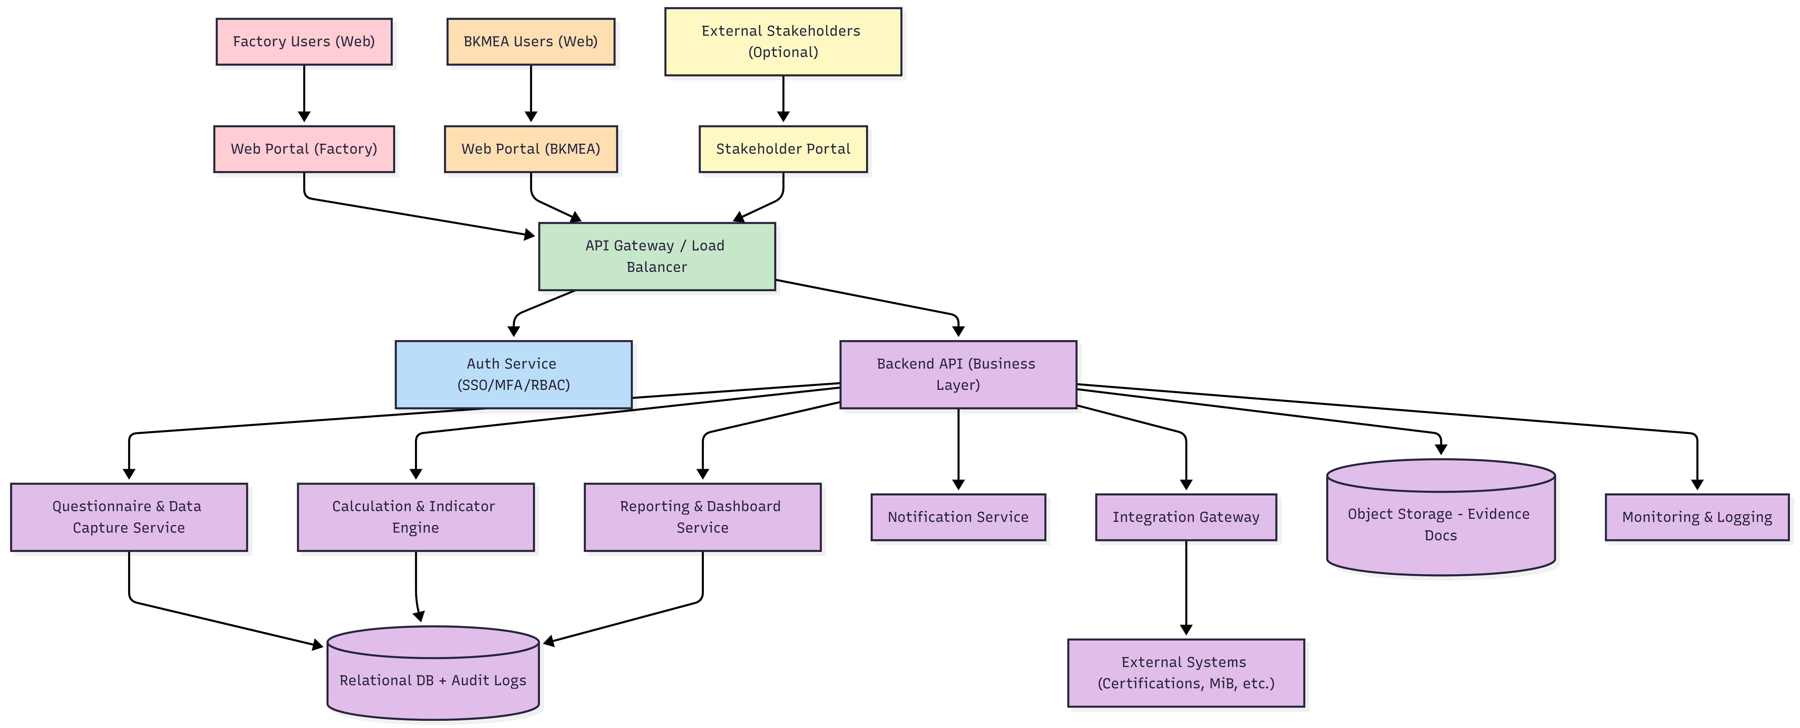

6.2 Data Submission and Validation Flow
Figure 2: Data Submission and Validation Flow

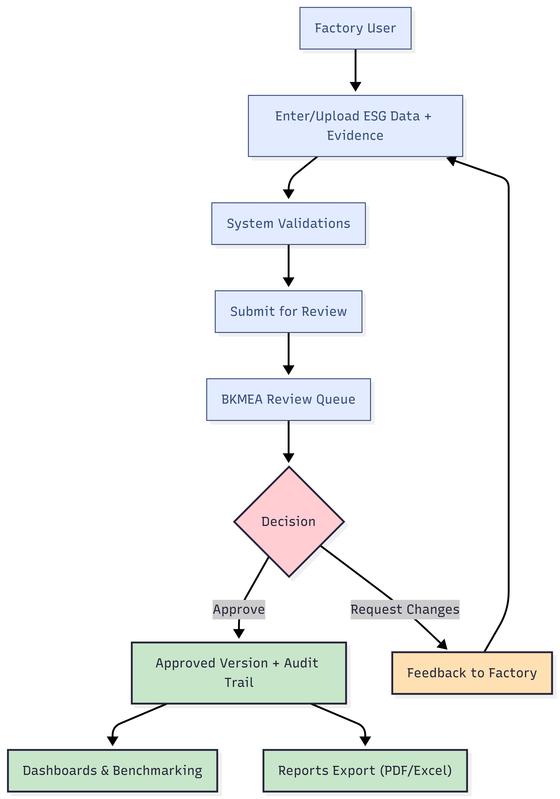

6.3 Simplified ERD
Figure 3: Simplified ERD

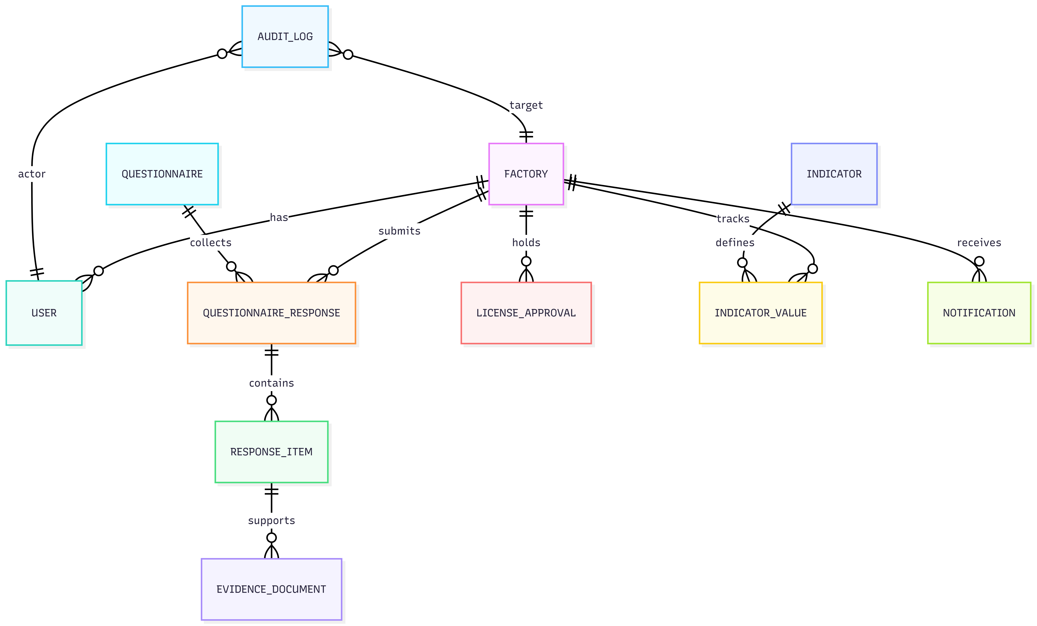

7. Proposed Technical Stack
The following stack is proposed to ensure security, maintainability, and scalability, while allowing BKMEA to own and operate the system long-term.
Layer | Proposed Technology | Rationale
Frontend (Web) | Bootstrap/Tailwind/Vue | Modern, fast UI, strong ecosystem.
Backend API | Laravel | Robust APIs and clean modular architecture.
Database | MySQL | Strong relational integrity, reporting, and GIS support.
Cache/Queue | Redis (If needed) | Background jobs for imports, reports, and notifications.
Object Storage | S3-compatible storage (AWS S3 / MinIO) | Secure evidence document storage.

7.1 DevOps and Hosting
- Environments: Development, Staging/UAT, and Production with controlled promotions.
- Hosting options:
- Cloud-first (recommended): AWS/Azure/GCP with managed database, WAF, monitoring, and automated backups.
- Secrets management: cloud secrets manager or Vault for storing keys and credentials.

8. Development Methodology and Project Approach

8.1 Delivery Model
We will apply an agile delivery model (2-week sprints) with clear stage gates for BKMEA and Solidaridad approvals.
- Sprint planning and backlog grooming with BKMEA product owners.
- Weekly progress reviews and risk/issue tracking.
- Monthly progress reporting aligned with the ToR monitoring and evaluation requirements.
- Formal stage gates for: Inception sign-off, Design sign-off, UAT acceptance, Go-Live approval, and Final Handover acceptance.

8.2 Requirements and Design
- Stakeholder workshops to validate ESG data modules, user roles, and reporting needs.
- System Requirements Specification (SRS) and prioritized user stories.
- Configurable questionnaire model and scheme mapping to reduce future change effort.
- UI/UX wireframes and prototype for key workflows before full development.

8.3 Build, Validate, and Iterate
- Iterative development of core modules with continuous QA.
- Early integration feasibility checks for selected external systems.
- Pilot onboarding and feedback loops to refine usability and data quality controls.
- Hardening phase including VA/PT, performance testing, and backup/restore validation.

10. Deliverables and Acceptance Criteria
Deliverables will be reviewed and accepted by BKMEA and Solidaridad based on agreed criteria during the inception phase.
Deliverable | Description | Acceptance Criteria (summary)
Inception Report | Refined concept, requirements, workplan, milestones, and risk plan. | Approved by BKMEA/Solidaridad; validated requirements and schedule.
Architecture and Design Pack | Architecture, data model, security controls, hosting and integration design. | Design sign-off; ToR-aligned and implementable.
Deployed ESG Platform | All agreed modules, dashboards, reports, integrations, and security controls. | UAT acceptance and go-live approval.
Testing Documentation | Test plan, cases, execution evidence, performance results. | Critical defects resolved; test summary approved.
Training Pack | Trainings, manuals, quick guides, and completion report. | Training delivered and materials handed over.
Pilot Implementation Report | Pilot onboarding summary, issues, refinements, recommendations. | Accepted by BKMEA/Solidaridad.
Final Handover Package | Source code, DB schema/backup, configs, scripts, runbooks, docs. | Full IP handover and operational readiness confirmed.

11. Testing and Quality Assurance
Quality will be ensured through continuous testing across sprints and formal acceptance gates.

11.1 Test Coverage
- Unit testing for business rules and calculation logic.
- API and integration testing for key workflows and connectors.
- UI testing for critical user journeys.
- Regression testing prior to UAT and go-live.



Fig: QA Test Process

12. Training and Capacity Building
Training will be delivered in practical, role-based formats with reusable materials.

12.1 Training Tracks
- BKMEA Admin Track: configuration, approvals, dashboards, and governance.
- BKMEA Technical Track: deployment, monitoring, backups, troubleshooting, and release management.
- Factory User Track: data entry, evidence uploads, and responding to findings.

12.2 Materials
- User manual and quick reference guides (editable).
- Administrator manual and operational runbook (backup, restore, monitoring, incident response).
- API and integration documentation for future extensions.

13. Risks, Assumptions, and Handover

13.1 Key Risks and Mitigation
Risk | Impact | Likelihood | Mitigation
Limited API availability from certification platforms | Reduced automation of data ingestion | High | Provide template imports; prioritize connectors with confirmed APIs.
Inconsistent data quality across factories | Reduced trust in analytics and reports | High | Strong validations, evidence requirements, completeness scoring, and BKMEA review workflows.
Regulatory/buyer requirements change | Rework and scope creep | Medium | Configuration-driven questionnaires and formal change control.
Security vulnerabilities | Data breach and reputational risk | Low-Medium | Security-by-design

13.2 Assumptions and Dependencies
- BKMEA will nominate focal points for requirements validation, UAT sign-off, and training coordination.
- BKMEA will confirm the prioritized schemes and questionnaires for the initial rollout.
- Data-sharing agreements and technical specifications for integrations will be facilitated by BKMEA/Solidaridad.
- Hosting decision (cloud vs on-prem) and data residency requirements will be finalized in inception.

14. Implemented Timeline
The assignment will be implemented from 20 March 2026 to 31 December 2026.

