Technical Proposal
Institutional Consultancy: Climate Education E‑Learning Course
Conversion of Climate Change Education Teacher Training Modules into Interactive E‑Content on Learning Passport (Zimbabwe)

Client: Ministry of Primary and Secondary Education (MoPSE), Zimbabwe (with UNICEF support)

1. Understanding of the Assignment
Zimbabwe faces significant climate-related hazards that disrupt education and livelihoods. MoPSE, with UNICEF, has developed Climate Change Education Teacher Training Modules for Infant, Junior Primary, and Lower Secondary levels. This assignment converts those modules into an interactive e‑learning course hosted on the MoPSE Learning Passport to rapidly scale teacher capacity through flexible, self‑paced learning.

2. Objectives and Scope
The proposed engagement will deliver an end‑to‑end, validated interactive learning course, including:
- Conversion of climate change teacher training modules into interactive content (audio, infographics, animations, quizzes, photos).
- Storyboard development for all modules and lessons.
- Voiceover production (including integration of Permanent Secretary’s opening/closing remarks, if provided).
- Assessments: pre‑test, in‑module/in‑test checks, post‑test and final post‑test (as applicable).
- Course completion certificate and post‑course feedback form.
- Collaborative validation workshops and pilot testing support, followed by refinement and final approval packaging.

3. Assumptions and Dependencies
- MoPSE/UNICEF provide the finalized training module content, curriculum standards, branding guidelines, and any required scripts for official remarks.
- MoPSE provides access to the Learning Passport environment (sandbox/staging) and defines publishing workflow (roles, approvals, upload mechanism).
- SMEs and curriculum reviewers are available for scheduled review cycles and pilot feedback within the 4‑month window.
- All media assets will comply with UNICEF/MoPSE safeguarding, accessibility, and licensing requirements (original or properly licensed).

4. Proposed Technical Approach

4.1 End‑to‑End Delivery Model
We will build the course from scratch as interactive digital learning content, using an instructional design + multimedia production pipeline. The approach ensures pedagogical coherence, usability across low‑bandwidth contexts, and compatibility with Learning Passport delivery constraints.

4.2 Content-to-Interactive Conversion Workflow
- Content intake and analysis: map modules to course structure, define lesson objectives, and identify concepts requiring visuals/animations.
- Instructional design and storyboards: create screen-by-screen storyboard with narration script, visuals, interactions, and assessment checkpoints.
- Multimedia production: create illustrations, infographics, animations, and supporting media aligned to age bands and Zimbabwe context.
- E‑learning assembly: build interactive lessons with navigation, checkpoints, and embedded media; ensure mobile-first layouts.
- Assessments and certification: implement question banks, scoring rules, pass thresholds, and certificate template logic.
- Validation and iteration: run structured review cycles with MoPSE/UNICEF/SMEs; incorporate changes with version control.
- Pilot testing: support pilot cohort testing; capture defects, UX issues, and content gaps; then finalize for approval.
- Packaging and publishing: deliver final assets and publish-ready course package to Learning Passport (or handover package per MoPSE workflow).

4.3 Accessibility, Inclusivity, and Usability
- Plain-language and age-appropriate phrasing (teacher-facing, with examples suitable for learners aged 5–15).
- Inclusive visuals (gender, ability, rural/urban, and cultural relevance).
- Accessibility checks: readable typography, sufficient contrast, captions/transcripts for audio where feasible, keyboard/touch navigation.
- Bandwidth-aware media: compress audio/video, provide image alternatives, and avoid unnecessary heavy animations.

5. Development Methodology
A structured iterative methodology will be used to meet the 4‑month timeframe while enabling continuous validation:
- Phase-gated Agile sprints (2-week iterations) with defined review workshops and sign-offs.
- Definition of Done per lesson: storyboard approved → media produced → interaction built → QA passed → reviewer feedback resolved.
- Change control: versioned assets, review logs, and traceability from TOR deliverables to final course components.

6. Proposed Technical Stack

6.1 Authoring and Interaction Layer
- Primary e-learning authoring: Articulate Storyline / Rise 360 or Adobe Captivate (depending on Learning Passport import constraints).
- Interactive components: Interactions (where supported) for quizzes, hotspots, drag-drop, and checkpoints.
- Standards alignment: SCORM/xAPI packaging where required by platform workflow; otherwise native lesson uploads per Learning Passport.

6.2 Visual Design and Animation
- Illustration & layout: Adobe Illustrator / Figma / Canva.
- Motion graphics/animation: Adobe After Effects (with export to web-friendly formats, e.g., MP4/Lottie where applicable).
- Image optimization: TinyPNG/Imagemin workflows; SVGs where appropriate for clarity and low size.

6.3 Audio Production
- Voice recording: studio or remote controlled recording with noise-managed pipeline; WAV masters + compressed delivery formats.
- Editing/mastering: Adobe Audition or Audacity; loudness normalization and consistent pacing.
- Transcripts/subtitles: generated and human-reviewed for accuracy where required.

6.4 Platform and Environment
- Target LMS: MoPSE Learning Passport
- Deployment approach: publish to staging for pilot → production release after acceptance.

6.5 Engineering and Governance Tooling
- Version control: Git for storyboards, scripts, and source files.
- Issue tracking: Jira/Trello/Asana for sprint planning, defect tracking, and review actions.
- Quality gates: QA checklists, acceptance criteria per module, and release readiness review.

7. Deliverables
Deliverables are aligned with the TOR and will be delivered and validated progressively:
Deliverable | Description | Acceptance / Evidence
D1. Storyboards (All Modules) | Screen-by-screen storyboard per lesson: objectives, narration script, visuals, interactions, and assessments mapping. | Approved storyboard pack signed-off by MoPSE/UNICEF/SME.
D2. Multimedia Asset Library | Original illustrations, infographics, icons, animations, photos (licensed), and optimized media files. | Asset inventory + source files + licensing register; accessibility and cultural relevance checks.
D3. Voiceovers Package | Recorded narration for lessons, including official opening/closing remarks integration (if provided). | Audio masters + delivery files; transcript pack; review sign-off.
D4. Interactive E‑Learning Course Build | Assembled interactive lessons with navigation, media, animations, and embedded interactions. | Deployed to staging/sandbox; functional demo; stakeholder walkthrough.
D5. Assessments Suite | Pre-test, in-test checks, post-test and final post-test with scoring rules and question bank structure. | Test plan + sample learner runs; reporting of scores completion.
D6. Feedback Form + Certificate | Post-course feedback form and certificate of completion template and issuance logic. | Verified end-to-end course completion flow; certificate output sample.
D7. Pilot Test Support + Final Release | Pilot testing facilitation, defect fixes, content refinements, and production-ready package. | Pilot report + defect closure report; final approval and publish confirmation.

8. Testing and Quality Assurance

8.1 QA Strategy
- Content QA: accuracy, consistency, alignment to teacher training modules, language quality, and Zimbabwe context appropriateness.
- Functional QA: navigation, interactions, quiz scoring, progress tracking, certificate issuance, and form submissions.
- Compatibility QA: web + Android (and other target devices) across common screen sizes; offline behavior where applicable.
- Accessibility QA: readability, contrast, audio transcript availability (where required), touch targets, and interaction clarity.
- Performance QA: media load time, asset size budgets, and smooth playback on low-end devices.

Fig: QA test process

10. Technical Diagrams

Figure 1: High‑Level Solution Architecture (Learning Passport Course Delivery)

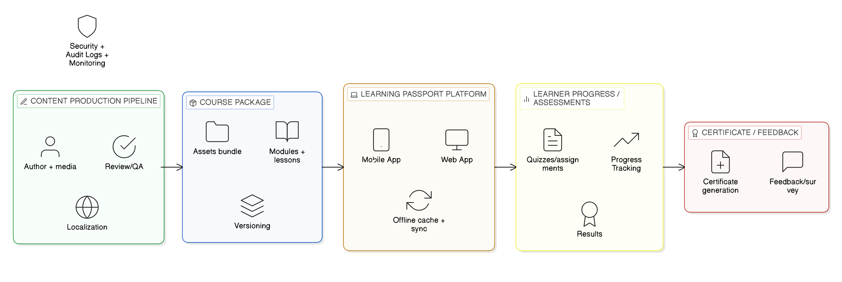

Figure 2: Content Conversion Workflow (Storyboard → Media → Build → QA → Publish)

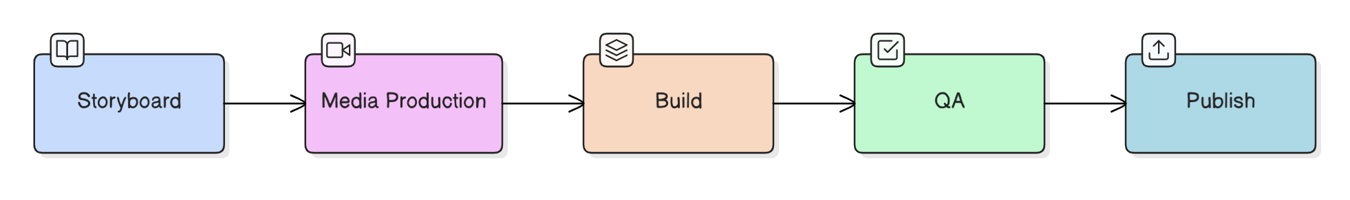

Figure 3: Assessment & Certification Flow

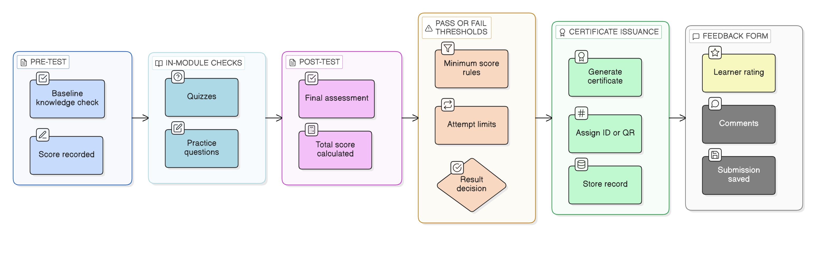11. Risks and Mitigation
Risk | Impact | Mitigation
Delayed content sign-offs | Schedule slippage and rework | Lock review calendar; phased approvals; time-box feedback; escalation path.
Platform constraints (import/interaction limits) | Reduced interactivity or rework | Prototype early; confirm upload formats; maintain fallback interaction patterns.
Connectivity/device limitations for learners | Low engagement, drop-offs | Optimize media; provide lightweight alternatives; test on low-end devices; offline readiness checks.
Voiceover inconsistencies | Uneven learner experience | Single voice profile per track; loudness normalization; script QA before recording.
Licensing/copyright issues | Compliance risk | Use original assets; maintain licensing register; prefer CC/royalty-free sources with documentation.

12. Handover and Sustainability
- Handover pack: final course package, source files, asset library, scripts, transcripts, and publishing notes.
- Admin orientation: course update workflow, content upload steps, and basic troubleshooting guide.
- Maintenance guidance: how to update visuals, swap audio, extend question banks, and re-publish with versioning.

9. Implementation Timeline
The timeline below is a practical plan aligned to the TOR duration. Exact dates will be finalized at kickoff based on stakeholder availability and content readiness.
Overall Project Duration: 4 Month

