Technical Proposal
Enterprise Corporate Website Development (From Scratch)

Prepared by | Riseup Labs
Date | 23 Feb 2026

1. Executive Summary
This proposal outlines the approach to design and develop a modern, secure, and scalable corporate website from scratch, aligned with enterprise brand standards and optimised for user experience, SEO, performance, and security. The solution will include a responsive public website, a role-based content management capability, content governance workflows, and integrations for analytics and lead capture.

2. Understanding of Requirements
Based on the provided scope documents, the target website must provide:
- Enterprise-grade corporate web presence with modern UX/UI and responsive design.
- Clear information architecture and consistent page templates for services, insights, leadership, and careers.
- Structured services and sub-services pages (5 to 10 sub-offerings per primary service line).
- Industry vertical pages with tailored content and case studies.
- Insights/Knowledge Hub with search, tagging, and filters.
- Events/Webinars section with calendar, registration, and post-event assets.
- Contact and office locations with enquiry forms and map views.
- Strong performance, security, privacy, accessibility, and cookie compliance.
- Content governance with role-based approvals and auditability.

3. Proposed Solution Overview
We propose an API-first, modular architecture using a high-performance frontend and an enterprise backend with a secure admin panel. This enables fast page delivery, strong SEO, and long-term scalability, while keeping content operations efficient through workflow-based publishing.

Figure 1: High-Level Solution Architecture
Public users access a Next.js web frontend protected by CDN and WAF. The frontend consumes APIs from a Laravel backend that provides CMS, search, forms, and integrations, backed by a relational database and secure storage for media assets.
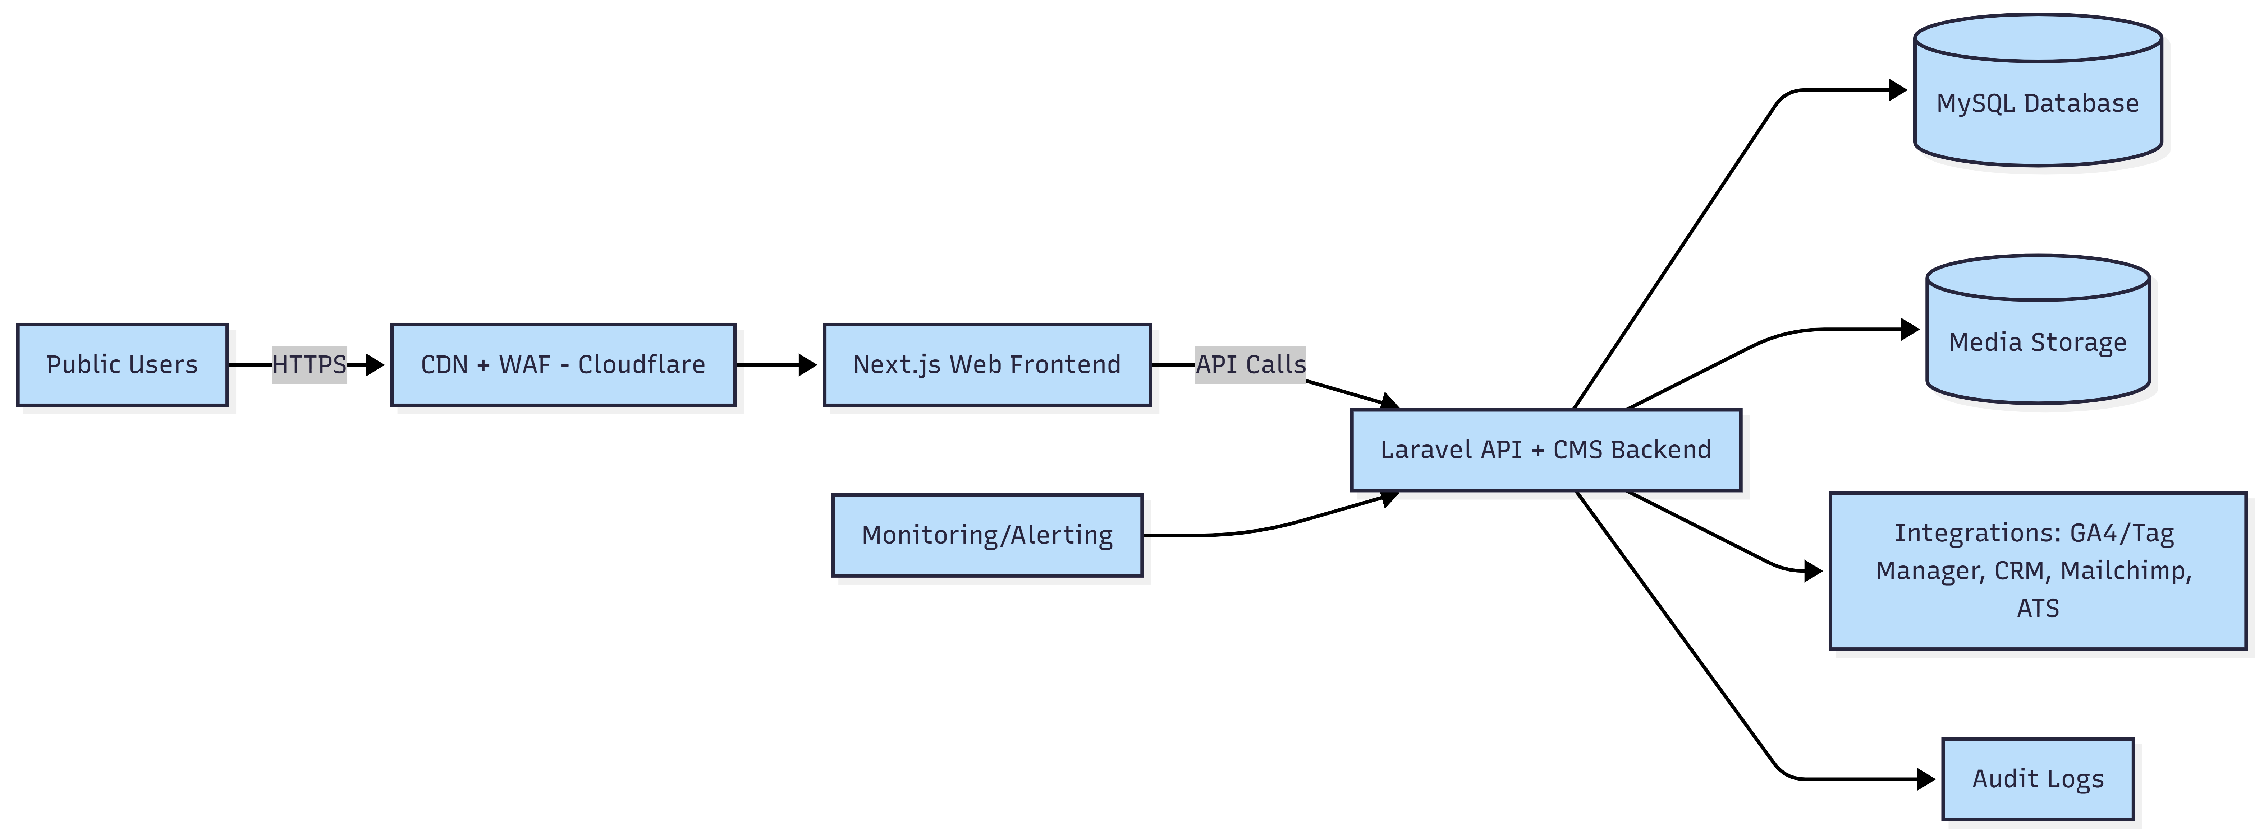

4. Scope of Work

4.1 Website Modules and Pages
The website will be developed using reusable page templates. Core sections include:

A. Homepage
- Hero section with dynamic content blocks.
- Quick navigation to Services, Insights, Industries.
- Client/partner logos section.
- Strategic calls-to-action (Talk to us, Request a meeting, Subscribe).

B. About KPMG
- Company overview
- Values, vision, mission
- Leadership profiles

C. Services
- Primary service line pages: Audit, Tax, Advisory, Consulting, Digital/Technology, ESG and Sustainability, Risk and Compliance.
- Sub-service pages under each primary service line (estimated 5 to 10 per category).
- Case highlights and lead capture sections.

D. Industry Verticals
- Sector pages such as Financial Services, Healthcare, Government/Public Sector, Energy and Utilities, Technology and Digital, Consumer Markets.
- Tailored content and case study blocks per industry.

E. Insights / Knowledge Hub
- Content types: articles, publications, reports, thought leadership.
- Search with tagging and filters (topic, industry, date).
- Share metadata support (Open Graph and Twitter cards).

F. Events / Webinars
- Event calendar and listings.
- Event detail pages.
- Registration forms and attendee export.
- Post-event assets (slides, video links, documents).

G. Careers (Optional)
- Jobs listing and detail pages (internal listing or integration with ATS).
- Application links or application forms.
- Culture and employer branding content.

H. Contact / Office Locations
- General enquiry form with spam and abuse protection.
- Office locations list by region.
- Map and directions.

4.2 Content Management and Governance
A secure admin portal will be delivered to manage content and publishing operations, including:
- Role-based access control (Admin, Editor, Reviewer, Publisher).
- Draft, review, approve, publish workflow with audit log.
- Reusable templates for pages, service entries, insight posts, leadership profiles, careers, and events.
- Media library with versioned uploads and optimised web formats.

Figure 2: Content Governance Workflow

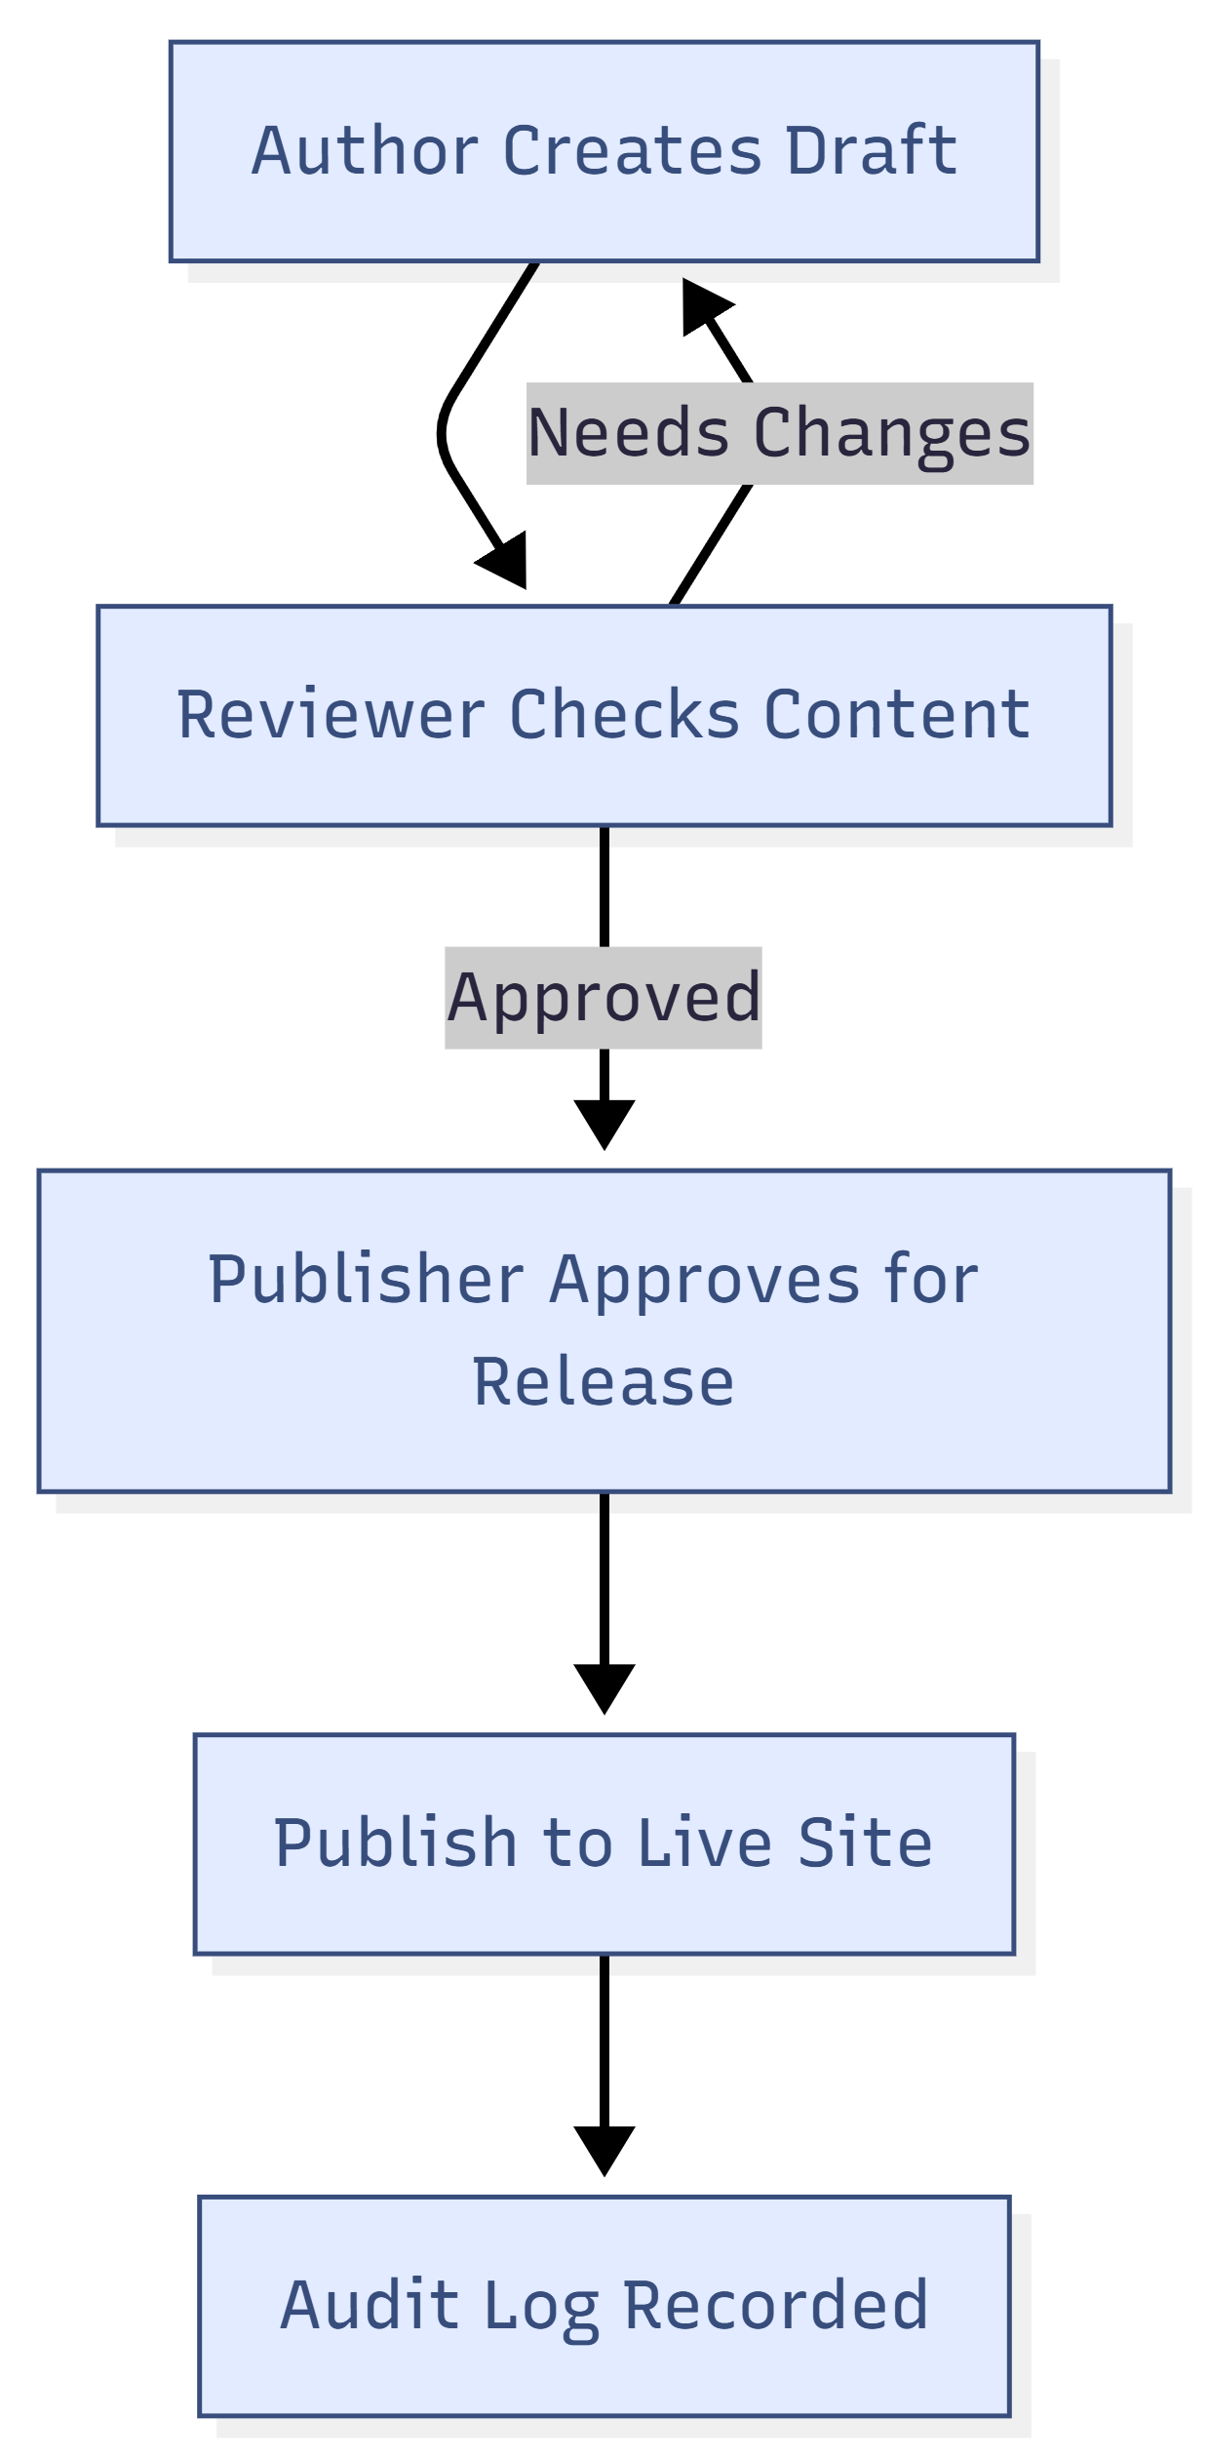

4.3 UI/UX and Asset Development (In Scope)
UI/UX and digital asset development are included. Design work will align with global brand guidelines and will include:
- Discovery workshops and user journey definition for key audiences.
- Information architecture, sitemap, and wireframes for all templates.
- High-fidelity responsive UI designs (desktop, tablet, mobile).
- Design system and reusable component library for consistent implementation.
- Asset creation and optimisation: icons, illustrations, image treatments, and web-ready exports.

4.4 Integrations (As Required)
The platform will support common enterprise integrations, including:
- Analytics: Google Analytics 4 and Google Tag Manager.
- Email marketing: newsletter signup via Mailchimp or corporate distribution tools.
- Careers: applicant tracking system integration (ATS) or external job portal links.
- CRM: form-to-CRM routing for lead management.
- Social: social links, sharing metadata, and structured preview cards.

5. Proposed Technical Stack
Layer | Proposed Technology | Notes
Frontend | Next.js (React) | Server-side rendering and static generation for performance and SEO.
Backend | Laravel (PHP) | API and admin CMS, workflows, RBAC, integrations.
Database | MySQL | Relational store for content, users, audit logs, and configuration.
CDN and Security | Cloudflare CDN + WAF | Edge caching, DDoS protection, WAF rules and bot mitigation.
Search | DB-backed search (MVP) or dedicated search service (optional) | Keyword search with filters and tagging; scalable option can be added later.
Media Storage | Object storage (S3 compatible) + CDN | Optimised images, documents, and event assets.
CI/CD | Git-based CI pipeline | Automated build, test, and deployment to staging and production.
Monitoring | Uptime monitoring + error tracking | Operational visibility, alerting, and incident response.

6. Development Methodology and Approach
We will follow an iterative delivery model with clear milestones, stakeholder checkpoints, and continuous quality assurance. The approach is aligned with the recommended roadmap: Discovery and Architecture, Design and Content Model, Development, Integration and Migration, Testing and Tuning, Launch and Stabilisation.

6.1 Discovery and Architecture
- Stakeholder workshops and requirement validation.
- Information architecture and navigation structure finalisation.
- Non-functional requirements definition (performance, security, accessibility, SEO).
- Solution architecture and environment planning.
Key deliverables:
- Requirement specification and sitemap.
- Architecture definition (high-level and component level).
- Initial content inventory and migration plan (if applicable).

6.2 UX/UI and Content Model
- Wireframes for key templates and user flows.
- UI design aligned with brand guidelines and responsive breakpoints.
- CMS content model definition for pages, services, industries, insights, events, leadership, careers, and locations.
- Design system components and handoff assets.
Key deliverables:
- Approved UI screens and reusable components.
- Content model and CMS field definitions.
- Asset pack for development.

6.3 Development
- Frontend development for public site templates and components.
- Backend development for APIs, admin CMS, RBAC, workflow, and audit logging.
- Implementation of search, tagging, filters, and structured content listing pages.
- Form handling with validation, rate limiting, and CRM routing if required.
- Media handling and optimisation pipeline.
Key deliverables:
- Working staging environment with full website templates.
- Admin portal and CMS workflows.
- Integrated analytics and tracking setup.

6.4 Integration and Content Migration (If Applicable)
- Integrate ATS, newsletter, CRM, and other third-party tools as agreed.
- Content migration support (manual import tools, batch upload, and QA).
- Redirect mapping and SEO preservation for migrated content.
Key deliverables:
- Integrated services and validated data flows.
- Migration checklist and sign-off.

6.5 Testing and Tuning
- Full QA cycle: functional, regression, and cross-browser tests.
- Performance optimisation and Core Web Vitals tuning.
- Security hardening: WAF rules, secure headers, vulnerability checks.
- Accessibility checks and remediation.
Key deliverables:
- QA sign-off report with test evidence.
- Performance and security readiness checklist.

6.6 Launch and Stabilization
- User acceptance testing (UAT) support and fixes.
- Production deployment and go-live execution plan.
- Post-launch monitoring and stabilisation support.
- Handover: documentation and knowledge transfer.
Key deliverables:
- Go-live checklist and rollback plan.
- Operational runbook and admin guide.

7. Security, Performance, SEO, and Compliance

7.1 Security Controls
- CDN and WAF at the edge for threat mitigation and DDoS protection.
- TLS encryption, secure HTTP headers, and strict input validation.
- Role-based access control for admin portal and content workflows.
- Audit logging for content changes, approvals, and administrative actions.
- Rate limiting and bot protection for public forms.

7.2 Performance Optimisation
- Next.js SSR and static generation for fast content delivery.
- Cloudflare caching strategy for global edge performance.
- Image optimisation, lazy loading, and responsive media delivery.
- Database indexing, query optimisation, and caching for high-traffic pages.

7.3 SEO and Content Structure
- SEO-friendly URLs and content templates with consistent heading hierarchy.
- Meta tags, Open Graph/Twitter cards, canonical URLs, and XML sitemap.
- Schema markup for articles, events, and organisation where applicable.
- Redirect strategy for legacy URLs (if migrating existing content).

7.4 Privacy, Accessibility, and Compliance
- Cookie notice, privacy policy hooks, and consent-based tracking configuration.
- Accessibility aligned to common corporate expectations (keyboard navigation, contrast, alt text, ARIA labels).
- Secure data handling for enquiry and registration forms.

Figure 3: Multi-Layer Security Model
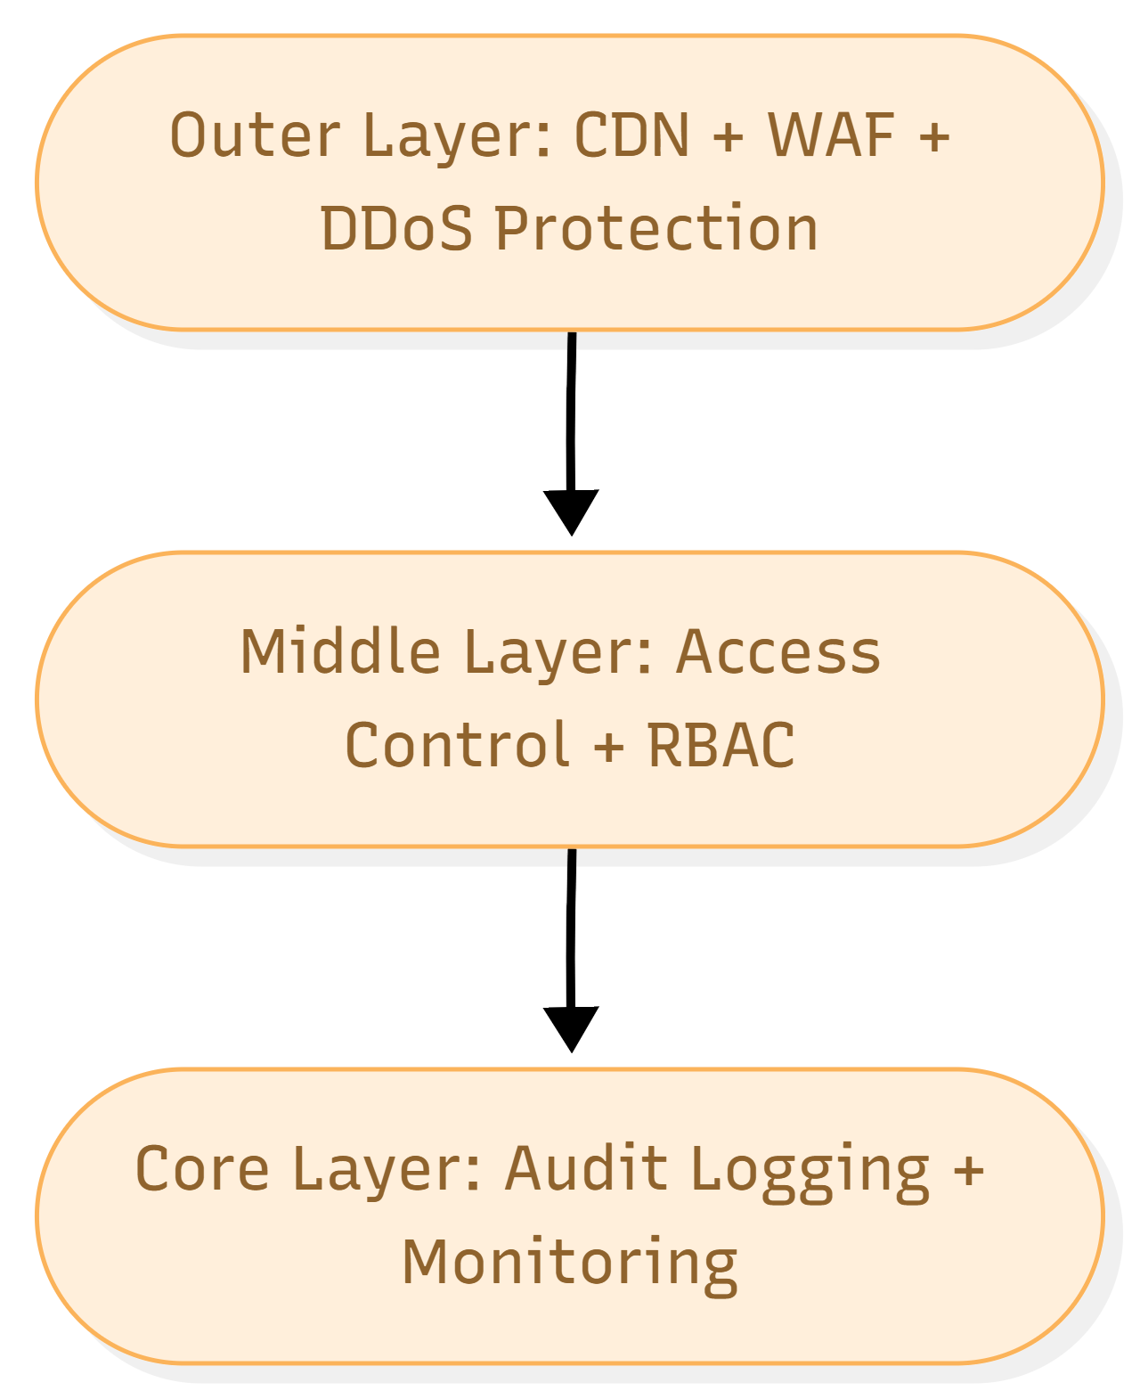

8. Testing and Quality Assurance
Quality assurance will be embedded throughout delivery. The testing strategy includes:

8.1 Test Types
- Testing for backend services and critical frontend utilities.
- Integration testing for APIs, forms, and third-party integrations.
- End-to-end testing for critical user journeys (navigation, search, enquiry, event registration).
- Cross-browser and responsive testing across common devices and screen sizes.
- Accessibility testing with automated checks and manual verification.
- Performance testing using Lighthouse metrics and load testing for peak traffic scenarios.
- Security testing includes OWASP-aligned checks, dependency scanning, and basic penetration testing support.

Fig: QA Test Process

9. Deployment and Operations
We will set up separate environments to reduce risk and ensure controlled releases.
- Environments: Development, Staging, Production.
- Automated deployments via CI pipeline with approvals for production.
- Backups and restore procedures for database and media storage.
- Monitoring, logging, and alerting for application health and security events.

10. Deliverables Summary
The key deliverables of this engagement include:
- Project initiation and requirement specification documents.
- Information architecture, sitemap, and UX wireframes.
- High-fidelity UI designs, design system, and asset pack.
- Fully developed responsive website (frontend and backend) from scratch.
- Admin CMS with RBAC, workflows, and audit logs.
- Search, tagging, filters, and content templates for insights and events.
- Integrations: analytics, newsletter, ATS/CRM (as agreed).
- Testing deliverables: test plan, test reports, UAT support, release checklist.
- Deployment artefacts: CI/CD configuration, runbook, and handover documentation.

11. Assumptions, Dependencies, and Exclusions

11.1 Assumptions
- Client will provide brand guidelines, content owners, and timely approvals.
- Required access to domains, DNS, hosting accounts, and integration endpoints will be provided.
- Content volumes and migration needs will be confirmed during discovery.

11.2 Dependencies
- Availability of stakeholders for workshops and reviews.
- Third-party vendors for ATS, CRM, email marketing, and analytics tools.
- Hosting and security policies required by the client organisation.

11.3 Exclusions (Unless Added by Change Request)
- Paid third-party licensing costs and subscriptions.
- Large-scale content creation beyond agreed templates and initial assets.
- Advanced personalisation, AI search, or multi-country multisite capabilities (can be scoped later).

