Technical Proposal
Development of Mobile Application for Information and Grievance Redressal at Union Level

Item | Details
Project | Together for Tomorrow: Enhancing Cooperation for Social Sustainability
Prepared For | DALIT
Prepared By | Riseup Labs
Date | 13 March 2026

1. Executive Summary
DALIT's initiative requires a secure, inclusive, and easy-to-use mobile application that enables information access, service request handling, and grievance redressal for marginalized citizens at union level. Based on the TOR, the solution must support both Android and iOS, function reliably on low-end devices, provide Bangla-language content, offer offline capability, and include an admin dashboard for DALIT staff to monitor, respond to, and report on cases.
Our proposed solution is a from-scratch cross-platform mobile ecosystem built on an open-source architecture. The solution combines a Flutter-based citizen mobile app, a Laravel-based API and admin portal, role-based workflow management, secure cloud hosting with Bangladesh data residency, and a structured post-launch support period. The approach emphasizes accessibility, simple user journeys, low-bandwidth optimization, and measurable operational transparency.
2. Understanding of the Assignment
The TOR positions the application as part of the 'Together for Tomorrow' project, which aims to strengthen inclusive civic engagement and participatory governance among Dalits, women, youth, fisherfolk, and landless communities in Bajua, Banishanta, and Loudobe unions of Dacope Upazila, Khulna. The digital platform is intended to reduce barriers to service access, support complaint submission and tracking, and generate dependable data for learning and evidence-based decision-making.
Requirement Area | Interpretation for Delivery
Geographic focus | Three unions in Dacope Upazila, Khulna; workflows should be configurable by union or service point.
Target users | Approx. 5,000 marginalized citizens, plus DALIT operational staff and administrators.
Primary language | Bangla-first citizen experience, with room for bilingual admin content if required.
Core value | Improve access to information, strengthen grievance handling, and increase accountability through digital case visibility.
Technology expectation | Open-source stack, secure cloud deployment, and integration readiness for Union Parishad / UISC systems.
Delivery expectation | 3 months of implementation followed by 6 months of maintenance, bug fixing, and guided handover.
3. Proposed Solution Overview
We propose a modular solution composed of four coordinated layers so the system remains practical for first launch and scalable for future growth.
• Citizen mobile application: A Bangla-first app for information access, service application submission, complaint creation, status tracking, notifications, and offline usage support.
• Web-based admin dashboard: A secure operations console for DALIT staff to review cases, manage content, route grievances, communicate status updates, and generate monitoring reports.
• Backend API and workflow services: Central business logic for authentication, case management, escalation, audit logging, notifications, synchronization, and external integration.
• Cloud hosting and operational tooling: Secure hosting in Bangladesh, database backup routines, monitoring, logging, and release pipelines for controlled deployment and support.
3.1 Indicative Functional Modules
Module | Key Capabilities
Information Centre | Rights awareness, health, education, climate, FAQs, service contacts, downloadable guidance, and localized announcements.
Service Request Module | Digital submission forms, attachments, acknowledgement receipt, tracking timeline, and status-based follow-up.
Grievance Redressal Module | Case creation, category selection, description, evidence upload, assignment, escalation, resolution notes, and closure confirmation.
Offline and Sync | Draft saving, offline form completion, queued submission, and automatic synchronization when connectivity returns.
Notifications | Notifications for submission receipt, status change, missing information, escalation, and closure updates.
Admin Dashboard | Case inbox, user management, content publishing, dashboard analytics, exportable reports, and audit trail review.
Integration Layer | API-ready hooks for Union Parishad / UISC MIS and future grievance systems, subject to third-party readiness and access.

Figure Placeholder 1 - High-Level Solution Architecture
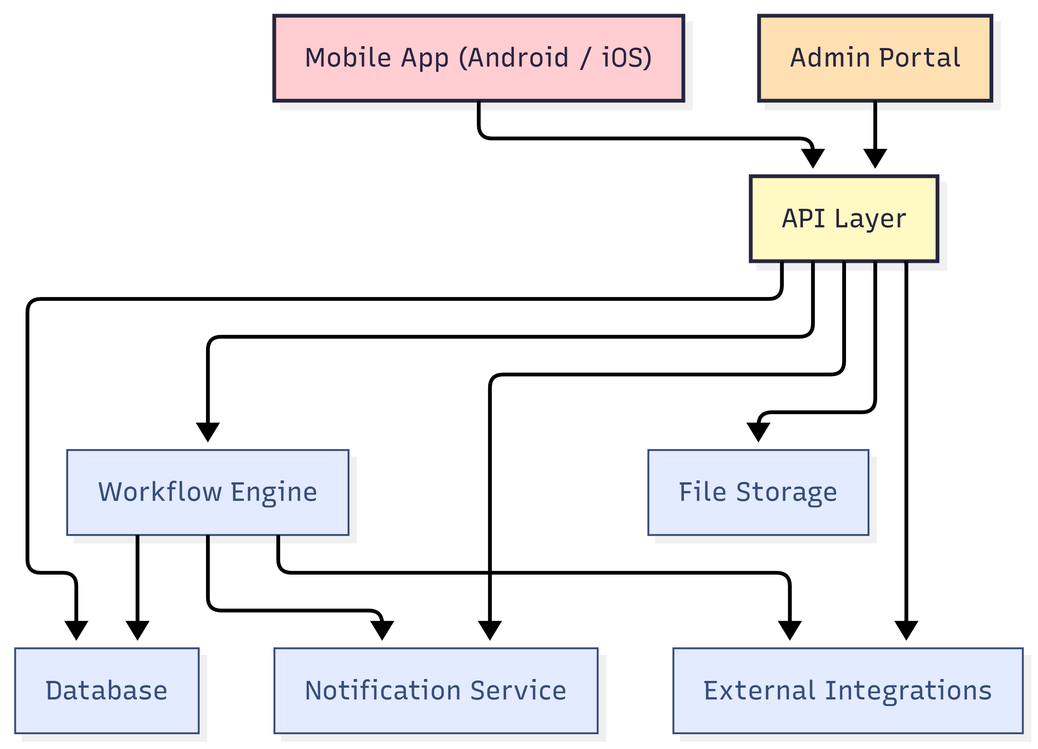

Figure Placeholder 1 - High-Level Solution Architecture
4. Proposed Technical Approach
4.1 Discovery and SRS
The engagement will start with a short inception and discovery cycle to convert the TOR into a detailed Software Requirements Specification. This stage will validate service categories, grievance workflows, escalation logic, user roles, reporting needs, field-level validation rules, offline scenarios, data retention requirements, and integration dependencies. The outcome will be a signed-off SRS supported by process flows, data flow diagrams, and a prioritized backlog.
4.2 User Experience and Accessibility Readiness
Although this proposal focuses on technical delivery, the mobile experience must be intentionally simplified for the target audience. The app will therefore prioritize clear Bangla labels, low-friction navigation, large touch targets, concise forms, readable typography, and a workflow that minimizes repeated data entry. Accessibility checkpoints will be embedded during UI review and QA to align with WCAG 2.1 requirements stated in the TOR.
4.3 Mobile Application Engineering
The citizen-facing application will be developed from scratch using Flutter so that Android and iOS are served from a shared codebase while preserving native-quality performance and device integration. The mobile app will include secure sign-in or lightweight access patterns as finalized during SRS, local data caching, structured form workflows, media attachment handling, and background-safe synchronization logic for intermittent connectivity.
4.4 Backend and Admin Platform
The backend will be implemented using Laravel with a modular REST API architecture. This layer will manage users, permissions, content blocks, service workflows, grievance cases, comment history, resolution actions, analytics snapshots, and outbound notifications. A web admin dashboard will allow DALIT staff to monitor case queues, assign or escalate issues, maintain reference content, and export operational reports.
4.5 Integration and Data Interoperability
Because the TOR expects readiness for Union Parishad, UISC, and national grievance systems, the solution will expose clean API endpoints and connector-ready service abstractions. Where direct external APIs are not yet available, the platform can support controlled data import or manual reconciliation workflows without redesigning the core system.
4.6 Deployment and Operationalization
Production deployment will include cloud environment setup, staging and production separation, HTTPS configuration, secure secrets handling, backup policies, health monitoring, app signing, store submission support, and handover documentation. The proposed release process includes internal QA, user acceptance testing, pilot launch, issue stabilization, and production release support for both app stores.

Figure Placeholder 2 - Complaint and Service Request Workflow
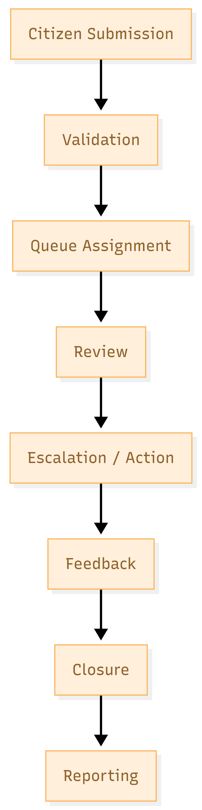
Figure Placeholder 2 - Complaint and Service Request Workflow
5. Proposed Technical Stack
The recommended stack stays within the TOR's open-source preference and is optimized for cross-platform delivery, maintainability, and cost-efficient future enhancement.
Layer | Recommended Technology | Rationale
Mobile App | Flutter (Dart) | Single codebase for Android and iOS, strong UI control, efficient performance on low-end devices, and mature plugin ecosystem.
Admin Portal | Laravel Blade or React front end on Laravel backend | Fast delivery of secure internal operations dashboard with role-based workflows.
API Layer | Laravel REST APIs | Well-structured backend for business rules, validation, authentication, and integration services.
Database | PostgreSQL | Reliable relational storage for case data, reporting, audit history, and structured workflow records.
Caching / Queues | Redis | Supports background jobs, notification queues, and performance optimization.
File Storage | S3-compatible object storage | Secure handling of attachments, documents, and evidence files with lifecycle control.
Notifications | Firebase Cloud Messaging and Apple Notification Service | Native delivery path for Android and iOS notifications.
Authentication | Laravel Sanctum / JWT with RBAC | Secure session and token management for citizens and staff roles.
5.1 Security, Privacy, and Compliance Controls
Control Area | Planned Approach
Application security | Secure coding standards, server-side validation, authentication controls, rate limiting, and dependency reviews aligned to OWASP mobile and web security practices.
Data protection | Encrypted transport with HTTPS/TLS, controlled access by role, secure credential management, and structured backup / restore policies.
Privacy | Consent-aware data collection, minimal required data capture, traceable case history, and privacy notice support for citizen-facing flows.
Accessibility | Bangla-ready design, readable text hierarchy, form validation messaging, accessible navigation structure, and practical alignment to WCAG 2.1.
Data residency | Production hosting and primary data storage in Bangladesh in line with the TOR requirement.
Auditability | Case history logging, status-change records, admin action logs, and exportable reporting for oversight.
6. Development Methodology
The project will follow an Agile delivery model with short feedback loops, structured sprint planning, and bi-weekly demonstrations, matching the methodology direction already stated in the TOR. This is especially suitable because the success of the platform depends on validating real user journeys, case categories, and staff operations early rather than waiting for a single final review.
Method Element | Application in This Project
Inception workshop | Confirm scope boundaries, stakeholder roles, service flows, reporting expectations, and integration assumptions.
Backlog-driven delivery | Translate SRS into prioritized user stories and technical tasks for controlled execution.
Bi-weekly demos | Review working increments with DALIT, gather feedback, and validate practical usability.
Iterative prototyping | Show two progressive prototypes before final hardening to reduce rework risk.
Quality gates | Move features through development, QA and release readiness with documented sign-off criteria.
Change management | Track feedback and revisions through a controlled issue and enhancement log.
7. Implementation Timeline
The proposed implementation plan follows the TOR's expected cadence of approximately 3 months for delivery and 6 months for post-launch support.
8. Testing and Quality Assurance
Quality assurance will be embedded throughout the project rather than applied only at the end. This is important because the platform combines citizen-facing usability, case workflow reliability, offline behavior, notification delivery, and data integrity requirements.
Test Type | Purpose | Typical Coverage
Integration Testing | Verify interaction between modules and services. | Mobile app with APIs, authentication, notifications, file uploads, sync handling.
System Testing | Confirm end-to-end business functionality. | Submission to closure journeys, admin actions, reporting outputs, role permissions.
Usability Testing | Ensure target users can complete core tasks. | Bangla labels, navigation clarity, low-end device experience, field guidance.
Performance Testing | Assess response time and stability. | API response, dashboard load, file handling, concurrent use patterns.
Store Readiness Review | Prepare compliant app release packages. | Build verification, app signing, release notes, privacy disclosures, final metadata.
8.1 Quality Deliverables
• Test plan and test scenario coverage matrix.
• Defect log with severity, status, and retest evidence.
• Test checklist and business sign-off record.
• Release readiness checklist for Google Play and Apple App Store submission.


9. Deliverables
Deliverable | Description
Inception Report | Project initiation summary, governance approach, assumptions, and implementation plan.
Cross-Platform Mobile Application | Android and iOS app build with the approved scope and production-ready release package.
Admin Dashboard | Operational web panel for case monitoring, content management, and reporting.
Documentation | Technical documentation, admin manual, and user guide.
Training Sessions | Two structured training sessions for DALIT staff, as required by the TOR.
Source Code and Handover Package | Version-controlled source code, environment notes, credentials handover checklist, and support closure summary.
10. Project Team Structure
The exact team size can be finalized during commercial discussion, but the following delivery roles are recommended to ensure balanced execution and governance.
Role | Indicative Responsibility
Project Manager | Planning, stakeholder coordination, progress tracking, risk management, and milestone reporting.
Product Analyst | Requirement validation, SRS preparation, process mapping, backlog management, and coordination.
Technical Lead | Architecture decisions, code quality oversight, integration strategy, and technical governance.
Flutter Developer(s) | Cross-platform mobile application development, offline logic, device integration, and release builds.
Backend Developer(s) | API development, database design, workflow rules, admin dashboard implementation, and integration services.
QA Engineer | Test planning, execution, defect tracking, regression testing, and release certification support.
DevOps | Environment setup, CI/CD, monitoring, backup policy, and production release support.
11. Assumptions and Dependencies
• DALIT will nominate focal persons for timely requirement clarification, prototype review, and test approval.
• Any third-party or government integration depends on API readiness, access permission, documentation availability, and external environment stability.
• Final content in Bangla and any bilingual administrative text will be provided or approved by DALIT during implementation.
• App store publisher accounts, legal disclosures, and submission assets will be coordinated during deployment; store fees remain outside this technical scope unless otherwise agreed.
• If field realities require additional offline-first behavior, data synchronization rules will be refined during SRS and prototype validation.
12. Post-Launch Support Approach
In line with the TOR, the proposal includes a 6-month post-launch support and maintenance window. This period is intended to stabilize the live system, address defects, monitor real usage patterns, and complete knowledge transfer for DALIT's operational team.
• Bug fixing for verified issues in the implemented scope.
• Minor configuration and stabilization updates based on live usage feedback.
• Monitoring of application health, error logs, and deployment stability.
• Knowledge transfer support and refresher guidance for DALIT administrators.
• Final support closure summary with pending recommendations, if any.
13. Conclusion
This proposal presents a practical, open-source, and scalable path to deliver DALIT's mobile application for information dissemination and grievance redressal. The recommended solution is designed to serve marginalized communities with a simple and resilient mobile experience while giving DALIT the operational tools required for transparency, responsiveness, and data-informed program management. With structured discovery, iterative delivery, strong QA, and a defined support window, the project can be launched in a controlled manner and extended safely in future phases.

