Technical Proposal
Digital Budgeting System for Union Parishads (UP)

Prepared by: Riseup Labs
Date: 29 January 2026

1. Executive Summary
This proposal presents a scratch-built, secure, mobile-first Digital Budgeting System to digitize the Union Parishad budgeting process, including the mandated budget forms, approval workflow, automated statutory report generation, expenditure tracking against allocations, and a citizen-facing public dashboard for transparency. The system will support Bangla input and provide Bangla-first and English user interfaces, store multi-year data for year-over-year comparisons, and operate reliably on low-end smartphones and low-bandwidth environments.

2. Understanding of the Assignment
The Terms of Reference (ToR) requires a comprehensive budgeting service system aligned with the Local Government (Union Parishad) Act, 2009 and the Union Parishad (Budget Formulation and Approval, and Other Related Matters) Rules, 2016. The platform must digitize the four key budget forms, enable electronic completion with validation and calculations, generate official reports in prescribed formats (including PDF export), provide an admin portal with role-based access and an approval workflow, and publish approved budget summaries through a public dashboard. It must include expenditure tracking against approved allocations, support multi-year storage and comparisons, and be fully mobile-friendly with Bangla input support.

3. Proposed Solution Overview

3.1 Solution Components
- Admin Portal (Union Parishad officials): secure login, role-based access, form entry, approvals, report generation, expenditure tracking, audit logs.
- Citizen Portal (Public Dashboard): read-only access to approved budget summaries, key charts/visualisations, and simple search/filter.
- Reporting Engine: template-driven generation of prescribed statutory outputs and export/print (PDF and configurable formats).
- Data & Analytics Layer: multi-year storage, year-over-year comparisons (allocation vs expenditure), and summarised dashboards.
- Operations Layer: hosting, backups, monitoring, security hardening, and support/maintenance for the agreed period.

3.2 Key Design Principles
- Administrative-first UX aligned to UP workflows and statutory forms.
- Mobile-first responsive web app optimised for Android/iOS browsers and low-end devices.
- Bangla-first input with Bangla and English interface options.
- Security-by-design: RBAC, secure authentication, audit trail, and encryption in transit.
- Modular architecture to allow future enhancements without major redevelopment.

4. Proposed Features and Functional Scope

4.1 Core Modules (Admin Portal)
Module | Key Features | Description / Outcome
User & Role Management (RBAC) | Roles, permissions, user lifecycle, password/OTP options | Controls who can create/edit forms, approve budgets, publish, generate reports, and record expenditures. Supports minimum roles: Data Entry, Reviewer/Approver, Admin.
Digitised Budget Forms (4 mandated forms) | Form-based entry, validations, auto-calculation, draft/save | Digitises statutory budget forms with mandatory field checks and automatic summations where applicable; supports attachments/notes and versioning per budget year.
Approval Workflow | Draft → review → approval → publish, comments, timestamps | Simple workflow for internal review and approvals with an audit trail; prevents editing after final approval unless reopened by authorised role.
Report Generation (Prescribed Formats) | One-click reports, PDF export/print, versioned outputs | Automatically generates official budget reports in prescribed formats and supports download/print in PDF; ensures outputs remain consistent with approved data.
Expenditure Tracking | Budget head-wise entries, allocation vs actual, alerts | Records expenditures against approved allocations for key heads; supports periodic updates and highlights over/near-limit items.
Dashboards & Analytics (Admin) | Year vs year comparison, summary KPIs, drill-down | Displays key summaries such as total allocation, total expenditure, remaining balances, and year-over-year comparisons for selected heads.
Audit Log & Activity Tracking | Change history, approvals log, user actions | Maintains traceability for edits, approvals, report generation, and expenditure updates for accountability.
Data Import/Export (Controlled) | Bulk upload templates, controlled export for analysis | Allows controlled bulk entry (e.g., from standard templates) and export for authorised stakeholders while preserving data integrity.
System Administration | Master data, fiscal year setup, budget head catalogue | Maintains reference data required for consistent budgeting and reporting (e.g., budget heads, fiscal years, UP identifiers).

4.2 Citizen-Facing Public Dashboard (Read-Only)
- Approved budget summaries by fiscal year and by key budget heads.
- Simple visualisations (e.g., allocation vs expenditure, top sectors/heads) suitable for low bandwidth.
- Search and filters (year, sector/head, UP) and printable/downloadable summary view (where permitted).
- Open access without login.

4.3 Cross-Cutting Requirements
- Bangla input support and Bangla + English user interface.
- Fully mobile-friendly responsive design for Android/iOS smartphone use.
- Multi-year data storage and year-over-year comparison views for budgets and expenditures.
- Pilot, user feedback loop, and refinement before rollout.
- Training for UP officials and Bangla user guide; basic technical documentation for administration and maintenance.

5. Proposed Technical Approach

5.1 Architecture Approach
We propose a modern, secure, three-tier web architecture: a responsive web frontend (Admin + Citizen portals), a backend API layer implementing business rules and workflows, and a database/reporting layer designed for multi-year storage and analytics. The system will be deployed on a secure cloud/VPS with HTTPS, automated backups, and monitoring.

Figure 1: High-Level Solution Architecture (Placeholder)

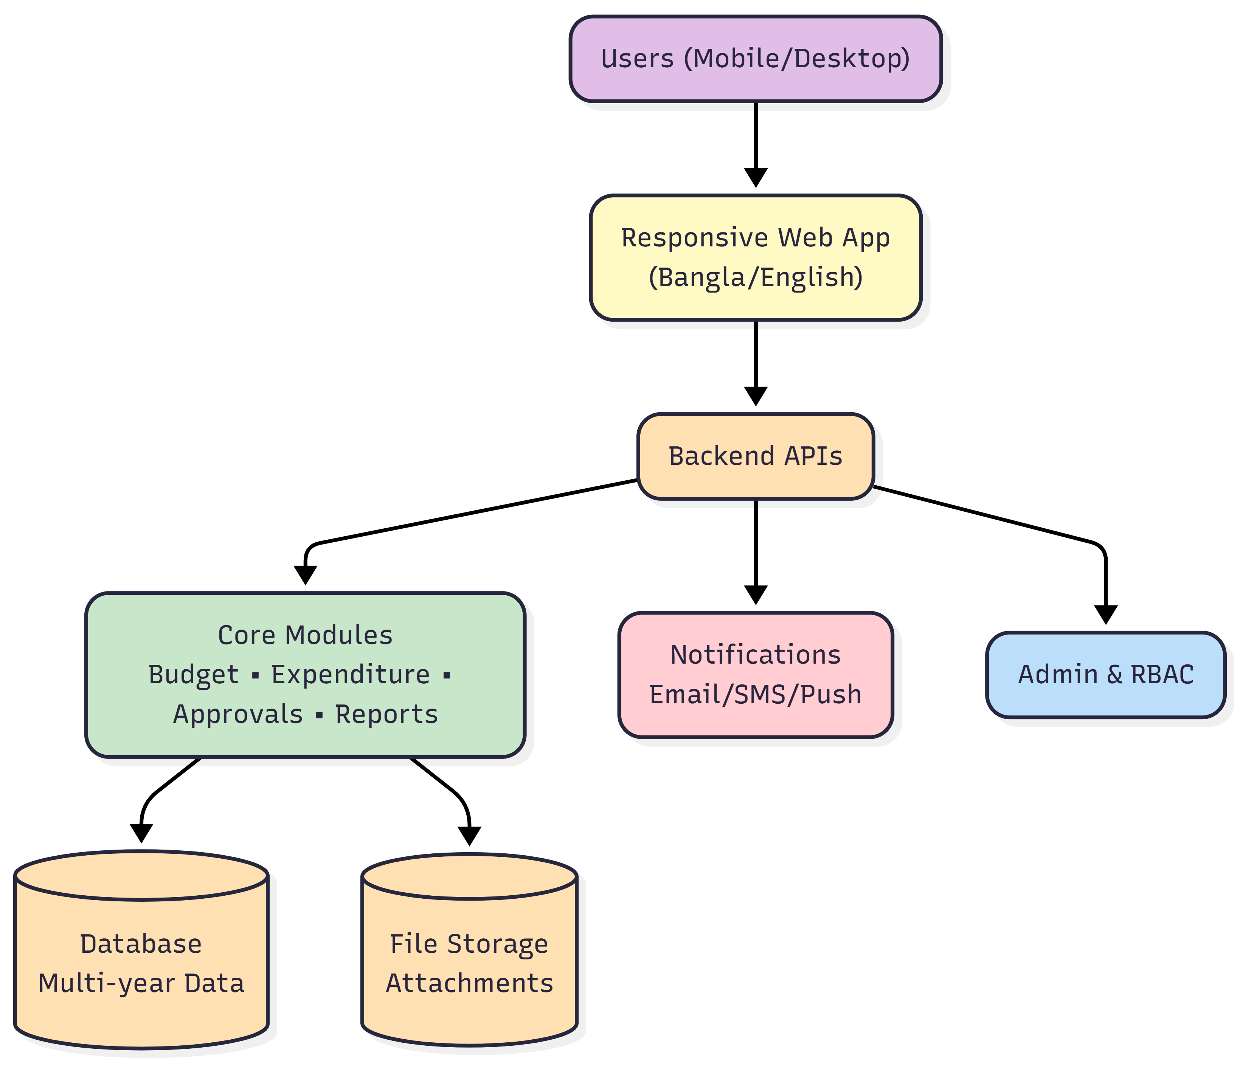5.2 Key Technical Design Decisions
- Mobile-first responsive web app (no native app required), ensuring broad reach and simplified maintenance.
- Template-driven reporting engine to generate prescribed official outputs consistently.
- Strong data model to support multi-year budgets, revisions, approvals, and expenditure tracking.
- Localization layer supporting Bangla-first UI and data entry, with English UI option.
- Security controls: RBAC, audit trails, secure authentication, and hardened hosting.

5.3 Proposed Technology Stack
Layer | Preferred Technology | Notes
Frontend (Web) | React (Next.js) + TypeScript | Responsive UI for Admin and Citizen portals; i18n support; works well on mobile browsers.
Backend APIs | Laravel (PHP) or Node.js (NestJS) (recommended: Laravel) | REST APIs; workflow/business rules; report generation endpoints; scalable and maintainable.
Database | PostgreSQL | Relational integrity for forms, approvals, budget heads; supports reporting and analytics; multi-year partitioning possible.
File Storage | S3-compatible object storage | Stores generated PDFs, attachments, and export files.
Authentication | Session/JWT + optional SMS OTP integration | Role-based access; OTP can be enabled for 2FA depending on stakeholder preference.
Reporting | Server-side PDF generation (wkhtmltopdf / headless Chromium) + templates | Ensures consistent prescribed format outputs; supports Bangla fonts in PDFs.
Analytics/Charts | Chart.js / ECharts | Lightweight charts for public dashboard and admin summaries.
DevOps/Hosting | Linux VPS/Cloud, CI/CD (GitHub Actions) | Automated deployments, backups, monitoring, and SSL renewal.

5.4 Bangla and English Language Support
- Unicode-compliant data entry for Bangla and English, stored as UTF-8 throughout the stack.
- UI localisation (i18n): Bangla-first labels and help text with English toggle.
- PDF/report outputs will embed Bangla-capable fonts to ensure correct rendering on all devices.
- Keyboard support for Bangla typing and copy-paste, including validation messages in Bangla.

5.5 Multi-Year Data Storage and Comparison
- Data model stores fiscal year as a first-class dimension across budgets, approvals, and expenditures.
- Year-over-year comparison views: previous year vs current year by head/sector, with allocation vs actual.
- Snapshotting approved budgets per year to preserve history and ensure reports remain reproducible.
- Exportable comparison summaries for stakeholders and auditors.

5.6 Mobile-Friendly and Low-Bandwidth Optimisation
- Responsive layouts optimised for 360–430px width devices; touch-friendly controls and step-based forms.
- Client-side validation and autosave to reduce re-entry on poor connections.
- Optimised payloads (lazy loading, compression) and caching for faster load times.
- Accessibility considerations: readable font sizes, high-contrast UI options, and clear error states.

5.7 Security, Privacy, and Auditability
- RBAC with least-privilege permissions and secure password policy; optional 2FA/OTP.
- HTTPS/TLS for all traffic; secure headers and CSRF protection.
- Protection against common web threats (OWASP Top 10) through secure coding, validation, and hardening.

Figure 2: Budgeting Workflow and Approval Process (Placeholder)

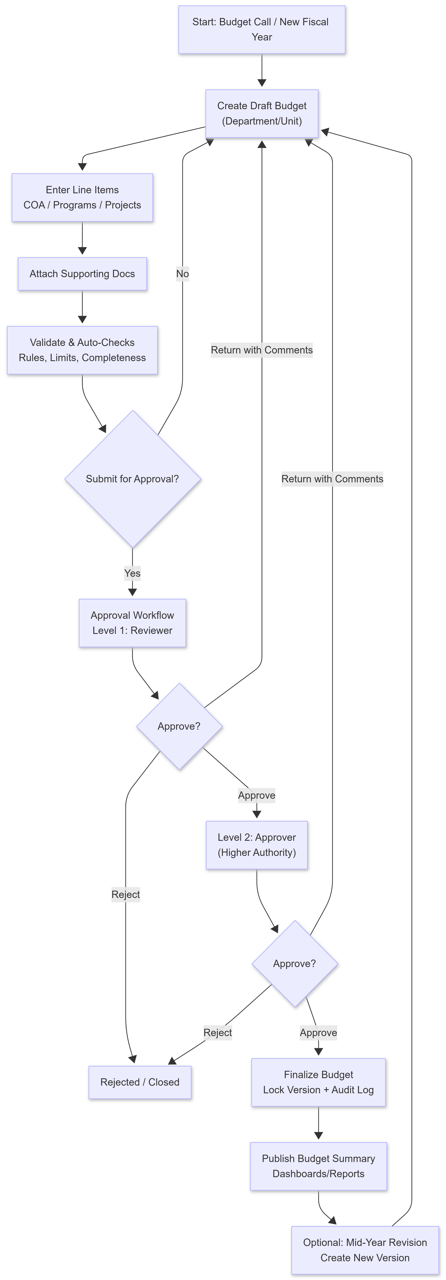

6. Development Methodology and Work Plan
We will follow an iterative Agile delivery approach with clearly defined milestones, stakeholder reviews, and a pilot-driven refinement cycle.

6.1 Phases and Activities

Inception & Co-Design
- Kickoff and inception meetings with Union Parishad officials and relevant authorities.
- Confirm user roles, workflows, acceptance criteria, and statutory form/report requirements.
- Prepare inception report including work plan, stakeholder analysis, and risk matrix.

System Design & Prototype
- UX flow and low-fidelity wireframes for Admin and Citizen portals (mobile-first).
- Finalize architecture, database schema, API specifications, and reporting templates.
- Develop a clickable prototype for stakeholder feedback and approval.

Core Development (Sprint-based)
- Implement digitised forms, validations, calculations, draft/save, and versioning.
- Implement approval workflow, RBAC, audit logs, and report generation/export.
- Implement expenditure tracking and dashboards (admin and citizen).

Testing & Refinement (Pilot)
- Internal QA, security checks, and cross-device testing (low-end Android focus).
- User Acceptance Testing (UAT) with pilot Union Parishads.
- Refinement based on pilot feedback; stabilization and performance tuning.

Deployment, Training & Rollout
- Production deployment with SSL, backups, and monitoring.
- Training sessions for key UP roles; Bangla user manuals and quick guides.
- Rollout support for 39 Union Parishads and initial hypercare.

Handover & Closure
- Source code handover, deployment/runbook, admin guide, and technical documentation.
- Final completion report including challenges and scaling recommendations.

6.2 Governance and Communication
- Weekly progress updates and sprint demos with the programme team.
- Issue/risk log maintained and shared; rapid escalation path for statutory alignment questions.
- Formal sign-off checkpoints: form templates, report templates, pilot acceptance, and rollout readiness.

7. Deliverables and Indicative Timeline
The assignment is expected to be completed within 120 working days and no later than 30 May 2026, subject to the agreement schedule. But we are offering to submit the deliverables (Exclude 39 trainings for UP) within 6 weeks after confirmation of the Inception Report. The following deliverables align with the ToR template and will be refined during inception.
Deliverable | Description
D1. Inception Report | Inception meetings; work plan; stakeholder analysis; risk matrix; draft system architecture; initial UX concept notes/wireframes and user journey maps.
D2. System Design & Prototype | Approved wireframes; architecture; database schema; API specs; clickable prototype (admin + citizen); reporting template drafts.
D3. Core System Development | Digitised forms, validations/calculations, approval workflow, RBAC, admin dashboard, citizen dashboard, report generation, expenditure tracking; internal testing.
D4. Testing & Refinement (Pilot) | UAT with pilot UPs; functional/security/performance testing; fixes and refinements based on feedback.
D5. Deployment & Training | Production deployment with SSL/backups/monitoring; training rollout (Bangla manuals, video tutorials); initial support and stability monitoring.
D6. Final Handover & Completion Report | Final technical documentation; source code; deployment/runbook; hosting and domain credentials; completion report and scaling recommendations.

8. Quality Assurance and Testing Strategy
- Functional testing: form validations, calculations, approvals, report outputs, and expenditure tracking.
- Cross-browser/device testing: focus on commonly used low-cost Android smartphones; iOS Safari support.
- Performance testing: page load targets, report generation time, and API responsiveness under expected loads.
- Security testing: vulnerability scanning, secure authentication checks, and OWASP-aligned testing.
- UAT: structured test scripts and sign-off criteria during pilot.


9. Deployment, Hosting, and Support
- The agency will provide and manage application hosting for 5 (five) years, including server/VPS/cloud setup, uptime monitoring, and routine backups.
- The hosting package will include domain/subdomain configuration, basic security hardening, and a valid SSL/TLS certificate (HTTPS) with renewal for the full hosting period.
- Technical support and maintenance will be provided for 5 (five) years, covering troubleshooting, bug fixing, and minor updates to keep the system stable and functional.
- Data retention, backup, and restore procedures will be designed to ensure multi-year availability and auditability.

10. Training and Documentation
- Role-focused training for: UP Administrative Officer, Accounts Assistant Cum Computer Operator (AACCO), and UDC Entrepreneur.
- Bangla user guide, quick reference sheets, and optional short video tutorials.
- Basic technical documentation: deployment guide, admin configuration, backup/restore, and operational runbook.

11. Assumptions and Dependencies
- Final statutory form templates and prescribed report formats will be confirmed and approved during inception.
- Pilot Union Parishads and UAT participants will be nominated early to avoid schedule delays.
- Any required SMS gateway, OTP provider, or payment gateway details (if applicable) will be provided by the client/programme.
- Hosting environment and domain/subdomain naming will be approved during inception; access credentials will be coordinated securely.
- Data migration from legacy paper records (if required) is not assumed unless explicitly requested and scoped.

