Technical Proposal
Developing a Digital Platform for Streamlining Social Protection in Bangladesh
Interoperable Mobile Application (Android & iOS) + NSSS M&E Dashboard Enhancement + Secure APIs

Prepared for: United Nations Development Programme (UNDP) Bangladesh
Assignment: Social Protection Policy Support (SPPS) Programme
Date: 16 February 2026

Prepared by: Riseup Labs

1. Executive Summary
This proposal presents a complete, from-scratch delivery plan for an interoperable digital platform that strengthens Bangladesh’s social protection ecosystem through (i) a citizen-centric Mobile Application for Android and iOS, (ii) enhancements to the existing National Social Security Strategy (NSSS) Monitoring & Evaluation (M&E) Dashboard, and (iii) secure, version-controlled APIs that enable controlled interoperability with authorized government systems. The solution is designed to align with the Finance Division’s updated programme database structure, improve analytical and visualization capabilities, enable offline access to core information on mobile, and ensure sustainability through documentation, training, and structured handover.
Key outcomes include:
- Unified, user-friendly access to programme information, progress tracking, and SDG-related insights via a mobile-first experience.
- Upgraded NSSS M&E Dashboard features aligned to revised classifications, indicators, and reporting needs.
- Secure API layer enabling near real-time or scheduled synchronization between dashboards, mobile app, and other authorized MIS platforms.
- Institutional capacity building through in-person training, technical documentation, and full source-code handover.

2. Understanding of the TOR and Objectives
UNDP, under the DFAT-supported Social Protection Policy Support (SPPS) Programme, aims to strengthen the Government of Bangladesh’s digital social protection ecosystem by developing an interoperable mobile application and enhancing the NSSS M&E Dashboard to reflect structural changes to the social protection programme database introduced by the Finance Division. The assignment also requires secure interoperability through APIs, rigorous testing, deployment and publication, training for Cabinet Division ICT staff, and maintenance/hosting support during the contract period.
The proposed solution directly addresses the TOR objectives by delivering:
- A cross-platform mobile application (Android and iOS) with offline-capable access to core programme information, analytics, and citizen-facing features (indicative eligibility checking, grievance guidance, FAQs).
- Dashboard enhancements that preserve continuity of the existing platform while aligning the data model and visualizations to the updated database structure.
- A secure API layer with authentication, authorization, throttling, logging, and versioning to support controlled data exchange and future interoperability expansion.

3. Proposed Solution Overview
The solution consists of five tightly integrated components:
- Mobile Application (Android & iOS): Citizen and policymaker access to programme information, progress tracking, SDG visualizations, and guidance features with offline mode.
- NSSS M&E Dashboard Enhancements: Data alignment updates, new analytical views, improved visualization, and administrative tooling to support updated metadata and classifications.
- Secure API Layer: Version-controlled REST APIs (and optional GraphQL for internal aggregation) providing controlled access for mobile and other authorized systems.
- Data Integration & Synchronization: Scheduled and/or event-driven synchronization patterns, caching, and safe fallbacks for partial outages.
- Operations, Capacity Building & Handover: Monitoring, incident processes, documentation, training, and transfer of source code, credentials, and intellectual property.

Figure 1: High-Level Solution Architecture

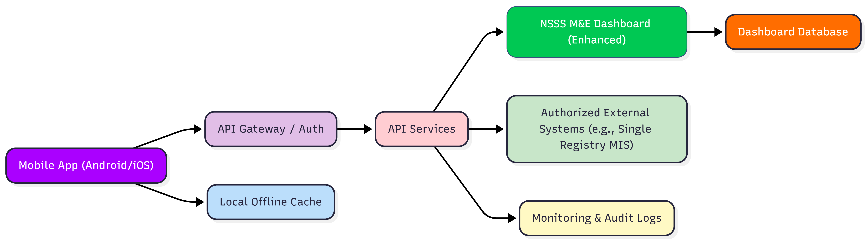

Figure 2: Data Flow and Synchronization Overview

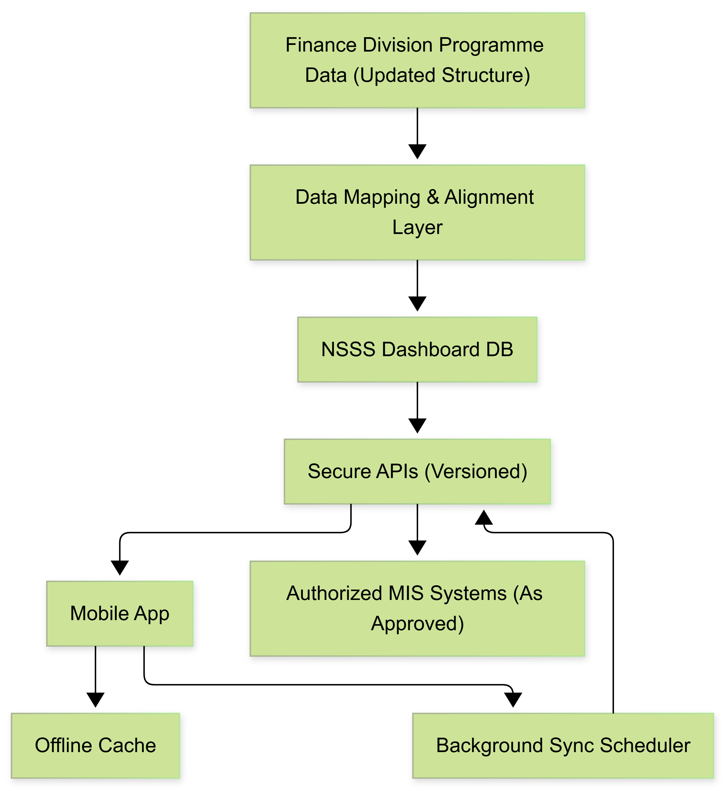

4. Proposed Technical Approach

4.1 Architecture Principles
Our design follows these principles to meet government-grade interoperability, reliability, and security expectations:
- Interoperability by design: Standards-based APIs and clear data contracts, compatible with cross-ministry MIS integration.
- Security-first: Least privilege access, strong authentication and authorization, encryption in transit and at rest, and auditable access logs.
- Resilience and scalability: Stateless API services, caching, rate limiting, health checks, and failover patterns for critical endpoints.
- Mobile-first with offline capability: Local data store and controlled synchronization to ensure usability with intermittent connectivity.
- Maintainability and ownership: Clean code standards, automated CI/CD pipelines, complete documentation, and structured handover.

4.2 Mobile Application (Android and iOS)
The mobile application will be developed from scratch and optimized for diverse devices and connectivity conditions.
Core feature groups:
- Programme discovery: searchable programme catalogue with lifecycle and functional categorization, FAQs, and key contacts.
- Indicative eligibility checking: rule-based questionnaire producing non-binding guidance and next steps (no automated entitlement decision).
- Progress and analytics: NSSS implementation progress summaries, thematic indicators, and SDG-related visualizations adapted for mobile.
- Grievance guidance: information, workflow guidance, and redirection/hand-off options as approved by GoB counterparts.
- Role-based experiences: public users (read-only), analysts (extended analytics), administrators (controlled admin tools), as approved.
Offline mode and synchronization:
- Offline cache for core content and selected datasets (e.g., programme summaries, FAQs, indicator snapshots).
- Background sync with conflict-safe rules (server-wins for reference data; client-wins only for local preferences).
- Graceful degradation when APIs are unavailable (cached read-only mode with clear last-sync timestamp).

4.3 NSSS M&E Dashboard Enhancement
We will enhance the existing NSSS M&E Dashboard by aligning it with the Finance Division’s revised programme database structures, introducing additional analytical and visualization features, and improving usability without disrupting existing stakeholders’ workflows.
Enhancement focus areas:
- Data alignment: update ETL/ingestion scripts, metadata mapping, and classification logic to reflect updated programme structures.
- New analytics and visualizations: lifecycle and functional views, time-series trends, pro-poor expenditure insights, and indicator drill-downs (subject to data availability).
- Administrative utilities: metadata management screens, import validation, change logs, and role-based admin access.
- Performance improvements: query optimization, caching strategies, and asynchronous processing for heavy aggregations.

4.4 Secure API Design and Interoperability
A secure API layer will enable controlled, auditable data exchange between the NSSS M&E Dashboard, the mobile application, and other authorized systems. APIs will support both near real-time fetch patterns and scheduled synchronization, depending on data sensitivity and governance rules.
API capabilities:
- Versioning (v1, v2), backward compatibility rules, and deprecation policy.
- Strong authentication and authorization (OAuth 2.0 / OpenID Connect for users; client credentials for system-to-system).
- Rate limiting and throttling per client, plus allow-listing for government networks where applicable.
- Structured logging and audit trails (who accessed what, when, from where, and with what scope).

4.5 Data Model Alignment and Governance
During inception, we will complete a full mapping of the updated Finance Division social protection programme database structure to the NSSS dashboard model. The API and mobile data models will be derived from this canonical mapping to ensure consistency across channels.
Key data governance measures:
- Data classification and access tiers (public, restricted, confidential) enforced at API gateway and application layers.
- Minimization: mobile app receives only the minimum dataset required for approved features.
- Auditability: change logs for reference data, metadata updates, and user/admin actions.
- Interoperability standards alignment (data format, identifiers, and API conventions) to support cross-platform integration.

4.6 Security, Privacy, and Compliance
The solution will be implemented in line with Government of Bangladesh cyber and data governance expectations, and international best practices. Controls will be built into architecture, code, deployment, and operations.
Security controls:
- Transport security: TLS 1.2+ for all external and internal service communication.
- Secrets management: vault-based secret storage and rotation; no credentials in source code or client apps.
- Encryption at rest: database and backup encryption; mobile secure storage for tokens/keys.
- Application security: OWASP-aligned secure coding, input validation, and automated SAST/DAST where feasible.
- Vulnerability management: patching policy and routine security updates during the support period.
- Monitoring and incident response: alerts, log retention, and defined escalation matrix.
Privacy controls:
- Privacy-by-design for any personally identifiable data (if/when enabled for authorized users).
- Role-based access controls (RBAC) and least-privilege scopes for all data endpoints.
- Consent and transparency notices in the mobile app aligned with government guidance and UNDP review.

4.7 Hosting, Deployment, and Operations
Deployment will follow a secure DevSecOps pipeline, with separated environments (Development, Staging, Production) and repeatable infrastructure-as-code. Hosting will be coordinated with UNDP and GoB authorities. During the contract period, the vendor will provide hosting and operational support for the NSSS M&E Dashboard and the Cabinet Division social protection website as specified in the TOR.
Operational design elements:
- Containerized services (Docker) with automated deployment pipelines and rollback support.
- High availability for critical APIs (load balancing, health checks, failover-ready configuration).
- Monitoring: uptime dashboards, performance metrics, and alerting for key service indicators.

5. Proposed Technical Stack
The following stack is proposed for new components (mobile app and API layer) and for enhancing the existing dashboard. During inception, we will validate the current dashboard technology and align enhancements accordingly to avoid unnecessary rewrites.
Layer | Proposed Technology | Notes / Rationale
Mobile App | Flutter (Dart)  Android + iOS (single codebase) | Fast cross-platform delivery, strong performance, offline-first support, and consistent UI across devices.
API Services | Laravel (PHP) REST APIs | Mature framework, rapid secure development, strong ecosystem;
API Gateway / Security | Nginx / Kong (gateway)  OAuth2 / OIDC (Keycloak or equivalent) | Centralized auth, rate limiting, auditing, and versioning; self-hosted IAM option for government deployments.
Dashboard Enhancements | Extend existing codebase  (UI components: Vue/React as per current stack) | Minimizes disruption; enhancements follow existing architecture and hosting constraints.
Database | SQLite | Preserve authoritative source; optional read-optimized store for analytics and mobile snapshots.
Caching | Redis | Improves response time for frequently accessed datasets and reduces DB load.
Data Sync / Jobs | Queue workers (Laravel Queue)  Cron-based schedules | Reliable background processing for aggregations and synchronization tasks.
Mobile Local Store | SQLite (encrypted where needed) | Offline cache for reference data and indicator snapshots with last-sync tracking.
CI/CD | Git-based workflow  GitLab CI or GitHub Actions | Automated builds, tests, security scans, and controlled production releases.
Containerization | Docker  Kubernetes (if available) | Repeatable deployments, scaling, and environment parity.
Monitoring & Logging | Prometheus + Grafana | Operational visibility, performance tracking, and audit-ready log retention.
Security Testing | OWASP ZAP (DAST)  SAST tooling | Automated security checks integrated into CI/CD to reduce risk before release.

6. Development Methodology

6.1 Delivery Model
We will follow an Agile delivery approach with iterative prototyping and sprints, aligned to the TOR expectation of agility and iterative refinement. The approach ensures early validation by UNDP and GoB stakeholders while keeping scope controlled through sprint-based prioritization.

6.2 Key Activities and Ceremonies
- Inception workshops: confirm scope, roles, data governance rules, interoperability needs, and acceptance criteria.
- Backlog grooming and sprint planning: define user stories, technical tasks, and sprint goals.
- Sprint reviews/demos: working software demonstrated every two weeks for stakeholder feedback.
- QA gates: functional and security checks integrated into each sprint, not only at the end.
- Change control: approved change requests with impact analysis (timeline, risk, dependency).

6.3 Documentation and Traceability
- Requirements traceability matrix (RTM) linking TOR requirements to user stories, test cases, and acceptance evidence.
- API documentation (OpenAPI), data mapping documentation, and deployment runbooks maintained continuously.
- Version-controlled repositories and tagged releases for reproducibility.

6.4 Project Governance
We propose the following coordination structure to ensure predictable delivery:
- Steering Committee (bi-weekly): UNDP/SPPS + Cabinet Division + key stakeholders to resolve escalations and approve milestones.
- Technical Working Group (weekly): ICT System Analysts, vendor tech leads, and programme team to review designs and integration constraints.
- UAT Working Group (as needed): representative end-users for dashboard and mobile app validation.

7. Testing and Quality Assurance
Quality assurance will be embedded throughout the delivery lifecycle. Testing will cover the mobile application, dashboard enhancements, APIs, and end-to-end data flows.

7.1 Test Strategy
- Shift-left testing: unit and integration tests added during development; defects fixed within the same sprint whenever possible.
- Environment parity: Staging mirrors production configuration to reduce deployment risk.
- Risk-based prioritization: high-risk modules (auth, data access control, synchronization, API security) receive deeper testing.


Fig: QA Test Process

8. Implementation Plan

Phase | Key Activities | Key Outputs
Phase 1: Inception & Requirement Analysis | Stakeholder inception workshops; review of current dashboard architecture, databases, and hosting; data model mapping to Finance Division structures; interoperability assessment; UI/UX wireframes; workplan and RTM. | Inception Report; architecture & data model overview; approved wireframes; detailed sprint plan; risk register.
Phase 2: Solution Design & Setup | Finalize technical designs; set up repositories and CI/CD; define API standards, auth model, and data contracts; prepare environments (Dev/Staging/UAT). | System Design Document (SDD); API specification baseline; environment setup; initial prototypes.
Phase 3: Build (Mobile + APIs + Dashboard Enhancements) | Mobile app development; API development and gateway configuration; dashboard enhancements and data alignment updates; iterative sprint demos; continuous testing. | Working mobile builds; implemented APIs; updated dashboard modules; sprint demo sign-offs; updated documentation.
Phase 4: Testing, and Hardening | Comprehensive functional/integration/security testing; performance tuning; UAT support; defect resolution; release candidate preparation. | Test reports; UAT sign-off; release candidate builds; deployment readiness checklist.
Phase 5: Deployment, Publication, Training & Handover | Production deployment: app publication (Play Store/App Store); monitoring configuration; training delivery; handover of source code, credentials, and documentation. | Production release; published apps; training completion report; handover package; operational runbook.

9. Deliverables and Acceptance Criteria
The following deliverables will be produced. Each deliverable will include measurable acceptance criteria and evidence artifacts to support UNDP/GoB review and sign-off.
Deliverable | Description | Acceptance Criteria (Summary)
D1. Inception Report | Stakeholder meeting outputs; architecture concept; updated data model alignment approach; API integration plan; data flow diagrams; UI/UX wireframes; detailed work plan and methodology. | Approved by UNDP/SPPS and relevant GoB stakeholders; includes RTM, risks, and implementation plan.
D2. System Design Document (SDD) | Detailed technical designs for mobile, APIs, dashboard enhancements, security model, hosting topology, and integration approach. | Reviewed and approved by Technical Working Group; designs are implementable and aligned to governance constraints.
D3. Mobile Application (Android) | Android production-ready build with offline capability and approved feature set; analytics visualizations and role-based access. | Passes functional, security, and compatibility tests; UAT sign-off for Android.
D4. Mobile Application (iOS) | iOS production-ready build with the same approved feature set and offline capability. | Passes functional, security, and compatibility tests; UAT sign-off for iOS.
D5. NSSS M&E Dashboard Enhancements | Implemented data alignment updates, new analytics/visualizations, and admin utilities as approved. | Validated against updated programme structure; performance meets agreed thresholds; UAT sign-off for dashboard modules.
D6. Secure APIs and API Documentation | Versioned REST APIs with auth, rate limiting, and audit logs; OpenAPI specs and integration guidance. | Successful end-to-end integration tests with mobile; security test passed; documentation complete.
D7. Testing Reports | Functional, integration, security, compatibility, and performance test reports; and sign-off. | All critical defects resolved; agreed exit criteria met.
D8. Deployment & Release Package | Production deployment, configuration, monitoring setup, and release notes; app store publication support. | Production verification complete; rollback plan available; operational readiness checklist signed off.
D9. Training Package and Completion Report | Training curriculum, materials, hands-on sessions for Cabinet Division ICT officials and SPPS staff. | Training delivered; participant attendance; post-training assessment/feedback captured.
D10. Handover Package | Source code repositories, credentials, configuration guides, architecture docs, DB schema, API docs, user manuals, admin guides, and IP transfer package. | Complete transfer verified; GoB/UNDP access validated; handover sign-off obtained.
D11. Maintenance & Support Completion Report | Summary of hosting, monitoring, security patching, incident handling, and support activities during the agreed period. | Support period delivered as per agreed SLA; final report submitted and accepted.

10. Training, Documentation, and Handover
Sustainability and institutional ownership are core deliverables. We will deliver a structured capacity development and handover program for Cabinet Division ICT System Analysts, relevant ICT officials, and SPPS Programme staff.

10.1 Training Plan (In-Person)
Training modules:
- System overview: architecture, environments, and operational responsibilities.
- Dashboard administration: data updates, metadata management, and report generation.
- API usage: authentication, endpoint usage, troubleshooting, and versioning practices.
- Mobile application management: release process, configuration, analytics, and support workflows.
- Routine maintenance: backups, monitoring, patching, and incident handling.

10.2 Documentation Set
- System Architecture Document and updated Data Model Mapping.
- API documentation (OpenAPI), integration guides, and sample requests.
- Database schema and configuration guides; ETL/sync job documentation.
- User manuals (mobile and dashboard) and admin runbooks.
- Deployment runbook, monitoring dashboard guide, and incident response playbook.

10.3 Handover
Handover will include full source code, repositories, build pipelines, credentials (via secure transfer), documentation, and intellectual property transfer artifacts, as required by the TOR.

11. Maintenance and Technical Support Approach
We will provide hosting, maintenance, and technical support for an agreed duration, including continuous monitoring, routine security updates, and timely resolution of technical issues. The support model will be finalized during inception and documented in an Operations and Support Plan.

11.1 Support Services
- System monitoring and uptime tracking (dashboard, APIs, and synchronization jobs).
- Security patch management and vulnerability remediation support.
- Incident management with defined severity levels and response times.
- Data synchronization integrity checks and corrective actions for failed syncs.
- Capacity and performance reviews, with scaling recommendations as usage grows.

11.2 High Availability and Disaster Recovery
- High availability configuration for critical API endpoints (load balancer + multiple instances).
- Automated backups and periodic restore drills; defined RPO/RTO targets agreed with UNDP/GoB.
- Failover-ready configuration for databases and storage where infrastructure permits.

12. Assumptions, Dependencies, and Risk Management

12.1 Key Assumptions
- UNDP and GoB counterparts will provide timely access to the existing NSSS M&E Dashboard source code (where applicable), databases, current APIs, and hosting details for assessment and enhancement.
- Finance Division database structure and mapping logic required for alignment will be shared in a usable format during inception.
- Data governance rules (public vs restricted datasets) and branding guidelines will be confirmed and formally approved before development finalization.
- App Store / Play Store publication will be supported by the owning entity (GoB/SPPS) through provision of required developer accounts and branding assets.
- A designated Technical Working Group will be available for weekly reviews and timely decisions.

12.2 Key Dependencies
- Interoperability requirements and permissions for connecting with the Single Registry MIS and other ministry-level MIS systems (as authorized).
- Hosting approvals and network/security approvals for production environments (NDC/BCC Cloud or other designated infrastructure).
- Availability of representative data samples for testing analytics and visualizations.

12.3 Risk Register (Summary)
Risk | Potential Impact | Mitigation
Late access to existing dashboard assets or data models | Design and development delays | Early access request; parallel planning; staged enhancement approach.
Unclear governance for restricted datasets | Rework on access controls and APIs | Data classification workshop in Week 1; sign-off on access matrix.
App store review delays | Delay in public availability of the mobile app | Submit early; follow store guidelines; maintain TestFlight/closed testing plan.
Performance bottlenecks on analytics queries | Slow dashboards/APIs under load | Caching, query optimization, and performance testing; optional read-optimized reporting store.
Integration constraints with external MIS systems | Reduced interoperability scope | Phased integration; API contracts and sandbox testing; clear authorization process.

