TECHNICAL PROPOSAL
Unimart Digital Commerce Platform
Web, Android, and iOS solutions to deliver a premium, habit-driven shopping experience for quality-focused customers.
Prepared For | Unimart
Prepared By | Riseup Labs
Document Type | Technical Proposal
Figma Link | Figma UI Link (Minimal Flow):  https://www.figma.com/design/As9uQWpF208p3AV0HqkZs3/Unimart-Website---App-Demo?node-id=0-1&t=5oJCQ83weGh3pWjF-1
Demo App Link | https://unimart-magic-wand.lovable.app  Email: rahim@example.com  Password: User@2024
Demo Web link | https://unimart-premium-groceries.lovable.app/

1. Executive Summary
Unimart’s concept document positions the platform as a premium digital experience for quality-focused customers, centered on four main pillars: refined UI/UX, customer memory and search intelligence, resilient platform architecture, and actionable customer data insights.
Based on that direction, we propose building the solution from scratch as a unified digital commerce platform consisting of:
• A customer application for Android and iOS using Flutter.
• A responsive web application for desktop and mobile browsers.
• A web-based admin and operations portal for content, promotions, configuration.
• A secure backend and integration layer to synchronize product, price, inventory, customer, order, and promotional data with Unimart’s existing enterprise systems.
• A basic rider application for Android and iOS to support login, order acceptance, delivery status updates, customer calling, Basic navigation, and completed delivery tracking.

The proposed solution is designed to convert the concept into a scalable, maintainable production system that supports premium browsing, intent-led discovery, contextual promotions and data-driven decision making across web and mobile channels.
2. Project Understanding and Objectives
The supplied concept emphasizes that the application should feel like a memory, guide, and brand extension rather than a generic grocery app. That vision has several practical implications for product strategy, architecture, and delivery.
• The experience must feel premium, minimal, calm, and fast.
• The platform should reduce customer effort through location awareness, strong search, repeat-buy cues, and personalized discovery.
• Merchandising and brand presence should be dynamic and context-sensitive, especially during seasonal or store-driven campaigns.
• The solution must be integration-ready so that inventory, pricing, and catalog accuracy remain aligned with enterprise data sources.
• The platform should continuously generate customer and operational insights for future optimization.
Project Objectives
• Launch a reliable web and mobile commerce platform.
• Provide a premium digital shopping journey across onboarding, browsing, product discovery, purchase, reorder, and customer engagement.
• Enable server-driven configuration for banners, promotions, event themes, and selected layout blocks without mandatory client updates.
• Support ERP-led synchronization of catalog, pricing, stock, and selected customer or purchase signals.
• Enable a basic rider delivery workflow covering login, online/offline availability, assigned order view, accept/reject action, delivery status updates, customer contact, delivery confirmation, and order history.
• Create a secure data foundation for analytics, merchandising insight, and future personalization

3. Proposed Solution Scope
To operationalize the concept document, the proposal combines explicitly stated experience requirements with the core commerce capabilities required to run a production retail platform.
3.1 In-Scope Functional Areas
Area | Capability
Customer onboarding | Brand-led onboarding flow, optional sign in, location/store selection, customer preferences, and fast start into shopping.
Catalog and navigation | Home page, categories, subcategories, filters, sorting, use-case-led collections, hover/floating category shortcut, and contextual promotional modules.
Search and discovery | Sticky search, keyword and intent-aware search.
Product experience | Premium product detail page, sourcing and quality cues, rich media gallery, price and stock visibility, add to cart, reorder indicator, and related brands or products.
Cart and checkout | Cart management, promo application, delivery address and time slot handling, payment initiation, order summary, and checkout confirmation.
Orders and engagement | Order history, reorder, order status updates, transactional notifications, abandoned cart nudges, and promotional notifications.
Rider application | Phone number and OTP login, online/offline toggle, assigned order details (pickup location, delivery address, customer phone), accept/reject order, delivery status flow (Picked Up, On the Way, Delivered), one-tap customer call, Google Maps handoff, delivery confirmation, and completed delivery history.
Integrations and data | ERP/POS synchronization, price and stock updates, analytics event capture, notification services, media storage, and performance monitoring.

3.4 Technical Diagrams
High Level Solution Architecture

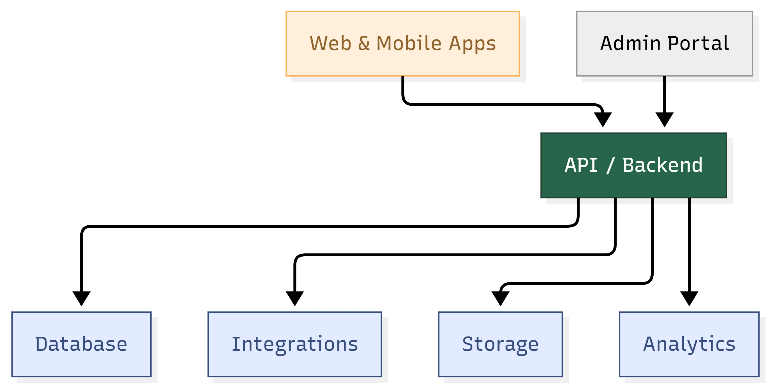
Figure 1. High-level system architecture.
Customer Commerce Journey Workflow

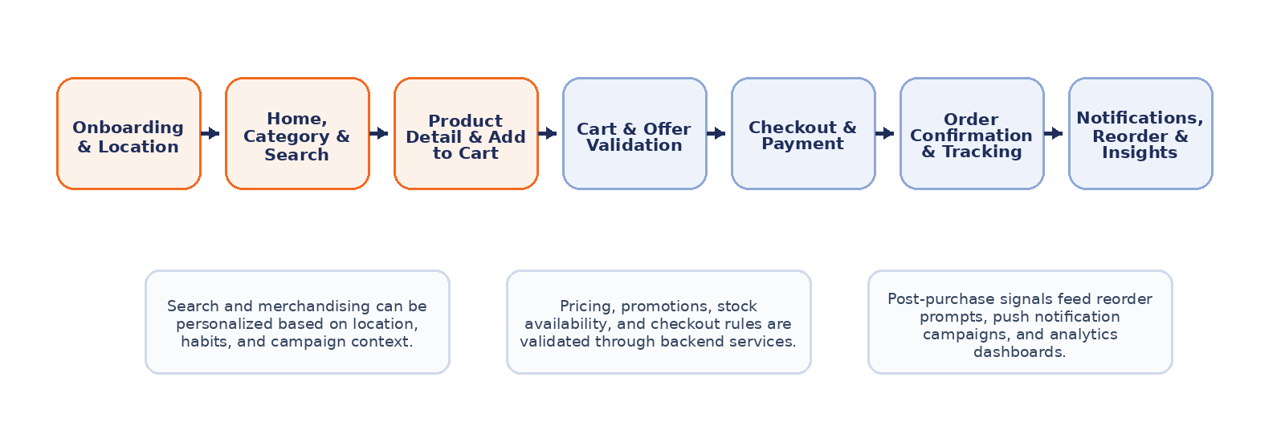
Figure 2. Customer commerce journey workflow.

4. Proposed Technical Approach
The recommended approach is to build a modular, API-first retail platform with a shared Flutter codebase for customer-facing channels and a secure backend that orchestrates commerce, content, promotions, and integrations.
4.1 Architecture Principles
• Single product vision, multiple channels: maintain consistent business logic across web and mobile while adapting the UI to each device context.
• API-first and integration-ready: keep commerce capabilities decoupled from ERP/POS systems using a dedicated integration layer.
• Server-driven experience controls: configure banners, campaigns, category modules, event themes, and selected layout blocks without mandatory client updates.
• Resilient synchronization: support catalog, price, stock, and store updates with logging, retry handling, and operational visibility.
• Security by design: implement role-based access control, secure authentication, encrypted data movement, and auditability for administrative actions.
• Analytics from day one: capture structured customer, order, search, and experience events to support optimization and future personalization.
4.2 Frontend Application Architecture
The customer solution will be developed in Flutter for Android, iOS. The codebase should follow a modular structure with clear separation of presentation, domain, and data layers.
• Feature-based module organization.
• Repository pattern for API, cache, and local storage abstraction.
• A lightweight rider-facing Flutter module to support assigned delivery execution with a simplified workflow and minimal interaction overhead.
• Design system components for cards, banners, search bars, product tiles, checkout steps, and campaign modules.
• Responsive layouts to support mobile-first use cases while maintaining usable desktop and tablet web views.
4.3 Backend Service Architecture
The backend should expose secure REST APIs and background job capabilities to support commerce operations, notifications, synchronization, and administration. Core service domains are expected to include:
• Identity and access management.
• Rider order assignment, delivery status tracking, OTP-based completion support, and rider activity history.
• Catalog, category, and pricing management.
• Inventory and store availability.
• Cart, checkout, order, and payment orchestration.
• Promotion and campaign rules.
• Search and recommendation support.
• Server-driven UI configuration and content delivery.
4.4 Integration Strategy
Because the concept explicitly mentions ERP-led inventory and price synchronization, integration design is a central part of the solution. We recommend a controlled approach in which master data continues to originate from enterprise systems while the digital platform manages customer experience, session, cart, campaign, and channel interaction data.
• Use scheduled jobs for catalog, price, and stock import during the initial production phase.
• Introduce event-based or near-real-time updates for high-volatility stock or campaign data where operationally justified.
• Normalize inbound data into platform-ready entities before publishing to customer channels.
• Maintain sync logs, validation reports, and retry queues for support and auditability.
• Separate internal source schemas from public API contracts to reduce long-term coupling.
4.5 Search, Personalization, and Customer Memory
The concept highlights customer memory and intent-driven search. To balance business value and delivery practicality, we recommend a layered rollout:
Layer | Implementation | Outcome
Layer 1 | Keyword search, synonym dictionary, curated suggestions, product and category indexing. | Fast and dependable discovery baseline.
Layer 2 | Repeat-buy memory, basket associations, location relevance, and campaign-aware ranking rules. | Smarter recommendations with operational control.
Layer 3 | Intent interpretation, natural-language search refinement, and advanced personalization. | Higher conversion and richer customer guidance.

4.6 Security, Reliability, and Operations
• Secure authentication for customers and administrators.
• Role-based access control for admin and operations users.
• Audit trails for promotion, pricing, content, and configuration changes.
• Environment separation for development, staging, and production.
• Centralized logging, exception monitoring, API health checks, and job alerts.
• Backup and recovery strategy for databases, media, and configuration.
5. Suggested Technology Stack
Layer | Recommended Stack | Purpose
Frontend | React/Vue | Shared codebase for Android, iOS, and web application delivery.
Mobile App | Flutter | Shared codebase for hybrid approach
State management | BLoC/Cubit | Predictable state handling for scalable Flutter modules.
Backend | NestJS / Node.js / Laravel | Structured API development, background jobs, and integration-friendly service design.
Database | PostgreSQL / Mysql | Transactional data store for customers, catalog views, carts, orders, and admin data.
Cache / queue | Redis | Session acceleration, caching, rate control, and background processing support.
Storage | S3-compatible object storage | Media assets, product images, campaign files, and static documents.
Search | Algolia, Melisearch, Or Indexing search | Phased discovery capability without early overengineering.
Analytics | Firebase Analytics | Customer behavior, funnel, campaign, and performance measurement.
Monitoring | Application monitoring and centralized logs | Operational visibility, alerting, and issue analysis.

Why Flutter is a strong fit. Flutter supports rapid delivery of consistent customer experiences across Android, iOS, and web while preserving a shared design system and reusable business logic. It is particularly suitable for the premium UI direction described in the concept document.

6. Development Methodology
We recommend an Agile delivery model with structured discovery, sprint-based implementation, and controlled release management.
6.1 Delivery Approach
Area | Capability
Discovery and alignment | Validate process flows, data sources, business rules, store model, promotion logic, and integration assumptions; finalize backlog and release plan.
Architecture and setup | Establish solution architecture, environments, repositories, CI/CD, coding standards, and technical foundations.
Sprint delivery | Deliver prioritized modules in 2-week sprints with demos, backlog refinement, and iterative stakeholder feedback.
System integration | Connect ERP/POS and notification services, validate data accuracy, and stabilize operational workflows.
QA and release | Execute functional, regression, integration, performance, and test cycles before production release.
Hypercare | Provide post-go-live monitoring, bug fixing, and controlled improvement support after launch.

7. Testing and Quality Assurance
Given that the solution will launch across web and mobile while relying on enterprise data synchronization, testing must cover both customer-facing quality and operational reliability.
Test Area | Focus | Purpose
Functional testing | Customer and admin features | Validate that each workflow behaves according to approved requirements and rules.
Integration testing | ERP/POS, notifications, payment, analytics | Confirm end-to-end data accuracy and resilient service interaction.
UI and responsive testing | Android, iOS, web resolutions | Ensure consistent experience across target devices and browsers.
Performance testing | API, app load, search, checkout | Measure responsiveness under expected traffic and operational load.
Security testing | Auth, permissions, data movement | Reduce risk related to unauthorized access or sensitive data exposure.
Regression testing | All stable modules during each release | Protect previously delivered features from unintended breakage.

7.1 QA Practices Recommended for This Project
• Requirement traceability from backlog item to test case.
• Dedicated test environments and test data strategy for catalog, stock, and pricing validation.
• Scenario-based testing for rider login, order acceptance/rejection, status progression, delivery confirmation, and maps/call handoff behaviors.
• Automated unit and API tests for critical business logic.
• Manual exploratory testing for premium UX, gesture behavior, and campaign flows.
• Pre-release smoke testing across the supported web and mobile targets.
• Post-deployment monitoring with rollback readiness.


8. Deliverables
Deliverable | Description
Technical proposal | Detailed technical approach, solution scope, architecture, technology stack, delivery methodology, QA strategy, and timeline.
Flutter applications | Customer-facing web, Android, and iOS applications developed from scratch, along with a basic rider application to support delivery execution workflows.
Admin portal | Web-based administration and operations portal for content, campaigns, and monitoring.
Backend services | API layer, business logic, authentication, integrations, and background processing services.

10. Assumptions and Dependencies
• SMS/OTP service access, rider account provisioning rules, order assignment logic, and the preferred delivery confirmation method (customer OTP or simple manual completion) will be confirmed during discovery.
• Detailed business rules for cart, checkout, payment, refund, delivery, and order fulfilment will be confirmed during discovery. The revised scope also includes a basic rider application to support simple delivery operations without expanding the platform into a complex fleet-management system.
• ERP/POS source systems will expose required data feeds, access methods, and validation support from the client-side technical team.
• Final UI design system, branding assets, and copy will be approved before full-scale sprint execution.
• Required third-party accounts or credentials for push notification, email/SMS, maps, analytics, and payment integration will be provided on time.
• Performance targets, non-functional requirements, and security/compliance expectations will be finalized during solution design.
11. Conclusion
The Unimart concept creates a strong opportunity to deliver a differentiated digital commerce experience beyond basic online shopping. A phased, from-scratch Flutter implementation across web and mobile, supported by secure backend services, ERP-ready integrations, server-driven experience controls, and analytics foundations, will allow Unimart to launch a premium digital channel that can scale into richer personalization, merchandising intelligence, and future optimization. Financial details are intentionally excluded from this document to keep the proposal technical in scope.

