Technical Proposal
ULAB Website Upgrade
  - A practical, scalable and requirement-aligned proposal for UI/UX redesign, information architecture, content migration, SEO, performance optimization, deployment support and existing system integration.
Prepared by: Riseup Labs


Table of Contents
1. Executive Summary 3
2. Understanding of ULAB Website Upgrade Priorities 3
3. Scope of Work 3
4. Proposed Technical Approach 4
5. Proposed Technology Stack 4
6. Information Architecture and User Journey 5
7. Key Website Areas and Functional Scope 5
8. Existing System Integration Approach 6
9. Content Migration and Governance Approach 6
10. Technical Diagrams 7
11. Development Methodology 9
12. Deliverables 9
13. Testing and Quality Assurance 9
14. Assumptions and Client Responsibilities 10
15. Out of Scope Items 10
16. Success Criteria 10
17. Conclusion 11

1. Executive Summary
ULAB aims to upgrade its website from an activity-documentation platform into a modern, globally competitive, student-centered university platform. The website should guide prospective students, parents, researchers, alumni and partners through clear journeys, stronger storytelling, relevant outcomes and improved conversion paths.
This proposal recommends a React and Laravel-based website upgrade with refreshed UI/UX, reviewed information architecture, reusable page templates, structured content migration, SEO readiness, performance improvement, mobile-first delivery, deployment support and controlled integration with existing systems such as ERP, LMS, Student Portal and online admissions systems.

2. Understanding of ULAB Website Upgrade Priorities
Based on the provided ULAB Website Upgrade Plan and supporting research into current higher-education website practices, the following priorities guide the proposed scope:
Priority Area | Proposal Response
Strategic repositioning | Present ULAB as a modern, globally competitive, student-centered university platform rather than only an institutional archive.
Homepage as conversion engine | Use strong above-the-fold messaging, visible CTAs, authentic visuals and outcome-led storytelling.
Clear admissions journey | Reduce friction for Apply Now, program discovery, scholarships, inquiry and campus/contact actions.
Improved information architecture | Support the journey Explore > Compare > Apply > Enroll through clearer navigation and fewer clicks.
Outcome-driven program pages | Emphasize career pathways, industry relevance, alumni success, research opportunities and international exposure.
Research and rankings visibility | Make research highlights, SDG initiatives, publications, collaborations and impact metrics easier to discover.
Mobile-first experience | Treat mobile as a primary experience with fast CTA access, short content blocks and optimized scrolling.
SEO and discoverability | Provide search-friendly program pages, metadata, structured headings, content hierarchy and redirect strategy.
Content governance | Use featured/archive logic, page templates, content workflows and update controls to prevent outdated content from dominating priority areas.

3. Scope of Work
The proposed scope is limited to the core items required for the ULAB website upgrade.
Scope Item | Included Activities
UI/UX Design | Modern academic minimalism, visual hierarchy, responsive layouts, campus/student imagery placement guidance, CTA-first design, reusable design components.
Information Architecture Review | Navigation review, sitemap refinement, page hierarchy, admissions journey simplification and content grouping around user journeys.
Laravel CMS/Admin and Page Templates | Laravel CMS/admin setup and configuration, reusable templates for homepage, programs, departments, admissions, research, news, events, pages and landing sections.
Homepage Upgrade | Above-the-fold value proposition, primary CTAs, featured content logic, outcome metrics, success stories and research/international highlights.
Admissions Experience | Prominent Apply Now, admission pathways, scholarship visibility, inquiry lead capture form, mobile-friendly admissions page flow and counselling/contact links.
Academic Program Pages | Structured content blocks for overview, eligibility, curriculum, career pathways, outcomes, faculty, research exposure and international opportunities.
Research & Rankings Visibility | Research overview structure, rankings/impact section, publications visibility, SDG initiatives and reusable highlight cards.
Content Migration | Existing content audit, content mapping, migration preparation, import/manual migration, media optimization, URL/redirect mapping and validation.
SEO Optimization | Metadata structure, semantic headings, XML sitemap, robots configuration, schema-ready templates, image alt text, internal linking and redirects.
Performance Enhancement | Image optimization, caching, lazy loading, code optimization, CDN readiness and Core Web Vitals-focused performance checks.
Existing System Integration | Integration points with ERP, LMS, Student Portal, online admissions or other ULAB systems through secure links, APIs, SSO-ready approach or embedded forms where available.
Deployment Support | Staging setup, launch checklist, production deployment support, smoke testing, rollback planning and post-launch handover.

4. Proposed Technical Approach
Approach Step | Description
1. Discovery and Technical Audit | Review current website structure, content inventory, current CMS/admin status, hosting environment, analytics/search visibility, integrations, page types and content ownership.
2. IA and UX Planning | Refine the sitemap and user journeys around admissions conversion, program exploration, research visibility, student life and institutional storytelling.
3. UI Design System | Design responsive page layouts, components, cards, CTA patterns and typography rules with a clean higher-education visual style.
4. Laravel and React Implementation | Build Laravel-based content models, admin workflows and React page templates so ULAB teams can manage pages, news, events, programs and highlights without developer dependency for routine updates.
5. Migration and Governance | Map existing pages into the new structure, migrate approved content, define featured/archive rules and validate content accuracy before launch.
6. Integration Layer | Connect existing systems using secure, low-risk patterns such as verified URLs, API endpoints, iframe/embed only when approved, SSO-ready handoff or form data endpoints.
7. SEO, Performance and Accessibility | Apply technical SEO, mobile-first responsiveness, Core Web Vitals optimization and accessibility checks as part of development, not as an afterthought.
8. Staging, QA and Launch | Complete testing on staging, resolve launch blockers, finalize redirects, deploy production release and hand over Laravel admin/CMS documentation.

5. Proposed Technology Stack
The proposed stack uses React for the public website frontend and Laravel for the backend, CMS/admin, APIs, content governance and integration layer. This approach is suitable for a content-heavy university website with admissions journeys, structured program pages, research visibility and controlled integrations. Final package and hosting choices should be validated during the technical audit.
Layer | Recommended Technology / Approach
Frontend Application | React-based public website frontend using reusable components, responsive layouts, CTA-focused pages and optimized static/dynamic rendering as appropriate for ULAB's hosting architecture.
Backend / CMS / API | Laravel backend for content management, admin workflows, page/content models, media handling, forms, API endpoints and controlled integration logic.
Runtime & Language | PHP 8.3+ for Laravel, Composer-managed dependencies, Node.js build tooling for React assets, and secure environment configuration.
Database | MySQL 8 / MariaDB 10.6+ or PostgreSQL depending on infrastructure preference and existing hosting compatibility.
Frontend UI Layer | React, HTML5, CSS3, JavaScript/TypeScript, Tailwind CSS or Bootstrap-based component system, depending on final design system approval.
Caching & Performance | Laravel cache, optimized asset builds, CDN readiness, image optimization, lazy loading and Redis/Varnish where available.
Search / Indexing | Laravel-managed site search or simple search-ready structure, sitemap/robots, SEO metadata and redirect mapping. Advanced search engine integration only if confirmed as required.
Analytics & SEO Tools | GA4-ready event structure, Google Search Console setup support, structured metadata and redirect mapping.
Integrations | REST/JSON API, secure external links, SSO-ready approach, form endpoints and approved embed patterns for ERP, LMS, Student Portal and admissions systems.
Deployment | Git-based version control, staging environment, production deployment checklist, backup/rollback plan and Laravel/React environment configuration documentation.

6. Information Architecture and User Journey
The navigation should support a clearer student journey while still serving researchers, alumni, partners and internal audiences.
Journey Stage | Supported Website Areas
Explore | Homepage, schools, programs, student life, campus, scholarship and international admissions entry points.
Compare | Program pages, career pathways, outcomes, tuition/fees, scholarships, research exposure and department differentiators.
Apply | Apply Now CTA, online admissions link, inquiry form, counselling/contact options and admission pathway guidance.
Enroll | Student portal/LMS/ERP links, registrar/service information and next-step content after application.

Recommended Primary Navigation | Content Grouping
Study at ULAB | Programs, admissions, scholarships, tuition and fees, application process, online counselling and contact.
Research & Innovation | Research overview, publications, journals, SDG initiatives, collaborations and research impact.
Student Life | Campus life, clubs, student services, events and student stories.
Global Opportunities | International admissions, partnerships, exchange exposure and global collaborations.
Apply Now | Persistent priority CTA linking to the application/inquiry path.

7. Key Website Areas and Functional Scope
Website Area | Core Scope
Homepage | Value proposition, high-impact hero, Apply/Explore/Visit/Scholarship/International Admissions CTAs, outcomes metrics, featured updates, alumni/research/international highlights and fresh news/events logic.
Admissions | Clear pathways for undergraduate, graduate and international audiences; Apply Now CTA; scholarship visibility; inquiry form; counselling/contact links; mobile-first layout.
Programs & Departments | Reusable page structure with overview, eligibility, curriculum, outcomes, career paths, faculty, research exposure, industry relevance and international opportunities.
Research & Rankings | Research overview, publications/journals, SDG initiatives, research highlights, impact metrics where available and homepage/section-level featured cards.
News & Events | Featured vs archived content logic, date-based ordering, expiry/archive rules, category filters and homepage content control.
About / Institutional Pages | Institutional story, leadership, mission, campus, achievements, rankings/impact references and governance-related pages.
Student Life | Campus experience, student clubs, services, stories, videos/highlights and practical service links.
Global / Partners | International admissions, global collaborations, partner visibility and exchange/research collaboration highlights.

8. Existing System Integration Approach
The website should integrate with ULAB's existing systems without rebuilding those systems inside the website scope. Integration depth will depend on available APIs, authentication policy and security approvals.
System / Area | Integration Method
ERP | Secure link or API-based information exchange if approved; no ERP module rebuild inside website scope.
LMS | Clear LMS access point, SSO-ready link/handoff if supported, and user journey placement for existing students/faculty.
Student Portal | Prominent portal access, authenticated system handoff and relevant service link placement.
Online Admissions System | Apply Now and admissions CTA integration, inquiry routing and lead form handoff where endpoint/API is available.
Analytics / Search Console | GA4-ready structure and Search Console setup support for post-launch monitoring.
Forms / Inquiry | Laravel-managed inquiry forms with validation, spam protection and email/endpoint routing as confirmed.

9. Content Migration and Governance Approach
Migration Activity | Description
Content Inventory | List current pages, program pages, departments, research content, news, events, documents, images and media assets.
Content Mapping | Map each content item to the new sitemap, templates and content types.
Content Cleanup | Identify outdated, duplicate, low-priority and broken content for archive, revision or removal based on ULAB approval.
Migration Execution | Migrate approved content through automated import where possible and manual entry where needed for quality-sensitive pages.
Media Optimization | Compress images, add meaningful file names, alt text and captions where required.
URL & Redirect Plan | Map old URLs to new URLs to protect SEO and reduce broken links.
Validation | Verify page accuracy, formatting, metadata, links, attachments, images and mobile layout.
Governance Setup | Configure roles, content expiry, featured/archived logic, page owners and reusable content blocks.

10. Technical Diagrams
The following diagrams are included as implementation reference visuals. They may be refined with ULAB-specific system names and infrastructure details after discovery.
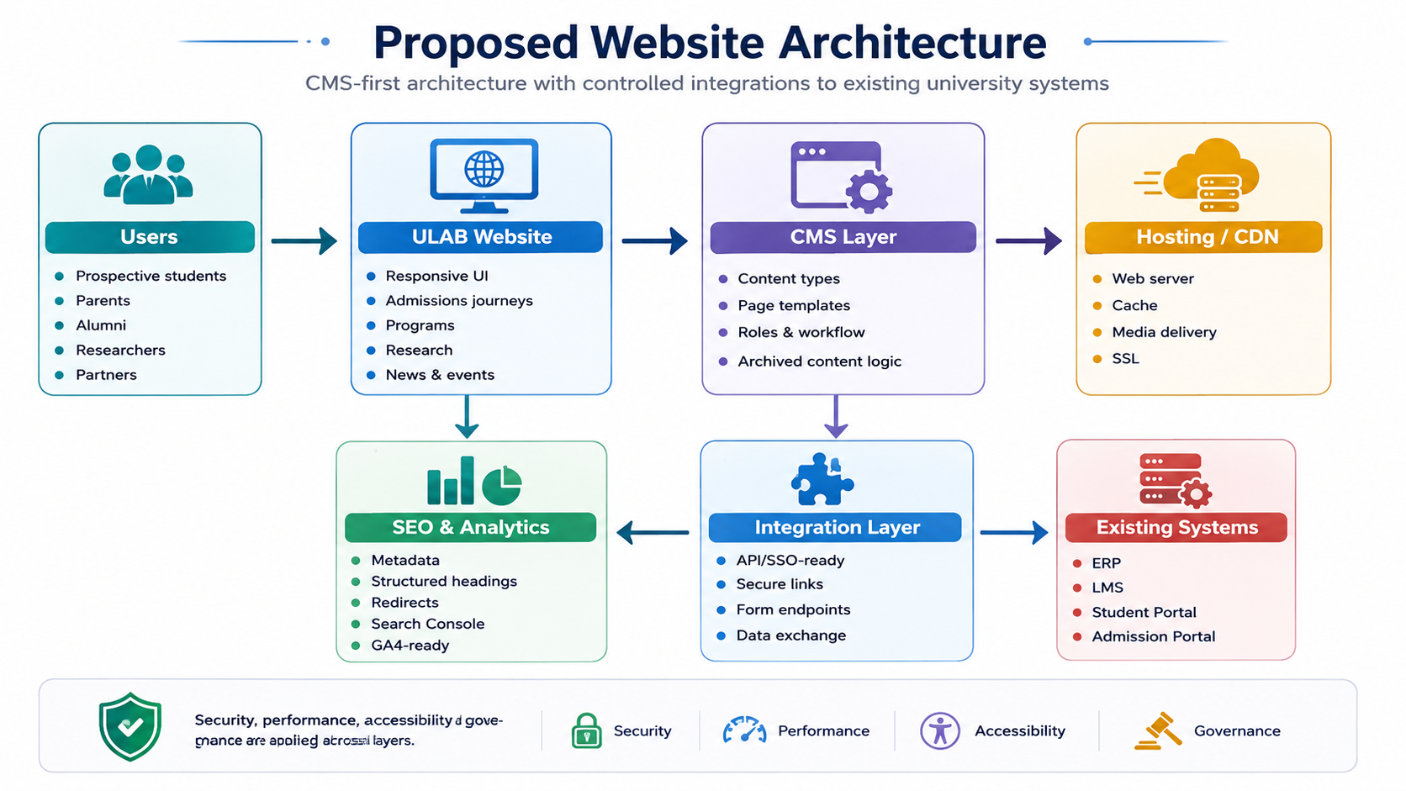
Figure 1: Proposed website architecture
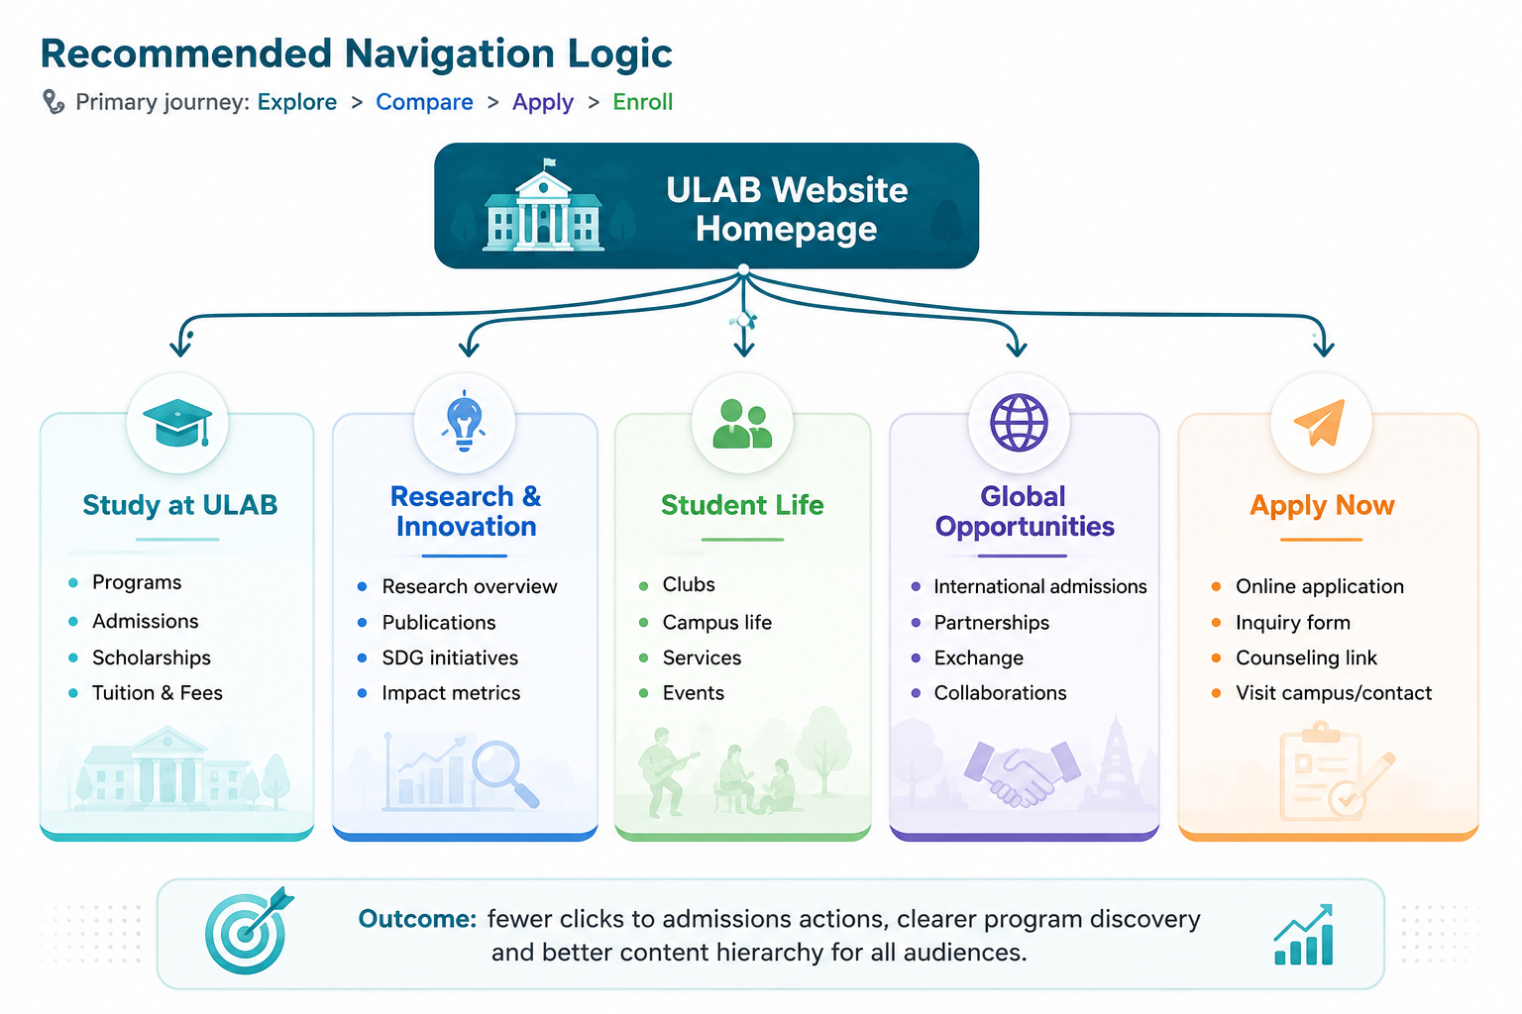
Figure 2: Recommended navigation and user journey

11. Development Methodology
A phased Agile delivery model is recommended, using short review cycles while keeping the approved scope controlled.
Phase | Activities
Discovery Sprint | Confirm requirements, content inventory, technical audit, integrations, user journeys and acceptance criteria.
Design Sprint | Prepare sitemap, wireframes, visual design, design system and responsive UI approval.
Development Sprints | Develop Laravel backend/CMS, React frontend templates, forms, integrations, SEO settings and performance foundations.
Content Migration Sprint | Migrate, review and validate approved content with ULAB content owners.
QA & Stabilization Sprint | Run full testing, fix issues, optimize performance, validate SEO redirects and finalize launch readiness.
Deployment & Handover | Production launch support, smoke testing, Laravel admin/CMS training and documentation handover.

12. Deliverables
Deliverable | Description
Project Discovery Report | Confirmed scope, technical findings, content inventory summary, integration requirements and risk notes.
Revised Sitemap / IA Document | Updated navigation logic and page hierarchy aligned with the student journey.
UI/UX Design Files | Approved responsive designs for key page templates and reusable components.
Design System / Component Guide | Typography, spacing, buttons, CTA styles, cards, grids and reusable web sections.
Laravel CMS/Admin Setup and Configuration | Content models, roles, menus, page templates, media handling and governance configuration in the Laravel admin/CMS.
Developed Website Templates | Homepage, admissions, program, department, research, news, event, generic page and landing sections.
Content Migration Output | Migrated approved content, media assets, metadata and redirects.
SEO Setup | Metadata structure, sitemap, robots, redirect mapping, heading structure and schema-ready templates.
Performance Optimization Setup | Caching, optimized assets, responsive images, lazy loading and performance baseline report.
Integration Setup | Approved connection points to ERP, LMS, Student Portal, admissions system and inquiry/contact routing.
QA Report | Functional, responsive, accessibility, SEO, performance, content and integration test results.
Deployment Package | Production deployment support, launch checklist, rollback notes and environment configuration summary.
Training and Handover Materials | Laravel admin/CMS user guide, admin walkthrough, content update instructions and governance guidelines.

13. Testing and Quality Assurance
QA will be performed throughout the project and before production launch. The focus is on reliability, usability, mobile performance, search readiness and content accuracy.
QA Area | Testing Coverage
Functional Testing | Menus, CTAs, forms, pages, search/navigation, Laravel CMS/admin workflows, featured/archive rules and content display.
Responsive Testing | Desktop, tablet and mobile layout checks across key browsers and viewport sizes.
Cross-Browser Testing | Chrome, Firefox, Edge and Safari compatibility for public pages and admin-managed layouts.
Content Migration Validation | Page-by-page checks for content accuracy, formatting, broken links, missing images, documents and metadata.
SEO QA | Metadata, headings, sitemap, robots, redirects, canonical logic, image alt text and crawlability checks.
Performance QA | Core Web Vitals-oriented checks: LCP, INP and CLS, plus image size, caching, script loading and page weight review.
Accessibility QA | WCAG 2.2 AA-oriented checks for color contrast, keyboard navigation, focus states, alt text, labels, headings and accessible forms.
Integration Testing | ERP/LMS/Student Portal/admissions link or API smoke testing, form submission routing and authenticated handoff validation where available.
Security Checks | SSL, secure headers, Laravel admin/CMS permissions, form spam protection, dependency updates and admin access controls.
Deployment QA | Staging sign-off, production smoke test, backup verification, rollback readiness and post-launch monitoring checklist.

14. Assumptions and Client Responsibilities
• ULAB will provide access to the current website admin/CMS, hosting, analytics, Search Console, domain/DNS and relevant technical documentation where available.
• ULAB will confirm the final page/template list, content owners, approval workflow and content migration priorities during discovery.
• ULAB will provide approved brand guidelines, logo files, existing imagery, campus/student photography and any compliance requirements.
• Content writing, rewriting and translation will be provided or approved by ULAB unless separately agreed.
• Integration with ERP, LMS, Student Portal and admissions systems depends on API availability, credentials, documentation and approval from system owners.
• Production deployment will require coordination with ULAB IT or hosting provider for DNS, SSL, backup and server access.
• Timeline assumes timely feedback and approvals within agreed review windows.

15. Out of Scope Items
The following items are not included in this website upgrade scope unless formally added later:
• Development or replacement of ERP, LMS, Student Portal or admissions systems.
• Complex two-way data synchronization unless approved APIs and a separate integration scope are confirmed.
• Custom mobile application development.
• Advanced chatbot implementation, AI content generation or AI recommendation engine.
• Custom CRM implementation beyond inquiry form readiness or basic endpoint/email routing.
• Payment gateway or online tuition payment module.
• Full content writing, rewriting, translation or large-scale photography/video production.
• Paid advertising, ongoing SEO campaign management or social media campaign execution.
• Hosting, third-party subscription, SSL, CDN, SMS/email gateway or paid plugin/module licensing costs.
• Long-term maintenance and support beyond the agreed handover/support period.
• Major redesign of third-party portals accessed through the website.

16. Success Criteria
Success Area | Acceptance Indicator
Admissions Journey | Apply Now and admissions-related actions are visible, mobile-friendly and reachable with fewer clicks.
Content Governance | News/events and featured content can be controlled through Laravel CMS/admin rules and do not show outdated items in priority areas.
Program Discoverability | Program pages use consistent structure and search-friendly metadata/headings.
Research Visibility | Research, rankings/impact, publications and SDG initiatives are easier to discover from homepage and Research section.
Mobile Experience | Core pages are responsive, fast and easy to scan on mobile devices.
Performance | Optimized images, caching and scripts support Core Web Vitals-oriented performance targets.
SEO Readiness | Sitemap, robots, redirects, metadata, headings and internal linking are configured before launch.
Admin/CMS Usability | ULAB content team can update routine pages, news/events and featured content using documented Laravel CMS/admin workflows.

17. Conclusion
The proposed ULAB website upgrade focuses on the exact priorities identified in the upgrade plan: modern academic design, stronger admissions conversion, improved storytelling, better program and research visibility, mobile-first usability, SEO readiness, performance enhancement and sustainable content governance.
By using a React frontend with a Laravel backend/CMS and controlled integration points, the upgraded website can support current launch needs while remaining scalable for future improvements without expanding the immediate scope unnecessarily.

