Technical Proposal
Urmi Group Corporate Website 2026
Prepared for: Urmi Group
Prepared by: Riseup Labs


Table of Contents
1. Executive Summary 3
2. Requirement Understanding and Proposal Objectives 3
2.1 Business Context 3
2.2 Proposal Objectives 4
3. Proposed Scope of Work 4
4. Proposed Feature List 4
5. Technical Approach 5
5.1 Architecture Approach 5
5.2 Content and Data Approach 5
5.3 Integration Approach 5
6. Solution Architecture and Technical Diagrams 6
7. Development Methodology 8
8. Proposed Technical Stack 9
9. SEO, Analytics, Accessibility and Compliance 9
9.1 SEO Foundation 9
9.2 Analytics Events 9
9.3 Accessibility and Compliance 10
10. Testing and Quality Assurance 10
Functional Testing 10
Responsive and Cross-Browser Testing 10
Accessibility Testing 10
Performance Testing 10
Security and Privacy Testing 11
Content and Launch Testing 11
11. Deliverables 11
12. Implementation Timeline 11
13. Assumptions, Dependencies and Scope Controls 12
13.1 Key Dependencies from Urmi Group 12
13.2 Scope Controls and Exclusions 12

1. Executive Summary
Urmi Group requires a modern, modular and content-rich corporate website for urmigroup.com 2.0. The new platform must present the group as a vertically integrated RMG and textile partner with strong sustainability, innovation, traceability, workplace and governance credentials. The website will replace the ageing single-page WordPress presence with a structured, SEO-ready and conversion-focused web experience.
The proposed solution is a headless CMS-driven corporate website with a high-performance frontend, structured content management, multilingual readiness, routed enquiry forms, careers integration, media and report libraries, search, analytics, accessibility support and controlled partner/auditor access where required.
Core objective
Build a corporate website that supports buyer conversion, sustainability transparency, talent attraction, press/investor confidence and stakeholder trust, while keeping implementation scope limited to the blueprint requirements.

Area | Proposal Summary
Business focus | Global buyer conversion, sustainability proof, traceability storytelling, talent attraction and media readiness.
Primary audience | Brand sourcing teams, sustainability and compliance teams, talent, investors, media, academia and community stakeholders.
Main website model | Structured corporate website with eight primary navigation tabs, utility bar, footer, CMS and supporting integrations.
Scope approach | Implement only the required website features and supporting integrations. Avoid cost-heavy modules that are not required by the blueprint.

2. Requirement Understanding and Proposal Objectives

2.1 Business Context
- The current website does not adequately reflect Urmi Group achievements from 2024-2026, including sustainability, traceability, workplace and capacity narratives.
- The new website must position Sustainability as a core destination, not only a small content page.
- The website must support day-one conversion features, including buyer enquiry, career application, newsletter subscription and press/media access.
- The website must provide a clear structure for global brand teams, auditors, journalists, investors and job seekers.

2.2 Proposal Objectives
- Translate the Website Blueprint 2026 into an implementable technical scope and delivery plan.
- Recommend a practical technical stack that supports SEO, performance, security, maintainability and multilingual content.
- Provide a controlled feature list aligned with the blueprint, without adding unnecessary cost-heavy features.
- Define a delivery methodology, deliverables, quality assurance approach and implementation timeline.
- Include technical diagrams and diagram placeholders that can be refined with final brand assets later.

3. Proposed Scope of Work

Scope Area | Included Work
Website redesign and frontend build | Develop a responsive, SEO-first corporate website based on the 8-tab information architecture and visual direction from the blueprint.
Headless CMS setup | Configure structured content models for pages, news, reports, awards, leadership, companies, sustainability data, careers content and downloads.
Core content sections | Implement Home, Who We Are, What We Do, Sustainability, Innovation & Technology, Life at Urmi, News & Insights, Contact & Locations.
Conversion features | Implement buyer enquiry, career application route, newsletter subscription, media contact, audit/compliance request and grievance/whistleblower forms.
Search and utility features | Implement global search, utility bar, multilingual readiness, footer navigation, cookie consent and persistent CTA patterns.
Integrations | Connect or embed approved third-party tools for CRM/forms, ATS/job board, newsletter, search, analytics, DPP/LCA preview and partner login as confirmed.
SEO and analytics | Set up metadata, schema, sitemap, redirects, tracking events and launch reporting.
Testing and launch | Complete functional, responsive, accessibility, performance, security, content and cross-browser testing before launch.

4. Proposed Feature List
Module | Proposed Features
Global Website Features | Responsive layout; utility bar; primary navigation; mega-menu where useful; footer; persistent Become a Partner CTA; contact/WhatsApp bubble; cookie/privacy banner; CMS-managed pages; global search; multilingual readiness; newsletter surfaces; analytics tracking.
Home | Video-first hero, two CTAs, three pillar cards, live/static impact ticker, customer constellation, capability tiles, sustainability spotlight, latest news and newsletter signup.
Who We Are | Our Story, leadership profiles, companies of the group, interactive timeline, awards and recognition with downloadable certificates, governance policy downloads and grievance access.
What We Do | Capabilities overview, clickable process flow, capacity calendar preview, knitting, dyeing/finishing, cutting/sewing, seamless, printing, embroidery, washing, packaging/logistics, product portfolio and customer showcase.
Sustainability | Sustainability navigator landing, environment pages, renewable energy, water/effluent/biodiversity, circularity/waste, sustainable materials, people sustainability, wellbeing and DEI, skill development, governance/compliance, community engagement, reports/data library and goals 2025-30.
Innovation, Traceability & Technology | Process automation, DPP demo, LCA and traceability preview, ESG digitization stack and partnership/knowledge network pages.
Life at Urmi | Culture landing, people stories, learning and development programmes, women in leadership, wellbeing and benefits, open roles/careers portal and speculative application/talent network.
News, Insights & Media | Press releases, in-the-media coverage, blog/insights, events, downloads/media kit, RSS feed and author profiles.
Contact & Locations | Smart contact router, corporate office details, factory/facilities map, buyer enquiry form, audit/compliance contact, whistleblower/grievance form and auto-acknowledgement.
Admin/CMS Features | Page/content management, media/report management, job content or ATS embedding, newsletter content capture, SEO fields, translation status, download library and role-based editorial workflow.

5. Technical Approach

5.1 Architecture Approach
- Use a composable corporate website architecture where the frontend, CMS and third-party integrations are separated but connected through APIs and embeds.
- Use server-side rendering and static generation where suitable to improve SEO, load speed and content reliability.
- Use a headless CMS to allow Urmi teams to manage pages, reports, awards, blogs, leadership profiles, sustainability content and media assets without developer involvement for routine updates.
- Keep live dashboards practical. Where real-time APIs are not ready, implement CMS-managed verified data tiles with a clear monthly update workflow.
- Use component-based UI development to keep the design consistent across Home, Sustainability, What We Do, Careers and News sections.

5.2 Content and Data Approach
- Create structured content types for top-level pages, sub-pages, KPI tiles, report downloads, certificates, news, blogs, media kit assets, jobs and contact routes.
- Attach data owner, source file and update cadence fields for sustainability and ESG-related numbers to keep claims evidence-led.
- Provide CMS-managed SEO fields for title, description, OG image, canonical URL and schema-relevant fields.
- Prepare multilingual content workflow for English first, with Bangla and Japanese rollout based on confirmed pages and translation responsibility.

5.3 Integration Approach
- Forms and CRM: route buyer, audit, media, sustainability and general enquiries to the right team with acknowledgement emails.
- Careers: integrate an ATS/job board where available or provide CMS-managed job posting as a fallback.
- Search: index public pages, news, reports, downloads and open roles for type-ahead site search.
- Newsletter: capture topic-tagged subscriptions through a compliant provider such as Mailchimp, Beehiiv or HubSpot.
- DPP/LCA: embed or connect confirmed GreenStitch/DPP sample cards and maintain a CMS-managed fallback for sample storytelling if API access is not available during launch.
- Partner/Auditor access: implement secure authentication for gated audit packs if the final access model and user list are confirmed.

6. Solution Architecture and Technical Diagrams
The following diagrams are included to make the proposal implementation ready. Final brand photography, real system screenshots and partner portal UI screens can be inserted during the design phase.
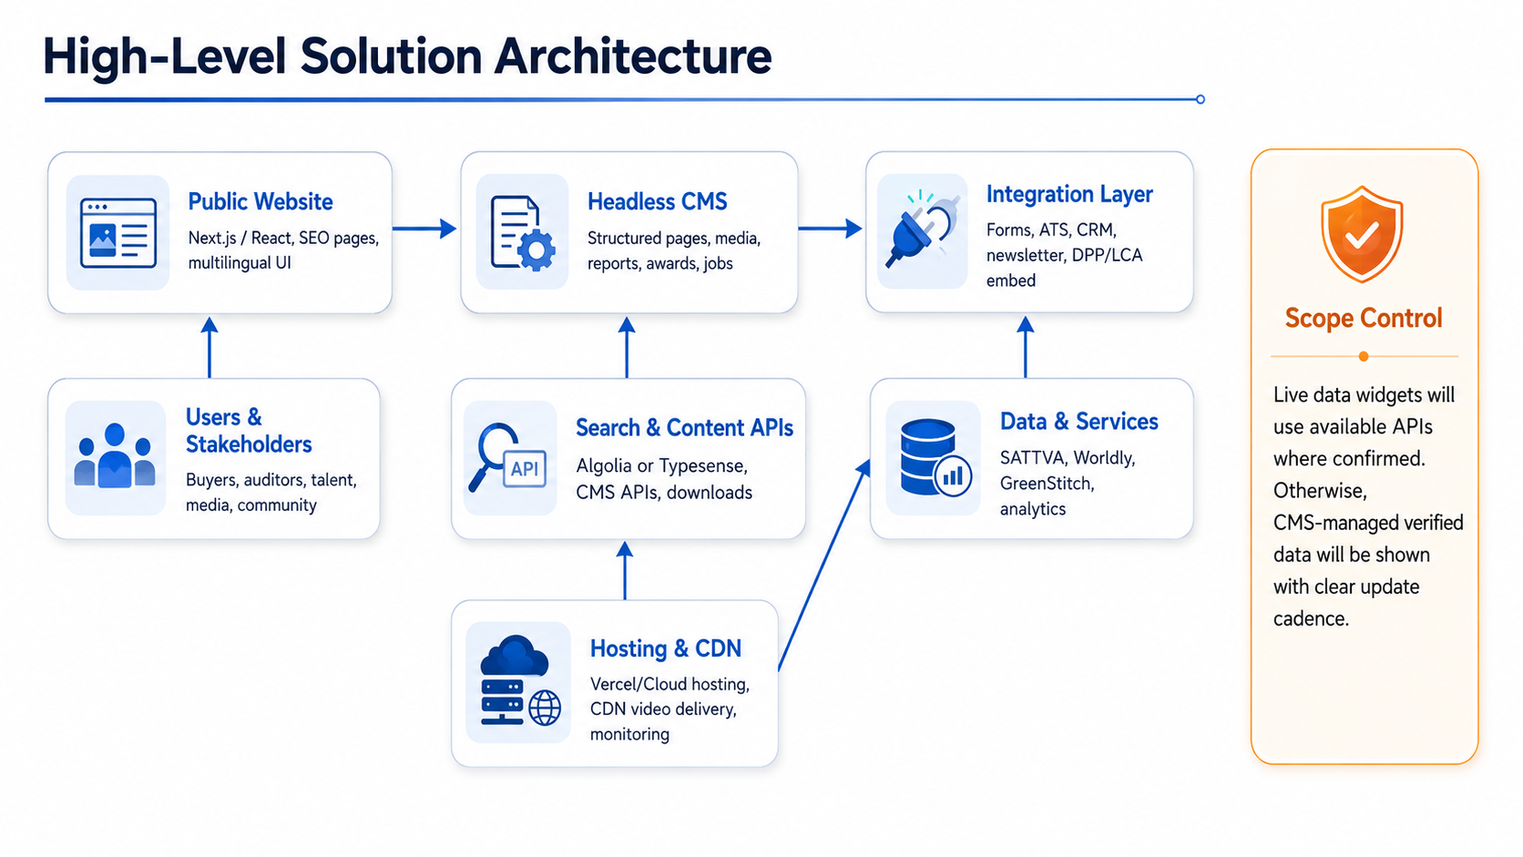
Figure 1: High-Level Solution Architecture
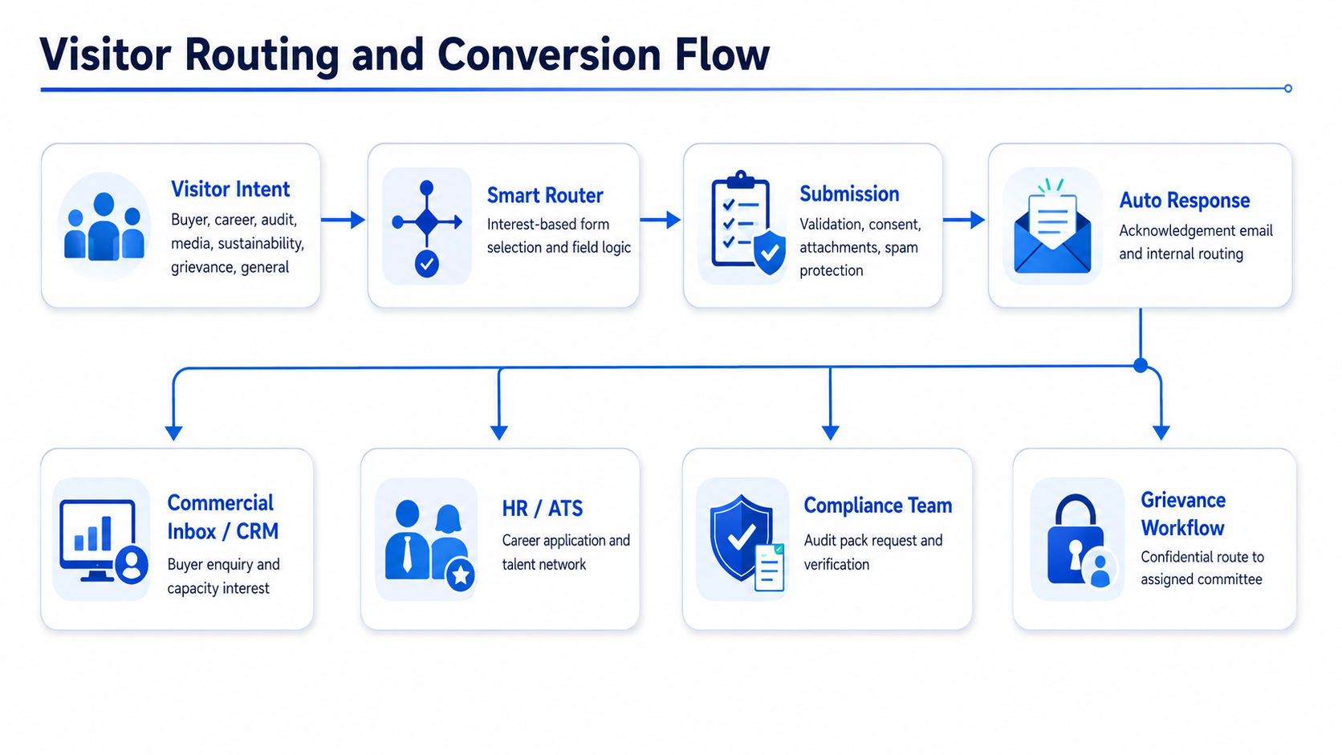
Figure 2: Visitor Routing and Conversion Flow
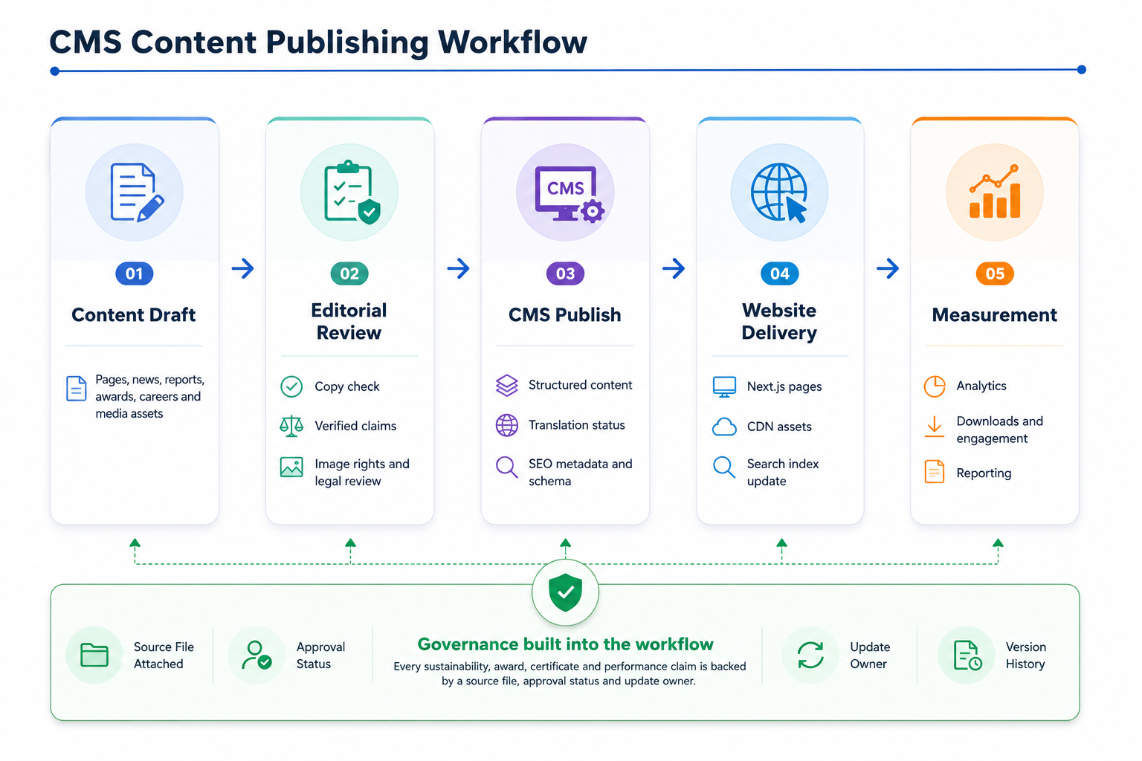
Figure 3: CMS Content Publishing Workflow
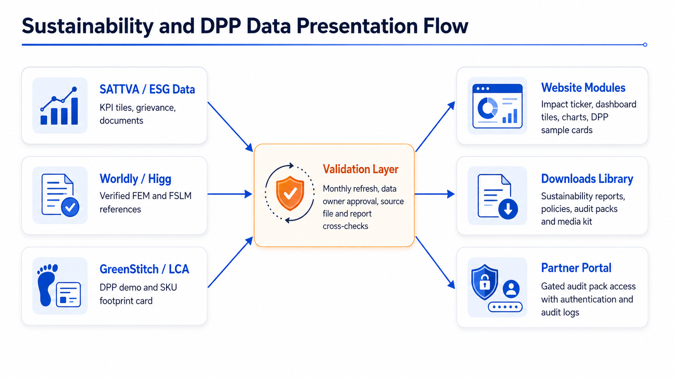
Figure 4: Sustainability and DPP Data Presentation Flow

7. Development Methodology
A milestone-based Agile delivery model is recommended. The work will be planned in short cycles, with clear review checkpoints at discovery, design system, CMS setup, frontend build, content migration, QA, and launch. This keeps the project controlled while allowing Urmi stakeholders to review content-heavy sections progressively.
Method Step | Activities
1. Discovery and scope confirmation | Confirm navigation, content inventory, data sources, integrations, CMS choice, multilingual phasing and launch criteria.
2. UX/UI and design system | Create reusable design components, page patterns and responsive layouts aligned with the brand tone and color system.
3. CMS and integration setup | Define content schemas, roles, preview workflow, form routing, newsletter, search, ATS and analytics setup.
4. Frontend development | Build the approved pages and modules using reusable components and SEO-friendly rendering.
5. Content migration and population | Upload and configure copy, images, reports, certifications, media kit, leadership profiles, news and job content.
6. QA and optimization | Conduct functional, responsive, accessibility, performance, SEO, security and content validation testing.
7. launch | Support stakeholder review, fix approved issues, configure redirects, deploy production and monitor launch.

8. Proposed Technical Stack

Layer | Recommended Technology | Purpose
Frontend | Next.js 14+ / current stable App Router, React, TypeScript | SEO-friendly rendering, reusable components, strong ecosystem and performance support.
Styling and UI | Tailwind CSS, Radix UI primitives | Consistent design system, accessible components and faster UI development.
CMS | Sanity.io or Strapi v5 | Structured content, multilingual readiness, media library, editorial workflow and API delivery.
Hosting and CDN | Vercel or managed cloud hosting, Bunny CDN or CloudFront for video/media | Fast global delivery, preview deployments, scalable media performance.
Forms and CRM | HubSpot Forms/CRM or custom form API with email routing | Buyer enquiry, media, audit/compliance, grievance and general enquiry routing.
Careers / ATS | Workable, Greenhouse, Bdjobs API or CMS-managed jobs | Embeddable jobs, application workflow and HR-friendly administration.
Search | Algolia or Typesense Cloud | Fast type-ahead search across pages, reports, downloads and jobs.
Newsletter | Mailchimp, Beehiiv or HubSpot | Topic-based subscription, double opt-in and campaign management.
Analytics | GA4, Plausible, Microsoft Clarity or Hotjar | Traffic, conversion events, engagement, heatmaps and UX iteration.
Authentication | Auth0 or Clerk for gated partner/auditor access | SSO/MFA option, user management and audit logs.
DPP/LCA embed | GreenStitch/DPP widget and custom React components | Sample DPP card, SKU footprint storytelling and traceability preview.
Monitoring and security | Sentry, UptimeRobot, HTTPS, HSTS, CSP, cookie consent | Error tracking, uptime monitoring, privacy and security baseline.

9. SEO, Analytics, Accessibility and Compliance

9.1 SEO Foundation
- Generate XML sitemap and robots.txt for the new website architecture.
- Set canonical URLs, page titles, meta descriptions, Open Graph tags and social sharing images for every public page.
- Implement structured data for Organization, Person, JobPosting, Article and Event content where relevant.
- Set up 301 redirects from the existing URL structure to the new page-based architecture.
- Optimize priority pages for buyer and sustainability search themes such as sustainable apparel manufacturer Bangladesh, vertically integrated RMG supplier, DPP-ready garment factory and Higg FEM verified supplier.

9.2 Analytics Events
- Buyer enquiry submission by category.
- Career application and speculative application submission.
- Newsletter signup by topic.
- Sustainability report and audit/media download events.
- Video play and completion tracking.
- Outbound clicks to certification, SBTi, UNGC, Worldly or partner references.
- Time on Sustainability and Innovation sections.

9.3 Accessibility and Compliance
- Target WCAG 2.2 AA accessibility for page structure, contrast, keyboard navigation, focus states, form labels, captions, transcripts and alternative text.
- Provide cookie consent with necessary, analytics and marketing preference options.
- Publish Privacy Policy, Cookie Policy, Modern Slavery Statement, Code of Conduct and Terms of Use as required by the blueprint.
- Make the whistleblower/grievance form functional, confidential and aligned with the approved routing process.
- Apply legal review to privacy, grievance, policy and compliance copy before launch.

10. Testing and Quality Assurance
Quality assurance will be performed across functionality, content, performance, accessibility, security and launch readiness. The QA process will avoid unnecessary overhead but will cover the risk areas required for a public corporate website used by global buyers, auditors and job seekers.

Functional Testing
- Validate navigation, mega-menus, utility bar, footer links and CTAs.
- Test all forms, validations, consent boxes, file uploads, auto-acknowledgements and internal routing.
- Validate CMS preview, publish, edit and rollback workflow.
- Check search indexing, filtering and type-ahead behaviour.
- Validate downloads, media kit assets, report library and gated audit pack access if implemented.

Responsive and Cross-Browser Testing
- Test desktop, tablet and mobile layouts for all major templates.
- Cross-browser coverage: Chrome, Safari, Firefox, Edge and Samsung Internet.
- Device coverage: iPhone 12+, Pixel 7+, Galaxy S22+ and low-end Android representative testing.

Accessibility Testing
- Run automated checks using Axe or equivalent tools.
- Perform manual keyboard navigation and visible focus state review.
- Validate alt text, labels, color contrast, captions and transcripts for required content.

Performance Testing
- Optimize images, videos, scripts and fonts.
- Target Lighthouse score above 90 for Performance, Accessibility, Best Practices and SEO on priority pages.
- Target LCP below 2.0 seconds, CLS below 0.05, INP below 200ms and FCP below 1.2 seconds, subject to final media weight and hosting environment.

Security and Privacy Testing
- Verify HTTPS, HSTS, basic CSP, form spam protection and secure headers.
- Validate protected routes for partner/auditor login if implemented.
- Check cookie consent, privacy links and data collection notices.
- Support security review or penetration test planning if required by Urmi policy.

Content and Launch Testing
- Validate all approved copy, numbers, awards, leadership details, policies and reports.
- Check all redirects, sitemap submission, analytics events and production environment settings.
- Run final launch checklist and post-launch monitoring.

11. Deliverables
Deliverable Category | Deliverables
Discovery and planning | Finalized sitemap, scope confirmation, content inventory, integration list, delivery plan and risk/dependency log.
UX/UI and design system | Responsive page layouts, design tokens, reusable components and prototypes for priority pages.
Website frontend | Developed and responsive website covering all approved pages and modules from the blueprint.
CMS configuration | Configured content models, roles, media library, publishing workflow and SEO fields.
Integrations | Configured forms, CRM/newsletter/ATS/search/analytics/DPP embed/partner login integrations as confirmed.
SEO and analytics setup | Metadata, schema, sitemap, redirects, analytics events and reporting baseline.
QA documentation | Test checklist, issue log, QA support notes and launch readiness checklist.
Deployment and launch | Production deployment, domain/redirect setup support, monitoring setup and launch support.
Handover | Admin user guide, CMS training session, credential handover checklist and maintenance recommendations.

12. Implementation Timeline
Total proposed Timeline: 2 months

13. Assumptions, Dependencies and Scope Controls

13.1 Key Dependencies from Urmi Group
- Final approval of the 8-tab primary navigation and page priority.
- Final decision on CMS choice, hosting environment, domain and DNS access.
- Approved brand assets, photography, video footage, leadership headshots and factory/location imagery.
- Final copy, verified numbers, policy documents, certificates, sustainability reports and downloadable assets.
- Access credentials or embed details for CRM/forms, newsletter, ATS, search, analytics, DPP/LCA tools and partner/auditor access if required.
- Legal review of privacy, cookie, grievance, modern slavery, code of conduct and terms content.
- Defined content owners for sustainability KPI updates and report/download management.

13.2 Scope Controls and Exclusions
- No ecommerce, payment gateway, procurement platform, ERP, MES, HRMS or production planning system is included.
- No custom ATS will be built unless separately confirmed. The proposal assumes ATS integration, embedded job board or CMS-managed jobs.
- No independent DPP/LCA calculation engine is assumed beyond website presentation, sample card, embed or integration with confirmed tools.
- No custom AI chatbot, recommendation system or complex personalization engine is included. Phase 2 personalization is limited to the visitor-type behaviour described in the blueprint if approved.
- Real-time ESG dashboards require confirmed API access and data governance. Without API access, the website will use CMS-managed verified data with update cadence.
- Multilingual rollout will follow the confirmed phase plan, and translated content must be provided or approved by Urmi.

