Technical Proposal
VarsityOS - AI Automation & Marketing Management Module

Prepared by: Riseup Labs


Table of Contents
1. Executive Summary 3
2. Understanding of Requirements 3
3. Scope of Work and Feature List 3
3.1 AI Core Engine and Governance 3
3.2 AI Counseling and Document Automation 3
3.3 AI Course Intelligence and Scholarship Recommendation 4
3.4 Marketing and Lead Generation 4
3.5 Communication, Feed, Referral and Events 4
3.6 AI Analytics, Forecasting and Fraud Detection 4
4. Proposed Technical Approach 4
4.1 Architecture Principles 4
4.2 Local LLM Gateway Design 5
4.3 Data and Integration Approach 5
5. Proposed Technical Stack - Local LLM-Based 7
6. Key Workflows and Technical Diagrams 8
6.1 AI Document Generation and Counseling Workflow 8
6.2 Lead Capture, Routing and Campaign Workflow 9
6.3 Referral, Event and Analytics Workflow 10
7. Role-Based Access Summary 10
8. Development Methodology 11
9. Deliverables 11
10. Testing and Quality Assurance 11
11. Assumptions and Dependencies 12
12. Out of Scope 12
13. Conclusion 12

1. Executive Summary
VarsityOS is proposed as an AI-powered Education Consultancy Management Platform focused on automating counseling support, document generation, course intelligence, marketing lead generation, CRM-based routing, communication automation, community engagement, referral growth, event management, and analytics-driven decision support.
This updated proposal replaces cloud GPT/OpenAI dependency with a client-controlled Local LLM approach. AI features will route through a secure AI Gateway connected to self-hosted open-weight LLM infrastructure, enabling stronger data control, private deployment, configurable model selection, auditability, rate limiting, and offline/on-premise readiness where required.

2. Understanding of Requirements
- AI Counseling & Content Generation for SOP, Cover Letter, Sponsor Letter, AI revision, document checklist and document validation.
- AI Course Intelligence covering course finder filters, AI match score, InfoBar, comparison, scholarship recommendation and university scoring.
- Marketing Automation & Lead Generation through landing pages, forms, campaign tracking, lead capture, routing and smart alerts.
- AI Communication Automation including smart replies, counseling assistant, birthday messages, digest emails and appointment slot suggestions.
- Feed & Community Automation with local LLM-based status generation, topic suggestions, auto-tagging, knowledge base integration and role-based visibility.
- Referral Management for teachers, smart partners, B2B agents/sub-agents, tracked links, status updates, leaderboards and commission workflow.
- Event & Fair Management through public event pages, RSVP/check-in, QR lead capture, forecasting, reporting and post-event follow-up.
- AI Analytics, Forecasting & Fraud Detection for lead trends, conversion analytics, forecasts, referral insights and unusual commission activity alerts.

3. Scope of Work and Feature List

3.1 AI Core Engine and Governance
- Laravel-based AI Gateway service for all Local LLM calls with model routing, prompt template management and access governance.
- Self-hosted model serving through vLLM or Ollama, with the final model selected after benchmark testing against SOP quality, response speed, Bengali/English language performance and infrastructure capacity.
- Per-user, per-role and per-tenant AI access control with usage logging, audit history and quota management.
- Redis-based caching and rate limiting for InfoBar queries, repeated prompts and quota control.
- Fallback handling for local model timeout or service failure with queued retry and graceful user message.
- Suspicious pattern detection for repeated prompts, bulk scripted use and abnormal model usage.
- RAG-based grounding using approved course, university, policy, feed and knowledge base content.

3.2 AI Counseling and Document Automation
- SOP Generator with profile-based inputs, target country/course context, tone selector and editable output.
- Cover Letter Writer using student, university and course data with country-aware formatting.
- Sponsor Letter Builder with sponsor details, PDF output and signature/seal placeholder.
- AI Revision Mode with version history and instruction-based rewriting through the local model.
- AI Document Checklist Generator mapped to required document slots.
- AI Document Validator using OCR and local AI review to flag missing pages, mismatches, expired dates and incomplete fields.
- Multilingual generation for English and Bangla initially, with support structure for future languages subject to model capability.

3.3 AI Course Intelligence and Scholarship Recommendation
- Course finder filters for country, degree level, subject, budget, duration, IELTS score and scholarship availability.
- AI Match Score combining student fit, budget alignment, IELTS gap and scholarship eligibility.
- AI InfoBar for course cards covering job future, ranking, official link, requirements, jobs, salary, PR, duration and visa context.
- Course comparison for up to three courses with fee, duration, scholarship, match score and InfoBar summary.
- AI Scholarship Recommender with ranked scholarship suggestions and natural-language query support.
- University AI Scoring using scholarship availability, ranking, employment rate, affordability and counselor endorsement.

3.4 Marketing and Lead Generation
- Drag-and-drop landing page builder with dynamic slugs, mobile responsive blocks, SEO metadata and branch branding.
- Form builder with drag-and-drop fields, public link generation, submission tracking, export and lead sync.
- Lead capture from website forms, Facebook Lead Ads, WhatsApp, referral links, walk-in entry and event/fair QR forms.
- Lead routing based on branch, location, counselor queue, campaign source or referral attribution.
- Lead pipeline stages from New to Enrolled with duplicate detection and merge support.
- Smart alerts for high-response leads not contacted and low-engagement counselor trends.
- Campaign tools for email, WhatsApp/SMS broadcasts and campaign performance dashboard.

3.5 Communication, Feed, Referral and Events
- Local LLM-based Smart Reply and AI Counseling Assistant with knowledge base and course/university context.
- Birthday wish automation, smart digest emails and AI appointment slot suggestion.
- Feed automation including generate status, topic suggestions, auto-tagging and high-engagement knowledge base archival.
- Referral systems for teacher, smart partner, B2B agent and sub-agent with tracked links, dashboards and leaderboards.
- Event setup, public event pages, RSVP, QR check-in, lead tracking, forecasting report and post-event WhatsApp follow-up.

3.6 AI Analytics, Forecasting and Fraud Detection
- Lead growth, conversion, source, branch, counselor and country dashboards.
- Course search heatmap, referral source chart and partner/teacher/smart partner leaderboards.
- Next-month lead volume and conversion forecasting with plain-language local AI summary.
- Commission-related fraud detection for duplicate codes, abnormal spikes and mismatched relationships.
- Audit logging for flagged cases and Super Admin review before payout approval.

4. Proposed Technical Approach

4.1 Architecture Principles
- Client-controlled AI deployment: AI inference runs on client-approved local/on-premise or private cloud infrastructure instead of sending prompts to external LLM APIs.
- Centralized AI orchestration: all AI features route through a Laravel-based AI Gateway instead of direct model calls from frontend or feature modules.
- Human-in-the-loop operation: AI outputs are suggestions or drafts; counselors, students or admins can review, edit, approve or dismiss them based on role and context.
- Multi-tenant and role-based security: tenant isolation, role restrictions, MFA for Super Admin and audit trail for AI and marketing actions.
- Performance control: model quantization, caching, scheduled batch jobs, rate limiting and GPU resource monitoring reduce unnecessary local inference load.
- Grounded AI responses: the counseling assistant uses RAG over approved knowledge base content, course data and university data before returning an answer.
- Modular build: AI, marketing, lead routing, communication, feed, referral, event and analytics services are implemented as separate modules over a shared platform layer.

4.2 Local LLM Gateway Design
- Each AI request captures userId, tenantId, role, feature name, language, prompt version, selected local model, token/input length, response time and response status.
- Prompt templates are versioned and editable by Super Admin without redeploying application code.
- Local LLM model routing separates lightweight tasks such as tagging/smart reply from document-heavy tasks such as SOP, cover letter and sponsor letter generation.
- Production serving can use vLLM for optimized GPU inference; Ollama can be used for development, proof-of-concept or smaller deployment environments.
- Redis caching is used for repeated course InfoBar queries and Redis rate limiting is used for per-user and per-tenant quota control.
- Laravel Queue with Redis handles batch jobs such as digest emails, topic suggestions, birthday wishes, forecasting recalculation and leaderboard refresh.
- Guardrails include prompt injection checks, PII masking where required, approved knowledge base grounding, output review and audit logging.

4.3 Data and Integration Approach
- CRM lead data, course data, event data and referral data are stored in structured relational tables with tenant-aware access rules.
- Generated documents, AI exports and media assets are stored in MinIO/S3-compatible object storage, AWS S3 or Firebase Storage based on deployment preference.
- Knowledge base and learning content are indexed in PostgreSQL pgvector or Qdrant for RAG-based AI counseling answers.
- Marketing integrations include Meta Pixel, Google Analytics/Tag Manager, Facebook Lead Ads API, WhatsApp Business Cloud API, email providers and webhooks/Zapier/n8n.
- Appointment integration can use Google Calendar/Meet API to create booking slots and meeting links.
- No external LLM API will be used unless the client separately approves an optional fallback model.
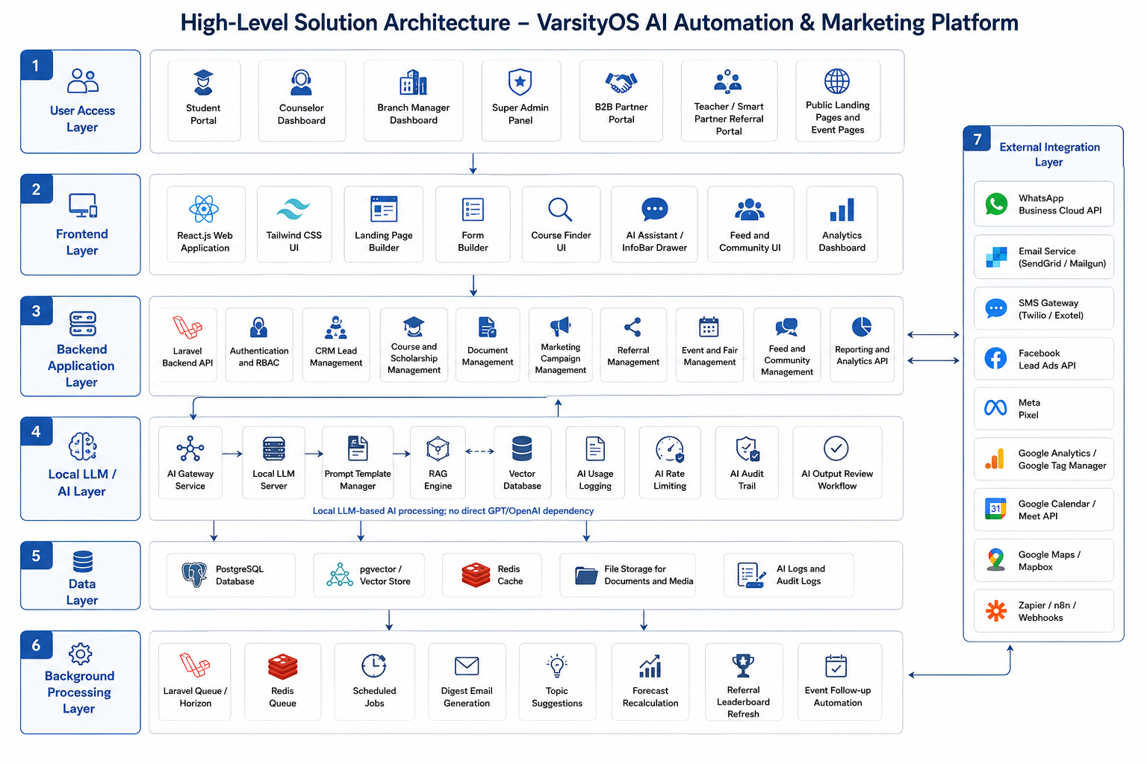
Figure 1: Proposed high-level architecture for Local LLM, marketing, CRM, analytics and integration layers.

5. Proposed Technical Stack - Local LLM-Based
Layer | Proposed Technology | Purpose
Frontend Web App | React.js, Tailwind CSS, Framer Motion | Responsive dashboards, AI drawers, InfoBar, builder UI and micro-interactions
Backend API | Laravel 11/12 REST API | Application APIs for CRM, lead routing, referral, event, feed, analytics and role-based access modules
AI Gateway | Laravel-based AI Gateway service/module | Central prompt management, local model routing, usage logging, RBAC, audit trail and AI orchestration
Local LLM Serving | vLLM for production GPU serving; Ollama for development/POC | Self-hosted local inference without external GPT/OpenAI dependency
Model Options | Open-weight LLM family to be selected after benchmark, e.g., Llama, Qwen or Mistral class models | Document generation, smart reply, tagging, summaries, InfoBar and counseling support
Embedding & RAG | PostgreSQL + pgvector or Qdrant | Vector search over course, university, policy, feed and knowledge base content
OCR | Tesseract.js / Tesseract OCR; optional self-hosted OCR pipeline | Document text extraction for AI document validation
Queue & Jobs | Laravel Queues + Redis | Batch AI jobs, digest emails, forecasting, leaderboards, retries and scheduled automation
Caching & Rate Limit | Redis | InfoBar caching, per-user/per-tenant quota enforcement and abuse control
Database | PostgreSQL | Relational records, tenant-aware data and reporting structure
Realtime | Laravel Reverb/WebSockets + optional Firebase where required | Live feed updates, suggestion sync and status updates
Landing Page CMS | Strapi or Sanity + React + dnd-kit | Drag-and-drop landing page and form builder
Storage | MinIO/S3-compatible storage, AWS S3 or Firebase Storage | Generated documents, exports, media and event images
Analytics | Recharts, Google Analytics, Meta Pixel, GTM | Internal dashboards and external conversion tracking
Communication | WhatsApp Business Cloud API, SendGrid/Mailgun, Twilio/Exotel | Messaging, broadcasts, fallback SMS and digest emails
Maps & Calendar | Google Maps/Mapbox, Google Calendar/Meet API | Event locations and appointment scheduling
Infrastructure | GPU-enabled server/on-premise VM/private cloud, Docker, Nginx, CI/CD | Local model hosting, secure deployment and scalable operations

6. Key Workflows and Technical Diagrams

6.1 AI Document Generation and Counseling Workflow
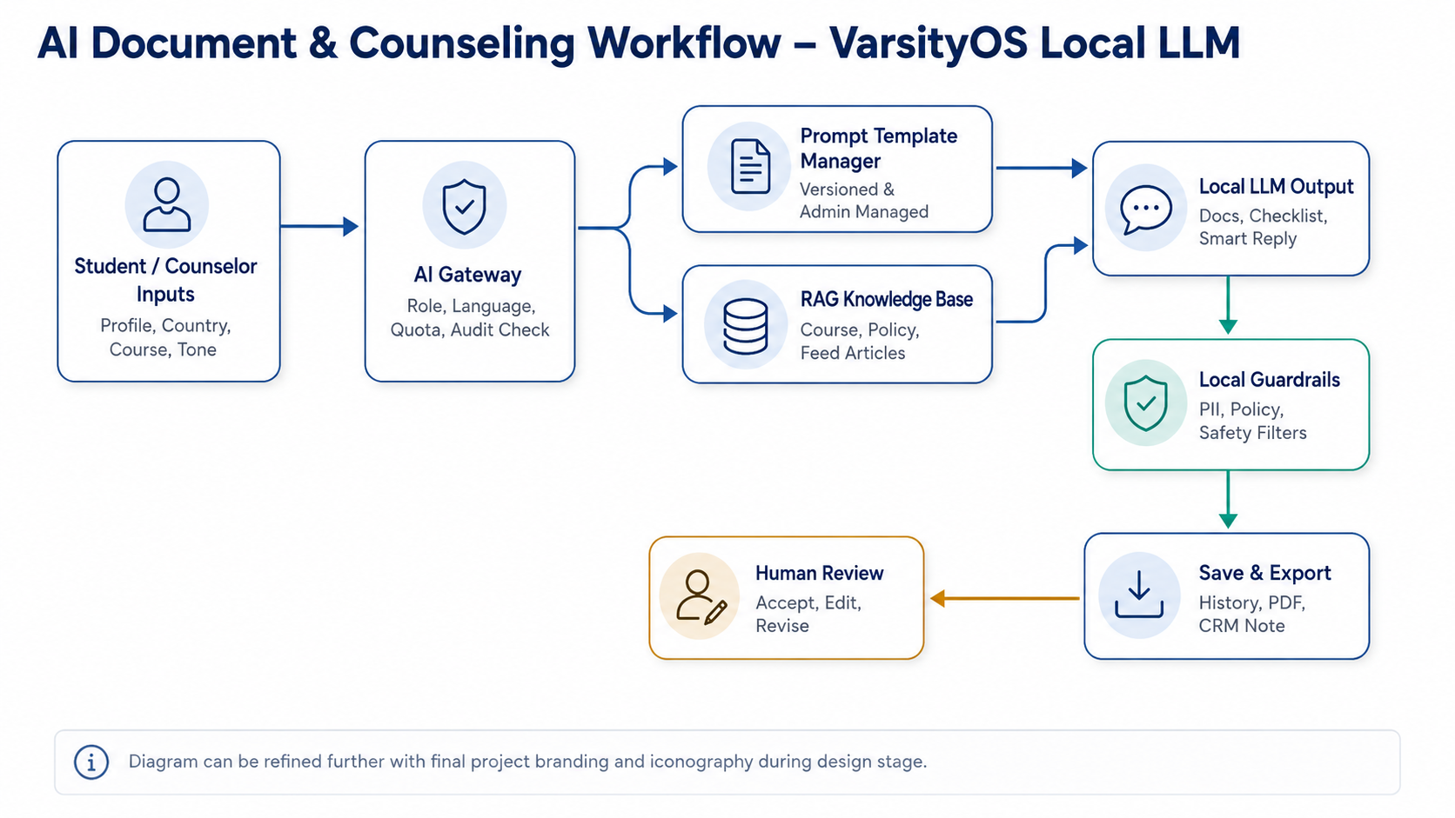
Figure 2: Local LLM workflow from user input to AI Gateway, RAG/prompt processing, human review, storage and export.

6.2 Lead Capture, Routing and Campaign Workflow
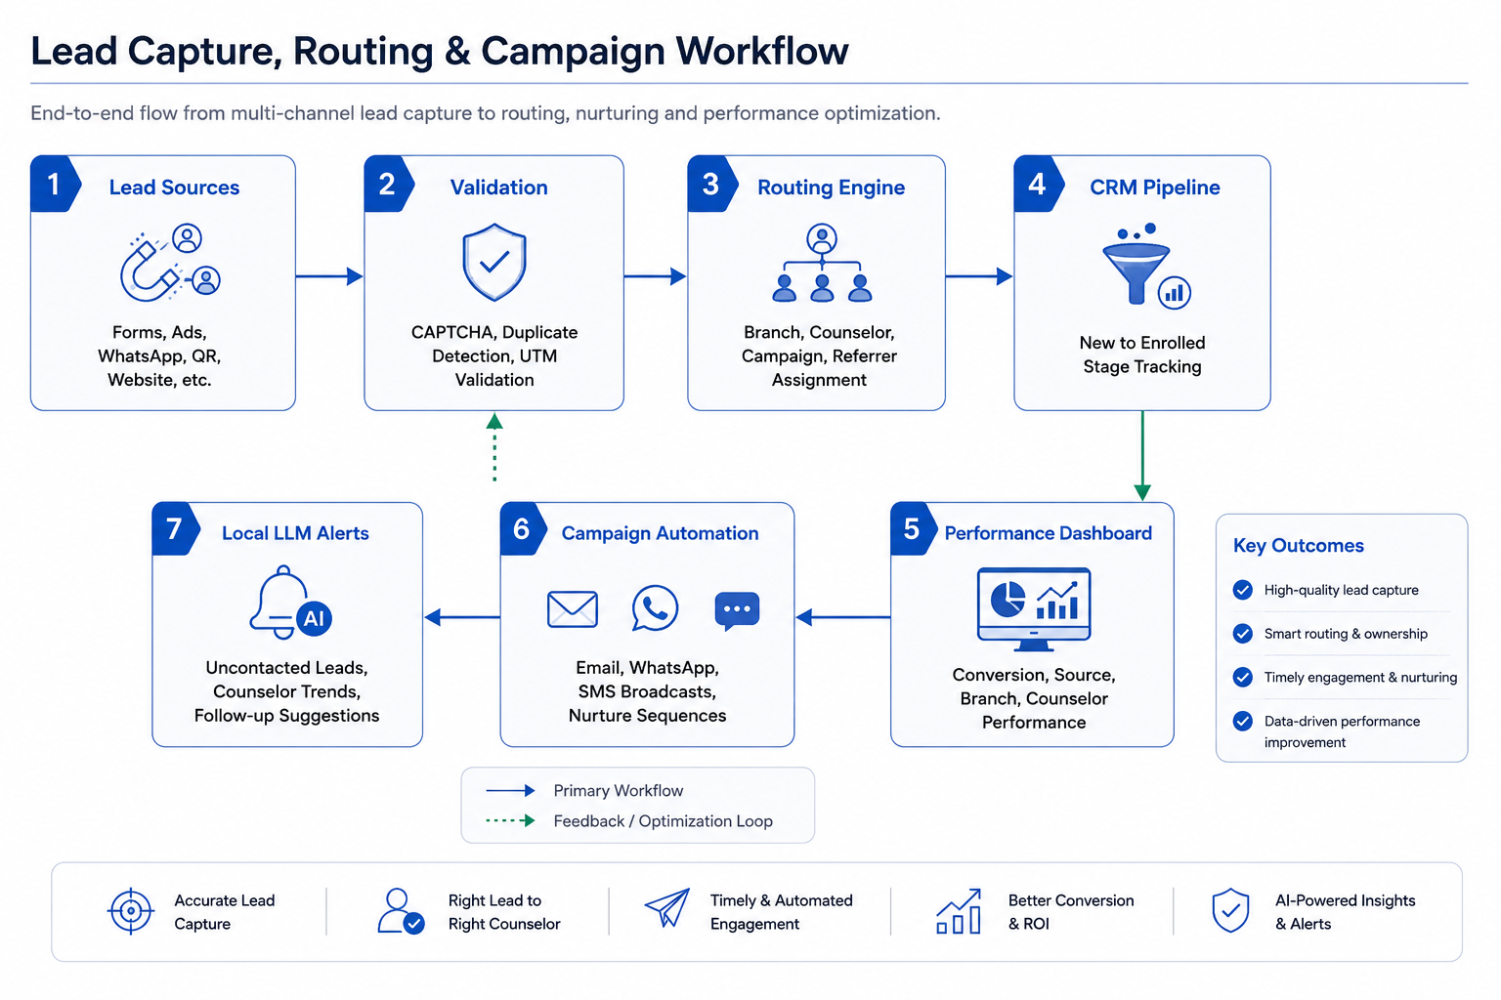
Figure 3: Lead capture sources, validation, routing, CRM pipeline, smart alerts and campaign automation.

6.3 Referral, Event and Analytics Workflow
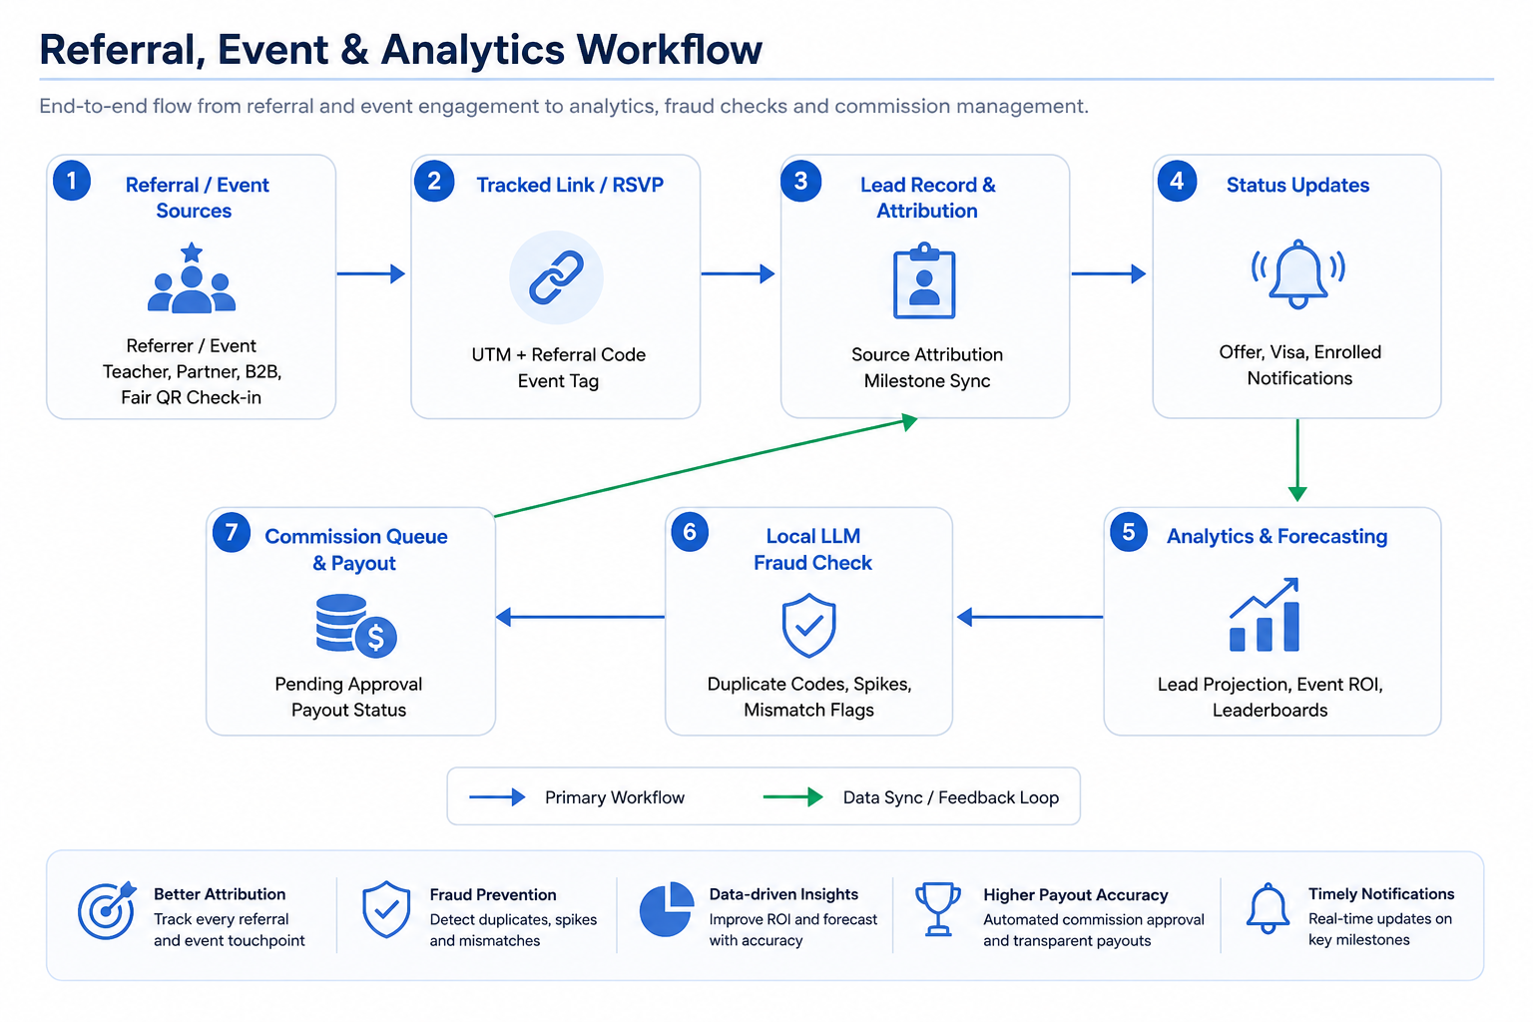
Figure 4: Referral/event attribution, status sync, commission queue, local fraud detection and analytics dashboards.

7. Role-Based Access Summary
Role | Capabilities | Restrictions
Super Admin | Full AI configuration, prompt templates, model usage analytics, all campaigns, all landing pages, fraud alerts | MFA enforced; full audit trail
Branch Manager | Branch landing pages, promotions, lead routing, branch AI usage stats and forecasting dashboards | Cannot edit global prompt templates
Counselor | AI Counselor, SOP/InfoBar tools, Smart Reply, Generate-a-Status and lead follow-up | Cannot access global AI infrastructure or usage analytics
B2B Partner | Tiered AI access, own branded pages and own campaign/lead view | Tenant-isolated data only
Teacher Referrer | Referral dashboard, own referred student status and AI content suggestions | No CRM core access
Smart Partner | Referral link, milestone notifications and monthly AI summary | No CRM access
Student | SOP/Cover/Sponsor generators, Course Finder InfoBar, Scholarship Recommender and document checklist | Per-day AI call limit enforced

8. Development Methodology
An Agile delivery methodology is recommended to deliver the platform in controlled increments while keeping the scope aligned with the approved SRD and Local LLM requirement. Each sprint should produce reviewable outputs such as screens, APIs, workflows, automation rules, model-serving configuration or dashboards.
- Discovery and backlog confirmation: validate SRD scope, roles, module boundaries, integrations, Local LLM deployment model and data dependencies.
- Solution architecture and UX planning: finalize workflows, information architecture, database design, API contracts, Laravel AI Gateway controls and local inference architecture.
- Model evaluation and setup: benchmark candidate local models using representative SOP, smart reply, InfoBar, Bengali/English and RAG tasks before finalizing production model routing.
- Iterative development: implement feature modules in sprints, starting with common platform foundations and then AI, marketing, lead, referral, event and analytics modules.
- Continuous QA: perform test planning, unit/API/UI testing, integration checks, AI output evaluation and regression testing during each sprint.
- Stabilization and deployment: complete security hardening, performance checks, GPU/load testing, production readiness review, deployment setup and handover documentation.

9. Deliverables
Deliverable | Description
Project Documentation | Finalized backlog, architecture notes, API documentation, Local LLM deployment guide and handover notes
UI/UX Deliverables | Responsive web UI screens for dashboards, builders, AI drawers, forms, feeds and analytics
Local LLM AI Gateway | Laravel AI Gateway with prompt templates, local model routing, rate limits, logs, guardrails and fallback handling
Local Model Serving Setup | Self-hosted LLM runtime configuration, model benchmark summary and production serving recommendation
AI Content Modules | SOP, cover letter, sponsor letter, revision mode, document checklist and document validator
Course Intelligence Modules | Course finder filters, InfoBar, AI match score, comparison and scholarship recommender
Marketing & Lead Modules | Landing page builder, form builder, lead capture, routing, pipeline, smart alerts and campaign tools
Communication Modules | AI smart reply, AI counseling assistant, birthday messages, digest emails and slot suggestions
Community, Referral & Event Modules | Feed automation, referral dashboards, event/fair pages, QR check-in and post-event follow-up
Analytics & Fraud Detection | Lead dashboards, forecasts, leaderboards, source charts and commission anomaly alerts
QA & Handover | Test cases, QA report, deployment support and knowledge transfer session

10. Testing and Quality Assurance
- Validate modules, user roles, workflows, forms, routing rules and outputs.
- Test landing page builder, public slugs, form submission and source tagging.
- Verify CRM lead creation, routing, referral codes and milestone sync.
- Check commission queue, leaderboard refresh and referral workflow.
- Test event setup, RSVP, QR check-in, counselor assignment and follow-up.
- Validate local AI output relevance, tone, structure, language quality, hallucination risk and fallback behavior.
- Test SOP, cover letter, sponsor letter generation and RAG answer accuracy against approved knowledge base content.
- Benchmark local model latency, throughput, GPU/CPU utilization, concurrent users and batch-job load.
- Verify AI rate limits, usage quota, caching, prompt versioning and audit history.
- Test integrations with WhatsApp, email, Meta Lead Ads, GA/GTM, storage and local model-serving endpoint.
- Validate security, RBAC, tenant isolation, CAPTCHA, file upload, performance and responsiveness.
- Perform prompt injection, data leakage and access-boundary tests for AI-facing workflows.

11. Assumptions and Dependencies
- Core CRM entities such as Student, Application and University are available or will be provided as platform dependencies.
- Client will provide final branding, domain/subdomain decisions, email/WhatsApp/Meta/Google credentials and approved prompt/content guidelines.
- Client will confirm preferred deployment mode for Local LLM: on-premise server, private cloud GPU server or hybrid private infrastructure.
- Client will provide or approve required GPU/CPU infrastructure, storage, networking and security access for local model hosting.
- Final Local LLM model will be selected after benchmark testing for output quality, language support, latency and infrastructure fit.
- Course, university, scholarship and country-related data should be validated by the client or connected data owners before production usage.
- AI-generated documents will be editable drafts and should remain subject to counselor/student review before final submission.
- Arabic/RTL and additional languages beyond initial English/Bangla support can be enabled in a later language expansion phase.
- External cloud AI fallback will remain disabled unless the client separately approves it.

12. Out of Scope
- Core finance, payroll, EMI and accounting systems.
- Branch and office HR management modules.
- E-signature/agreement system unless separately approved.
- Full redesign of master CRM data models beyond the AI and marketing module dependencies.
- Custom foundation model training from scratch; the proposed build uses self-hosted open-weight models with prompt engineering, RAG, evaluation and governance controls.
- Large-scale multilingual model fine-tuning unless separately approved after benchmark results.

13. Conclusion
The proposed VarsityOS AI Automation & Marketing Management Module provides a focused, scalable and controlled implementation of the client requirements using a Local LLM-first architecture. By combining a centralized AI Gateway, self-hosted model serving with Laravel backend orchestration, RAG-based counseling, CRM-driven lead routing, marketing automation, referral/event workflows and analytics dashboards, the platform can support education consultancy operations while maintaining data control, governance, auditability and practical development scope.

