Technical Proposal

iBook Phase 2 - Clarified Scope and Conditions

Prepared by | Riseup Labs
Date | 24 February 2026

1. Executive Summary
iBook Phase 2 focuses on stabilizing member authentication, improving the member dashboard for mobile performance, enabling booking-related member actions (cancellation and invoice requests), applying an automatic first-booking member discount, enhancing the Super Admin member management area, and fixing B2B hotel room content and imagery via automated Excel-driven import.
Implementation will be done through new/refactored code, UI components, and supporting scripts developed from scratch within the iBook platform (no off-the-shelf page builders), with staging-first validation and production promotion only after sign-off. The clarified scope document is treated as binding for development, testing, and deployment.

2. Project Understanding and Objectives

2.1 Objectives
- Fix broken member sign-up and ensure immediate auto-login after successful registration.
- Implement Google (Gmail) one-click sign-up/login with account auto-linking by email.
- Deliver a clean, mobile-fast member dashboard that shows only member-relevant data and removes any SSU-related elements.
- Enable member booking actions with clear rules for postpaid vs prepaid cancellations and prepaid invoice requests via WhatsApp.
- Automatically apply an RM5 first-booking discount for logged-in members across both B2B and direct hotels, including checkout re-entry after sign-up.
- Ensure members can see only their own bookings, while Super Admin can view member-linked bookings read-only.
- Enhance Super Admin member management: list, edit, delete (hard delete), and view bookings (read-only).
- Add a phone country code selector at checkout (default: Malaysia) with search by name/code and UI consistency.
- Fix B2B room images and content by importing from Excel links; enforce a default image rule when room images are missing.
- Ensure perfect UI compatibility on both mobile and desktop with strong performance in admin members tab.

2.2 In-Scope Functional Modules
Module | Key Outcomes (Phase 2)
Member Sign-Up and Login | Restore sign-up flow, auto-login, Google login, account linking.
Member Dashboard (Mobile-First) | Mobile-friendly bookings list, navigation entry point, remove SSU elements.
Booking Actions | Postpaid instant cancel; prepaid request cancellation via WhatsApp; prepaid invoice request via WhatsApp.
Member Discount | Auto-apply RM5 first booking discount; checkout messaging; preserve checkout context after sign-up.
Booking Visibility | Member sees own bookings only; admin can view member-linked bookings read-only.
Admin Member Management | List members, edit, hard delete, view bookings read-only; keep members tab fast.
Checkout Phone Country Code | Selectable searchable country code list; default Malaysia; clean UI.
B2B Hotel Data Fixes | Automated import from Excel links for descriptions/features/policies and room images; default missing room images.
Deployment and Compatibility | STG-first delivery, sign-off, production promotion; mobile and desktop compatibility.

2.3 Out of Scope
- Financial and commercial proposal (pricing, payment terms, cost breakdown).
- New SSU-related features or screens (any SSU elements will be removed from member dashboard where present).
- Net-new features not mentioned in the clarified scope document.
- Full UI redesign of the entire platform. Only scope-required UI/UX work is included (mobile friendliness, layout cleanup, and required checkout/dashboard messaging).

3. Assumptions, Dependencies, and Constraints

3.1 Key Assumptions
- iBook will provide access to the existing codebase, staging and production environments, and any required third-party credentials (e.g., Google OAuth client credentials).
- iBook will provide Excel file links and agreed column formats for B2B hotel content and room images.
- Existing booking/checkout/payment workflows remain unchanged except for the member discount logic and UI messaging required in scope.
- WhatsApp-based requests are implemented via a 'click to chat' deep link with a pre-filled message (no direct WhatsApp Business API integration is assumed unless separately agreed).
- Final UI text, branding assets (logos, icons), and policy rules used for cancellation are provided or confirmed by iBook where not already implemented.

3.2 Constraints and Delivery Conditions
- All features will be developed and tested on the STG environment first; production deployment will occur only after sign-off.
- Member dashboard must be optimized for mobile speed and must not show SSU-related elements.
- Members tab in admin must remain performant; list and aggregation queries must be optimized.
- All customizations must work perfectly on mobile and desktop across modern browsers.

4. Proposed Technical Approach

4.1 High-Level Solution Overview
Phase 2 will be delivered by implementing new/refactored features from scratch within the iBook platform: authentication fixes, Google OAuth integration, discount and checkout continuity logic, admin enhancements, responsive UI adjustments, and automated Excel-driven import jobs. The approach prioritizes backward-compatible changes, performance optimization, and strong regression coverage.
Figure 1: High-Level Solution Architecture (Web, API, Data, and Integrations)
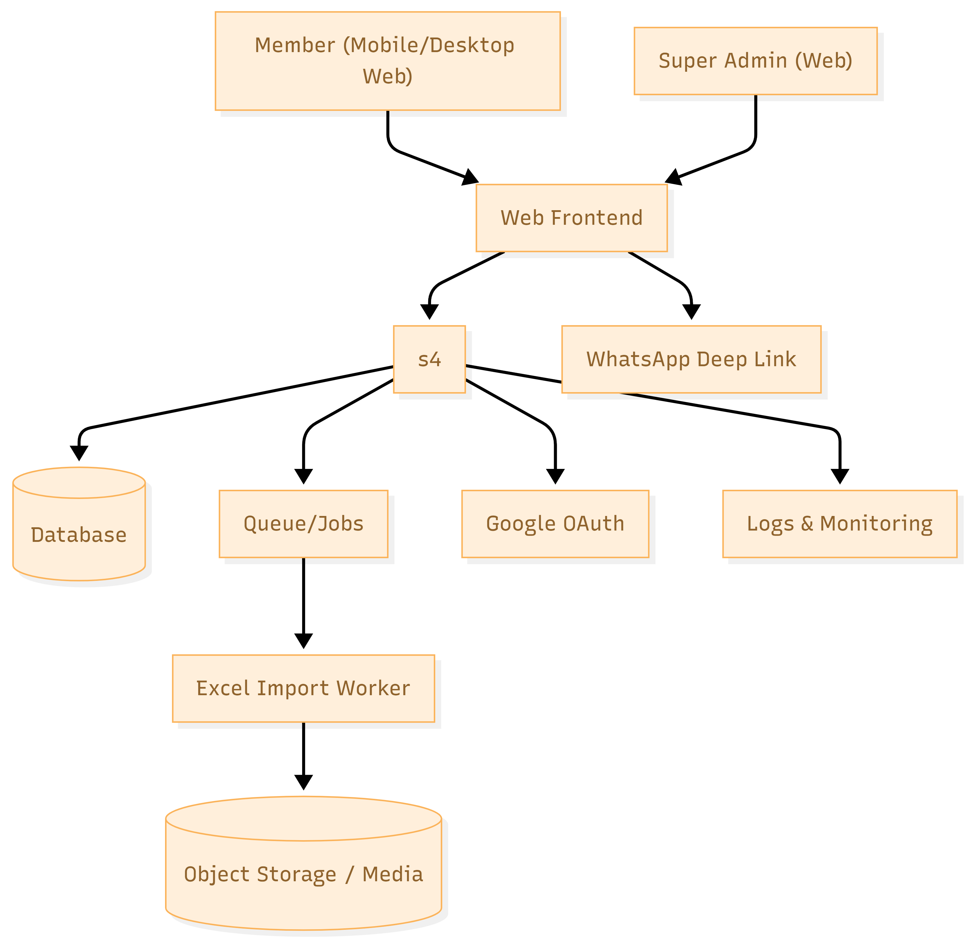

4.2 Member Authentication and Account Linking
- Fix the current member sign-up flow including validation, duplicate email handling, and consistent session creation.
- Auto-login immediately after successful sign-up (issue a session/token and redirect user to the intended page).
- Implement Google sign-up/login using OAuth 2.0 Authorization Code flow.
- If a member account already exists with the same email, auto-link Google identity to the existing member profile after successful OAuth verification.
- Apply rate limiting and abuse controls (captcha or throttling) to reduce fraudulent sign-ups where applicable.
Figure 2: Authentication and Account Linking Flow (Email/Password + Google OAuth)
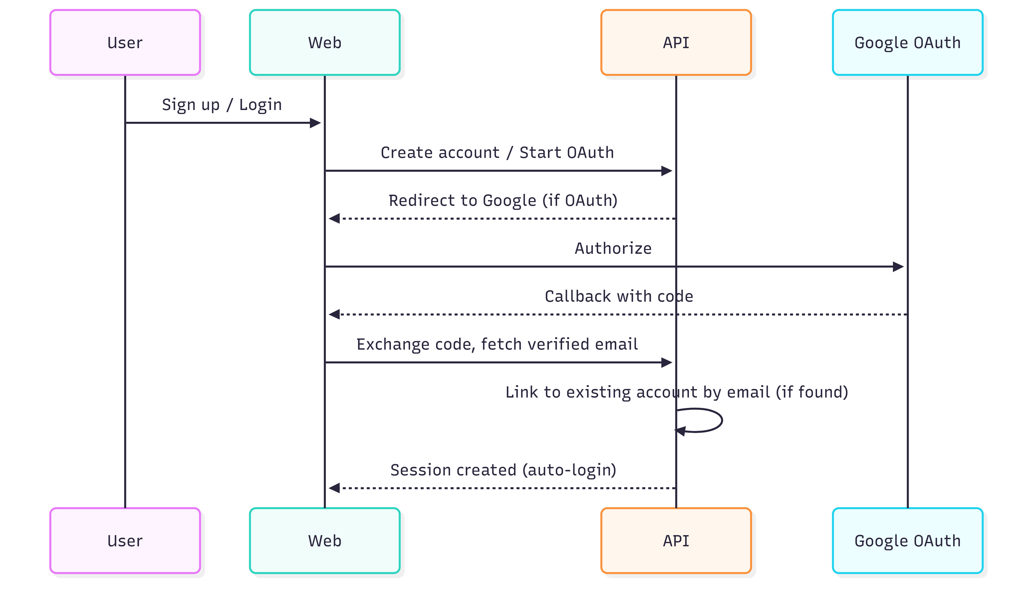

4.3 Member Dashboard (Mobile-First)
- Remove any SSU-related elements from member views as per scope.
- Optimize layout and component rendering for mobile (responsive grid, minimized heavy assets, lazy loading where applicable).
- Bookings list will display: Booking ID, Hotel Name, Stay Dates, Payment Type (Prepaid/Postpaid), Booking Status, and Amount.
- If user is logged in, provide one-click access to Dashboard from the top-right corner entry point on the home page.

4.4 Booking Actions: Cancellation and Invoice Requests
- Postpaid bookings: show 'Cancel Booking' action in booking dropdown and apply instant cancellation based on hotel policy rules configured in the system.
- Prepaid bookings: show 'Request Cancellation' action that opens WhatsApp with a pre-filled message containing Booking ID.
- Prepaid bookings only: show 'Request Invoice' action that opens WhatsApp with a pre-filled message containing Booking ID.
- Ensure actions are visible and enabled based on booking payment type and booking status; log actions for audit and support.

4.5 Member Discount Logic and Checkout Continuity
- Apply RM5 discount on a member's first booking across both B2B and direct hotels.
- Discount is automatically applied at checkout when the user is logged in and eligible.
- Checkout messaging will display: 'Logged in members save up to 10% on first booking.'
- If a new member signs up during checkout, the user is redirected back to the same checkout state and the voucher is auto-applied after sign-in.
- Implement eligibility rules using a single source of truth (e.g., member profile flags + booking history) to prevent double-use.

4.6 Bookings Visibility and Admin Read-Only Access
- Member portal: enforce authorization so members can view only their own bookings.
- Super Admin: can view member-linked bookings in read-only mode from member profile or bookings list.
- All access is logged for traceability (who viewed what, when).

4.7 Super Admin - Member Management Enhancements
- Member list view with: Name, Email, Phone, Total Amount Spent.
- Admin actions: edit member details, hard delete member account (complete removal from database), and view member bookings (read-only).
- Performance: optimize members tab with indexed queries, pagination, and server-side aggregation (cache totals where appropriate).

4.8 Checkout Phone Country Code Selector
- Implement a country code selector for checkout phone field with default Malaysia (MY).
- Search by country name and dialing code; maintain clean and modern UI aligned with existing design system.
- Store phone numbers in normalized format (E.164) and preserve local display as needed.

4.9 B2B Hotel Data Fixes - Content and Media Import
- Provide an automated import pipeline that downloads iBook-provided Excel files from links and updates the database.
- Images: fix missing room images for B2B hotels (rooms only) and remove unnecessary B2B images from the server as instructed.
- Content: update hotel descriptions, features, and policies from Excel inputs (existing content may be deleted and reuploaded).
- Default rule: if a room image is missing in Excel, use the hotel's featured image as the default room image automatically.
- Implement validation, import logs, and rollback strategies to protect production data integrity.
Figure 3: B2B Excel Import Pipeline and Image Fallback Logic
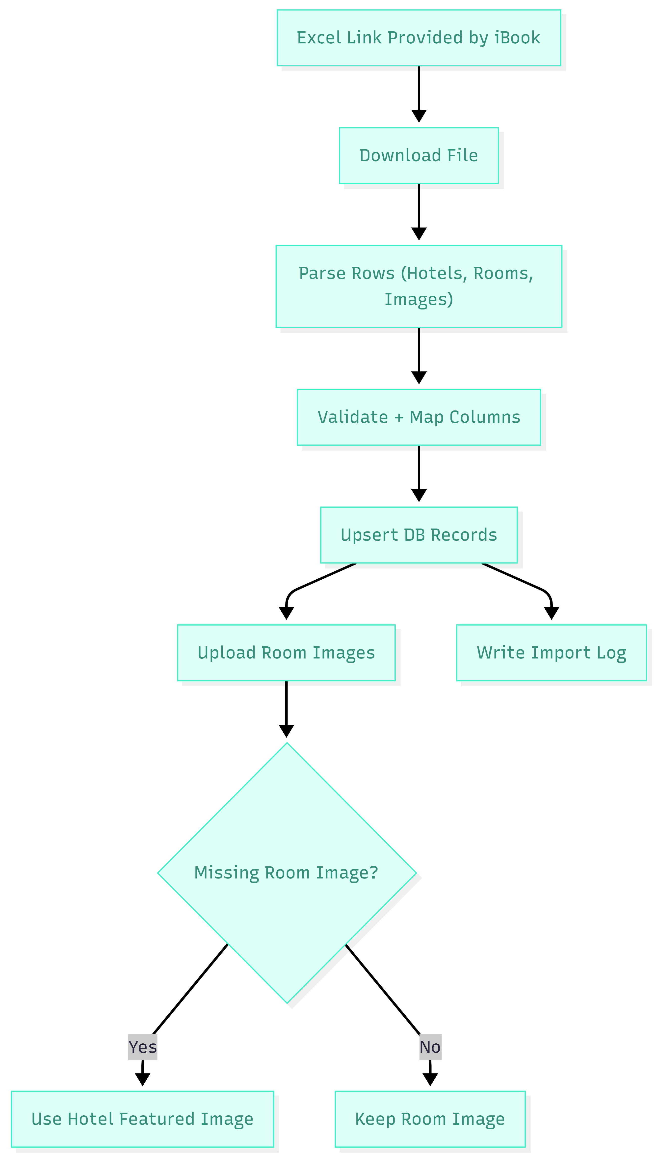

5. Development Methodology
A sprint-based Agile delivery model will be used with clear Definition of Done, continuous QA, and staging-first releases. The approach is designed to minimize risk in an existing production system while delivering Phase 2 scope reliably.

5.1 Delivery Phases
Phase | Activities | Key Outputs
Phase A - Discovery and Technical Assessment | Codebase review, environment setup, requirement walkthrough, data format confirmation. | Implementation plan, risk log, refined backlog.
Phase B - Build and Iteration (Sprints) | Feature development, API/UI updates, import scripts, code reviews, automated tests. | Working increments on STG, sprint demos.
Phase C - System QA and Support | Regression, cross-device tests, performance checks, security checks, fixes. | Ready release candidate, test evidence.
Phase D - Production Release | Deployment to prod after sign-off, smoke test, monitoring, rollback readiness. | Prod release, release notes, handover.

5.2 Governance and Communication
- Weekly sprint planning and review sessions with iBook stakeholders.
- Regular progress updates via agreed channel (email/Slack/WhatsApp group).
- Centralized issue tracking (Jira/Trello) with clear priorities and acceptance criteria.
- Change requests handled via a simple impact note (scope, timeline, risk) and written approval.

6. Proposed Technical Stack
The final implementation will align with the existing iBook technology baseline. The stack below is recommended for robust delivery and long-term maintainability, and can be adapted to match the current codebase where needed.
Layer | Recommended Technologies | Notes
Frontend (Web) | Next.js (React) + TypeScript + Tailwind CSS | SSR for performance; responsive UI for mobile-fast dashboard.
Admin Panel | Next.js Admin UI or Laravel Blade/Inertia (based on existing baseline) | Member management with server-side pagination and optimized queries.
Backend API | Laravel (PHP) REST API (or existing backend framework) | Auth, booking actions, discount rules, import jobs, admin operations.
Database | MySQL/MariaDB | Indexed tables, migrations, referential integrity, transactional updates for discounts.
Cache and Queue | Redis + job queue (Laravel Queue) | Import jobs, async tasks, caching totals for admin views.
Storage | S3-compatible object storage or existing storage | Hotel/room images; controlled cleanup of unused media.
Auth Providers | Google OAuth 2.0 | Secure token storage; account linking by verified email.
Observability | Centralized logging + APM (e.g., ELK/CloudWatch + Sentry) | Error tracking, audit logs, performance monitoring.
CI/CD | GitHub/GitLab CI, staging pipeline, manual prod approval | Automated tests; deploy to STG first, promote to Prod.
Security | HTTPS/TLS, secrets management, optional WAF | Rate limiting, input validation, OWASP-aligned controls.

7. Testing and Quality Assurance
Quality assurance will be embedded throughout the delivery lifecycle. Each feature will be implemented with measurable acceptance criteria, automated test coverage where feasible, and manual verification on real devices/browsers.

7.1 Test Strategy
- Tests: core business rules (discount eligibility, booking visibility authorization, import validation).
- API/Feature tests: sign-up/login flows, Google OAuth callback processing, admin actions.
- UI tests: responsive layout checks for member dashboard and checkout components.
- End-to-end (E2E) tests: critical journeys (sign-up -> checkout -> discount applied; booking actions).
- Regression testing: ensure Phase 2 does not break existing booking/search/payment flows.
- Performance testing: validate admin members tab responsiveness and import job performance on STG.
- Security testing: authentication hardening, authorization checks, and basic vulnerability scanning.

Fig: QA test Process

8. Deployment and Operational Approach

8.1 Environments and Release Flow
- Development and QA will be performed on STG first, using production-like configuration and sanitized data where possible.
- Release candidate deployed to STG; issues triaged and fixed iteratively.
- After written approval, promote the same tested build to Production.
- Post-release smoke tests and monitoring to confirm stability.

8.2 Monitoring, Logging, and Support Readiness
- Implement structured logs for authentication events, booking actions, admin changes, and import jobs.
- Enable error monitoring and alerting for critical failures (OAuth failures, import errors, broken checkout).
- Maintain an import dashboard/log view for transparency and troubleshooting.
- Provide rollback plan for production deployment (database backups, feature flags where applicable).

9. Deliverables
The following deliverables will be provided as part of Phase 2 implementation. Deliverables are structured to support sign-off and safe production release.

9.1 Functional Deliverables
- Fixed member sign-up flow with auto-login.
- Google sign-up/login with email-based account auto-linking.
- Mobile-first member dashboard updates with SSU removal and bookings list enhancements.
- Booking action rules implemented for postpaid cancellation and prepaid WhatsApp-based requests (cancellation and invoice).
- Automatic RM5 first booking discount applied at checkout (B2B and direct), including checkout return after sign-up and required messaging.
- Authorization updates ensuring members see only their own bookings; Super Admin read-only booking visibility by member.
- Admin member management enhancements: list, edit, hard delete, view bookings read-only; performance optimization.
- Checkout phone country code selector with default Malaysia and search.
- Automated B2B hotel content and room image import from Excel links, including default image fallback and server cleanup logic.

9.2 Technical, UI/UX, and Documentation Deliverables
- Responsive UI component updates (mobile-first layouts, required checkout/dashboard messaging, and UI consistency adjustments).
- Updated source code in version control with release tagging.
- Database migrations and seed/update scripts (where applicable).
- Import job scripts with runbook and logs format.
- Test cases and regression checklist.
- Deployment runbook: STG deployment, production promotion steps, rollback plan.
- Release notes summarizing changes and configuration steps.

10. Risks and Mitigation
Risk | Impact | Mitigation
Unknown legacy issues in existing sign-up/checkout code | Delays or regressions | Early technical assessment; feature flags; strong regression testing.
Inconsistent Excel formats or broken file links | Import failures, data quality issues | Define template; validate before import; import logs with error reporting.
Large media storage and cleanup operations | Accidental deletion or long runtimes | Dry-run mode on STG; backups; operate in batches.
Admin members tab performance on large datasets | Slow UI and poor admin experience | Indexes, pagination, caching totals, query optimization.
OAuth misconfiguration or domain restrictions | Google login failures | Coordinate with iBook for OAuth setup; STG validation; fallback messaging.

