Technical & Financial Proposal
Eyes-on-Glass Cloud Deployment Plan

Prepared by: Riseup Labs

1. Introduction
This document provides a technical and financial proposal for the Eyes-on-Glass Cloud Deployment Plan. The proposal is focused on a lightweight deployment of the existing Eyes-on-Glass platform using a simplified cloud infrastructure approach.
The deployment scope is limited to:
- Deploying the existing application stack
- Configuring runtime infrastructure
- Database provisioning
- Redis setup
- CI/CD setup
- Production deployment and operational handover
Key prerequisites for this proposal:
- The client already has a working codebase ready for deployment.
- The backend and frontend applications are functional.
- Environment variables and deployment requirements are available.
- No major development or architectural changes are required.

2. Project Context & Objectives
Eyes-on-Glass requires production deployment of its existing application stack. The objective is to configure the required cloud runtime environment, deploy the backend and frontend applications, provision the database, configure Redis, set up CI/CD, and complete production handover within the planned two-week timeline.

2.1 Deployment Objectives
- Prepare and validate the deployment environment based on the available repositories and environment requirements.
- Provision a single Linux VM and a single PostgreSQL RDS instance for the production deployment.
- Deploy the FastAPI backend application and connect it with the database.
- Deploy the existing frontend application with Nginx and SSL configuration.
- Configure Redis on the same VM.
- Configure a lightweight GitHub Actions-based CI/CD workflow.
- Perform smoke testing, runtime validation, final deployment validation, documentation, and handover walkthrough.

3. Proposed Technical Approach & Methodology
The proposed approach is to deploy the existing functional application stack without major development or architectural changes. The delivery will follow a practical deployment sequence: environment review, infrastructure setup, backend deployment, frontend deployment, Redis and CI/CD setup, testing and stabilization, and final production handover.

3.1 Deployment Approach
- Review the available repositories, deployment requirements, and environment variables before infrastructure configuration.
- Provision the runtime environment using a single Ubuntu Linux VM and a PostgreSQL RDS instance.
- Configure Nginx, SSL, process management, Redis, firewall/security settings, and application runtime services.
- Deploy backend and frontend applications using the existing codebase and deployment-ready configuration.
- Set up GitHub Actions for repository-based deployment triggers, build and deployment validation, automated deployment to the VM, service restart/reload, and environment variable handling.
- Complete smoke testing, deployment fixes, runtime validation, documentation, deployment walkthrough, and final validation.

3.2 Delivery Methodology
1. Environment Review and Planning
2. Infrastructure Provisioning and Security Configuration
3. Backend Deployment and Database Connectivity
4. Frontend Deployment, Nginx, and SSL Configuration
5. Redis Setup and CI/CD Pipeline Configuration
6. Testing, Stabilization, and Runtime Validation
7. Production Handover and Deployment Walkthrough

4. Proposed Technical Stack
Component / Layer | Deployment Choice
Application Hosting | Single Linux VM (Ubuntu)
Backend APIs | FastAPI Application
Frontend | Existing Frontend Deployment
Database | Single PostgreSQL RDS Instance
Redis | Redis installed on the same VM
Reverse Proxy | Nginx
Process Manager | Systemd or Supervisor
CI/CD | GitHub Actions
SSL | Let's Encrypt
Monitoring | Basic VM and application monitoring

5. Scope of Work
The scope of work follows the Eyes-on-Glass Cloud Deployment Plan and remains limited to the deployment activities listed below.

5.1 Environment Review
- Review repository readiness.
- Validate available environment variables and deployment requirements.
- Confirm deployment plan and runtime requirements before setup.

5.2 Infrastructure Setup
- Provision the single Linux VM using Ubuntu.
- Provision the single PostgreSQL RDS instance.
- Configure firewall and security settings required for deployment.

5.3 Backend Deployment
- Deploy the existing FastAPI backend application.
- Configure backend environment variables.
- Validate database connectivity with the PostgreSQL RDS instance.

5.4 Frontend Deployment
- Deploy the existing frontend application.
- Configure Nginx for application access.
- Configure SSL using Let's Encrypt.

5.5 Redis and CI/CD Setup
- Install and configure Redis on the same VM.
- Configure GitHub Actions deployment workflow.
- Set up deployment triggers, build and deployment validation, automated deployment to the VM, service restart/reload, and environment variable handling.

5.6 Testing, Stabilization, and Handover
- Perform smoke testing.
- Apply deployment fixes where required.
- Validate runtime behavior after deployment.
- Prepare documentation, conduct deployment walkthrough, and complete final deployment validation.

6. Human Resources & Responsibilities
Role | Allocation | Key Responsibilities
DevOps / Cloud Engineer | Primary | VM setup, RDS setup, firewall/security configuration, Nginx, SSL, Redis, CI/CD, deployment, monitoring baseline, and handover support.
Backend Engineer | Partial | Application configuration, environment variable support, FastAPI deployment support, and database connectivity validation.
Project Lead / PM | Minimal | Coordination, deployment oversight, timeline tracking, communication, and handover support.

7. Suggested Timeline
The estimated deployment timeline is two (2) weeks.
Day Range | Focus | Activities
Day 1-2 | Environment Review | Repository review, environment validation, deployment planning
Day 3-4 | Infrastructure Setup | VM provisioning, RDS setup, firewall/security configuration
Day 5-6 | Backend Deployment | FastAPI deployment, environment configuration, DB connectivity
Day 7-8 | Frontend Deployment | Frontend deployment, Nginx setup, SSL configuration
Day 9-10 | Redis & CI/CD | Redis setup, GitHub Actions deployment pipeline
Day 11-12 | Testing & Stabilization | Smoke testing, deployment fixes, runtime validation
Day 13-14 | Production Handover | Documentation, deployment walkthrough, final deployment validation

8. Deliverables
- Environment review and deployment planning completion.
- Provisioned single Linux VM and PostgreSQL RDS instance.
- Firewall/security configuration for the deployment environment.
- FastAPI backend application deployed and connected with the database.
- Existing frontend application deployed with Nginx and SSL configuration.
- Redis installed and configured on the same VM.
- GitHub Actions CI/CD workflow configured.
- Smoke testing, deployment fixes, runtime validation, and final deployment validation.
- Deployment documentation and handover walkthrough.

9. Technical Diagram Placeholders

Diagram 1: Proposed Cloud Deployment Architecture

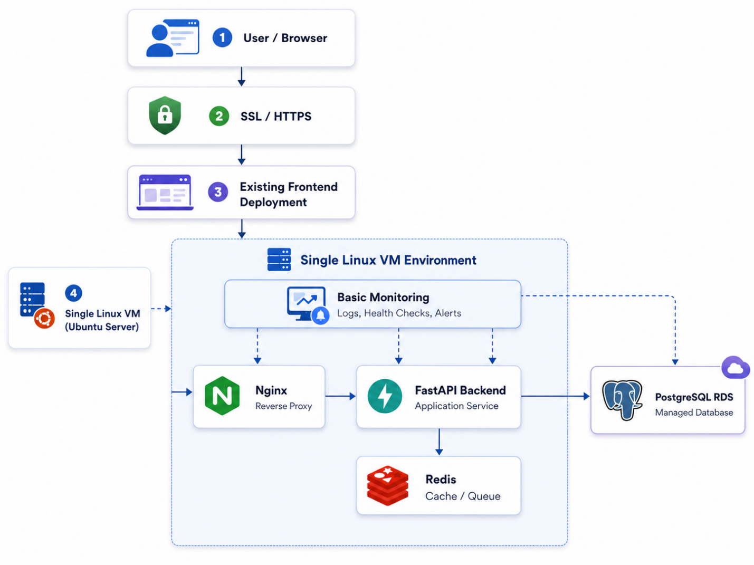

10. Complimentary Support (1 Month)
After production handover, one (1) month of complimentary support will be provided for the delivered deployment scope.
Included support:
- Bug fixing for reproducible deployment-related issues within the delivered scope.
- Minor adjustments related to configuration or deployment setup.
- Support for reviewing deployment/runtime issues where required access is provided.
- Support boundary:
- Major development, architectural changes, application refactoring, or new features are outside the scope of this support period.

11. Financial Proposal
The source deployment plan provides the estimated monthly infrastructure cost. The professional deployment service fee can be inserted in the table below based on the final commercial decision.
Scope | Scope of Work | Timeline / Billing Type | Estimated Cost (USD)
Cloud Deployment Service | Environment review, infrastructure setup, backend deployment, frontend deployment, Redis setup, CI/CD setup, testing, stabilization, and handover | 2 Weeks | $2,500
Estimated Initial Monthly Infrastructure Cost | Single VM, PostgreSQL RDS, networking/bandwidth, monitoring/logs | Monthly recurring | Approx. USD $110-330/month

11.1 Estimated Monthly Infrastructure Cost
Service | Estimated Monthly Cost | Notes
Single VM | $40-120 | Application hosting and Redis
PostgreSQL RDS | $60-150 | Small production database
Networking / Bandwidth | $10-40 | Traffic dependent
Monitoring / Logs | $0-20 | Operational monitoring

Estimated Initial Monthly Infrastructure Cost: Approximately USD $110-330/month

11.2 Payment Terms
- 30% advance payment upon project kickoff.
- 30% payment upon completion of infrastructure setup and backend deployment.
- 30% payment upon completion of frontend deployment, Redis setup, CI/CD setup, and testing/stabilization.
- 10% payment upon production handover and final deployment validation.

11.3 Change Request
Any requirement beyond the agreed Eyes-on-Glass Cloud Deployment Plan will be treated as a separate change request and will require confirmation before execution.
CR Man-day Rate: USD 150 per man-day or USD 25 per man-hour.

12. Assumptions & Prerequisites
- The client will provide working repositories and deployment-ready code.
- All required environment variables and credentials will be available.
- No major application refactoring is required.
- The backend/frontend applications are already functional.
- The database schema and migrations are already prepared.
- Required domain/DNS access will be provided by the client.

13. Acceptance & Sign-off
The deployment will be considered ready for acceptance after the production deployment is completed, smoke testing and runtime validation are performed, deployment fixes are addressed, documentation is provided, the deployment walkthrough is completed, and final deployment validation is confirmed.

