Kwando — iOS MVP Development (Technical & Financial Proposal)
Project: Kwando — iOS MVP (Personal Calendar + Social Planning + Circles)
Document Type: Technical & Financial Proposal (Development Only)
Design & UI/UX: Out of Scope (to be provided/approved separately).

1. Introduction
This proposal outlines the recommended technical approach, phased scope of work, timeline, and cost estimate to develop the “Kwando — iOS MVP” from scratch. The MVP is calendar-first (personal utility) with optional social layers for inviting, RSVPs, planning-mode polling, event-based chat, and community organization via Circles.
All requirements and constraints are derived from the provided PRD. This proposal focuses on development execution, backend services, quality assurance, and release readiness for TestFlight/App Store.

2. Project Scope Overview
Kwando is a privacy-first, mobile-first calendar platform designed to help users manage personal schedules and coordinate real-world plans with others—without becoming a social network. The MVP is iOS-first and includes a lightweight guest web RSVP page.

2.1 In Scope (MVP)
- Native iOS application (iPhone-first) implementing the MVP feature set described in the PRD.
- Backend services supporting event data, invites, RSVPs, polls, shared views, chat, circles, and notifications.
- Guest Web RSVP interface (mobile responsive) for non-app users, with one-time token invite links and revoke/resend capability.
- Admin Console (Admin Dashboard).
- Security, privacy controls, moderation tools (host/circle admin), and audit-friendly logs for critical actions.
- QA, and release readiness for TestFlight/App Store submission.

2.2 Out of Scope (Explicit)
- UI/UX design, branding, illustrations, and user research (development will implement approved designs).
- Android application.
- Full web application (beyond the guest RSVP pages).
- Public feed/discovery of events or Circles; public browsing of events by location/interest.
- Payments/monetization (paid Circles, ticketing, subscriptions).
- Two-way external calendar sync (Google Calendar/iCal/Outlook).
- Direct messaging outside event/circle contexts and other post-MVP stretch features (unless rescoped).

2.3 Delivery Approach
- Agile delivery with 1–2-week sprints, demo at the end of each sprint.
- Feature flags where appropriate to enable staged rollout and controlled testing.
- Privacy-by-default implementation: nothing shared unless explicitly enabled by the user.

3. Phase 1 – Foundation + Personal Calendar (Core Usability)

Feature Scope
- Project setup and baseline architecture (modular iOS app structure, environments).
- Authentication & onboarding (Mobile/Password, Apple Sign-In).
- User profile basics (name, avatar) and settings scaffolding (notification + privacy settings placeholders).
- Personal calendar core: Day/Week/Month views; event list for upcoming items.
- Create/Edit personal events (private by default): title, date/time, location (search/manual), notes.
- Reminders: local notifications for personal events; basic repeat scaffolding (future-proofing).
- Data persistence: event storage tied to user; offline-first caching for calendar viewing.
- Basic analytics/logging for critical flows (opt-in, privacy-friendly).

Deliverables
- iOS MVP build with personal calendar functionality and authenticated user accounts.
- Backend schema and security rules for Users and Personal Events.
- Dev/staging environment setup.
- Phase 1 test plan + test execution report.

Human Resources & Responsibilities
- Project Manager: Sprint planning, backlog grooming, acceptance criteria, stakeholder updates.
- iOS Engineer(s): Implement calendar UI flows, event CRUD, local reminders, caching, accessibility basics.
- Backend Engineer: Laravel API development, database schema, authorization policies, environments.
- QA Engineer: Test cases, functional testing, regression suite creation, TestFlight smoke testing.
- DevOps/Release Engineer: CI/CD, signing, environment configs, optional crash reporting setup.
Suggested Timeline
Estimated duration: 3 weeks.

Key Assumptions
- Approved UI screens and interaction specs will be provided before development of each feature set.
- Calendar views will be Kwando-native (no external calendar sync in MVP).
- Timezone handling follows device timezone; event times stored in a normalized format with timezone metadata.
- MVP non-functional targets emphasize stability and usability; advanced optimization can be iterative post-MVP.

Acceptance Criteria
- User can sign up/login and reach calendar home reliably (no critical crashes).
- User can create, edit, and delete a private event and see it reflected in day/week/month views.
- Local reminder notifications trigger at configured times on supported iOS versions.
- Data is persisted securely and visible after app relaunch; basic offline viewing works for recently loaded data.

4. Phase 2 – Social Planning (Invites + RSVP + Planning Mode + Guest Web RSVP)

Feature Scope
- Social event creation enhancements: Date TBD (Planning Mode), RSVP deadline, guest visibility toggle.
- Invite Kwando users (search/select) and generate personalized external invite links per guest.
- RSVP tracking (Yes/Maybe/No) for users and guests; host dashboard to view status and engagement.
- Planning Mode polls: multiple-choice polls and calendar-based date voting; host finalize/lock date.
- Guest Web RSVP (responsive): view event basics; RSVP; add-to-calendar export (iCal/Google calendar link).
- Invite link lifecycle: one-time use, token-based; revoke/resend; link open tracking (basic).
- Notifications: invite sent, RSVP updates, poll updates/finalization (push + in-app where applicable).
- Abuse prevention basics: rate limiting for RSVP endpoints, token throttling, bot/scan resistance.

Deliverables
- iOS build with social planning flows (invites + RSVP + planning mode).
- Guest web RSVP page deployed (token-based links, revoke/resend, calendar export).
- Backend services for Invites, RSVPs, Polls, and Notifications with security rules and audit logs for critical actions.
- Phase 2 QA report and TestFlight build.

Human Resources & Responsibilities
- Project Manager: Clarify invite edge cases, coordinate web RSVP content requirements.
- iOS Engineer(s): Event creation enhancements, RSVP UI, host dashboard UI, poll interfaces.
- Backend/Cloud Engineer: Tokenized invite generation, RSVP APIs, poll aggregation, notification triggers.
- Web Engineer: Guest RSVP UI, calendar export, responsive behavior, link token validation.
- QA Engineer: End-to-end testing for invite→RSVP→poll→finalize flows; notification reliability checks.
- DevOps/Release Engineer: Deploy web RSVP, environment hardening, monitoring/alerts.
- Security Review (part-time): Threat review for invite links, PII handling, rate limit validation.
Suggested Timeline
Estimated duration: 3 weeks.

Key Assumptions
- SMS sending is not included unless an SMS provider and budget are confirmed; links can be shared via any channel.
- Guest RSVP requires no account; guests cannot access chat without installing the app.
- Resend issues a new token and invalidates the old one; revoked tokens can no longer RSVP.
- Notifications may be batched to avoid excessive alerts and reduce user fatigue.

Acceptance Criteria
- Host can invite a mix of Kwando users and external guests; each guest has a unique token link.
- Guest can RSVP successfully via web and the host sees the update in the app.
- Host can revoke a link; revoked links can no longer submit RSVP.
- Planning Mode date poll collects votes and host can finalize a date; participants receive an update notification.

5. Phase 3 – Shared Views + Event Chat + Circles + Release Readiness

Feature Scope
- Shared Views: mutual request/accept flow; permission levels (full events / shared-only / busy-free); overlay toggles and color coding.
- Event-based chat (for RSVP Yes/Maybe only): text, emojis, links; push notifications for new messages.
- Chat lifecycle: archive/mute after event (auto-archive 24 hours post-event) with retention policy.
- Host moderation: remove participants, delete messages; basic anti-abuse controls (reporting hooks).
- Circles: create circle, join/approve membership (public/private), post events.
- Circle chat (single thread per circle) with admin moderation and mute controls.
- Release readiness: performance pass, baseline accessibility pass, crash-free stability, App Store checklist.

Deliverables
- iOS MVP build with Shared Views, Event Chat, and Circles modules enabled.
- Backend services for Views, Chat, Circles, Memberships, and moderation actions.
- Data retention policies (TTL where applicable) and operational dashboards/alerts (basic).
- Final QA report, production release package, and App Store submission-ready build.

Human Resources & Responsibilities
- Project Manager: Scope governance, rollout planning, release coordination.
- iOS Engineer(s): Shared views overlays, chat UI, circles UI, privacy surfaces and settings.
- Backend/Cloud Engineer: Real-time chat data model, TTL/archive logic, membership workflows, security rules.
- Web Engineer (support): Minor guest web adjustments if required; deep links coordination.
- QA Engineer: Regression + exploratory testing, security/privacy checks, notification reliability matrix.
- DevOps/Release Engineer: Release builds, App Store technical checklist support, monitoring and backup policy.
- Security Review (part-time): Chat abuse mitigation review, privacy configuration validation, penetration-style checks on sensitive endpoints.
Suggested Timeline
Estimated duration: 3 weeks.

Key Assumptions
- Shared Views are targeted for small groups in MVP; large overlays may require further optimization post-MVP.
- Chat moderation is host/admin-based for MVP; automated moderation is optional for later phases.
- Circles discovery is limited/restricted; no public feed or broad discovery in MVP.

Acceptance Criteria
- Users can create/accept a Shared View, set permissions, and overlay calendars with correct visibility rules.
- Event chat is accessible only to RSVP’d users; guests cannot access chat without app onboarding.
- Chat auto-archives after event end (24 hours) and is muted by default; retention follows agreed policy.
- Circle admins can manage membership
- Meets App Store/TestFlight technical requirements.

Phase 4 – Admin Console (Admin Dashboard)

Feature Scope
• Admin Access & Data Protection
- Secure admin login: Admin console accessible only to authorised admins.
- Basic audit logging: Record critical moderation actions (user suspension, user ban, event removal) with admin ID, timestamp, action type, and target user/event ID; logs are read-only.
- Personal data visibility controls: Phone numbers masked by default; explicit admin action to reveal full number; gender and DOB view-only; no bulk PII export.

• Safety & Spam Moderation
- User search & profile view: Search by user ID or exact phone number; profile shows account status, creation date, number of events created, number of circles created.
- Event search & removal: Search by event ID or creator user ID; event view shows title, creator, creation date; removed events hidden from user app.
- User sanctions: Apply temporary suspensions or permanent bans; sanctioned users cannot create events, circles, or send invites; fixed reason required.

• Growth & Product Analytics
- Core KPI dashboard: Total users, new users (last 7 and 30 days), total events created, total circles created; metrics auto-update.
- Usage distribution metrics: Average events created per user and average circles created per user (aggregated only).
- Basic demographic insights: Aggregated metrics by gender (if provided), age bands (from DOB), and country (from phone code); no individual export.
- Active users: DAU and MAU counts (aggregated only).
- Event activity rate: Percentage of users who created at least one event in selected period.
- Circle participation: Total active circles and average members per circle.
- Invite activity: Total invites sent and average invites per event (aggregated only).
- Event attendance proxy: Percentage of events with at least one RSVP or join action.
- Retention snapshot: Percentage of users returning after 7 and 30 days; no cohort drill-down.
- Top-level geography: User distribution by country (top 5 only); aggregated.

Deliverables
- Admin console (web) with secure login, audit logs, PII masking controls, moderation tools, and KPI dashboards as listed above.
- Backend endpoints and role-based access control for admin operations; logging and rate limiting applied to sensitive actions.
- Phase 4 test plan + test execution report.

Human Resources & Responsibilities
- Project Manager: Backlog grooming, acceptance criteria, stakeholder updates for admin scope.
- Web Engineer: Build admin console UI, dashboards, search views, and moderation workflows.
- Backend Engineer: Laravel admin auth, RBAC, APIs for search/moderation/analytics, audit logs, and FCM notification triggers where applicable.
- QA Engineer: Admin workflow testing (auth, search, sanctions, removals), dashboard correctness, and regression on existing MVP flows.
- DevOps/Release Engineer: Environment setup, deployment pipeline, monitoring, and access control hardening.
Suggested Timeline
Estimated duration: 2 weeks.

Key Assumptions
- Admin access is restricted to whitelisted accounts as provided by the Client.
- Analytics are aggregated and derived from backend data; no bulk export of personal data is included.
- Admin console is internal-use only and not publicly accessible.

Acceptance Criteria
- Only whitelisted admins can access the console; failed logins are rate limited.
- Admin actions (sanction/remove) are recorded in immutable audit logs with required fields.
- User and event search work as specified; sanctions and removals reflect in the iOS app behavior.
- KPI dashboard and aggregated analytics render correctly and refresh as expected.

6. Recommended Technical Stack

6.1 iOS Application: Native iOS (Swift + SwiftUI)
Recommendation: Build the MVP as a native iOS app using Swift and SwiftUI.
6.2 Backend: Laravel (REST API + Database) + Firebase Cloud Messaging (FCM) for Notifications Recommendation: Use Laravel as the primary backend for MVP (API-driven), while keeping Firebase Notification (FCM) for push messaging.

6.3 Guest Web RSVP Interface
- Responsive web page hosted on standard web hosting (lightweight React/Next.js or equivalent).
- Token-based invite links per guest, validated server-side via Laravel API.
- RSVP actions (Yes/Maybe/No) plus add-to-calendar export links (iCal/Google template).
- Host controls: revoke/resend links; resend issues a new token and invalidates the old one.

6.4 Supporting Tooling
- Monitoring: Firebase Crashlytics + Performance Monitoring (recommended).
- Code quality: SwiftLint, PR-based code reviews.
- Environments: dev/staging/prod Laravel environments with strict access control.

7. Backend Scope & Data Model
The backend will cover (at minimum) the following domains:
- Users, Events, Invites, RSVP, Polls, Shared Views, Chat, Circles, Memberships, Notifications.
High-level entity coverage:
- Users: profile, settings, device tokens, privacy preferences.
- Events: host, time/date or TBD state, location, notes, visibility settings.
- Invites: invitee (user/guest), guest token, status, openedAt, revokedAt.
- RSVP: status and timestamps; source (app/web).
- Polls/Votes: poll type, options, votes, finalization lock.
- Shared Views: participants, permissions, mutual acceptance.
- Chat: threads and messages; moderation and archive/TTL metadata.
- Circles/Memberships: join policies, approvals, roles and event targeting.
- Notifications: event-driven logs for audit and retry.

7.1 Admin-like Controls (In-App)
- Host moderation for event chat (remove participant, delete message).
- Circle admin membership management (approve/deny, remove, promote admin).

7.2 Security & Privacy Controls (Implementation)
- Tokenized invite links: per-guest, one-time use, revocable; avoid PII in URLs; do not log tokens.
- Abuse throttling on RSVP/token endpoints via Laravel middleware and rate limiting.
- API authorization enforcing least-privilege access by participant membership and permission level.
- Privacy-first defaults across events and views; explicit opt-in prompts for sharing.
- Retention policy for chat (archive after event).

8. System Architecture Overview
The MVP uses a client–serverless architecture optimized for real-time collaboration and rapid iteration.

Figure 1 — System Architecture
- iOS app ↔ Laravel API for core data operations (Auth + Events + Social modules).
- Laravel services for token issuance/revocation, RSVP endpoints, rate limiting, and notification triggers (via FCM).
- Guest Web RSVP hosted on standard web hosting with secure token validation via Laravel API.
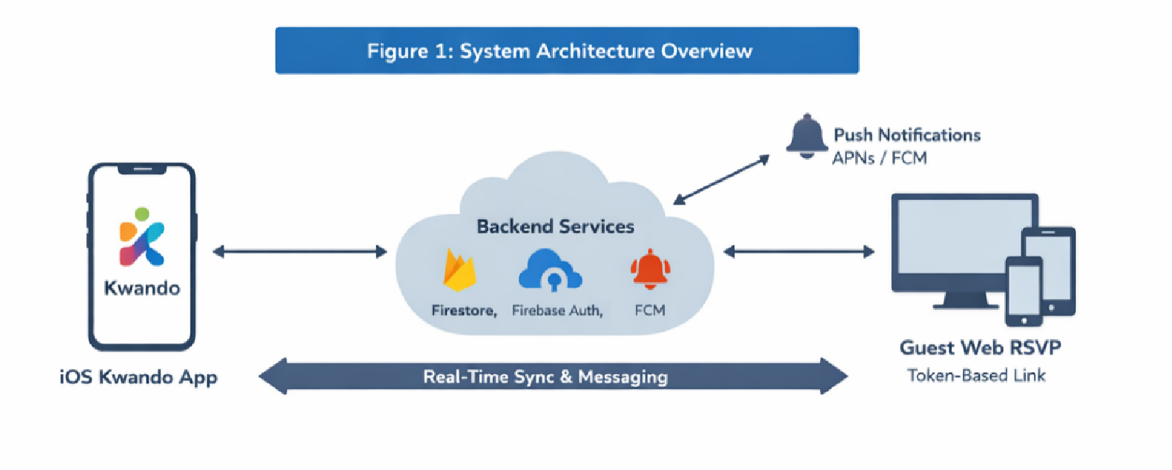

Figure 2 — Data Flow: Invite → RSVP → Poll → Finalize → Notify
- Host creates event and invites users + generates guest tokens.
- Guests/users RSVP → host dashboard updates → planning polls collect votes.
- Host finalizes date/time → event state updates → notifications delivered to participants.
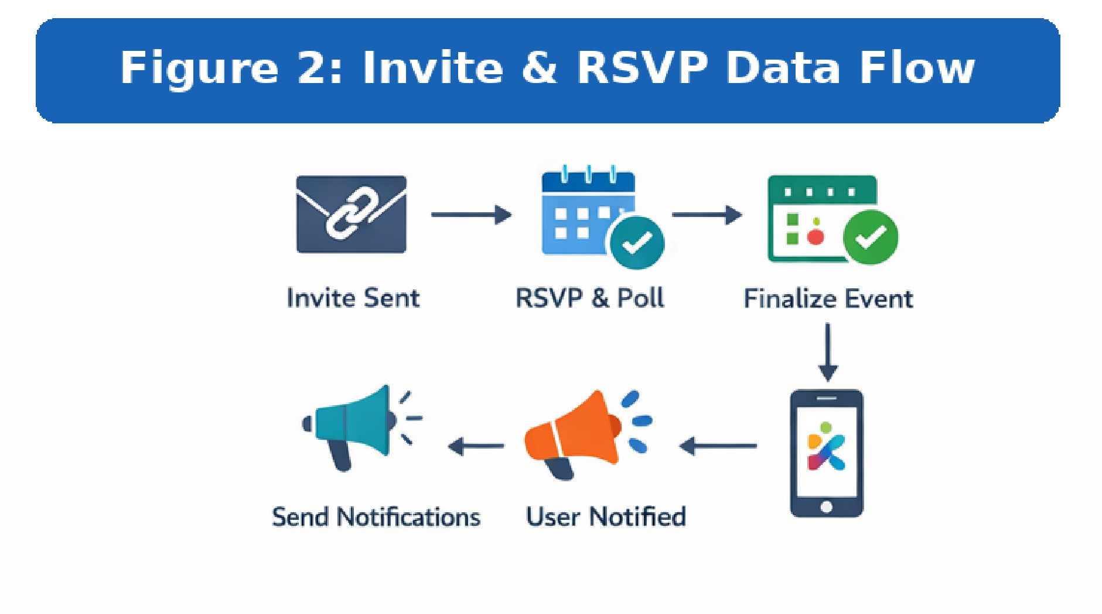

Figure 3 — High-Level ERD
- Entities: User, Event, Invite, RSVP, Poll, Vote, SharedView, Circle, Membership, ChatThread, Message, Notification.
- Relationships: User–Event (owner/participant), Event–Invite/RSVP/Poll/ChatThread, Circle targeting.
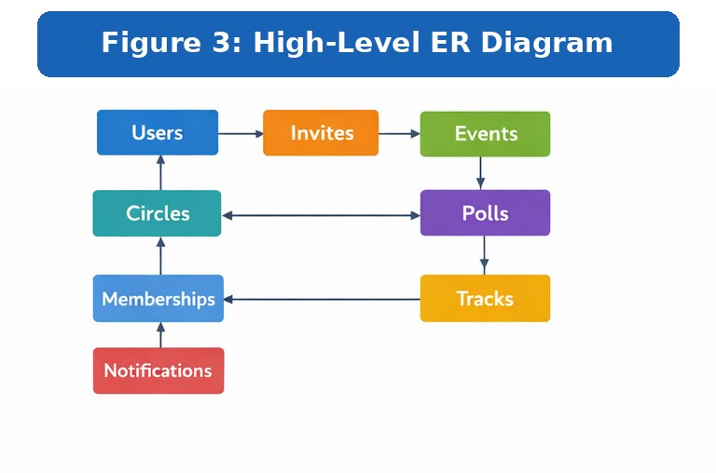

9. Security, Privacy, Risks & Mitigation

9.1 Security & Privacy Posture
- Privacy-first defaults: nothing shared without explicit user action and mutual consent for shared views.
- Least-privilege enforcement via API authorization plus server-side validation for sensitive actions.
- Sensitive operations (token issuance, revoke/resend, membership approvals) executed in Laravel services.
- Transport security: HTTPS; secure headers on web RSVP; secrets managed securely in environment configuration.

9.2 Key MVP Risks & Mitigations
Risk | Mitigation
Invite link leakage/forwarding | Per-guest one-time token; revoke/resend; optional expiry; do not embed PII in links.
Privacy misconfiguration (Shared Views) | Safe permission presets; mutual consent; clear visibility indicators; quick revoke.
Notification reliability & iOS edge cases | Device token refresh handling; retry queue;  TestFlight matrix across iOS versions; avoid spam.
Chat abuse/moderation gaps | Host/admin moderation; reporting hooks; optional automated moderation later.
Scalability & Firestore cost spikes | Pagination; minimize fan-out; monitoring; retention/TTL for stale chat data.

10. Development Methodology, QA & Release Plan

10.1 Methodology
- Agile Scrum with 1–2-week sprints, weekly demos, and phase-level QA.
- Definition of Done includes code review, critical-flow testing, QA pass, and updated documentation.
- Source control with feature branches + pull requests; tagged releases per phase.

10.2 QA Strategy
- Functional testing for each module; end-to-end testing for invite/RSVP/poll flows.
- Regression test suite maintained and executed before each phase handover.
- Security/privacy checks (permissions, token misuse attempts, rate limit validation, PII review).
- Notification reliability testing (foreground/background, deep link routing, token refresh, retries).
- Device and iOS version coverage through TestFlight beta testing.
10.3 TestFlight / App Store Release Checklist (Technical) • Bundle IDs, signing, provisioning, and entitlements validated.
- Apple Sign-In compliance and privacy disclosures reviewed.
- APNs/FCM setup verified; notification payloads validated and tested.
- Crash-free stability and performance baseline achieved for release candidate.
- Release notes, versioning, and rollback strategy prepared.

11. Deliverables
- Source code repositories (iOS, web RSVP, Laravel backend) and build/deploy documentation.
- Backend data model documentation (collections, indexes), security rules, and environment notes.
- Function/API documentation for invite, RSVP, poll, shared view, and notification workflows.
- QA artifacts: test cases, defect logs, and phase-wise test reports.
- Release artifacts: TestFlight builds, production build, and deployment checklist.

11.1 Maintenance Support
Bug fixing for minor UI issues and crashes reproducible in supported environments
Basic performance tuning and UI responsiveness improvements
Assistance interpreting frontend logs and issues (requires Client to provide access to crash/analytics tools).
App Store privacy and policy update related issue fixes
iOS and third-party SDK update (If mandatory to resolve release dependency)
Server downtime and performance related issue fixes

Note: Feature enhancements, new screens, or changes due to backend/API changes are excluded and treated as change requests.
12. Relevant Project References (Similar Delivery Experience):
U-Report UNICEF
app store: https://apps.apple.com/tt/app/u-report/id1598072043 play store: https://play.google.com/store/apps/details?id=org.unicef.ureport
- Lentho Community —
iOS: https://apps.apple.com/de/app/lentho-community/id1602655332 Android : https://play.google.com/store/apps/details?id=com.riseuplabs.lentho

13. Conclusion
This proposal delivers a phased, privacy-first MVP implementation aligned to the PRD: a strong personal calendar foundation, followed by social planning with guest RSVPs, then shared views, chat, and Circles with release readiness. Native iOS + Laravel is recommended to maximize quality and reliability while keeping MVP delivery fast and operationally lean.

Financial Proposal

A. Effort & Cost Summary (Phase-wise)
Estimates below are based on role-wise effort (man-days) and indicative rate ranges. Final pricing can be adjusted based on the agreed delivery model and team composition.
Phase | Scope Focus | Weeks | Estimated Cost (USD) | Total  Development cost
Phase 1 | Foundation +  Personal Calendar | 3 | $4,985 | $15,344
Phase 2 | Social Planning + Guest Web RSVP | 3 | $4,985 | $15,344
Phase 3 | Shared Views +  Chat +  Circles +  Release | 3 | $3,780 | $15,344
Phase 4 | Admin Console  (Admin  Dashboard) | 2 | $1,585 | $15,344

Monthly Maintenance Cost
Phase | Scope | Time | Cost
Maintenance | Described in 11.1 | Per Month | $350

C. Payment Terms (Phase-based)
- Each phase begins after scope confirmation for that phase and receipt of the phase advance payment.
- Payment schedule per phase: 30% advance to start the phase; 70% upon successful delivery.
- Next phase commences only after the previous phase payment is fully settled.

D. Inclusions, Exclusions & Change Request Policy
- Included: development, backend setup, QA, and TestFlight/App Store technical release support per scope above.
- Excluded: UI/UX design work, copywriting, branding assets, and paid third-party services unless specified.
- Change Requests: any request outside the approved scope will be estimated and scheduled via a formal change request.

E. Remarks
- Costs are indicative and provided as a range to avoid false precision; final commercial terms depend on final team mix and confirmed scope.
- Third-party operational costs (Apple Developer Program, domains, SMS fees, etc.) are not included unless explicitly stated.

