Technical Proposal
Moodle Multilingual Course Build and Learner Navigation Configuration
Prepared for: Survivor Alliance
Prepared by: Riseup Labs


1. Executive Summary
This proposal outlines a practical Moodle configuration approach to build six additional course instances for Survivor Alliance. The new courses will follow the already established U.S. Live Cohort and Self-Directed learning path, while separating learners by language and cohort so they access the correct course version only. The work will focus on course duplication/configuration, content upload, enrollment/access setup, sequencing/progression logic, QA validation, and staff handover documentation. No custom Moodle feature development is proposed unless a gap is found in the existing Moodle setup.
2. Understanding of Scope
The project scope is limited to building, configuring, and validating additional Moodle course versions based on the approved existing course framework.
Scope Area | Required Work
Course Builds | Create six additional course instances: one Global Live English version and five translated versions in Spanish, French, Hindi, Russian, and Bangla.
Structure Replication | Mirror the structure and layout of the existing U.S. Live Cohort and Self-Directed learning path.
Content Upload | Upload and organize provided translated content inside each course according to the established structure.
Learner Navigation | Configure clear Moodle pathways so learners are routed to the correct language/cohort course.
Enrollment and Access Control | Set enrollment and access rules to prevent learners from entering the wrong course version.
Sequencing and Progression | Configure activity completion, access conditions, and course sequence logic across the learning paths based on the existing model.
Staff Navigation Support | Prepare documentation and transfer knowledge/access to Survivor Alliance staff so they can understand and manage the course structure.
2.1 Scope Control
- No translation service is included; translated content will be provided by Survivor Alliance.
- No new LMS platform, theme redesign, mobile app, payment gateway, or external system integration is included.
- No custom plugin development is included unless existing Moodle configuration cannot meet a confirmed requirement.
- The proposal assumes the existing Moodle environment and the approved U.S. course structure are available for reference and reuse.
3. Proposed Technical Approach
Step | Approach Area | Description
1 | Course Audit and Baseline Mapping | Review the existing U.S. Live Cohort and Self-Directed courses, identify sections, activities, labels, files, sequencing rules, completion criteria, and enrollment logic that must be replicated.
2 | Course Shell Creation | Create six new Moodle course instances with consistent naming, categories, visibility settings, language labels, and course summary information.
3 | Structure Replication | Use Moodle course copy/import/backup-restore methods as appropriate to replicate the approved source structure without rebuilding each section manually from scratch.
4 | Content Upload and Organization | Upload translated materials provided by Survivor Alliance, place them in the matching sections/activities, and check formatting, file names, links, and learner-facing labels.
5 | Learner Routing Setup | Configure cohorts, groups/groupings, enrollment settings, and course visibility/access rules so learners are assigned to the right course version by language and cohort.
6 | Sequencing and Progression Logic | Apply activity completion and restrict access rules to maintain the intended learning sequence across Live Cohort and Self-Directed paths.
7 | Staff Handover and Documentation | Prepare a course map, access logic notes, and staff navigation guide explaining how the versions are organized and how designated staff can manage them.
The approach prioritizes Moodle core configuration to reduce cost, implementation risk, and future maintenance dependency. Official Moodle documentation supports the use of cohorts for bulk course enrollment, restricted access for activity/section availability conditions, and activity completion for progress tracking and sequencing support.
4. Implementation Methodology
A short configuration-focused delivery methodology is recommended. This keeps the work controlled, avoids unnecessary development, and allows the client team to review one completed model before all language versions are finalized.
Phase | Method | Outcome
Phase 1: Setup Review | Confirm source course structure, content readiness, course naming conventions, and staff access requirements. | Approved course map and setup plan.
Phase 2: Pilot Course Build | Build one new course version first using the approved template and validate structure, access, and completion logic. | Reusable configuration pattern for the remaining versions.
Phase 3: Batch Course Build | Create and configure the remaining five course versions using the validated pattern. | Six configured course instances.
Phase 4: Content Upload and Validation | Upload provided translated content, organize course sections, check links/files/media, and align learner labels. | Course-ready content structure.
Phase 5: QA and Handover | Run QA checks, fix configuration issues, and deliver staff documentation and handover notes. | Validated courses and staff-ready documentation.
5. Proposed Technical Stack
The proposed stack is based on the existing Moodle platform and standard Moodle administration features. No separate application stack is required for this scope.
Layer | Proposed Stack / Tooling | Purpose in This Project
Learning Management System | Existing Moodle LMS instance | Create and manage multilingual course instances, activities, resources, learner access, and progress tracking.
Course Build Tools | Moodle course copy/import/backup-restore features | Replicate the approved U.S. course structure into the six new course versions.
Enrollment and Access Control | Moodle cohorts, groups/groupings, manual enrollment or cohort sync as supported by the current site | Route learners correct course versions and prevent access to wrong versions.
Progression Logic | Moodle activity completion, course completion settings, and restrict access conditions | Maintain sequencing and progression across Live Cohort and Self-Directed learning paths.
Language Support | Moodle language packs where required for interface support; provided translated course content | Support learner-facing language versions while using Survivor Alliance-provided content.
Content Types | Existing Moodle-supported activity/resource types already used in the source course | Maintain consistency with the established learning design without introducing new costly features.
Documentation | Course map, setup guide, access matrix, and staff handover notes | Help Survivor Alliance staff understand and maintain the course structure after delivery.

6. Technical Diagrams
6.1 Moodle Course Build and Versioning Architecture
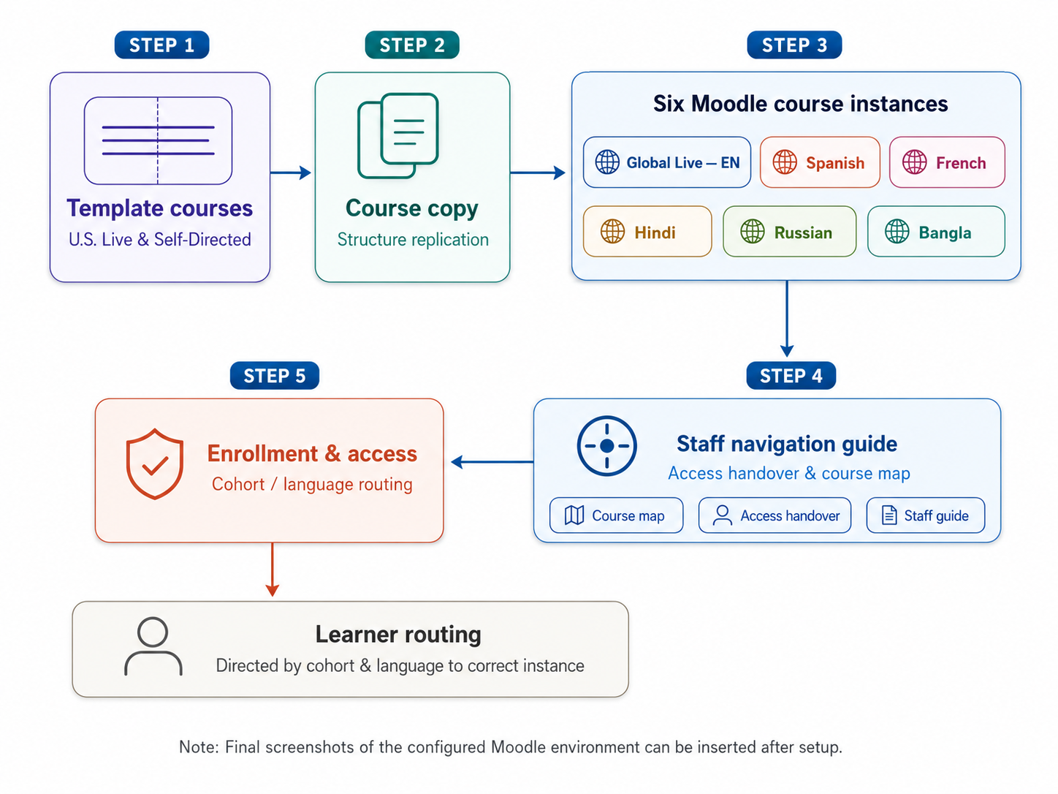
Figure 1: Moodle course replication and versioning architecture. Final Moodle screenshots can be inserted under this figure after configuration.
6.2 Learner Routing and Course Access Control Flow
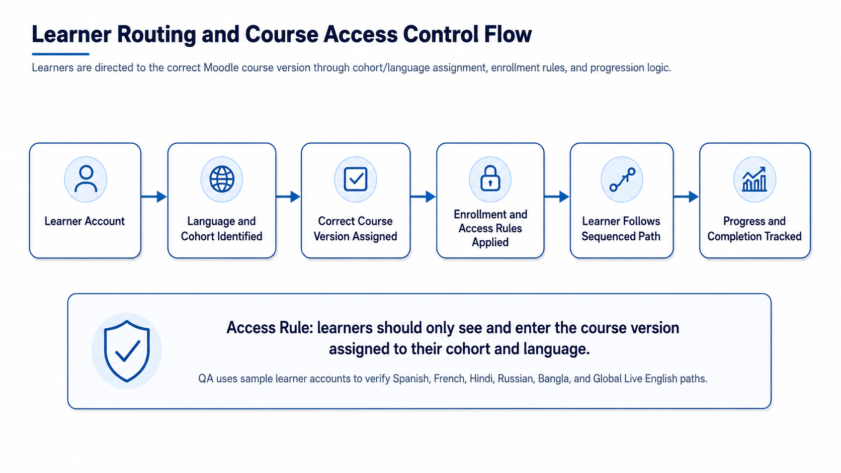
Figure 2: Learner routing and access control flow. This diagram can be replaced or supplemented with a final Moodle flow screenshot during proposal presentation.
7. Project Deliverables
Deliverable | Description
Course Baseline Mapping | Documented map of the existing U.S. Live Cohort and Self-Directed course structure to guide replication.
Six Moodle Course Instances | One Global Live English course and five translated course versions: Spanish, French, Hindi, Russian, and Bangla.
Configured Course Structure | Sections, activities, resources, labels, and layout aligned with the approved source course structure.
Uploaded and Organized Content | Provided content uploaded and placed in the correct course sections and activities.
Learner Routing and Access Setup | Cohort/language-based enrollment, access controls, and visibility settings configured to reduce wrong-course access.
Progression and Completion Setup | Sequencing, activity completion, and restrict access logic configured according to the established learning path.
QA Checklist and Issue Log | Validation checklist covering course structure, content, links, access, sequencing, and sample learner navigation.
Staff Documentation and Handover Notes | Course map, version structure, access logic, and staff navigation instructions for Survivor Alliance team members.
8. Testing and Quality Assurance
QA will focus on configuration accuracy, content placement, access control, and learner navigation. The QA scope will be limited to the course-build requirements.
- Validate each new course against the approved U.S. Live Cohort and Self-Directed structure.
- Check uploaded files, links, labels, embedded content, and section placement across all six course versions.
- Test sample learner accounts for each language/cohort to confirm they can access only the correct course version.
- Verify activity completion, sequencing, and restrict access behavior for Live Cohort and Self-Directed paths.
- Review learner navigation on common desktop and mobile browser views within Moodle.
- Verify staff access, course visibility, and documentation accuracy before final handover.
9. Assumptions and Dependencies
- Survivor Alliance will provide all translated content in final or near-final form before content upload starts.
- Existing Moodle admin or course manager access will be provided to the implementation team.
- The approved U.S. Live Cohort and Self-Directed courses are available as the source framework.
- Learner cohort and language assignment rules will be confirmed before access-control configuration begins.
- Any major content changes after upload may affect the timeline and effort estimate.
- The current Moodle version supports the required core features such as cohorts, restrict access, and activity completion.
10. Acceptance Criteria
- Six new Moodle course instances are available and named according to the agreed language/cohort convention.
- Each course mirrors the source U.S. Live Cohort and Self-Directed learning path structure.
- Provided content is uploaded and organized in the correct sections and activities.
- Sample learners are able to access only their assigned language/cohort course version.
- Activity completion and progression rules behave consistently with the approved learning path.
- Survivor Alliance staff receive documentation explaining course structure, version mapping, access rules, and navigation.

13. Conclusion
This project will enable Survivor Alliance to expand its Moodle-based learning program into six additional course versions while maintaining the same structure, learner flow, and access control model already established for the U.S. Live Cohort and Self-Directed courses. By configuring language-specific courses, proper cohort routing, content organization, progression logic, and staff handover documentation, the platform will support a smooth multilingual learning experience with minimal operational complexity.

